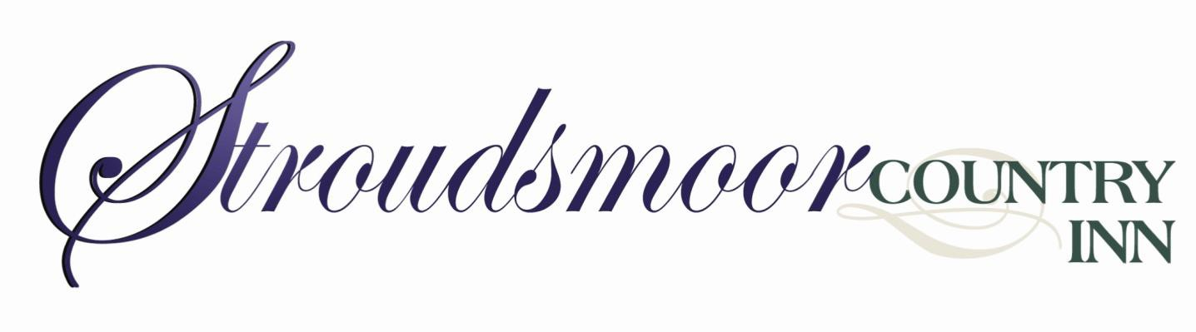

Time-honored Table Etiquette

Basic Questions and Answers for table setting and social dining.

Table Setting 101

Table tips for intimate gatherings or Holiday Tables.

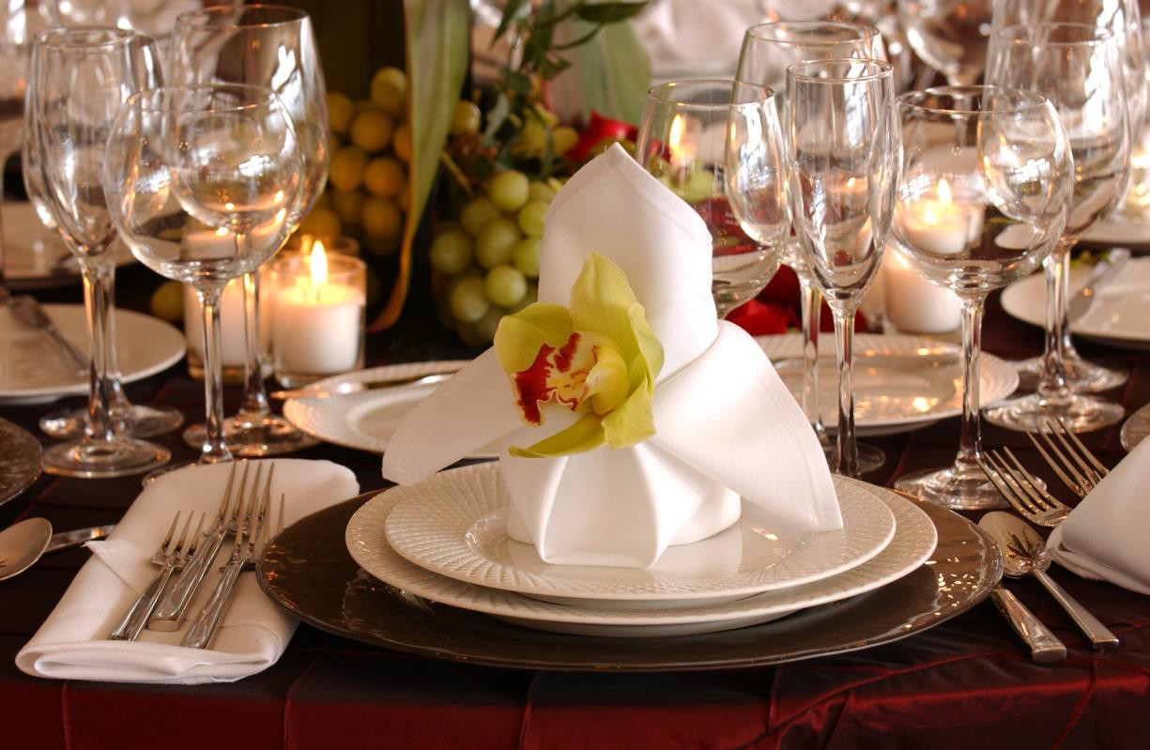

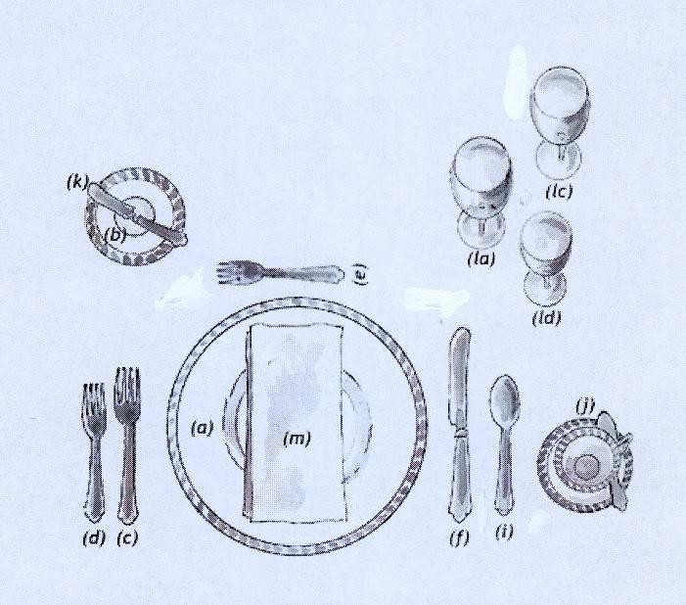

**Table Setting Guide: Formal Place Setting**

The one rule for a formal table is for everything to be geometrically spaced: the centerpiece at the exact center; the place settings at equal

distances; and the utensils balanced. Beyond these placements, you can vary flower arrangements and decorations as you like.

The placement of utensils is guided by the menu, the idea being that you use utensils in an “outside in” order. For the illustrated place

setting here, the order of the menu is:

**First Course:** Soup

**Second Course:** Salad

Entrée

Dessert

* Service Plate: This large plate, also called a charger, serves as an underplate for the plate holding the first course, which will be brought to the table. When the first course is cleared, the service plate remains until the plate holding the entrée is served, at which point the two plates are exchanged.
* Butter plate: The small butter plate is placed above the forks at the left of the place setting.
* Dinner fork: The largest of the forks, also called the place fork, it is placed on the left of the plate. Other smaller forks for other courses are arranged to the left or right of the dinner fork, according to when they will be used.
* Appetizer/Salad fork: If salad is served after the entrée, the small salad fork is placed to the right of the dinner fork, next to the plate. If the salad is to be served first, then the forks would be arranged (left to right): salad fork then dinner fork.
* Dessert spoon and/or fork: These can be placed either horizontally above the dinner plate (the spoon on top with its handle facing to the left; the fork below with its handle facing right); or beside the plate. If placed beside the plate, the fork goes on the left side, closest to the plate (because it will be the last fork used) and the spoon goes on the right side of the plate, to the right of the dinner knife and to the left of the soupspoon.
* Dinner knife: The large dinner knife is placed to the right of the dinner plate.
* Centerpiece: Always placed in the center of the table and should be either low to the table or high above to ensure guest visibility when seated.
* When in doubt use a utensil rather than your fingers even with foods you eat by hand at home. Cut French fries, bacon and any food with a bone – even chicken.
* Tuck paper trash under the rim of your plate or on the edge of a saucer or bread plate.
* If you are not sure how to eat something that comes with what you ordered, leave it or watch to see how others eat it. Use the edge of your plate to twirl pasta, not a spoon.
* If you drop a utensil on the floor – leave it and ask for another. Never place a dirty utensil back on the table cloth.
* RELAX and use your common sense.
* Never ever, ask for a doggy bag when dining formally!
* Never ever, ever answer your cell phone during a social or business function – this includes text messages!!!!

**In general . . .** Knife blades are always placed with the cutting edge toward the plate. No more than three of any implement is ever placed on the table, except when an oyster fork is used in addition to three other forks. If more than three courses are served before dessert, then the utensil for the fourth course is brought in with the food; likewise the salad fork and knife may be brought in when the salad course is served. Dessert spoons and forks are brought in on the dessert plate just before dessert is served if it is the fourth fork required for the meal.

* Napkin: The napkin is placed on top of the charger (if one is used) or in the space for the plate.
* Condiments: Salt and pepper shakers should always be set together on the host side of the table; creamer and sugar are also set next to each other – placed on the table at the opposite end of the salt and pepper.
* Soup spoon or fruit spoon: If soup or fruit is served as a first course, then the accompanying spoon goes to the right of the knives.
* Coffee Cup & Teaspoon: Our illustration shows a table setting that would be common in a restaurant serving a large number of people at once, with coffee being served during the meal. The coffee cup and saucer are placed to the right of the knife and spoons in line with the bottom end of the utensils.
* Butter knife: This small spreader is paced diagonally on top of the butter plate, handle on the right and blade down.
* Glasses: These can number up to five and are placed so that the smaller ones are in front. The water goblet (la) is placed directly above the knives. Just to the right goes a champagne flute (lc); In front of these are placed an all-purpose (ld) wine glass – when using three glasses a triangle should be formed. Not shown on our diagram is the second wine (lb) which would be used for a white wine and be placed next to the first red (all-purpose) wine glass. The fifth glass would be a sherry glass (le) placed next to the white wine glass.

**Etiquette . . .** is defined as “the forms, manners, and ceremonies established by convention as acceptable or required in social relations, in a profession, or in official life.” Times change and this affects the guide lines of etiquette. Common sense will typically be your best guide, but it is helpful to have some general ideas regarding dining and business etiquette. This handout will provide some basic information for your day-to-day experiences. There are many things to keep in mind when dining, but as always common sense should be your guide. When dining with a prospective employer remember it may look like lunch/dinner but its still business. The way you act during a meal will have impact on an interviewer’s hiring decision and your future.

**For the Men . . .** Gentlemen will rise and pull out the chair for a woman who is leaving the table, and again when the woman returns to the table.

**For the Ladies . . .** Never put your purse on the table and never refuse to be seated by a gentleman.

**What to do with the Napkin . . .** When dining with others place your napkin on your lap after everyone at your table has been seated. Do not open your napkin in mid-air. As you remove your napkin from the table begin to open below the table level and place folded in half on your lap. When leaving the table in the middle of the meal place your napkin on your chair. When meal is completed, place your napkin to the left of your plate-never on the plate.

**Dinner is served . . .** Wait for everyone at your table to be served before beginning to eat. However, if an individual who has not been served encourages you to begin eating, you may do so. Eat slowly while waiting for their food to be served. It can be very confusing to be presented with a variety of eating utensils. Remember the guideline “to start at the outside and work you way in.” If you have been given two forks, which are the same size, begin with the fork on the outside. Many restaurants use the same size of fork for both the salad and main course.

**Breaking Bread . . .** Bread/rolls should never be eaten whole. Break into smaller, more manageable pieces, buttering only a few bites at a time. Toast and garlic bread however may be eaten as whole pieces since they are usually already buttered. If you are served a piping hot muffin or biscuit, you may break in half crosswise, butter and put back together. However when ready to actually eat, break into smaller pieces. If you are the first to pass the bread, offer the guest to your right and pass left.

**Pass the . . .** Pass “community food” such as the breadbasket, salt and pepper and salad dressing to the right counter clockwise. Always pass the salt and pepper together – when passing items such as a creamer, syrup pitcher or gravy boat, pass it with the handle pointing toward the recipient. Never do the “boarding house reach” across the table!

**Other etiquette tips to know . . .**

* By making eye contact – the waiter will know you need assistance and attend to your needs as soon as possible.
* It is acceptable to raise your hand to head level to attract the waiter’s attention – bringing your arm back down if the waiter is out of sight.
* Raise your arm way above your head and wave it about to attract the waiter’s attention. Snap your fingers together to attract the waiter’s attention.
* Is more than one answer correct?

The British statesman Edmund Burke placed manners on a par with laws. If we use manners and respect as our constitution, laws might not be as necessary. If people start instinctively behaving in ways that respect another’s beliefs and don't tread inordinately on each other's personal space the need for the strict enforcement of laws might diminish.

Rudeness is both dehumanizing and threatening, whether you play by the rules of a Victorian snob or a modern street gang – manners are what bind people together. Always error on the side of good manners – you will achieve greatness when you have a high opinion of your neighbors treating them as you wish to be treated.

* Before taking a sip of your drink. It’s unsightly to see food particles or grease on the rim of your glass.
* Before greeting an unexpected guest, who arrives while you are dining.
* If you feel your nose is running and you are embarrassed to take out your hankie – pretend to be wiping your mouth and cross your nose with the napkin.
* Before each new course is served.
* Before leaving the dinner table – then place it on the left of your plate or in the center of our seat if the plate has been cleared.
* Is more than one answer correct?

**When cutting meat, the correct way is to**

* Rip off a piece that’s about one or two bites in size, butter it, and eat it. Repeat slowly through the meal.
* Butter the top and bite straight into a roll.
* Cut roll in half, butter the bottom half, replace the top and begin eating.
* Cut the roll in half and butter both sides, cut each side into quarters and eat quarter pieces.
* Is more than on answer correct?

**The proper way to butter a piece of bread is**

**1.**

**When dining for business or social reasons when is it most appropriate to begin eating your meal:**

* Wait until the entire table has been served their food.
* Begin eating immediately if your food temperature is at high risk in decreasing the enjoyment of the meal.
* Wait until 50% of the table has been served then begin eating.
* Begin before others at the table have been served if guests are incessantly insisting you begin.
* Is more than one answer correct?

**2.**

**3.**

* Cut a piece and then switch your fork to your right hand to pick it up. This method is considered the “American” way.
* Cut a piece don’t switch your fork using your left to eat the piece. This is called the “Continental” way, and is done most often in
* European countries.
* Cut meat a piece or two, never more, at a time and begin eating.
* Cut the entire portion of meat up into pieces then begin eating.
* Is more than one answer correct?

**4.**

**Wiping your mouth is important and proper when**

**What is proper when you don’t want to swallow a piece of food in your mouth (e.g. a bone or a piece of fat)**

**5.**

* Pick up your napkin, spit out the debris in the napkin, fold the napkin and place it on the table next to your plate.
* Move the piece to the front of your mouth and use your fork (or spoon if that’s what you were using) to retrieve it from your mouth then place it on the side of your plate.
* Using you finger and your thumb take the fish bone out of your mouth and place it on the side of your plate or the fish dish if part of the place setting.
* Say “excuse me I have a bone (or other type of unwanted food) in my mouth” and spit it onto your plate.
* Is more than one answer correct?

**6.**

**The proper way to get the waiter’s attention is**