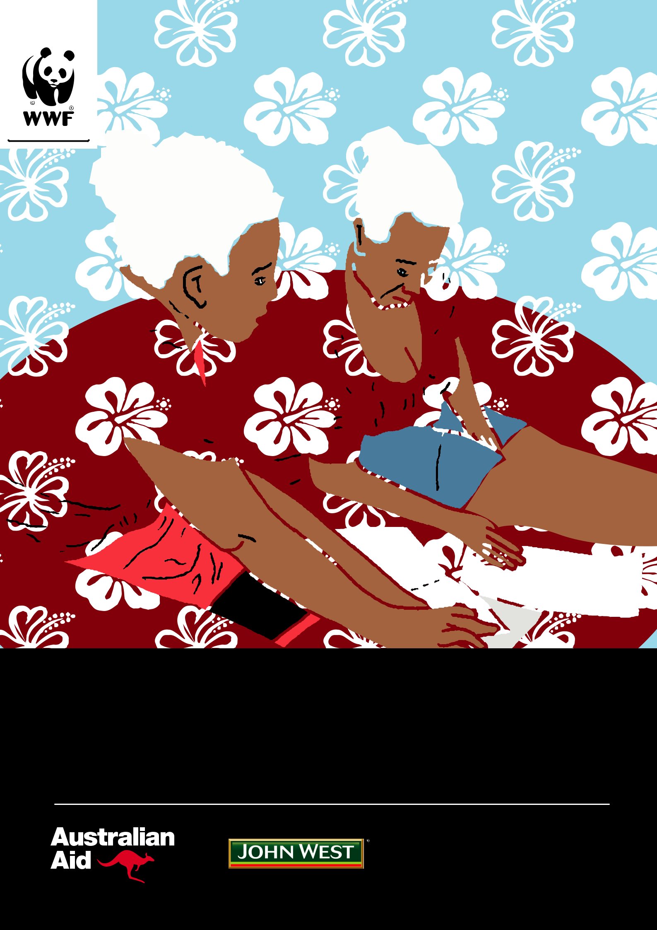

FINANCIAL INCLUSION TRAINING MANUAL

A GUIDE TO THE WWF WOMEN’S FINANCIAL INCLUSION MODEL WITH COMMUNITIES IN WESTERN PROVINCE, SOLOMON ISLANDS

OUR VISION:

The people of Solomon Islands managing their natural resources for food security, livelihoods and a sustainable environment.

“ Olketa pipol lo Solomon Islands lukaotim gud olketa samting lo land an sea fo kaikai, wokim seleni, an gudfala place fo stap. ”

PUBLISHED BY:

WWF-Pacific (Solomon Islands) P.O.Box 1373,

Honiara Hotel SOLOMON ISLANDS

TEL: +677 28023

EMAIL: sseeto@wwfpacific.org

June 2018

Any reproduction in full or in part of this publication must mention the title and credit the above-mentioned publisher as the copyright owner. All rights reserved.

Written by Nicole Lowrey

Design and graphics by Toli Wanefalea

Edited by Dr Alice Aruhe’eta Pollard

Photos by WWF Solomon Islands, Gizo Office, and Nicole Lowrey

Special thanks to Dr Alice Aruhe’eta Pollard, and WWF staff Shannon Seeto, Salome Topo, and Dafisha Aleziru for providing information and guidance for the report.
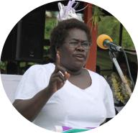

For additional information, or if you would like to donate, please send an email to Shannon Seeto to at WWF-Pacific (Solomon Islands): sseeto@wwfpacific.org

This publication has been funded by the Australian Government through the Australian NGO Cooperation Program (ANCP) and John West Australia. The views expressed in this publication are the author’s alone and are not necessarily the views of the Australian Government or John West Australia.

INTRODUCTION

Dr Alice Aruhe’eta Pollard started her financial inclusion model in Solomon Islands with the West 'Are'Are Rokotanikeni Association (WARA) in 2006 to empower women in the rural areas for development and help them reach gender equality. In 2013, Dr Pollard discussed the WARA model with WWF and women in Western Province, and how it could work for them, noting good cash flow in the Gizo and surrounding communities. The WARA model (Balancing Model) was then adapted to fit the women and communities WWF works with.

The WWF financial inclusion work is a component of the Sustainable and Resilient Island Communities Programme. This programme supports island communities to manage their forests, reef and fish resources, and provides alternative livelihood opportunities, away from the reef or land, to women through financial inclusion training and savings clubs.

A key difference between the financial inclusion model built by WWF and Dr Alice Pollard and other

organisations is its strong focus on the environment and social impacts. Communities that sign up to

financial inclusion with WWF must follow sustainability criteria when taking out loans and starting businesses,

to ensure that any business or development opportunities do not harm the environment or have negative

impacts on the community. As many small businesses in remote communities make money from the

natural resources in the environment, it is important for communities to ensure their usage is sustainable, so

businesses can be sustained and thrive for years to come.

WWF has trained local women in financial inclusion and these women can be invited by any interested communities to conduct awareness training and establish savings groups. With the increasing demand for financial inclusion programs coming in from various groups in and around Gizo communities, it is fitting that WWF engages in capacity building with local women in financial inclusion which is sustainable and accessible.

This manual is designed to help trainers facilitate financial inclusion training workshops with interested members in their communities, and to help communities establish and operate their own savings clubs. It is designed as a guide for training sessions, to be used alongside other training materials. The manual can also be used by government agencies, Non- Government Organisations (NGOS), and Community-Based Organisations (CBOs) as a guide for how financial inclusion has worked in practice in remote island communities in Western Province.

While WWF’s financial inclusion model has been designed specifically for women, to empower them and build their financial and business capacity, a similar model can be developed for both men and women by using this manual as a guide. There are other models that are available and used by other NGOs working in Solomon Islands such as the World Vision model.

ESTABLISHING AND RUNNING SAVINGS CLUBS

There are multiple stages to starting savings clubs, and ensuring they run long-term for the benefit of all members and are sustainable. The first stage is community awareness and consultations on financial inclusion, and then a community invitation. From there, financial literacy training can be conducted to engage the groups perspective and their level of understanding and commitment to organise and lead such an initiative. Having identified the strength of the group in terms of leadership, literacy and commitment, a savings club can be established. Over time and based on proven financial record of the group, a loan component could be established in parallel with the savings. Sustainability, accountability and transparency criteria can be introduced with additional training in loans, calculations, interest and loan repayments. Simple addition/subtraction, balancing, clear recording and writing are crucial in savings. Annual Action Audits occur to ensure accounts are all up to date and money is being correctly recorded and balanced. These processes should be transparent with all members. Stages include:

Community awareness | 1. |  | Community expression of | 2.
on financial inclusion |  |  | interest / invitation to start
The community must discuss if |  |  | the savings club
financial inclusion is something |  |  | Once community agreement is
they are interested in, in addition |  |  | reached, an invitation can be sent
to sustainable fisheries training. |  |  | to WWF for support and training.

Financial literacy training | 3. |  | Savings club | 4.
The first training provided to teach |  |  | established
women what savings are, how to set |  |  | During financial literacy
goals and budgets, and how to reach |  |  | training, a committee is
them. |  |  | organised and the savings
 |  |  | club is established.

Microfinance, administration, | 5.
loan and sustainability training

This training discusses administration and can be held straight after financial literacy training. It also introduces what loans are, and why businesses need to be sustainable.

Sustainability | 7.
criteria introduced

Savings club members must follow sustainability criteria if they take out a loan.

Loan component

established

During the training, the loan component is established (after fundraising for the Revolving Fund) and members can start to take out loans.

Balance and

Action Audits

Monitoring of the movement of money to ensure correct processes and procedures are followed.

6.

8.

Additional | 9. |  | Share | 10.
training |  |  | knowledge
If requested, this can include: |  |  | Members can share the benefits
» Business plan template training |  |  | with other communities, and
 |  |  | how they can become involved.
» Business and management training
» Leadership training.

4 Financial Inclusion Training Manual | Published by: WWF-Pacific (Solomon Islands) JUNE 2018

HOW A SAVINGS CLUB WORKS

A savings club is an informal financial group, where members save money and aim to achieve a short, medium or long-term goal. Savings clubs can also help by providing loans to members through the loan scheme, but only some savings clubs allow this. Women’s savings clubs encourage women members, female children to join. This assists women to provide leadership and make decisions about money. In addition, families, tribes or communities can organise their savings group that may be inclusive of both genders.

In the WARA/WWF model, women’s savings clubs have three types of funds; Savings Funds from the individual women's savings, a Revolving Fund which includes money working through the hands of women in the community through a small-loan component, and an Operations Fund that supports the administration of the savings club. The money comes from financial membership fees, fundraising from the group, or donation from donors. WWF encourages savings clubs to fundraise for the Operations Fund to support natural resource management and/ or enforcement, as many small businesses depend on natural resources in the environment being sustainably managed. Each savings club will also raise $1,000 as an annual contribution to the Peer-to-Peer Network for Women’s Savings Clubs to help support management of community fisheries and resources. Extra funds can also be raised for community-wide needs with a positive environment or social impact, if all executive agree.

To participate in women’s savings clubs, a woman must attend Financial Literacy training first and purchase a Savings Club Passbook. She must also be a financial member of the club through paying a small membership fee. Through training, women are encouraged to save their money, learn to budget for themselves and their family, discuss savings and what it means with their husbands and partners, and to think about beginning small-scale business opportunities through the small-loan component. To ensure any new businesses are in line with WWF’s conservation and environmental goals, sustainability criteria for loans have been developed that must be met before a loan is granted to an individual. Ongoing monitoring of the club is done through the committees and a Balance and Action Audit with WWF and local women trainers twice a year.
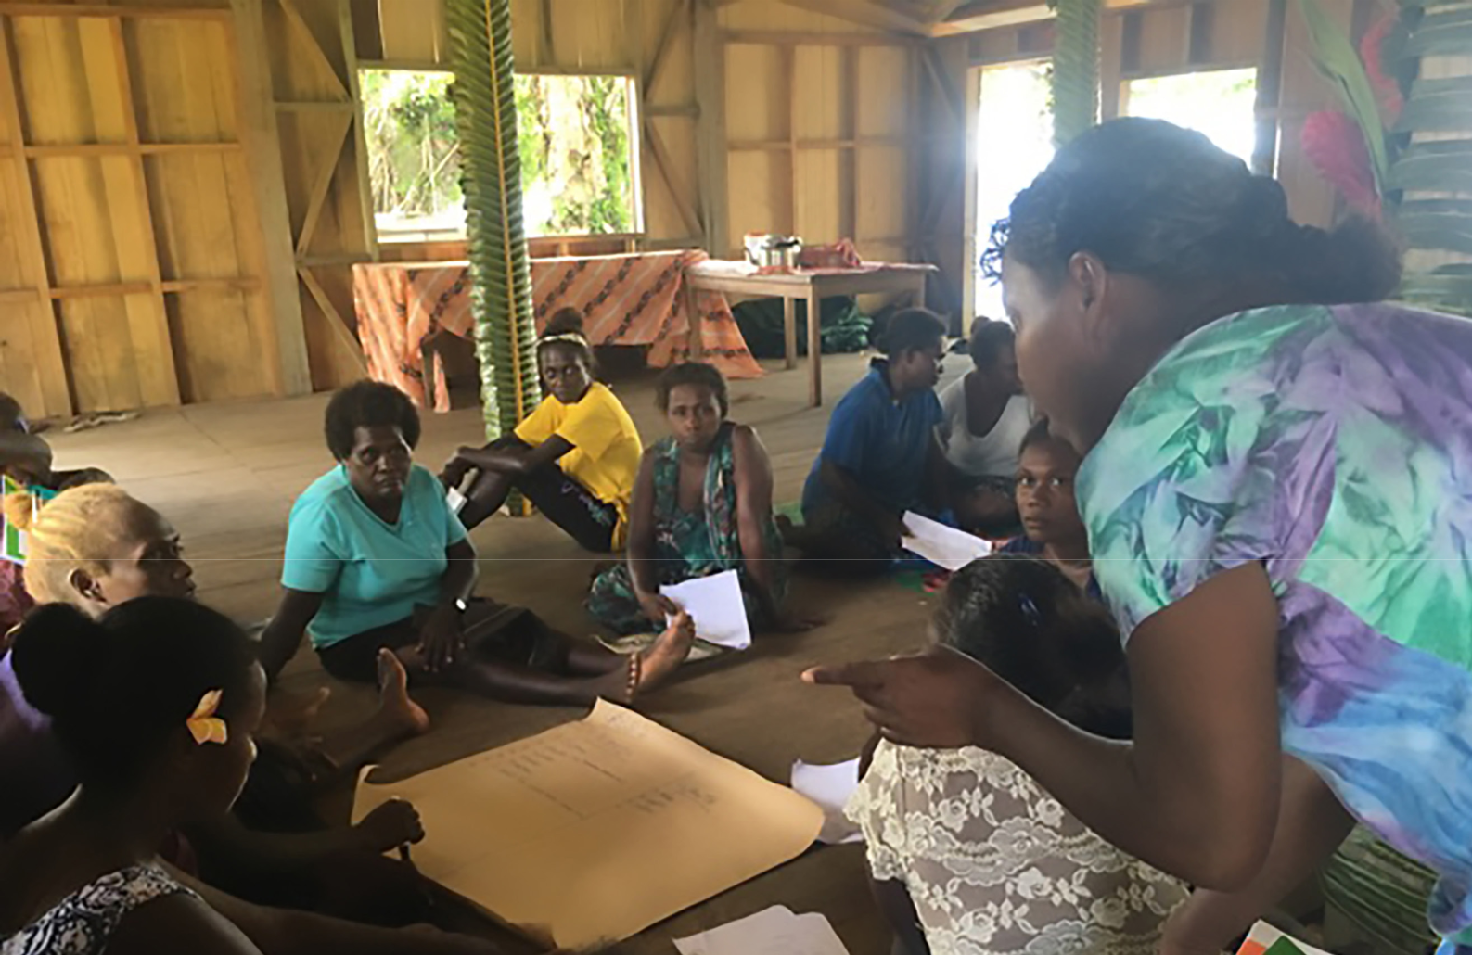

Financial Inclusion Training Manual | Published by: WWF-Pacific (Solomon Islands) JUNE 20XX 5

BEFORE TRAINING STARTS

Communities must express their interest and talk to WWF about the financial inclusion process first. WWF’s financial inclusion work is part of the Sustainable and Resilient Island Communities programme and linked to sustainable fisheries co-management work.

If communities are still interested, they must write a letter to WWF asking for training

and support. Interested communities must introduce the sustainable fisheries programme before they can receive financial inclusion training.

Once a letter is received, WWF organises a time to visit the community and conduct training. The community then has to talk to the women and see how many are interested in joining a savings club, and to write down the names of women who want to be in the savings club committee and what roles each of them will take. This is important as the work involved requires commitment, discipline and trustworthiness. It is also voluntary and involves huge personal costs. Positions and roles of the executive include:

Roles include:

- President – leader and manager of the savings club group

- Vice-President – second in charge

- Treasurer – responsible for storing and accounting for the money

- Vice Treasurer – responsible for storing and accounting for the money

- Secretary – responsible for recording minutes and organising meetings

- Assistant Secretary – responsible for recording minutes and organising meetings

- Money Counters x 3 – collect and count the money on Bank Day and record it against the passbook, individual record book and the zone record book.

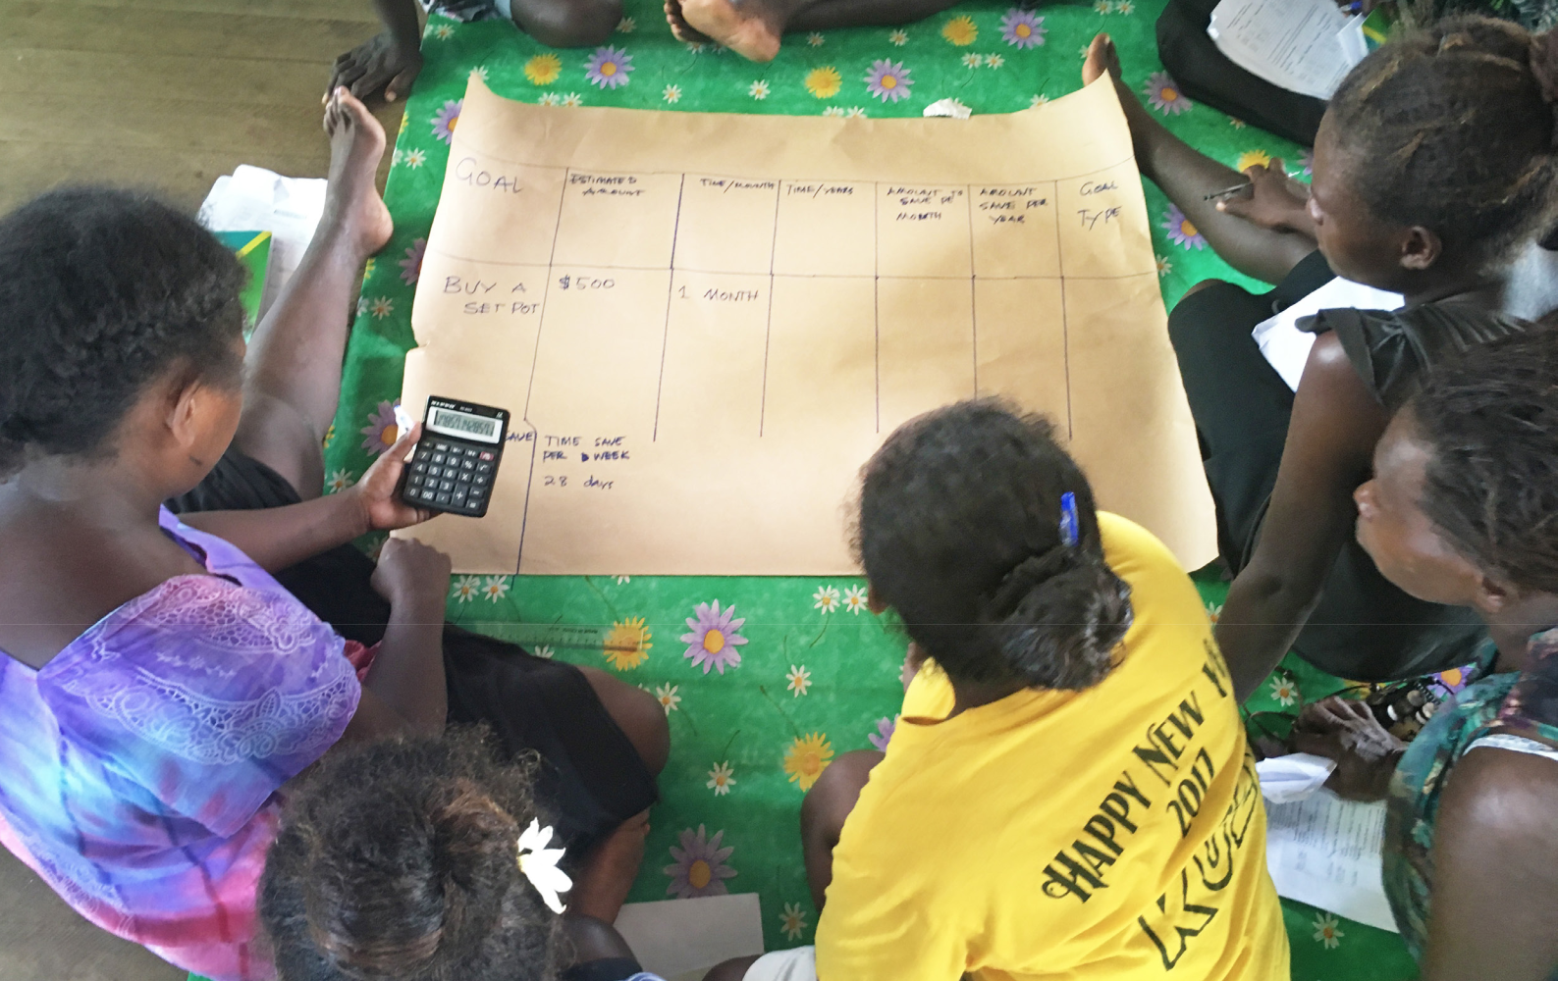

6 Financial Inclusion Training Manual | Published by: WWF-Pacific (Solomon Islands) JUNE 20XX

FINANCIAL LITERACY TRAINING – 3 DAYS

What: Financial Literacy training teaches women the value of money, what saving is, and

how to save and use money. The savings club is established, as well as the committee. Good Governance training teaches women their key roles and responsibilities.

When: This training is given once the community has invited WWF to train them, and is mandatory for all women who wish to join the savings club. If more women request to join the club, the training may be given to new members.

DAY 1: FINANCIAL LITERACY TRAINING

To start, the trainer has to discuss the goals of the workshop to participants. How

to manage money (personal savings and collective savings schemes), what savings groups will involve, challenges, achievements and the function of the established savings club group.

The trainer splits the women into small groups according to the number of women present and gives them paper and pens. Then the trainer discusses how women get money and use money, for themselves or for their family, and where it goes. This includes understanding money.

Activity 1: Personal Savings

The trainer asks the group:

- 1. List what ways women earn money.

- 2. List what ways women spend money.

- 3. Write down who you currently owe money to.

- 4. Write down who currently owes you money.

As a group a list is recorded of all the ways women can earn money, and a list of how women spend money. This activity shows that there are many opportunities to make money, but just as many ways to spend. It is important to understand that money flows. It is important to save little by little to see your money grow. If you save, they will add up to a large amount.

Main messages: How long does it take you to earn money compared to how long it takes you to spend? Money should not control us; we should be the boss of our money.

Activity 2: Needs vs. Wants

Most important things versus less important things. The trainer divides participants into small groups and asks them to:

- List the things you really need to buy.

- List the things that you want, but don’t really need.

- List the things that can wait until you have enough funds.

A woman from each group reads their answers. The outcome of the activity is to make women think about what they need to spend money on, and identify those things that women can reconsider buying. This activity is very important for participants

to understand that they have limited money and to use their small earnings wisely, and to prioritise what are important items for the limited money they have.

Main Messages: Think and ask yourself before you buy things. Some things can wait

until you have enough money to buy them. Self-control and discipline are very important.

Financial Inclusion Training Manual | Published by: WWF-Pacific (Solomon Islands) JUNE 2018 7

Goal Setting

The trainer will discuss how to set a goal, like an aim or target, to help manage money. Explain goals are important so we can stay focused, help us work hard, give us a target

to work to and help us save money. To set your goal, be specific, and list the benefits of reaching your goal.

Activity 3: Set a Goal

Timeframes are important to help reach goals. The trainer asks each woman to set a goal in their Individual Record Book. If they have a goal, they need to know the estimated price of the item they want to buy, for how long they would save, and how much in a week, month or year to save before achieving that goal. This section is very important as women can calculate the amount that they could save daily, weekly, monthly or yearly. Goal setting refers to SMART goals. These initials stands for Specific, Measurable, Achievable, Realistic and Time bound.

The SMART goal concept can help women to set realistic goals.

- S= Specific

- M= Measurable

- A= Achievable

- R= Realistic

- T= Timely

Example:

 |  |  |  | Amount | Amount
 | Estimated | Time/ | Time/ | to save
Goal |  |  |  |  | to save | Goal type
 | amount | Months | Years | per
 |  |  |  |  | per year
 |  |  |  | month
Buy solar | $2,280 | 24 | 2 year | $95 | $1,140 | Medium
set |  | months |  |  |  | Term*

Timeframes:

- Short Term = 0-6 months

- Medium Term = 7 months – 1 year

- Long Term = 1 year +

Volunteers can present their goal back to the big group. Main messages: keep saving, and don’t set more than one goal at once. If you fail, don’t worry. Review your plan and set a new plan.

8 Financial Inclusion Training Manual | Published by: WWF-Pacific (Solomon Islands) JUNE 2018

Budgeting

A budget is a plan on how to save and spend money. It can be daily, weekly, monthly or yearly. Budgets include the sources of funds, and the outflow of funds.

 |  |  | Savings
Date | Income | Spending | (income minus | Balance
 |  |  | spending)
Monday | Nil | Nil | Nil | Nil
Tuesday - | $100 - sold | Soap $5
 | tomatoes | Betelnut $5 | $100-$20 =$80 | $80
Market Day
 | and lettuce | Food $10
 |  | Mobile Topup
Wednesday | Nil | $20 | $80-$30 = $50 | $50
 |  | Betelnut $5
 |  | Food $5
Thursday | Nil | Kerosene $5 | $50-$10 = $40 | $40
 |  | Betelnut $5
 | $100 – | Betelnut $5
Friday | selling |  | $140 – 10 = $130 | $130
 |  | Food $5
 | vegetables
Saturday | Nil | Church $5 | $130 - $5 = $125 | $125
Sunday | Nil | Betel Nut $5 | $125 - $15= $110 | $110
 |  | Food $10
Monday | Nil | Betel Nut $5 | $110 - $ 5 = $105 | $105

When budgeting, try to live within your budget and discipline yourself. Carry a notebook to record everything that goes in and out, and spread money across storage bottles for different things (e.g. weddings/funerals, transport, school fees)

Activity 4: Set a Budget

The trainer will ask each woman to write a budget for what you have spent money for

last week, using the same table as above. Once finished, write up a budget for next week. Volunteers will be asked to share to the big group. This is a very important part of the training to teach participants how to do budgeting daily, weekly, monthly and yearly. There are budget techniques that can be taught to participants on how to do budgeting at home.

Financial Inclusion Training Manual | Published by: WWF-Pacific (Solomon Islands) JUNE 2018 9

DAY 2: ELECTION OF THE ZONE MANAGEMENT COMMITTEE

On the second day of Financial Literacy training, the community agrees the roles and responsibilities of the committee and who will take what roles.

The President’s role is to host the Annual General Meeting, all general meetings and executive meetings, and oversee the administration, operation and financial matters of the club. The Vice President takes the role of the President in her absence, or when delegated to.

The Treasurer and Vice Treasurer keep records of all financial transactions, store bank money and receipts, and prepare financial reports for the Annual General Meeting. They look for any financial inconsistencies and report them to the President, and keep registers of small businesses and loans that have been started.

The Secretary and Vice Secretary attend all meetings, keep minutes, files and reports, and keep an up-to-date membership register. They are also responsible for organising meetings and agendas.

Money Counters are responsible for collecting the money women save during the Bank Day, and record the money into the Savings Passbook, Individual Record Book and the Zone Record Book. At the end of the bank day, they have to count the money and make sure it reconciles and balances with the record in the Tally Sheet. They are responsible for administering and managing members’ savings.

Once women have been allocated to each of the roles, the committee is then established, and the first bank day starts for women to deposit their savings. The trainer helps the Money Counters to record the money.

Savings Schemes in Solomon islands – Four savings Models:

The trainer discusses four well-known models of savings clubs in the Pacific and Solomon Islands, to show that it is not a new idea and women have been saving through different methods around the Pacific. They include the:

- Live and Learn model

- World Vision model

- Vanwood model (Vanuatu)

- Rokatanikeni model (West Are’ Are’)

The Rokotanikeni Model (West Are’ Are’) is the model that WWF has adapted for communities in Western Province. There are three types of funds:

- Savings Fund – this is where a women saves her money.

- Revolving Fund – this is where the loan money comes from. The money to start the revolving fund can be from donors, donation from supporters, or from fundraising.

- Operations Fund – this is where administration costs come from. Each zone fundraises for this fund for operation costs of their savings club to cover costs of transportation for meetings, stationary, etc.

10 Financial Inclusion Training Manual | Published by: WWF-Pacific (Solomon Islands) JUNE 2018

Activity 5: Coordinating Zones and Money Counter Training

Savings clubs are established according to zones, and members are allocated to a zone. This is usually based on community groups. In this activity, the trainer divides group members according to their zones and each group has to come up with a name of their savings club. The three selected Money Counters come to the table with the trainers and learn how to record and manage the savings deposits from members. Each member is required to buy a Savings Passbook and Money Counters allocate each member with a member account number.

Each woman receives a member number as 01 for the first registered member, then 02, 03, 04, etc. Then the year the member joins is added, i.e. 18 for a member who joined in 2018.
For example, Gizo Environment Livelihood Conservation Women’s Savings Club (GELCWSC)

allocates their members number as follows:

GEL: stands for GELCWSC

Z1: Zone 1 (depending on what zone you are in e.g. Zone 2 would be Z2)

- The first register member, the next would be 02, 03, 04 etc.

- The year the member joined e.g 2018

The first member number will look like – GELZ10118

Each zone is given two ledger books. The first is named the Individual Deposit and Withdrawal Record Book. The first page of the book is left for recording member number and name in two columns.
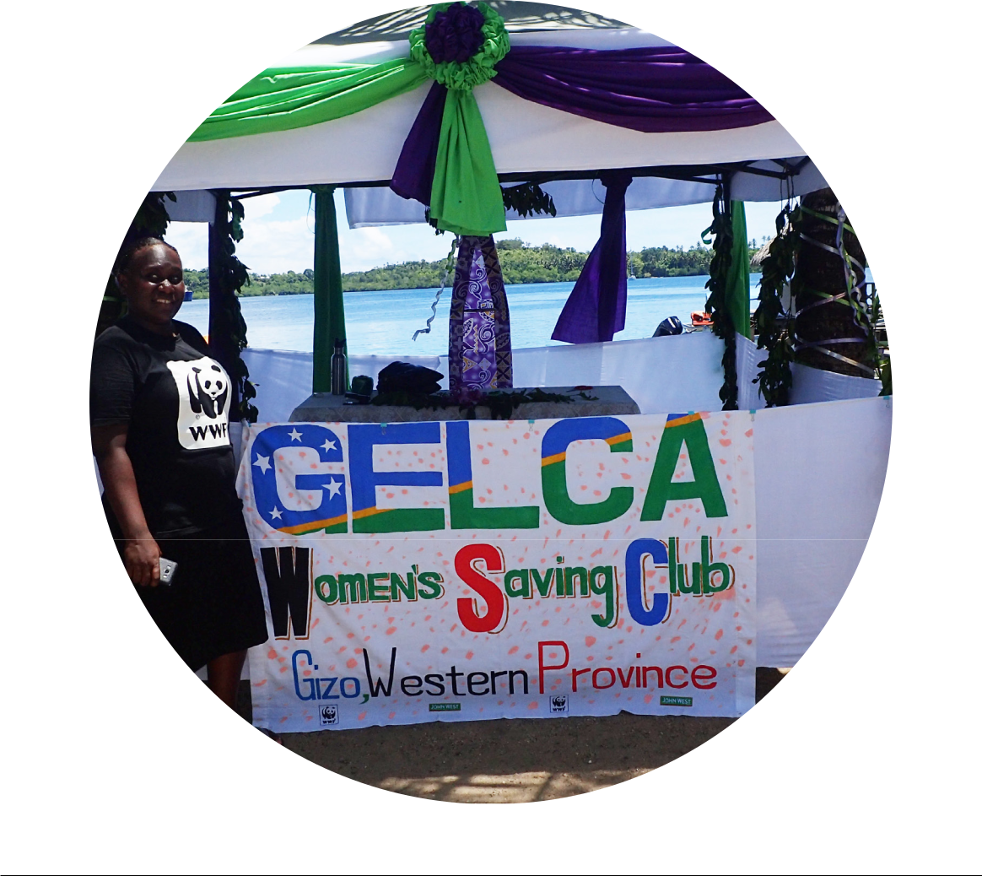

Financial Inclusion Training Manual | Published by: WWF-Pacific (Solomon Islands) JUNE 2018 11

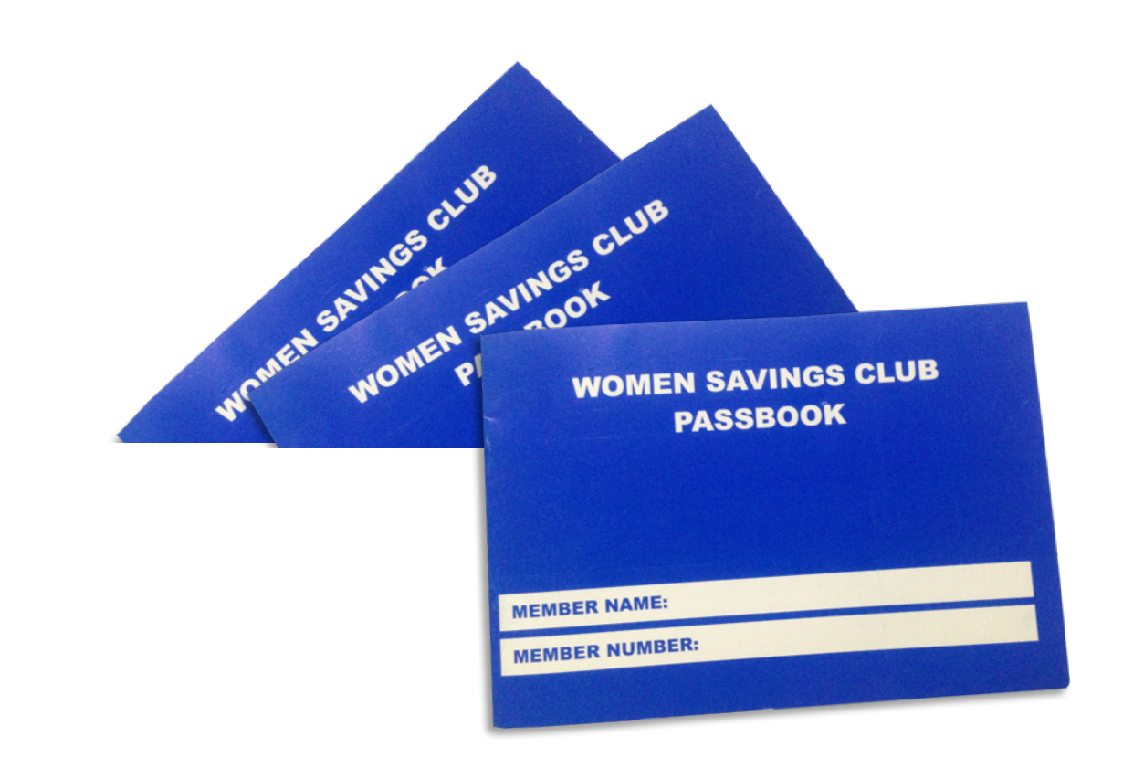

1. Filling in the Savings Passbook

Each woman buys a Savings Passbook when they join a savings club, and will add her real name into it. On each Bank Day the money counters must fill in the passbook with the date, how much you are putting into the club to save, how much you are withdrawing, and the balance. The two Money Counters will then co-sign it and you keep the passbook with you until the next Bank Day.

Example Savings Passbook:

Date | Paid in $ |  | Withdrawn $ |  | Balance $ |  | Money | Money
 |  |  |  |  |  |  | Counter 1 | Counter 2
5/10/17 | 50 | 00 |  |  | 50 | 00 | SL | JK
8/11/17 | 100 | 00 |  |  | 150 | 00 | SL | JK
16/1/18 | Balance | B/F |  |  | 150 | 00 | SL | JK
16/1/18 | 200 | 00 |  |  | 350 | 00 | SL | JK
1/2/2018 | 100 | 00 |  |  | 450 | 00 | SL | JK

As you can see, each year the record balance is brought forward for New Year. After each year’s record, give breathing space for easy audit and balancing. Leave a space between each year to make it easy for someone outside to check the recording and balance the books.

2. Filling in the Individual Record Book

While every woman has their Savings Passbook, the savings club has an Individual Record Book. This is kept by the Money Counter. The recording in the Individual Record Book is similar as the Savings Passbook, but it keeps all members individual deposit or withdrawal records together in a book. The Money Counters have to make sure that each individual member has her own page to record the woman’s name, account number, money deposited, withdrawn, and the balance. After four pages, the Money Counter records the next Bank Day with the member’s name, account number, money deposited, withdrawn and total balance, etc. This book must always reconcile with the Savings Passbook, after it is signed by two Money Counters.

12 Financial Inclusion Training Manual | Published by: WWF-Pacific (Solomon Islands) JUNE 2018

Example Individual Record Book:

Name: Brenda Kaniki |  |  |  |  |  |  | Account No:
 |  |  |  |  |  |  | GELZ50113
Date | Deposit $ |  | Withdraw $ |  | Balance $ |  | Money Counters 1
 |  |  |  |  |  |  | & 2 Signatures
5/10/17 | 50 | 00 |  |  | 50 | 00 | Stella |  | Julie
8/11/17 | 100 | 100 |  |  | 150 | 00 | Stella |  | Julie
16/1/18 | 200 | 00 |  |  | 350 | 00 | Stella |  | Julie
1/2/18 | 100 | 00 |  |  | 450 | 00 | Stella |  | Julie

Similarly to the recording in the Savings Passbook, give breathing space between the years so that it makes audit check easier and clearer. Both Money Counters must sign this record.

3. The Zone Record Book (Group Record Book)

The money counter also records all money deposited by women that banking day into a Zone Record Book. This records the banking that was done that day. The Money Counter keeps the women’s money in a box with a lock and key. The key is kept by three different women chosen by the members of the savings club.

Money Counters must also fill in the Zone Record Book at the end of each Bank Day. This is to show the records of each woman who banked on that day. The Money Counter will fill in the date, women’s names and account numbers. Then they write the amount each woman deposited or withdrew, and the member will sign the book. The two money counters sign the transaction and the zone running collection is tallied, as well as the zone running balance. A spare line is left between each bank day.

Example zone record book:

Date | Names | Account No: | Deposit | Withdraw | Member | Money | Money | Zone | Zone
 |  |  |  |  | Signature | Counter | Counter | running | Running
 |  |  |  |  |  | 1 | 2 | Collection | Balance
 |  |  |  |  |  |  |  | $ | $
5/10/17 | Brenda Kaniki | GELZ50113 | 50 |  | Brenda | SL | JK | 50
5/10/17 | Glady’s | GELZ50813 | 20 |  | Glady’s | SL | JK | 70
 | Fationa
5/10/17 | Jane Su | GELZ51013 | 100 |  | Jane | SL | JK | 170
 | Total |  |  |  |  |  |  | 170 | 170
 | Collected
8/11/17 | Brenda Kaniki | GELZ50113 | 100 |  | Brenda | SL | JK | 100
8/11/17 | Glady’s | GELZ50813 | 200 |  | Gladys | SL | JK | 300
 | Fationa
8/11/17 | Jane Su | GELZ51013 | 250 |  | Jane | SL | JK | 550
8/11/17 | Anita Kuma | GELZ52013 |  | 100 | Anita | SL | JK | 450
 | Total |  |  |  |  |  |  | 450 | 620
 | Collected

Financial Inclusion Training Manual | Published by: WWF-Pacific (Solomon Islands) JUNE 2018 13

4. Tally Sheet

At the end of each Bank Day, a Tally Sheet is filled in to record who banked, and to reconcile funds against the Zone Record Book. The Tally Sheets are kept by the Money Counters, and they make sure that the amount received from each individual member recorded in the Tally Sheet always reconciles with the Zone Record Book. The zone President does a final check-up, physically counting the money received that Bank Day before the Tally Sheet is signed off. The bankers can announce the total collection of savings that day to all members.

WWF keeps a database of the overall recordings of the total money saved and withdrawn from each woman’s savings club, after Balance and Action Audits that are conducted twice a year in each savings club.

Steps for Money Counters on Banking Day:

- Record everything in each member’s Savings Passbook

- Find member page in Individual Record Book and record their details

- Enter details into Zone Record Book (remember to cross check balance against Individual Record Book member balance)

- Enter details into Tally Sheet

- At the end of Bank Day, add up total cash amount and cross check it matches

the zone amount, then record how many notes and coins collected on the tally form

- Make sure zone President does the last check of all the recording and physical counting of the money received or withdrawn on this Bank Day, before signing off the Zone Record Book and Tally Sheet

Note that each savings zone determines which day every week or two weeks that they will have a banking day. The decision will be made by the elected management committee.

Rules of Savings Clubs:

The trainer discusses the rules of being part of the savings club. This includes:

- There is no minimum deposit amount on savings.

- Each zone must raise money for their savings club’s operation costs.

- Members must save money first, and then wait one year before loan component can start

- Members must attend all training.

- You must trust each other, and the box holders with the money.

- Executives choose a bank day for each savings club, usually once every two weeks on same day.

- Members must respect and encourage each other to save little by little, and share skills and knowledge.

14 Financial Inclusion Training Manual | Published by: WWF-Pacific (Solomon Islands) JUNE 2018

DAY 3: GOOD GOVERNANCE TRAINING

The trainer discusses with the group what good governance is, what administration is, and how to properly manage a savings club.

What is Governance?

Governance is a process of decision-making, or a system of governing an organisation or group. Good governance provides mechanisms to follow, so proper process and administration is followed.

Organisations are governed by a Board of Directors, or a committee, to direct the management team of an organisation or group. This group is led by the Chair. It is important you are careful in who you select as a Chair. They need to be someone who is a leader, thinker and a visionary, as this person is responsible to ensure the group is well run, financially sound, and compliant with relevant rules.

ADMINISTRATION, LOAN SCHEME AND SUSTAINABILITY TRAINING - 3 DAYS

What: To talk about administration of the savings club, including declarations, withdrawals, rules and regulations of the club. This training also sets up the revolving fund and loan component.

When: This training is conducted one year after the savings club is established, after women have learned how to save and a large amount of savings has been deposited. Now they can start thinking about withdrawing money, establishing a revolving fund, and learning how to take out a loan.

Day 1: Will Declaration Form

The trainer discusses the will declaration form and teaches the women how to fill out the form. This is an important part of the process, as if a women passes away, it might be unclear who should inherit her money. The will declaration makes sure the money goes to the right person.

To fill out the form, a woman must write her name, member number and zone. Then she can choose to nominate one person or more who will inherit her money, if she dies, and what reasons the money can be used for. The woman must then sign the form, and a witness will also sign.

Withdrawing Money

The trainer discusses the withdrawal form and teaches the women how to fill out the form. To withdraw money, a woman must make a request to her savings club. She must take a withdrawal request form and fill out her zone number, date, name and passbook number. The woman will also write her reason for withdrawing the money, and any outstanding loan she has. The woman will give the form to the money counter to cross check against their Savings Passbook, Individual Record Book, and Zone Record Book before sign off. The balance in the woman’s savings is recorded before the withdrawal, and recorded after the withdrawal. Two Money Counters must then sign the woman’s request form. It is then signed off by the Zone President. You can only withdraw money three times a year, or as decided by the Advisory Management Committee.

Financial Inclusion Training Manual | Published by: WWF-Pacific (Solomon Islands) JUNE 2018 15

Administration

Members learn about administration of the savings club in the Financial Literacy training. However, if women need refresher training, the trainer can arrange for another Financial Literacy training to be held in the community. The committee can decide if refresher training is needed or not.

Revolving Fund (Loan Component)

In addition to women’s individual savings, a savings club can be set up to have a revolving fund. A Revolving Fund is a loan scheme where women who are savings club members can take out a loan of money, and pay it back over time with a small amount of interest. The money to set up and start the revolving fund can come from donors, donations from supporting communities, or from community-held fundraisers.

The Revolving Fund is administered by the savings club Zone Executive Committee. Members are allowed to apply for loans up to the amount that you have personally saved. The repayment of the loan is based on the timeframe that the applicant writes in the Revolving Fund Application Form. It is based on the woman’s capability and the timeframe in the application form.

All loans are charged interest on top. The committee meets about once every month, looks at every application that comes in and assesses it. If your application is successful, the executive committee will let you know and the money will be given to you.

Taking out a Loan

Loaning means borrowing money from the bank or credit union, which you must pay back

with an additional fee (interest). In a savings club loan scheme, you can take out a loan like you would with a bank. The money you are loaned does not belong to you though, so you must repay it.

To take out a loan, you must fill out a Revolving Fund Application Form. You fill out your name, zone, and personal details, and whether you are a savings club member. You must let the committee know if you have attended business or skills training, and if you currently own

a business. You will also need to write how much money you wish to take out as a loan, what the money will be used for, and all the resources the project will use. The last part of the form is to describe how you will repay the loan and what the timeframe will be. The Zone Executive Committee will assess it, and if successful, the zone President and Treasurer will sign the form to approve the loan. The Vice President can sign for the president, and the Vice Treasurer can sign for treasurer, if needed.

You will be given a grace period of a month. You must start to repay your loan the following month, and after that you will pay a little bit back each month for as long as your loan timeframe. This arrangement may depend on your zone’s management rules. If you were unsuccessful in an application for a loan, you can apply again. And if you have fully paid back a loan, you can apply for a new one. If you do not repay your loan, the zone executive can negotiate with you to withdraw some of your savings to kill your loan or each zone has management rules you will need to comply with, or you may be brought up at the Zone Annual General Meeting.

16 Financial Inclusion Training Manual | Published by: WWF-Pacific (Solomon Islands) JUNE 2018

Activity 1: Loans

After explaining the process of the revolving funds application form, the trainer will ask the participants to sit in their respective savings club group. Each individual can fill in the Revolving Fund Application Form and send to the committee, where the committee will sit and thoroughly screen each application form during the training. The committee has to make sure the project applied for by each member is sustainable and environmentally friendly. Then the committee makes a decision about whether the applicants are successful or not. After that, the Treasurer fills out all the approval applicants in the Loan Record Book.

Monitoring of Loans

The Zone Executive Committee is responsible for monitoring of loans. Individuals have a Loan Record Book where they record when they take out a loan. In the Loan Record Book, you will write your passbook number, the date, the project, the amount of the loan and the interest. You will also write how much has been repaid, the balance, and sign it. The Treasurer keeps the Loan Record Book, and the Loan Monitoring Form for each individual. The Loan Monitoring Form is kept by the executive committee. In the form, the committee writes the women’s names, the year and projects. They also write the amount of the loan, the interest, the amount repaid, the balance, and the outstanding loan. A copy of the form is sent electronically to WWF.

Sustainability Criteria

One of the differences between WWF established women’s savings clubs and other clubs is the Sustainability Criteria for Savings Clubs to Guide Loans (from Revolving Fund) and Business Activities. These criteria outline the principles and standards the clubs should run by, and how loans that are taken out by women must be used to fund sustainable business or activities.

The criteria include that a woman has to be a current member of the savings club, and has saved money with the club. A loan must be used on an environmentally sustainable project and encourages economic empowerment. For example, sewing, sarongs and lavalava, cooking, baking, tourism, weaving mats, fans, baskets, and agriculture.

Women must be skilful and active in the project she is applying for money for, and any project that will cause disharmony in the community will not be allowed. Projects that cause sickness are not allowed (such as betelnuts, cigarettes and spears) or buying equipment that will hurt the environment (such as chainsaws, fishing nets). And applying for a casino business is prohibited.

Additional Training

Once the savings club is running, the loan component has been added, and sustainability criteria are being used by women who take out loans, the club can start to look at additional training. WWF advises that as a savings club grows, members would benefit from learning additional skills. Leadership is a three-day training course that helps women learn the skills to become good leaders in their communities.

Business and management training is another three day training that can be provided, that helps to teach women how to run a small business, record money, and costing and pricing of goods they sell.

Business plan template training is a one day training about how to plan for a business, assess if a business will be viable or not, and determine what your income, profits and costs will be. To develop a business in the community, it is good practice to have a business plan. This helps you to think about how you will make money, and how you will save money.

Financial Inclusion Training Manual | Published by: WWF-Pacific (Solomon Islands) JUNE 2018 17

The first step is to come up with a business idea. Once you have an idea, you will write the names of the people in the business into the plan, their experience, and any education and training courses they have attended. The second step is to develop a marketing plan. You will need to think about the following questions.

- What products or services will you be selling?

- Who are your customers?

- Why will they want to buy my product/service?

- What prices will they pay?

- How will I run my business?

- Why is this business needed?

- Will my business be environmentally sustainable?

By thinking through these questions, you will have a better idea what products or services people want, what they will pay, and how you will work to make the business run. The third step is to work out how much money you will make. You will estimate the income you will get from sales, and minus the expenses. This calculation will give you your profit.

The fourth step is to work out a Cash Flow Plan. This is a plan to work out how much money you need every month, and when you will use money to buy products, and how much you need to sell every month. It helps calculate the money in and money out. The fifth step is to work out what Capital (start-up money) you need at the start to build your business.

WWF can advise about any of the additional trainings listed above, and how training can be conducted to women in regional communities that are part of a savings club.

Balance and Action Audit

Local trainers are trained to do ongoing monitoring of the club. Four times a year, a Balance and Action Audit is conducted with zone money counters, local women trainers and officers from WWF, to ensure the books all balance and that monitoring and evaluation of the savings clubs and operations is conducted. The audit takes one day, or may be less or longer, depending how many books are collected. Tally Sheets are reconciled with Zone Record Books, Individual Record Books and Savings Passbooks.

To fill in the Tally Sheet, the zone name is first recorded. Then the dates are filled in, the women’s names, and their deposits and withdrawals, along with any outstanding loan repayments. Additionally, the number of notes is tallied. The Tally Sheets, once complete and cross-checked, are handed to WWF officers for record keeping purposes. repayments. Additionally, the number of notes is tallied. The Tally Sheets, once complete and cross-checked, are handed to WWF officers for record keeping purposes.

18 Financial Inclusion Training Manual | Published by: WWF-Pacific (Solomon Islands) JUNE 2018

Zone: ________________________

Date | Names | Deposits | Withdrawals | Outstanding loan
 |  |  |  | Repayments

Total Amount

Collected

Zone: ________________________ |  | Date: ________________________
Notes | Number of Notes | Total | Comments
$100
$50
$20
$10
$5
$2
$1
50c
20c
10c
 | Grand Total

Financial Inclusion Training Manual | Published by: WWF-Pacific (Solomon Islands) JUNE 2018 19

