LOGIC MODEL TEMPLATE
Inputs |  |  |  |  | Outputs
 |  |  | Assess
 |  |  | worksite
Coalition |  |  | tobacco |  |  |  | Worksite
 |  |  | policies and |  |  |  | owners,
Time |  |  | practices |  |  |  | managers
Dollars
 |  |  | Develop
 |  |  |  |  |  |  | Unions
Partners |  |  | community
Including |  |  | support for
youth |  |  | SF worksites
 |  |  |  |  |  |  | Workers;
 |  |  | Organize |  |  |  | union
 |  |  | and |  |  |  | members
 |  |  | implement
 |  |  | strategy for
 |  |  |  |  |  |  | Public
 |  |  | targeted
 |  |  | worksites

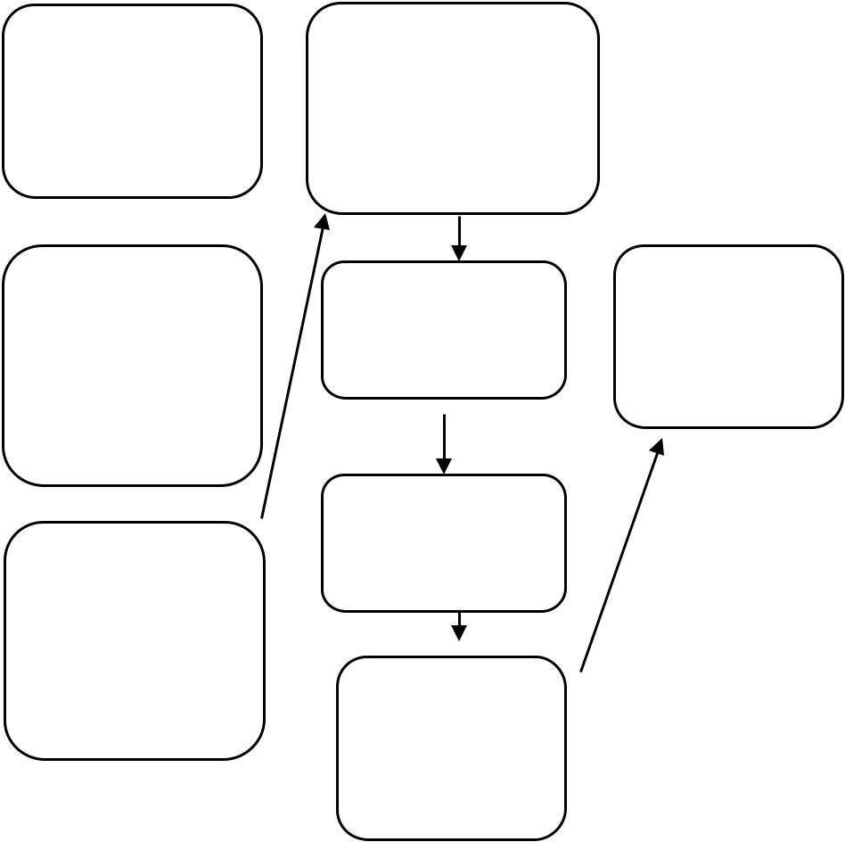
Increased awareness of importance of SF worksites

Increased knowledge of SF worksite benefits & options

Increased commitment, support and demand for SF worksites

Outcomes

Demonstrations of public support for SF worksites

SF worksites policies drafted

SF worksite policies passed

Adherence to smoke-free policies

SF worksite

