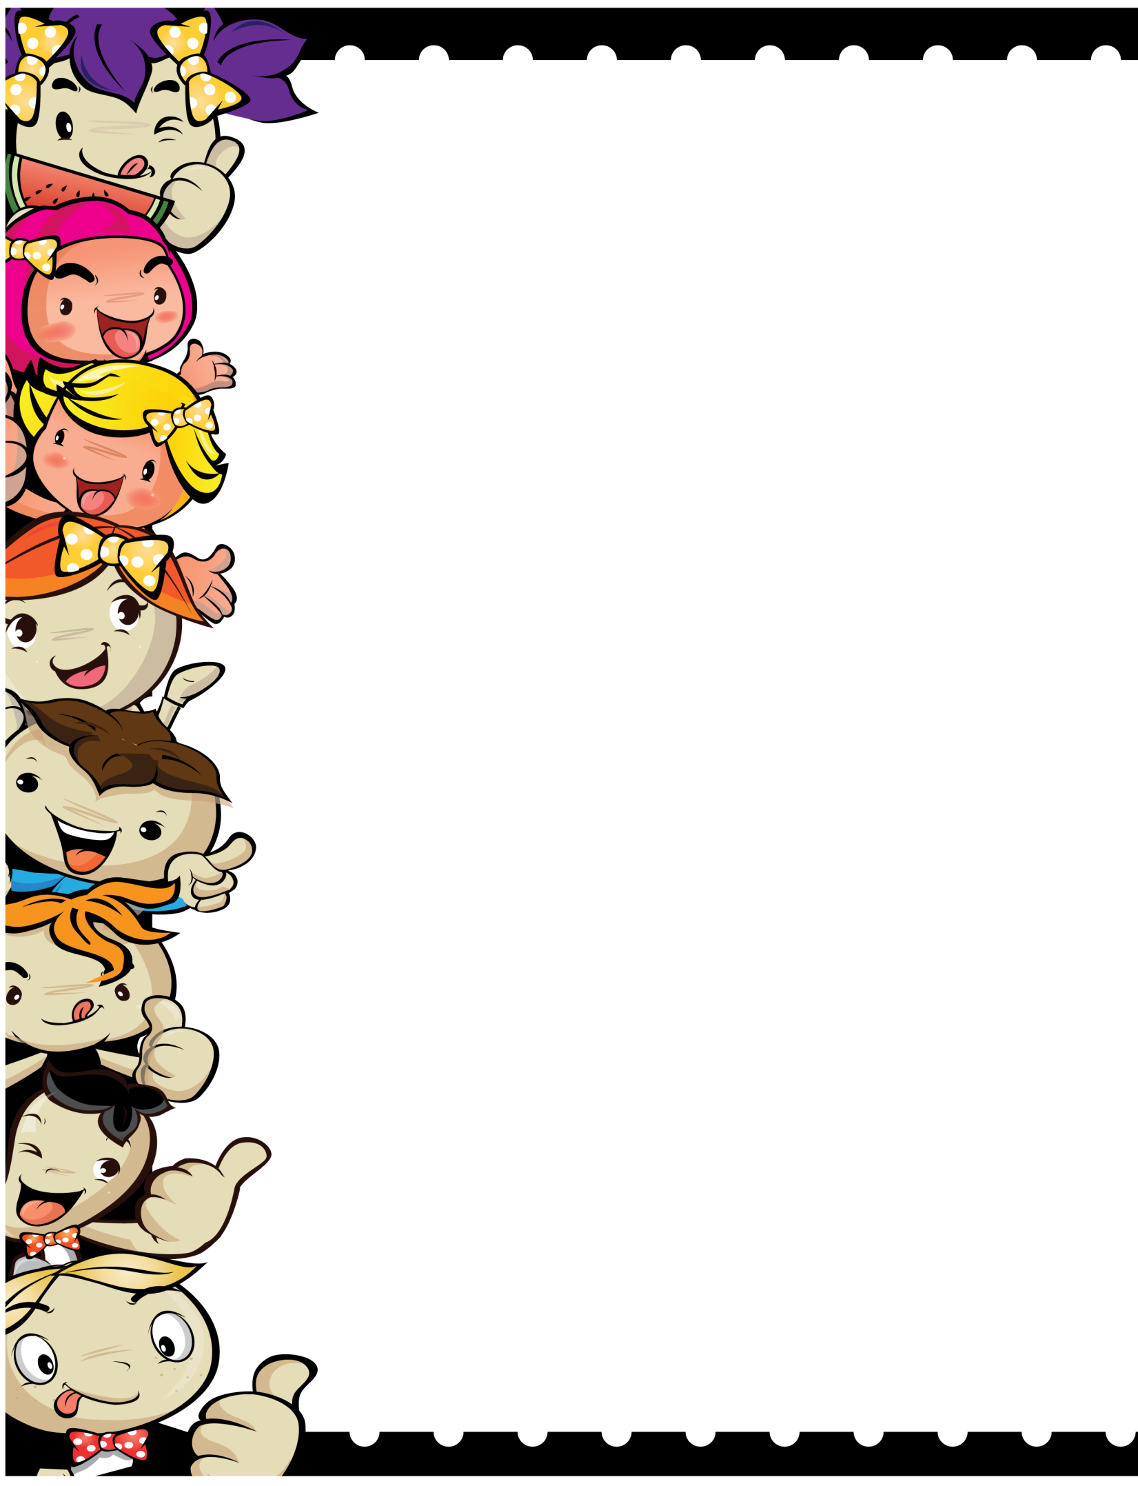

BOOK REPORT

The Author of the book is _____________________

The main characters of the story are

_____________________________________________________________  
________________________________

My favorite part of the story was

_____________________________________________________________  
________________________________

What was the problem in the story?   
______________________________________________________  
____________________________

Resolution   
______________________________________________________  
_____________________________

Pictures of my favorite character in the story