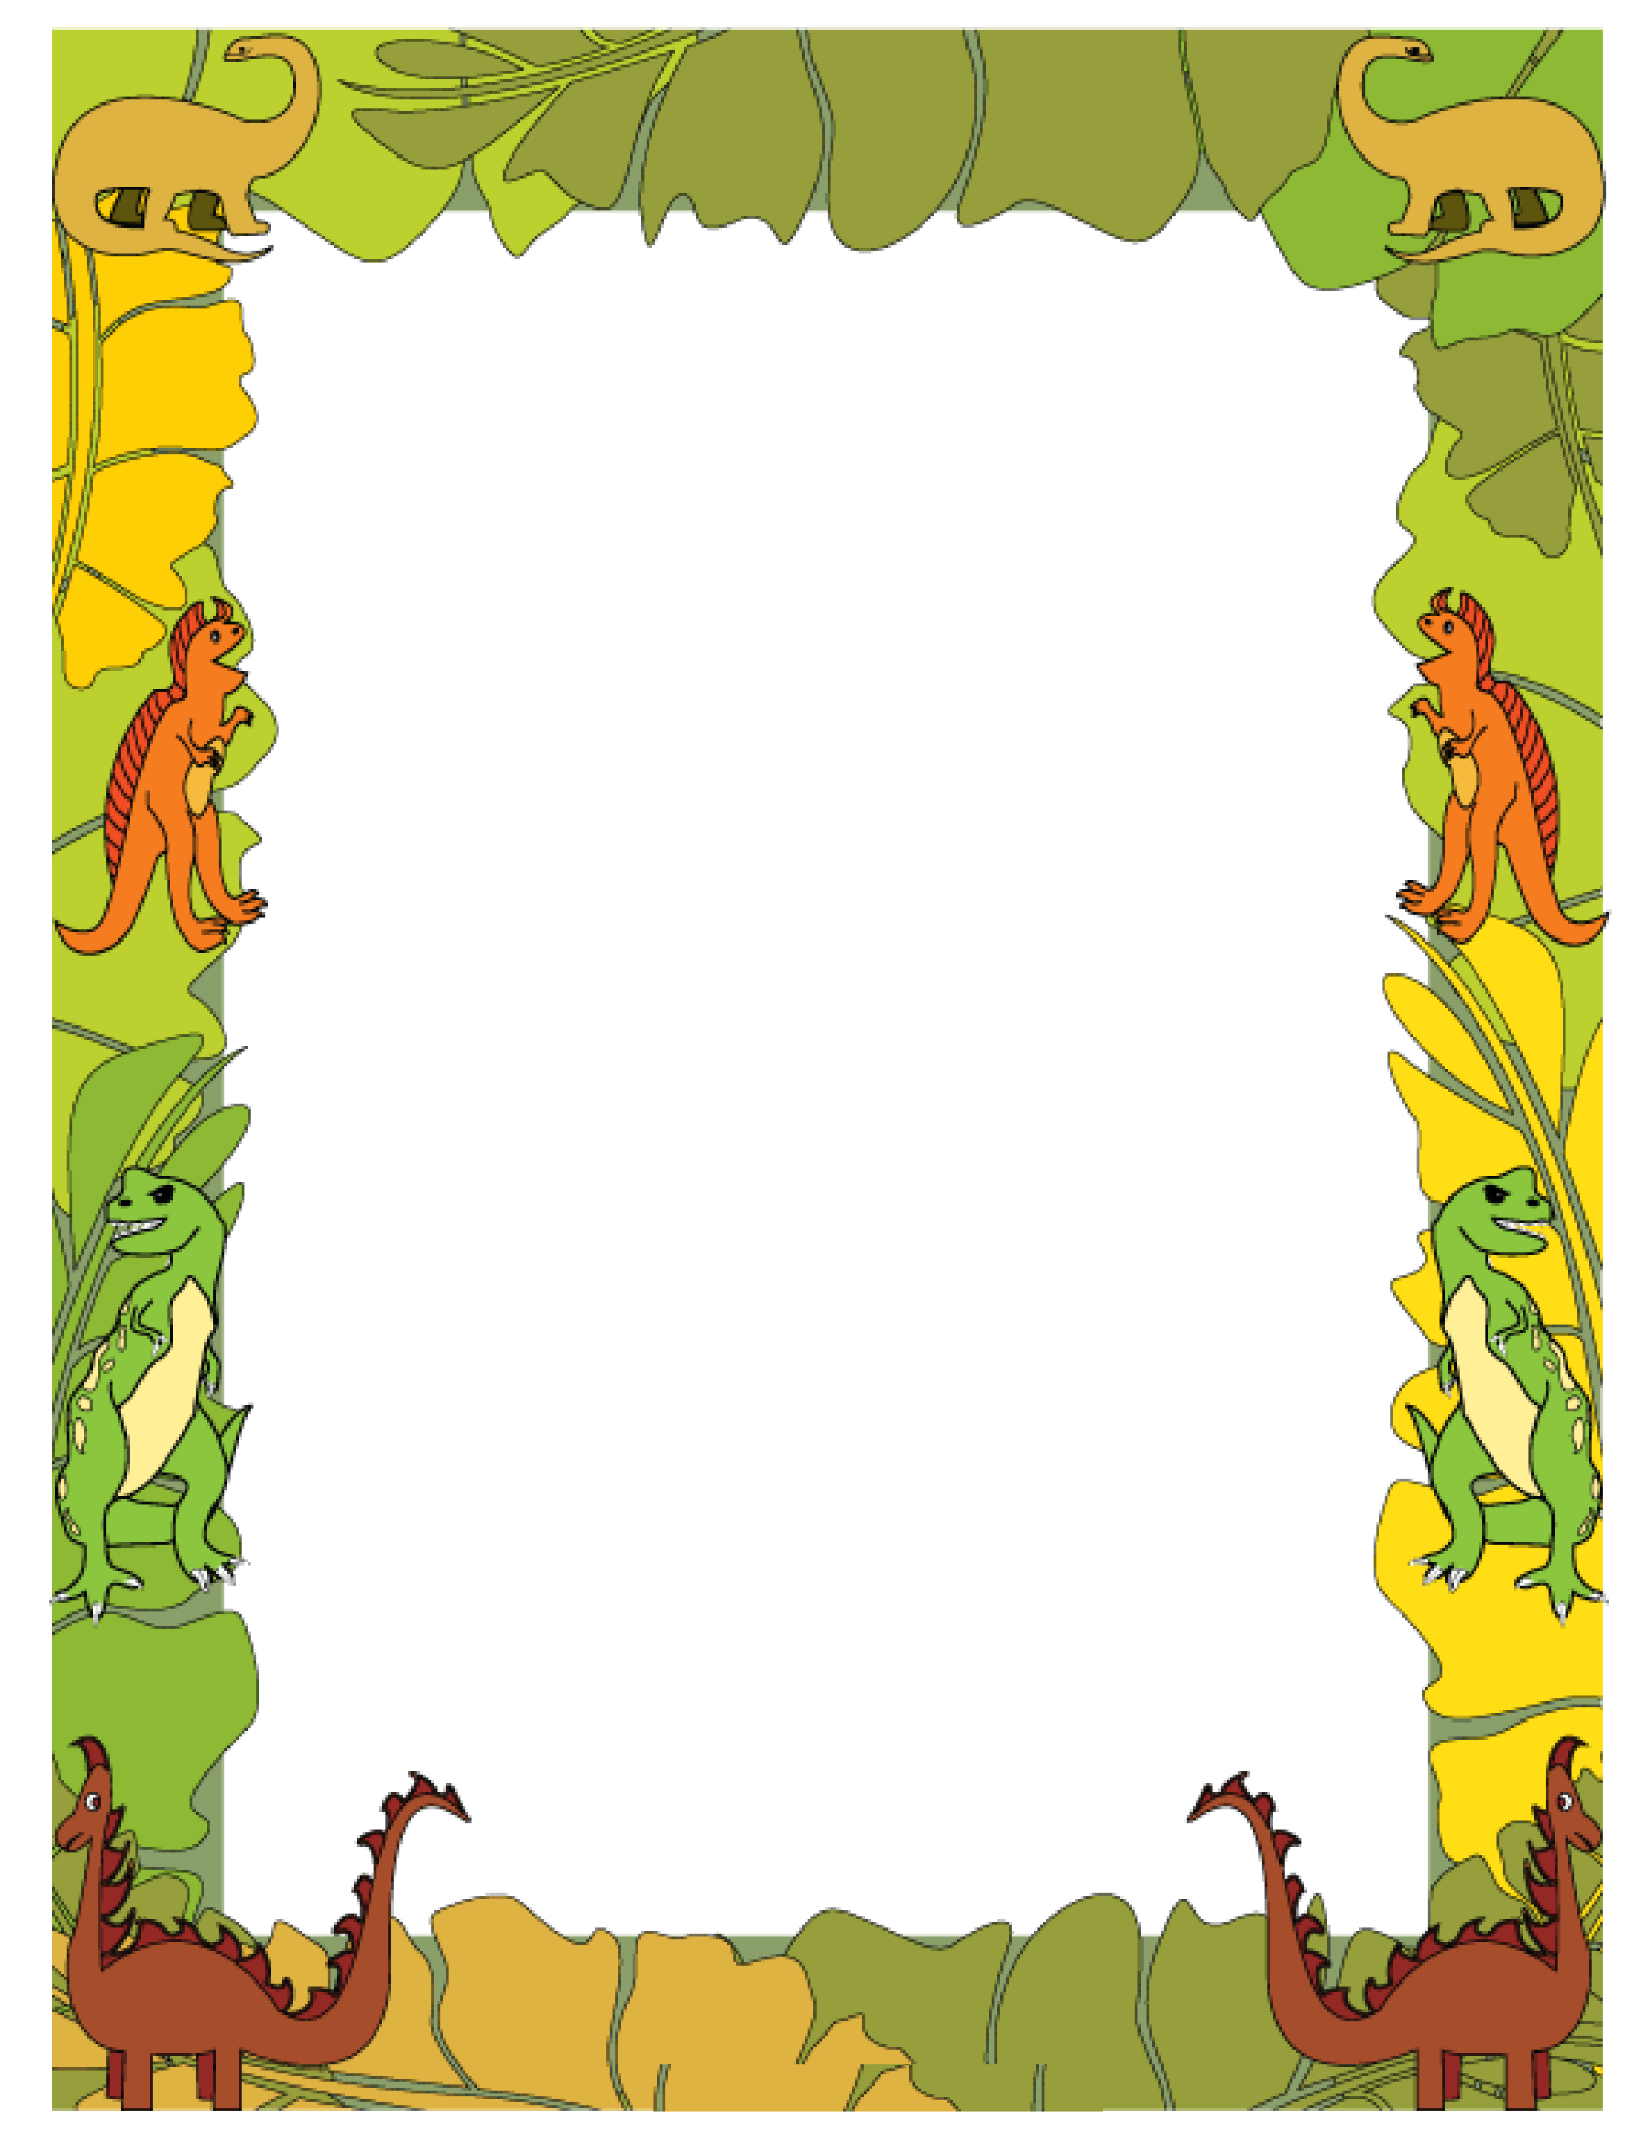

Draw Setting then use details to explain

__________________________________________________________________________________________

How did the story start?

______________________________________________________________________

How did the story end?

______________________________________________________________________

**MY BOOK REPORT**

