Name Class Date
Concept Map
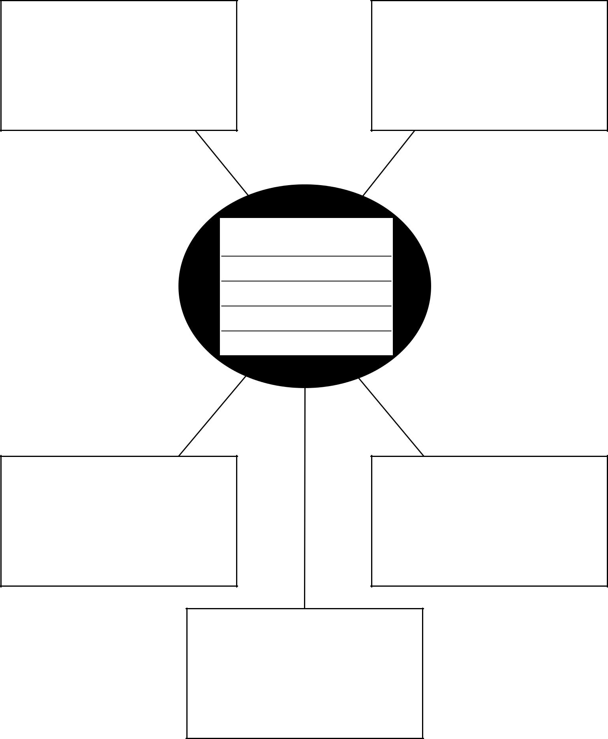

Concept:

(

