Frederick County | Superintendent’s
 | FY 2020
Public Schools | Budget Proposal
 | Presented February 19, 20XX
 | Dr. David T. Sovine

1415 Amherst Street

Winchester, Virginia 22601

www.address.com

Superintendent’s FY 2020 Budget Proposal Executive Summary

Dear Citizens of Frederick County,

Frederick County Public Schools (FCPS) is a high performing school division that is recognized as a leader in Virginia with a mission to ensure all students an excellent education. The Fiscal Year 2020 Superintendent’s Proposed Budget is based on School Board priorities that improve student achievement, compensate high quality staff, preserve assets, and develop professionals. The operating budget is proposed at $182.0 million and debt service budget at $16.7 million. To fully fund the budget proposal, $11.1 million more funds are requested from the Board of Supervisors for operations and debt service. State and other sources of funds will provide $4.2 million more next school year—primarily earmarked for compensation. Additionally, the budget proposal requests $3.9 million from the county’s fund balance to support capital equipment and bus replacements. Details of the budget proposal are organized by School Board budget priority and include costs to continue current programs and services.

Priority: Instructional initiatives to address increased accountability, improve student achievement, and reflect student voice—$2.6 million more, 40 new positions

- 16 classroom teachers to reduce average class sizes and address student enrollment growth—$1.3 million

- Principal and bookkeeper for Jordan Springs Elementary School—$0.1 million

- Four school counselors to phase in new state staffing standards to promote positive mental health and support the whole student—$0.3 million
- Parent liaison to support students and engage their families—$0.1 million

- Two senior teachers to support teaching and leadership at over-capacity middle schools—$0.2 million

- Eight bus drivers due to more routes, increased ridership, and full-time substitute drivers—$0.2 million

- Six bus aides to support students with special needs—$0.2 million

- Athletic trainer to support middle school students—$0.1 million

- Extending registration and scheduling service for parents at elementary and middle schools—$0.1 million

Priority: Compensation packages that enable the recruitment and retention of high quality staff—$4.9 million more, 4% division average

The FY 2020 budget proposal provides a division average four percent salary initiative. Teachers are central to quality education and are the majority of FCPS staff. Recruiting and retaining effective teachers is essential to successful schools. Due to size and location, FCPS competes with Loudoun County Public Schools (LCPS) to retain teachers and attract new hires in a time of teacher shortage. LCPS will hire almost 1,000 teachers next school year—the equivalent of two-thirds of FCPS teaching staff. Current LCPS teacher pay at certain year benchmarks is $15,000 to $30,000 more than FCPS. Over a 30 year teaching career, LCPS teachers make $539,000 more than a FCPS teacher.

 | Our Competition - Teacher pay gap between FCPS and LCPS
$100,000
$95,000
$90,000
$85,000
$80,000
$75,000
$70,000
$65,000
$60,000
$55,000
$50,000 |  |  |  |  |  | $61,110 | $65,205
$45,000 |  |  |  |  | $57,015
 |  |  | $48,825 | $52,920
 |  | $47,460
$40,000 | $42,000
$35,000
 | Start | 5 Years | 10 Years | 15 Years | 20 Years | 25 Years | 30 Years
 | Frederick Today |  | Loudoun Today |  | Frederick Proposed
2
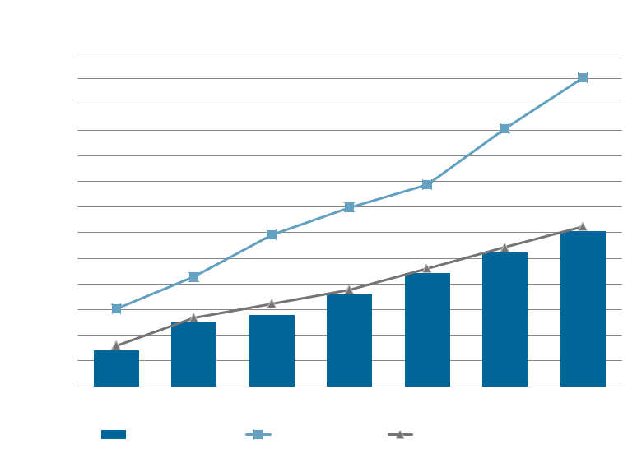

Superintendent’s FY 2020 Budget Proposal Executive Summary

Priority: Operational Funding to address preservation of assets, replacement school buses, safety and environmental enhancements, and aging infrastructure—$4.0 million more

- Eight new/replacement buses due to more routes, increased ridership, and aging fleet—$0.8 million

- Capital Asset Preservation Plan, critical facility system replacements, and maintenance projects— $1.7 million

- Technology wireless capacity, new and replacement student Chromebooks, and replace failing light and sound systems at Sherando and James Wood High Schools—$1.5 million

Priority: Professional development designed to support operational efficiencies, evidence-based instructional practices, and student needs—$0.1 million more

- Professional learning to address student mental health—$50,000

Costs to Continue Current Programs—$2.0 million more, 1 new position

- Virginia Preschool Initiative local match to sustain program for 54 students—$0.1 million

- Regional programs for gifted and special educational programs—$0.5 million

- Restricted state and federal programs, personnel attrition, and inflation—$1.4 million

- One new pharmacy technician instructor fully funded by a grant

Debt Service—$1.7 million more

- Principal and interest payments on Jordan Springs Elementary and Robert E. Aylor Middle schools

- Recover funding that was cut in the FY 2019 budget by the Board of Supervisors

Capital Projects—$3.9 million

Replace obsolete classroom technology, 13 school buses as 23 buses have over 300,000 miles, and facility-related projects that are beyond the scope of the Capital Asset Preservation Plan.

In summary, the Fiscal Year 2020 Superintendent’s Proposed Budget supports FCPS’ mission, addresses School Board budget priorities, and meets financial obligations. FCPS is projected to serve more than 13,700 students from diverse backgrounds with unique educational needs. We employ 2,300 educators and support staff dedicated to providing quality services to our county’s youth and their families. The pages that follow provide additional information on FCPS such as cost efficiency, funding uses and sources, district ratings, and ways to get involved in the budget process. I look forward to working with the School Board, the Board of Supervisors, and community members to address FCPS needs to prepare all students to be successful and engaged citizens.

Sincerely,
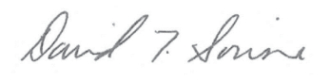

Dr. David T. Sovine Superintendent of Schools

3

Superintendent’s FY 2020 Budget Proposal Executive Summary

Uses of Operating Funds
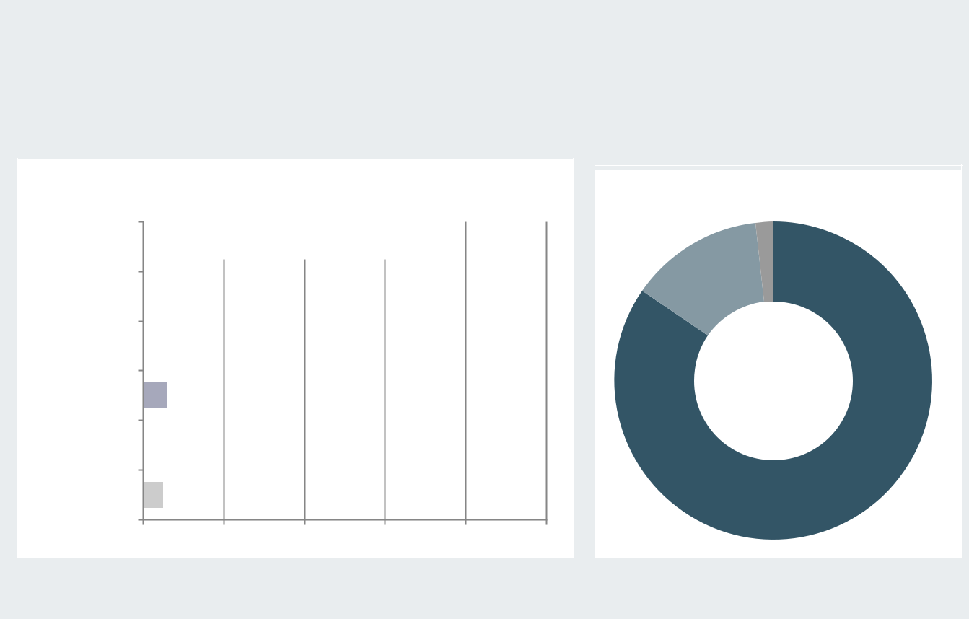

Seventy-five percent of operating dollars go directly to instructing students. Education is a people-intensive business. Eighty-five percent of funds are spent on compensation. FCPS employs almost 2,300 full-time employees—the largest employer in Frederick County.

 |  |  | Where $182 million goes |  |  |  | What the budget pays for
Instruction |  |  |  |  |  | 75% | Capital
 |  |  |  |  |  |  | 2%
Attendance & |  |  |  |  |  |  | Operating
 |  | 1% |  |  |  |  | 13%
Health

Administration 3%

Student
Transportation ^{6%}

$182 Million

Facilities Services 10%

Salaries &
_{Technology} 5% ^{Benefits}

85%

0% 20% 40% 60% 80% 100%
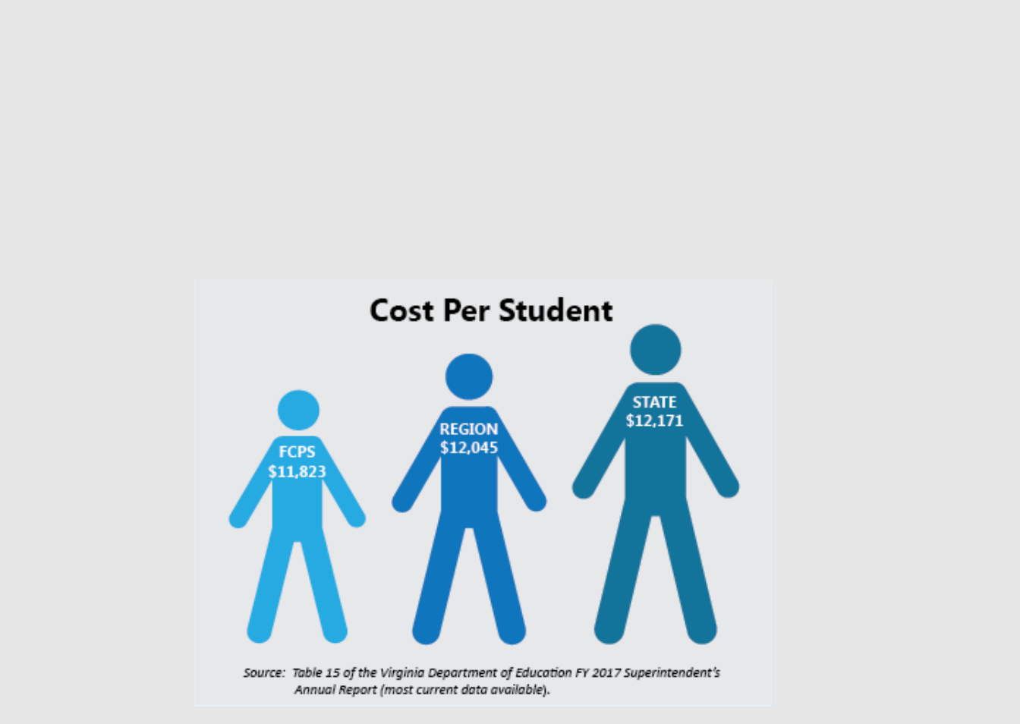

Cost per Student

The cost per student calculation for all Virginia public school divisions is based on the Virginia Department of Education’s definition of operations. All Virginia school divisions report expenses in a standardized format to ensure consistency in reporting and comparison of costs.

Based on the most current information from the Virginia Department of Education, FCPS is below the regional and state cost per student averages.

4

Superintendent’s FY 2020 Budget Proposal Executive Summary

Student Enrollment
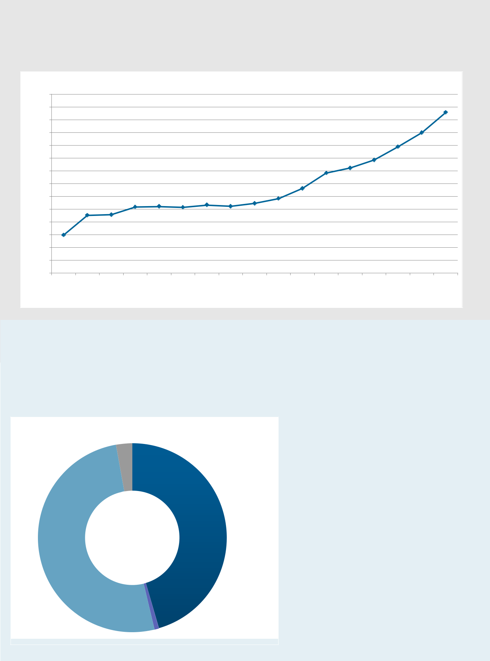

Student enrollment is the greatest determinant of funding and resource needs for a school division. FCPS will provide services to more than 13,700 students in the 2019-20 school year. Since 2016, FCPS grew by 479 students or four percent.

Student Enrollment
14,800
14,600
14,400
14,200
14,000
13,800
13,600
13,400
13,200
13,000
12,800
12,600
12,400
12,200
12,000
2007 | 2008 | 2009 | 2010 | 2011 | 2012 | 2013 | 2014 | 2015 | 2016 | 2017 | 2018 | 2019 | 2020P | 2021P | 2022P | 2023P
 |  |  |  |  |  |  |  |  |  |  |  |  |  |  | P = projected

Sources of Operating Funds

School operations are funded by state, county, federal, and miscellaneous sources. To fund the proposed FY 2020 operating budget, an additional $9.4 million is requested from the Frederick County Board of Supervisors. Additionally, $1.7 million more is requested from the Board of Supervisors for debt service and $3.9 million from the county’s fund balance for one-time capital items.

Where the proposed operating money comes from

Federal

3%

 | $182 | State
 |  | 45%
County | Million
51%
 | Fees & Other
 | 1%

Funding Request of County

– $9.4 million more county funds to support the operating budget

– $1.7 million more to support debt service

– $3.9 million from fund balance to replace equipment, buses, and classroom technology displays

5

Superintendent’s FY 2020 Budget Proposal Executive Summary

Local Revenue Capacity Comparison
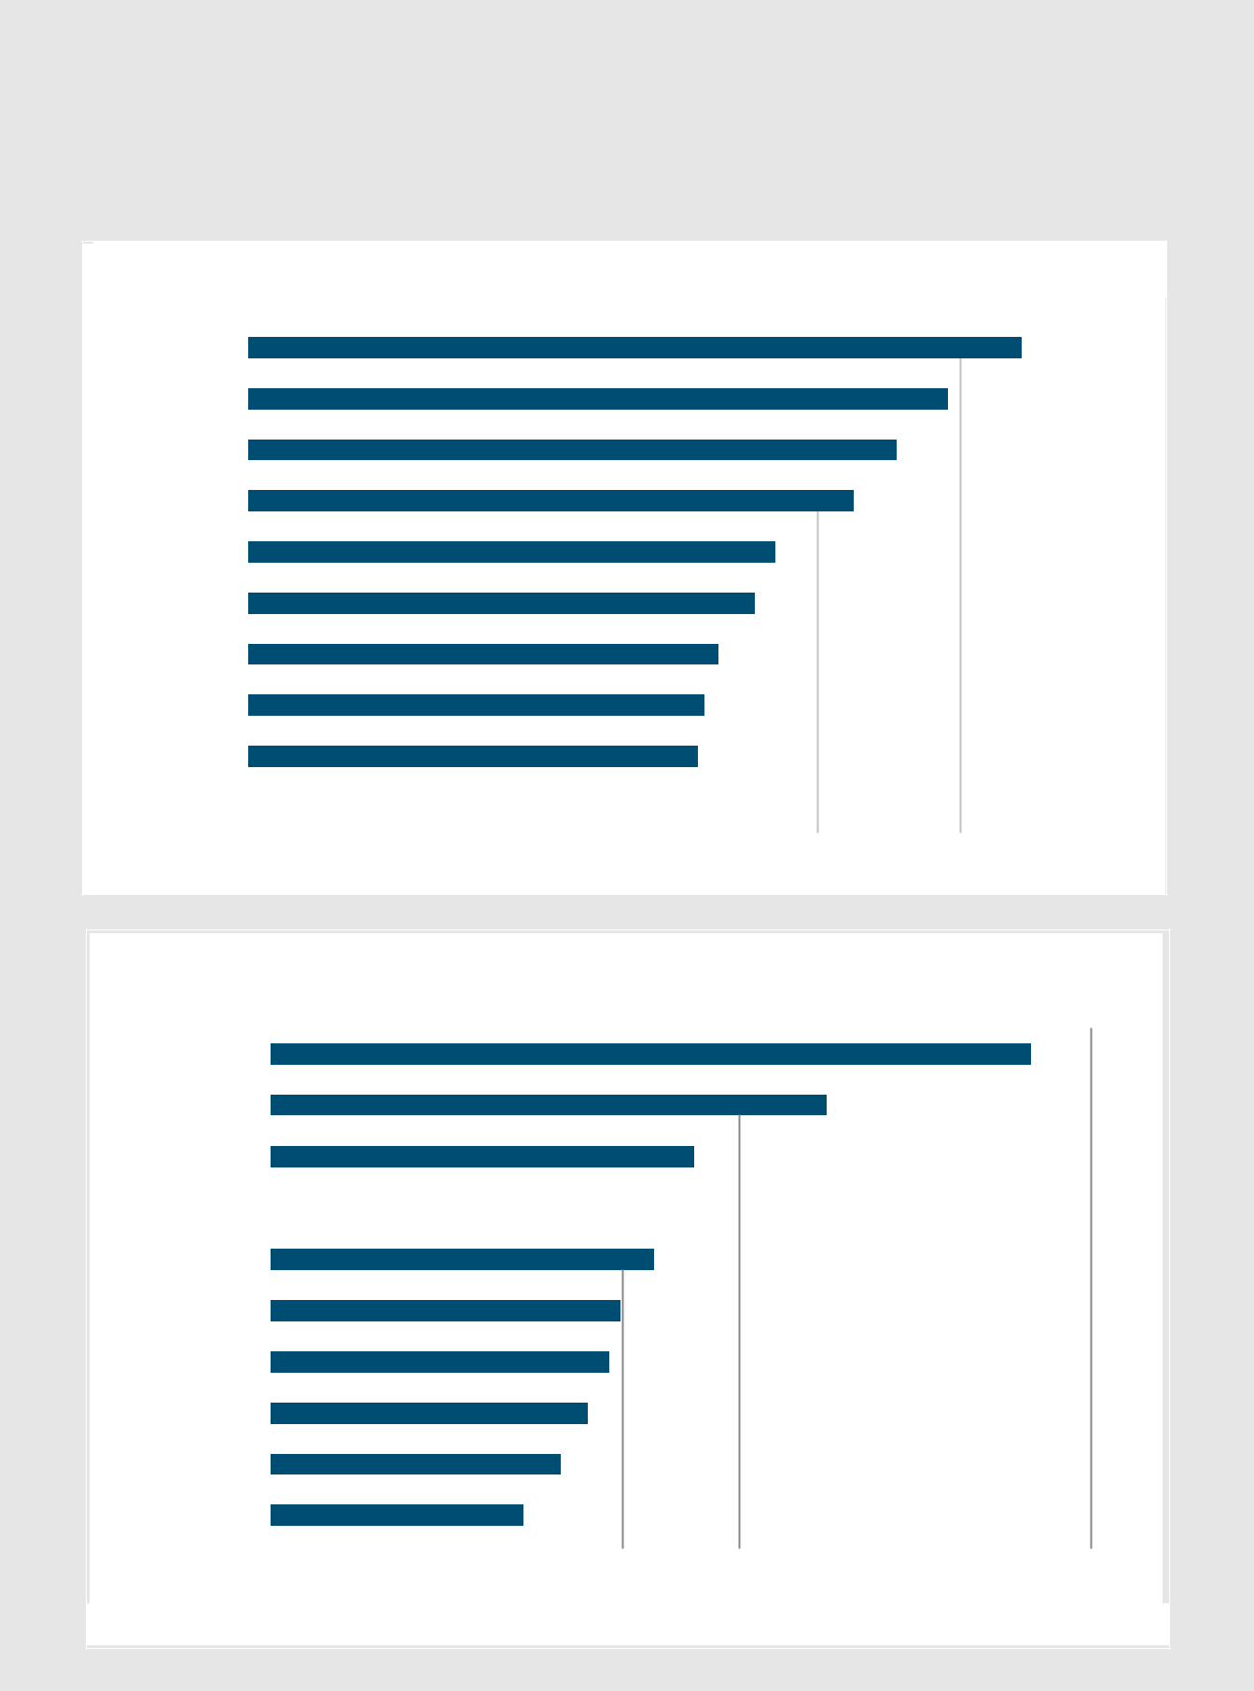

Monies collected from real estate taxes are a primary revenue source for county government and public schools. Frederick County has the lowest real estate tax rate and the fourth highest median income in the surrounding Virginia area. To the taxpayer, a one cent increase to the real estate tax rate on an average home value of $260,000 equals $26.00.

Real Estate Tax Comparison to Surrounding and Area Localities

Loudoun |  |  |  |  |  |  |  |  |  |  |  |  | $1.085
Fauquier |  |  |  |  |  |  |  |  |  |  |  | $0.982
Winchester |  |  |  |  |  |  |  |  |  |  | $0.910
Harrisonburg |  |  |  |  |  |  |  |  |  |  | $0.850
Rockingham |  |  |  |  |  |  |  |  | $0.740
Clarke |  |  |  |  |  |  |  |  | $0.710
Warren |  |  |  |  |  |  |  |  | $0.660
Shenandoah |  |  |  |  |  |  |  |  | $0.640
Augusta |  |  |  |  |  |  |  |  | $0.630
Frederick |  |  |  |  |  |  |  | $0.610
$0.000 |  |  | $0.200 |  | $0.400 |  | $0.600 |  | $0.800 |  | $1.000 |  | $1.200

 | Median Income Comparison to Surrounding and Area
 |  |  |  |  |  |  |  | Localities
Loudoun |  |  |  |  |  |  |  |  |  |  |  |  |  |  |  |  |  | $129,588
Fauquier |  |  |  |  |  |  |  |  |  |  |  |  |  | $ | 94,775
Clarke |  |  |  |  |  |  |  |  |  |  |  | $ | 72,129
Frederick |  |  |  |  |  |  |  |  |  |  |  | $71,037
Warren |  |  |  |  |  |  |  |  |  | $65,353
Augusta |  |  |  |  |  |  |  |  |  | $59,544
Rockingham |  |  |  |  |  |  |  |  |  | $57,651
Shenandoah |  |  |  |  |  |  |  | $ |  | 53,934
Winchester |  |  |  |  |  |  |  | $49,330
Harrisonburg |  |  |  |  |  |  | $43,009
$0 |  |  | $20,000 |  | $40,000 |  |  | $60,000 |  |  |  | $80,000 |  | $100,000 |  | $120,000 |  | $140,000

Source: U.S. Census Bureau Quick Facts

6

Superintendent’s FY 2020 Budget Proposal Executive Summary

FCPS Ranked 27th in Virginia

The 2019 Best School Districts ranking by Niche is based on academic and student life data from the U.S. Department of Education along with test scores, college data, and ratings collected from Niche users including students and parents.

Niche School District Ranking 2019

 | School District | StateRanking | Overall NicheGrade | Academics | Teachers | Clubs &Activities | Diversity | College Prep | Health &Safety | Adminis-tration | Food | Sports | Resources &Facilities
 | Loudoun County | 2 | A+ | A+ | A | A | A | A+ | A | A- | C+ | A+ | B+
 | Fauquier County | 26 | A | A | B+ | A- | B | A- | B | B- | C | A | B-
 | Frederick County | 27 | A- | A- | A | B+ | B+ | A- | B | A- | C | A | C+
 | Winchester City | 40 | A- | A- | B- | A- | A+ | A | B+ | C | C | A- | C+
 | Clarke County | 48 | B+ | A | B- | B | C+ | B+ | B+ | C | C | A | B-
 | Shenandoah County | 68 | B+ | B+ | A- | C+ | B | B | B- | B- | C | B+ | C+
 | Warren County | 92 | B | B+ | C+ | C+ | B | B | B- | B | C- | B | B-

Budget Calendar of Upcoming Events

February
19 | Superintendent proposes FY 2020 budget to School Board
27 | Joint School Board/Board of Supervisors budget work session, 5:30 pm
March
5 | Regular School Board work session and budget public hearing
19 | Regular School Board meeting
27 | Board of Supervisors meeting and budget public hearing
April
2 | Regular School Board work session
10 | Board of Supervisors approval of FY 2020 budget funding level for schools

- FCPS Finance Committee meeting

- School Board approval of FY 2020 budget

All School Board and regular Board of Supervisors meetings begin at 7:00 p.m. unless otherwise noted.

7

Superintendent’s FY 2020 Budget Proposal Executive Summary

Get Involved
The Frederick County School Board wants to hear from you. You can speak at the March 5, 20XX, public hearing on the proposed FY 20XX budget. You may also contact School Board members directly. It is also important to share your views with our local leaders. You can speak during the Frederick County Board of Supervisors public hearing on March 27, 20XX, at 7:00 p.m., or contact the Supervisors directly.

Frederick County School Board Contact Information

Dr. John J. Lamanna, Chairman
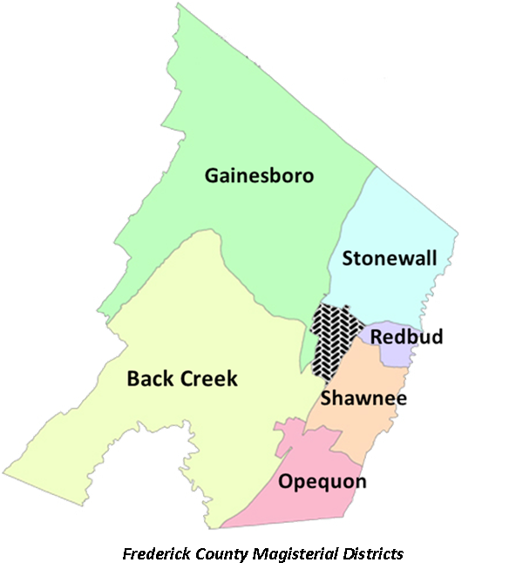
Member at Large

M:

Ph:

Mr. Jay W. Foreman, Vice Chairman

Shawnee District

M:t
Ph:

Mrs. Kali C. Klubertanz Back Creek District
M:
Ph:

Mr. Michael A. Lake Gainesboro District M:
Ph:

Mr. Seth T. Thatcher

Opequon District

M:

Ph:

Mrs. Shontyá Washington

Redbud District

M:

Ph:

Mr. Frank E. Wright

Stonewall District

PH:

M

Frederick County Board of Supervisors Contact Information

Mr. Charles S. DeHaven, Chairman

Member at Large

M:
Ph:

Mr. Gary A. Lofton, Vice Chairman

Back Creek District

M:
Ph:

Mr. J. Douglas McCarthy

Gainesboro District

M:
Ph:

Mr. Robert W. Wells

Opequon District

M:
Ph:

Mr. Blaine P. Dunn

Redbud District

M:
Ph:

Ms. Shannon Trout

Shawnee District

M:
Ph:

Mrs. Judith McCann-Slaughter

Stonewall District

M:
Ph:

8

Superintendent’s FY 2020 Budget Proposal Executive Summary

NOTICE OF NON-DISCRIMINATION

In compliance with the Executive Order 11246; Title II of the Education Amendments of 1976; Title VI of the Civil Rights Act of 1972; Title IX Regulation Implementing Education Amendments of 1972; Section 504 of the Rehabilitation Act of 1973; and all other Federal and State laws and school policies and regulations, Frederick County Public Schools does not discriminate on the basis of race, color, national origin, religion, sex, age, political affiliation, disability, or veteran status in the education program and activities, or employment and provides equal access to the Boy Scouts and other designated youth groups.

It is the intent of Frederick County Public Schools to comply with both the letter and spirit of the law in making certain that discrimination does not exist in its policies, regulations, and operations. Grievance procedures, for Title IX and Section 504, have been established for students, their parents, and employees who feel discrimination has been shown by the school division.

All students attending Frederick County Public Schools may participate in education programs and activities, including but not limited to health and physical education, music, career and technical education. Educational programs and services will be designed to meet the varying needs of all students and will not discriminate against any individual for reasons of race, color, national origin, sex, religion, age, political affiliation, disability, or veteran status.

Questions concerning the application of this non-discrimination policy may be made to:

Title IX Coordinator | Title IX Coordinator (Students)
(Adults) | Section 504 Coordinator
Jennifer Rydholm | Teresa Ritenour
Executive Director of | Director of Student
Human Resources | Support Services
1415 Amherst Street | 1415 Amherst Street
Winchester, VA 22601 | Winchester, VA 22601
540-662-3888 | 540-662-3888
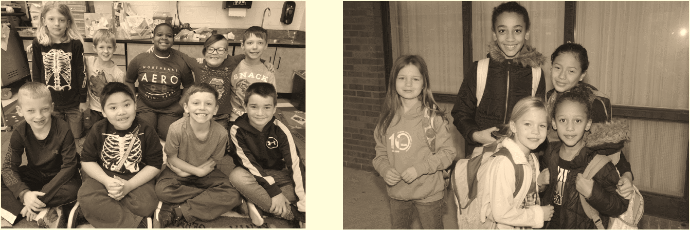

9

