Chapter 3 • 5

CONCEPT MAP

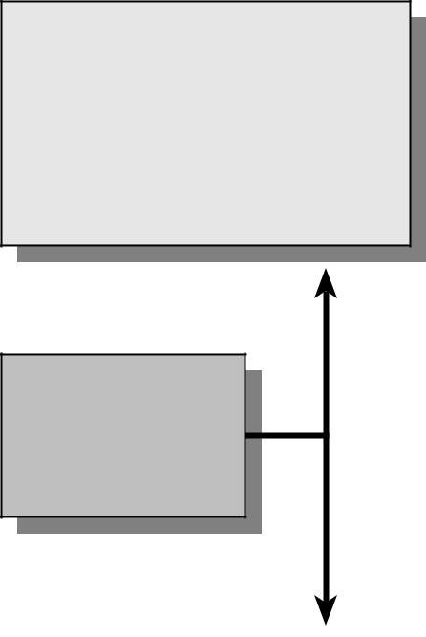

Chapter 4 • 7

Specific Benefits to
Students and Teachers

_{G}raphic organizers enable teachers to show and explain relationships between content and subcontent and how

they in turn relate to other content areas. On the other hand, through the use of the organizers, students can make more abstract comparisons, evaluations, and conclusions. In short, graphic organizers allow students an active role in their learning. For easy understanding, specific benefits to students and teachers are presented in the following organizer.
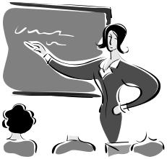

Benefits
to
Students
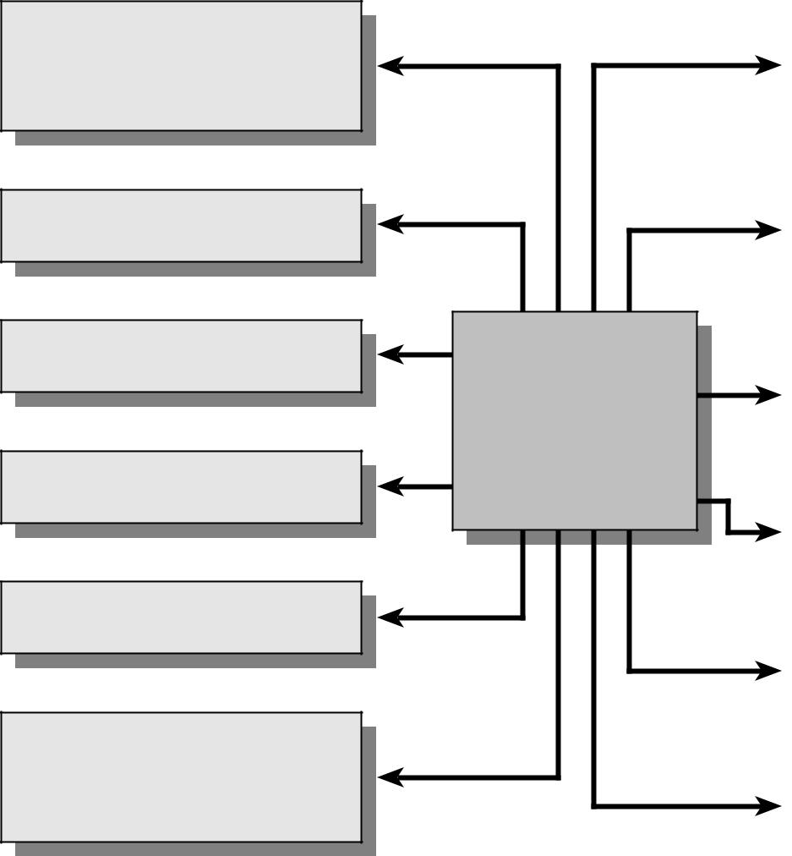
Understand the concept of part to whole

Record relationships

Clarify and organize ideas

Improve memory

Comprehend texts

Recognize and assimilate different points of view

The Use of
Graphic
Organizers

Benefits
to
Teachers

Show and explain relationships between and among content

Make your lessons interactive

Help visual learners to acquire information more easily

Motivate students

Assist students in prewriting techniques

Assess what students know

The Use of Graphic Organizers to Enhance Thinking Skills in the Learning of Economics

Chapter 5 • 9

How to Use the
Graphic Organizers?

_{T}eachers can use the graphic organizers recommended in this book as they see appropriate because the organizers are really flexible tools. Teachers can use them for instruction,

review, extension and enrichment, and have their students work in pairs, groups or in whole class to complete them.

In order to help students get the most out of the graphic organizers, the following steps are recommended.

Familiarize yourself with different types of graphic organizers
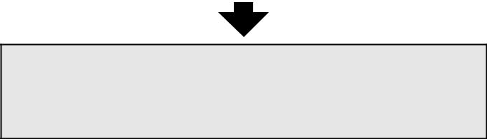

Explain to students what graphic organizers are and why they are useful in learning
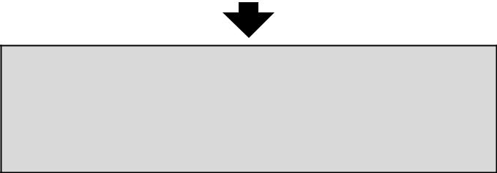

Present the specific graphic organizer for a topic. Point out its subject and organizational framework

Use examples to illustrate the use of some graphic organizers

Assign the graphic organizer as an individual, paired, or group activity

Review students’ work. Generate classroom discussion on the effective use of graphic organizers

The Use of Graphic Organizers to Enhance Thinking Skills in the Learning of Economics

Chapter 6 • 11

Thinking Skills and
Graphic Organizers

_{A}mong the brain’s many functions is the ability to think (Parry and Gregory, 1998), but many students do not have

the skills necessary for the more “higher-order” creative and critical thinking needed to thrive both within and beyond the economics lessons.

Generally speaking, there are five different ways in which thinking skills can be used to enhance classroom instruction in economics lessons. First, thinking skills can be used to enhance students’ learning by generating ideas and activating relevant diagrams of economic concepts. This makes it more likely that they can connect new knowledge to their prior knowledge. Second, thinking skills help students organize ideas and components of economic concepts by searching for meaningful patterns, organizing information, and putting things in groups or categories in order to understand. Third, thinking skills help students understand the parts of an economic idea to the whole by seeing the structure of a concept or an event. Fourth, by focusing on similarities and differences, thinking skills can be used to help students establish relationships between two or more ideas, concepts and events. Finally, knowing how to use thinking skills in teaching economics will provide teachers with a vast repertoire of activities to use with any unit or lesson. (Johnson, 2000)

Graphic organizers have a number of attributes that enhance students’ thinking skills. They allow students to make connections among pieces of information and make information easier to recall. Furthermore, they also allow students to break information into manageable chunks, so that they can easily see the relationships among the separate ideas.

The Use of Graphic Organizers to Enhance Thinking Skills in the Learning of Economics

12 • Thinking Skills and Graphic Organizers

Finally, graphic organizers also provide a structure or framework to display the internal process of thinking in an external, visual form. In other words, they provide a means to observe and assess the students’ thought processes.

Four primary ways of using graphic organizers to enhance students’ thinking skills are compiling information, generating ideas, analyzing or evaluating ideas, and reflecting.

 | compiling information |  |  |  |  |  |  |  |  |  | generating ideas
 | compiling information |  |  |  |  |  |  |  |  |  | generating ideas
The use of graphic The use of graphic

organizers can organizers can

enhance students’ enhance students’

thinking skills in…… thinking skills in……

 | analyzing ideas |  |  |  |  |  |  |  |  |  | reflecting
 | analyzing ideas |  |  |  |  |  |  |  |  |  | reflecting

The Use of Graphic Organizers to Enhance Thinking Skills in the Learning of Economics

Chapter 7 • 13

Graphic Organizers:
Description, Procedures and
Exemplars

_{I}n this chapter, we’ve included a variety of graphic organizers that can be used in many areas of economics learning. They are accompanied by brief descriptions, step-by-step procedures and exemplars. However, teachers are reminded to modify the ideas to meet their own needs. The modification should depend

on students’ developmental level and their experience with graphic organizers. Certainly, the modification itself is a valuable opportunity for critical thinking.
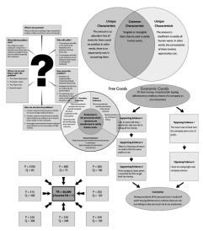

The Use of Graphic Organizers to Enhance Thinking Skills in the Learning of Economics

14 • Graphic Organizers: Description, Procedures and Exemplars

Big Question Map

Description

This organizer can be used to help students improve their research and problem-solving skills. Students are trained to plan their research and investigation of a topic and thus promote their ability to learn and think independently.

Procedures

- Identify an authentic question for which there is no easy, pre-existing answer or solution.

- Brainstorm the procedures and resources required for answering the questions.

- Record the information in the organizer.

- Add, delete or change the boxes in the organizer whereas appropriate.

The Use of Graphic Organizers to Enhance Thinking Skills in the Learning of Economics

Chapter 7 • 15

Big Question Map
What?
What?
(The Question)
(The Question)

When? Who?
When? Who?

Where? Why?
Where? Why?

How?
How?

The Use of Graphic Organizers to Enhance Thinking Skills in the Learning of Economics

16 • Graphic Organizers: Description, Procedures and Exemplars
Exemplar

Big Question Map

Topic

Occupational Mobility of Labour

Concepts

- Referring to a recent research, employees in Hong Kong in general lack loyalty to their employees.

- Most of the employees are preparing to change their jobs whenever they can find better ones.

- Most of the companies in Hong Kong are small in size, so that the employers lack experience and funding to provide fringe benefits to the employees.

- High occupational mobility of labour will bring along high training cost with new employees.

The Use of Graphic Organizers to Enhance Thinking Skills in the Learning of Economics

_{Exemplar} Chapter 7 • 17
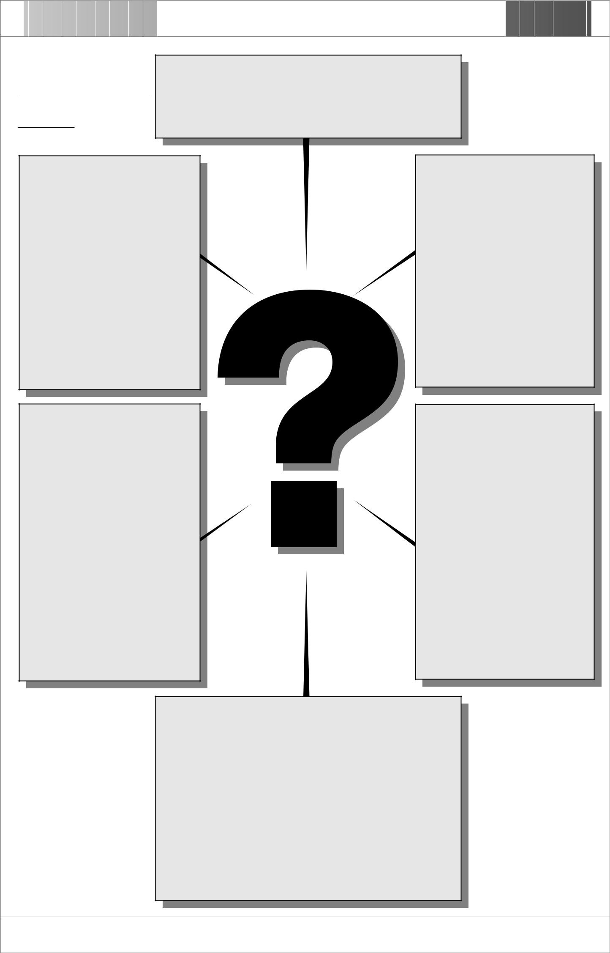

Topic :
What is the question?
Occupational Mobility ^{What is the question?}
What are the factors leading to high occupational _{of Labour} What are the factors leading to high occupational

mobility of labour and how it can be minimized? mobility of labour and how it can be minimized?

When did the problem When did the problem start?
start?

The problem has been The problem has been

existing for a long time. It existing for a long time. It

becomes more serious when becomes more serious when

employees strongly feel that employees strongly feel that

they are unfairly treated by they are unfairly treated by

their employers. their employers.

Where can we seek Where can we seek help to solve the help to solve the problem? problem?
- The Labour Department
  - The Labour Department
- The Labour Union
  - The Labour Union
- The Trade Union
  - The Trade Union
- Research experts
  - Research experts

Who will suffer? Who will suffer?
- The employers will suffer
  - The employers will suffer
as the experienced as the experienced

employees leave employees leave

whenever they find whenever they find

better jobs. better jobs.
- The employees will suffer
  - The employees will suffer
as the employers are not as the employers are not

willing to spend money willing to spend money

in training their in training their
employees.
employees.

How comes the How comes the problem? problem?
- Employers are
  - Employers are
inexperienced in inexperienced in

improving employer-improving employer-

employee relationship. employee relationship.
- Employees feel that they
  - Employees feel that they
are underpaid and are underpaid and

poorly treated. poorly treated.
- The searching cost is
  - The searching cost is
relatively low as the relatively low as the

access of information of access of information of

new jobs is easy. new jobs is easy.

How can we solve the problem? How can we solve the problem?
- Conduct research and interviews to identify
  - Conduct research and interviews to identify
the causes of high mobility of labour. the causes of high mobility of labour.
- Conduct research and interviews to identify
  - Conduct research and interviews to identify
what employers are willing to do to improve what employers are willing to do to improve

labour loyalty to their companies. labour loyalty to their companies.
- Encourage communication between employers
  - Encourage communication between employers
and employees to solve the problem of high and employees to solve the problem of high
mobility.
mobility.

The Use of Graphic Organizers to Enhance Thinking Skills in the Learning of Economics

18 • Graphic Organizers: Description, Procedures and Exemplars

Characteristics Map

Description

This organizer can be used to promote students’ critical and analytical thinking about key concepts and their characteristics. Students are expected to list the major characteristics of a concept and illustrate with examples.

Procedures

- Select a concept and write it in the middle of the organizer.

- Identify the categories belong to the concept and write them in the ‘category’ boxes. You may change the number of these boxes as appropriate.

- Brainstorm the major characteristics of each category. Annotate with evidence whereas appropriate and necessary.

The Use of Graphic Organizers to Enhance Thinking Skills in the Learning of Economics

 |  | Chapter 7 • 19
Characteristics Map
Characteristic | Category | Characteristic
Characteristic |  | Characteristic
Category | Concept | Category
Characteristic |  | Characteristic
Characteristic | Category | Characteristic
 | The Use of Graphic Organizers to Enhance Thinking Skills in the Learning of Economics
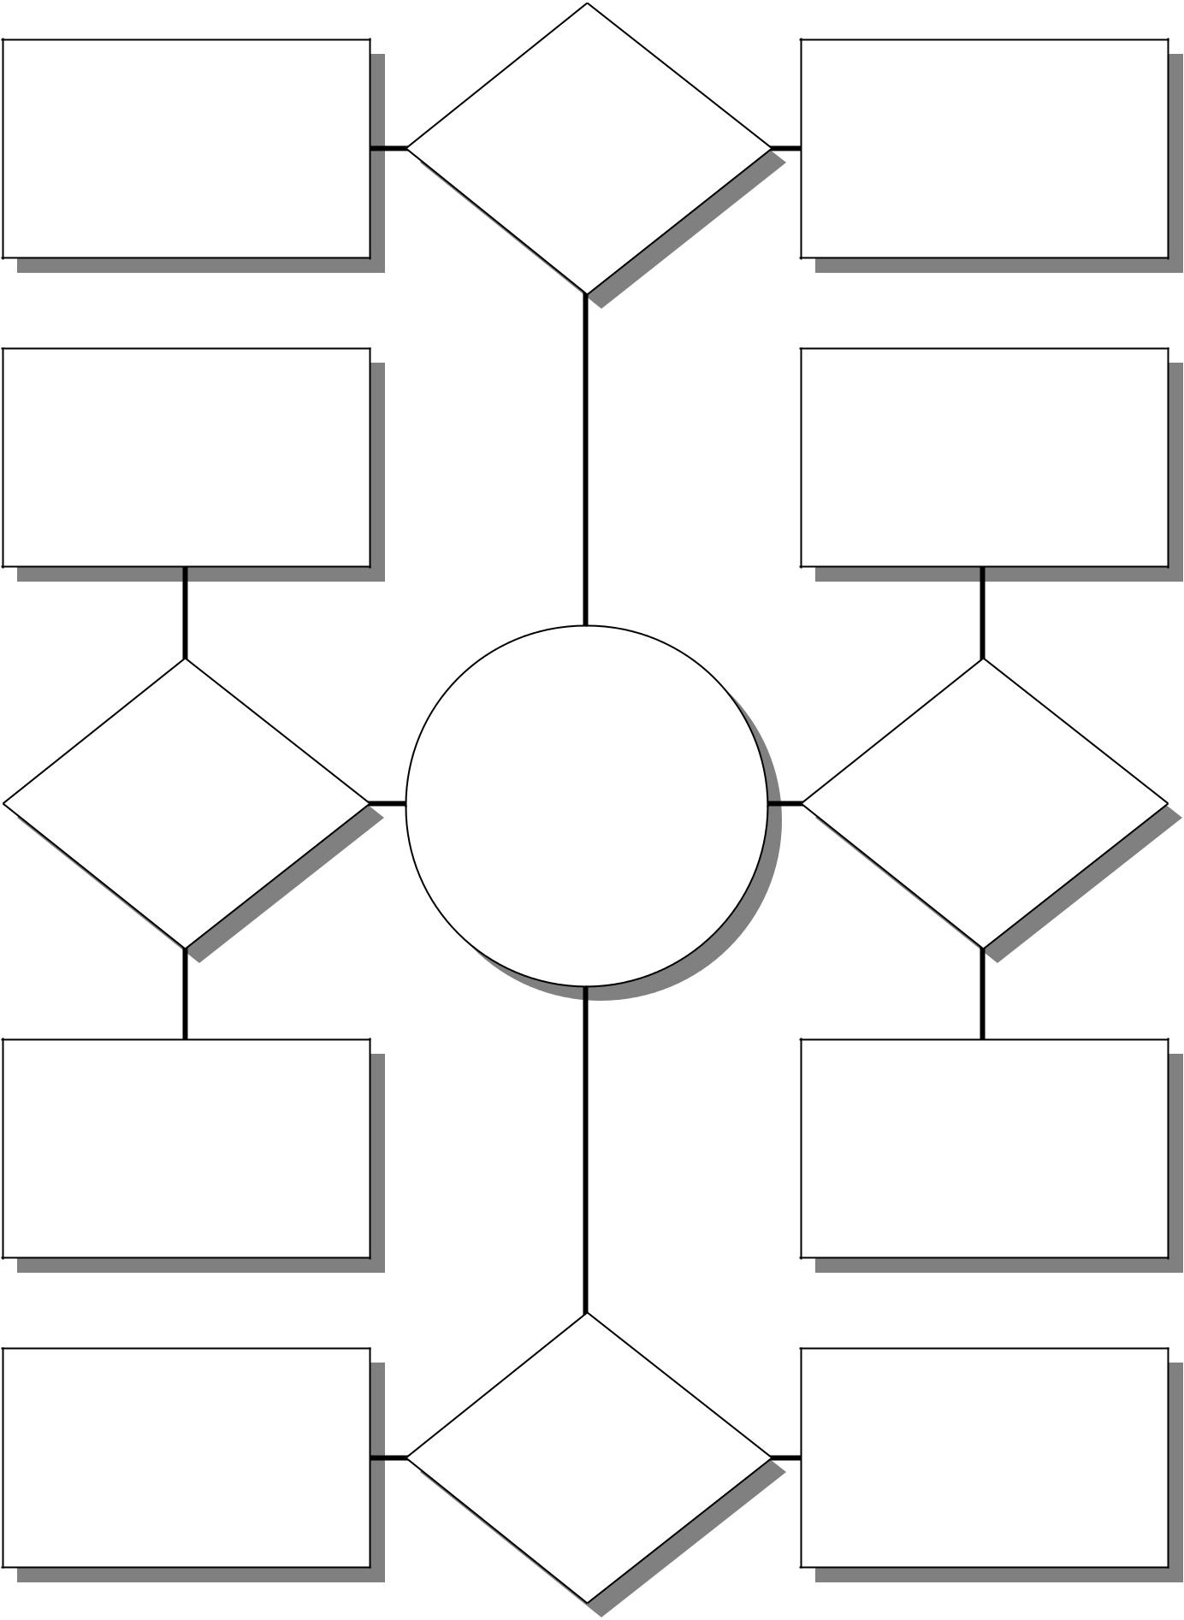

20 • Graphic Organizers: Description, Procedures and Exemplars
Exemplar

Characteristics Map

Topic

Economic Systems

Concepts

- Economic systems can be distinguished along many lines, but two seem most important:

  - How is economic activity coordinated; and

  - Who owns the means of production?

- Based on the above criteria, there are three different types of economic system using different ways to deal with the three basic economic problems of what to produce, how to produce and for whom to produce.

- A purely planned economy is one in which the state owns the means ofproduction and all basic economic activities are heavily planned.

- A purely market economy is one in which the means of production are privately owned and all economic decisions are relied on free markets.

- In reality, all economies are to some extent mixed. In a mixed economy, there are both public and private sectors working hand in hand so as to ensure economic growth of the state.

The Use of Graphic Organizers to Enhance Thinking Skills in the Learning of Economics

_{Exemplar} Chapter 7 • 21
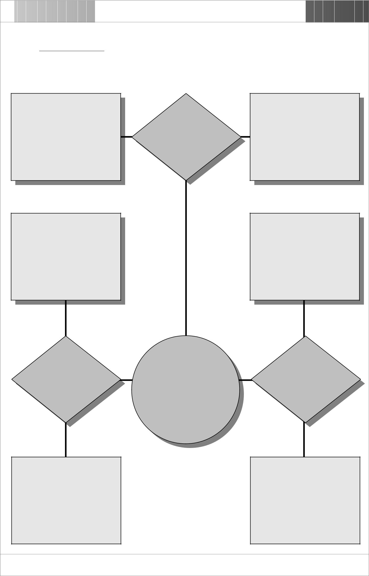

Topic : Economic Systems

Both public and private | Mixed | Means of production are
 |  | both state and privately
sectors join hand in hand to
 | Economy | owned
solve economic problems

Means of production are | Means of production are
privately owned | state owned

Purely |  | Purely
Market | Economic | Planned
Economy | Systems | Economy

Major economic decisions |  | Major economic decisions
rely heavily on free market |  | are made by the government

The Use of Graphic Organizers to Enhance Thinking Skills in the Learning of Economics

22 • Graphic Organizers: Description, Procedures and Exemplars

Circle Organizer

Description

This organizer can be used to help students understand the sequence of events in a process. On a sequence circle there is a consecutive flow of events with the last cycling back to the first event. Sequence circles are appropriate to represent the relationship of events that are continuous.

Procedures

- Discuss a cycle process with students and encourage them to retell the sequence of events.

- Write the concept to be discussed in the middle of the organizer.

- In clockwise direction write the events in order.

- Write a brief note to explain the steps in the process under the ‘concept title’.

The Use of Graphic Organizers to Enhance Thinking Skills in the Learning of Economics

Chapter 7 • 23

Circle Organizer
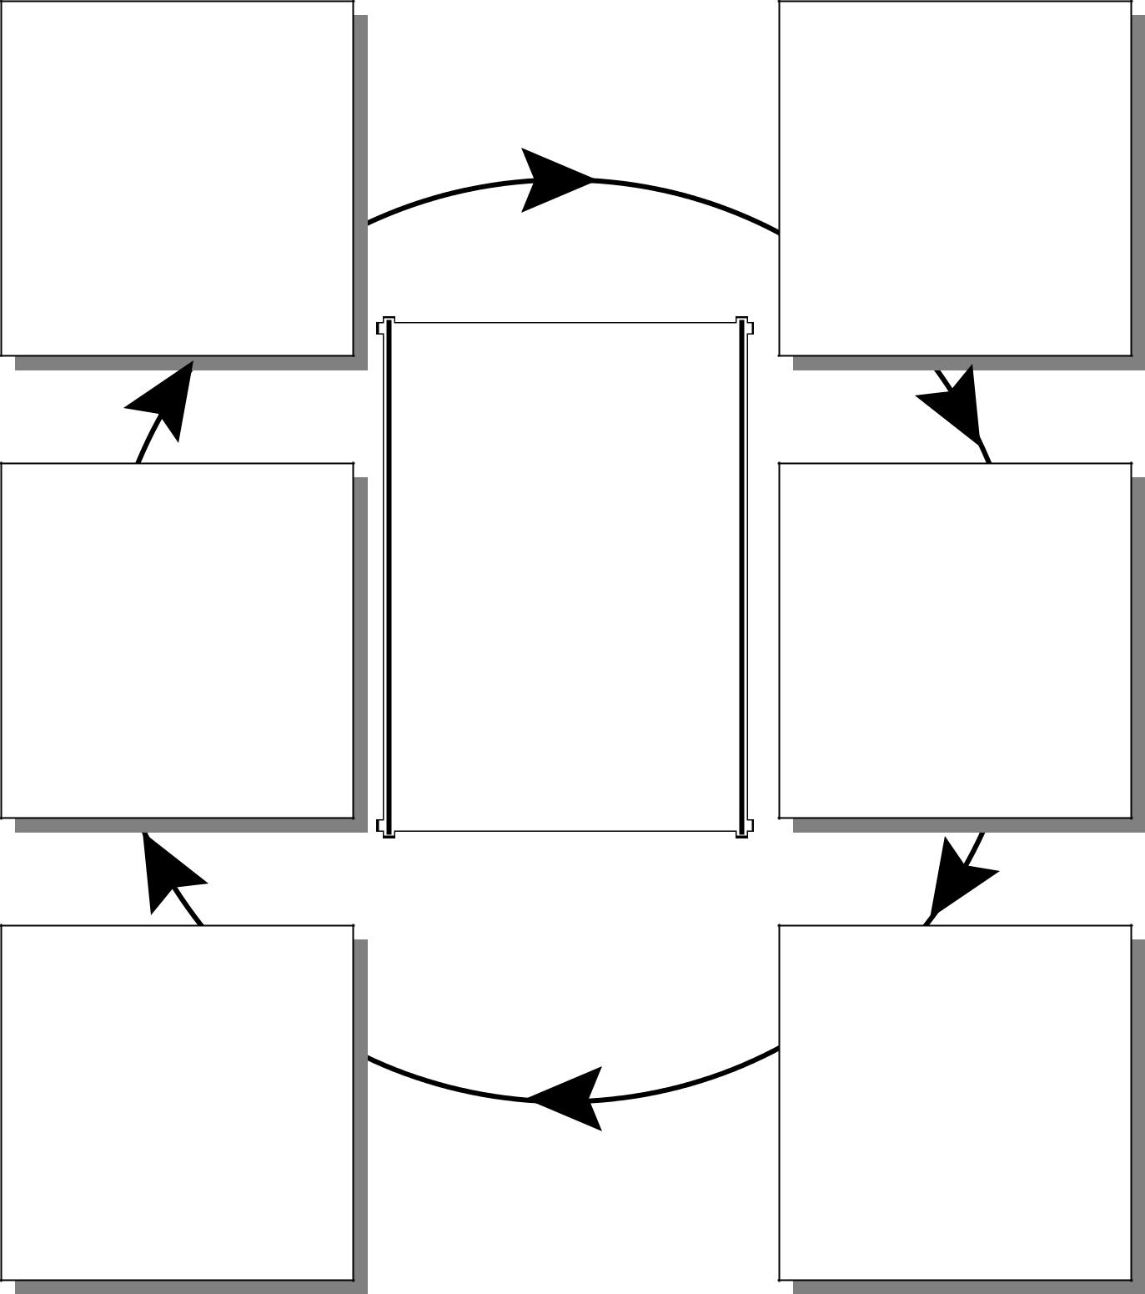

Event 6

Concept

Event 5

Explanation

Event 4

Event 1

Event 2

Event 3

The Use of Graphic Organizers to Enhance Thinking Skills in the Learning of Economics

24 • Graphic Organizers: Description, Procedures and Exemplars
Exemplar

Circle Organizer

Topic

Multiple Money Creation

Concepts

- This can be defined as a process of multiple money creation, whereby a small given deposit, will lead to a greater increase in the money supply in the economy.

- Generally, if the reserve ratio is R (a percentage of the deposit received), meaning that each dollar of deposits requires only a fraction R of a dollar in reserves. The deposit will expand by 1/R for each dollar of new reserves that are injected into the system.

- Assumes that all the banks in our society hold exactly the 20% required reserves (no excess reserves), and that each loan recipient re-deposits the proceeds in the next bank. The total money supply created (including the initial deposit (D)) will be: D + D(1-R) + D(1-R)² + D(1-R)³ + D(1-R)⁴ +……= D x 1/R = D/R

The Use of Graphic Organizers to Enhance Thinking Skills in the Learning of Economics

_{Exemplar} Chapter 7 • 25
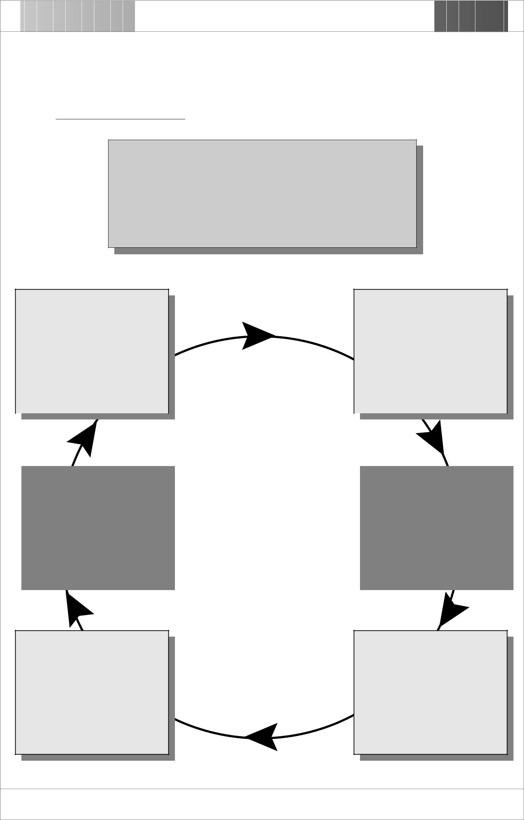

Topic : Multiple Money Creation

Assume the new loans from bank F are re-deposited into

Bank A and the process goes on and on.

The total money supply thus created (including the initial amount) would be: $1,000 x 1/0.2 = $5,000

Bank F | Bank A
Deposit received = $327.7 | Deposit received = $1,000
Required reserves = $65.5 | Required reserves = $200
New loans = $262.2 | New loans = $800

 |  |  | Multiple Money
 |  |  | Creation
 |  | Assume:
Bank E |  | 1. | There are many banks |  |  | Bank B
 |  | 2. | Required reserve ratio =
Deposit received = $409.6 |  |  |  |  |  | Deposit received = $800
 |  |  | 20%
Required reserves = $81.9 |  |  |  |  |  | Required reserves = $160
 |  | 3. | Initial deposit = $1,000
New loans = $327.7 |  |  |  |  |  | New loans = $ 640
 |  | 4. | Banks keep no excess
 |  |  | reserves
 |  | 5. | All loans are re-deposited
 |  |  | in banks

Bank D

Deposit received = $512 Required reserves = $102.4 New loans = $409.6

Bank C

Deposit received = $640 Required reserves = $128 New loans = $512

The Use of Graphic Organizers to Enhance Thinking Skills in the Learning of Economics

26 • Graphic Organizers: Description, Procedures and Exemplars

Compare Map

Description

This organizer can be used to help students compare two concepts according to a set of criteria. Students can make use of it to record a discussion between two concepts/subjects and as an organizing tool for comparison.

Procedures

- Identify two concepts/subjects that are to be compared and write them in the ‘concept’ boxes.

- List the criteria for comparing the two concepts/subjects. Put the criteria in the ‘criteria’ boxes.

- Discuss the similarities and differences between the two concepts/subjects.

- Record information on the appropriate lines.

The Use of Graphic Organizers to Enhance Thinking Skills in the Learning of Economics

Chapter 7 • 27

Compare Map

Illustration |  | Criterion |  | Illustration
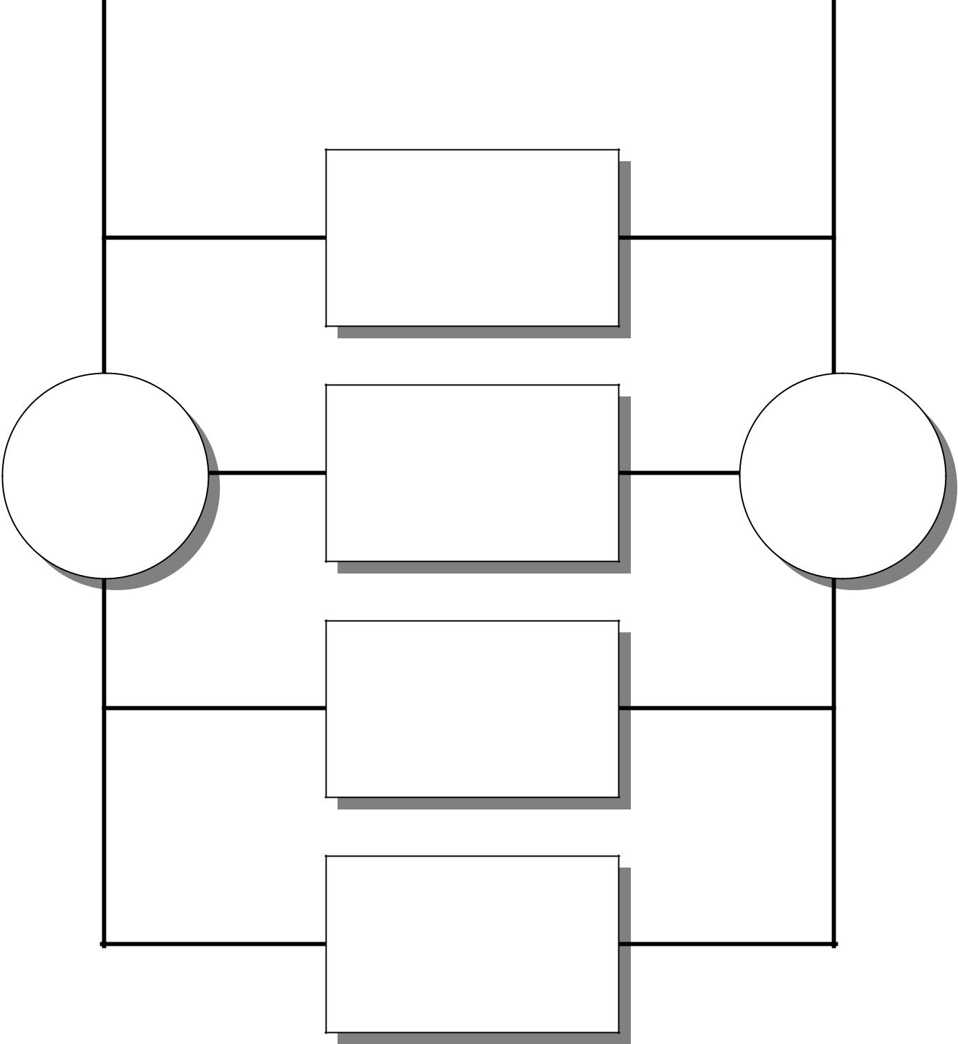

Criterion

Concept | Criterion | Concept

Criterion

Criterion

The Use of Graphic Organizers to Enhance Thinking Skills in the Learning of Economics

28 • Graphic Organizers: Description, Procedures and Exemplars
Exemplar

Compare Map

Topic

Private and Public Limited Companies

Concepts

- There are two types of limited companies, they are private limited companies and public limited companies.

- Both private limited companies and public limited companies enjoy limited liability. Furthermore, they can raise more capital by issuing shares.

- Under existing regulations, private limited companies cannot have more than 50 shareholders, while the number of shareholders of public limited companies is unlimited.

- The shares of public limited companies can be traded in the stock market. On the other hand, private limited companies cannot offer their shares to the public.

- In order to protect public interest, public limited companies are required by law to provide more information to the public.

The Use of Graphic Organizers to Enhance Thinking Skills in the Learning of Economics

_{Exemplar} Chapter 7 • 29
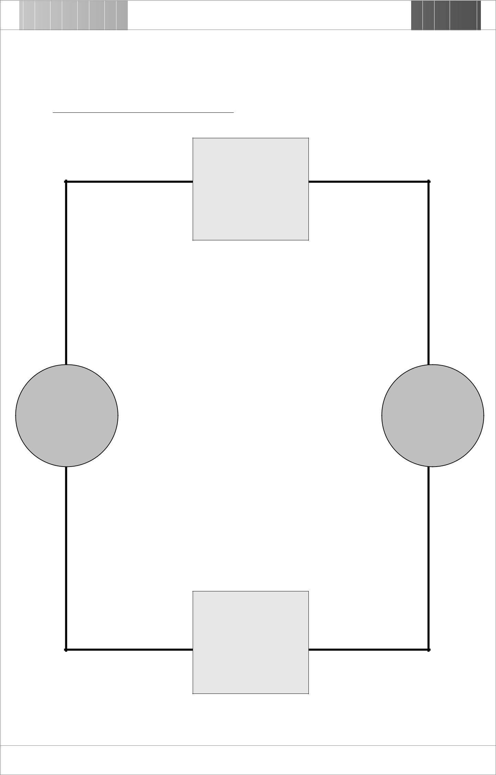

Topic : Private and Public Limited Companies

2 to 50 | unlimited (min. 2)
Number of

Shareholders

 | Limited liability |  | Liability | Limited liability
Private |  |  |  |  | Public
Limited |  | Shares |  | Shares can | Limited
Company |  | cannot be |  | be traded | Company
 |  | traded in |  | in the
 |  | the stock |  | stock
 |  | market | Trading of Shares | market

Disclosure is not required | Disclosure of

Company Finance

Must be disclosed to the

public

The Use of Graphic Organizers to Enhance Thinking Skills in the Learning of Economics

30 • Graphic Organizers: Description, Procedures and Exemplars

Concept Definition Map

Description

This organizer can be used to help students focus attention on the main components of a definition. These may include categories, properties and illustrations. It not only enriches students’ understanding of a concept, but also encourages them to integrate their own experience with the definition.

Procedures

- Discuss basic elements related to the definition of a concept, for example, what is it? What are their properties? What are the examples?

- Choose a concept and tell students discuss the meaning and brainstorm its properties and examples.

- Ask students to justify the examples they have given.

The Use of Graphic Organizers to Enhance Thinking Skills in the Learning of Economics

Chapter 7 • 31

Concept Definition Map
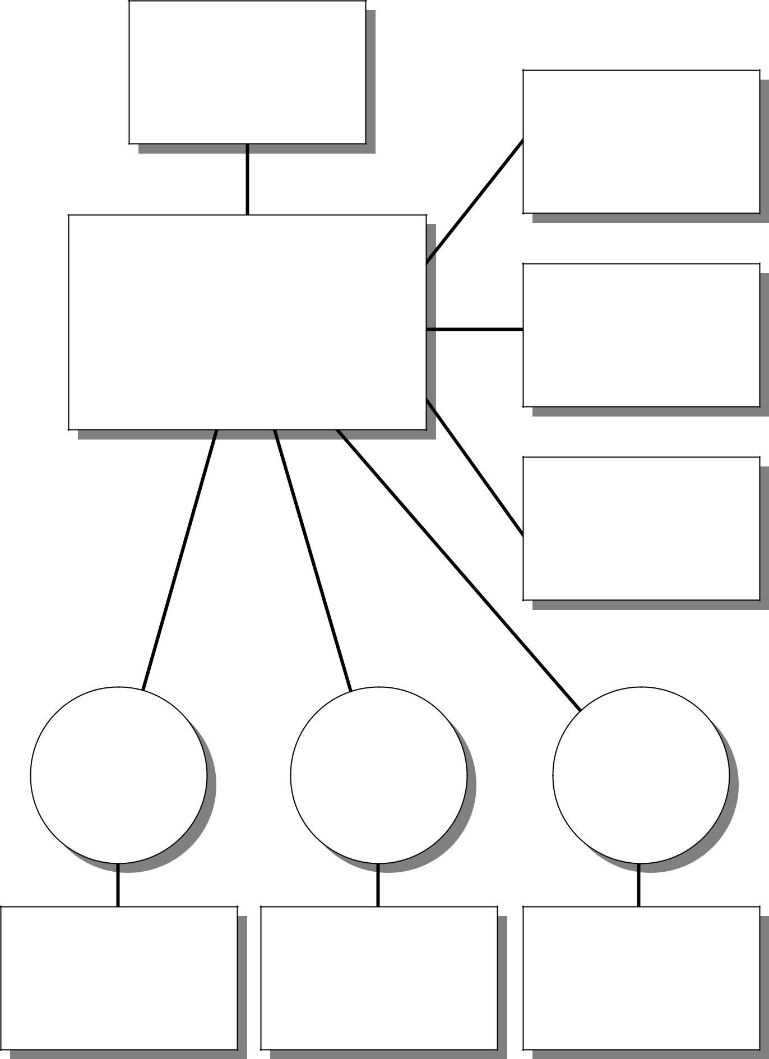

Definition

Property

Concept

Property

Property

Example Example Example

This is an example because This is an example because This is an example because

The Use of Graphic Organizers to Enhance Thinking Skills in the Learning of Economics

32 • Graphic Organizers: Description, Procedures and Exemplars
Exemplar

Concept Definition Map

Topic

Money

Concepts

- Money is defined as a generally accepted medium of exchange.

- Besides the function of medium of exchange, money usually performs basic functions of unit of account, standard of deferred payment and store of value.

- To perform the functions effectively, money should have the qualities of stability (in intrinsic value), durability, divisibility, portability and homogeneity.

- Paper notes, coins and demand deposit (cheques) are generally accepted as examples of money because they perform most of the basic money functions.

The Use of Graphic Organizers to Enhance Thinking Skills in the Learning of Economics

_{Exemplar} Chapter 7 • 33
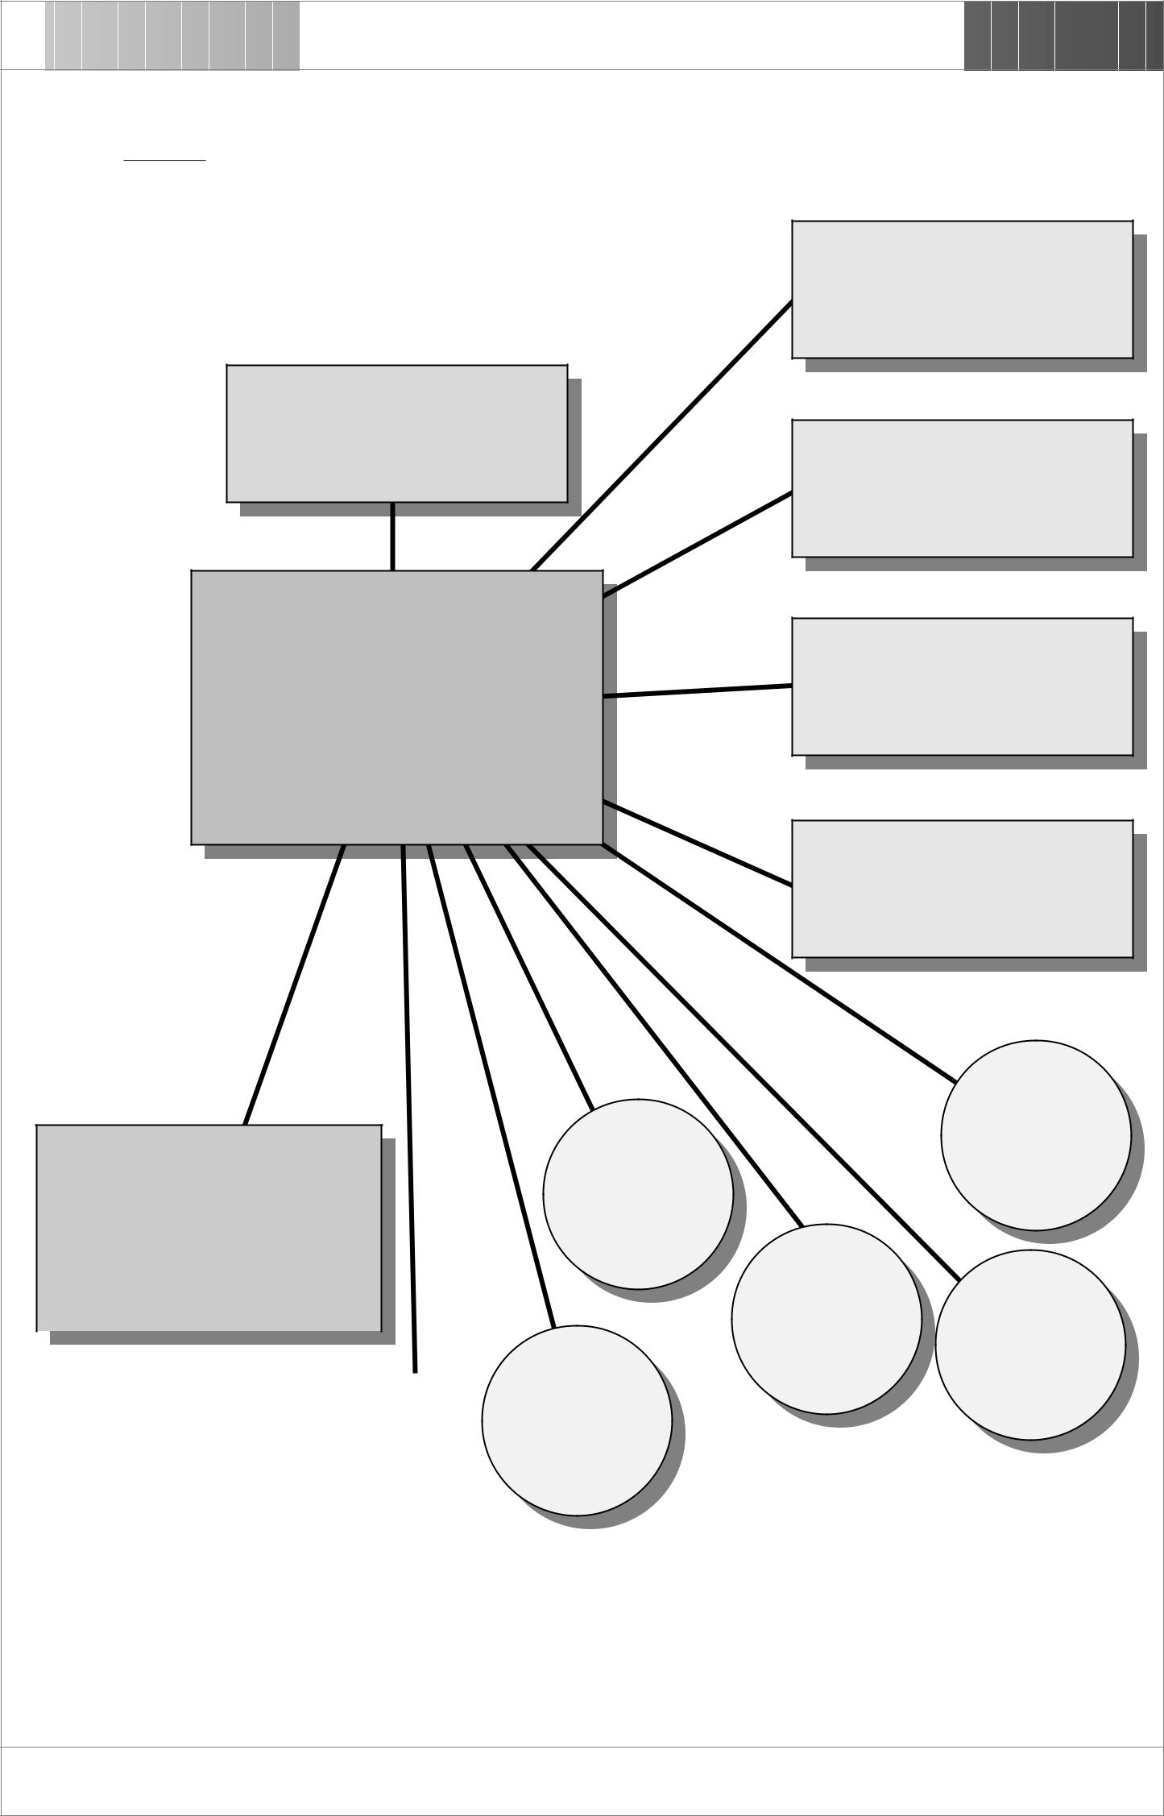

Topic : Money

(Functions)

Medium of Exchange

(Definition)

Generally accepted medium

of exchange
Unit of Account

Money | Store of value

Standard of Deferred

Payment

Divisibility

Paper notes and coins are
Durability

money because they perform all four functions of money

 |  |  |  | Stability
 |  |  |  | Homogeneity
 |  |  |  | Portability
 | Demand deposit is in general
 | defined as money because the |  |  | (Qualities)
 | cheque is generally accepted as
 | medium of exchange, and the
 | deposit itself performs the
 | function of store of value.
 | (Examples)

The Use of Graphic Organizers to Enhance Thinking Skills in the Learning of Economics

34 • Graphic Organizers: Description, Procedures and Exemplars

Data Grid

Description

This organizer can be used to help students organize information into different categories. It allows students compare and contrast information according to various criteria. Students are thus trained to see patterns of information and are able to generate hypotheses.

Procedures

- Choose a topic to research.

- List subtopics to be compared and contrasted and write them across the top of the organizer.

- Brainstorm all criteria for comparing and contrasting and list them vertically down the left side of the organizer.

- Conduct research on and/or search for the required information and write it in the appropriate boxes.
- Use the grid to launch a discussion.

The Use of Graphic Organizers to Enhance Thinking Skills in the Learning of Economics

 |  |  |  |  |  | Chapter 7 • 35
Data Grid
Research Topic :
 |  |  |  | Sub-topics
 | Criteria |  | Sub-topic 1 | Sub-topic 2 | Sub-topic 3 | Sub-topic 4
 | Criterion 1
 | Criterion 2
 | Criterion 3
 | Criterion 4
 | Criterion 5
 | Criterion 6

The Use of Graphic Organizers to Enhance Thinking Skills in the Learning of Economics

36 • Graphic Organizers: Description, Procedures and Exemplars
Exemplar

Data Grid

Topic

Market Structure

Concepts

- Market structure describes the important features of a market, such as the number of firms, type of products, ease of entry, and forms of competition.

- A perfectly competitive market is a market structure involving large numbers of fully informed buyers and sellers of a homogeneous product. There are no obstacles to entry or exit of firms. Individual firms have no control over the price.

- A pure monopoly is an industry with a single firm that produces a product for which there are no close substitutes and in which significant barriers prevent other firms from entering to compete away profits. The firm can raise price without losing all demand for their product.

- A monopolistic competitive market is a market structure in which there are a large number of firms. None of the firms can influence market price by virtue of size only. Some degree of market power is achieved by firms producing differentiated products. New firms can enter and established firms can exit such industry with ease.

- An oligopoly is a market involving only a few firms that are each large enough to influence market price by virtue of size. Products may be homogeneous or differentiated. The behaviour of any one firm very much depends on the behaviour of others.

The Use of Graphic Organizers to Enhance Thinking Skills in the Learning of Economics

_{Exemplar} Chapter 7 • 37

Research Topic : Market Structure

Market Structure

 | Perfect | Monopolistic | Oligopoly | Monopoly
 | Competition | Competition
Number of Firms | Many | Many | Few | One
Types of Product | Homogeneous | Differentiated | Homogeneous / | ----
 |  |  | Differentiated
Forms of
Competition | ---- | Non-price | Price/Non-price | ----
among the |  | Competition | Competition
Producers
Availability of | Perfect | Imperfect | Imperfect | Imperfect
Information | Information | Information | Information | Information
Barrier of Entry | Free Entry | Free Entry | Entry Restricted | Entry Restricted
Control over Price | Price Taker | Price Searcher | Price Searcher | Price Searcher

The Use of Graphic Organizers to Enhance Thinking Skills in the Learning of Economics

38 • Graphic Organizers: Description, Procedures and Exemplars

Discussion Map

Description

This organizer can be used to help students consider both sides of an issue before drawing conclusion. Students are trained to develop skills in comparing and contrasting points of view from different people.

Procedures

- Discuss and identify an issue that students are interested in.

- Students brainstorm the reasons for and against the argument and record their ideas in the appropriate boxes.

- Having considered all the pros and cons, try to arrive at a class conclusion and write a brief justification to support the decision.

The Use of Graphic Organizers to Enhance Thinking Skills in the Learning of Economics

Chapter 7 • 39

Discussion Map

(Reasons For) (Reasons Against)
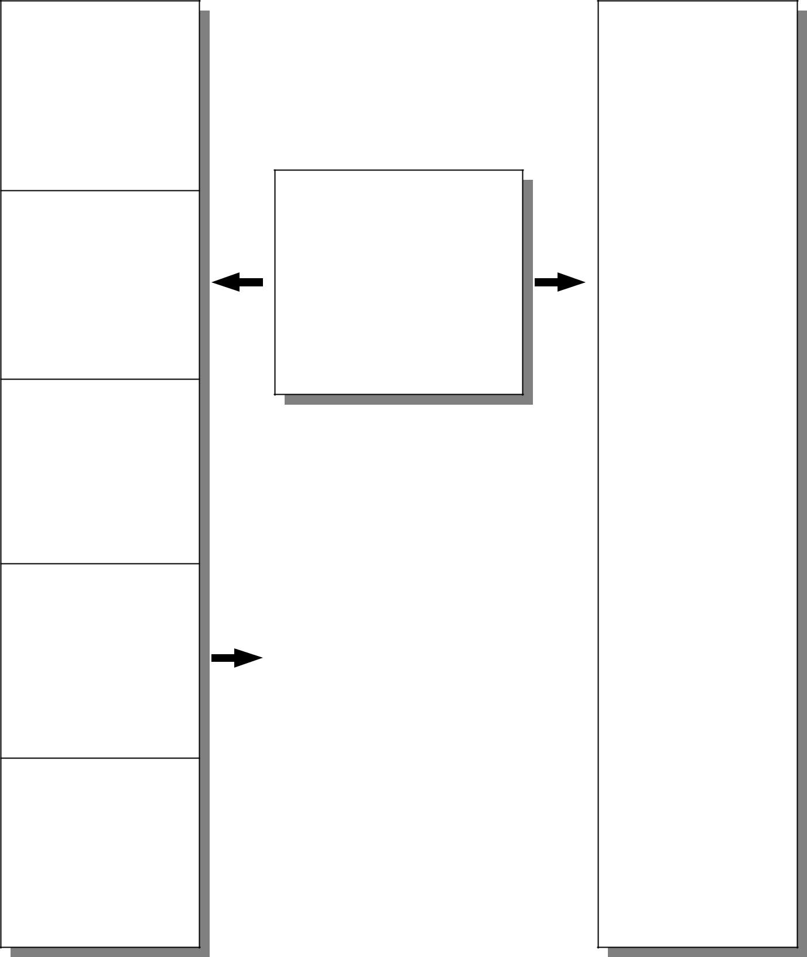

Question/Issue
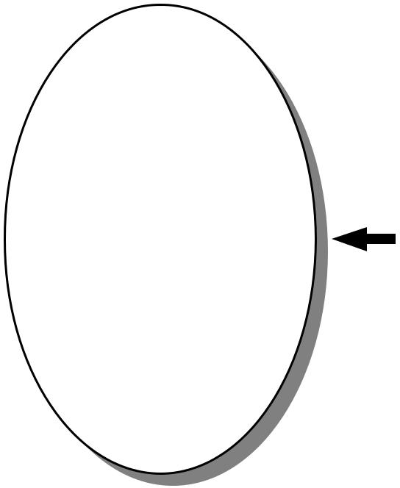

Conclusion
and
Justification

The Use of Graphic Organizers to Enhance Thinking Skills in the Learning of Economics

40 • Graphic Organizers: Description, Procedures and Exemplars
Exemplar

Discussion Map

Topic

Protectionism

Concepts

- Reasons for protectionism:

  - Protection of local infant industries

  - Correcting adverse balance of payment position

  - Protecting declining industries

  - Preventing dumping goods from other countries

  - Increasing local employment rate

- Reasons against protectionism:

  - Limiting choices of consumers

  - Reduction in world output

  - Resource misallocation

  - Retaliation from other countries

  - Inefficient use of resources

The Use of Graphic Organizers to Enhance Thinking Skills in the Learning of Economics

_{Exemplar} Chapter 7 • 41
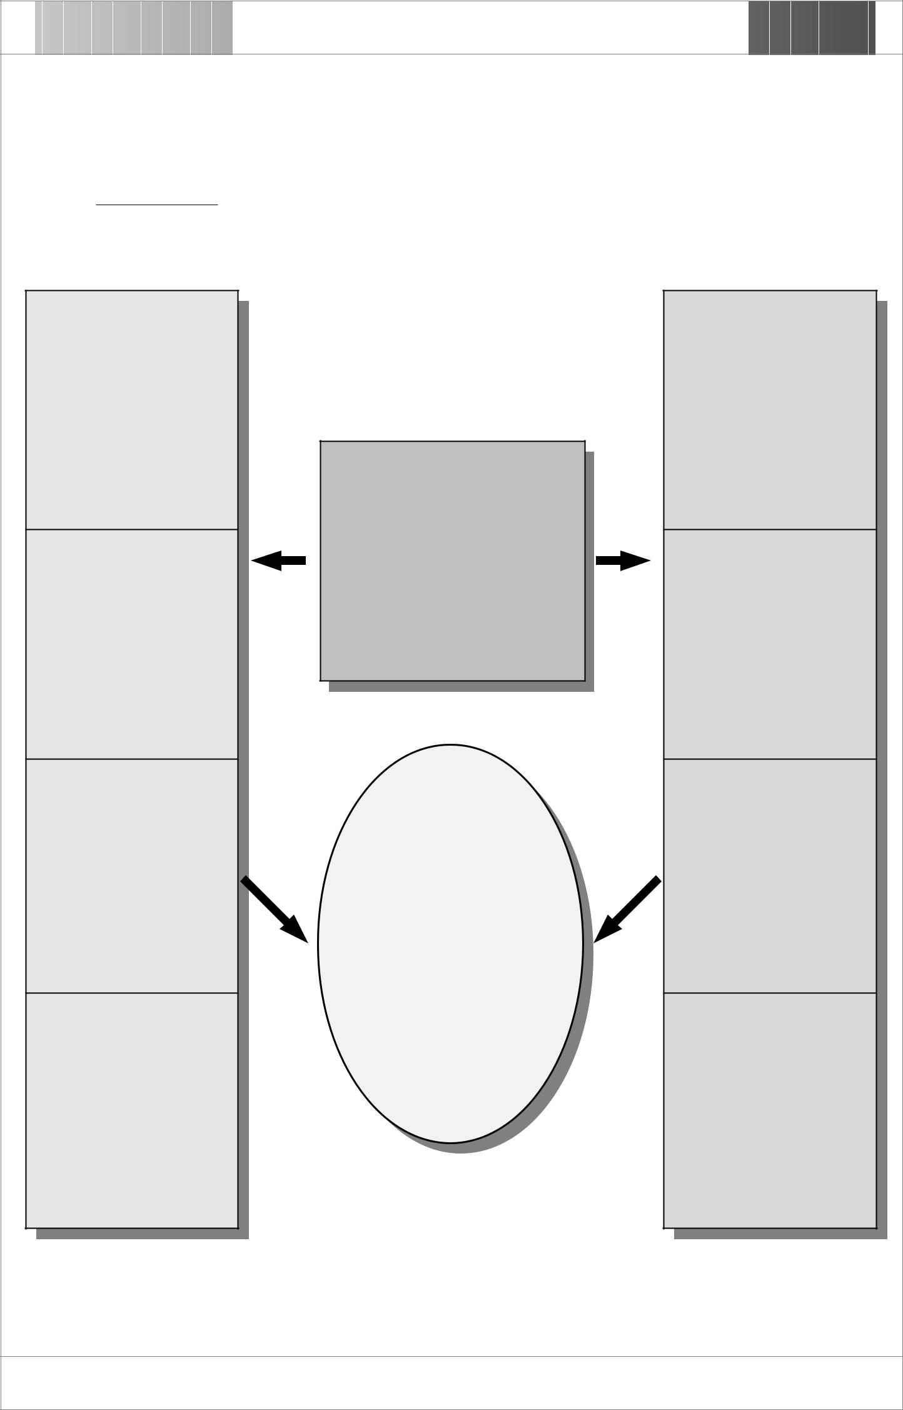

Topic : Protectionism

(Reasons For)

The local computer industry can develop under the protection

The reduction of import will lead to a reduction of trade deficit

The development of the local computer industry will bring along with an increase in employment rate

Local computer producers are willing to spend more money in researching new products as their market are secured

The Issue

Hong Kong should impose a tariff on the import of computer products from other countries.

Conclusion
and
Justification

Hong Kong should not impose tariff on imported computer products as this would limit our choice in using high technological

products. In turn, our computer literacy would then be
lowered.

(Reasons Against)

The variety of computer products is limited

More local resources are allocated to the production of computer products which are not yet efficient in resource utilization

Total world production of computer products is reduced

The price of locally produced products will be higher than those imported from abroad

The Use of Graphic Organizers to Enhance Thinking Skills in the Learning of Economics

42 • Graphic Organizers: Description, Procedures and Exemplars

Divergent and Convergent

Thinking Web

Description

This organizer can be used to help students brainstorm ideas in such a way as to show the relationship between various topics and subtopics. Students are encouraged to generate as many ideas as possible in relation to a given topic. They are then required to refine their ideas by thinking convergently and finally weave them into a definition.

Procedures

- Choose a topic to discuss and write it down in the centred box.

- Brainstorm ideas in such a way as to show the relationship between the subtopics.

- After discussion, refine the ideas by eliminating certain unrelated/incorrect attributes from the list.

- Put the critical attributes into the appropriate outer layer boxes.

- Take the critical attributes and weave them into a definition.

- Write the definition under the topic title in the centred box.

- Check the definition by applying it to a wide range of examples and cases.

The Use of Graphic Organizers to Enhance Thinking Skills in the Learning of Economics

Chapter 7 • 43

Divergent and Convergent Thinking Web
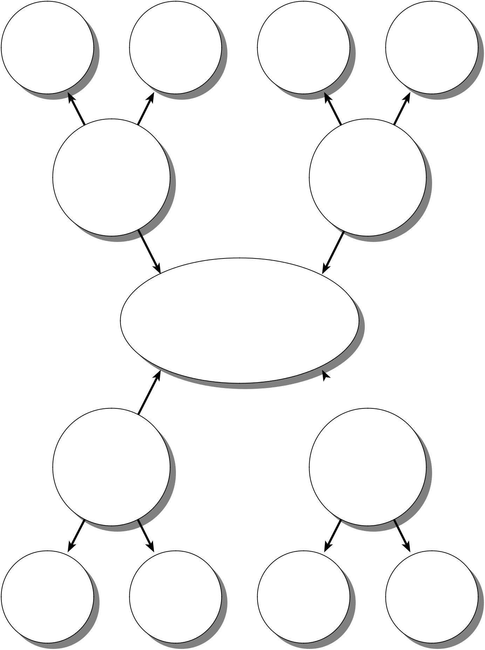

Idea Idea Idea Idea

Sub-topic

Sub-topic

Topic Title and Definition

Sub-topic

Sub-topic

Idea Idea Idea Idea

The Use of Graphic Organizers to Enhance Thinking Skills in the Learning of Economics

44 • Graphic Organizers: Description, Procedures and Exemplars
Exemplar

Divergent and Convergent

Thinking Web

Topic

Integration of Firms

Concepts

- An integration of firms occurs when two previously independent firms are combined under a single owner or group of owners, with the main reason to raise their competitiveness in the market.

- A horizontal integration is the combining of two firms producing similar products. The aims for doing so are to use the resources more efficiently, to enlarge the market shares, and to enjoy the advantages of economies of scale. The integration of two banks is a typical example.

- A vertical integration is the combining of two firms one of which is the input supplier/market outlet of the other. A backward vertical integration is formed in order to ensure the supply of inputs whereas a forward vertical integration is for the purpose of having an outlet of production. Both backward and forward vertical integration can enjoy the benefit of economies of scale and more efficient use of resources. The integration of a flour manufacturing firm and a bakery shop is an example of backward vertical integration to the bakery shop, but an example of forward vertical integration to the flour manufacturing firm.

- A lateral integration is the combining of two firms producing related but not competitive products. The aims of doing so are to have better use of resources and diversity of production and risks. The integration of two shops selling watches and jewellery is a typical example.

- A conglomerate integration is the combining of two firms producing unrelated products. The firms are combined together in order to have more efficient use of resources, and to diversify lines of production and risks. The combining of a transport company and a restaurant is an example of conglomerate integration.

The Use of Graphic Organizers to Enhance Thinking Skills in the Learning of Economics

Exemplar | Chapter 7 • 45
Topic : Integration of Firms
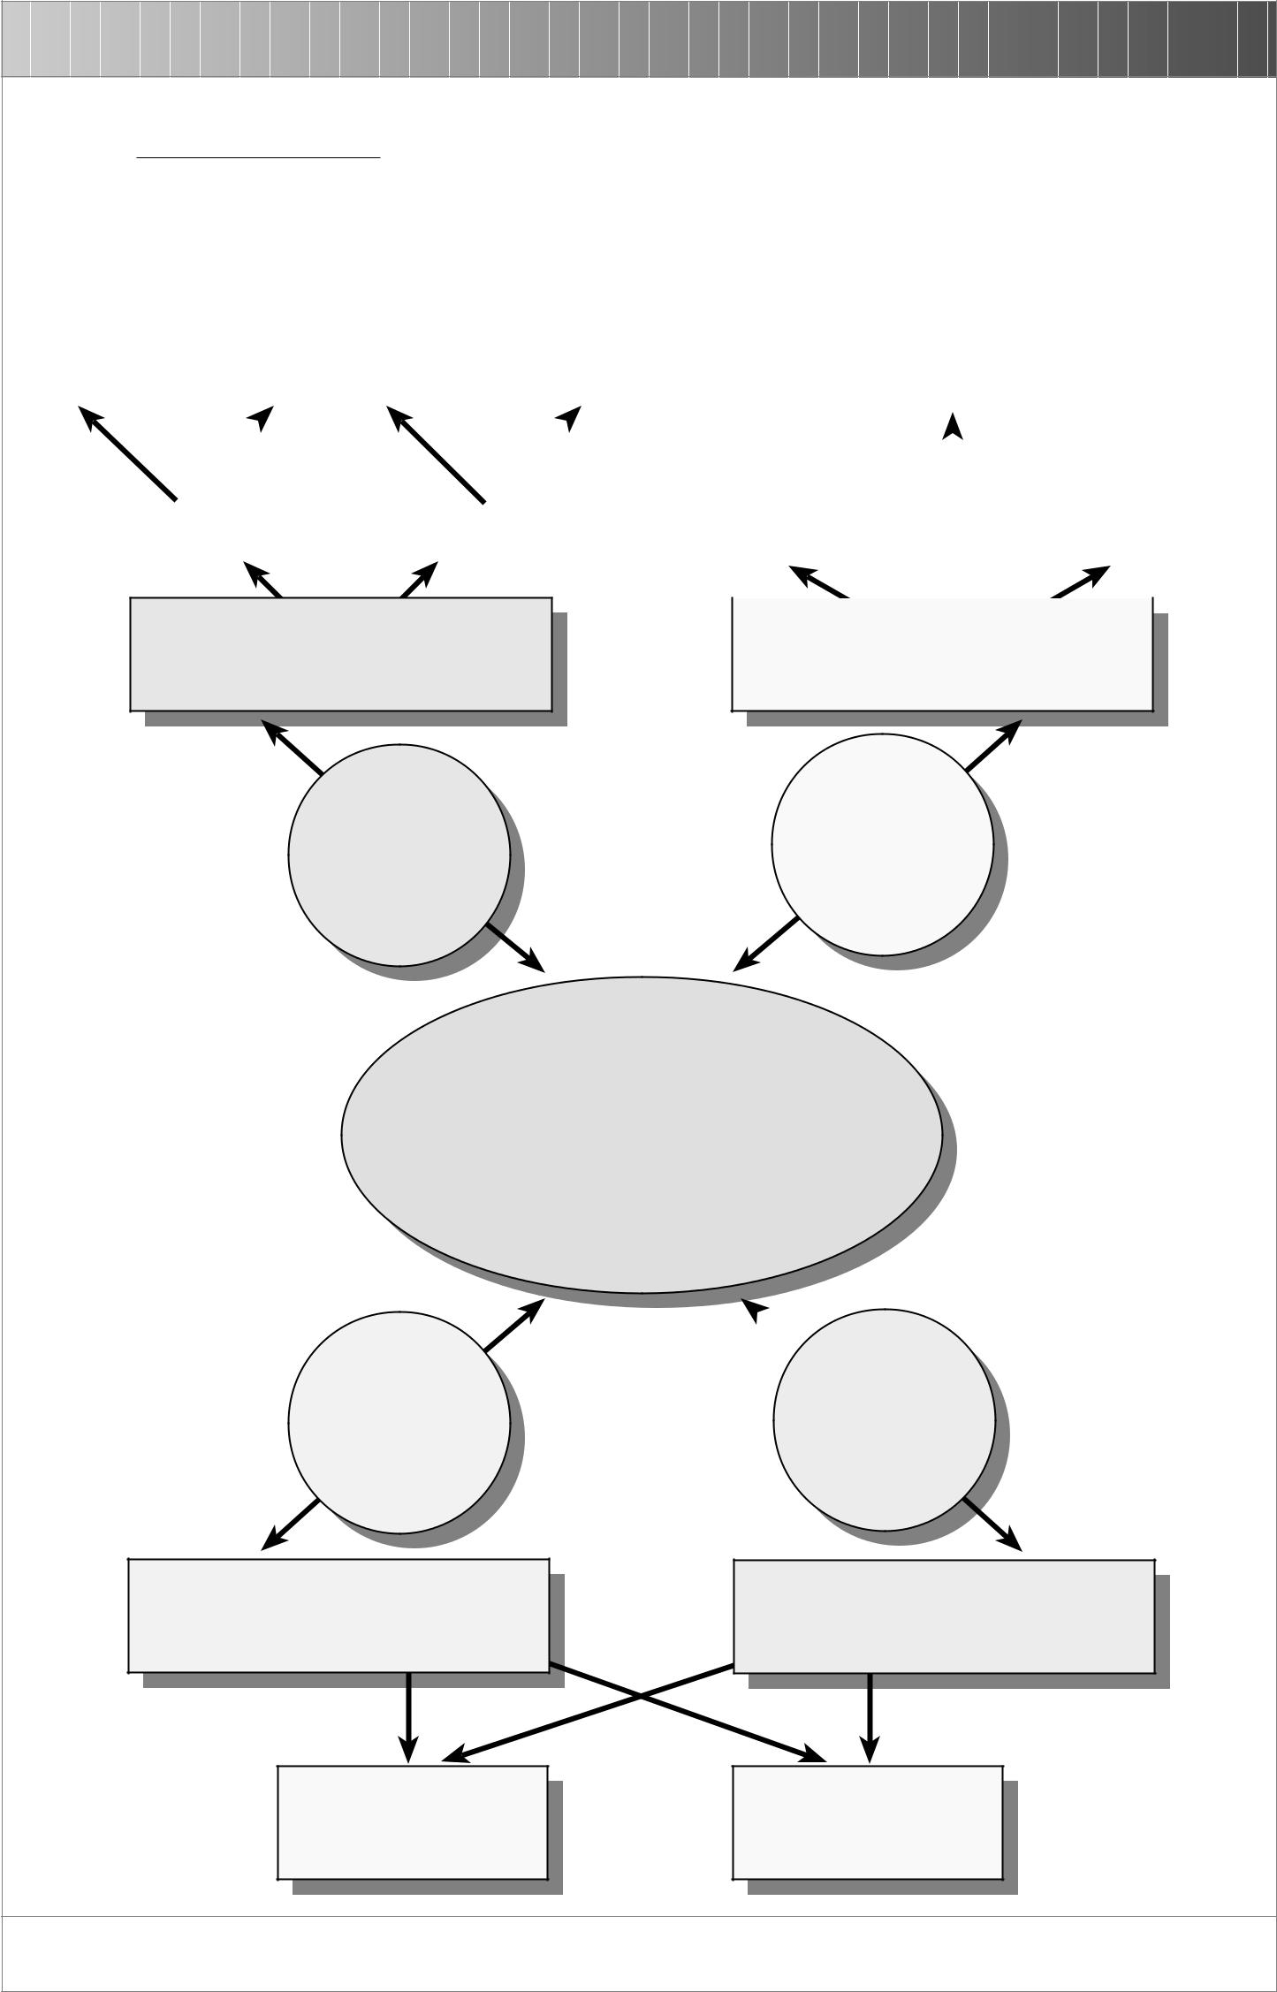
 |  |  |  |  | Enjoy
 |  |  |  |  | economies
 |  |  |  |  | of scale and
 | Ensure |  |  |  | better use |  |  |  | Ensure |  |  |  | Enjoy economies of
 | resource |  |  |  | of |  |  |  | market
 |  |  |  |  |  |  |  |  |  |  |  |  | scale
 | supply |  |  |  | resources |  |  |  | outlet

 | Backward Vertical |  |  |  | Forward Vertical
 | Integration |  |  |  | Integration

Combining of two firms which are at different stages in producing a product

 | Have a larger market |  |  |  |  |  | More efficient use of
 |  | share |  |  |  |  | resources

Combining of two firms which produce similar products

Vertical | Horizontal
 | Integration
Integration

Integration of Firms

Combining of two previously independent firms in order to have more efficient use of resources and to raise the competitiveness in the market

Lateral
Integration

Combining of two firms which produce related but not competitive products

Conglomerate
Integration

Combining of two firms which produce unrelated products

More efficient use of resources

Diversity of production and risks

The Use of Graphic Organizers to Enhance Thinking Skills in the Learning of Economics

46 • Graphic Organizers: Description, Procedures and Exemplars

Hierarchy Diagram

Description

This organizer can be used to help students see superordinate and subordinate categories of a concept or topic. It clarifies relationships between and among concepts/topics in different levels.

Procedures

- Choose a topic and write it in the box at the top of the organizer.

- Brainstorm a list of the subcategories of the topic.

- Cluster the ideas into different levels of ranks and levels.

- Write the first subordinates in the boxes in the second level. Add or delete boxes whereas appropriate.

- With materials that have more than two levels, students can add additional levels to the organizer.

The Use of Graphic Organizers to Enhance Thinking Skills in the Learning of Economics

Chapter 7 • 47

Hierarchy Diagram
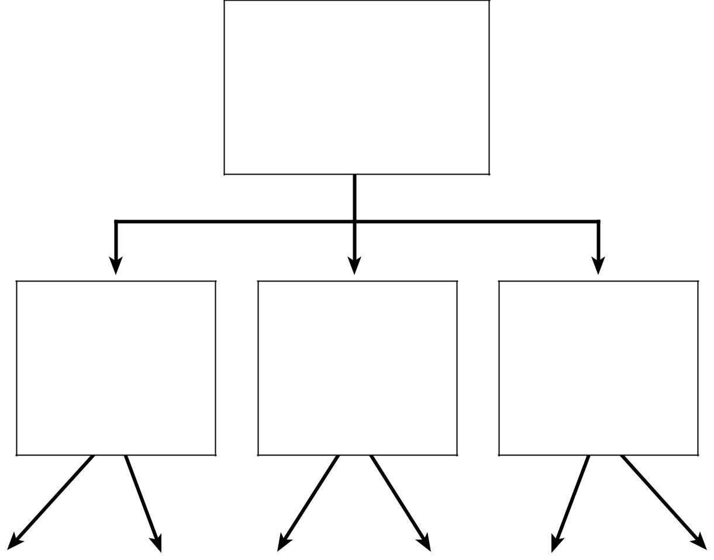

Main Topic

Sub-topic 1 Sub-topic 2 Sub-topic 3

The Use of Graphic Organizers to Enhance Thinking Skills in the Learning of Economics

48 • Graphic Organizers: Description, Procedures and Exemplars
Exemplar

Hierarchy Diagram

Topic

Types of firm

Concepts

- Firms can be divided generally into private and public enterprises.

- For the private enterprises, there are three different types of firm, namely sole proprietorship, partnership and limited company.

- Partnership can be further divided into general partnership and limited partnership.

- There are also two different types of limited company; they are private limited company and public limited company.

The Use of Graphic Organizers to Enhance Thinking Skills in the Learning of Economics

_{Exemplar} Chapter 7 • 49
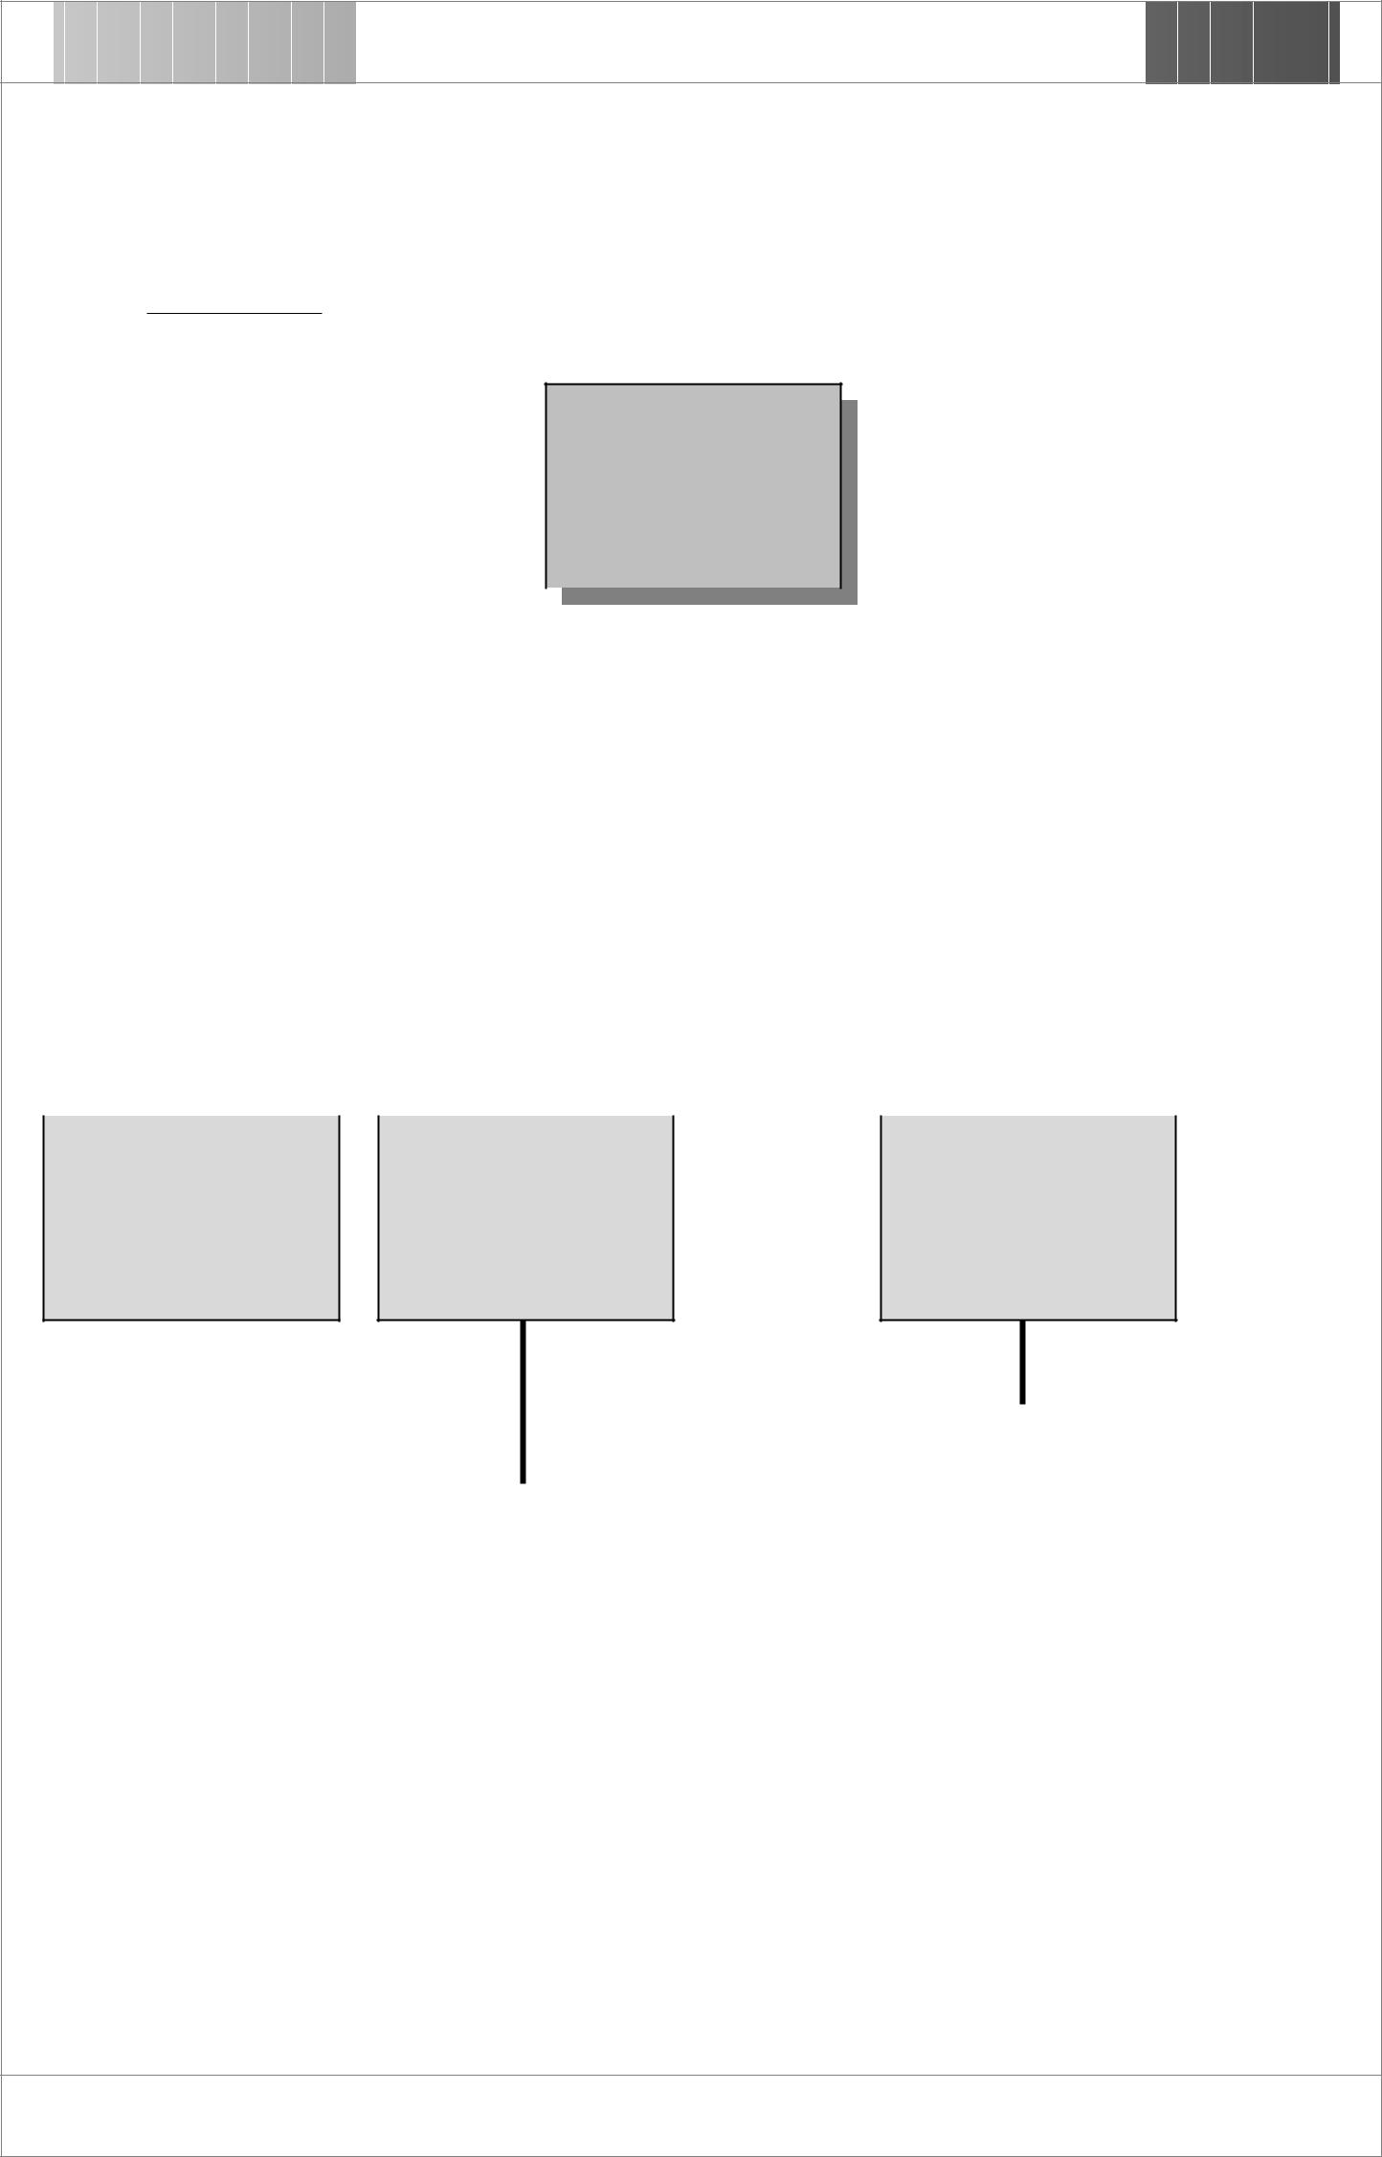

Topic : Types of firm

Firm

 |  |  |  | Private Enterprise |  |  |  |  |  | Public Enterprise

Sole Proprietorship |  | Partnership |  | Limited Company

 | General Partnership |  |  |  |  | Limited Partnership |  |  |  |  | Private Limited |  |  |  |  | Public Limited
 |  |  |  |  |  |  |  |  |  |  | Company |  |  |  |  | Company

The Use of Graphic Organizers to Enhance Thinking Skills in the Learning of Economics

50 • Graphic Organizers: Description, Procedures and Exemplars

K-W-H-L Chart

Description

This organizer can be used to help students understand the questions of what they know (K), what they want to know (W), how they will learn (H) and what they have learned (L) in relation to a specific topic. This is an effective tool to make students identify their prior knowledge and let them set their own targets and means of learning. Finally students are required to write down what they have learned to show the new knowledge they have obtained.

Procedures

- Choose a topic that students are interested in researching.

- Record the questions the students have about the topic in the ‘W’ column. This establishes a guide for researching.

- Ask students to share the prior experience on the topic and list them in the ‘K’ column.

- Help students identify possible ways to research the need information and record them in the ‘H’ column.

- List the new information and knowledge in the ‘L’ column.

- Discuss whether students’ prior knowledge listed in the ‘K’ column can be confirmed or denied.

The Use of Graphic Organizers to Enhance Thinking Skills in the Learning of Economics

Chapter 7 • 51

K-W-H-L Chart

Topic :

K | W | H | L
What do I | What do I | How I will | What I have
know? | want to know? | learn? | learned?

The Use of Graphic Organizers to Enhance Thinking Skills in the Learning of Economics

52 • Graphic Organizers: Description, Procedures and Exemplars
Exemplar

K-W-H-L Chart

Topic

The Stock Market

Concepts

- The stock market provides people with a way to invest in companies and corporations.

- People can gain or lose money in the stock market.

- People make money in the stock market by receiving dividends and/or selling the stock at a price higher than the purchase price.

- People lose money if they sell the stock at a price lower than the purchase price.

- The price of stock is affected by many factors.

The Use of Graphic Organizers to Enhance Thinking Skills in the Learning of Economics

_{Exemplar} Chapter 7 • 53

Topic : The Stock Market

 | K |  | W |  | H |  | L
 | What do I |  | What do I |  | How I will | What I have
 | know? | want to know? |  |  | learn? |  | learned?
1. | Stock market is | 1. | How is stock | 1. | Referring to | 1. | Stock is transacted
 | a mechanism for |  | transacted in stock |  | Economics |  | in the market
 | investing in |  | market? |  | textbooks and |  | though brokers.
 | companies. | 2. | Why are stock |  | journals. | 2. | The higher the
2. The price of a |  |  | prices in HK | 2. | Reading business |  | stock price in US
 | stock rises when |  | affected by the US |  | and financial news |  | market, the more
 | the demand for |  | stock market? |  | in newspapers. |  | favourable the
 | it increases, and | 3. | What are bull | 3. | Watching business |  | future world
 | vice versa. |  |  |  |  |  | economy we
 |  |  | market and bear |  | and financial
 |  |  |  |  |  |  | expect. So people
3. | Usually when |  | market? |  | report
 |  |  |  |  |  |  | are more willing to
 | the stock price | 4. | What are the |  | programmes.
 |  |  |  |  |  |  | pay higher price
 | in US market
 |  |  | factors affecting | 4. | Researching
 |  |  |  |  |  |  | for HK stocks.
 | increases, the
 |  |  | stock price? |  | related
 | stock price in |  |  |  |  | 3. | Major factors
 |  | 5. | Why are most |  | information in the
 | HK will increase |  |  |  |  |  | affecting stock
 |  |  |  |  | Internet.
 |  |  | people willing to
 | too. |  |  |  |  |  | prices are the
 |  |  | buy more of a | 5. | Interviewing
4. | People cannot |  |  |  |  |  | companies’
 |  |  | stock when its |  | people who are
 |  |  |  |  |  |  | earning power,
 | buy and sell
 |  |  | price increases, |  | experienced in
 |  |  |  |  |  |  | world events,
 | stocks directly,
 |  |  | and vice versa? |  | stock transaction.
 |  |  |  |  |  |  | investors’
 | but through the
 |  |  |  |  |  |  | expectation, and
 | brokers.
 |  |  |  |  |  |  | so on.
- Many people buy stocks of a company without knowing what the company is.

The Use of Graphic Organizers to Enhance Thinking Skills in the Learning of Economics

54 • Graphic Organizers: Description, Procedures and Exemplars

Main Concepts Map

Description

This organizer can be used to help students identify the main concepts of a topic. Students are encouraged to give a broad interpretation of the components of a topic and to support their ideas with specific information from relevant source.

Procedures

- Choose a topic to discuss.

- Identify main concepts that are important to the understanding of the topic.

- Research information that illustrates the interrelationship among the main concepts.

- Quote the source(s) of the information you get.

The Use of Graphic Organizers to Enhance Thinking Skills in the Learning of Economics

Chapter 7 • 55

Main Concepts Map
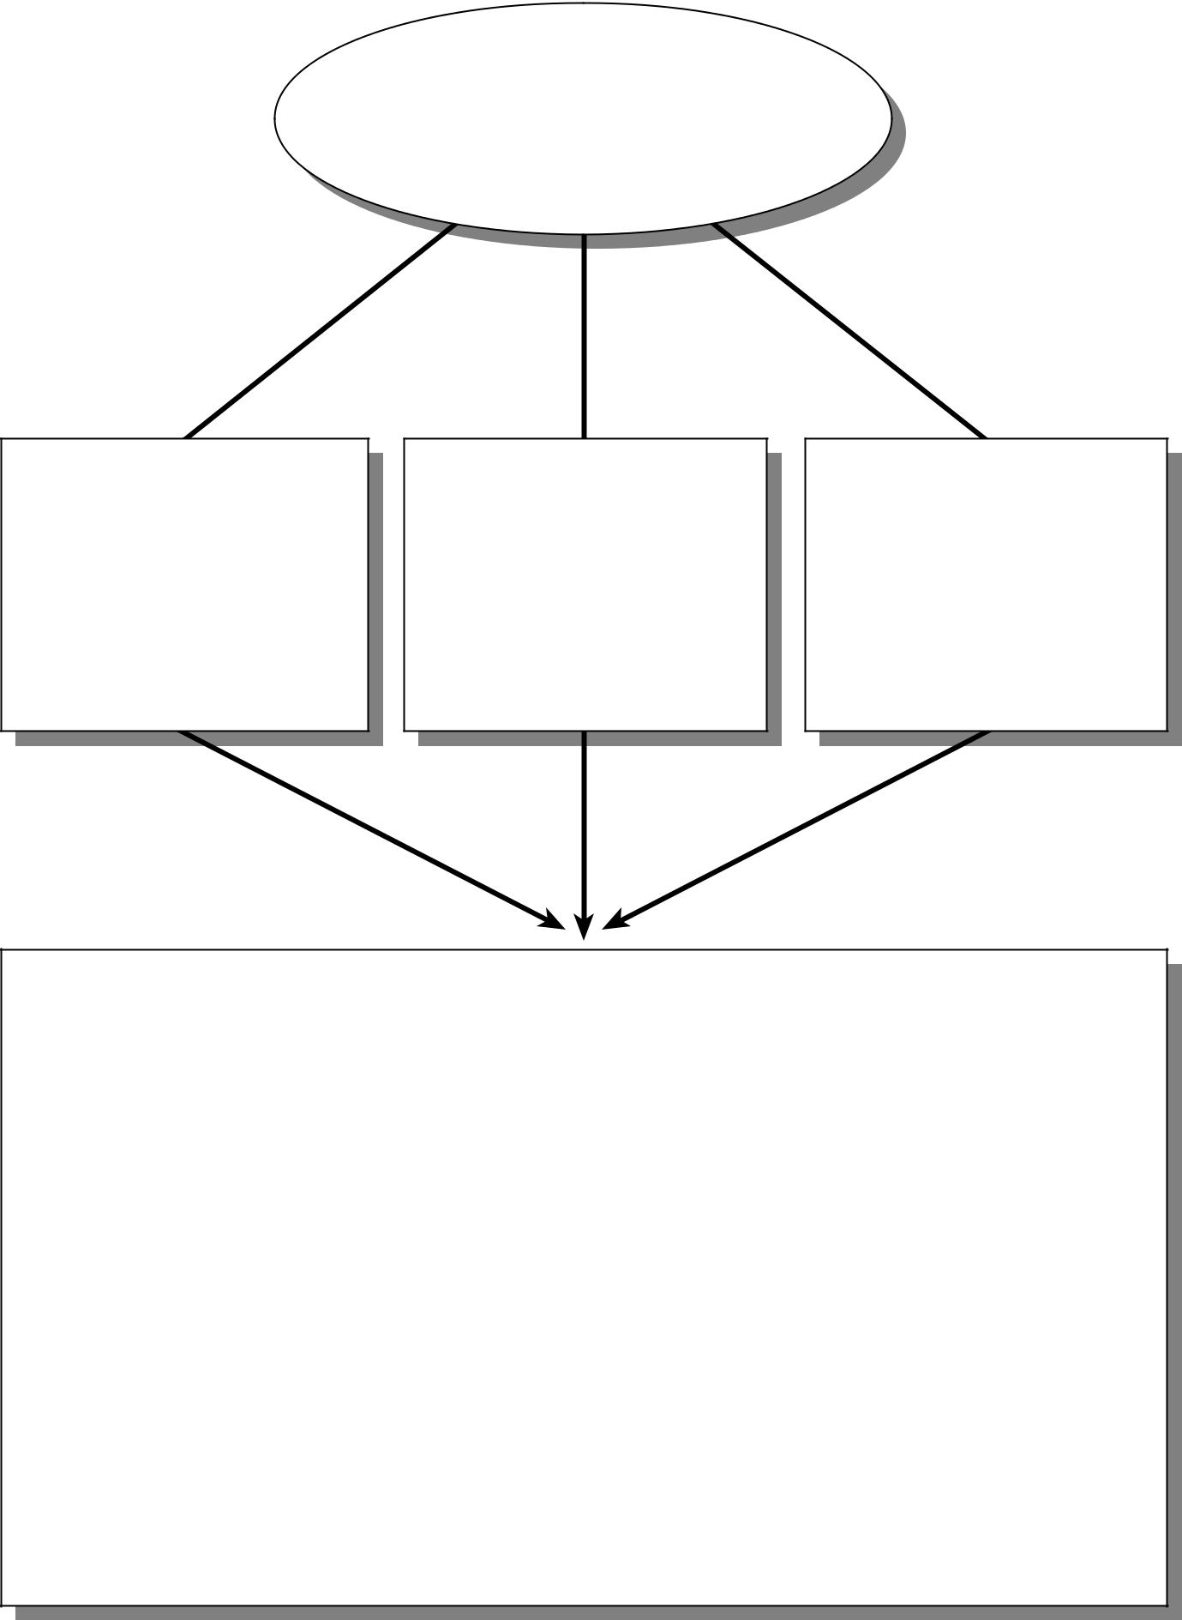

Topic

Main Concept Main Concept Main Concept

Illustration

Source(s) of Information

The Use of Graphic Organizers to Enhance Thinking Skills in the Learning of Economics

56 • Graphic Organizers: Description, Procedures and Exemplars
Exemplar

Main Concepts Map

Topic
Balance of Payments Account

Concepts

- A balance of payments account is an integrated statistical statement, for a particular time period, of an economy’s external transactions with the rest of the world. It contains a detailed current account, and an aggregated capital and financial account with net change in reserve assets.

- In a Balance of Payment Account, every external transaction is presented by two entries, a credit and a debit.

- In the current account, exports of goods and services, factor income inflows and current transfers from abroad are all credit entries whereas debit entries refer to imports of goods and services, factor income outflows and current transfers to abroad. A positive value for the balance figure in the current account represents a surplus whereas a negative value a deficit.

- In the capital and financial account, credit entries indicate increases in external liabilities and decreases in external assets whereas debit entries refer to decreases in external liabilities and increases in external assets. A positive value for the balance figure indicates a net capital and financial inflow and a negative value indicates a net outflow.
- A negative value for net change in reserve assets represents a net increase and a positive value a net decrease.

- The Hong Kong’s Balance of Payment Account for the first quarter of 2000 is as follow:

 | HK$ million
 | 2000
STANDARD COMPONENTS | 1st Qtr@
Current Account | 10,288
Goods | -19,344
Services | 23,754
Income | 9,226
Current transfers | -3,347
Capital and Financial Account | -3,863
Capital and financial non-reserve assets (net change) | -22,038
Capital transfers | -1,938
Financial non-reserve assets (net change) | -20,100
Direct investment | -1,440
Portfolio investment | 87,045
Financial derivatives | -41,504
Other investment | -64,201
Reserve assets (net change) | 18,175
Net errors and omissions | -6,426
Overall Balance of Payments | -18,175

(in deficit)

Source: Hong Kong Monthly Digest of Statistics December 2000

The Use of Graphic Organizers to Enhance Thinking Skills in the Learning of Economics

_{Exemplar} Chapter 7 • 57
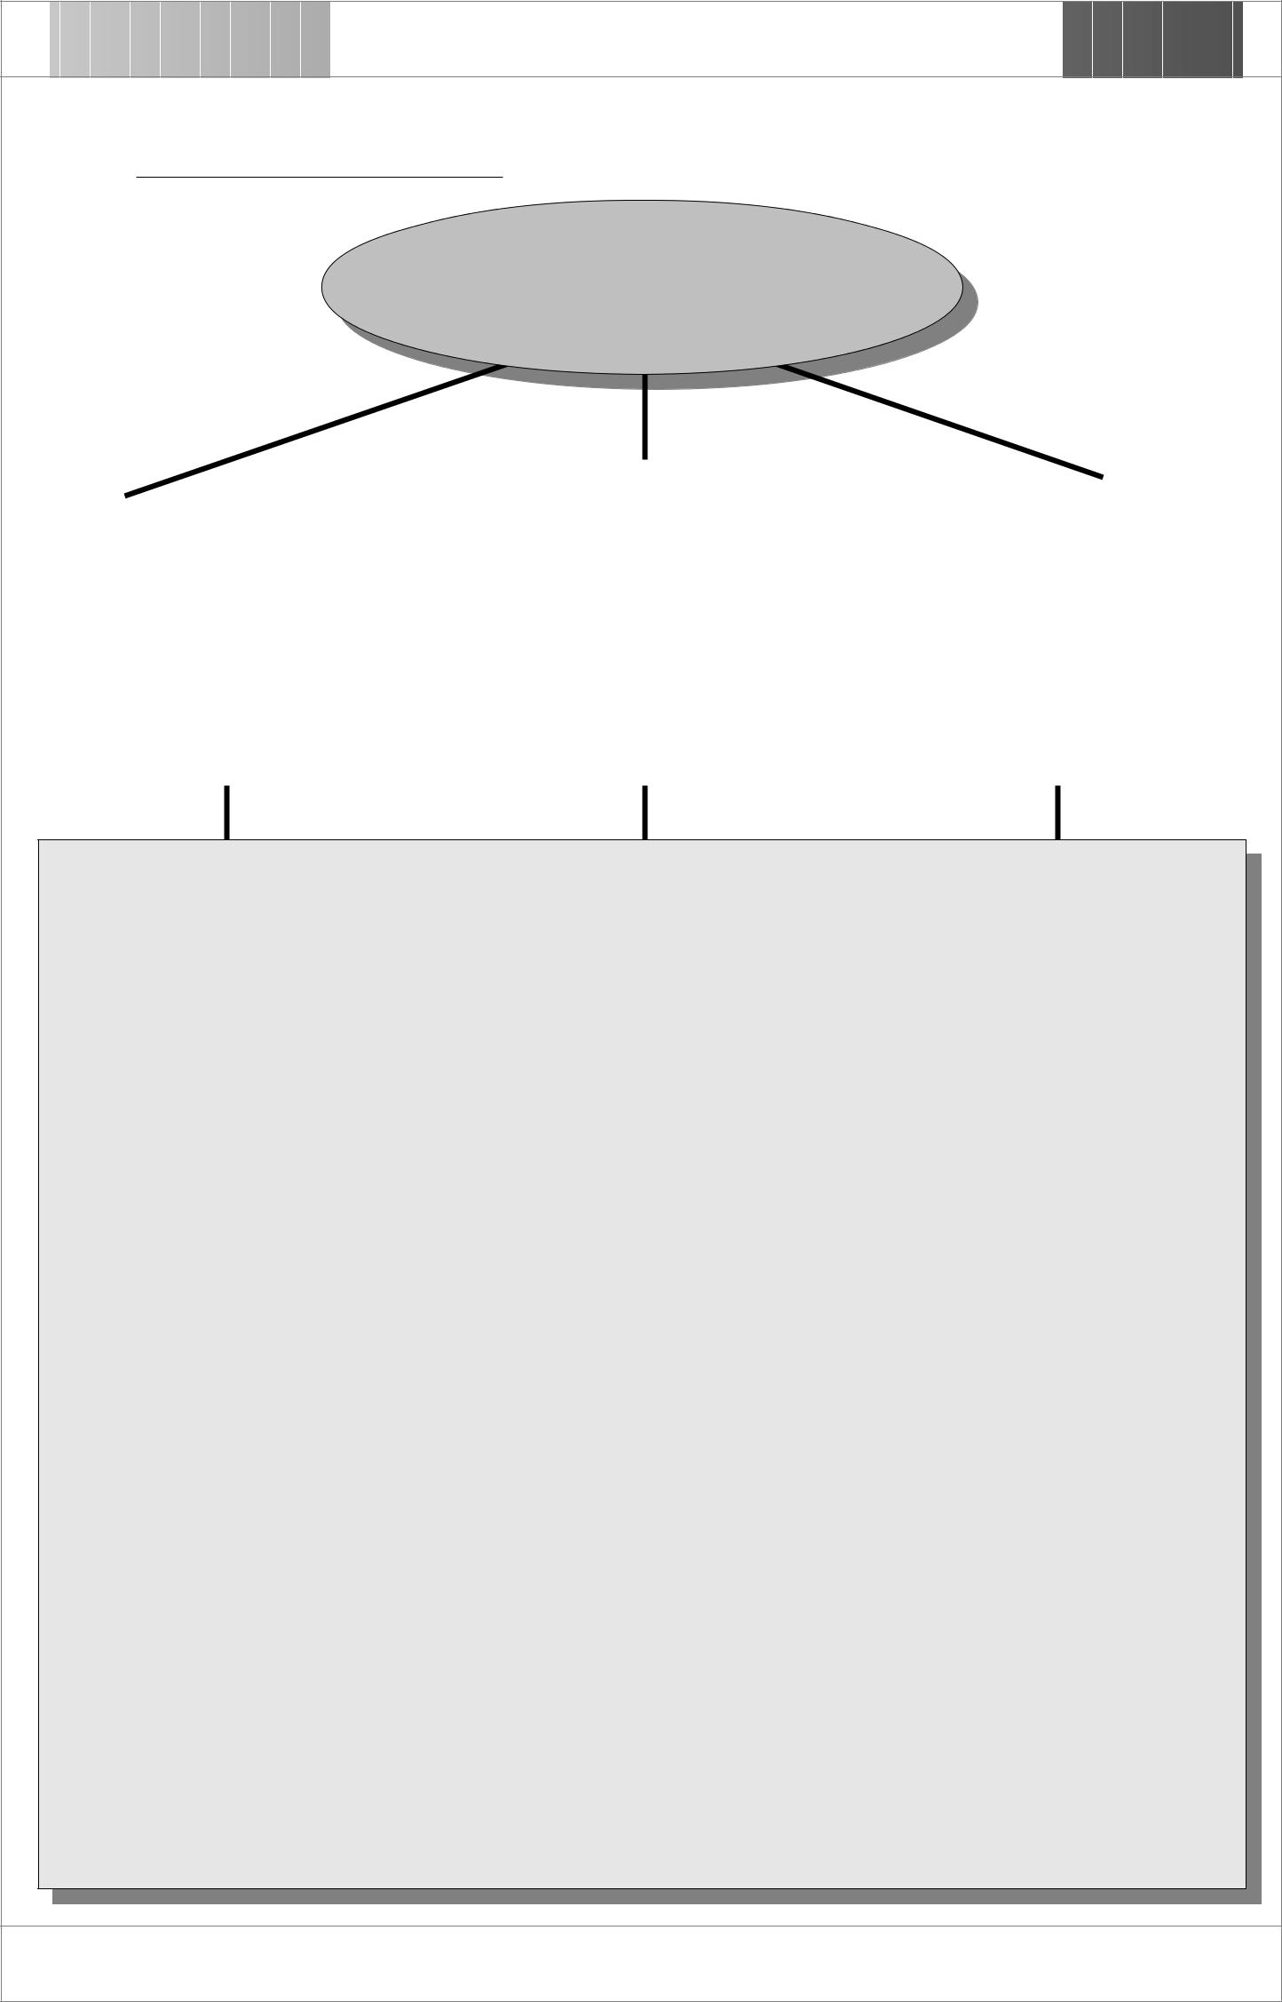

Topic : Balance of Payments Account

Balance of Payments
Accounts in Hong Kong

 | Main Concept |  |  |  | Main Concept |  |  |  | Main Concept
 | Balance of Payments |  |  |  | Current account consists of |  |  |  | Capital and financial
 | Account = Current Account |  |  |  | imports/exports of goods |  |  |  | account consists of changes
 | + Capital and Financial |  |  |  | and services, factor income |  |  |  | of external liabilities and
 | Account |  |  |  | inflows and outflows, and |  |  |  | assets
 |  |  |  |  | current transfers to/from
 |  |  |  |  | abroad.

Illustration

- Balance of Payments Account

This is an integrated statistical statement of an economy’s external transactions with the rest of the world. It contains the current account, the integrated capital and financial account a9with net change in reserve assets).

- Current Account

 | Credit entries | Debit entries
 | a. exports of goods and services | a. imports of goods and services
 | b. factor income inflows | b. factor income outflows
 | c. current transfers from abroad | c. current transfers to abroad
 | • A ‘+’ value for the balance figure represents a surplus whereas a ‘-‘ value a deficit.
3. Capital and Financial Account
 | A. Capital and financial non-reserve assets
 | Credit entries | Debit entries
 | a. increases in external liabilities | a. decreases in external liabilities
 | b. decreases in external assets | b. increases in external assets

• A ‘+’ value for the balance figure indicates a net inflow whereas a ‘-‘ value a net outflow.

B. Net change in reserve assets

A ‘-‘ value represents a net increase whereas a ‘+’ value a net decrease.

Source of Information

Census and Statistics Department http://www.info.gov.hk/censtatd/eng/press/bal_payment/bop_0699.htm (as at 29 May 2000)

The Use of Graphic Organizers to Enhance Thinking Skills in the Learning of Economics

58 • Graphic Organizers: Description, Procedures and Exemplars

Math Factors Organizer

Description

This organizer can be used to help students understand possible factors that make up a concept. In other words, students are expected to brainstorm all associative properties of the concept.

Procedures

- Choose and write the concept in the centred box of the organizer.

- Discuss possible factors contributing to the concept.

- Brainstorm possible associative property of numbers that make up the same result as stated in the concept.

The Use of Graphic Organizers to Enhance Thinking Skills in the Learning of Economics

Chapter 7 • 59

Math Factors Organizer
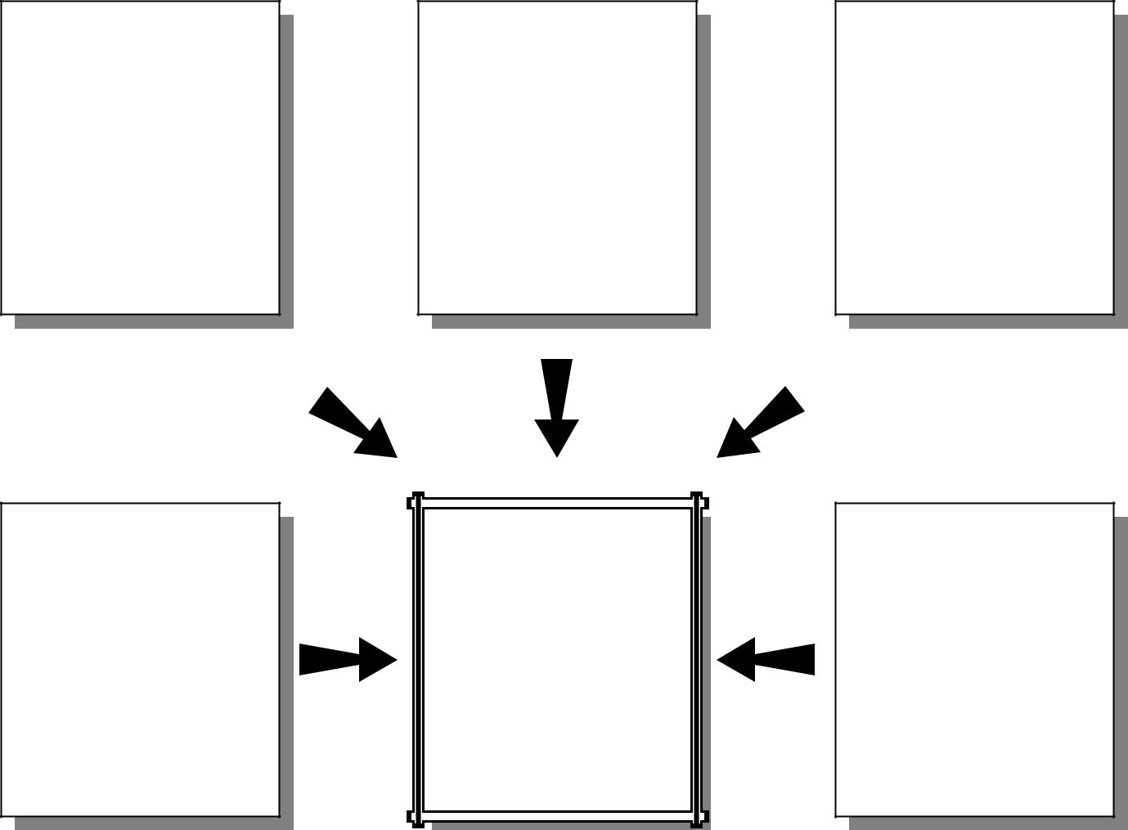

Concept
and Idea
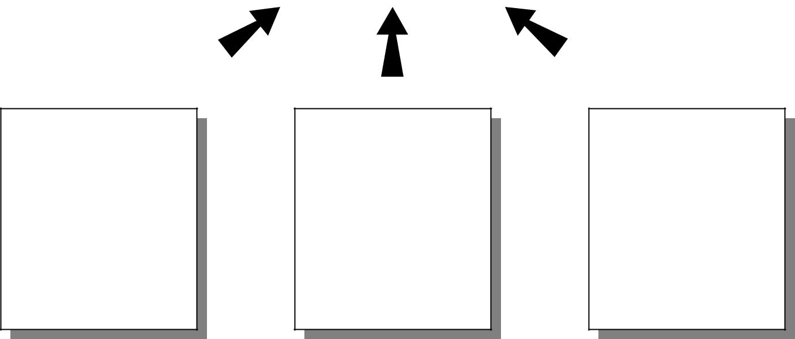

The Use of Graphic Organizers to Enhance Thinking Skills in the Learning of Economics

60 • Graphic Organizers: Description, Procedures and Exemplars
Exemplar

Math Factors Organizer

Topic

Total Revenue and Price Elasticity of Demand

Concepts

- Total Revenue(TR) = Price per unit(P) x Quantity sold(Q)

- If the price elasticity of demand (Ed) is equal to one, any change in price will result in a same proportional change in its quantity sold. Therefore, the total revenue of the product sold will remain constant.

The Use of Graphic Organizers to Enhance Thinking Skills in the Learning of Economics

Exemplar |  | Chapter 7 • 61
Topic : Total Revenue and Price Elasticity of Demand
P = $100 | P = $80 | P = $60
Q = 60 | Q = 75 | Q = 100
P = $15 | TR = $6,000 | P = $50
Q = 400 | (Assume Ed = 1) | Q = 120
P = $20 | P = $30 | P = $40
Q = 300 | Q = 200 | Q = 150
 | The Use of Graphic Organizers to Enhance Thinking Skills in the Learning of Economics
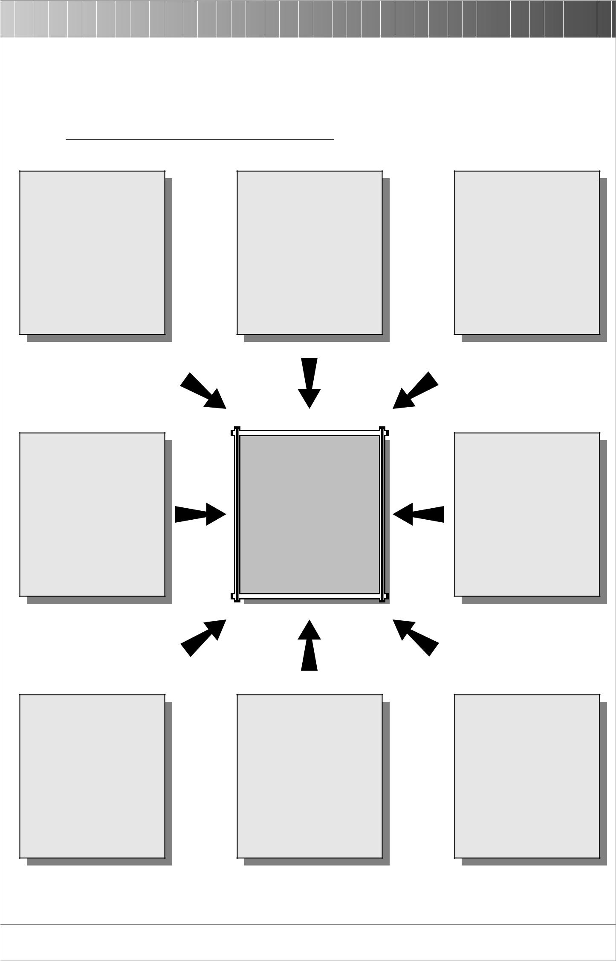

62 • Graphic Organizers: Description, Procedures and Exemplars

Multiple Meaning Map

Description

This organizer can be used to help students explore concepts with more than one meaning, definitions, examples and categories. It is an excellent tool to develop students’ skill in creating associations and conceptual links.

Procedures

- Choose a concept/word with multiple meanings, definitions, examples...etc. and put it in the centre of the organizer.

- Identify the various meanings (or other categories) of the concept/word and help students make connections. Put these categories in the boxes of the outer level. Adding or deleting the number of boxes as needed.
- Brainstorm associations to each of the categories.

The Use of Graphic Organizers to Enhance Thinking Skills in the Learning of Economics

 | Chapter 7 • 63
Multiple Meaning Map
Description | Description
Category | Category
 | Concept
Category | Category
Description | Description
 | The Use of Graphic Organizers to Enhance Thinking Skills in the Learning of Economics
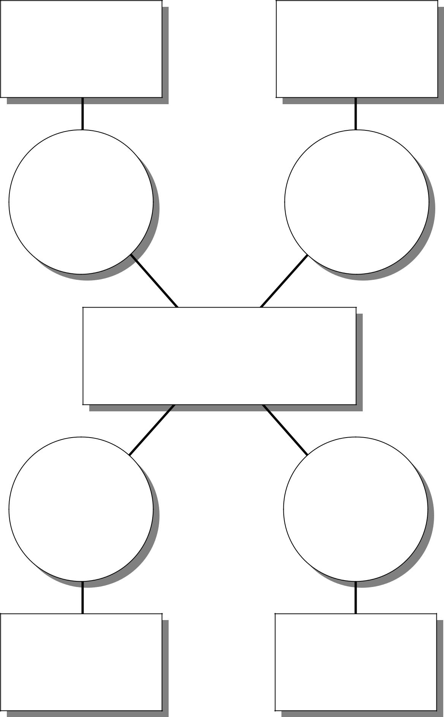

64 • Graphic Organizers: Description, Procedures and Exemplars
Exemplar

Multiple Meaning Map

Topic

Unemployment

Concepts

- Fictional unemployment is unemployment that arises because of the time required to match job seekers with job openings.

- Structural unemployment is unemployment that arises because those who are unemployed do not possess the skills demanded by employers or do not live in regions where the jobs are.

- Seasonal unemployment is unemployment caused by seasonal shifts in labour supply and demand.

- Cyclical unemployment is unemployment caused by the decline in the economy’ aggregate production during recessions.

The Use of Graphic Organizers to Enhance Thinking Skills in the Learning of Economics

_{Exemplar} Chapter 7 • 65
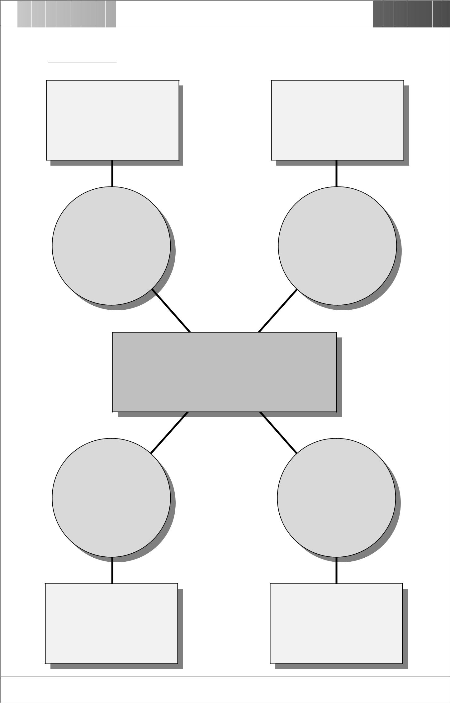

Topic : Unemployment

This arises because those who are unemployed do not possess the skills demanded by employers or do not live in regions where the jobs are.

This arises because of the time required to match job seekers with job openings.

Structural | Fictional
Unemployment | Unemployment

Unemployment

Cyclical
Unemployment

This arises because of the decline in the economy’s aggregate production during recessions.

Seasonal

Unemployment

This arises because of seasonal shifts in labour supply and demand.

The Use of Graphic Organizers to Enhance Thinking Skills in the Learning of Economics

66 • Graphic Organizers: Description, Procedures and Exemplars

Multiple Timeline

Description

This organizer can be used to help students acquire the skill to look at various aspects of a time period and see the influences they have on one another. For instance, students may trace the relationship between rates of unemployment and inflation in a specific period of time.

Procedures

- Choose a topic of the multiple timeline and put it at the top of the organizer.

- Enter the beginning and ending points of time of study in the appropriate blanks.

- Decide upon what subtopics or aspects to be compared on the left-hand side of the organizer.

- Research and collect information (data and/or events) that fit the subtopics or aspects, and enter them in the appropriate boxes.

- Give a brief conclusion of the relationship between/among the subtopics or events at the end of the organizer.

The Use of Graphic Organizers to Enhance Thinking Skills in the Learning of Economics

Chapter 7 • 67

Multiple Timeline

Topic :

Dates
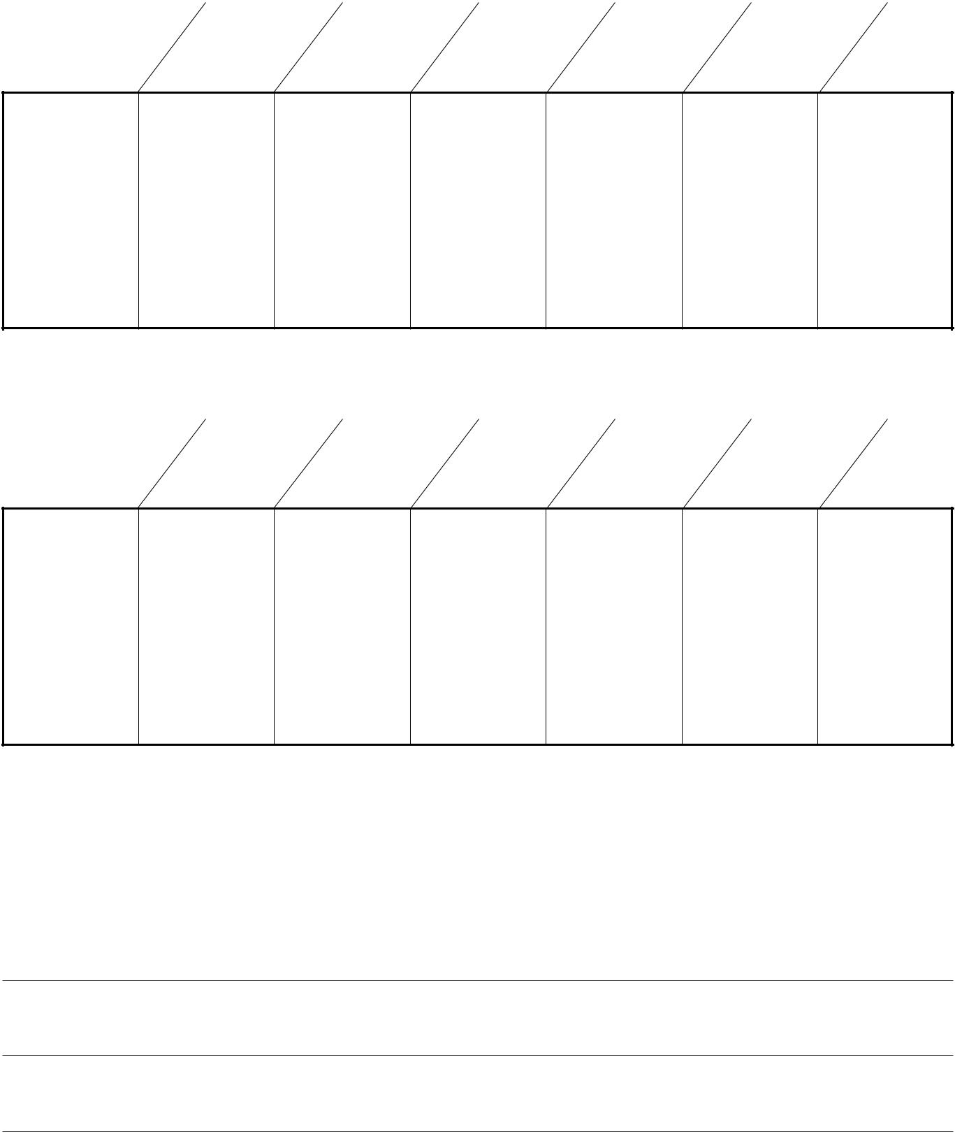

Subtopic/ Events/

Aspect Data

Dates

Subtopic/ Events/

Aspect Data

Conclusion:

The Use of Graphic Organizers to Enhance Thinking Skills in the Learning of Economics

68 • Graphic Organizers: Description, Procedures and Exemplars
Exemplar

Multiple Timeline

Topic

Unemployment and Inflation

Concepts

- Inflation refers to the sustained increase in the general level of prices of goods and services.

- Unemployment occurs whenever the aggregate demand for goods is less than the aggregate supply of goods in an economy.

- The higher the level of unemployment rate, the less money spent in consuming goods and services. The decrease in aggregate demand would make the general price levels rise in a slower rate or even drops, so that there will be a decrease in inflation rate.

The Use of Graphic Organizers to Enhance Thinking Skills in the Learning of Economics

Exemplar | Chapter 7 • 69

Topic : Unemployment and Inflation
 |  | 9/97 |  | 11/97 |  |  | 1/98 |  | 3/98 |  | 5/98 |  | 7/98 |  | 9/98
Unemploy- |  | 2.4% |  | 2.5% |  |  | 3.5% |  | 4.1% |  | 4.8% |  | 5.0% |  | 5.5%
ment Rate
 |  | 9/97 | 10/97 | 11/97 | 12/97 | 1/98 |  | 2/98 | 3/98 | 4/98 | 5/98 | 6/98 | 7/98 | 8/98 | 9/98 | 10/98
Inflation |  | 5.6% | 5.7% | 5.4% | 5.2% |  | 5.4% | 4.7% | 4.8% | 4.7% | 4.5% | 4.0% | 3.2% | 2.7% | 2.5% | 0.1%
rate
 |  | 11/98 |  | 1/99 |  |  | 3/99 |  | 5/99 |  | 7/99 |  | 9/99 |  | 11/99
Unemploy- |  | 5.8% |  | 6.2% |  |  | 6.3% |  | 6.0% |  | 6.1% |  | 6.1% |  | 5.7%
ment Rate
 |  | 11/98 | 12/98 | 1/99 | 2/99 |  | 3/99 | 4/99 | 5/99 | 6/99 | 7/99 | 8/99 | 9/99 | 10/99 | 11/99 | 12/99
Inflation |  | -0.7% | -1.6% | -1.1% | -1.7% | -2.6% |  | -3.8% | -4.0% | -4.1% | -5.5% | -6.1% | -6.0% | -4.2% | -4.2% | -4.0%
rate
Source: Census and Statistics Department
 | http://www.info.gov.hk/censtatd

Conclusion:

In general, there is an inverse relationship between unemployment rate and inflation rate. The

higher the unemployment rate, the less demand for goods and services. The lower aggregate

demand would then lead to a fall in general price level, so that the inflation rate decreases.

The Use of Graphic Organizers to Enhance Thinking Skills in the Learning of Economics

70 • Graphic Organizers: Description, Procedures and Exemplars

One and All Organizer

Description

This organizer can be used to help students uncover similarities and differences among several items. It is designed to facilitate the development of students’ comparing and contrasting skills.

Procedures

- Choose a topic to be discussed.

- Divide the class into several groups and assign each group a subtopic.

- Have students name a characteristic of their subtopic. Decide whether the characteristic is unique, or if it is shared.

- Record the shared characteristics in the centered circle, and the unique characteristics in respective subtopic boxes.

- Ask students to give examples as well as the rationale for their decisions.

The Use of Graphic Organizers to Enhance Thinking Skills in the Learning of Economics

Chapter 7 • 71

One and All Organizer

Subtopic

Subtopic Subtopic

Topic

Subtopic

The Use of Graphic Organizers to Enhance Thinking Skills in the Learning of Economics

72 • Graphic Organizers: Description, Procedures and Exemplars
Exemplar

One and All Organizer

Topic

Types of Production

Concepts

- Production is the process by which resources are transformed to satisfy human wants.

- Primary production refers to activities that directly utilize natural resources in the process of production. Fishing and mining are typical examples.

- Secondary production refers to production activities that turn raw materials into goods for future production or final consumption. Manufacturing and construction industries are typical examples.

- Tertiary production refers to the provision of services. Financial services and social services are typical examples.

The Use of Graphic Organizers to Enhance Thinking Skills in the Learning of Economics

_{Exemplar} Chapter 7 • 73
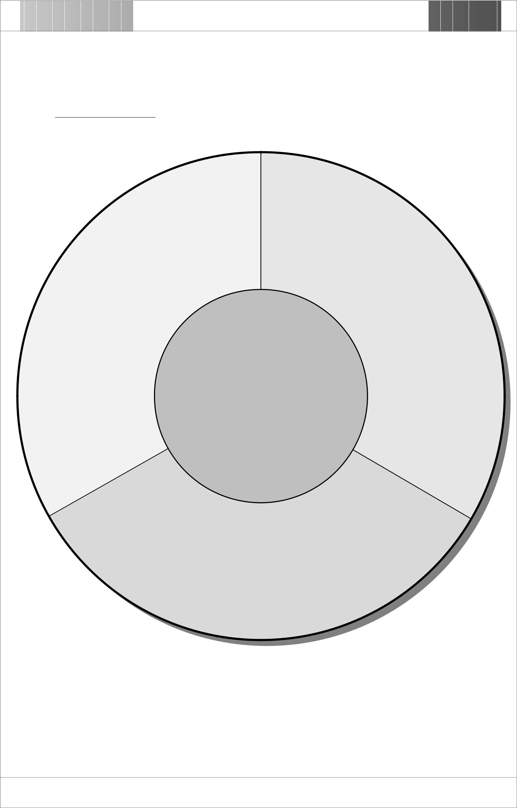

Topic : Types of Production

 | Secondary | Primary
Production |  | Production
These are production |  | These are production
activities that turn raw |  | activities that directly
materials into goods |  | utilize natural
for future |  |  | resources.
production or final | Production is |  | Typical examples
consumption.
 | the process by which |  | are mining and
Typical examples |  |  | fishing.
 | resources are
are manufacturing
 | transformed to satisfy
and construction
industries. | human wants

Tertiary Production

These are production activities that provide services to consumers.

Typical examples are financial and social services

The Use of Graphic Organizers to Enhance Thinking Skills in the Learning of Economics

74 • Graphic Organizers: Description, Procedures and Exemplars

Overlapping Circles Map

Description

This organizer can be used to help students develop skill in comparing and contrasting similarities and/or differences. This is specially designed to show the relationship of two concepts of which one is the subset of the other. This organizer may consist of two or more circles.

Procedures

- Identify and label above each circle the concepts to be compared and contrasted.

- Discuss and record their similarities and differences.

- Put the shared characteristics in the appropriate overlapping sectors.

- Record the unique characteristics of each concept in its own sector.

The Use of Graphic Organizers to Enhance Thinking Skills in the Learning of Economics

Chapter 7 • 75

Overlapping Circles Map

Characteristics

Characteristics

Characteristics

Concept 1

Concept 2

Concept 3

The Use of Graphic Organizers to Enhance Thinking Skills in the Learning of Economics

76 • Graphic Organizers: Description, Procedures and Exemplars
Exemplar

Overlapping Circles Map

Topic

Money Supply

Concepts

- Money supply is the total stock of money available in the economy

- Hong Kong has three measures of money supply

- Money supply definition 1 (M1)

This is the sum of legal tender notes and coins held by the public plus customers’ demand deposits placed with banks.
- Money supply definition 2 (M2)

This is the sum of M1 plus customers’ savings and time deposits with banks, as well as the negotiable certificates of deposit (NCDs) issued by banks held outside the banking sector.

- Money supply definition 3 (M3)

This is the sum of M2 plus customers’ deposits with restricted licence banks and deposit-taking companies, as well as negotiable certificates of deposit (NCDs) issued by these institutions held outside the banking sector.

The Use of Graphic Organizers to Enhance Thinking Skills in the Learning of Economics

_{Exemplar} Chapter 7 • 77

Topic : Money Supply

➣ deposits with restricted

licence banks and

deposits-taking

companies

➣ negotiable certificates of

deposit issued by the

above two institutions
held outside the

➣ savings and time deposits with banks

➣ negotiable certificates of deposit issued by banks held outside the banking sector

➣ legal tender notes and coins held by the public

➣ demand deposits placed with banks

banking sector
M1

M2

M3

The Use of Graphic Organizers to Enhance Thinking Skills in the Learning of Economics

78 • Graphic Organizers: Description, Procedures and Exemplars

Persuasion Map

Description

This organizer can be used to help students get familiar with the process of persuasive writing. Students are required not only to identify evidence in support of their argument, but also to acknowledge opposing opinions.

Procedures

- Choose an issue of interest.

- Discuss the ideas and facts to support both sides of the controversial issue.

- List all facts and ideas on the blackboard.

- Students choose a position on one side or the other.

- According to their own understanding and choice, write several reasons to support their position in the ‘supporting evidence’ boxes. Opposing evidences should also be identified and written in the ‘opposing evidence’ box.

- Help students reconsider their position if needed and write it in the ‘conclusion’ boxes.

The Use of Graphic Organizers to Enhance Thinking Skills in the Learning of Economics

Chapter 7 • 79

Persuasion Map
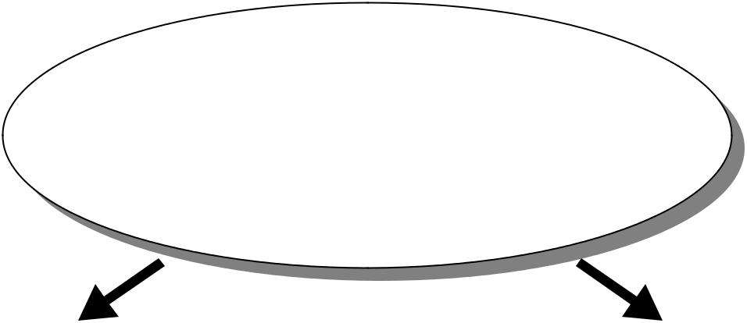

Position

 | Supporting Evidence 1 |  |  |  | Opposing Evidence 1

 | Supporting Evidence 2 |  |  |  | Opposing Evidence 2

 | Supporting Evidence 3 |  |  |  | Opposing Evidence 3
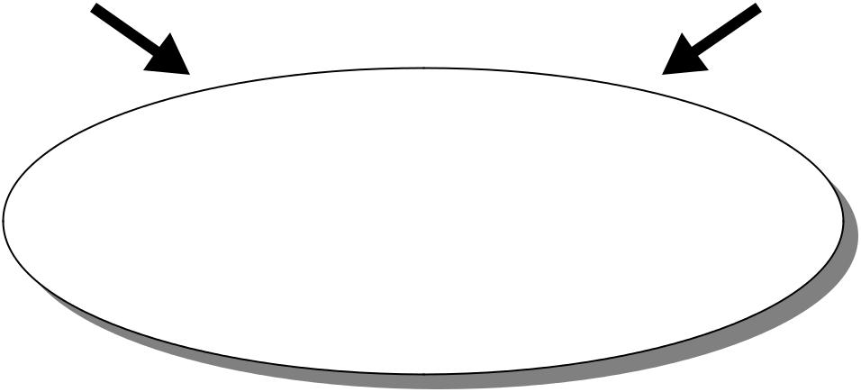

Conclusion

The Use of Graphic Organizers to Enhance Thinking Skills in the Learning of Economics

80 • Graphic Organizers: Description, Procedures and Exemplars
Exemplar

Persuasion Map

Topic

Ordinary Shares and Debentures

Concepts

- Both ordinary shares and debentures are ways that a company obtains capital from the public.

- Ordinary shareholders have voting right in shareholders’ meeting.

- Ordinary shareholders may receive a high rate of dividend if the profit of the company is high, but low or even no dividend if the profit is low.

- Ordinary shareholders can only receive their dividends after preference shareholders are fully paid. Furthermore, if the company closes down, ordinary shareholders would be the last to get back their money. To conclude, the risk to buy ordinary shares is quite high.

- Debenture holders are creditors, but not shareholders of a company, so they have no voting right over company matters.

- Debenture holders received a fixed rate of return no matter the company makes a profit or not.

- If the company closes down, debenture holders would be the first to get back their investment.

The Use of Graphic Organizers to Enhance Thinking Skills in the Learning of Economics

_{Exemplar} Chapter 7 • 81
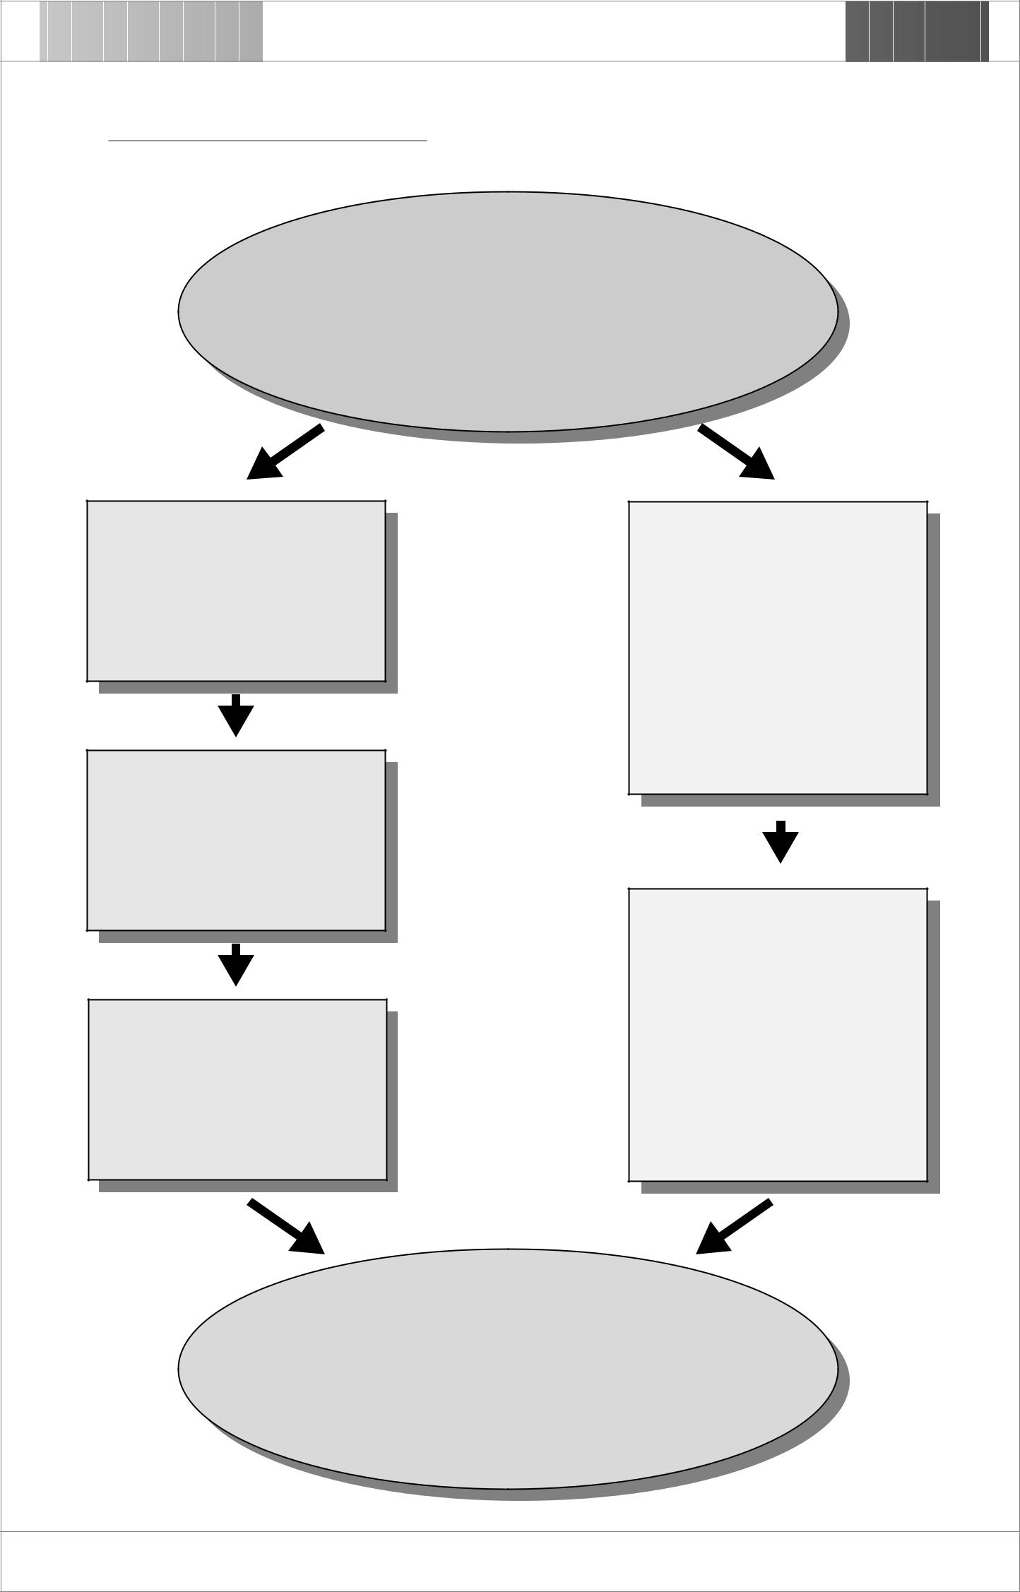

Topic : Ordinary Shares and Debentures

Position

If I have money, I would prefer buying debentures to ordinary shares of a company as my investment

Supporting Evidence 1

I am 45 years old now, I would not take any risk in losing all my money.

Supporting Evidence 2

There is a fixed rate of return no matter the firm earns profit or not.

Supporting Evidence 3

If the company closes down, I would be the first to get back my money.

Opposing Evidence 1

The return rate is fixed even

the company earns a lot of

profit.

Opposing Evidence 2

I have no voting right over

company matters.

Conclusion

Having considered all the pros and cons, I would still

prefer buying debentures to ordinary shares as I am

not willing to take too much risk in my investment.

The Use of Graphic Organizers to Enhance Thinking Skills in the Learning of Economics

82 • Graphic Organizers: Description, Procedures and Exemplars

Pie Chart

Description

This organizer can be used to help students explore the relationship between the parts and the whole. The pie represents a whole entity or unit, and the individual “slices” represent segments, or fractions, of the whole. This organizer is often used to visualize budget allocations and demographic information.

Procedures

- Identify a topic to research.

- Research and calculate the percentage of the parts to the whole.

- Draw segments to represent the relative weight of different parts.

- Encourage students to discuss and evaluate whether they would make any comment on the relative importance of the parts.

The Use of Graphic Organizers to Enhance Thinking Skills in the Learning of Economics

Chapter 7 • 83

Pie Chart

Category 6 Category 1

Category 2

Category 5

Category 3

Category 4

The Use of Graphic Organizers to Enhance Thinking Skills in the Learning of Economics

84 • Graphic Organizers: Description, Procedures and Exemplars
Exemplar

Pie Chart

Topic

Labour Force

Concepts

- The labour force refers to the land-based non-institutional population aged 15 and above who satisfy the criteria for inclusion in the employed population or the unemployed population.

- The labour force by age group in 1999 (Oct. – Dec.) is:

 | 1999 (Oct. – Dec.)
Age Group | Number(in 1,000) |  | %
Under 25 | 444 |  | 12.6
25-44 | 2,129 |  | 60.3
45-64 | 914 |  | 25.9
65 and over | 43 |  | 1.2
Total | 3,530 |  | 100.0

Source: Census and Statistics Department

http://www.info.gov.hk/censtatd/eng/hkstat/hkinf/labour/labor2.htm

The Use of Graphic Organizers to Enhance Thinking Skills in the Learning of Economics

_{Exemplar} Chapter 7 • 85
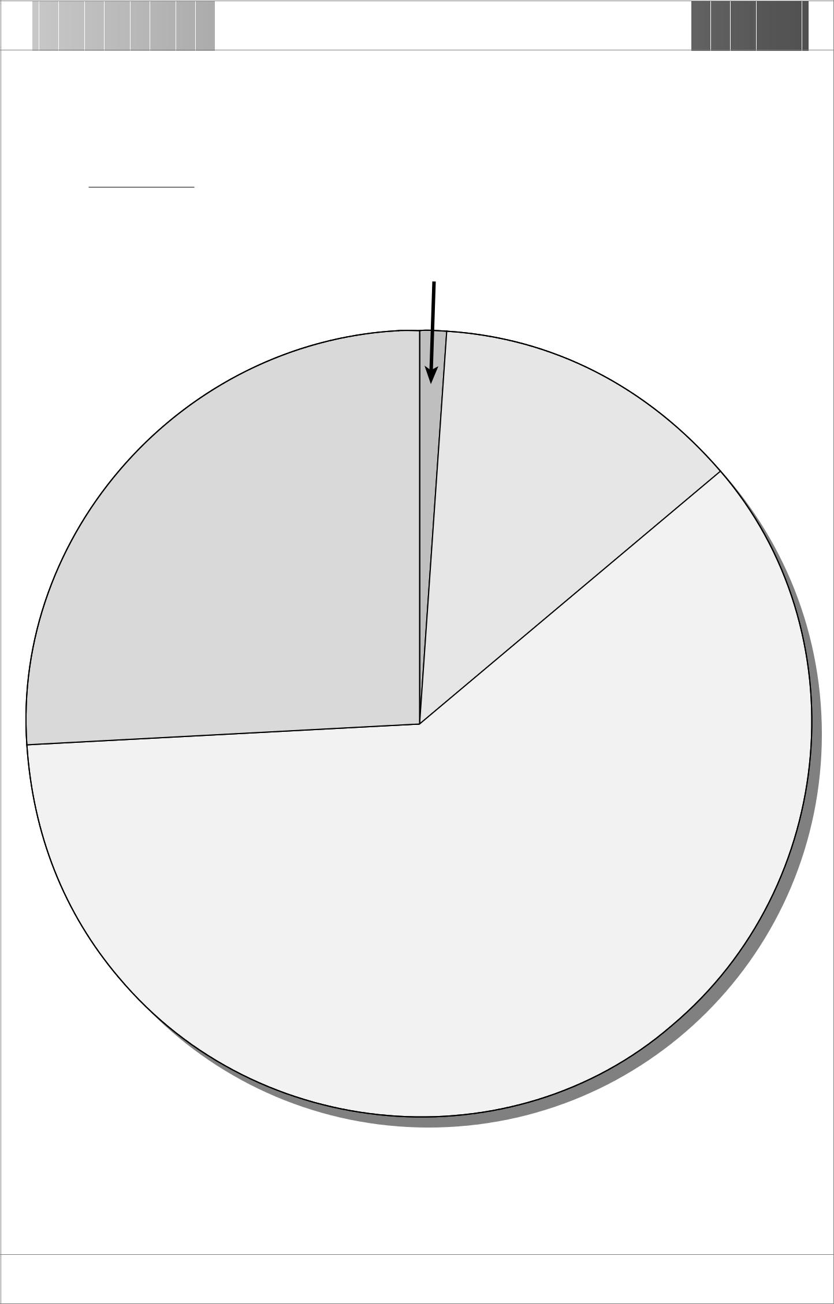

Topic : Labour Force

1.2%
(65 and over)

12.6% (Under 25)

25.9%
(45 – 64)

60.3%
(25 – 44)

The labour force by age group in 1999 (October – December)

The Use of Graphic Organizers to Enhance Thinking Skills in the Learning of Economics

86 • Graphic Organizers: Description, Procedures and Exemplars

Problem-Solving Organizer

Description

This organizer can be used to help students develop the problem-solving skills that they need throughout their lives. With this organizer students are trained to pose and evaluate possible solutions to problems

Procedures

- Students identify a problem and write in the ‘problem’ box.

- Ask students to think about what specially makes this a problem.

- Let students list all possible solutions, and the pros and cons of each of them, in the appropriate box and choose the one they think is the best.

- Ask students to consider all possible consequences of the selected solution.

- Students then write a persuasive paragraph arguing that how the selected one could be modified to make it the best solution.

The Use of Graphic Organizers to Enhance Thinking Skills in the Learning of Economics

Chapter 7 • 87

Problem-Solving Organizer
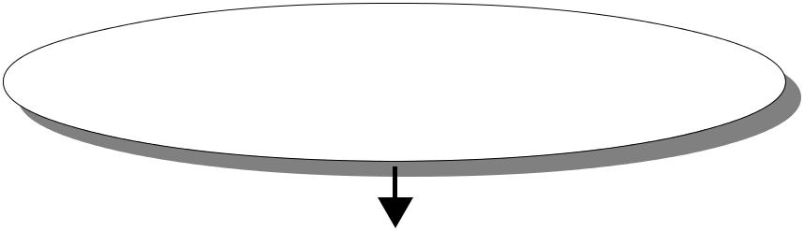
The Problem

Why is this a Problem?

Possible Solutions

 | Solution 1 |  | Solution 2 |  | Solution 3
 | Pros and Cons |  | Pros and Cons |  | Pros and Cons
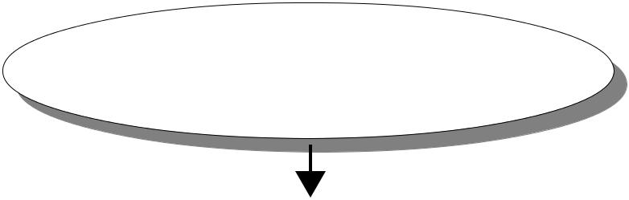

Solution Considered

Possible Consequences of the Selected Solution

Recommended Solution (with Modification)

The Use of Graphic Organizers to Enhance Thinking Skills in the Learning of Economics

88 • Graphic Organizers: Description, Procedures and Exemplars
Exemplar

Problem-Solving Organizer

Topic

Unemployment

Concepts

- The unemployed population comprises all unemployed persons. For a person aged 15 or over to be classified as unemployed, that person should:

  - not have had a job and should not have performed any work for pay or profit during the 7 days before enumeration; and

  - have been available for work during the 7 days before enumeration; and

  - have sought work during the 30 days before enumeration.

- Statistics on unemployment

Period | Unemployment | Period | Unemployment | Period | Unemployment
 | Rate |  | Rate |  | Rate
9/97-11/97 | 2.4% | 7/98-9/98 | 5.0% | 5/99-7/99 | 6.0%
11/97-1/98 | 2.5% | 9/98-11/98 | 5.5% | 7/99-9/99 | 6.1%
1/98-3/98 | 3.5% | 11/98-1/99 | 5.8% | 9/99-11/99 | 6.1%
3/98-5/98 | 4.1% | 1/99-3/99 | 6.2% | 11/99-1/00 | 5.7%
5/98-7/98 | 4.8% | 3/99-5/99 | 6.3% | 1/00-3/00 | 5.5%

Source: Census and Statistics Department

http://www.info.gov.hk/censtatd/eng/hkstst/fas/labour/labour.htm

- The costs of unemployment are:

  - People who are unemployed lose his/her money income, thus leading to a lower standard of living;

  - People who are still employed may have to pay higher taxes so that sufficient funding could be provided as unemployment subsidy; and

  - Waste of productive resources resulting in underproduction.

- Possible ways to solve the problem of unemployment:

  - Fiscal policy:

    - Increase government expenditures to increase the aggregate demand for goods and services in the society. This could be resulted in an increase demand for labour.

    - Decrease taxes to lower the prices of goods and services, or to give people a higher level of disposable income. This will lead to a higher demand for goods and services and finally a higher demand for labour.

  - Monetary policy

Increase money supply by lowering the bank interest rate or reserve ratio. This will lead to an increase in money supply in the market and an increase in demand for goods and services. Producers therefore employ more labours.

The Use of Graphic Organizers to Enhance Thinking Skills in the Learning of Economics

_{Exemplar} Chapter 7 • 89
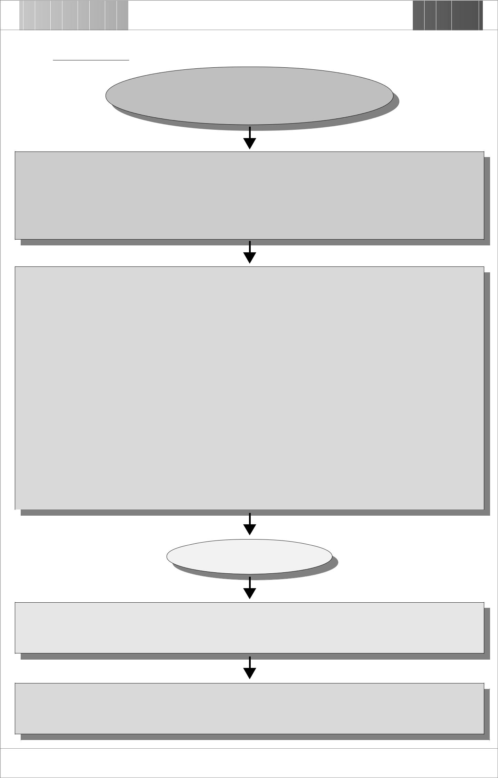

Topic : Unemployment

The Problem

The unemployment rate in HK rises to a record average of 5.5%.

Why is this a Problem?
➣ More and more people lose their income and suffer from lower living standard.

➣ Government may raise tax to provide sufficient unemployment benefit to the unemployed. ➣ Valuable human resources are left idle and wasted.

Possible Solutions

 | Solution 1 |  | Solution 2 |  | Solution 3
 | Increase government |  | Decrease taxes |  | Increase money supply
 | expenditures |  | Pros |  | Pros
 | Pros |  | Low administrative cost |  | No adverse effect on
 | Effect on aggregate |  | in conducting this |  | government budget.
 | demand is immediate |  | expansionary policy. |  | Cons
 | and certain. |  | Cons |  | Adverse effect on
 | Cons |  | People may not spend |  | balance of payments as
 | Increase expenditure |  | the extra income on |  | lower interest rate would
 | may lead to government |  | consumption and lessen |  | lead to capital outflow.
 | deficit. |  | the effect on aggregate
 |  |  | demand.

Solution Considered

Possible Consequences of the Selected Solution

(Students may give different answers from their own perspective and understanding)

Recommended Solution (with Modification)

(Students may give different answers with justification and support)

The Use of Graphic Organizers to Enhance Thinking Skills in the Learning of Economics

90 • Graphic Organizers: Description, Procedures and Exemplars

V Map

Description

This organizer can be used to help students get familiar with the process of scientific thinking and investigation. With the aid of this organizer, students can be helped to focus on the various steps and the types of knowledge required for research investigations.

Procedures

- Choose a research topic and write it at the top center.

- Recall knowledge and facts that are related to the topic and write them under the heading ‘What I already know’.

- Discuss and record the relevant principles and concepts that are important to your investigation.

- Identify a specific area you are interested in your investigation. Write the question at the bottom of the organizer.

- Decide the tools that can be used to research the question and write them in the centre of the graph.

- Design the research plan, including dates, times and methods.

- Finally, complete the top right corner by recording an analysis of the data, conclusion, and implication.

The Use of Graphic Organizers to Enhance Thinking Skills in the Learning of Economics

Chapter 7 • 91

V Map

Research Topic :
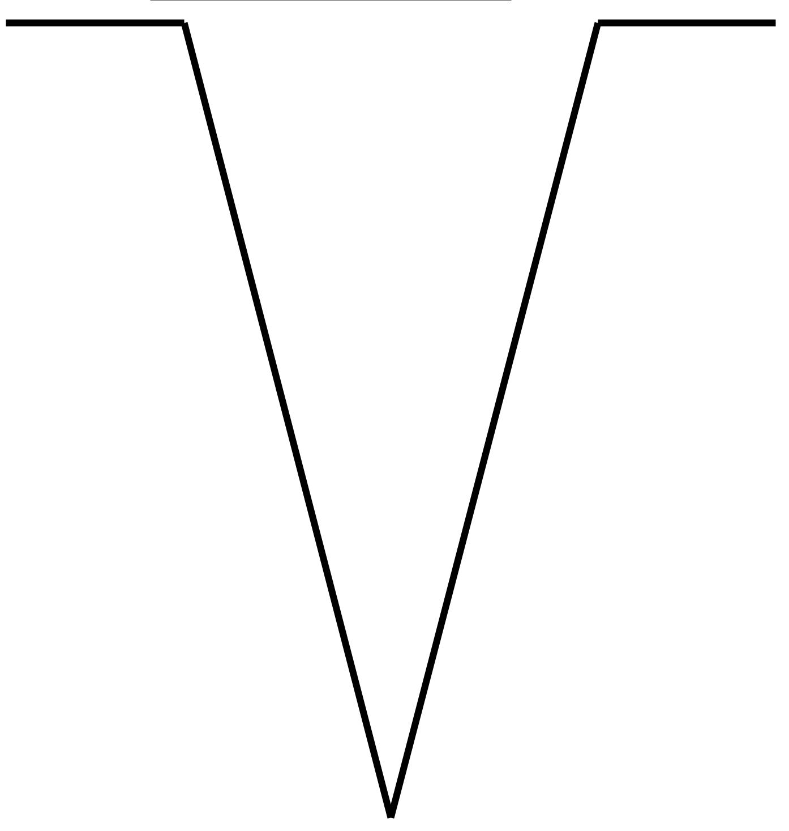

What I Already Research Tools: Conclusion and
Know: Findings:

Key Concepts: Research Plan:

(Date and Activities)

The Research Question(s)

The Use of Graphic Organizers to Enhance Thinking Skills in the Learning of Economics

92 • Graphic Organizers: Description, Procedures and Exemplars
Exemplar

V Map

Topic

Inflation and Standard of Living

Concepts

- Inflation is the continuous increase in general price level.

- Inflation occurs whenever aggregate demand is greater than aggregate supply when the economy is near full employment

- When the rise of income is lower than the rise of price level, standard of living (purchasing power) becomes lower.

The Use of Graphic Organizers to Enhance Thinking Skills in the Learning of Economics

Exemplar | Chapter 7 • 93
Topic : Inflation and Standard of Living
Research Topic : Inflation
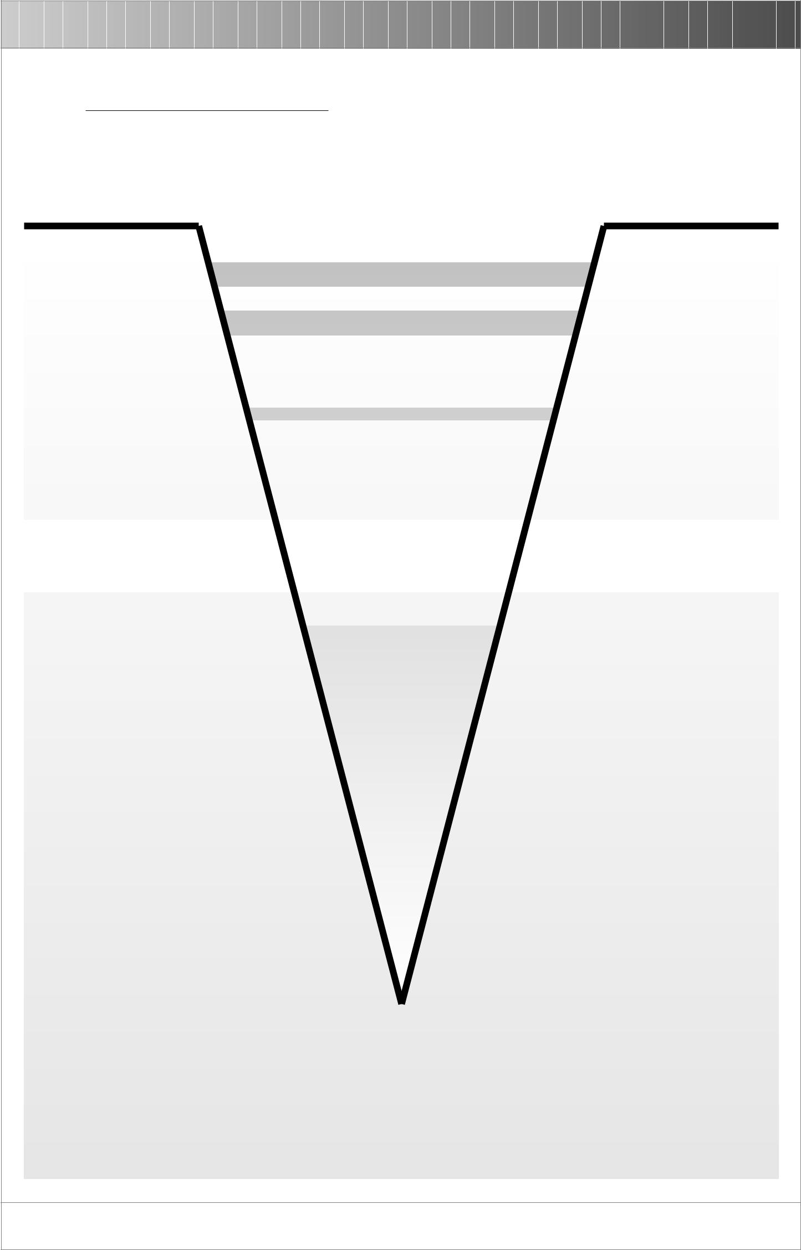
What I |  | Conclusion
 | Research Tools:
Already |  | and Findings:
Know: | ➣ Economics Textbook | The amount
 | ➣ Social Welfare Department website
 |  | received from the
Inflation is the | http://www.info.gov.hk/swd/html
 |  | CSSA scheme
continuous rise in
general price level. |  | generally rises lower
The higher the price, |  | than the rise of price
 |  | level. So their
the less we can buy,
 |  | standard of living
the lower the living
 |  | becomes lower.
standard.

Key Concepts:

Any event that stimulates aggregate demand when the economy is near full employment is likely to result in inflation.

Whether people gain or lose during a period of inflation depends on whether their income rises faster or slower than the rise of prices of the things they buy.
Research Plan: (Date and Activities)

Conduct interview with people who are receiving CSSA.

Conduct questionnaire survey to investigate the change of living standard of the people who are receiving CSSA in a period of inflation.

The Research Question(s)

Why are people receiving Comprehensive Social Security Assistance (CSSA) suffering during a period of inflation?

The Use of Graphic Organizers to Enhance Thinking Skills in the Learning of Economics

94 • Graphic Organizers: Description, Procedures and Exemplars

Venn Diagram

Description

This organizer can be used to help students develop skill in comparing and contrasting similar and/or different information. A Venn diagram may consist of two or more circles.

Procedures

- Identify and label each circle the concepts to be compared and contrasted.

- Discuss and record the similarities and differences among the concepts.

- Put the shared characteristics in the appropriate overlapping sectors.

- Record the unique characteristics of each concept in its own sector.

The Use of Graphic Organizers to Enhance Thinking Skills in the Learning of Economics

Chapter 7 • 95

Venn Diagram
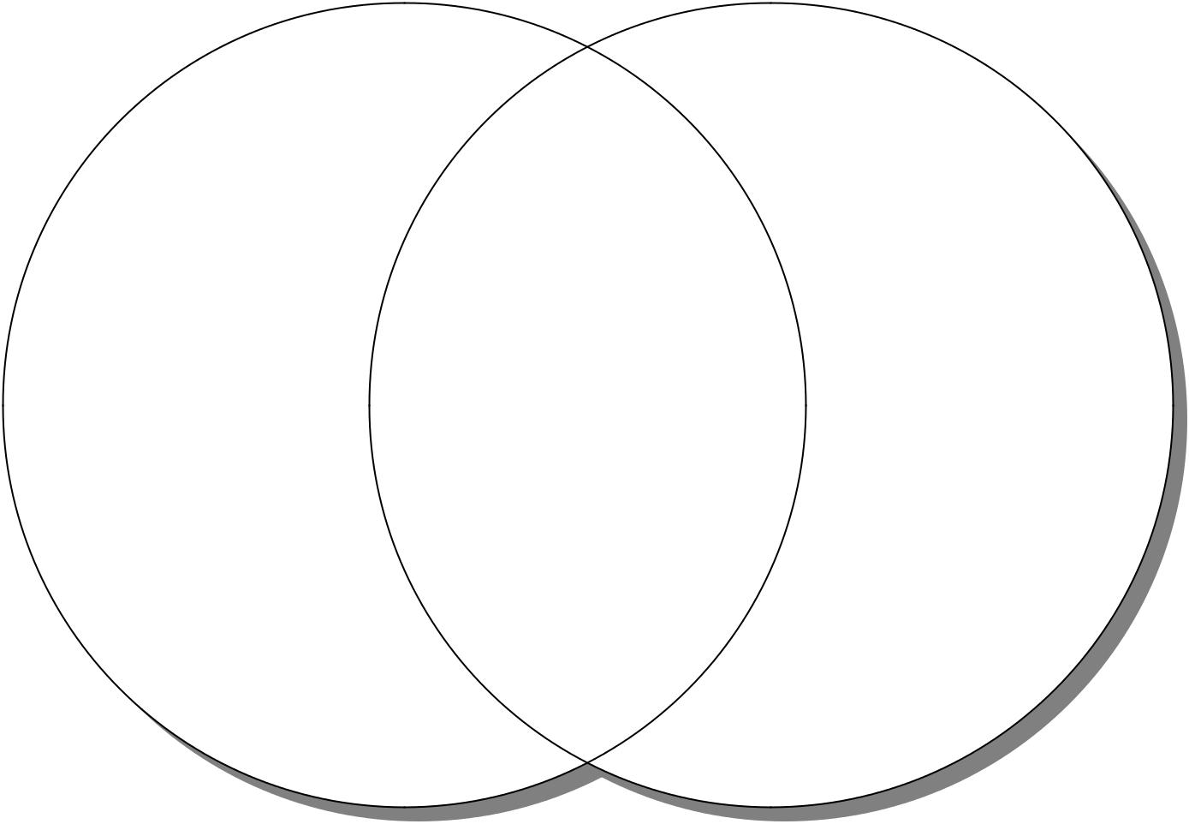

Unique | Common | Unique
Characteristics | Characteristics | Characteristics

Concept 1 Concept 2

The Use of Graphic Organizers to Enhance Thinking Skills in the Learning of Economics

96 • Graphic Organizers: Description, Procedures and Exemplars
Exemplar

Venn Diagram

Topic

Free goods and economic goods

Concepts

- Goods are tangible or intangible items that are used to satisfy human wants.

- Free goods are goods that the amounts are so abundant that all human wants of them can be satisfied.

- Economic goods are goods that the amounts are not sufficient to satisfy all our wants of them.

The Use of Graphic Organizers to Enhance Thinking Skills in the Learning of Economics

_{Exemplar} Chapter 7 • 97
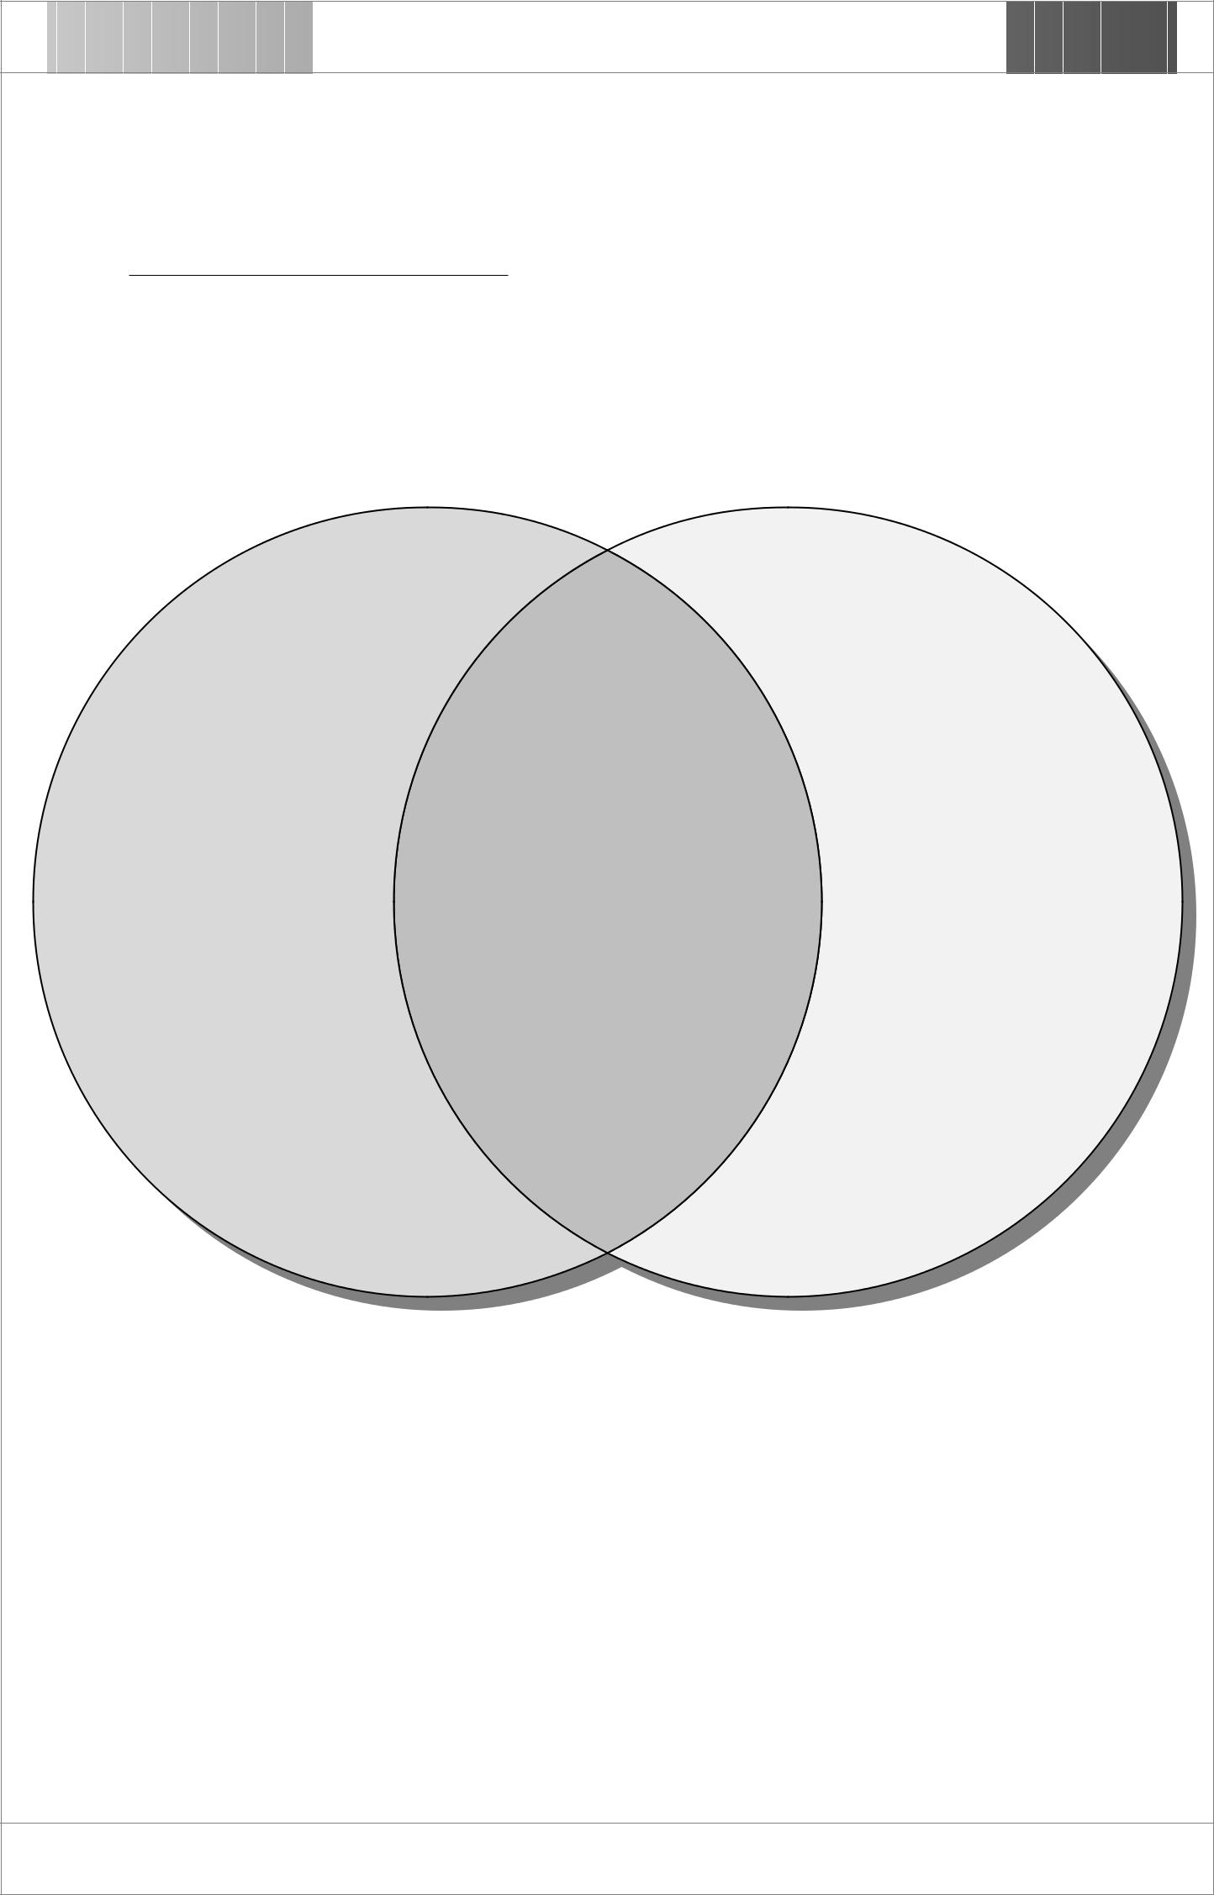

Topic : Free goods and economic goods

Unique

Characteristic

The amount is so abundant that all

wants for them could be satisfied. In other words, there is no opportunity cost in
consuming them.

Common | Unique
Characteristic | Characteristic
Tangible or intangible | The amount is
items that are used to satisfy | insufficient to satisfy all
human wants | human wants. In other
 | words, the consumption
 | of them involves
 | opportunity cost.

Free Goods Economic Goods

The Use of Graphic Organizers to Enhance Thinking Skills in the Learning of Economics

Chapter 8 • 99

Web Sites for Graphic Organizers

- Brain Dancing for Students

http://braindance.com/bdi.htm

- Graphic Organizers: The Use of Graphic Organizers in Processing Information
http://www.graphic.org/goindex.html

- Graphic Organizers as Thinking Technology

http://www.fno.org/oct97/picture.html

- Graphic Organizer as an Instructional Tool

http://www.ncrel.org/sdrs/areas/issues/students/learning/ lrlgrorg.htm

- Mind Tools — Helping You to Think Your Way

to an Excellent Life

http://www.demon.co.uk/mindtool/mindmaps.html

- Semantic Mapping for Concept Formation

http://www.ilt.columbia.edu/k12/livetext/does/semantic. htm

- The Mind Module

http://classes.aces.uiuc.edu/ACES100/

- Using Concept Mapping in a Sensation &
Perception Course

http://river.clarion.edu/TRVILBERG/conceptmap.html

- Venn Diagram

http://coe.ilstu/portfolios/students/caheiss/c&i456teach. htm
10. Visual Learning Using Inspiration

http://www.inspiration.com/inspclass.html

11. Vocabulary Graphic Organizer

http://www.history.org/other/teaching/tchmhvoc.htm

* The recommended websites are correct and available as at the production date of this teaching package.

The Use of Graphic Organizers to Enhance Thinking Skills in the Learning of Economics

Chapter 9 • 101

References

Ausubel, D.P. (1968). Educational Psychology: A Cognitive View.

New York: Holt.

Barnekow, D.J. (1998). Graphic Organizers for Social Studies

Classes. Maine: J. Weston Walch Publisher.

Bromley, K., DeVitis, L. I. and Modlo, M. (1995). Graphic

Organizers: Visual Strategies for Active Learning. New York:

Scholastic Professional Books.

Bromley, K., DeVitis, L. I. and Modlo, M. (1999). 50 Graphic

Organizers for Reading, Writing & More. New York: Scholastic

Professional Books.

Cassidy, J. (1991). “Using graphic organizers to develop critical thinking.” Gifted Child Today, 12(6), pp.34-36.

Curriculum Development Council (1989). Syllabuses for

Secondary Schools: Economics (Secondary 4-5). Hong Kong: The

Government Printer.

Drapeau, P. (1998), Great Teaching With Graphic Organizers:

Lessons and Fun-shaped Templates That Motivate Kids of all

Learning Styles. New York: Scholastic Professional Books, pp.4-10.

Dunston, P.J. (1992). “A critique of graphic organizer research.” in

Reading Research and Instruction, 31 (2), pp.57-65.

Johnson, A.P. (2000). Up and Out: Using Creative and Critical

Thinking Skills to Enhance Learning. Massachusetts, Allan &

Bacon, pp.10-15.
Moline, S. (1995). I See What You Mean: Children at Work With

Visual Information. York, ME: Stenhouse.

The Use of Graphic Organizers to Enhance Thinking Skills in the Learning of Economics

102 • References

Novak, J.D. and Gowin, D.B. (1984). Learning How to Learn. New York: Cambridge University Press.

Parry, T. and Gregory, G. (1998). Designing Brain Compatible Learning. Victoria: Hawker Brownlow Education, pp.168-206.

Pobl, M. (1997). “Thinking Skills for Explicit Teaching; Graphic Organizers” in Teaching Thinking Skills in the Primary Years: A Whole School Approach. Victoria: Hawker Brownlow Education, pp.61-74.

Prawat, R. (1991). “Embedded Thinking skill Instruction in Subject Matter Instruction” in A. Costa (ed.) Development Minds

(Vol. 1), pp.185-186. Alexandria, VI: Association of Supervision and Curriculum Development.

Robinson, D.H. (1998). “Graphic organizers as aids to text learning.” in Reading Research and Instruction, 37(2), pp.85-105.

Schrenko, L. (1994). “What are the most effective instructional strategies?” in Structuring a Learner-Centred School. Victoria: Hawker Brownlow Education, pp.81-132.

Sorenson, S. (1991). Working with special students in English language arts. TRIED, ED 336902, Bloomington, IN: ERIC Clearinghouse on Reading and Communication Skills.

Vygotsky, L.S. (1962). Thought and Language. Cambridge, MA:

MIT Press.

The Use of Graphic Organizers to Enhance Thinking Skills in the Learning of Economics

Chapter 10 • 103

How to Use the CD-ROM

_{T}he enclosed CD-ROM contains a soft copy of this book which is in Adobe Acrobat Portable Document Format

(PDF). The CD-ROM is in Hybrid Format which is usable in both Windows or Macintosh Computers.

To read the file, you need to have Adobe Acrobat Reader installed on your computer. For your convenience, the Acrobat Reader Installer is included on the CD-ROM.

The Asian Font Packs included is not required to read this book, it is just for your convenience if you want to read other
.pdf documents in Asian languages in the future.

How to Use

Windows

- Turn on the computer.

- Place the CD-ROM in your CD-ROM Drive.

- Double click My Computer icon.

- Double click CD-ROM Drive icon (Usually D: or E:).

- Double click the file “TheBook”.

Macintosh

- Turn on the computer.

- Place the CD-ROM in your CD-ROM Drive.

- Double click Graphic_Organizers icon.

- Double click the file “TheBook.pdf”.
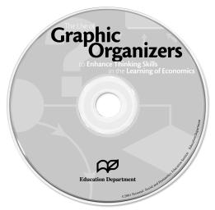

The Use of Graphic Organizers to Enhance Thinking Skills in the Learning of Economics

104 • How to Use the CD-ROM

How to Install Adobe Acrobat Reader
Windows

- Turn on the computer.

- Place the CD-ROM in your CD-ROM Drive.

- Double click My Computer icon.

- Double click CD-ROM Drive icon (Usually D: or E:).

- Double click to open the folder Acroread.

- Double click to open the folder Installers.

- Double click Acrd4enu icon.

Macintosh

- Turn on the computer

- Place the CD-ROM in your CD-ROM Drive.

- Double click Graphic_Organizers icon.

- Double click to open the folder Acrobat Reader 4.0.

- Double click to open the folder Installers.

- Double click Reader Installer icon.

If you are not familiar with the operation of Adobe Acrobat Reader, please refer to the guide book inside the Help folder under the same directory of your Acrobat Reader 4.0 folder.

System Requirements

Windows

- i486™ or Pentium® processor-based personal computer.

- Microsoft® Windows® 95, Windows 98, or Windows NT® 4.0 with Service Pack 3 or later.

- 10 MB of available RAM on Windows 95 and Windows 98 (16 MB recommended).

- 16 MB of available RAM on Windows NT (24 MB recommended).

- 10 MB of available hard-disk space.

- 50 MB of additional hard-disk space for Asian fonts .

Macintosh

- Apple Power Macintosh or compatible computer.

- Mac OS software version 7.1.2 or later.

- 4.5 MB of available RAM (6.5 MB recommended).

- 8 MB of available hard-disk space.

- 50 MB of additional hard-disk space for Asian fonts .

The Use of Graphic Organizers to Enhance Thinking Skills in the Learning of Economics

