 | Budget
21 | Newsletter |  | May 20XX
 | Rush-Henrietta Central School District
 | 20XX-20XX District | Proposed Budget: $132,072,542
 | Budget Proposal | Budget-to-Budget Change: 3.96%
 |  | Tax Rate Change: Less Than 2%
 | Developing a budget is a complex task. As we developed a proposed 20XX-20XX budget, we
MAY | spoke with many community members to solicit their feedback. The Rush-Henrietta Central
 | School District continues to deal with rising mandatory expenses, such as health insurance,
 | special education, and state-mandated employer pension contributions. After a careful analysis
 | that included input from many different corners of our community, Board of Education members
 | are presenting a proposed budget they believe is educationally sound, fiscally responsible, and
 | equitable.
 | Rush-Henrietta is presenting a budget-to-budget increase of 3.96 percent. Under this proposal,
 | the true value tax rate would increase by less than 2 percent, and the total tax levy would be
 | within the limits established under the state’s Tax Levy Cap. Rush-Henrietta’s tax rate should
 | remain the lowest among the 17 local suburban school districts. The Board of Education is
 | pleased that the proposal maintains all educational programs for children.
 | Highlights of Proposed Budget
 | • Maintains instructional programs and student services for more than 5,400 students.
 | • Preserves the district’s successful small-class-size initiative at K-3 schools.
 | • Reflects a reduction in the Payments in Lieu of Taxes agreement for The Marketplace Mall.
VOTE | • Freezes discretionary spending. Uses reserve funds to remain tax-cap compliant.
 | • Advances school improvement priorities, including special education, equity and
 | inclusion, and mental wellness.
 | What Does This Mean in Dollars and Cents?
 | • Taking into account the STAR exemption – for which all homeowners are eligible – a
 | district resident owning a house assessed at $150,000 would see school taxes increase
 | by $60 annually. A senior citizen with the enhanced STAR exemption who owns a house
 | assessed at $150,000 would see school taxes increase by $60 annually. However, an
 | increase in the state Property Tax Relief Credit rebate largely will offset this increase.
 | Did You Know?
 | • Thanks to aggressive cost-cutting measures in recent years, if the proposed budget is
 | approved, Rush-Henrietta’s true value tax rate in 2019-2020 will be less than 1 percent higher
 | than it was during the 2005-2006 school year.
 | • Moody’s Investors Service recently reaffirmed the district’s Aa2 Bond Rating, citing the
 | district’s “sound financial position, stable tax base influenced by a degree of institutional
 | presence, and a below average direct debt burden.” The district’s reserve funds were cited
 | as a financial strength.
 | • Rush-Henrietta has had the lowest true value tax rate in Monroe County for many years.
 | Under the proposed budget, Rush-Henrietta should have the lowest rate again next year.

Rush-Henrietta Senior High School has been named a Reward School for outstanding

academic achievement by the New York State Education Department.

RUSH-HENRIETTA CENTRAL SCHOOL DISTRICT

From the Board of Education

May 1, 20XX

Dear Community Resident:

On Tuesday, May 21, eligible voters in the Rush-Henrietta Central School District will have the opportunity to vote on the proposed 20XX-20XX school budget adopted by the Board of Education. The proposal reflects our efforts to put forth a budget that is educationally sound, fiscally responsible, and equitable. It demonstrates our continued commitment to provide a high-quality education for all children in our school district.

The budget development process begins each November when community members join teachers, staff members, and administrators to serve on the Budget Advisory Council. The council meets multiple times to review all aspects of the budget – including any new proposals – and makes recommendations to the superintendent. During the budget-development process, stakeholders provided feedback at community forums and public hearings. At the same time, the Board of Education and district administration conducted a comprehensive program and service review to determine how the budget supports the district’s priorities. After a careful review, the Board of Education adopted its proposed budget for community consideration.

The Board of Education’s proposed budget for 20XX-20XX ensures that all programs and services that our children receive this year will be available next year. It includes funding to preserve the successful small-class size initiative next year at our K-3 schools; freezes discretionary spending; is designed to provide resources that help ensure similar outcomes at all schools; reflects a reduction in the Payment in Lieu of Taxes agreement for The Marketplace Mall; and uses reserves to remain tax-cap compliant. In addition, it advances improvement priorities, including special education, equity and inclusion, and mental wellness. (As brick-and-mortar retail struggles, The Marketplace Mall approached the school district seeking a significant reduction in their PILOT payment to allow them funds to rejuvenate the mall. We have worked closely with the town and mall to develop a reduction that is fair to district taxpayers, but also accommodates challenges the mall is facing.)

Maintaining all of our programs and services at current levels requires a budget of $132 million, an increase of 3.96 percent compared to last year. Factors driving this increase include a significant increase in the number of special education students, as well as contractual obligations, utilities, and transportation costs. Some of these increased costs will be offset by higher state aid, so the tax rate impact is less than 2 percent.

Given our expense and revenue assumptions, we project a true value tax rate increase of less than 2 percent. For the past 10 years, the final true value tax rate has actually been lower than the proposed rate. The actual tax rate is established after town assessments are finalized. As in previous years, this projected tax rate increase is among the lowest in Monroe County, while continuing to fund our current initiatives and school improvement priorities. A homeowner with property assessed at $150,000 and either the basic or enhanced STAR exemption would pay an additional $60 next year. This likely will be offset for many families by an increase in the New York Property Tax Relief Credit rebate, which is paid each fall. This will increase $105 for families with income under $150,000.

All eligible voters are urged to vote between 6 a.m. and 9 p.m. Tuesday, May 21, 20XX, at the Transportation and Operations Center at the corner of Lehigh Station and Middle roads. You do not need to own property in the district, but you must reside here. A valid form of identification – such as a driver’s license or other government-issued photo ID, along with proof of residency – is suggested.

If you have questions, please contact any board trustee listed below. We genuinely appreciate the strong support that our community continues to demonstrate for the delivery of quality programs and services that make our district a great place to learn and live.

Sincerely,
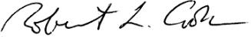

20XX-20XX Rush-Henrietta Board of Education

 |  | Robert L. Cook, President | Mail@.com |  | Ph:
 |  | Annmarie Strzyzynski, Vice President | Mail@.com |  | Ph:
 |  | Mai Abdullah | Mail@.com |  | Ph:
 | Robert L. Cook | Jennifer M. Laird | Mail@.com |  | Ph:
 |  | Nichole M. LaPlaca | Mail@.com |  | Ph:
 | President
 |  | Diane E. McBride | Mail@.com |  | Ph:
 | Board of Education | James C. O’Brien | Mail@.com |  | Ph:
 |  |  |  | Budget 20XX
2 |  |  |  | Budget 20XX
2

RUSH-HENRIETTA CENTRAL SCHOOL DISTRICT

Celebrating Student Achievement

20XX New York State Regents Results

 |  |  |  | Advanced Placement Results
Regents Exam | # Tested | % Passing
ASL | 57 | 100.0 |  | Advanced Placement courses are offered in many academic
 |  |  |  | areas. In Rush-Henrietta, 859 exams were taken last spring;
CCLS English | 407 | 91.2
 |  |  |  | 632 scored at a “3” or higher. That means 73.5 percent of
French | 55 | 98.2 |  | students earned a 3 or better on their exam. Exams are
 |  |  |  | graded on scores of 1 to 5; scores of 3 and above generally
German | 35 | 100
 |  |  |  | are accepted for college credit. We continue to encourage
Spanish | 98 | 89.8
 |  |  |  | our students to take advantage of these Advanced Placement
 |  |  |  | offerings.
CCLS Algebra | 430 | 86.7
CCLS Geometry | 332 | 91.9
CCLS Algebra 2 | 280 | 96.1
Earth Science | 386 | 80.6
Biology | 457 | 87.7
Chemistry | 312 | 83.7
Physics | 165 | 86.7
Global History and Geography | 402 | 89.6
US History and Government | 398 | 94.5
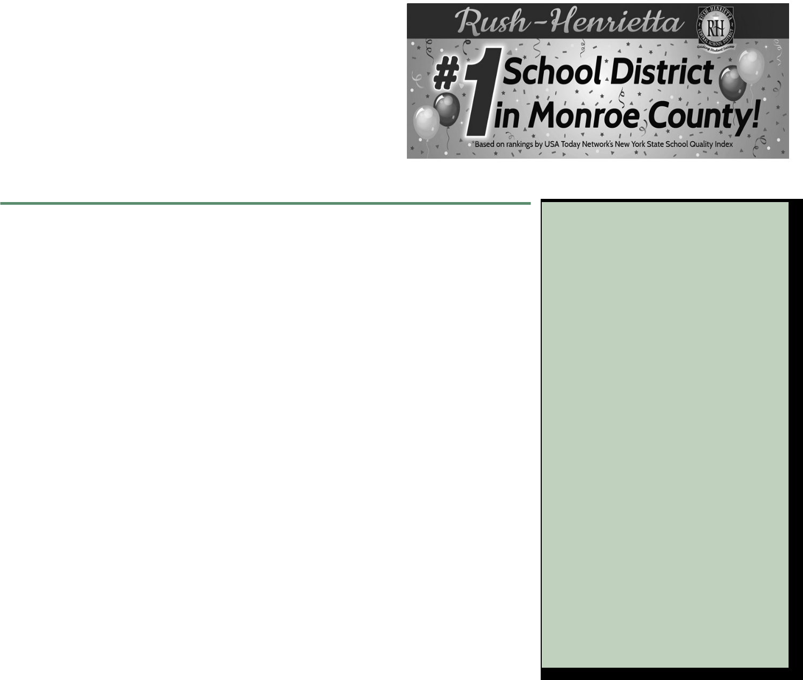

Rush-Henrietta continues to challenge its students to take more rigorous courses in an effort to increase their college readiness. For example, Rush-Henrietta requires all eighth graders to take Earth Science, a class typically taught elsewhere in ninth grade. This gives students the opportunity to take an extra year of science to prepare for college. Rush-Henrietta also offers more challenging math courses.

Graduation Results

Percent of Graduates Receiving Regents Diplomas 2013-2018

100.0% | 97.8% | 96.1% | 98.7% | 97.1% | 97.6% | 96.8%
90.0%
80.0%
70.0%
60.0%
50.0%
40.0%
30.0%
20.0%
10.0%
0.0% | 2013 | 2014 | 2015 | 2016 | 2017 | 2018
Regular | 38.1% | 40.6% | 39.1% | 34.1% | 30.8% | 39.3%
Advanced | 59.7% | 55.5% | 59.6% | 63.0% | 66.8% | 57.5%
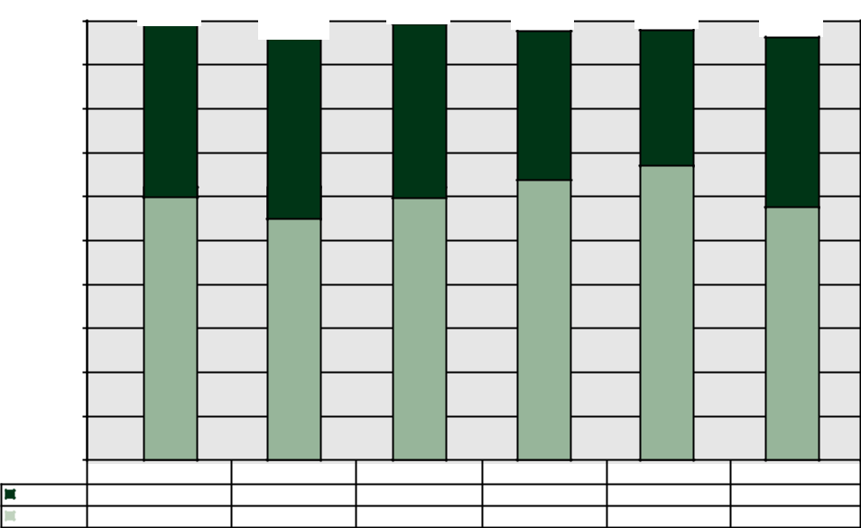

STUDENT
ACHIEVEMENT DATA

The New York State Department of Education requires the district to make documents related to student achievement available prior to annual district budget votes . Information regarding the 20XX-20XX School Report Cards Part 1, which provides accountability status for all schools within the Rush-Henrietta Central School District, and the Fiscal Accountability Supplement for the district, is available at www.address.com

In addition, a hard copy of each report is available through the Office of Strategic Initiatives, located in the Parker Administration Building at 2034 Lehigh Station Road. To make an appointment to review these documents during regular business hours, please call .

Budget 20XX | 3
 |  | 3
Budget 20XX

RUSH-HENRIETTA CENTRAL SCHOOL DISTRICT
RUSH-HENRIETTA CENTRAL SCHOOL DISTRICT

Rush-Henrietta Central School District - Budget Notice

Overall Budget Proposal |  |  |  |  | Budget Adopted for the | Budget Proposed for the | Contingency Budget for the
 |  |  |  |  | 2018-19 School Year | 2019-20 School Year | 2019-20 School Year*
Total Budgeted Amount, Not Including Separate Propositions |  |  |  |  | $127,043,033 | $132,072,542 | $129,801,957
Increase/(Decrease) for the 2019-20 School Year |  |  |  |  |  | $5,029,509 | $2,758,924
Percentage Increase/(Decrease) in Proposed Budget |  |  |  |  |  | 3.96% | 2.17%
Change in the Consumer Price Index |  |  |  |  |  | 2.44%
A. Proposed Levy to Support the Total Budgeted Amount |  |  |  |  | $77,613,095 | $79,883,680
B. Levy to Support Library Debt, if Applicable |  |  |  |  | - | -
C. Levy for Non-Excludable Propositions, if Applicable ** |  |  |  |  | - | -
D. Total Tax Cap Reserve Amount Used to Reduce Current Year Levy |  |  |  |  | - | -
E. Total Proposed School Year Tax Levy (A+B+C-D) |  |  |  |  | $77,613,095 | $79,883,680 | $77,613,095
F. Total Permissible Exclusions |  |  |  |  | - | -
G. School Tax Levy Limit, Excluding Levy for Permissible Exclusions |  |  |  |  | $77,613,095 | $79,883,680
H. Total Proposed School Year Tax Levy, Excluding Levy to support Library Debt
and/or Permissible Exclusions (E-B-F+D) |  |  |  |  | $77,613,095 | $79,883,680
I. Difference: (G-H); (Negative Value Requires 60.0% Voter Approval -
See Note Below Regarding Separate Propositions)** |  |  |  |  | - | -
Administrative Component |  |  |  |  | $14,035,047 | $14,029,554 | $13,698,294
Program Component |  |  |  |  | $96,385,707 | $100,339,748 | $98,935,458
Capital Component |  |  |  |  | $16,622,279 | $17,703,240 | $17,168,205

- The Contingency Budget information displayed above has been calculated in total, should the proposed budget be defeated pursuant to Section 2023 of the Education Law. Budget items excluded from the calculation include equipment expenditures and other non-contingent expenses. The actual appropriations under a contingency budget, should this be necessary, would be determined by the Board of Education and may include additional contingent expenditures if funding sources other than additional tax levy amounts are identified.

**Separate Propositions that are not included in the Total Budgeted Amount:

 | Description |  | $ | Amount
 | Bus purchases |  |  | 2,400,000
 | Capital Improvements |  | $12,500,000

Basic STAR Exemption Impact
Estimated Basic STAR Exemption Savings based upon the standard $30,000 exemption authorized by Section 425 of the Real Property Tax Law.

Under the Budget Proposed

for the 2019-20 School Year

Estimated Basic STAR Exemption Savings | $602

The annual budget vote for the fiscal year 2019-20 by the qualified voters of the Rush-Henrietta Central School District, Monroe County,
New York, will be held at the Transportation & Operations Center in said district on Tuesday, May 21, 2019, between the hours of

6:00 a.m. and 9:00 p.m. prevailing time, in the Transportation & Operations Center, 1133 Lehigh Station Road, Henrietta, N.Y. 14467,

at which time the polls will be opened to vote by voting ballot or machine.

If you are a United States citizen, will be at least 18 years old by May 21, 2019, and have been a resident of the school district at least 30 days prior to the vote, you may vote.

R-H True Value Tax Rate: Still the LOWEST in Monroe County
Monroe County School
districts. The true value tax rate
District Comparison*
County. Next year, Rush-
Tax rates are a means of
comparing taxes between
in the Rush-Henrietta Central
School District is consistently
the lowest tax rate. |  |  |  |  |  |  |  |  |  | Rush-Henrietta
among the lowest in Monroe
published by the Monroe County
Henrietta again should have
* Data from “2019 Facts and Figures”
School Boards Association
4 |  |  |  |  |  |  |  | Budget 2019
4
 |  |  |  |  |  |  |  | Budget 2019
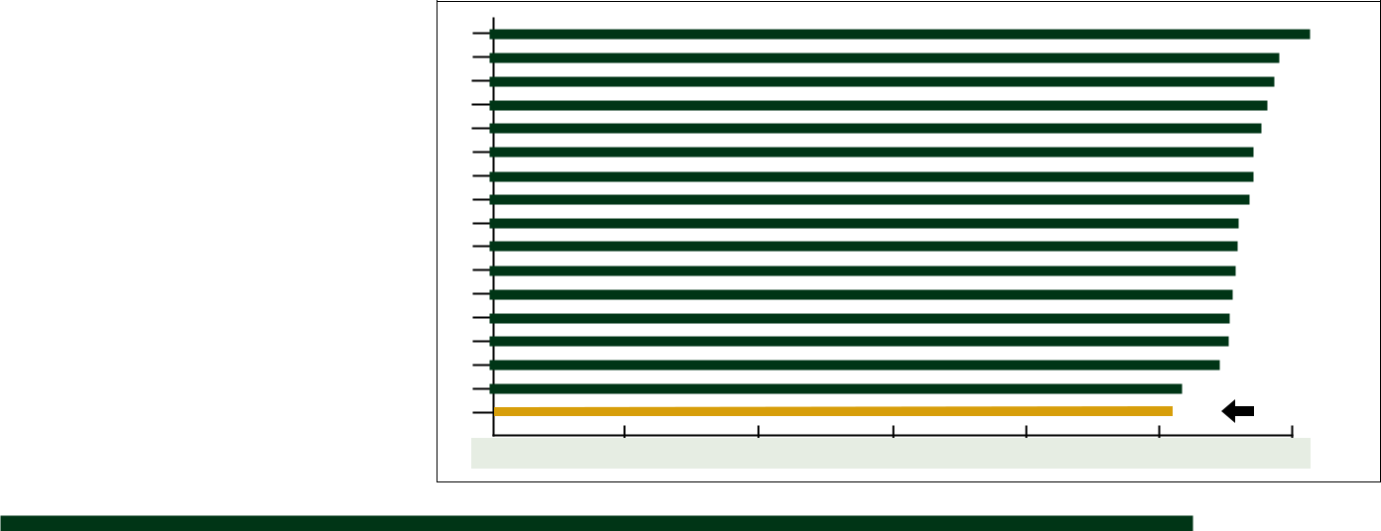

RUSH-HENRIETTA CENTRAL SCHOOL DISTRICT
RUSH-HENRIETTA CENTRAL SCHOOL DISTRICT

Rush-Henrietta Central School District Budget Proposal

2019-2020 Projected Revenue Statement

 | Revenue Source | 2018-2019 | 2019-2020 | % Change
 | State Education Aid | $35,243,749 | $37,648,798 | 6.8
 | Real Property Taxes and
 | Payments in Lieu of Taxes | 81,863,095 | 84,133,680 | 2.8
 | Sales Tax-County | 4,545,000 | 4,800,000 | 5.6
 | Other Revenue Sources | 1,891,189 | 2,055,064 | 8.7
 | Fund Balance and Reserves | 3,500,000 | 3,435,000 | -1.9
 | GRAND TOTALS | $127,043,033 | $132,072,542 | 4.0

REVENUES AS A PERCENTAGE OF BUDGET

Other Revenue Sources |  |  |  |  |  |  |  | Fund Balance and Reserves
1.6% |  |  |  |  |  |  | 2.6% |  |  | State Education Aid
Sales Tax-County |  |  |  |  |  |  | 28.5%
3.6%
 |  |  |  |  |  |  |  |  | Real Property Taxes and
 |  |  |  |  |  |  |  |  | Payments in Lieu of Taxes
 |  |  |  |  |  |  | 63.7%

2019-2020 Proposed Expenditures

There are five expenditure categories in the 2019-2020 budget proposal, as outlined below, that support educational programs and school district operations.

Instruction: 52.8% — The instructional program is the largest category in the budget and is the focal point of our educational system. All services that provide, or directly affect, instruction to students are budgeted in this area. The following are included in this category: regular school program, special education, summer school and support services [school libraries, health, psychological and social work services, curriculum coordination and supervision, curriculum development, research and evaluation], BOCES instructional programs, student activities [interscholastic sports, intramurals, co-curricular activities] and required tuition payments for Rush-Henrietta students attending approved private and public school programs.

General Support: 9.4% — This part of the budget covers the areas that support the educational program through central administration, business operations, human resources, community relations, maintenance and repair of all district grounds and facilities, printing, mailing, district meetings, Board of Education and legal services.

Transportation: 6% — Includes bus transportation for more than 6,000 students to district, charter, parochial and private schools; BOCES centers for vocational and special education programs; field trips and athletic team trips.

Employee Benefits: 24.5% — Included in the employee benefits category are health insurance, retirement, social security, and the risk fund which includes unemployment insurance, worker’s compensation insurance, disability and life insurance.

Other: 7.3% — A small portion of the budget is for other expenditures that include capital reserve fund (buildings and grounds reconstruction, repairs, and improvements), and community services.

EXPENDITURES AS A PERCENTAGE OF BUDGET

 |  |  | Other
 |  |  | 7.3% |  |  |  |  |  |  |  | Instruction
Employee Benefits |  |  |  |  | 52.8%
24.5%
Transportation |  |  |  |  |  |  |  |  |  | General Support
6%
 |  |  | 9.4%
Budget 2019 |  |  | 5
 |  |  |  |  |  |  |  |  |  |  |  | 5
Budget 2019

RUSH-HENRIETTA CENTRAL SCHOOL DISTRICT

Rush-Henrietta Central Sch

2019-2020 Component Budget

Administrative Component 10.6% of Budget

The Administrative Component provides for overall general support and management activities, including business office operations, payroll, purchasing, general administration, personnel, legal and auditing services. Cost for administration and supervision of each of the district’s schools is also included in this component.

 | Function or Account | 2018-2019 | 2019-2020 | Increase/(Decrease)
 | Board of Education | 126,318 | 136,180 | 9,862
 | Central Administration | 348,852 | 284,660 | (64,192)
 | Finance | 690,075 | 711,983 | 21,908
 | Legal Services | 78,055 | 84,563 | 6,508
 | Personnel | 579,293 | 617,174 | 37,881
 | Public Information | 200,401 | 231,151 | 30,750
 | Other Central Services | 1,358,335 | 1,443,976 | 85,641
 | Other Special Items | 1,301,159 | 1,203,145 | (98,014)
 | Curriculum Development and Supervision | 1,870,555 | 1,953,065 | 82,510
 | Supervision-Regular School | 2,888,310 | 2,895,087 | 6,777
 | Supervision-Special School | 294,072 | 289,214 | (4,858)
 | Research, Evaluation and Planning | 423,154 | 434,242 | 11,088
 | Employee Benefits | 3,876,468 | 3,745,114 | (131,354)
 | TOTALS | $14,035,047 | $14,029,554 | ($5,493)

Program Component 76.0% of Budget

The Program Component provides funding for the instruction of and educational support services for the District’s students. Programs are offered in four (4) primary buildings, two (2) intermediate buildings, two (2) junior high schools, one (1) high school, and one (1) alternative high school. Funds are also included in this component for transporting students.

 | Function or Account | 2018-2019 | 2019-2020 | Increase/(Decrease)
 | Instruction | 60,739,899 | 63,788,549 | 3,048,650
 | In-Service Training | 311,361 | 313,114 | 1,753
 | District Transportation | 6,198,367 | 6,651,287 | 452,920
 | Garage Building | 182,770 | 185,730 | 2,960
 | BOCES Transportation | 1,134,452 | 1,164,829 | 30,377
 | Community Services | 176,250 | 204,250 | 28,000
 | Employee Benefits | 26,537,608 | 26,789,489 | 251,881
 | Other Transfers | 1,105,000 | 1,242,500 | 137,500
 | TOTALS | $96,385,707 | $100,339,748 | $3,954,041

Capital Component 13.4% of Budget

The Capital Component pays for maintaining buildings, for upkeep of property, and for electricity, gas heat, oil, water, sewer, and telephone services. Transfers to capital fund pay for buildings and grounds reconstruction, repairs, and improvements, and funding for BOCES capital projects. Funds are also included for “debt service” payments on capital projects (principal and interest payments) and for refund of taxes for claims against property assessments.

 |  | Function or Account | 2018-2019 | 2019-2020 | Increase/(Decrease)
 |  | Operation of Plant | 4,622,713 | 4,914,977 | 292,264
 |  | Maintenance of Plant | 2,245,976 | 2,275,259 | 29,283
 |  | Refund of Taxes | 215,000 | 215,000 | 0
 |  | Other Special Items | 181,094 | 272,033 | 90,939
 |  | Employee Benefits | 1,865,962 | 1,846,158 | (19,804)
 |  | Transfer to Capital | 5,768,371 | 6,451,419 | 683,048
 |  | Debt Service | 1,723,163 | 1,728,394 | 5,231
 |  | TOTALS | $16,622,279 | $17,703,240 | $1,080,961
 |  | GRAND TOTAL | $127,043,033 | $132,072,542 | $5,029,509
6
 |  |  |  |  |  | Budget 2019
6
 |  |  |  |  |  | Budget 2019

RUSH-HENRIETTA CENTRAL SCHOOL DISTRICT

ool District Budget Proposal

2019-2020 Proposed Expenditures

Instruction: 52.8% of Budget

 | 2018-2019 | 2019-2020 | % Change
Salaries | 48,566,202 | 50,292,115 | 3.6%
Equipment | 304,411 | 307,435 | 1.0%
Supplies and Materials | 1,141,688 | 984,238 | -13.8%
Textbooks and Software | 459,531 | 578,824 | 26.0%
Contractual Expenses | 1,469,434 | 1,562,331 | 6.3%
BOCES | 12,584,610 | 12,997,408 | 3.3%
Tuition | 2,001,475 | 2,950,920 | 47.4%
Totals | $66,527,351 | $69,673,271 | 4.7%

General Support: 9.4% of Budget

 | 2018-2019 | 2019-2020 | % Change
Salaries | 4,993,082 | 5,024,656 | 0.6%
Equipment | 326,544 | 335,035 | 2.6%
Supplies and Materials | 665,538 | 677,569 | 1.8%
Contractual Expenses | 3,717,110 | 3,941,073 | 6.0%
BOCES | 2,244,997 | 2,411,768 | 7.4%
Totals | $11,947,271 | $12,390,101 | 3.7%

Transportation: 6% of Budget

 | 2018-2019 | 2019-2020 | % Change
Salaries | 4,418,283 | 4,733,892 | 7.1%
Equipment, Supplies and Materials, Contracts | 1,877,854 | 2,008,125 | 6.9%
BOCES, Public, Contract Transportation | 1,219,452 | 1,259,829 | 3.3%
Totals | $7,515,589 | $8,001,846 | 6.5%

Employee Benefits: 24.5% of Budget

 | 2018-2019 | 2019-2020 | % Change
Social Security | 4,442,157 | 4,483,656 | 0.9%
Retirement | 6,939,284 | 6,257,620 | -9.8%
Insurance | 20,898,597 | 21,639,485 | 3.5%
Totals | $32,280,038 | $32,380,761 | 0.3%

Other: 7.3% of Budget

 |  | 2018-2019 | 2019-2020 | % Change
 | Bus Purchase and Capital Transfers | 5,768,371 | 6,451,419 | 11.8%
 | Community Service | 176,250 | 204,250 | 15.9%
 | Transfer to Special Education Extended School Year 387,500 |  | 462,500 | 19.4%
 | Transfer to State Schools (Blind and Deaf) | 437,500 | 450,000 | 2.9%
 | Transfer to School Food Services | 280,000 | 330,000 | 17.9%
 | Debt Service | 1,723,163 | 1,728,394 | 0.3%
 | Totals | $8,772,784 | $9,626,563 | 9.7%
 | GENERAL FUND TOTALS | $127,043,033 | $132,072,542 | 3.96%

Budget 2019
Budget 2019 |  | 7
 |  | 7

RUSH-HENRIETTA CENTRAL SCHOOL DISTRICT
On May 21, 2019, Eligible Voters Will Vote On... | NOT affect the tax rate.
 | Propositions 2 and 3 will

Proposition 1

BUDGET PROPOSITION

Shall the following proposition be adopted?

Resolved, that the Board of Education of the Rush-Henrietta Central School District be authorized to expend the sum set forth in the estimate of amount of money required for school purposes during the fiscal year 2019-2020 in the total amount of $132,072,542 and to levy the necessary tax therefore.

Proposition 2

BUS EXPENDITURES

Shall the following proposition be adopted?

Resolved, that the Board of Education of the Rush-Henrietta Central School District be authorized to expend the sum of up to $2,400,000 to be funded from the 2016 Bus Purchase Reserve, the balance in existing Capital Fund bus purchase funds, and the General Fund Transfer for the purchase and replacement of vehicles for the transportation of district students.

Proposition 3

CAPITAL EXPENDITURES

Shall the following proposition be adopted?

Resolved, that the Board of Education of the Rush-Henrietta Central School District be authorized to expend the sum of up to $12,500,000 to be funded from undesignated balances in the Capital Fund and from the 2015 and 2016 Capital Reserve Funds for the rehabilitation and reconstruction of the school facilities and districtwide systems including, without limitation, the Burger, Crane, Fyle, Leary, Roth, Sherman, Sperry, Vollmer, Webster, and Winslow schools; the Parker Administration Building; the John R. “Jack” Gaffney West Henrietta Education Building; the Good Shepherd buildings; and the Transportation and Operations Center building, such projects to include, without limitation, roof replacements; boiler replacements; sidewalk, parking lot, and bus loop replacement; carpet and flooring

replacement; HVAC; ADA compliance; health, safety, and security projects; door and window replacement; freezer/cooler replacement and renovation; lighting upgrades; classroom upgrades; climatic conditions projects; clock system upgrades; fire alarm system upgrades; computer and media-related cabling; building exterior and interior upgrades and repairs; telephone and public address systems; lavatory renovations and installation; purchase of equipment; locker upgrades and repairs; water heater replacements; food service equipment replacement; auditorium refurbishment; gymnasium equipment; office renovations; site improvements; electronic building security systems and security cameras; energy conservation; bus lifts repair and replacement; and structural projects.

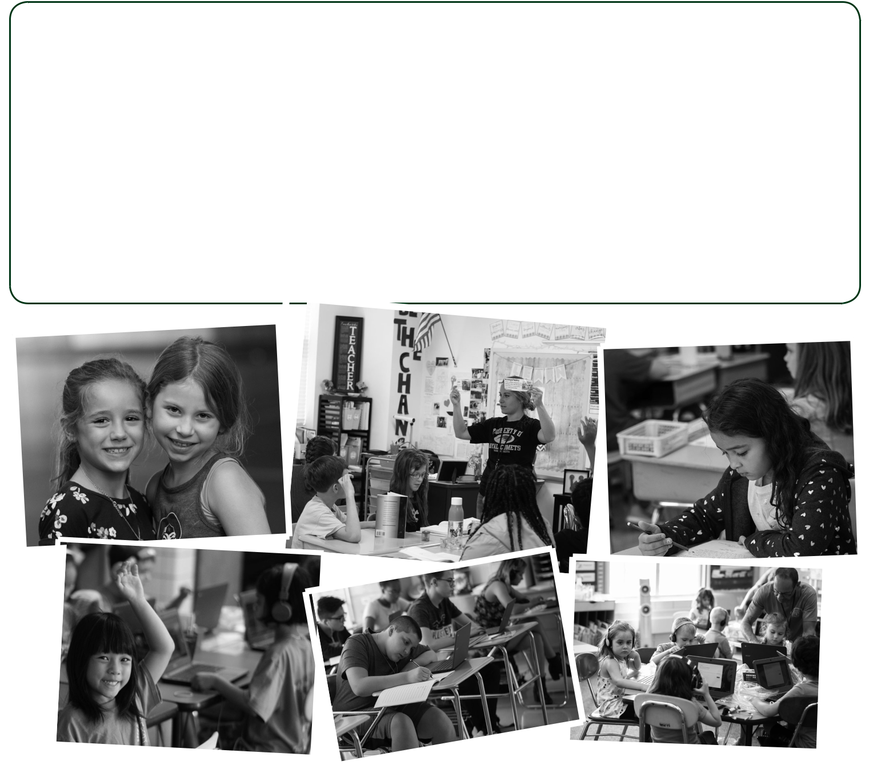

8 |  | Budget 2019
8
 |  | Budget 2019

RUSH-HENRIETTA CENTRAL SCHOOL DISTRICT

Because You Asked...
Since January, the Board of Education and Superintendent Lawrence Bo Wright have been engaging the community in an open and frank dialogue about financial issues impacting our community and Rush-Henrietta Central School District. Board members and Mr. Wright have been answering questions on the district website at www.rhnet.org/budgettalk. If your topic hasn’t been addressed, please share it by visiting the website and clicking the Contact Us button. We look forward to hearing from community members and seeing you during the budget vote on Tuesday, May 21. Among the questions and answers posted online:

Q. What is the property tax cap?
A. In 2011, New York state established a property tax cap that limits how much a local government or school district can increase its property tax levy each year. The cap was made permanent in 2019. Under this law, the growth in the property tax levy – the total money to be raised through property taxes charged on a district’s taxable assessed value of property

– will be capped at 2 percent or the rate of inflation, whichever is less. Sometimes, a district is allowed to propose a tax levy increase in excess of 2 percent based on a complicated, eight-step formula created by the state. For example, in addition to the base 2 percent limit, school districts are able to add the value of new property development. They also can add to the cap for certain exemptions, including voter-approved local capital expenditures; increases in the state-mandated employer contribution rates for teacher and employee pensions that exceed 2 percent; and court orders and judgments resulting from tort actions of any amount that exceeds 5 percent of a district’s current levy. Local communities have the ability to override the cap, by a super majority vote of the public, but Rush-Henrietta has not chosen to do that. Although this was publicized as a 2 percent tax cap, there are many factors outlined in the law that cause the final cap to be lower or higher than 2 percent, and this amount varies in each school district. Significantly, the cap constrains a school district’s ability to raise new revenue to support programs and services.

  - What are “unfunded mandates” and how do they drive costs?

    - Unfunded mandates are legal requirements placed upon school districts without the specific funding source to offset their cost. Many of these mandates are well-founded, but they are expensive. Both the federal and state governments impose unfunded mandates upon school districts. A good example of unfunded mandates is for special education costs where the federal government mandates that appropriate, least-restrictive educational services be provided to special education students “regardless of cost.” The state has imposed further special education requirements that add to this expense so it now costs more than three times as much to educate a special education student as it does a general education student. Another example of federal mandates is reflected in transportation. Bus prices have increased more than 45 percent during the past five years because of mandated pollution control and upgraded communications equipment. Employee wages and benefits also are affected by state mandates. In addition to these major unfunded mandates, there are hundreds of smaller ones requiring much administrative cost to implement and ensure compliance. Recent state budgets included more of these, including requirements to provide feminine hygiene products to all students in grades 6-12. There also is a new requirement to provide a full lunch to students even if they have no money to pay. Legislative mandates continue to add new state programs and millions of dollars of associated costs to our school district budget. In conjunction with the tax cap, these unfunded mandates could result

in reduced opportunities for our students. New mandates put significant pressure on school budgets, the growth of which is already capped.

Q. How will the proposed budget affect homeowners?
A. The Board of Education’s $132 million budget proposal calls for an increase of less than 2 percent in the true-value tax rate. A homeowner with property assessed at $150,000 and the basic STAR exemption would pay an additional $60 annually. A senior citizen with property assessed at $150,000 and the enhanced STAR exemption would pay an additional $60 annually. However, if the family income is under $150,000, the planned $105 increase in the Property Tax Relief Credit rebate will offset this higher cost.
Q. How are school taxes determined?

A. Your school taxes are determined by three factors – the school tax levy, property assessments, and equalization rates.

  - The school tax levy is the total dollar amount the district must collect from property owners to support the annual operating budget.

  - In terms of property assessments, Rush-Henrietta uses property values provided by the four towns in the school district – Brighton, Henrietta, Pittsford, and Rush – to levy taxes. Each property within a town is assigned a value by the town assessor.

  - Each year, the New York State Office of Real Property Services evaluates each town’s assessment practices and sets specific equalization rates to ensure a fair tax burden distribution across the district. For this reason, an 8 percent increase in property assessments in one town does not mean that all four towns within our school district would experience the same increase. If the school tax levy increase is greater than the increase in property assessments for the district as a whole, the district’s true value tax rate increases.

- Because the district’s proposed budget is under the state tax cap, Rush-Henrietta residents will again be eligible to receive the property tax relief credit from New York. Amounts are determined by the state and are income dependent. Approximate amounts are as follows:
Income |  |  | % of Basic Star |  | Approximate Rebate
$75,000 or less |  |  | 85.0% |  | $512
$75,000 - $150,000 |  |  | 60.0% |  | $361
$150,000 - $200,000 |  |  | 35.0% |  | $211
$200,000 - $275,000 |  |  | 10.0% |  | $60

Seniors eligible for the Enhanced STAR credit will receive 34 percent of that credit, approximately $445.

 | For more information about school district finances or the budget development process, please consult the district website at www.rhnet.org/budgettalk.
9 | Or, contact Andy Whitmore, assistant superintendent for school finance and operations, at 359-5037 or awhitmore@rhnet.org. | Budget 2019
9
 |  | Budget 2019

Candidates Vie for Two Board of Education Seats

The school district is governed by a seven-member Board of Education elected by the eligible voters of the district. Members are volunteer public officials
RUSH-HENRIETTA CENTRAL SCHOOL DISTRICT
who serve without pay. As elected representatives of district residents, and as officers of the state of New York, board members must carry out duties

required by the state Legislature, the Board of Regents, and the state Commissioner of Education. The board establishes policies for the operation of the district. On Tuesday, May 21, 2019, eligible voters in Rush-Henrietta will elect two candidates to the Board of Education. The following information is provided by each candidate. A random drawing determined the ballot order of the candidates.
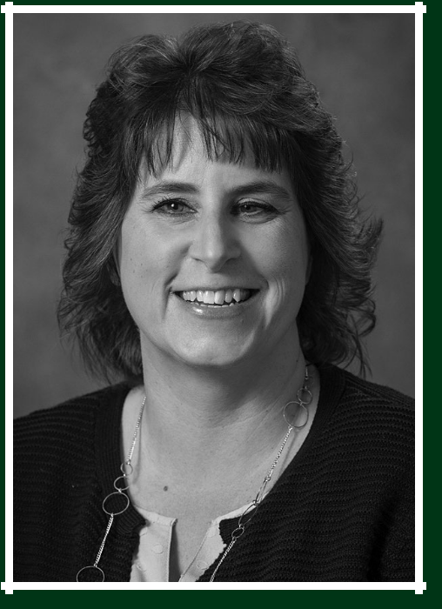

ANNMARIE STRZYZYNSKI
71 Derrick Drive, West Henrietta, N.Y. 14586 • Resident of the district for 42 years

FAMILY: Spouse, Mark; Children, Steven, 28, and Sara, 26

EDUCATION: Monroe Community College, Associate of Science
SUNY Empire State, College Bachelor of Science

EMPLOYMENT: Lifetime Assistance Inc., Staff Development Specialist

HONORS/ACTIVITIES: Vice president, Rush-Henrietta Board of Education, 2018-2019; Trustee, Board of Education, 2016-2019; member, Monroe County School Boards Association Information Exchange Committee; member, Rush-Henrietta Safety Committee; member, Rush-Henrietta Wellness Committee; member, Kicking Hunger Committee; member, Henrietta Youth Development Advisory Committee; board liaison to Crane Elementary and Sherman Elementary schools.

STATEMENT: Three years ago I was asked by a friend - and encouraged by family - to run for a seat on the Board of Education. They felt I would be able to listen openly to concerns from the district staff and community members, and provide open, honest feedback. In addition, they trusted that I would stand up for what I believe is right. As my husband, children, and I are all R-H graduates, I decided to run and have had the privilege and honor to serve on the board for the past three years, currently serving as vice-president. I have been nothing but amazed at the dedication of the RHCSD staff. If re-elected, I would like to continue building relationships that allow the district staff to feel comfortable sharing both concerns and successes, continue advocating for wellness of the whole child, and, most importantly, furthering the district’s mission.
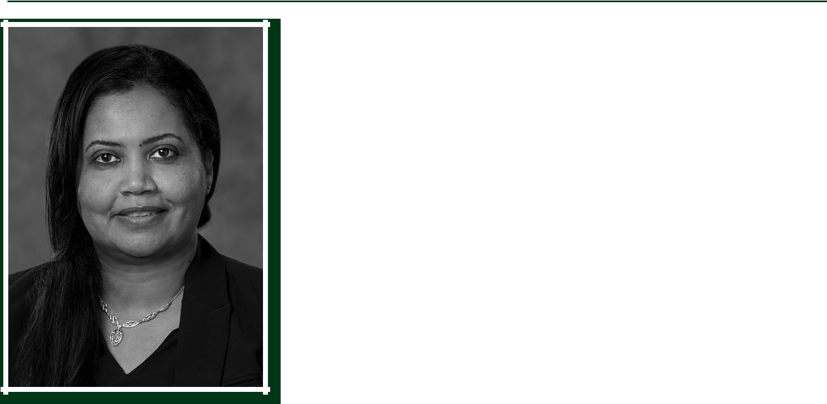

MAI ABDULLAH
83 Churchview Lane, Pittsford New York 14534 • Resident of the district for 21 years

FAMILY: Spouse, Mohamed Mekkielamin; Children, Danya, 18, Zeena, 13, and Amin, 11

EDUCATION: Rochester Institute of Technology, Master’s degree in Environmental Health and
Safety Management; Oumdruan Ahlia University, Bachelor’s degree in Environmental Studies

EMPLOYMENT: New York State Unified Court System, Arabic Interpreter
Pathways Inc., Family Peer Advocate

HONORS/ACTIVITIES: Trustee, Rush-Henrietta Board of Education, 2018-2019; member, Rush-Henrietta Multicultural Committee and Diversity Steering Committee; volunteer interpreter with several local organizations; graduate, Parent Leadership Training Institute.

STATEMENT: I’ve been a Henrietta resident for 21 years and have three children - a freshman in college and two in the district. I’m fortunate to be part of the Rush-Henrietta community. The connection between students, parents, and faculty the district provides is truly a blessing. I’m a strong believer in parents as equal partners in their child’s education. As our school grows more diverse, it becomes increasingly important the board mirrors that diversity. Boards with a diversity of backgrounds, experiences, and abilities benefit from multiple perspectives. Thus, I decided to run to advocate for – and give more exposure to – diverse issues. Having a child with different needs has fueled my passion to promote awareness and provide aid for children with disabilities and their families. I was fortunate to have had the opportunity to serve on the board for a year and consider that both an honor and a responsibility.

Budget 2019 | 10
 |  | 10
Budget 2019

RUSH-HENRIETTA CENTRAL SCHOOL DISTRICT

Rush-Henrietta Recognized for Excellence on Multiple Fronts

We are proud to share that the Rush-Henrietta Central School District has received a number of impressive accolades during the past 18 months.

As you may recall, as part of USA Today Network’s New York State School Quality Index, the Democrat and Chronicle unveiled a list of best public school districts in Monroe County. This new index took into account “non -academic factors that parents say they value, but can be hard to measure.” Rush-Henrietta likes to refer to this as a measure of school climate. Rush-Henrietta ranked as the No. 1 school district in all of Monroe County! The banners on display outside of each school serve as a constant reminder of the significant progress our district has made.

This was one of four major recognitions our school district received during the past 18 months. Another involved the New York State Education Department recognizing Rush-Henrietta Senior High School as a High Performing Reward School for a second consecutive year. This honor acknowledges outstanding student achievement and our significant progress in closing gaps in student achievement among subgroups. This recognition is given on a limited basis. There are more than 4,800 individual schools in New York, and less than 75 from Upstate New York were chosen for this honor. Only five Monroe County schools were so honored. Rush-Henrietta was joined in this select company by Brighton High School, Honeoye Falls-Lima Senior High School, Penfield Senior High School, and Pittsford-Mendon High School. Our district is especially proud to achieve this recognition while working with a student population that is diverse in so many ways.

In addition, Rush-Henrietta Senior High School earned a Silver ranking for the second year in a row in the U.S. News and World Report’s annual Best High Schools in America poll. That places our Senior High School in the top 11 percent of schools in this country!

Lastly, the National Association of Music Merchants once again named Rush-Henrietta one of the Best Communities for Music Education. This is the 10th consecutive time our district has been awarded this honor, and the 14th time overall. Our music programs continue to thrive!

For our students and our staff members, this is an exciting time to be part of the Rush-Henrietta Central School District. Such recognition does not occur by chance. Each instance is a reflection of the good work we have done as a team, and evidence that our

efforts are making a significant difference for the children we work with each day.
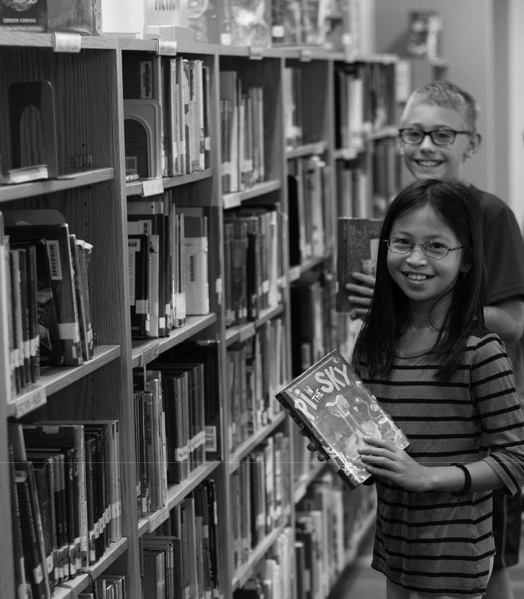

Many thanks to our community, as well, for its continued support. We couldn’t do this without you!

Budget 2019 | 11
 |  | 11
Budget 2019

RushRush-Henrietta-CentralHenriettaSchoolDistrict

2034 Lehigh Station Road

Henrietta, New York 14467

Ph:
www.Addressorg

2018-2019 Board of Education

Mr. Robert L. Cook, President

Mrs. Annmarie Strzyzynski, Vice President

Mrs. Mai Adbullah

Mrs. Jennifer M. Laird

Mrs. Nichole M. LaPlaca

Mrs. Diane E. McBride

Mr. James C. O’Brien

Superintendent of Schools

Mr. Lawrence Bo Wright

Published by the Office of Community Relations

Non-Profit Organization
U.S. POSTAGE

PAID

Henrietta, NY

Permit No. 2

VOTE MAY 21

Voter Eligibility

- You must be a United States citizen.

- You must be at least 18 years old by May 21, 2019.

- You must be a resident of the school district at least 30 days prior to the vote.
- You do not have to own property in the district.

Absentee Ballots

Absentee ballots are available to eligible residents of the district who are unable to vote in person on Tuesday, May 21, 2019, for reasons specified by law. Voters must complete an application for an absentee ballot in order to receive one. Applications are available by phone or in person at the District Clerk’s Office, Parker Administration Building, 2034 Lehigh Station Road.

If you have questions regarding voter eligibility or absentee ballots, please call Karen Flanigan, district clerk, at 359-5010.

2019-2020 Proposed Budget: Striving for a Fiscally Sound, Educationally Responsible Budget

- Maintains instructional programs and student services

- Preserves the successful small-class-size initiative

- True value tax rate remains lowest in the county

RUSH-HENRIETTA CENTRAL SCHOOL DISTRICT

TUESDAY, MAY 21, 2019
6 a.m. to 9 p.m.

Vote at the Transportation

and Operations Center

1133 Lehigh Station Road

Voters will elect two members to the Board of Education and vote on three propositions:

PROPOSITION NO. 1
BUDGET PROPOSITION
$132,072,542

PROPOSITION NO. 2

BUS EXPENDITURES

PROPOSITION NO. 3

CAPITAL EXPENDITURES

Propositions 2 and 3 will NOT
affect the tax rate.

