EXECUTIVE SUMMARY

Climate-KIC Start-up Tour

Application Form [Venture Name]
Name Venture : Year founded (or not yet):
Name Contact (traveler 1) : Job Title:
E-mail : Website :
Mobile number : Related to CLC:

Name Contact (traveler 2) :
Job Title :
E-mail :

Management:

CEO
CTO
Finance
Marketing
Product Development

Number of Employees:

Industry: i.e. automotive, solar etc.

Platform:

Financing Sought:
i.e. $2M (not only Climate-KIC)

Use of Funds: i.e. Product development, marketing/sales, distribution, etc…

Mission: i.e. A PV panel on every roof

Business Description (max 35 words): Briefly describe the general nature of your company. From this section the stakeholders and reviewers must be convinced of the uniqueness of the company and gain a clear idea of the market in which the company will operate.

Company Background: Provide a short summary of the company’s background.
_________________________________________________________
Products/Services: Convey to the reviewers that the solution truly fills an unmet need in the marketplace. The characteristics that set the solution apart from the competition need to be identified (competitive advantage).
The classical six points of a value proposition are:
FOR [the ideal customer]
WHO [has this specific pain or problem]
OUR [product name]
IS A[product category]
THAT PROVIDES [this main benefit and reason to buy]
UNLIKE [the primary alternative or competitor]
OUR PRODUCT [has this unique selling proposition]

Technologies: In this section, highlight whatever aspects of your solution that may be protected by current IP or patent law. Provide evidence of how your offerings are different and will be able to develop a barrier to entry for potential competitors. Also, identify any relevant dependencies.

Climate Impact: Describe in what way your startup has a beneficial impact on climate change adaptation and/or mitigation. This can be quantitative (i.e. 'xxx ton CO2 captured per year') or qualitative (i.e. 'much improved rain data necessary for urban water management')

Markets: This is about the chosen market niche where you want to achieve total global domination. Provide a clear description of your target market, and any market segments that may exist within that market. Include potential market size and growth rate. Also, mention your revenue model in this section.

Distribution Channels: Indicate which channels will be used to deliver your products/service to your target markets (i.e. systems integrators, independent software vendors, partner offerings, direct sales force, channel partners, etc…).

Competition: List any current or potential direct and indirect competition. Briefly describe the competitive outlook and dynamics of the relevant market in which you will operate.
Financial Insights:

Ownership of your venture
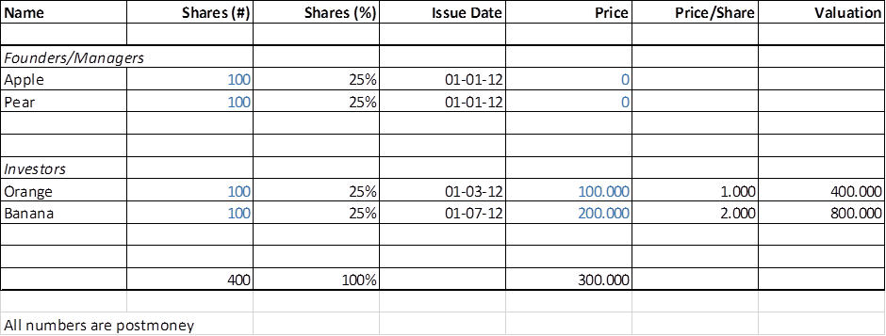

Capital - Explain the origin of the capital , i.e. How much did you raise, type of money and in case of investors, the valuation principles.

Current financial situation
What are your current financials? Please supply insights in your Profit & Loss, Balance Sheet and Cashflow, per 31/12/2012.

Projections
 | Y 2013 | FY 2014 | FY 2015 | FY 2016 | FY 2017
Revenue
Operating Income
Headcount

More Information and Submission:
The Start-up Tour is open to all EU clean tech startups that -in terms of maturity- are at least in stage 2 of the Climate-KIC Acceleration Programme. In order to apply, you have to:
• Application Form: fill out this 2-page Executive Summary to be used to send to potential partners & investors
• Motivation: a 200 word description of what you business is and what you are looking for in Chindia
• Pictures: Team picture including all team members in the start-up tour and a picture of your technology.

More information: marjan.heijkamp@climate-kic.org

