FY-2019 BUDGET PROPOSAL

36

Mission and Administration
Mission
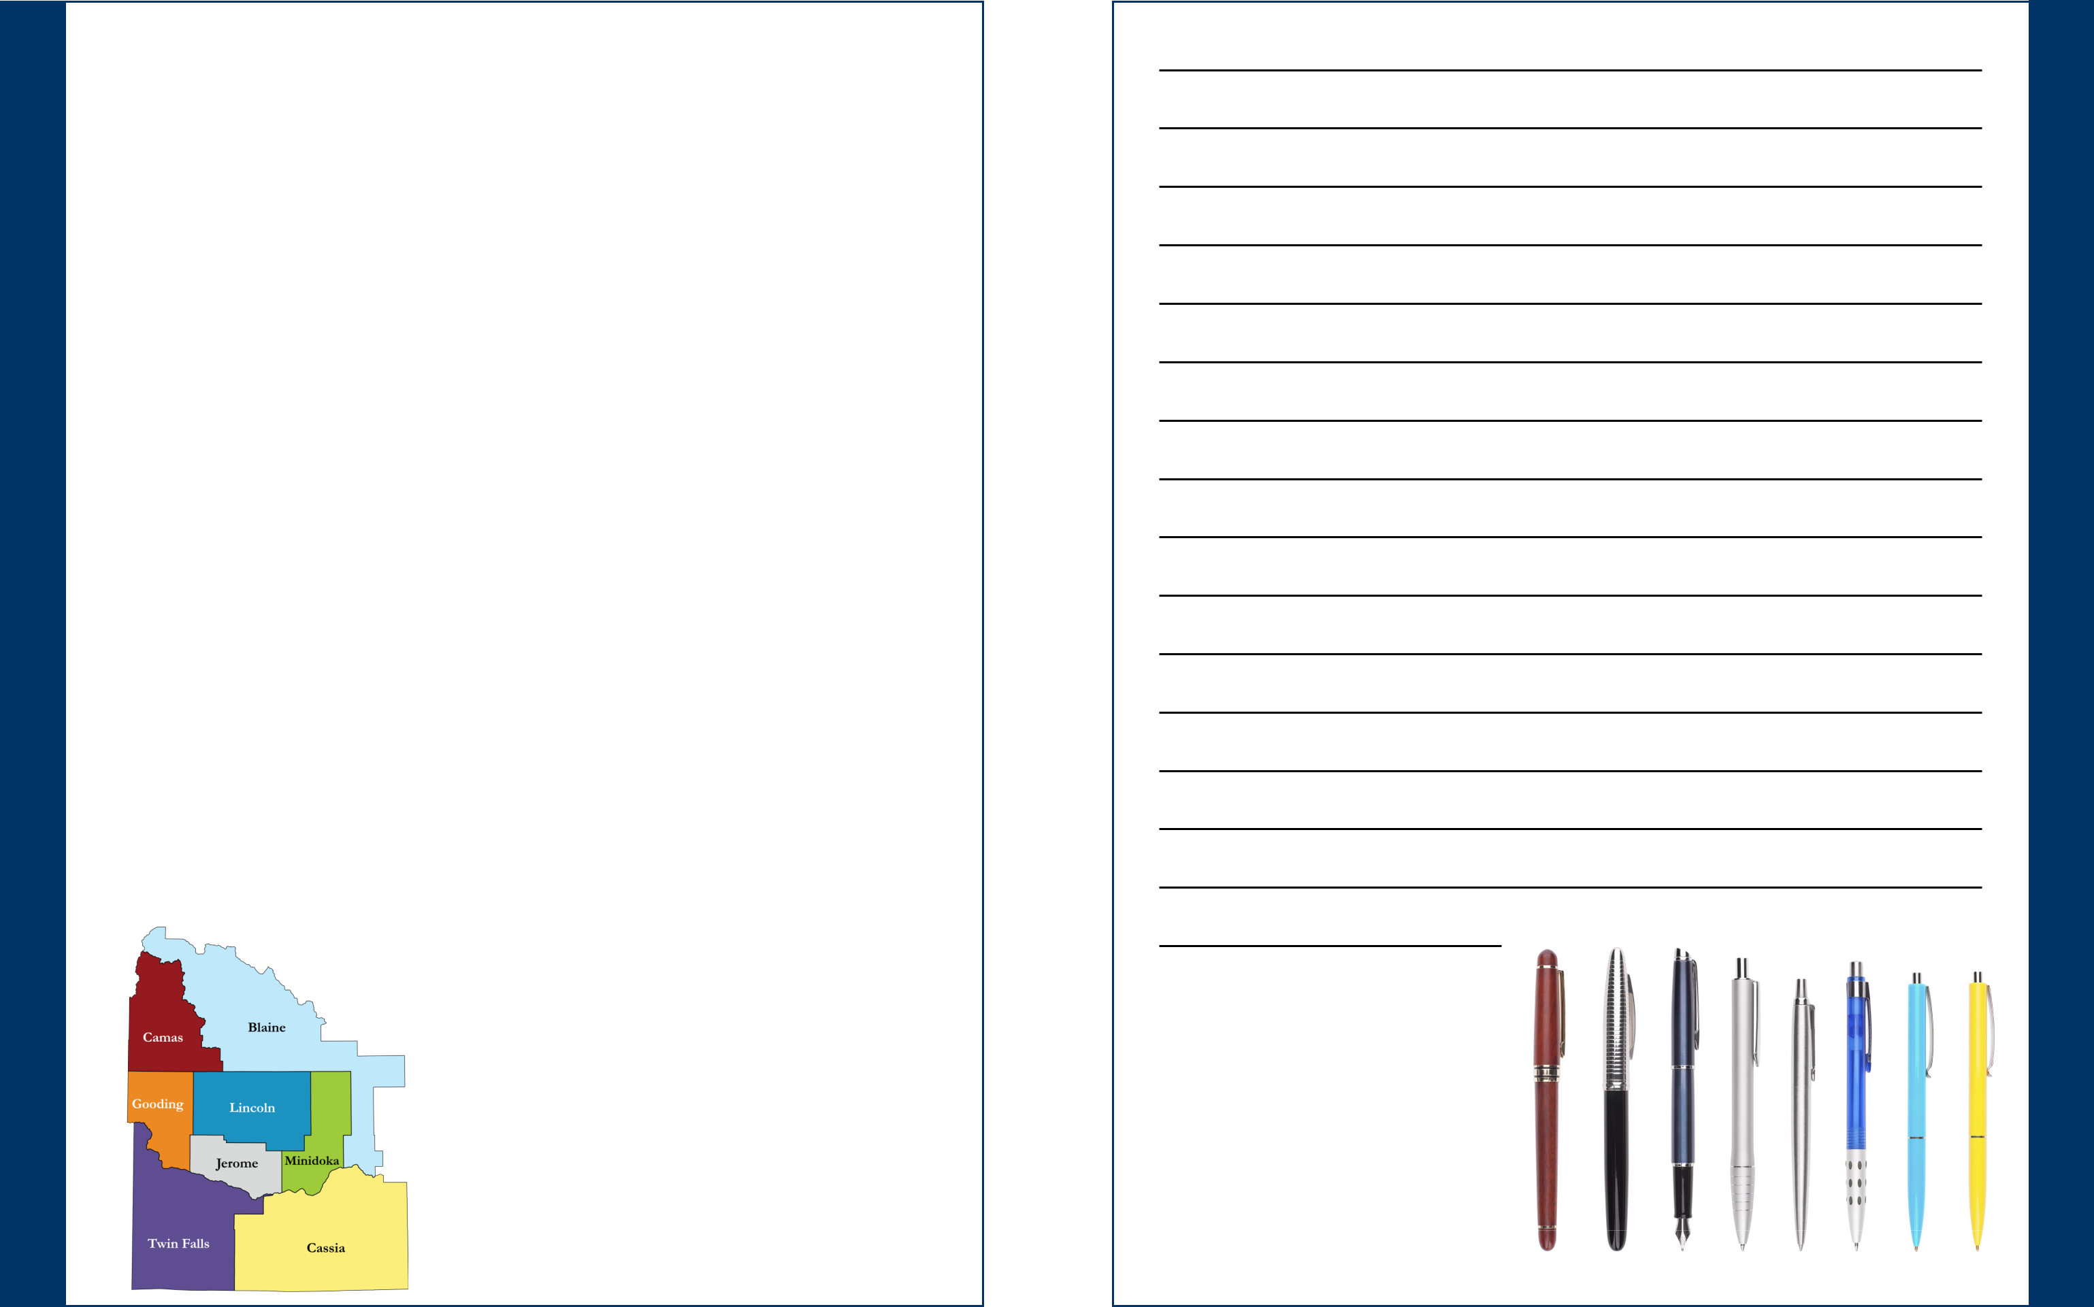

PREVENT disease;

PROMOTE healthy lifestyles; and

PROTECT and PREPARE the public against health threats.

Administration

Melody Bowyer, MBA, REHS, CPM District Health Director

Jeremy St Clair Financial Specialist, Principal

Bob Moulson, MBA IT Resource Manager

Eric Myers Business Operations Specialist

Yvonne Humphrey Administrative Assistant II

Nancy Andreotti Administrative Assistant I

Division Directors

Cheryle Becker, RN Family and Children’s Health Division Administrator

Craig Paul, MS, REHS, CPSS Environmental Health and Public Health Preparedness

Division Director

Susie Beem, BS, CHES Community Health Division Director

 |  | Blaine |  | Jerome
 |  | County |  | County
 |  | Camas |  | Lincoln
 |  | County |  | County
 |  | Cassia |  | Minidoka
 |  | County |  | County
 |  | Gooding |  | Twin Falls
 |  | County |  | County
2 |  |  | 35

Notes

Linda F. Montgomery | Charles Ritter | Robert Kunau
Chair | Vice-Chair | Trustee/ Ex Counsel Member
Jerome County | Lincoln County | Cassia County
 |  | (Commissioner)

Notes

Angenie McCleary
Blaine County
(Commissioner)

Tracy Haskin
Minidoka County

Pamela J. Jones, RN
Camas County

Terry Kramer
Twin Falls County
(Commissioner)

Helen Edwards
Gooding County
(Commissioner)

Peter Curran, MD
Medical Consultant

Board of Health

Melody Bowyer, MBA, REHS/RS
District Health Director
Board Secretary

34 3

FY-2019 Budget Proposal
SCPHD FY-2019 Budget Proposal

 |  | APPROVED
 | FY-2018 BUDGET
ESTIMATED EXPENDITURES
BY CLASSIFICATION
Personnel costs | $ | 4,901,361
Operating expenses |  | 1,429,939
Sub-grantee payments |  | 1,443,000
Capital outlay-- general |  | 224,570
Capital outlay-- building |  | 259,900
TOTAL ESTIMATED EXPENDITURES | $ | 8,258,770
ESTIMATED INCOME
County funds | $ | 1,184,644
State general fund |  | 1,204,400
State millennium fund |  | 91,400
Contracts |  | 4,465,756
Fees/insurance and |  | 1,024,700
miscellaneous
Reserve draw |  | 287,870
TOTAL ESTIMATED INCOME | $ | 8,258,770

The Board shall not ignore fiscal reality and is expected to revise the budget should variable-type

Twin Falls (Main Office)
1020 Washington St N
Twin Falls, ID 83301
Ph:
Fax:

Gooding Office
255 North Canyon Drive
Gooding, ID 83330
Ph:
Fax:

Mini-Cassia Office
485 22nd Street
Heyburn, ID 83336
Ph:
Fax:

Bellevue Office
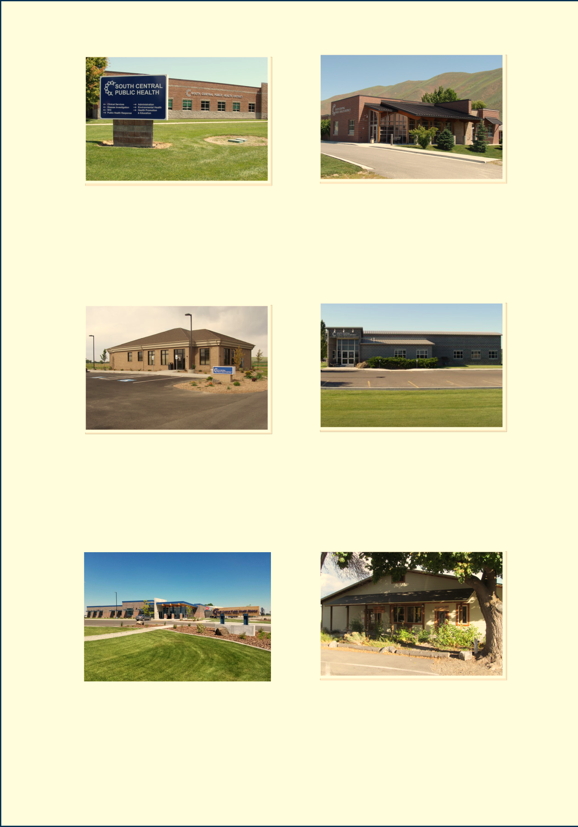
117 East Ash Street
Bellevue, ID 83313
Ph:
Fax:

Jerome Office
951 East Avenue H
Jerome, ID 83338
Ph:
Fax:

Shoshone Clinic
Lincoln County Community Center
201 South Beverly Street
Shoshone, ID 83352
Ph:
Fax:

SCPHD Offices

revenues increase or decrease during the fiscal year.

4 33

Idaho Public Health Districts

Panhandle Health | Public Health— |  |  | Southwest District |  |  | Central District
District | Idaho North Central |  |  |  | Health |  | Health Department
 |  | District
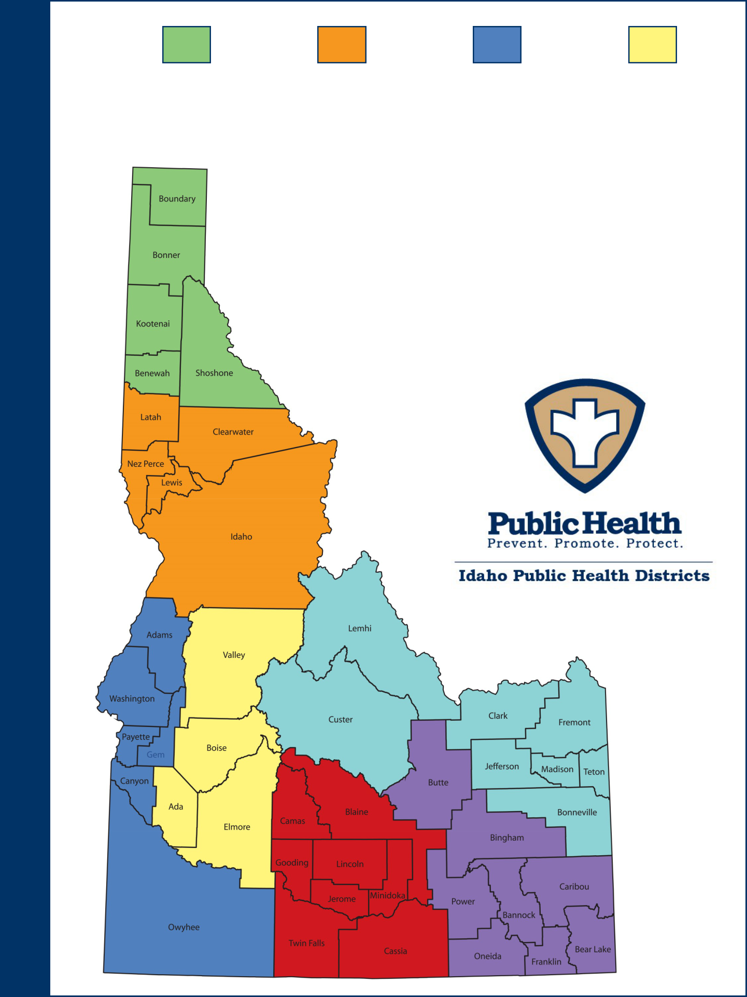

South Central | Southeastern Idaho | Eastern Idaho
Public Health | Public Health | Public Health
District |  | District

 |  | PROPOSED |  | CHANGE -- FY-2018
 |  | BUDGET |  | PROPOSED TO FY-19 FINAL
 | $ | 4,853,371 |  | (47,990) |  | -0.98%
 |  | 1,341,129 |  | (88,810) |  | -6.21%
 |  | 1,517,795 |  | 74,795 |  | 5.18%
 |  | 101,721 |  | (122,849) |  | -54.70%
 |  | 65,200 |  | (194,700) |  | -74.91%
 | $ | 7,879,216
 |  |  |  |  | (379,554) | -4.60%

 | $ | 1,220,181 | 35,494 |  | 3.00%
 |  | 1,209,400 | 5,000 |  | 0.42%
 |  | 91,400 | - |  | 0.00%
 |  | 4,400,065 | (65,648) |  | -1.47%
 |  | 958,170 | (66,530) |  | -6.49%
 |  | - | (287,870) |  | -100.00%
 | $ | 7,879,216 |  | (379,554) | -4.60%

32 5

FY-2019 Budget Proposal

County Contribution: FY-2019
with 3% Increase |  |  |  |  |  |  |  |  | Idaho | Blaine | Camas | Cassia | Gooding | Jerome | Lincoln | Minidoka | Twin Falls
 |  |  |  |  |  |  |  | Length of Life
 | FY-2019
 |  |  |  |  |  |  |  | Premature age-adjusted mortality | 307 | 201 | NR | 390 | 405 | 367 | 274 | 320 | 350
 | AMOUNTS |  |  |  |  |  |  | Infant mortality | 5 | NR | NR | 7 | NR | 10 | NR | NR | 4
 |  | BLAINE | CAMAS | CASSIA
 |  |  |  |  |  |  |  | Child mortality | 49.7 | NR | NR | 75.8 | 105.7 | 123.8 | NR | 55.4 | 40.9
 | WITH ?%
 |  |  |  |  |  |  |  | Quality of Life
 | INCREASE
 |  |  |  |  |  |  |  | Frequent physical distress | 11% | 10% | 13% | 11% | 12% | 12% | 13% | 12% | 11%
 |  |  |  |  |  |  |  | Frequent mental distress | 11% | 11% | 13% | 12% | 12% | 12% | 12% | 12% | 12%
 | EST. | 22,024 | 1,102 | 23,664 |  |  |  | Diabetes | 9% | 6% | 10% | 9% | 10% | 8% | 8% | 11% | 9%
 |  |  |  |  |  |  |  | HIV prevalence | 79 | 23 | NR | NR | 82 | 34 | NR | NR | 35 |  | County
 | POPULATION+
 |  |  |  |  |  |  |  | Health Behaviors
 | VALUE++
 | PROPORTION | 0.1120 | 0.0056 | 0.1203
 |  |  |  |  |  |  |  | Food insecurity | 14% | 10% | 15% | 10% | 11% | 10% | 10% | 9% | 13%
 |  |  |  |  |  |  |  | Limited access to healthy foods | 7% | 8% | 55% | 12% | 1% | 12% | 45% | 8% | 3%
 |  |  |  |  |  |  |  | Drug overdose deaths | 14 | NR | NR | NR | NR | NR | NR | NR | 16
 | MARKET | 9,445,929,066 | 130,797,627 | 1,442,845,425 |  |  |  | Drug overdose deaths-modeled | 15.2 | 5.0 | 5.0 | 5.0 | 7.0 | 6.0 | 6.0 | 9.0 | 7.0
 |  |  |  |  |  |  |  | Motor vehicle crash deaths | 13 | 9 | NR | 26 | 25 | 21 | 33 | 23 | 18
 | PROPORTION | 0.4591 | 0.0064 | 0.0701 |  |  |  | Insufficient sleep | 29% | 26% | 29% | 29% | 31% | 31% | 31% | 29% | 28% |  | Health
 |  |  |  |  |  |  |  | Clinical Care
 |  |  |  |  |  |  |  | Uninsured adults | 16% | 19% | 25% | 24% | 28% | 27% | 24% | 25% | 19%
 |  |  |  |  |  |  |  | Uninsured children | 6% | 11% | 15% | 9% | 9% | 10% | 10% | 8% | 7%
 | 70%
 |  | 95,629 | 4,785 | 102,750 |  |  |  | Health care costs | $8,411 | $7,583 | $8,383 | $8.608 | $10,703 | $9,605 | $8,889 | $7,449 | $9.016
 | POPULATION |  |  |  |  |  |  | Other primary care providers | 1080:1 | 2421:1 | 1072:1 | 1567:1 | 1380:1 | 3285:1 | 1318:1 | 4123:1 | 1031:1
 | 30% |  |  |  |  |  |  | Social & Economic Factors |  |  |  |  |  |  |  |  |  |  | Rankings
 |  | 168,069 | 2,327 | 25,672 |  |  |  | Median household income | $51,674 | $66,210 | $49.153 | $48,983 | $46,948 | $48,590 | $47,754 | $48,903 | $49,415
 | VALUATION
 |  |  |  |  |  |  |  | Children eligible for free lunch | 47% | 41% | 46% | 52% | 64% | 67% | 70% | 99% | 54%
 | COUNTY |  |  |  |  |  |  | Residential segregation– black/ | 70 | NR | NR | NR | NR | NR | NR | NR | 72
 |  |  |  |  |  |  |  | white
 |  | 263,697 | 7,112 | 128,422
 | TOTALS |  |  |  |  |  |  | Residential segregation– non | 30 | 19 | NR | 23 | 8 | 33 | NR | 22 | 24
 |  |  |  |  |  |  |  | white/white
 |  |  |  |  |  |  |  | Homicides | 2 | NR | NR | NR | NR | NR | NR | NR | 2
FY-2018 County Totals |  |  |  |  |  |  |  | Physical Environment
 |  |  |  |  |  |  |  | Demographics
 |  |  |  |  |  |  |  | Population | 1,683,140 | 21,791 | 1,072 | 23,504 | 15,185 | 22,994 | 5,271 | 20,616 | 83,514
 | COUNTY | 262,037 | 6,886 | 125,849 |  |  |  | % below 18 years of age | 26% | 22.9% | 23.1% | 32.2% | 27.5% | 31.2% | 30.4% | 28.7% | 27.8%
 |  |  |  |  |  |  |  | % 65 and older | 15.1% | 17.9% | 21.3% | 14.0% | 16.7% | 12.4% | 13.5% | 15.9% | 15.1%
 | TOTALS
 |  |  |  |  |  |  |  | % Non-Hispanic African Ameri- | 0.7% | 0.2% | 0.3% | 0.2% | 0.2% | 0.3% | 0.4% | 0.3% | 0.6%
 |  |  |  |  |  |  |  | can
 |  |  |  |  |  |  |  | % American Indian and Alaskan | 1.8% | 1.7% | 1.5% | 1.6% | 2.0% | 2.3% | 1.6% | 2.3% | 1.3%
 |  |  |  |  |  |  |  | Native
FY-2019 Increase/Decrease
 |  |  |  |  |  |  |  | % Native Hawaiian/Other Pacific | 1.5% | 1.0% | 0.5% | 0.8% | 0.8% | 0.5% | 0.5% | 0.6% | 1.5%
 |  |  |  |  |  |  |  | % Asian
 |  |  |  |  |  |  |  | Islander | 0.2% | 0.1% | 0.1% | 0.2% | 0.3% | 0.2% | 0.2% | 0.0% | 0.2%
 | COUNTY
 |  | 1,660 | 226 | 2,573 |  |  |  | % Hispanic | 12.3% | 21.7% | 7.8% | 27.4% | 29.3% | 34.3% | 30.1% | 34.8% | 15.9%
 | TOTALS |  |  |  |  |  |  | % Non-Hispanic white | 82.4% | 75.9% | 86.4% | 69.9% | 67.7% | 63.4% | 67.2% | 62.5% | 79.9%
 |  |  |  |  |  |  |  | % not proficient in English | 2.1% | 5.4% | 1.6% | 7.0% | 8.8% | 11.5% | 8.9% | 9.2% | 3.2%
+ U.S. Census Bureau |  |  |  |  |  |  |  | % Females | 49.9% | 49.4% | 48.6% | 49.1% | 48.7% | 49.3% | 48.7% | 49.6% | 50.6%
++ State of Idaho Tax Commission |  |  |  |  |  |  |  | % Rural | 29.4% | 32.8% | 100.0% | 51.5% | 58.1% | 51.3% | 100.0% | 44.2% | 28.0%
 |  | 6 |  |  |  |  |  |  |  |  |  | 31

 |  |  | Idaho | Blaine | Camas | Cassia | Gooding | Jerome | Lincoln | Minidoka | Twin Falls
 |  | Health Outcomes
 |  | Length of Life
 |  | Premature death | 6290 | 4809 | NR | 7909 | 8802 | 8114 | 7402 | 6804 | 6701
 |  | Quality of Life
 |  | Poor or fair health | 15% | 14% | 18% | 18% | 19% | 18% | 19% | 20% | 16%
 |  | Poor physical health days | 3.7 | 3.3 | 4.1 | 3.7 | 4.0 | 4.0 | 4.1 | 4.0 | 3.7
 |  | Poor mental health days | 3.7 | 3.4 | 4.1 | 3.8 | 4.0 | 3.8 | 3.9 | 3.9 | 3.7
 |  | Low birth weight | 7% | 7% | NR | 7% | 7% | 8% | 7% | 9% | 7%
 |  | Health Factors
Rankings |  | Health Behaviors
 |  | Adult smoking | 14% | 12% | 16% | 14% | 16% | 16% | 17% | 14% | 16%
 |  | Adult obesity | 29% | 18% | 26% | 35% | 33% | 35% | 30% | 36% | 31%
 |  | Food environment index | 7.1 | 8.2 | 2.9 | 7.8 | 8.7 | 7.9 | 4.8 | 8.4 | 8.2
 |  | Physical inactivity | 20% | 13% | 22% | 23% | 24% | 25% | 21% | 24% | 24%
 |  | Access to exercise opportunities | 80% | 79% | 6% | 66% | 76% | 73% | 20% | 68% | 81%
 |  | Excessive drinking | 17% | 19% | 15% | 15% | 16% | 17% | 15% | 15% | 16%
 |  | Alcohol-impaired driving deaths | 32% | 17% | 0 | 14% | 26% | 24% | 36% | 6% | 33%
Health
 |  | Sexually transmitted infections | 345 | 177 | NR | 263 | 305 | 342 | 282 | 325 | 393
 |  | Teen births | 26 | 16 | NR | 43 | 41 | 53 | 36 | 48 | 37
 |  | Clinical Care
 |  | Uninsured | 13% | 17% | 22% | 18% | 22% | 21% | 19% | 19% | 15%
 |  | Primary care physicians | 1555:1 | 939:1 | 1066:0 | 1469:1 | 3057:1 | 2535:1 | 5267:1 | 3410:1 | 1350:1
 |  | Dentists | 1541:1 | 1090:1 | 1072:0 | 1383:1 | 5062:1 | 3285:1 | 5271:1 | 2945:1 | 1326:1
County |  | Mental health providers | 523:1 | 703:1 | NR | 940:1 | 799:1 | 5749:1 | 5271:1 | 4123:1 | 405:1
 |  | Some college | 64.5% | 60.4% | 49.7% | 53.5% | 42.3% | 43.5% | 37.2% | 48.1% | 59.8%
 |  | Preventable hospital stays | 32 | 15 | NR | 50 | 50 | 32 | 32 | 34 | 32
 |  | Diabetic monitoring | 82% | 83% | NR | 74% | 76% | 81% | 85% | 79% | 83%
 |  | Mammography screening | 58% | 66.1% | NR | 50.0% | 52.1% | 48.8% | 50.0% | 57.4% | 59.6%
 |  | Social & Economic Factors
 |  | High school graduation | 79% | 88% | NR | 84% | 68% | 82% | NR | 68% | 82%
 |  | Unemployment | 3.8% | 3.2% | 3.8% | 3.0% | 6.4% | 6.4% | 4.5% | 3.3% | 3.4%
 |  | Children in poverty | 17% | 13% | 14% | 18% | 20% | 22% | 19% | 21% | 18%
 |  | Income inequality | 4.2 | 4.5 | 3.9 | 3.8 | 3.8 | 3.7 | 3.5 | 3.5 | 4.0
 |  | Children in single-parent house- | 25% | 38% | 43% | 24% | 23% | 20% | 14% | 32% | 24%
 |  | holds
 |  | Social associations | 7.4 | 13.9 | 28.1 | 6.8 | 7.9 | 7.0 | 5.7 | 5.9 | 10.0
 |  | Violent crime | 212 | 201 | 31 | 189 | 170 | 244 | 270 | 136 | 247
 |  | Injury deaths | 71 | 73 | NR | 102 | 90 | 84 | 94 | 86 | 91
 |  | Physical Environment
 |  | Air pollution - particulate matter | 7.2 | 6.5 | 5.9 | 6.9 | 7.5 | 7.6 | 6.7 | 7.3 | 7.4
 |  | Drinking water violations |  | Yes | No | Yes | No | Yes | No | Yes | Yes
 |  | Severe housing problems | 16% | 18% | 22% | 13% | 19% | 17% | 16% | 12% | 15%
 |  | Driving alone to work | 78% | 76% | 77% | 79% | 80% | 81% | 70% | 85% | 82%
 |  | Long commute - driving alone | 22% | 23% | 52% | 17% | 26% | 16% | 49% | 15% | 14%

TWIN
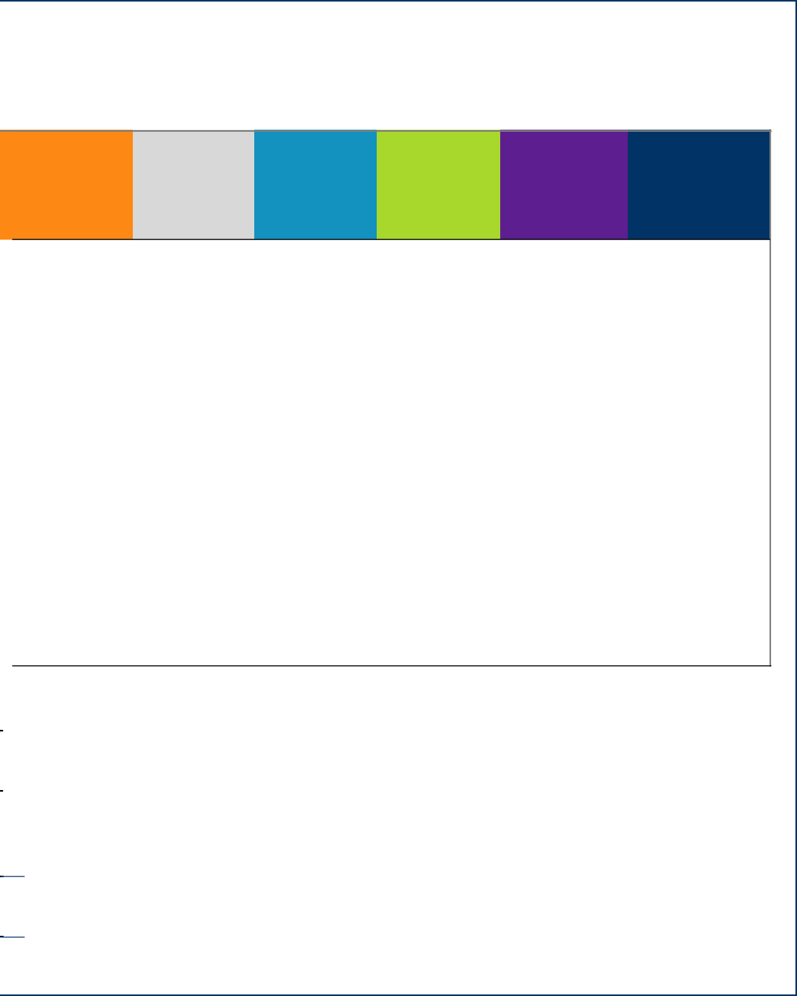
GOODING JEROME LINCOLN MINIDOKA TOTAL FALLS

 | 15,124 | 23,627 | 5,318 | 20,729 | 85,124 | 196,712
 | 0.0769 | 0.1201 | 0.0270 | 0.1054 | 0.4327 | 1.0000
 | 1,076,686,284 | 1,340,341,635 | 359,948,727 | 1,333,670,955 | 5,443,064,573 | 20,573,284,292
 | 0.0523 | 0.0651 | 0.0175 | 0.0648 | 0.2646 | 1.0000
 | 65,669 | 102,589 | 23,091 | 90,006 | 369,610 | 854,127
 | 19,157 | 23,848 | 6,404 | 23,730 | 96,847 | 366,054
 | 84,826 | 126,437 | 29,495 | 113,735 | 466,457 | 1,220,181

83,273 | 122,097 | 28,589 | 110,663 | 445,248 | 1,184,642

1,553 | 4,340 | 906 | 3,072 | 21,209 | 35,539

30 7

Summary of Expenditures and Revenues by PCA FY-2018

 |  |  |  |  |  |  |  |  | Expenses
PCA |  |  |  | Salary |  | Fringe | Operating |  | Capital Outlay | SubGrantee | Total Exp
 | Administration and General Support
 | 11100 | Admin |  | 93,889.54 |  | 32,979.99 | 8,400.00 |  | - | - | 135,269.52
 | 11200 |  | Board | 6,750.00 |  | 668.49 | 8,020.00 |  | - | - | 15,438.49
by | 11999 | Admin Misc. |  | - |  | - | 2,360.00 |  | - | - | 2,360.00
 | 12000 |  | Gen Support | 450,183.45 |  | 215,808.29 | 50,190.00 |  | 101,720.84 | - | 817,902.58
 | 12010 | IT Operating/Repair/Maintenance |  | - |  | - | 157,000.00 |  | - | - | 157,000.00
 | 12011 |  | IT Allocated Computer Costs | - |  | - | 30,000.00 |  | - | - | 30,000.00
Revenues | 12020 | Auto Fleet Costs |  | - |  | - | (45,440.00) |  | - | - | (45,440.00)
 | 12030 |  | Allocated District Costs | - |  | - | 4,000.00 |  | - | - | 4,000.00
 | 12040 | Training/Travel Costs - Dist |  | - |  | - | - |  | - | - | -
 |  | Funded & Carryover
 | 12100 |  | Build Fund Gen | - |  | - | - |  | - | - | -
 | 12110 | Build Fund Bellevue |  | - |  | - | 1,000.00 |  | 11,300.00 | - | 12,300.00
 | 12140 |  | Building Fund Gooding | - |  | - | 690.00 |  | 6,800.00 | - | 7,490.00
 | 12150 | Build Fund Jerome |  | - |  | - | 4,260.00 |  | 15,800.00 | - | 20,060.00
 | 12170 |  | Build Fund Mini-Cassia | - |  | - | 750.00 |  | - | - | 750.00
 | 12180 | Build Fund TF |  | - |  | - | 28,380.00 |  | 30,800.00 | - | 59,180.00
 | 12210 |  | Maint Bellevue | - |  | - | 26,000.00 |  | - | - | 26,000.00
and | 12240 | Maint Gooding |  | - |  | - | 20,320.00 |  | - | - | 20,320.00
 | 12250 |  | Maint Jerome | - |  | - | 35,060.00 |  | - | - | 35,060.00
 | 12260 | Maint Shoshone |  | - |  | - | 2,000.00 |  | - | - | 2,000.00
 | 12270 |  | Maint Mini-Cassia | - |  | - | 43,420.00 |  | - | - | 43,420.00
 | 12280 | Maint TF |  | - |  | - | 96,100.00 |  | - | - | 96,100.00
Expenditures | 12600 |  | Community Relations | 22,229.89 |  | 5,246.85 | 29,227.00 |  | - | - | 45,703.74
 | 12850 |  | Vital Statistics | 1,583.41 |  | 957.07 | 254.00 |  | - | - | 2,749.48
 | 12999 | General Support Misc. |  | - |  | - | 3,330.00 |  | - | - | 3,330.00
 | GSP Division Totals |  |  | 563,635.28 |  | 255,660.69 | 505,321.00 |  | 166,420.84 | - | 1,491,038.80
 | Family, Children's Health
 | 13100 | FCH IT |  | 34,264.93 |  | 17,312.88 | (51,850.00) |  | - | - | (2.19)
 | 13210 |  | Adult Services | - |  | - | 50.00 |  | - | - | 50.00
 | 13220 |  | School Health | 11,579.48 |  | 5,023.94 | 3,115.00 |  | - | - | 19,718.43
 | 13225 |  | Lead Screening | 3,419.33 |  | 1,598.80 | 3,377.00 |  | - | - | 8,395.12
 | 13230 |  | AIDS | 5,908.38 |  | 2,392.14 | 2,816.00 |  | - | - | 11,116.52
 | 13231 |  | HIV Surveillence | 2,224.23 |  | 897.30 | 378.00 |  | - | - | 3,499.53
 | 13236 |  | STD | 4,794.60 |  | 1,955.34 | 6,958.00 |  | - | - | 13,707.93
 | 13245 |  | RMA Refugee | 30,729.25 |  | 14,721.29 | 14,933.00 |  | - | - | 60,383.54
 | 13250 |  | Child Health | - |  | - | 30.00 |  | - | - | 30.00
 | 13255 |  | Early Headstart | 29,034.25 |  | 12,522.13 | 5,174.00 |  | - | - | 46,730.74
of | 13265 |  | Nurse Home Visitation | 158,542.03 |  | 72,193.94 | 32,862.00 |  | - | - | 263,597.97
 | 13266 |  | District Nurse Home Visit | 40,850.49 |  | 18,182.29 | 7,283.00 |  | - | - | 66,315.79
 | 13390 |  | Imm-VFC | 212,588.61 |  | 105,464.68 | 92,427.00 |  | - | - | 410,480.30
Summary | 13392 |  | Imm-DP Adult | 161,725.24 |  | 79,872.73 | 300,934.00 |  | - | - | 542,531.97
 | 13394 |  | Imm Provider Assessment | 17,322.23 |  | 7,173.76 | 4,015.00 |  | - | - | 28,510.99
 | 13395 |  | Imm Follow-up | 6,511.02 |  | 2,542.52 | 559.00 |  | - | - | 9,612.54
 | 13396 |  | Prenatal HepB | 1,032.82 |  | 409.85 | 73.00 |  | - | - | 1,515.67
 | 13400 |  | Epi | 42,961.41 |  | 18,167.89 | 6,723.00 |  | - | - | 67,852.30
 | 13405 |  | Comm Dis | 14,318.79 |  | 5,960.43 | 3,002.00 |  | - | - | 23,281.22
 | 13410 |  | NEDSS Capacity | 10,751.52 |  | 9,736.51 | 1,800.00 |  | - | - | 19,288.04
 | 13415 |  | Biosense | 7,624.72 |  | 2,876.79 | 2,271.00 |  | - | - | 12,772.51
 | 13450 |  | TB | 35,721.55 |  | 14,477.72 | 12,079.00 |  | - | - | 62,278.27
 | 13500 |  | SHIP | 58,374.72 |  | 26,736.87 | 12,086.00 |  | - | - | 97,197.59
 | 13670 |  | BCC | 30,711.95 |  | 13,916.37 | 17,066.00 |  | - | - | 61,694.32
 | 13820 |  | Epi Surveillance | 78,480.45 |  | 31,074.62 | 6,541.00 |  | - | - | 116,096.07
 | 13999 |  | FCH Misc | 1,145.98 |  | 493.21 | 114.00 |  | - | - | 1,753.18
 |  |  | FCH Division Totals | 1,000,618.34 |  | 462,704.01 | 485,086.00 |  | - | - | 1,948,408.35
Crisis Center of South Central Idaho

Over the last year the Crisis Center has strived to create a warm, safe, place for individuals who are experiencing a mental health or substance abuse crisis to access help. Below are some graphs showing the number of visits, and the Counties served during the year.

Every county in Region 5 has been served by the Crisis Center.

Due to the location most clients served are from Twin Falls County.

779 of those
served were
unduplicated.

Administration

8 29

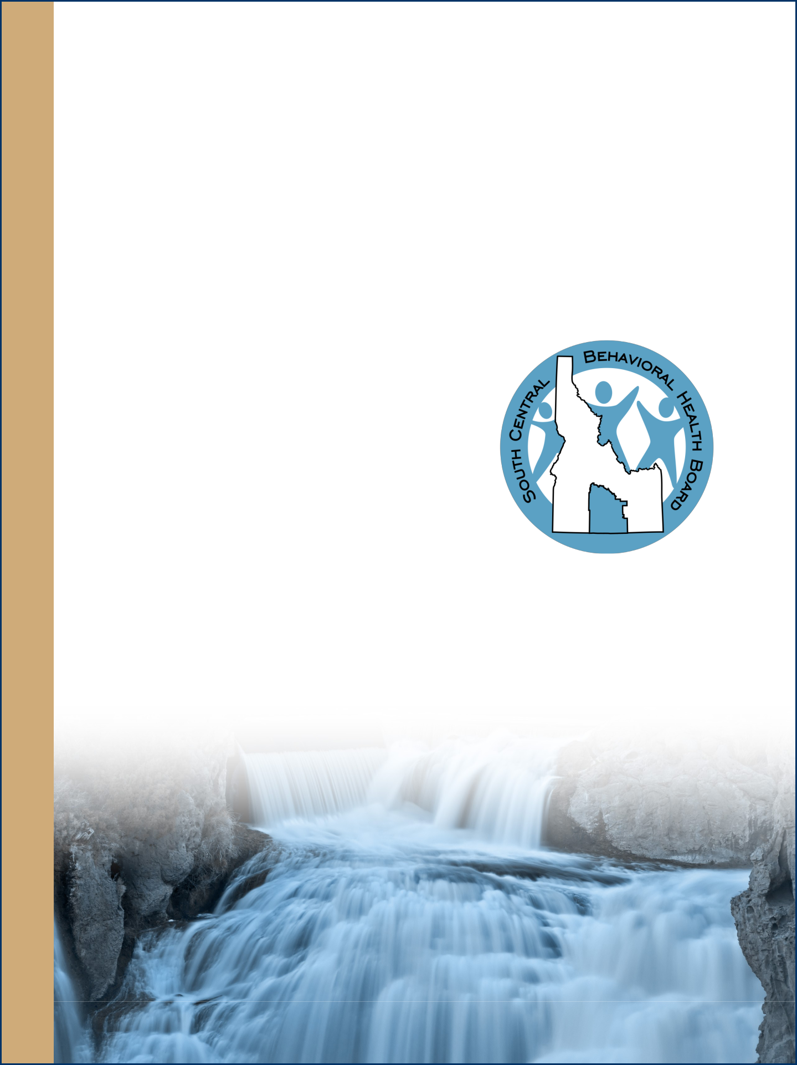
Regional Behavioral Health Board

SCPHD has a contract with the State of Idaho to support the South Central Behavioral Health Board (SCBHB) with administrative duties. Salaries and other administrative fees used to give that support are calculated and deducted from the contract monthly. At the end of FY-2016 the sum of $5,792.31 was awarded to SCBHB as “Free Funds” in accordance to policy.

The Free Fund amount at the end of contract year 2017 was $34,002.91, giving SCBHB a substantial amount of money to use to fund mini-grants.

With that in mind, SCBHB has worked diligently over the last few months to updated their Gaps & Needs (G&N) Analysis for the State Behavioral Health Planning Council and setting their strategic priorities for the upcoming year. With those priorities established, they are now in the position to accept applications for mini-grants, which will align with the following:

 | 1. | Access to Care
 |  | a. Mobile Care
Administration |  | b. Tele-behavioral Health
 |  | c. Youth Services
 |  | d. Crisis Services
 | 2. | Transportation
a. Uber Models
b. Voucher Models
c. Volunteer Models

3. Public Education and Outreach
a. Education to School Personnel (Office Staff, Teachers, Administrators)
b. Law Enforcement
c. General Public
d. Legislators, Law Makers, Commissioners

For more information, or to apply for a mini-grant go to:

28

 |  | Legend: |  |  |  | White = Administration
 |  |  |  |  |  | Red = Category 1: Mandatory/Statutory |  |  |  | Yellow = Category 3: Federal Contracts through IDHW/IDEQ
 |  |  |  |  |  | Orange = Category 2: Core Public Health |  |  |  | Green = Category 4: Local Board of Health Option
 |  |  | Revenues |  |  |  |  |  |  |  |  |  | Previous Year Comparison
 | Contract |  | Fees/Donations |  |  |  | Total Rev |  |  |  | Total | Estimate of | Total Exp |  | Trend
 |  |  |  |  |  |  |  |  | Indirect |  | Expenditures | District Support
1,20,138.00 |  |  |  |  | 30,000.00 |  | 1,250,138.00 |  |  |  |  |  | 146,723.59 |  | -
 | - |  |  |  | - |  | - |  |  |  |  |  | 15,684.19 |  | -
- |  |  |  |  | - |  | - |  |  |  |  |  | 7,578.55 |  | -
 | 500.00 |  |  |  | 20,540.00 |  | 21,040.00 |  |  |  |  |  | 684,633.60 |  | +
- |  |  |  |  | - |  | - |  |  |  |  |  | 153,500.00 |  | +
 | - |  |  |  | - |  | - |  |  |  |  |  | 10,000.00 |  | +
- |  |  |  |  | - |  | - |  |  |  |  |  | (41,300.00) |  | -
 | - |  |  |  | - |  | - |  |  |  |  |  | - |  | +
- |  |  |  |  | 5,900.00 |  | 5,900.00 |  |  |  |  |  | - |  | -
- |  |  |  |  | - |  | - |  |  |  |  |  | 16,000.00 |  | -
 | - |  |  |  | - |  | - |  |  |  |  |  | 6,000.00 |  | -
 | - |  |  |  | - |  | - |  |  |  |  |  | 31,200.00 |  | -
 | - |  |  |  | - |  | - |  |  |  |  |  | 26,800.00 |  | -
 | - |  |  |  | - |  | - |  |  |  |  |  | 54,100.00 |  | -
 | - |  |  |  | - |  | - |  |  |  |  |  | 1,372,000.00 |  | -
- |  |  |  |  | - |  | - |  |  |  |  |  | 209,450.00 |  | -
 | - |  |  |  | - |  | - |  |  |  |  |  | 25,550.00 |  | +
- |  |  |  |  | - |  | - |  |  |  |  |  | 17,357.00 |  | +
 | - |  |  |  | - |  | - |  |  |  |  |  | 33,100.00 |  | +
- |  |  |  |  | - |  | - |  |  |  |  |  | 3,650.00 |  | -
 | - |  |  |  | - |  | - |  |  |  |  |  | 10,500.00 |  | -
- |  |  |  |  | - |  | - |  |  |  |  |  | 96,569.00 |  | -
 | - |  |  |  | - |  | - |  | 5,345.43 |  | 51,049.17 | 51,049.17 | 69,842.76 |  | -
 | - |  |  |  | 3,000.00 |  | 3,000.00 |  | 753.70 |  | 3,548.18 | 548.18 | 4,635.12 |  | -
- |  |  |  |  | - |  | - |  | - |  | 3,330.00 | 3,330.00 | 3,850.00 |  | -
1,220,638.00 |  |  |  |  | 59,440.00 |  | 1,280,078.00 |  | 6,099.13 |  | 57,927.35 | 54,927.35 | 2,957,423.81 |  | -
- |  |  |  |  | - |  | - |  | - |  | (2.19) | (2.19) | 44.77 |  | -
 | - |  |  |  | - |  | - |  | - |  | 50.00 | 50.00 | - |  | +
 | 16,500.00 |  |  |  | - |  | 16,500.00 |  | 5,511.83 |  | 25,230.26 | 8,730.26 | 29,628.18 |  | -
 | - |  |  |  | 5,000.00 |  | 5,000.00 |  | 1,627.60 |  | 10,022.72 | 5,022.72 | 3,237.14 |  | +
21,380.00 |  |  |  |  | - |  | 21,380.00 |  | 2,812.39 |  | 13,928.91 | (7,451.09) | 6,959.23 |  | +
 | 4,550.00 |  |  |  | - |  | 4,550.00 |  | 1,058.73 |  | 4,558.26 | 8.26 | 5,871.14 |  | -
14,000.00 |  |  |  |  | - |  | 14,000.00 |  | 2,282.23 |  | 15,990.16 | 1,990.16 | 21,615.37 |  | -
 | 70,000.00 |  |  |  | 5,000.00 |  | 75,000.00 |  | 14,627.12 |  | 75,010.66 | 10.66 | 108,346.00 |  | -
- |  |  |  |  | - |  | - |  | - |  | 30.00 | 30.00 | 399.62 |  | -
 | 33,660.00 |  |  |  | - |  | 33,660.00 |  | 13,820.47 |  | 60,551.22 | 26,891.22 | 36,984.44 |  | +
268,330.00 |  |  |  |  | - |  | 268,330.00 |  | 75,466.00 |  | 339,063.97 | 70,733.97 | 209,864.18 |  | +
 | - |  |  |  | - |  | - |  | 19,444.83 |  | 85,760.62 | 85,760.62 | 10,071.13 |  | +
- |  |  |  |  | 90,000.00 |  | 90,000.00 |  | 101,192,.18 |  | 511,672.48 | 421,672.48 | 485,534.12 |  | -
 | - |  |  |  | 226,040.00 |  | 226,040.00 |  | 76,981.22 |  | 619,513.18 | 393,473.18 | 441,379.91 |  | +
36,750.00 |  |  |  |  | - |  | 36,750.00 |  | 8,245.38 |  | 36,756.37 | 6.37 | 44,535.92 |  | -
 | 9,270.00. |  |  |  | - |  | 9,270.00 |  | 3,099.24 |  | 12,711.78 | 3,441.78 | 6,277.36 |  | +
2,000.00 |  |  |  |  | - |  | 2,000.00 |  | 491.62 |  | 2,007.29 | 7.29 | 953.24 |  | +
 | 62,220.00 |  |  |  | - |  | 62,220.00 |  | 20,449.63 |  | 88,301.93 | 26,081.93 | 36,090.33 |  | +
30,000.00 |  |  |  |  | - |  | 30,000.00 |  | 6,815.74 |  | 30,096.96 | 96.96 | 35,278.20 |  | -
 | 20,000.00 |  |  |  | - |  | 20,000.00 |  | 5,117.73 |  | 24,405.76 | 4,405.76 | 11,607.78 |  | +
16,353.00 |  |  |  |  | - |  | 16,353.00 |  | 3,629.37 |  | 16,401.87 | 48.87 | - |  | +
 | 13,630.00 |  |  |  | 14,000.00 |  | 27,630.00 |  | 17,003.46 |  | 79,281.73 | 51,651.73 | 57,185.42 |  | +
89,000.00 |  |  |  |  | - |  | 89,000.00 |  | 27,786.37 |  | 124,983.96 | 35,983.96 | 212,972.49 |  | -
 | 29,870.00 |  |  |  | 4,000.00 |  | 33,870.00 |  | 14,618.89 |  | 76,313.20 | 42,443.20 | 89,525.55 |  | -
125,330.00 |  |  |  |  | - |  | 125,330.00 |  | 37,356.69 |  | 153.452.76 | 28,122.76 | 105,034.45 |  | +
 | - |  |  |  | 130.00 |  | 130.00 |  | 545.48 |  | 2,298.67 | 2,168.67 | 1,314.92 |  | +
862,843.00 |  |  |  |  | 344,170.00 |  | 1,207,013.00 |  | 459,984.22 |  | 2,408,392.57 | 1,201,379.57 | 1,960,710.90 |  | -

9

 |  |  |  |  |  |  |  |  |  | Expenses
 |  |  |  |  |  |  | Salary | Fringe | Operating | Capital Outlay | SubGrantee |  | Total Exp
 |  | 14100 Environmental IT |  |  |  |  | 22,137.25 | 11,360.15 | (33,500.00) | - | - |  | (2.60)
 |  | 14210 |  | Nuisance Complaints |  |  | 921.58 | 400.34 | 252.00 | - | - |  | 1,573.92
 |  | 14225 |  | Childcare |  |  | 39,119.68 | 18,690.24 | 11,573.00 | - | - |  | 69,382.92
PCA |  | 14227 |  | Childcare Complaints |  |  | 2,032.38 | 970.62 | 434.00 | - | - |  | 3,436.99
 |  | 14240 |  | Food |  |  | 160,302.48 | 74,532.67 | 44,718.00 | - | - |  | 279,553.15
 |  | 14241 |  | Secondary Food |  |  | 6,957.21 | 2,770.40 | 795.00 | - | - |  | 10,522.61
 |  | 14245 |  | FDA Program |  |  | 7,369.74 | 2,506.52 | 1,623.00 | - | - |  | 11,499.26
 |  | 14260 |  | Land |  |  | 13,977.04 | 7,041.42 | 2,154.00 | - | - |  | 23,192.46
by |  | 14280 |  | Mort Surv |  |  | 10,174.15 | 4,511.86 | 1,820.00 | - | - |  | 16,506.01
 |  | 14300 |  | Public Wat |  |  | 64,508.57 | 25,258.87 | 9,432.00 | - | - |  | 99,199.45
 |  | 14310 |  | Sewage Disposal |  |  | 236,067.95 | 115,323.38 | 53,246.00 | - | - |  | 404,637.33
 |  | 14320 |  | Solid Waste |  |  | 6,205.77 | 2,637.09 | 606.00 | - | - |  | 9,448.87
Revenues |  | 14380 |  | Pools |  |  | 4,525.03 | 2,253.91 | 1,768.00 | - | - |  | 8,546.94
 |  | 14800 |  | Planning |  |  | 152,258.87 | 66,894.79 | 25,233.00 | - | - |  | 244,386.66
 |  | 14825 |  | Ebola Preparedness |  |  | 8,323.27 | 3,465.34 | 2,232.00 | 500.00 | - |  | 14,520.61
 |  | 14895 |  | HRSA |  |  | 59,994.57 | 26,173.92 | 8,610.00 | - | 18,000.00 |  | 112,778.49
 |  | 14897 |  | Medical Reserve Corp |  |  | 11,620.33 | 5,462.15 | 1,615.00 | - | - |  | 18,697.47
 |  | 14898 |  | NACCHO MRC |  |  | - | - | 1,240.00 | - | - |  | 1,240.00
 |  | 14999 |  | Eviron Misc |  |  | 2,774.29 | 1,155.47 | 2,594.00 | - | - |  | 6,523.77
 |  |  |  | Environmental Division Totals |  |  | 809,290.16 | 371,409.14 | 136,445.00 | 500.00 | 18,000.00 |  | 1,335,644.31
 |  | Community Health
 |  | 15100 CH IT |  |  |  |  | 23,578.39 | 12,230.61 | (35,810.00) | - | - |  | (1.00)
 |  | 15300 |  | WIC Clinical |  |  | 263,830.39 | 150,935.60 | 55,303.00 | - | - |  | 470,068.98
and |  | 15305 |  | WIC Administration |  |  | 91,300.67 | 37,389.20 | 28,174.00 | - | - |  | 156,863.87
 |  | 15310 |  | WIC Nutrition Education |  |  | 180,411.47 | 97,765.50 | 26,609.00 | - | - |  | 304,785.97
 |  | 15320 |  | WIC Breastfeeding |  |  | 82,552.73 | 46,034.01 | 17,399.00 | - | - |  | 145,985.73
 |  | 15321 |  | WIC Breastfeeding Peer |  |  | 24,588.46 | 14,661.73 | 7,140.00 | - | - |  | 46,390.19
 |  | 15325 |  | Early Headstart Dieticians |  |  | 6,808.51 | 2,757.21 | 1,016.00 | - | - |  | 10,581.72
Expenditures |  | 15401 |  | PAN |  |  | 30,196.94 | 13,088.88 | 6,456.00 | - | - |  | 49,741.82
 |  | 15403 |  | Heart Disease & Stroke |  |  | 24,551.97 | 12,051.86 | 6,715.00 | - | - |  | 43,318.83
 |  | 15410 |  | Prescription Drug Overdose Prevention |  |  | 20,224.66 | 9,866.14 | 5,284.00 | - | - |  | 35,374.80
 |  | 15525 |  | Seat Belt Observation |  |  | 1,650.04 | 929.93 | 763.00 | - | - |  | 3,342.97
 |  | 15530 |  | Carseats |  |  | 8,158.39 | 4,998.07 | 25,971.00 | - | - |  | 39,127.46
 |  | 15630 |  | Injury Prevention |  |  | 19,259.78 | 8,196.92 | 5,321.00 | - | - |  | 32,777.70
 |  | 15635 |  | APP |  |  | 11,178.17 | 4,803.49 | 3,346.00 | - | - |  | 19,327.66
 |  | 15637 |  | APP - PREP |  |  | 9,444.55 | 4,005.48 | 1,386.00 | - | - |  | 14,836.03
 |  | 15660 |  | Dental Health |  |  | 29,433.17 | 12,544.77 | 12,324.00 | - | - |  | 54,311.94
 |  | 15680 |  | Comp Cancer Control |  |  | 17,793.46 | 89,16.25 | 5,237.00 | - | - |  | 31,946.71
 |  | 15750 |  | Tobacco Prevention |  |  | 19,217.69 | 93,22.83 | 3,328.00 | - | - |  | 31,868.52
 |  | 15752 |  | Millennium Fund |  |  | 39,271.79 | 19,239.43 | 33,274.00 | - | - |  | 91,785.22
 |  | 15999 |  | Comm Misc |  |  | - | - | 110.00 | - | - |  | 110.00
 |  |  |  | Comm Division Totals |  |  | 903,461.21 | 469,737.91 | 209,346.00 | - | - |  | 1,582,545.13
 |  | Regional Behavioral Health Board
of |  | 17000 |  | RBHB |  |  | 8,728.49 | 4,200.17 | 2,291.00 | - | 39,795.00 |  | 55,014.65
 |  | 17200 |  | Crisis Center |  |  | 2,782.53 | 1,142.40 | 2,640.00 | - | 1,460,000.00 |  | 1,466,564.77
 |  |  |  | Comm Division Totals |  |  | 11,511.02 | 5,342.40 | 4,931.00 | - | 1,499,795.00 |  | 1,521,579.42
Summary
 |  |  |  |  |  | District Totals | 3,288,517.01 | 1,564,854.16 | 1,341,129.00 | 166,920.85 | 1,517,795.00 |  | 7,879,216.00
 |  |  |  |  |  | White = Administration
 |  |  | Legend:
 |  |  |  |  |  | Red = Category 1: Mandatory/Statutory |  | Yellow = Category 3: Federal Contracts through IDHW/IDEQ
 |  |  |  |  |  | Orange = Category 2: Core Public Health |  | Green = Category 4: Local Board of Health Option

Health Promotion (Employee Wellness)
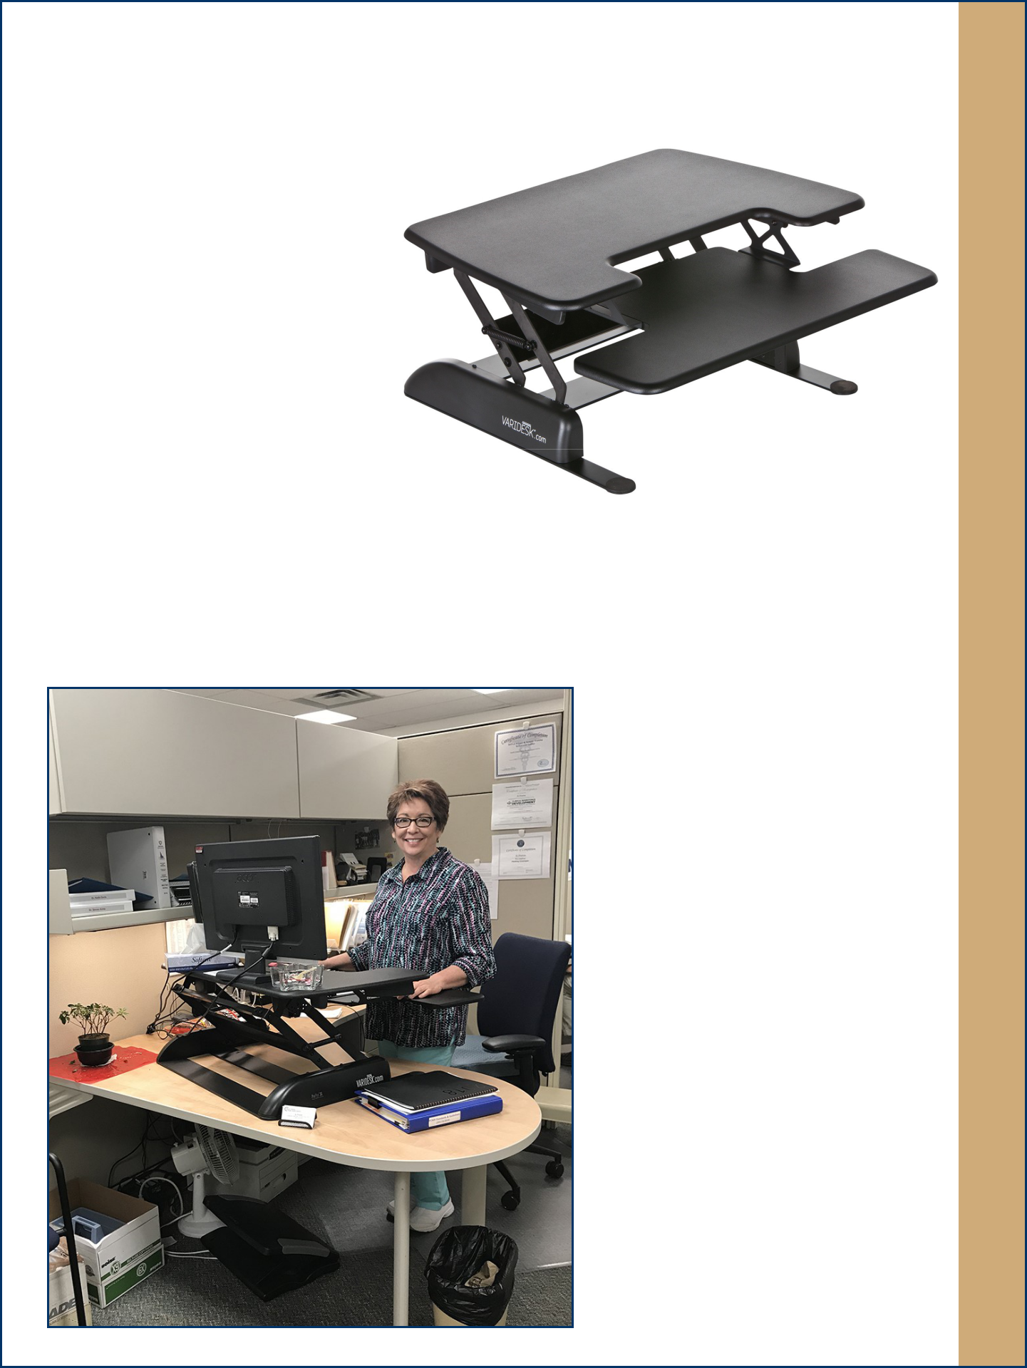

Recent research has shown the cumulative impact of sitting all day for years is associated with a range of health problems, ranging from obesity to cancer to diabetes. The average office worker spends about five to six hours sitting at a desk.

It’s not enough to sit all day and visit the gym after work (or sit all day after a workout in the morning). Experts suggest the negative effects of sitting can’t be reversed by brief times of strenuous exercise. They suggest that interrupting the sitting with standing or pacing helps. Stand-up

desks can help encourage staff to alternate between sitting and standing throughout the workday, and could ultimately help improve their health. Stand-up desks could also be beneficial for employees with back and neck pain. Some studies also suggest using stand-up desks can improve employee mood, morale, energy, and productivity levels.

During the summer of 2017, a SCPHD survey revealed that 90% of employees were interested in a stand-up desk. In the fall of 2017, the Board of Health approved carryover funding for the Community Health Director to purchase 15 Varidesk stand-up desks. Some Health Promotion subgrants paid for desks for the health promotion staff. The stand-up desks arrived in February 2018 and employees are working together to share the desks. As more funding is available, SCPHD hopes to purchase more desks for employee use.

Administration

10 27

Administration

Health Heroes
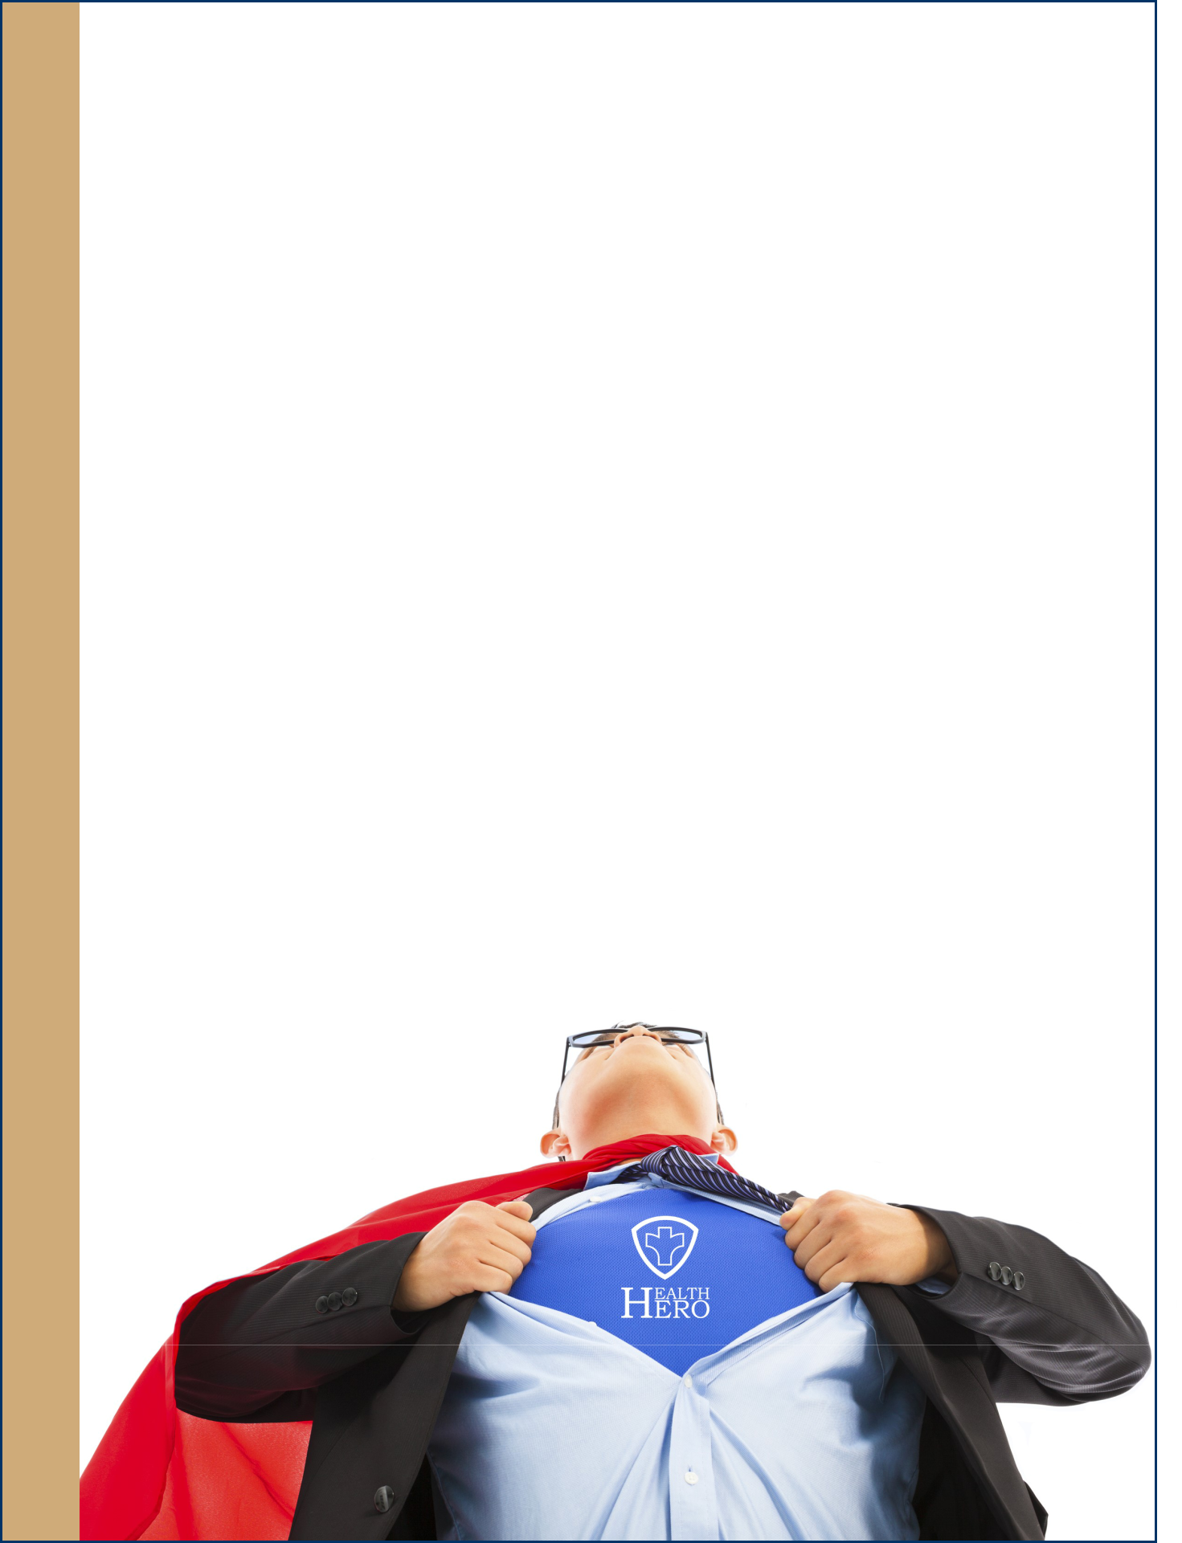

Every year SCPHD honors members of the community as their “Health Heroes”.

Through this annual event, SCPHD seeks individuals or groups who have gone above and beyond the call of duty to promote health in the community by working to prevent disease, promote healthy lifestyles, and protect the health and environment of Southern Idaho citizens.

This year, there are four nomination categories:
- Youth—17 years of age or younger
- Adult Volunteer—18 years of age or older
- Adult Professional—Behavioral Health Advocate, Environmental Advocate, Dietician
- Group or organization—Service groups, schools, civic organizations etc.

The nomination process for the 2018 “Health Heroes” award will start in March and must include a brief description explaining why the nominee deserves the Health Heroes Award. Examples of qualifying activities include, but are not limited to the following:
- promoting a healthy lifestyle through activities at schools, churches, and places of work
- activities that help reduce suicides
- promoting physical activity
- activities that reduce obesity
- preparing a community for a disaster
- decreasing workplace injuries
- promoting policies that lead to healthy outcomes.

Nominees must be residents of or do business in Blaine, Camas, Cassia, Gooding, Jerome, Lincoln, Minidoka, or Twin Falls counties. Nominations forms were available March 1-April 1, 2018. All nomination forms were due by April 1, 2018.

 |  | Revenues |  |  |  |  | Total | Estimate of | Previous Year Comparison
 | Contract | Fees/Donations |  | Total Rev |  | Indirect | Expenditures | District Support | Total Exp | Trend
- |  | - |  | - |  | - | (2.60) | (2.60) | 4.11 | -
 | - | - |  | - |  | 438.67 | 2,012.59 | 2,012.59 | 5,885.66 | -
45,000.00 |  | 12,000.00 |  | 57,000.00 |  | 18,620.97 | 88,003.89 | 31,003.89 | 77,733.78 | -
 | 3,000.00 | - |  | 3,000.00 |  | 967.41 | 4,404.40 | 1,404.40 | 1,690.36 | +
- |  | 150,000.00 |  | 150,000.00 |  | 76,303.98 | 355,857.13 | 205,857.13 | 273,044.10 | -
 | - | 13,000.00 |  | 13,000.00 |  | 3,311.63 | 13,834.24 | 834.24 | 12,755.07 | -
15,000.00 |  | - |  | 15,000.00 |  | 3,508.00 | 15,007.26 | 7.26 | 14,339.43 | -
 | - | 25,000.00 |  | 25,000.00 |  | 6,662.59 | 29,855.06 | 4,855.06 | 22,731.37 | +
- |  | 4,000.00 |  | 4,000.00 |  | 4,842.89 | 21,348.91 | 17,348.91 | 12,505.98 | +
 | 85,000.00 | - |  | 85,000.00 |  | 30,706.08 | 129,905.53 | 44,905.53 | 61,465.28 | +
- |  | 330,800.00 |  | 330,800.00 |  | 112,368.34 | 517,005.68 | 186,205.68 | 403,987.44 | +
 | - | - |  | - |  | 2,953.95 | 12,402.82 | 12,402.82 | 7,236.76 | +
- |  | 760.00 |  | 760.00 |  | 2,153.92 | 10,700.86 | 9,940.86 | 8,129.76 | +
 | 280,000.00 | - |  | 280,000.00 |  | 72,475.22 | 316,861.88 | 36,861.88 | 223,790.84 | +
17,500.00 |  |  |  | 17,500.00 |  | 3,961.87 | 18,482.48 | 982.48 | 67,257.52 | -
115,000.00 |  | - |  | 115,000.00 |  | 28,557.42 | 141,335.91 | 26,335.91 | 100,588.65 | +
 | 13,750.00 | - |  | 13,750.00 |  | 5,531.27 | 24,228.75 | 10,478.75 | 11,225.77 | +
- |  | - |  | - |  | - | 1,240.00 | 1,240.00 | 5,353.86 | -
 | 4,000.00 | - |  | 4,000.00 |  | 1,320.56 | 7,844.33 | 3,844.33 | 6,568.23 | -
578,250.00 |  | 535,560.00 |  | 1,113,810.00 |  | 374,684.79 | 1,710,329.09 | 596,519.09 | 1,316,314.08
- |  | - |  | - |  | - | (1.00) | (1.00) | 1.50 | -
 | 1,000,000.00 | - |  | 1,000,000.00 |  | 125,583.26 | 595,652.25 | 430,012.21 | 402,873.16 | +
 | - | - |  | - |  | 43,459.12 | 200,322.99 | - | 198,644.04 | -
 | - | - |  | - |  | 85,875.86 | 390,661.83 | - | 361,745.07 | -
- |  | - |  | - |  | 39,295.10 | 185,280.83 | - | 96,591.08 | +
 | - | - |  | - |  | 11,704.11 | 58,094.30 | - | 54,136.63 | -
13,790.00 |  | - |  | 13,790.00 |  | 3,240.85 | 13,822.56 | 32.56 | 10,216.51 | +
 | 61,420.00 | - |  | 61,420.00 |  | 14,373.74 | 64,115.56 | 2,695.56 | 16,338.75 | +
55,000.00 |  | - |  | 55,000.00 |  | 11,686.75 | 55,005.56 | 5.56 | 8,016.97 | +
 | 45,000.00 | - |  | 45,000.00 |  | 9,626.94 | 45,001.74 | 1.74 | - | +
4,000.00 |  | - |  | 4,000.00 |  | 785.42 | 4,128.39 | 128.39 | 3,973.76 | -
 | 24,000.00 | 7,000.00 |  | 31,000.00 |  | 3,883.39 | 43,010.85 | 12,010.85 | 28,332.33 | +
41,000.00 |  | - |  | 41,000.00 |  | 9,167.65 | 41,945.35 | 945.35 | 26,259.45 | +
 | 21,000.00 | - |  | 21,000.00 |  | 5,320.81 | 24,648.47 | 3,648.47 | 25,316.81 | -
17,000.00 |  | - |  | 17,000.00 |  | 4,495.60 | 19,331.63 | 2,331.63 | 5,222.69 | +
 | 45,000.00 | 12,000.00 |  | 57,000.00 |  | 14,014.95 | 68,326.89 | 11,326.89 | 69,610.71 | -
40,305.00 |  | - |  | 40,305.00 |  | 8,469.69 | 40,416.40 | 111.40 | 18,615.06 | +
 | 41,000.00 | - |  | 41,000.00 |  | 9,147.62 | 41,016.14 | 16.14 | 28,282.94 | +
91,400.00 |  | - |  | 91,400.00 |  | - | 91,785.22 | 385.22 | 95,126.81 | -
- |  | - |  | - |  | - | 110.00 | 110.00 | 700.00 | -
1,499,915.00 |  | 19,000.00 |  | 1,518,915.00 |  | 400,130.85 | 1,982,675.98 | 463,760.98 | 1,450,004.27 | +
50,000.00 |  | - |  | 50,000.00 |  | 4154.76 | 59169.42 | 9169.42 | - | +
1,500,000.00 |  | - |  | 1,500,000.00 |  | 1324.48 | 1467889.25 | (32110.75 | - | +
 | 1,550,000.00 | - |  | 1,550,000.00 |  | 5479.24 | 1527058.66 | (22941.34) | - | +
 | 5,711,646.00 | 958,170.00 |  | 6,669,816.00 |  | 1,246,378.23 | 7,686,383.65 | 2,293,645.65 | 7,684,453.06
 | Projected State Appropriation |  |  | 1,209,400.00
 | Carryover Funds from FY-16
 |  | Admin/General Support
 |  | Facilities/Equipment
 |  | IT and Clerical Support
 |  | FCH and Preparedness
 |  | Environmental Health
 |  | Community Health
 |  | Building Fund
 |  | Total Revenue FY-19 |  | 7,879,216.00
 | Adjustment for personnel savings |  |  | -
 | REVENUE TOTAL BUDGET REVISION |  |  | 7,879,216.00

26 11

DATA DICTIONARY – PROJECT COST ACCOUNTS FY-2018

 | PCA |  | Program | Program Definition
 |  |  |  | Administration
 | 11100 |  | Admin | Office of the District Director – Salary (and fringe); includes
 |  |  |  | apportioned operating expenses; Member County Apportionment per
 |  |  |  | IC 39-424 is accounted for as Revenue under PCA 11100.
 | 11200 |  | Admin | Board of Health – Payments for meeting attendance; mileage
 |  |  |  | reimbursements; conference registration and per diem & travel to the
 |  |  |  | Annual IADBH Conference.
 | 11999 |  | Admin | Admin. Misc. Represents small contracts managed by the Director.
 | 12000 |  | Admin | General Support – Salaries (and fringe) for staff time benefitting all
 | to |  |  | divisions of the district. Includes capital expense: general and outlay
 | 12040 |  |  | (building infrastructure, district vehicles, new construction, etc.)
 | 12020 |  | Admin | Auto fleet costs
 | 12100 |  | Admin | Project & Building Fund General – One-time projects and
Dictionary |  |  |  | maintenance.
 | 12110 |  | Admin | Building Fund – Bellevue
 | 12140 |  | Admin | Building Fund – Gooding
 | 12150 |  | Admin | Building Fund – Jerome
 | 12170 |  | Admin | Building Fund – Mini-Cassia
 | 12180 |  | Admin | Building Fund – Twin Falls
 | 12210 |  | Admin | Maintenance - Bellevue
Data | 12230 |  | Admin | Maintenance – Mini-Cassia
 | 12240 |  | Admin | Maintenance – Gooding
 | 12250 |  | Admin | Maintenance – Jerome
 | 12260 |  | Admin | Maintenance – Shoshone
 | 12270 |  | Admin | Maintenance – Mini-Cassia
 | 12280 |  | Admin | Maintenance – Twin Falls
 | 12850 |  | Admin | Vital Statistics – Local Registrar activities for issuance of Death
 |  |  |  | Certificates under MOA with IDHW, Bureau of Vital Records and
 |  |  |  | Statistics.
 | 12999 |  | Admin | Misc. activities; usually non-recurring events.

Legend:

White = Administration

Red = Category 1: Mandatory/Statutory

Orange = Category 2: Core Public Health

Yellow = Category 3: Federal Contracts through IDHW/IDEQ

Green = Category 4: Local Board of Health Option

12

Internships
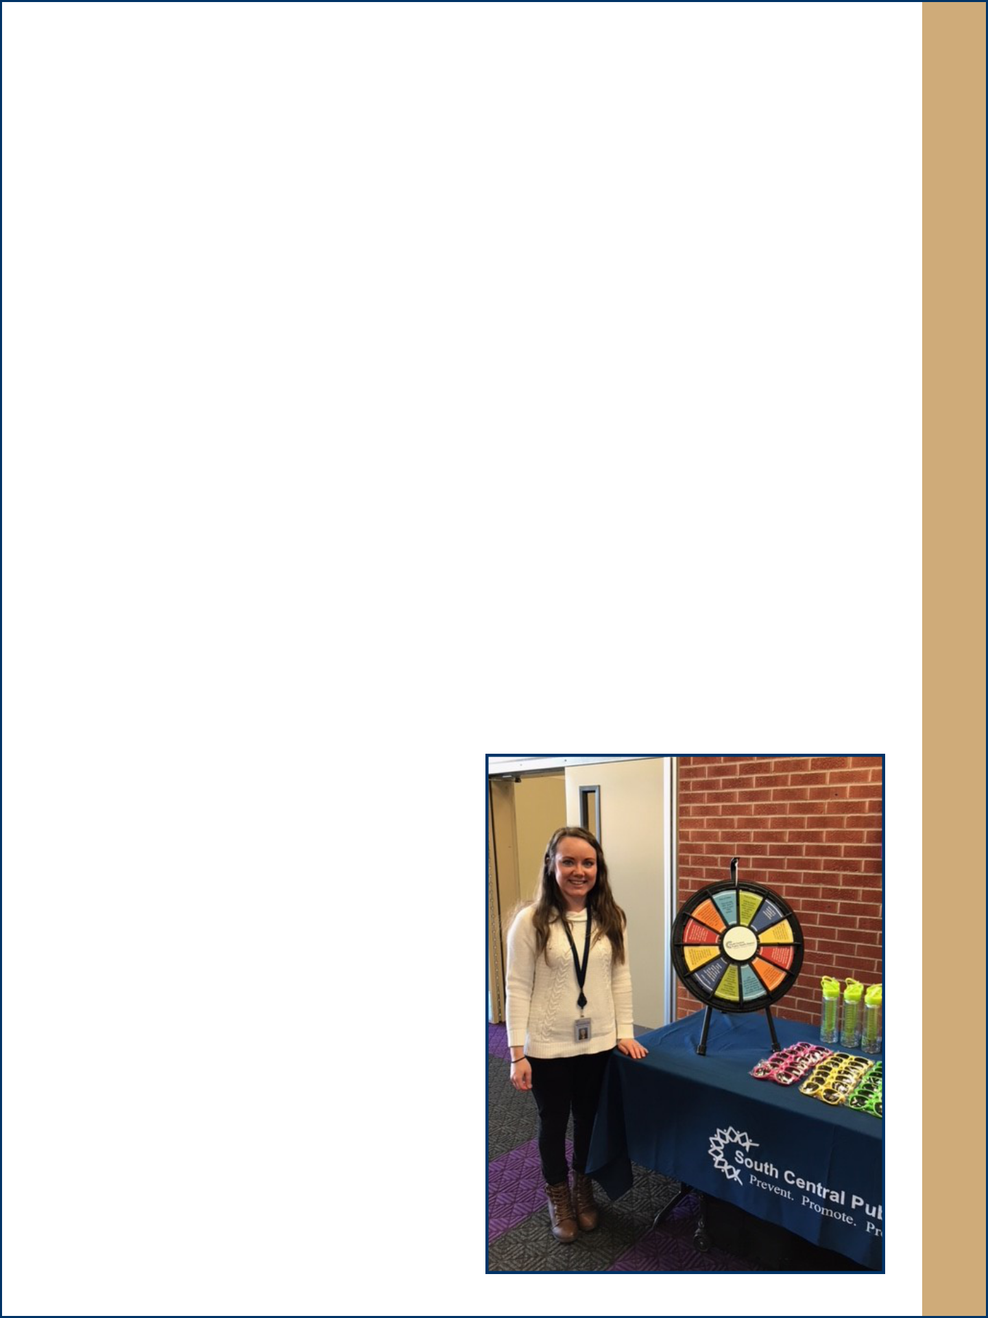

Every year, SCPHD programs work with students and interns to help further their education and give them practical, hands on experience in public health.

Several local and regional colleges and universities use SCPHD nurses to provide their students with public health experience. Most of the students come from CSI, but Lewis and Clark, BYU Idaho, Boise State, Idaho State, and Western Governor’s Universities have placed students at our agency.

The nursing staff at SCPHD are proud and honored to be able to share their knowledge and skills with an average of 100 nursing students each year. SCPHD partners with the College of Southern Idaho to give each RN student nurse at least one day at the health department. These students are exposed to a variety of the programs, including immunizations, refugee health, epidemiology, and home visitation. In addition, SCPHD works with all other in-state colleges and universities to provide the necessary public health clinical hours needed for those students obtaining their bachelors or masters degrees. SCPHD also provides clinical hours for nurses in online programs if proper agreements are in place and has allowed local high school seniors who need hours for their senior projects the opportunity to job shadow and complete service projects that benefit District.

The Community Health division has been fortunate enough to have two health education interns from BYU-Idaho in the last year. The first intern worked in the fall of 2017, the second one in the winter of 2018, both focusing on Physical Activity and Nutrition, Adolescent Pregnancy Prevention, and Fit and Fall Proof, under the supervision of Adria Masoner, Health Education Specialist, Sr. each intern completed 200 hours of work at SCPHD. Their main goal is to learn how to implement health education in a public health setting.

WIC typically has two interns per school year (one in the fall semester, one in spring semester). Those interns complete 120 hours of work in three weeks, under the supervision of Cynthia Holly-Rausch, RD. They help write newsletter articles and education guidelines for classes/ individual education. They also update WIC referral lists and participate in outreach and meeting presentations. Their main goal is to learn how to educate clients in a community setting as a dietitian.

Working in partnership with these learning institutions provides an opportunity to increase the visibility of public health to the health professionals of the future. It also allows us to partner with some of the institutions, like CSI, to provide staffing for mass clinics during emergencies. Working with students allows our agency to recruit potential employees for future open positions as well.

Stephanie Gines, Health Education Intern

25

Administration

Administration

Jerome Office Upgrades
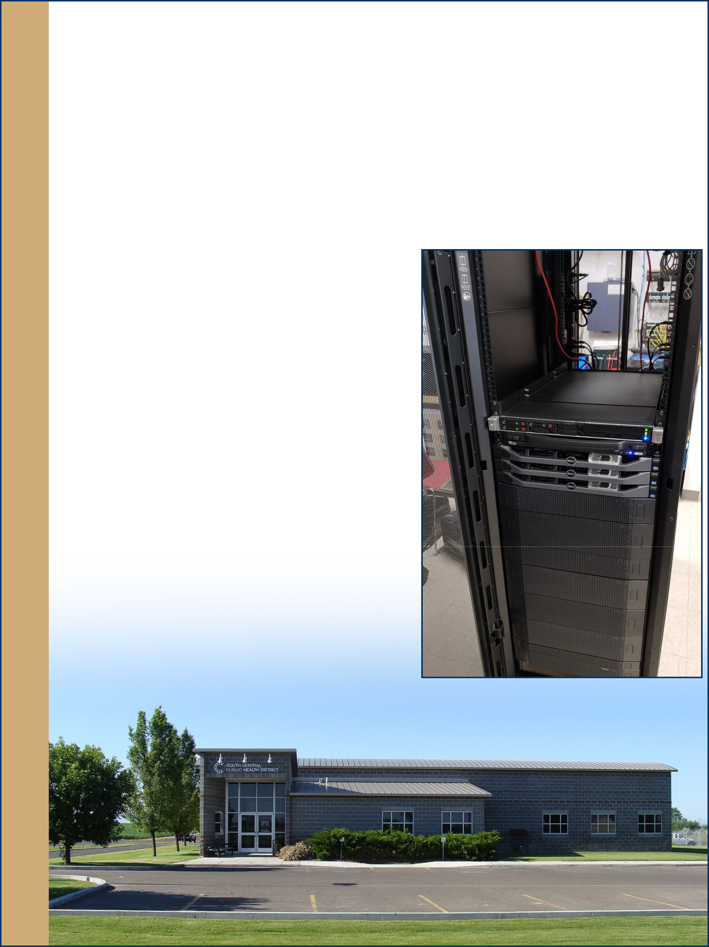

In 2017, upgrades were made to the Jerome facility so it could act as an emergency network backup in the case of a computer system failure in the main Twin Falls facility. Power and data systems were both improved to accommodate the new backup system.

At the Jerome building an Eaton Uninterruptable Power Supply System (UPS) installation was completed in December 2017. The equipment provides clean filtered electrical power in support of the secondary datacenter equipment recently installed. The UPS has enough capacity to support the uninterrupted operation of servers during a utility interruption while emergency power generation is initialized.

A redundant datacenter is being configured at the Jerome center to provide better uptime in case of an outage at the Twin Falls center. We have purchased a new APC rack to hold the equipment needed to perform this redundancy. The other equipment includes three Dell servers that will connect via fibre channel to an EMC SAN, which will hold the data and virtual servers. A new Juniper POE+ gigabit switch will be installed to improve the network communications.

24

 | PCA |  | Program |  | Program Definition
 |  |  |  | Information Management Division
 | 12600 |  | Admin | Community Outreach: Advertising, media; Public Information
 |  |  |  | activities; Social Media
 | 13100 |  | FCH– IT | IT Direct Support to Family & Children’s Health
 | 14100 |  | Environmental– IT | IT Direct Support to Environmental Health
 | 15100 |  | CH– IT | IT Direct Support to Community Health
 |  |  | Family and Children’s Health Division
 | 13210 | Adult Services -- Other |  | Rarely used. Used for general questions from clients.
 | 13220 |  | School Health | Contracted services provided to mostly rural school districts.
 | 13225 |  | Lead Screening | Capillary blood lead tests provided to any client, but usually to Head
 |  |  |  | Start children (requirement of that program).
 | 13230 |  | AIDS | HIV testing provided in a variety of settings. |  |  | Data
 | 13231 |  | HIV Surveillance | Monitoring healthcare providers to ensure complete HIV reporting.
 |  |  |  | Also includes reporting of diagnosed HIV or AIDS.
 | 13236 |  | STD | Reporting and investigation of sexually disease infections.
 |  |  |  |  |  |  | Dictionary
 | 13245 |  | RMA Refugee Health | Health Screening provided to newly arriving refugees.
 | 13250 |  | Child Health -- Other | Rarely used. Most common involves calls about head lice.
 | 13255 |  | Early Head-Start | This is a contracted program to provide home visits for families in
 |  |  | Program | Twin Falls, Jerome, Minidoka and Cassia counties.
 | 13265 | Nurse Home Visitation |  | Parents as Teachers home visitation model. Contracted for Twin Falls
 |  |  |  | and Jerome counties.
 | 13266 |  | District Nurse Home | Parents as Teachers home visitation model. District supported to
 |  |  | Visitation | cover the other six counties.
 | 13390 |  | Immunizations | Immunizations provided to birth through 18 years of age. Includes
 |  |  | Vaccine for Children | insured children through the insurance pool.
 | 13392 | Immunization District |  | All immunizations provided to adults and overseas immunizations
 |  |  | Purchased | provided to children.
 | 13394 |  | Immunization | Community or staff education programs and special community
 |  |  | Contract | clinics.
 | 13395 |  | Immunization | Services through the Idaho Immunization Program. Compliance visits
 |  |  | Provider Assessment | to healthcare providers (VFC program standard).
 | 13396 |  | Prenatal HepB | Epidemiology services to pregnant women with hepatitis B.
 |  |  | Surveillance

13

 | PCA |  | Program | Program Definition
 |  |  | Family and Children’s Health Division
 | 13400 |  | Epidemiology | Investigation of reportable diseases.
 | 13405 |  | Communicable | Education of epidemiology staff and involvement with infection
 |  |  | Disease Education | prevention hospital committees. Providing information to healthcare
 |  |  |  | providers during outbreaks or important disease investigations.
 | 13410 |  | NEDSS Capacity | Reporting diseases in the electronic database.
 | 13450 |  | Tuberculosis Control | Investigation and control of tuberculosis.
 | 13500 |  | Strategic Health | Limited subgrant, ending January 2019, that assists local healthcare
 |  |  | Innovation Plan | providers to transform their policies to patient centered medical
 |  |  |  | homes.
 | 13670 |  | Breast and Cervical | Provide vouchers for low income, uninsured women to receive
 |  |  | Cancer | breast and cervical cancer screening. Limited clinical services
Dictionary |  |  |  | provided in Twin Falls.
 | 13820 |  | Surveillance | Provide staff time for pager carrier duties to respond to local
 |  |  |  | emergency situations (communicable disease or hazmat involving
 |  |  |  | food or water). Provide additional staff to respond to communicable
 |  |  |  | disease outbreaks.
 |  |  | Environmental Health and Public Health Preparedness Division
Data | 14210 |  | Nuisance | Covers miscellaneous complaints or inquiries received from the
 |  |  | Complaints | public which do not fall into any other category. May include
 |  |  |  | inquiries about mold, pests, private water, etc.
 | 14225 |  | Childcare | Contracted childcare inspections, reporting, fee collections, etc.
 | 14227 |  | Childcare | Contracted childcare complaint inspections and investigations.
 |  |  | Complaints
 | 14240 |  | Primary Food | Food protection services: permitting, inspections, consultations,
 |  |  |  | investigations, enforcement action, etc.
 | 14241 |  | Secondary Food | Food protection services which do not fall into the primary food
 |  |  |  | PCA, such as plan reviews, or second school cafeteria inspections
 |  |  |  | mandated by the USDA School Lunch Program.

Legend:

White = Administration

Red = Category 1: Mandatory/Statutory

Orange = Category 2: Core Public Health

Yellow = Category 3: Federal Contracts through IDHW/IDEQ

Green = Category 4: Local Board of Health Option

14
Public Health Preparedness
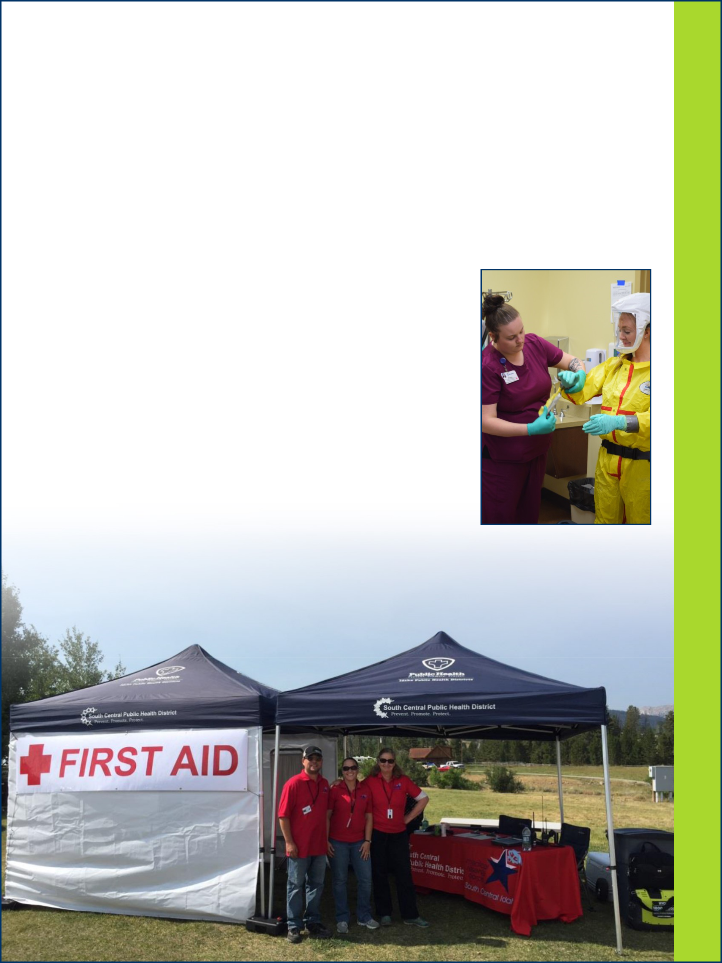

The Public Health Preparedness Program (PHP) at SCPHD is charged with increasing health system capacities to respond to acts of bioterrorism, infectious disease outbreaks, and other public health threats and emergencies.

Over the past year, PHP has been involved in several training and exercise opportunities throughout the district. These activities ranged from an Ebola functional exercise to an actual deployment of Medical Reserve Corp (MRC) volunteers during the total solar eclipse. SCPHD endeavors to support the emergency response to any and all hazards where our expertise will aid the communities we serve.

2017-2018 Highlights

Medical Shelter Training and Exercise – March 2017
- Conducted training and exercise with Jerome County and the American Red Cross to test the activation process for opening and operating a 25 bed medical shelter.

Ebola Functional Exercise – April 2017
- Developed, planned, and facilitated an exercise with Cassia Regional Hospital, Minidoka Memorial Hospital, St. Luke’s Jerome, St. Luke’s Magic Valley, and St. Luke’s Wood River.

- The exercise focused on multi-agency emergency operations, information sharing, and coordination to respond to a patient with Ebola-like symptoms.

Total Solar Eclipse Event Planning and MRC Deployment – June and August 2017

- Deployed MRC volunteers to Blaine County to staff first aid stations at Smiley Creek Lodge and Festival Meadows in Sun Valley.

23

Environmental Health and Preparedness

Environmental Health and Preparedness

Environmental Health
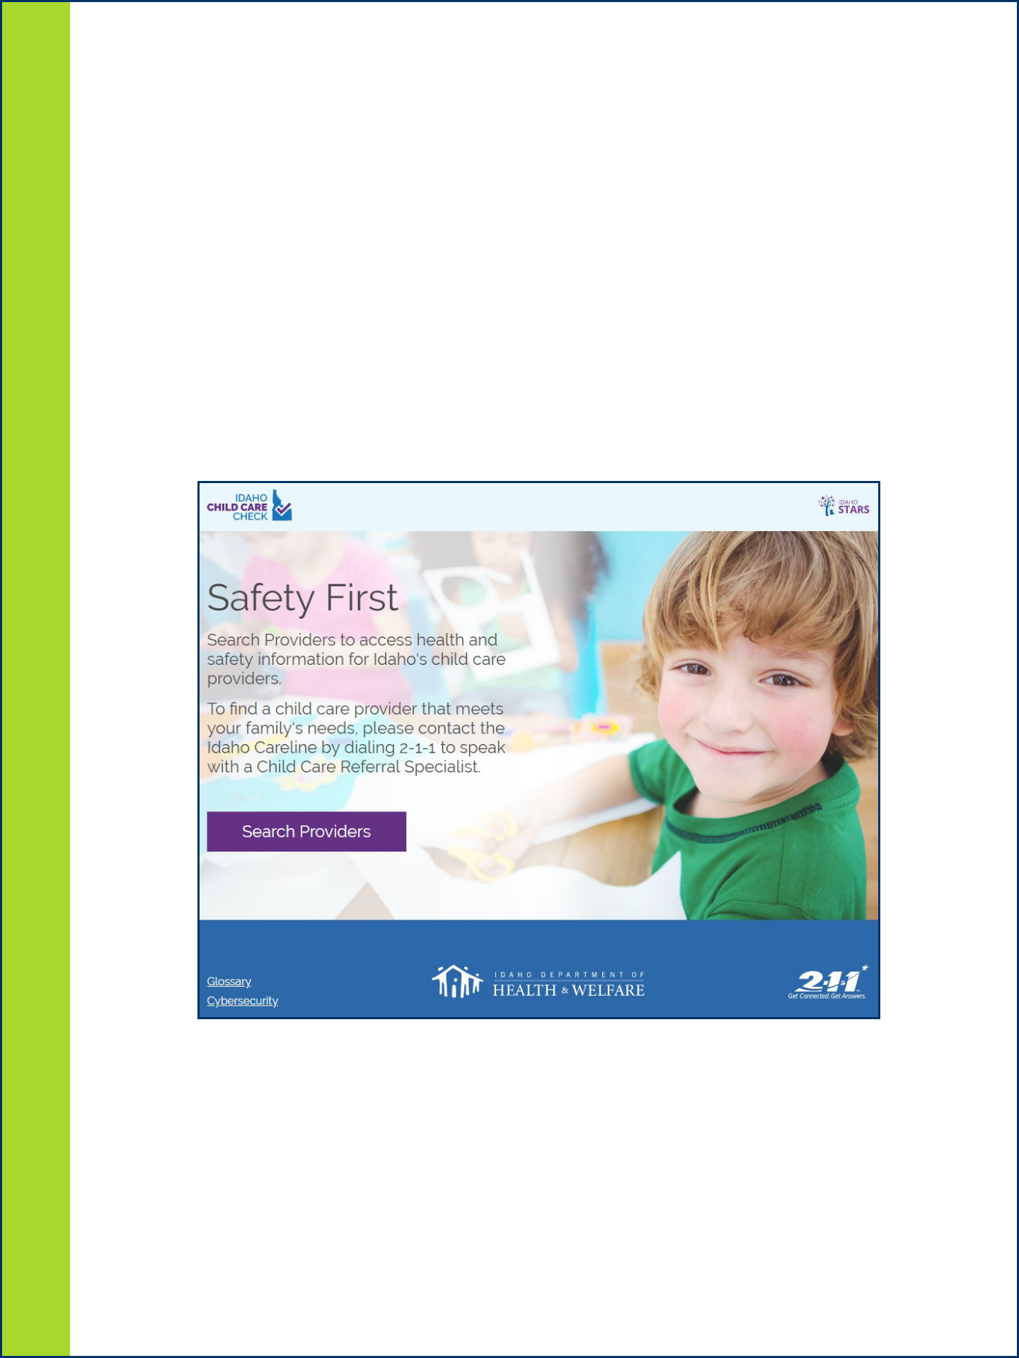

Food Establishments
On July 1 of this year, the Certified Food Protection Manager provision in the Idaho Food Code will take effect. This section of the rule added an additional requirement, above the existing demonstration of knowledge, to all establishments which are regulated by the Idaho Food Code.

Regulated establishments now must have on staff a manager, or other employee with similar authorities, who has passed a course which has been approved by the Conference for Food Protection Standards for Accreditation of Food Protection Manager Certification Programs.

However, there is a provision in the Food Code to allow for a variance from this requirement for minimal-risk facilities, such as convenience stores that only sell pre-packaged foods. SCPHD has been working with the Department of Health and Welfare and the other six health districts to ensure that this variance process is in place prior to the July 1 deadline.

Childcare Inspections
We are also happy to announce the launch of a state-wide online database of childcare inspection results, available at SCPHD has provided an online searchable database of childcare inspection reports for more than five years, but it only covers the childcare facilities within our district, and we have had a hard time publicizing it. Now, with the introduction of the state-wide database, parents will have one location to get information, no matter where they go in the state, and, with all of the health districts, Health and Welfare, and 211 helping to spread information about the website, we hope that more parents will learn about, and use, this tool to help them pick quality childcare.

As new inspections are conducted they will be added to the new database, so it will take some time before all facilities have results available.

22

 | PCA | Program | Program Definition
 |  | Environmental Health and Public Health Preparedness Division
 | 14245 | FDA Program | Contracted inspections of FDA-regulated facilities.
 | 14260 | Land Development | Land divisions, subdivision reviews and approvals.
 | 14280 | Mortgage Survey | Surveys of water and septic systems at the request of a client.
 |  |  | Generally performed at the time of a sale.
 | 14300 | Public Water | Contracted regulation of public water systems. Includes inspections,
 |  |  | monitoring, consultations, paperwork, enforcement actions, etc.
 | 14310 | Sewage Disposal | Septic system permitting, inspections, and sewage complaint
 |  |  | investigations. Permitting and complaint investigations of septic
 |  |  | system installers and septic pumpers.
 | 14320 | Solid Waste | Regulating solid waste transfer stations and landfills, complaint
 |  |  | investigations.
 | 14380 | Pools | Regulating public pools, as defined in rule.
 |  |  |  |  | Data
 | 14999 | Environmental Misc. | Generally covers activities funded by governmental grants.
 | 14800 | Planning/ | Ensure SCPHD can accomplish emergency preparedness and response
 |  | Preparedness | activities to address public health threats and other emergencies.
 |  |  | SCPHD will also work with local communities to accomplish |  | Dictionary
 |  |  | Medical Reserve Corps.
 |  |  | preparedness activities.
 | 14895 | Hospital | Assist healthcare organizations with developing preparedness and
 |  | Bioterrorism (ASPR) | response plans and strategies.
 | 14897 | Medical Reserve | Recruit and train volunteers to assist in emergency response situations.
 |  | Corp. | Maintain a register of approved volunteers with license verification as
 |  |  | appropriate.
 | 14898 | NACCHO MRC | Provide funds to assist in recruitment and training of volunteers for the
 |  |  | Community Health Division
 | 15300 | WIC Clinical | Direct contact with participants. Weighing, measuring, diet and health
 |  | -Women, Infants & | assessments; appointments, reminder calls, service coordination and
 |  | Children | referral.
 | 15303 | WIC Administration | Program management and monitoring. Administrative record keeping
 |  |  | and reports; time studies and site visits.
 | 15310 | WIC Nutrition | Planning, developing and providing nutrition education, participant
 |  | Education | counseling and goal setting.
 | 15320 | WIC Breastfeeding | Planning or providing breastfeeding promotion, education and
 |  |  | encouragement.

15

PCA | Program | Program Definition
 |  | Community Health Division
15321 | WIC Breastfeeding, | Planning or providing breastfeeding promotion, education and
 | Peer | encouragement, by a trained Peer Counselor, to first time pregnant
 |  | clients during the prenatal period and up to 3 months postpartum.
15325 | Early Head Start, | Provide nutrition counseling and menu plans to families enrolled in
 | Dieticians | Head Start. Review nutrition risks of pregnant mothers; participate in
 |  | Health Advisory Committee meetings.
15401 | PAN | Host and facilitate Let’s Move Child Care workshops and assist
 | -Physical Activity | providers in developing and completing action plan and activities.
 | and Nutrition | Promote policy, system, and environmental changes to increase
 |  | healthy nutrition and physical activity in child care centers. Promote
 |  | wellness initiatives to worksites and facilitate the completion of the
 |  | CDC Health Scorecard Assessment and workplan. Host Looking
 |  | Glass Academy to assist community members assessing a
Idaho Prescription Drug Overdose Prevention Program
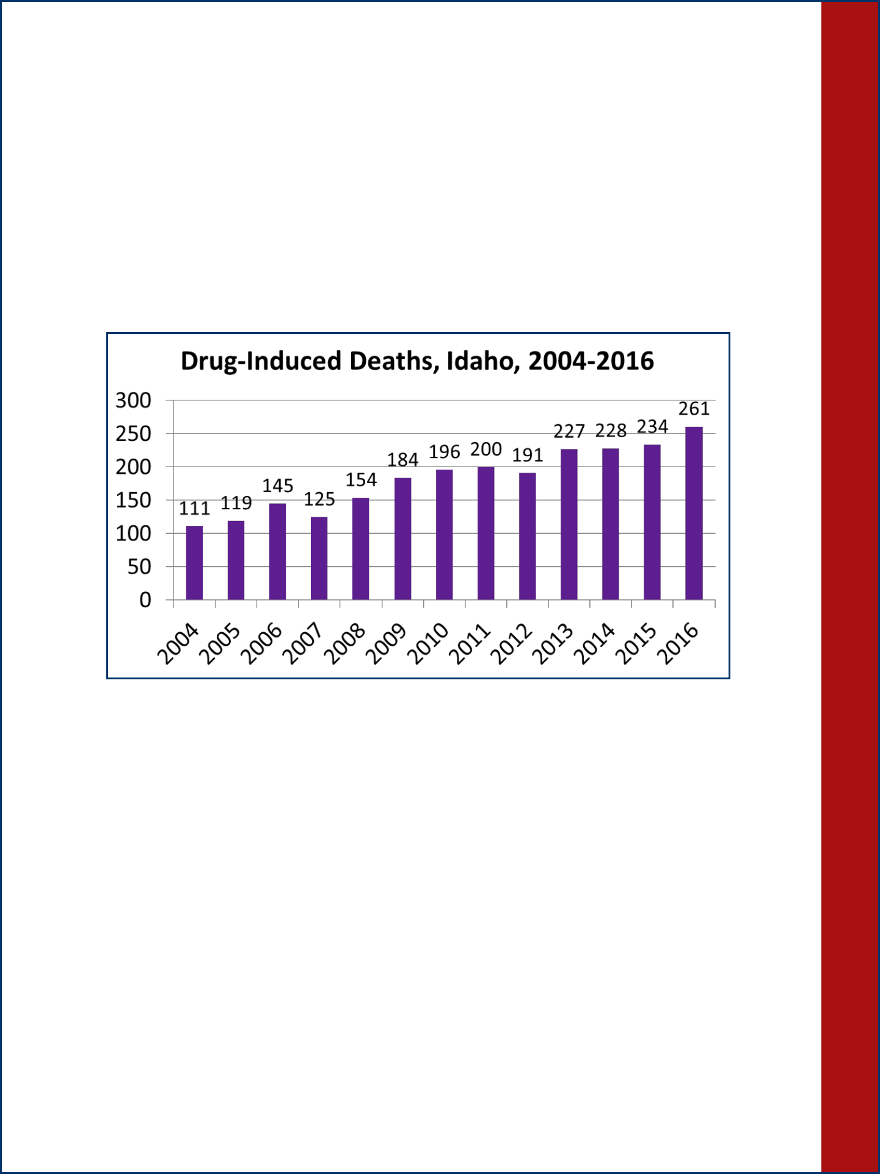

The subgrant awarded from Idaho Department of Health and Welfare in December 2016 for prescription drug overdose prevention is continuing. The funding from Centers for Disease Control and Prevention allows the Idaho Public Health Districts to provide education to physicians and other healthcare providers about prescription drug misuse and overdose, and new naloxone regulations. During the last fiscal year, SCPHD provided education to 10 prescriber’s offices, and two Physician Champions presented to over 90 prescribers throughout District 5.

 |  |  | community’s walkability and bikeability.
Dictionary
 | 15403 | Chronic Disease | Provide resources and technical assistance to health care providers/
 |  | Prevention & Control | medical clinics to implement evidenced based and/or evidenced
 |  |  | informed resources for hypertension, diabetes and pre-diabetes
 |  |  | prevention and management. Host and facilitate a chronic disease
 |  |  | health care coalition.
 | 15410 | Prescription Drug | Identify two physician champions who will provide education about
 |  | Overdose Prevention | opiate prescribing use and the Prescription Monitoring Program to the
Data
 |  |  | healthcare provider community in the health district. Provide
 |  |  | educational toolkits to primary care providers that promote the use of
 |  |  | the Prescription Monitoring Program.
 | 15525 | Seatbelt Observations | Conduct official seat belt observational survey in accordance with
 |  |  | National Highway Traffic Safety Administration standards.
 | 15530 | Car seats | Coordinate, schedule and promote low cost child car seat classes for
 |  |  | WIC clients. Order child safety seats, provide translation services, and
 |  |  | evaluate class outcomes.
 | 15630 | Injury Prevention | Coordinate Fit and Fall Proof™, an exercise-based fall prevention
 |  |  | program for older adults. Recruit and coordinate training for
 |  |  | volunteers to teach the classes in their community. Partner with
 |  |  | healthcare providers to refer patients to FFP classes. Conduct fall
 |  |  | prevention safety checks in the homes of seniors.

Number of drug-induced deaths by county of
residence: Idaho residents, 2014-2016.
County | Number
Blaine | 3
Camas | 0
Cassia | 6
Gooding | 5
Jerome | 6
Lincoln | 2
Minidoka | 9
Twin Falls | 40

*Numbers may not be reliable due to lack of all suspected drug-induced deaths appropriately reported on death certificates.

According to Idaho data, in 2016, drug-induced deaths reached at least 261 Idaho residents. This was approximately 2% of total deaths. Drug overdoses accounted for more than 93% of drug-induced deaths. According to the Opioid Needs Assessment prepared by the Idaho Department of Health and Welfare, October 2017, there were 466 drug-overdose deaths in Idaho with opioid drug(s) specified on the death certificate from 2012-2016. The number of drug-induced deaths are under-reported throughout the state, so the number of true opioid-involved overdose deaths is likely higher than what is reported on death certificates.
Community Health

16

21

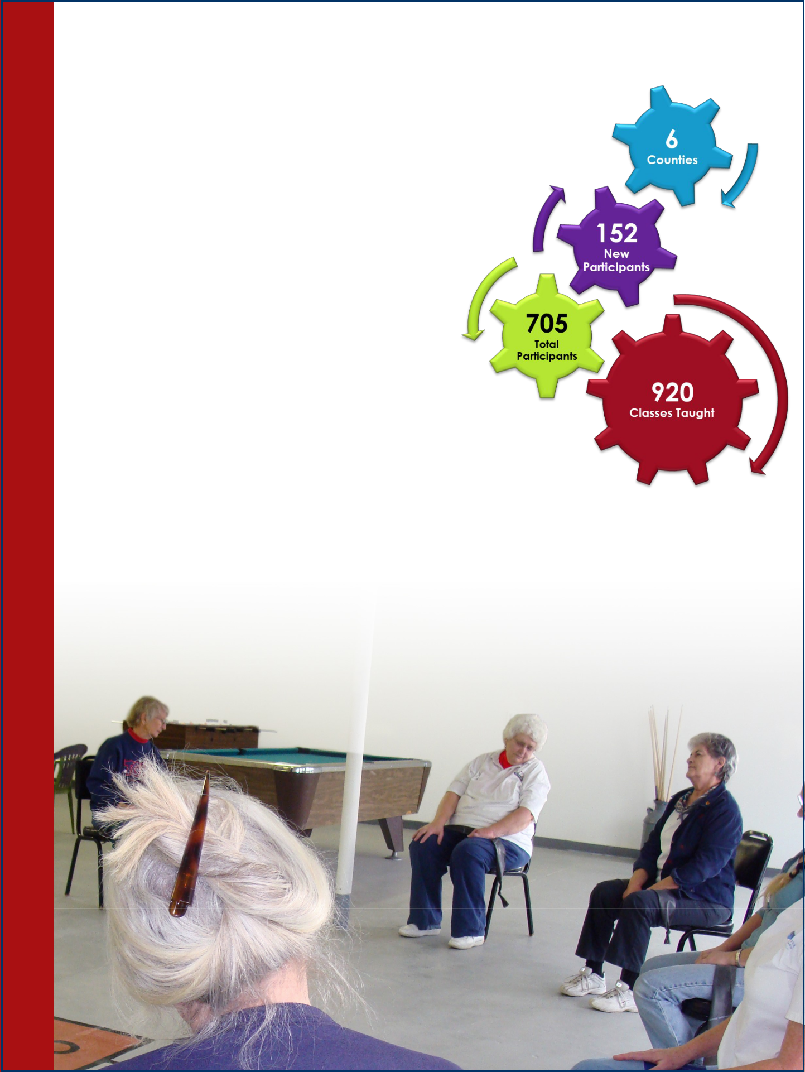
Fit and Fall Proof™

Each year, one in three adults over the age of 65 falls. In 2015-16, Idaho Emergency Medical Services (EMS) calls responding to falls for individuals 65 years of age or older was up 26% from 2014-2015. When an older adult falls, it can create a domino effect on their health. They may suffer a severe injury, such as a hip
fracture, resulting in lost mobility and subsequent loss of
independence.

Developed in Idaho in 2004, and implemented in
 | SCPHD in 2005, Fit and Fall Proof™ (FFP) is an
 | exercise-based fall prevention program for older
 | adults in Idaho that focuses on improving strength,
 | mobility, and balance to reduce an older adults'
Health | risk of falling. Local volunteer leaders are trained to
 | teach classes in their communities. Classes are held in
 | places such as senior centers, community centers, churches,
 | libraries, and hospitals.
 | In SCPHD, nine FFP Classes are held in six of the eight counties
 | we serve (Blaine, Camas, Cassia, Gooding, Jerome, and Twin Falls).
Community | In FY-2016-2017, there were 920 classes held serving 705 participants, 152 which were new to
 | the program. Of all the programs in Idaho, SCPHD has the most consistent class participation in
the state. This is due in no small part to our faithful class leaders, many of whom have been volunteering since 2005!

Over the last two years, SCPHD has been working with five local healthcare providers (mainly physical therapists) to refer their patients to an FFP class in their area. This spring SCPHD will also begin working with Home Health agencies to do in-home falls safety checks for some of our older citizens.

20

PCA | Program | Program Definition
 |  | Community Health Division
15635 | APP -Adolescent | Provide information on sexual health education, including abstinence
and | Pregnancy | and contraception, for the prevention of pregnancy and sexually
15637 | Prevention & | transmitted infections. In partnership with local schools, teach and
 | APP-PREP | facilitate discussion on one of two evidenced-based curriculums,
 | -Personal | Reducing the Risk or Draw the Line. Coordinate and facilitate a
 | Responsibility | Youth Adult Partnership to develop leadership skills and influence
 | Education Program | attitudes and norms.
15660 | Dental Health | Coordinate and implement school-based dental sealant clinics at
 |  | schools with more than 35% on the Free and Reduced Lunch Program.
 |  | Coordinate and implement fluoride varnish clinics with an emphasis
 |  | on children enrolled in WIC, Head Start and other early education
 |  | programs. Participate in the state-wide oral health screening program,
 |  | the Smile Survey, to monitor and collect data on the oral health status
 |  | of third-grade students, every four years. Participate in the regional | Data
 |  | Oral Health Network meetings to eradicate dental disease in children
 |  | and to improve oral health care in Idaho.
15680 | Comprehensive | Coordinate, facilitate and implement cancer control initiatives, | Dictionary
 | Cancer Control | including sun safety, colorectal, and breast cancer screening. Provide
 |  | resources and technical assistance to health care providers/medical
 |  | clinics to implement evidenced based and/or evidenced informed
 |  | resources for the implementation of quality improvement measures to
 |  | increase colorectal cancer screening rates.
15750 | Tobacco Prevention | Prevent initiation of tobacco use among youth and adults through
 |  | education, policies, and community engagement. Eliminate exposure
 |  | to second-hand smoke by establishing or strengthening smoke/tobacco
 |  | free policies. Promote cessation for adults and youth through
 |  | community partnerships; work with health care providers to establish
 |  | patient referrals.
15752 | Millennium Fund | Promote and provide tobacco cessation education using standardized
 |  | criteria for best practices and offer classes specifically designed for
 |  | pregnant women, adults, and teens.
15999 | Community Misc. | Special projects and/or short term mini-grants.

Legend:

White = Administration

Red = Category 1: Mandatory/Statutory

Orange = Category 2: Core Public Health

Yellow = Category 3: Federal Contracts through IDHW/IDEQ

Green = Category 4: Local Board of Health Option

17

Family and Children’s Health

Influenza and Pertussis 20XX-20XX
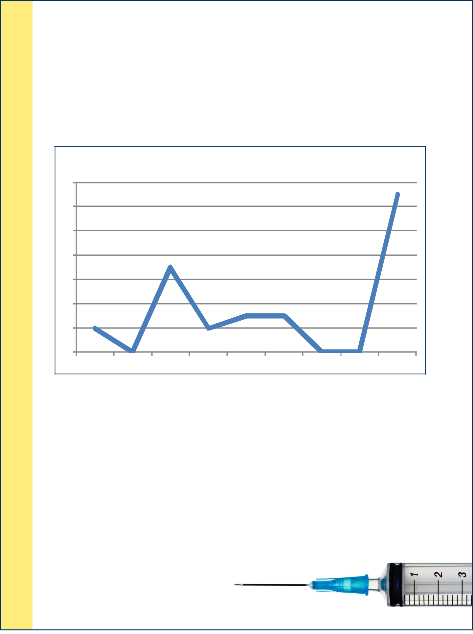

During the 2017-2018 influenza season, SCPHD began receiving reports of pertussis cases. Since both diseases produce a cough illness, diagnosing and preventing further spread became challenging. The current influenza season saw the highest number of cases during the first week of January. As of February 5, 2018, seven influenza-related deaths had occurred. Since January 1, 2018, 13 cases of pertussis have been reported in our district. All of these cases were school-aged children. The following shows the reported cases in our district each year since 2010.

 |  | Pertussis Cases 20XX-20XX
14
12
10
8
6
4
2
0
2010 | 2011 | 2012 | 2013 | 2014 | 2015 | 2016 | 2017 | 2018*

* Cases reported as of February 5, 2018

The only way to confirm the diagnosis of either disease requires laboratory testing. Influenza is characterized by sudden onset of muscle aches, tiredness, fever, and cough. Pertussis begins with cold-like symptoms followed by a cough. This cough may be severe, with vomiting or difficulty breathing after cough episodes. Infants under 1 year of age are most at risk of severe complications or death from Pertussis. Since symptoms may only include a continued cough, many cases of Pertussis go undiagnosed. This allows the disease to spread through a community and makes control difficult.

SCPHD staff investigate each reported case of Pertussis. Control measures include identifying close contacts that may need medication to prevent the disease; educating the public by sending letters to parents of children in a school with Pertussis cases; and

media interviews and health messages for healthcare providers. Providing one dose of Pertussis-containing vaccine to adults is an important tool

in reducing the spread of Pertussis, especially in families with infants.

18
Human Papilloma Virus
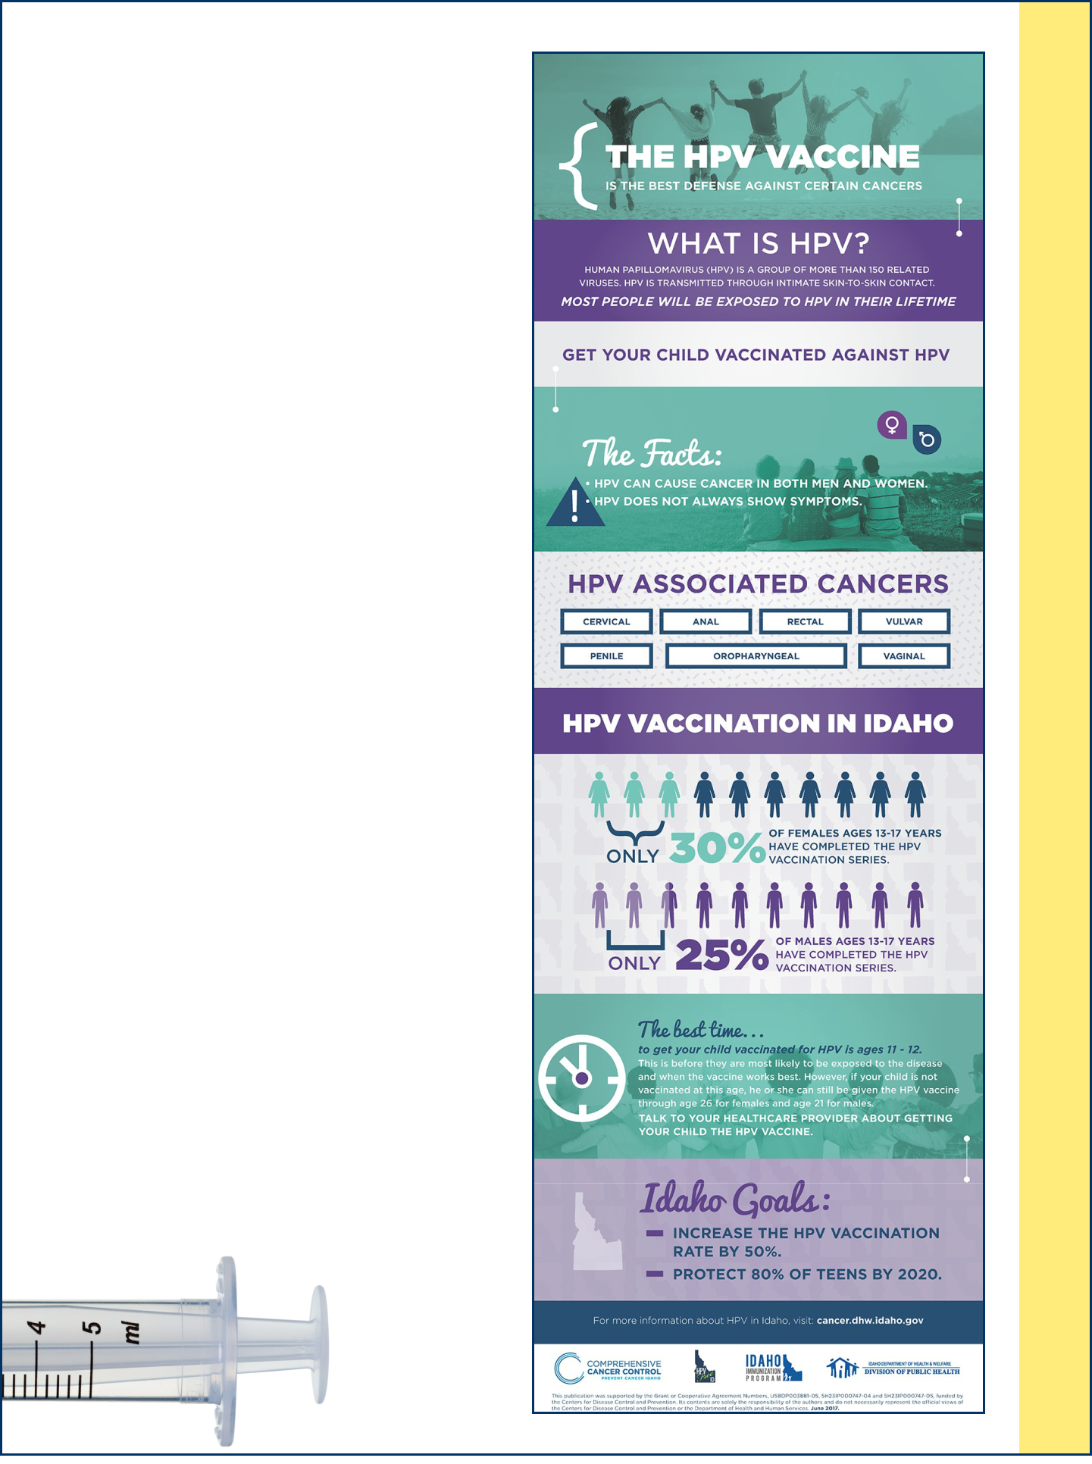

According to the Centers for Disease Control and Prevention (CDC), every year in the United States, 31,000 women and men are diagnosed with a cancer caused by Human Papilloma Virus (HPV) infection. Cervical cancer accounts for 1 in 3 cancers caused by HPV infection. While there is screening for cervical cancer, there is no routine screening for the other 20,000 cancers caused by HPV infections each year in the United States. Often these cancers—such as cancers of the back of the throat (oropharynx) and cancers of the anus/rectum—aren't detected until later stages when they are difficult to treat. Most of these cancers could be prevented by HPV vaccination.

HPV vaccine is usually administered starting at age 11-12. If the vaccine series is started by age 14, two doses are needed. If the series is started after age 14, three doses are needed. HPV vaccine is provided to all Vaccines For Children (VFC) providers at no cost. An administration fee is the only cost to the patient.

SCPHD offers HPV vaccine through clinics in each of our district offices. Idaho Administrative Rules, require children, entering the 7th grade, to have one dose of Tdap and meningococcal vaccines. Since 7th grade is the target age for HPV vaccine, it is beneficial to offer this vaccine with the other required vaccines. To address this requirement, staff travel to several schools to provide vaccines to students entering 7th grade. Schools and parents have responded favorably to having an immunization clinic during registration. SCPHD has provided clinics in 6 different schools and are evaluating other school sites.

19

Family and Children’s Health

