Candor Central School District

Budget Proposal

20XX-20XX

Candor Schools - Shaping Our Future

District Mission Statement
The mission of the Candor Central School Community is to challenge students to become responsible,
knowledgeable, contributing citizens within a caring environment where lifelong learning is valued
and differences are accepted.

PAGE 2

CANDOR CENTRAL SCHOOL DISTRICT BUDGET PROPOSAL 20XX-20XX

ANNUAL | SCHOOL BUDGET VOTE &
BUDGET HEARING | SCHOOL BOARD ELECTIONS
Tuesday, May 14, 20XX | Tuesday, May 21, 20XX
7:00 p.m. | Noon - 9:00 p.m.
High School Auditorium | High School Auditorium

Residents will vote on:

- 20XX-20XX Budget

- Proposition 1: lease/purchase of two 65-passenger buses and one

24-passenger/wheelchair accessible bus

- Proposition 2: Establishment of the “2020 Capital Reserve Fund”

- Board of Education seats (2)

Inside this issue

Message from the Board ……………….3

Q & A about the Budget.……………….4

Property Tax Report Card……………..5

Three Part Budget………...………………6

Statement of Expenditures…………...7

Three Components

Statement of Expenditures…………...8
by Object

Revenue Report ............. ……………...9

Propositions ………………...…….………10

STAR Program Info………...……………11

Candidate info………….………...……...12

Candidate info………….………...……...13

Candidate info……………………………..14

Voter & Absentee Ballot info….……15

Administrative Disclosure: Chapter 474 of the laws of 1996, includes a provision for the publication of the salary of the Superintendent of Schools as part of the annual school district budget process. A copy of the Superintendent’s Salary Disclosure is available in the School District Office, 1 Academy Street, Candor, New York, between the hours of 8:00 a.m. and 4:00 p.m.

Detailed Budget: A more detailed copy of the budget is also available at the Candor School District Office.

Real Property Exemption Notice: A report detailing the total assessed value exempted from real property tax is available upon request of the District.

PAGE 3

CANDOR CENTRAL SCHOOL DISTRICT BUDGET PROPOSAL 2019-2020

MESSAGE FROM THE BOARD OF EDUCATION

Dear Candor School Community Members:

The creation of the annual school district budget is one of the most important activities that occur during each school year. The District’s financial plan is a representation of both the community’s commitment to its children and the District’s action plan for meeting the State’s academic requirements for each and every student. As is always the case, the goal of the budget development process is to create a plan that balances the needs of our students and the expectations of the school community.

Throughout the year, the development of the annual school district budget is a priority of the Administrative Team and the Board of Education. Much thought and planning goes into the school district budget before it is turned over to and voted on by the public. We hope you find this publication and the information it contains helpful.

As in recent years, the District has proposed a tax levy increase at or below the calculated Tax Cap. This means all primary residence owners will receive a rebate equal to their tax levy increase through the State’s Tax Freeze initiative. The 2019-2020 School Budget proposal has a tax levy increase of 1.94% and is equal to the District’s calculated Tax Cap of 1.94%. Please take the time to read through this information and we hope that, as in the past, the budget meets your approval and earns your support.

The annual Budget Hearing will be held on Tuesday, May 14, 2019 at 7:00 p.m. in the High School Auditorium. We welcome the opportunity to personally present this year’s budget and address any questions you may have.

Voting on the 2019-2020 budget will take place on Tuesday, May 21, 2019 in the High School Auditorium from Noon – 9:00 p.m. As always, thank you for your consideration and support.

Sincerely,

The Candor Central School District Board of Education

President Raymond Parmarter, Vice-President Brent Doane, Hannah Murray, Mike Blake, Josh Soper, Rebecca Lyon, and Nate Brace

PAGE 4

CANDOR CENTRAL SCHOOL DISTRICT BUDGET PROPOSAL 2019-2020

QUESTIONS & ANSWERS ABOUT THE 2019-2020 BUDGET

  - How is the annual budget developed?

The community-based Budget Advisory Committee, along with the elected Board of Education, gives direction regarding the philosophy that guides the budget process. Much thought and consideration go into the creation of the budget as it directly determines the programs and support we offer the community’s children. The proposed budget reflects the BAC’s desire to meet the intent of the Governor’s tax cap legislation while maintaining and improving the school district’s student programs and supports that exist.

- What are the significant attributes of the 2019-2020 budget?

    - As mentioned earlier in the newsletter, the District has created an annual budget that contains a tax levy increase of 1.94%, which is equal to the calculated District Tax Cap of 1.94%.

    - The State’s Tax Freeze initiative remains in place for 2019-2020. This means that any school district that maintains a tax levy increase at or below their calculated tax cap is automatically eligible for the Tax Freeze rebate. Because of Candor School District’s tax levy increase being below the calculated Tax Cap, all primary residence owners will receive a rebate equal to the Tax Levy increase.

    - The 2019-2020 proposed budget adds student supports in the form of a full-time certified School Social Worker (currently half-time) and a half-time shared School Psychologist. The budget also adds a half-time Math/Computer Science position to the staff.

- What is good about the 2019-2020 budget?

    - Throughout the recession and continuing through the 2019-2020 budget, the school district has not lost student programs or supports. We have been able to continue to offer a robust and

comprehensive array of student programs in our attempt to create “21st Century Learners”.

  - If approved, the 2019-2020 voter referendum allows for the establishment of a District Capital Reserve Fund. A Capital Reserve Fund will allow the District to cover the taxpayer share of future capital projects. During the 2016-2017 Capital Project, the District successfully utilized reserve funds so that taxes were not raised to pay for the project. Although the District has no immediate plans for a project, the Capital Reserve Fund can be used to address issues such as roof repairs, bus purchases, or heating and plumbing implements.

  - The tax levy increase of 1.94% complies with the Governor’s Tax Cap and Tax Freeze
Legislation.

- Why should I support the 2019-2020 school budget?

  - Education remains critically important to our children and our country. Year after year, the Department of Labor offers statistics on the average income of high school graduates vs. drop outs. On average, graduates earn over 35 percent more than non-completers and are 50 percent less likely to be unemployed.

  - Candor’s academic offerings and programs enable our graduates to be well prepared to enter college or start a career and begin a successful life. We feel very fortunate to present a budget that maintains ALL current programs and student supports and allows us to more fully prepare all students to be “College and Career Ready” and successful contributors to society.

2019-2020 Property Tax Report Card

600301—CANDOR CENTRAL SCHOOL DISTRICT |  | Budgeted (A) | Proposed Budget (B)
Contact Person: Sydney Wade | Telephone: 607-659-5010 Option #3 | 2018-19 | 2019-2020
Total Budgeted Amount, not Including Separate Propositions |  | 18,713,925 | 18,864,148
A. Proposed Tax Levy to Support the Total Budgeted Amount 1 |  | 5,667,821 | 5,777,777
B. Tax Levy to Support Library Debt, if Applicable |  | 0 | 0
C. Tax Levy for Non-Excludable Propositions, if Applicable 2 |  | 0 | 0
D. Total Tax Cap Reserve Amount Used to Reduce Current Year Levy, if Applicable |  | 0 | 0
E. Total Proposed School Year Tax Levy (A + B + C - D) |  | 5,667,821 | 5,777,777
F. Permissible Exclusions to the School Tax Levy Limit |  | 80,957 | 48,239
G. School Tax Levy Limit , Excluding Levy for Permissible Exclusions 3 |  | 5,586,864 | 5,729,820
H. Total Proposed School Year Tax Levy, Excluding Levy to Support Library Debt and/or Permissible Exclusions (E - B - F + D) |  | 5,586,864 | 5,729,538
I. Difference: (G - H); (negative value requires 60.0% voter approval) 2 |  | 0 | 282
Public School Enrollment |  | 730 | 730
Consumer Price Index |  |  | 2.44%

1 Include any prior year reserve for excess tax levy, including interest.

2 Tax levy associated with educational or transportation services propositions are not eligible for exclusion under the School Tax Levy Limit and may affect voter approval requirements.

3 For 2019-20, includes any carryover from 2018-19 and excludes any tax levy for library debt or prior year reserve for excess tax levy, including interest.

 | Actual 2018-19 (D) | Estimated 2019-20 (E)
Adjusted Restricted Fund Balance | 2,452,948 | 2,739,470
Assigned Appropriated Fund Balance | 543,052 | 550,000
Adjusted Unrestricted Fund Balance | 1,589,180 | 754,565
Adjusted Unrestricted Fund Balance as a Percent of the Total Budget | 8.49% | 4.00%
Schedule of Reserve Funds

We apologize for the size of the font on the 19-20 Property Tax Report Card. In order to include all of the information that the New York State Education Department requires us to include, and in order to fit it on one page, the font has to be smaller.

PROPERTY TAX

Reserve Type | Reserve Name | Reserve Description* | 3/31/19 Actual Balance | 6/30/19 Estimated Ending Balance | Intended Use of the Reserve in the 2019-20 School Year
Capital | 2020 Capital Reserve Fund | To pay the cost of any object or purpose for which bonds may be issued. | 0 | 780,000 | 0
Repair |  | To pay the cost of repairs to capital improvements or equipment. | 0 | 0 | 0
Worker’s Compensation | Workers’ Compensation Reserve | To pay for Workers’ Compensation and benefits. | 100,000 | 100,000 | 25,000
Unemployed Insurance | Unemployment Insurance Reserve | To pay the cost of reimbursement to the State Unemployment Insurance Fund. | 393,646 | 393,700 | 0
Reserve for Tax Reduction |  | For the gradual use of the proceeds of the sale of school district real property. | 0 | 0 | 0
Mandatory Reserve for |  | To cover debt service payments on outstanding obligations (bonds, BANS) after the | 0 | 0 | 0
Debt Service |  | sale of district capital assets or improvements.
Insurance | Insurance Reserve | To pay liability, casualty, and other types of uninsured losses. | 250,271 | 250,300 | 0
Property Loss |  | To establish and maintain a program of reserves to cover liability claims incurred. | 0 | 0 | 0
Liability |  | To establish and maintain a program of reserves to cover liability claims incurred. | 0 | 0 | 0
Tax Certiorari |  | To establish a reserve fund for tax certiorari settlements. | 0 | 0 | 0
Reserve for Insurance Recoveries |  | To account for unexpended proceeds of insurance recoveries at the fiscal year end. | 0 | 0 | 0
Employee Benefit Accrued | Employee Benefit Accrued Liability Reserve | For the payment of accrued ‘employee benefits’ due to employees upon termination | 164,573 | 140,000 | 20,000
Liability |  | of service.
Retirement Contribution | Retirement Contribution Reserve | To fund employer retirement contributions to the State and Local Employees’ | 1,472,349 | 1,242,349 | 230,000
 |  | Retirement System.
Reserve for Uncollected Taxes |  | For unpaid taxes due certain city school districts not reimbursed by their city/county | 0 | 0 | 0
 |  | until the following fiscal year.
Other Reserve | Teachers’ Retirement Contribution Reserve | To fund employer retirement contributions to the New York State Teachers’ | 0 | 108,200 | 0
 |  | Retirement System (TRS)

REPORT CARD

PAGE 5

* Note: Reserves with blue boxes will be allowed to add rows for multiple entries. Use a different name for each in the Reserve Name column.

PAGE 6

CANDOR CENTRAL SCHOOL DISTRICT BUDGET PROPOSAL 20XX-20XX

THREE PART BUDGET

 |  |  |  | 2018-19 | 2019-20
CODE |  | TITLE |  | BUDGET |  | PROPOSED |  | CHANGES

1099

1299

1399

1420

1460

1699

1998

2020

2060

9098

1420

2999

5510

5530

8998

9098

9951

1620

1621

1964

5510

9098

9899

 | ADMINISTRATION
Board of Education |  |  |  |  |  |  | $ |  | 20,400.00
Central Administration |  |  |  |  |  |  | $ |  | 198,300.00
 |  | Finance |  |  |  |  | $ |  | 252,500.00
 |  |  | Legal |  |  |  | $ |  | -
Records Management |  |  |  |  |  |  | $ |  | 11,000.00
Other Central Services |  |  |  |  |  |  | $ |  | 271,500.00
Other Special Items |  |  |  |  |  |  | $ |  | 271,500.00
 | Supervision |  |  |  |  |  | $ |  | 277,500.00
Research, Planning, Evaluation |  |  |  |  |  |  | $ |  | -
Employee Benefits |  |  |  |  |  |  | $ |  | 382,017.07
 |  |  | TOTAL |  |  |  | $ |  | 1,684,717.07
 |  | PROGRAM
 |  |  | Legal |  |  |  | $ |  | 10,000.00
 | Instructional |  |  |  |  |  | $ |  | 8,033,450.00
 | Transportation |  |  |  |  |  | $ |  | 1,270,500.00
 | Bus Garage |  |  |  |  |  | $ |  | 51,000.00
Community Service |  |  |  |  |  |  | $ |  | 33,500.00
Employee Benefits |  |  |  |  |  |  | $ |  | 3,923,048.28
Other Transfers |  |  |  |  |  |  |  | $ | 60,000.00
 |  |  | TOTAL |  |  |  |  | $ | 13,381,498.28
 |  |  | CAPITAL
Operation of Plant |  |  |  |  |  |  | $ |  | 841,500.00
Maintenance of Plant |  |  |  |  |  |  | $ |  | 177,500.00
Refund of Real Property Taxes |  |  |  |  |  |  | $ |  | 2,000.00
Transportation - Purchase of Buses |  |  |  |  |  |  | $ |  | 12,000.00
Employee Benefits |  |  |  |  |  |  | $ |  | 340,599.65
 | Debt Service |  |  |  |  |  |  | $ | 2,274,110.00
 |  |  | TOTAL |  |  |  |  | $ | 3,647,709.65

$ 20,400.00

$ 204,800.00

$ 244,500.00

$ -

$ 11,000.00

$ 271,500.00

$ 271,500.00

$ 283,500.00

$ -

$ 355,842.78

9.0% $ 1,663,042.78

$ 10,000.00

$ 8,327,176.00

$ 1,403,500.00

$ 51,000.00

$ 33,500.00

$ 3,857,504.66

$ 160,000.00

71.5% $ 13,842,680.66

$ 761,500.00

$ 177,500.00

$ 2,000.00

$ 12,000.00

$ 297,317.55

$ 2,108,107.00

19.5% $ 3,358,424.55

 |  | $ |  | -
 |  | $ |  | 6,500.00
 |  | $ |  | (8,000.00)
 |  | $ |  | -
 |  | $ |  | -
 |  | $ |  | -
 |  | $ |  | -
 |  | $ |  | 6,000.00
 |  | $ |  | -
 |  | $ |  | (26,174.29)
8.8% |  | $ |  | (21,674.29)
 |  | $ |  | -
 |  | $ |  | 293,726.00
 |  | $ |  | 133,000.00
 |  | $ |  | -
 |  | $ |  | -
 |  | $ |  | (65,543.62)
 |  |  | $ | 100,000.00
73.4% |  | $ |  | 461,182.38
 |  | $ |  | (80,000.00)
 |  | $ |  | -
 |  | $ |  | -
 |  | $ |  | -
 |  | $ |  | (43,282.09)
 |  | $ |  | (166,003.00)
17.8% |  | $ |  | (289,285.09)

GRAND TOTAL $ |  | 18,713,925.00

$ 18,864,148.00 $ 150,223.00

PAGE 7

CANDOR CENTRAL SCHOOL DISTRICT BUDGET PROPOSAL 20XX-20XX

STATEMENT OF EXPENDITURES

STATEMENT OF ESTIMATED EXPENDITURES
THREE COMPONENT PRESENTATION

80.00%
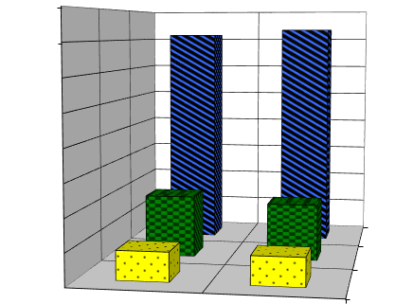

70.00%

60.00% |  |  |  |  |  |  |  |  |  |  |  |  |  |  |  |  | 73.4%
 |  |  |  |  |  |  |  |  |  |  | 71.5%
50.00%
40.00% |  |  |  |  |  |  |  |  |  |  | z
30.00%
20.00%
 |  |  |  |  |  |  |  |  | 19.5%
 |  |  |  |  |  |  |  |  |  |  |  |  |  |  |  | 17.8%
10.00%
 |  |  |  |  |  |  |  | 9.0%
0.00% |  |  |  |  |  |  |  |  |  |  |  |  |  |  | 8.8%
 |  |  |  |  |  |  | Current |  |  |  |  |  |  | Proposed
General Support |  |  |  |  |  |  |  |  |  |  | Capital |  |  |  |  | Program

Administration: The administration component includes district and principals’ office administrative expenses, administrative salary expenses, and related expenses for benefits, materials and supplies and equipment. It also includes Board of Education expenses.

Capital: The capital component includes all facilities costs to the district, annual debt service, and cost of construction and reconstruction. The capital component also includes costs for operation and maintenance; all expenditures associated with custodial salaries and benefits; service contracts; materials and supplies; utilities; and maintenance and repair of school facilities.

Program: The program expenditures are the instructional component of the budget. It includes salaries and benefits; materials, supplies, and equipment for librarians, guidance counselors, teachers, and non-teaching personnel who spend a majority of time performing teaching duties; and all transportation operating expenses.

PAGE 8

CANDOR CENTRAL SCHOOL DISTRICT BUDGET PROPOSAL 20XX-20XX

STATEMENT OF EXPENDITURES BY OBJECT

2019-2020 Statement of Estimated Expenditures

Spending by Object of Expense - Where the Money Goes
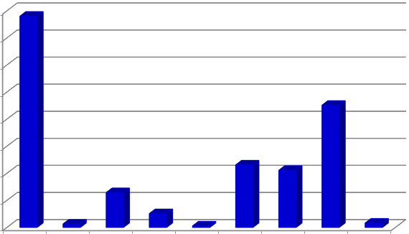

$8,000,000

$7,000,000

$6,000,000

$5,000,000

$4,000,000

$3,000,000

$2,000,000

$1,000,000

$-
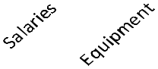

Object of Expense |  | Current |  | Proposed |  | Change
Salaries | $ | 7,472,500 | $ | 7,800,800 | $ | 328,300
Equipment | $ | 128,000 | $ | 128,000 | $ | -
Contractual Expense | $ | 1,293,850 | $ | 1,286,776 | $ | (7,074)
Materials and Supplies | $ | 499,300 | $ | 509,300 | $ | 10,000
Educational Materials | $ | 53,000 | $ | 53,000 | $ | -
BOCES Services | $ | 2,287,500 | $ | 2,307,500 | $ | 20,000
Debt Service | $ | 2,274,110 | $ | 2,108,107 | $ | (166,003)
Fringe Benefits | $ | 4,645,665 | $ | 4,510,665 | $ | (135,000)
Transfers | $ | 60,000 | $ | 160,000 | $ | 100,000
Total: | $ | 18,713,925 | $ | 18,864,148 | $ | 150,223

PAGE 9

CANDOR CENTRAL SCHOOL DISTRICT BUDGET PROPOSAL 20XX-20XX

REVENUE REPORT
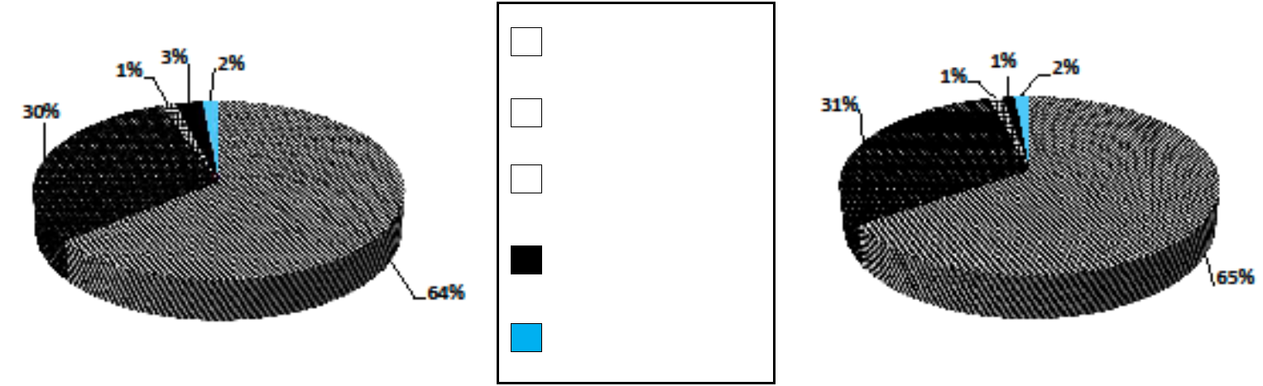

State Aid

Real Property Tax

Appropriated Fund

Balance

Use of Fund Balance

& Reserves

Other Sources

Source of Revenue | 2018-2019 Current |  | 2019-2020 Proposed |  | Change
State Aid | $ | 12,019,104 | $ | 12,321,371 | 302,267
Real Property Tax |  | 5,667,821 |  | 5,777,777 | 109,956
Appropriated Fund Balance |  | 250,000 |  | 250,000 | -
Use of Fund Balance |  | 262,000 |  | - | (262,000)
Transfer from Debt Service |  | - |  | - | -
Employees Retirement Reserve |  | 230,000 |  | 230,000 | -
Other Sources: |  |  |  |  | -
Interest |  | 10,000 |  | 10,000 | -
Federal Aid (Medicaid) |  | 50,000 |  | 50,000 | -
Local Sources (BOCES Refund) |  | 225,000 |  | 225,000 | -
Totals | $ | 18,713,925 | $ | 18,864,148 | 150,223

PAGE 10

CANDOR CENTRAL SCHOOL DISTRICT BUDGET PROPOSAL 20XX-20XX

BUDGET PROPOSTITIONS

Please remember that your vote is important. With our busy lifestyles, it is understandable that it is difficult to find the time to get out and vote. However, what could be more important than taking time out to ensure the best possible education for our students? You will be casting your vote for the following items included on this year’s ballot:

Budget: | Shall the Board of Education of the Candor Central School District be authorized to
 | expend for school purposes, the sums set forth in the proposed 2019-2020 budget,
 | in the amount of $ 18,864,148 and to levy the necessary tax on the property of said
 | District?
Proposition I: | Shall the Board of Education be authorized, pursuant to Education Law §1709(25)(i),
 | to lease or purchase by installment, for a term not to exceed five years, the
 | following motor vehicles: Two (2) sixty-five passenger school buses, and one (1)
 | twenty-four passenger/wheelchair accessible bus, for a term not to exceed five
 | years, at an amount not to exceed the estimated maximum cost of $70,000 per year
 | and not to exceed an estimated maximum cost of $350,000 for five years, such cost
 | to include costs incidental thereto and the financing thereof, which sum shall be
 | raised by a levy of real estate taxes?
Proposition II: | Shall the Board of Education of the Candor Central School District (the “District”) be
 | authorized to establish a reserve fund in accordance with Section 3651 of the New
 | York Education Law, to be known as the “2020 Capital Reserve Fund,” for a probable
 | term of five (5) years, commencing on June 30, 2019 and ending on June 30, 2024,
 | for the purpose of financing, in whole or in part, the purchase of school buses and
 | other vehicles and/or the cost of authorized alterations, construction and/or
 | reconstruction of District facilities, buildings and/or additions, including related site
 | work, health and safety improvements, security improvements, and handicap
 | accessibility improvements, and to fund this 2020 Capital Reserve Fund in the
 | maximum amount of $2,500,000, to be raised by the transfer of surplus funds
 | remaining in the District’s undesignated fund balance at the end of each fiscal year,
 | in amounts to be determined annually by the Board?
Board of Education: | Please vote for two (2) candidates:
 | Kelly Haynes | Hannah Murray | Michael Blake

PAGE 11

CANDOR CENTRAL SCHOOL DISTRICT BUDGET PROPOSAL 20XX-20XX

STAR PROGRAM

Changes to STAR

If you currently receive your STAR benefit as a reduction on your school tax bill (the STAR exemption), you may receive a greater benefit if you switch to the STAR credit to receive a check instead.

Recent changes in the law beginning this year:

- The value of the STAR credit savings may increase by as much as 2% each year, but the value of the STAR exemption savings will not increase.
- The income limit for the Basic STAR exemption is now $250,000.

If your income is more than $250,000, you must switch to the STAR credit to continue receiving a STAR benefit.

If your income is $250,000 or less, you have the option to switch.

To switch to the STAR credit: Notify your assessor to withdraw from the STAR exempt register for the STAR credit

Requirements for Basic and Enhanced STAR

Factor | Basic STAR | Enhanced STAR
Residency | You must own your own home and it must be your primary residence.
Age | No age restriction | 65 or older
 |  | For jointly owned property, only one spouse or sibling
 |  | must be at least 65 by December 31 of the year when
 |  | the exemption will begin.
Income | $500,000 or less for the STAR credit | For 2019 benefits, $86,300 or less.
 | ($250,000 or less for the STAR exemption) | For 2020, $88,0500 or less
 | The income limit applies to the combined | The income limit applies to all owners (residents and
 | incomes of only the owners and owners’ | non-residents), and any owners’ spouse who resides at
 | spouses who reside at the property. | the property.

BASIC STAR MAXIMUM SAVINGS

(New York State School Tax Relief Program)

For 2019-2020, the Basic Star tax savings per town is as follows:

 | Municipality | Basic Amount | Enhanced Amount
 | Town of Candor | $569.00 | $1,136.00
 | Town of Caroline | $645.00 | $1,293.00
 | Town of Danby | $645.00 | $1,293.00
 | Town of Spencer | $668.00 | $1,350.00
 | Town of Tioga | $556.00 | $1,113.00

PAGE 12

CANDOR CENTRAL SCHOOL DISTRICT BUDGET PROPOSAL 20XX-20XX

MEET THE CANDIDATES
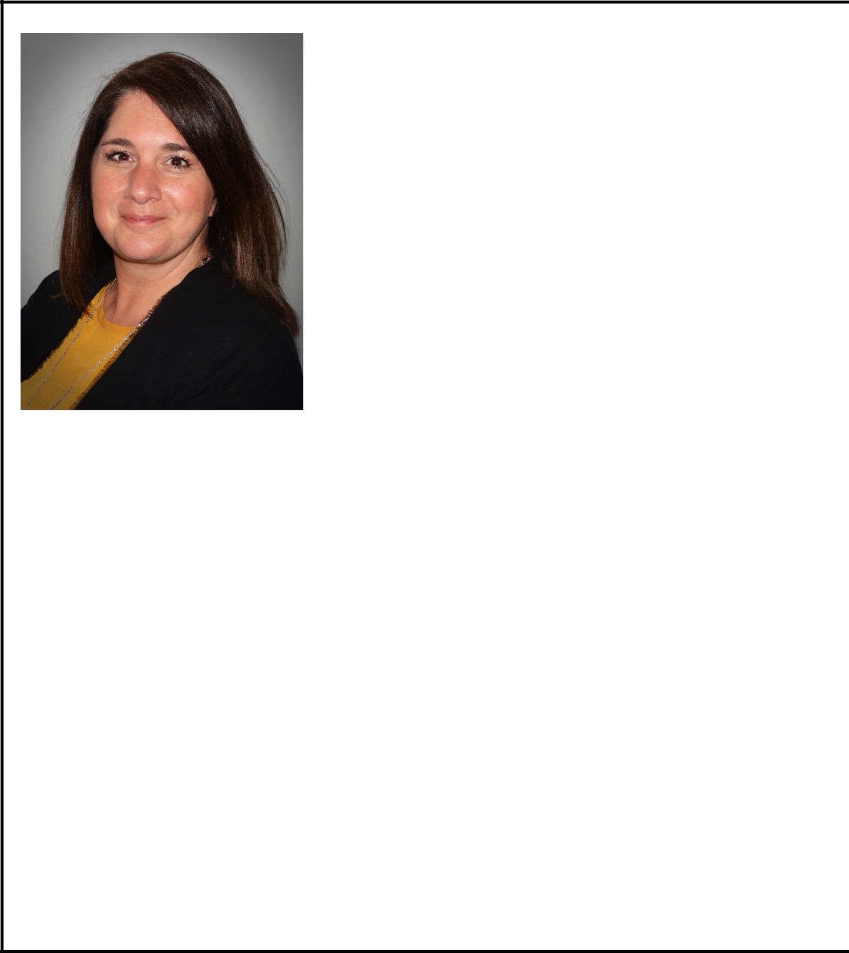

Kelly Haynes

I am running for school board because I have a vested interest in the success of the Candor community and its students. I moved here after marrying my husband, Kevin, of 22 years. Kevin and I have three children in the district (Christian, Senior; Hunter, Freshman; Emma, 6th Grade). I also own Spencer Agency which is a small insurance office right in the village of Candor (the other location is in Spencer).

As a small business owner and parent, I have always felt that community service is a huge part of my responsibility and currently serve on several boards throughout the county.

I truly feel that the community, parents and the school district need to all work together to provide our children with the best education and resources afforded. I believe that serving on the school board will allow me to collaborate with others to ensure Candor students have a safe, happy and well-rounded education that carries them into the future whether that be into the work force or into further education.

I am confident that my experience on other boards and as a local small business owner will provide a unique vantage point within the board. I would be proud to know that I am doing everything I can within our community for our children, their education and their future success.

PAGE 13

CANDOR CENTRAL SCHOOL DISTRICT BUDGET PROPOSAL 20XX-20XX

MEET THE CANDIDATES
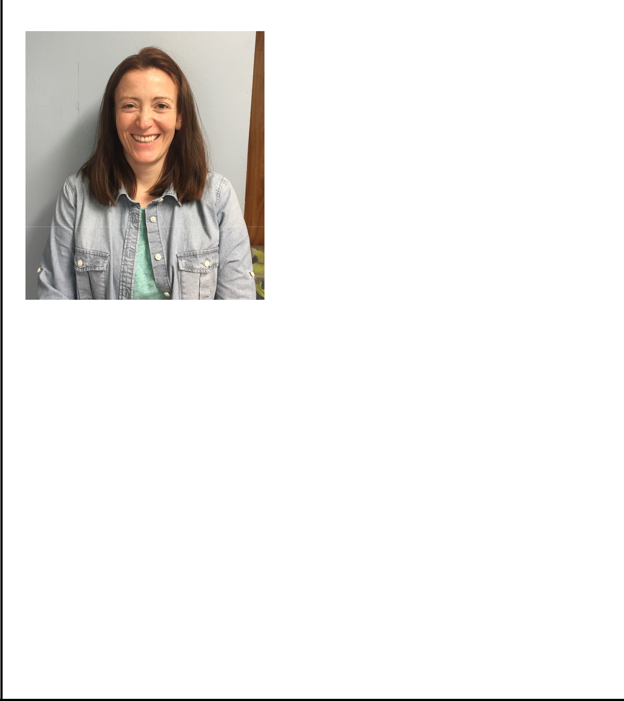

Hannah Murray

I am running for election to a second term on the Candor Central School Board of Education. I consider myself a level-headed, fiscally conservative person who can understand differing perspectives, and those characteristics should serve the Board well.

I view serving on the Board as a way to contribute to our community. In the fall, I will have two children in the Candor School District. My decisions will be made with an eye to providing all of Candor's kids educational opportunities to learn and gain the skills needed to become successful young adults.

I graduated from Candor High School in 2000 and attended the University of Maryland. I stayed in the Washington DC area after graduation and worked for an engineering firm as a landscape architect. After my husband, Rob and I welcomed our first child we moved back to Candor to prioritize family over the ‘rat race’ with long commutes in the DC area. It turns out life as a family of two young kids and two working parents are hectic anywhere, but we love being close to family and back in the Candor community. I have been working

at my family’s business, R.B. Robinson Contracting, for several years, though I plan to transition into starting my own landscape architecture practice soon.

PAGE 14

CANDOR CENTRAL SCHOOL DISTRICT BUDGET PROPOSAL 20XX-20XX

MEET THE CANDIDATES

Michael Blake

Tina and I are proud to have made Candor our home since 1983. Our children, Dan and Daron, were born and raised in Candor. Both children graduated from Candor Central School and benefitted from the small-town personal care provided by the Candor school faculty, staff, and administration.

Tina and I graduated from Binghamton University in 1974 after studying English Literature and Physics respectively. After 38½ years as a System Engineer, I retired from Lockheed Martin in September 2016.

I have served on the Candor Central School District Board of Education (BOE) for 12 years and on the Tompkins-Seneca-Tioga School Boards Association for the past 3 years, the last 2 as president.

I am also a Board of Directors member at the Kopernik Observatory and Science Center (KOSC). Although our children and grandchild now live in the Albany area, our family has always enjoyed living here, and we are proud to call Candor our home.

Board Of Education (BOE) members oversee the general direction and policies of the school district. The most important function of every BOE member is to facilitate the administration, faculty, and staff in providing the best affordable education for the children in our community. It is essential that school board candidates do not have pre-determined agendas when running to be on the school board, but instead listen to all stakeholders and act with an open mind. Volunteering on the BOE is a way of contributing to the community at the very heart of the community.

I bring to the board a perspective that balances the needs of the students with the fiscal health of the community. My intent is to be accessible to the community and school while contributing to the ongoing success that is the Candor Central School District.

PAGE 15

CANDOR CENTRAL SCHOOL DISTRICT BUDGET PROPOSAL 20XX-20XX

VOTER QUALIFICATIONS

In order to vote at any school election or meeting, a person must:

- Be a citizen of the United States,

- Be 18 years of age or over, and

- Have been a resident of the school district for a period of thirty days or more prior to the meeting at which he or she offers to vote, and who is not otherwise prohibited from voting under the provisions of section 5-106 of the Election Law.

ABSENTEE BALLOTS

The Board of Education authorizes the District Clerk or a Board designee to provide absentee ballots to qualified district voters. Absentee ballots can be used for the election of school board members and for the adoption of the annual budget and referenda.

A district voter must request in advance an application for an absentee ballot. The voter must complete the application and state the reason he/she will not be able to appear in person on the day of the district vote. The application must be received by the District Clerk/designee at least seven (7) days before the election/vote if the ballot is to be mailed to the voter, or received the day before the election if the ballot is to be delivered personally to the voter.

Pursuant to the provisions of Education Law, a district voter is eligible to vote by absentee ballot under any one of the following conditions:

- Illness or physical disability,

- Business responsibilities or studies which require travel outside of the county or city of residence on the day of the vote,

- Vacation outside the county or city of residence,

or

- Detention or confinement to jail after conviction for an offense other than a felony.

An absentee ballot must reach the office of the District Clerk/designee not later than 5:00 p.m. on the day of the election.

To obtain an absentee ballot, please contact Kathy Hinkle at Ph: or Address@com

Candor Central School District | Non-Profit Organization
P.O. Box | U.S Postage Paid
Candor, NY 13743 | Candor, NY 13743
 | Permit No. 14

BOX HOLDER

ANNUAL BUDGET HEARING

Tuesday, May 14, 20XX

7:00 p.m.

High School Auditorium

SCHOOL BUDGET VOTE

&

SCHOOL BOARD ELECTIONS

Tuesday, May 21, 20XX

Noon - 9:00 p.m.

High School Auditorium

