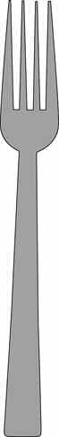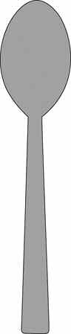

**Spoon**

**Glossary of Table Setting Utensils:**

**SETTING THE TABLE**

**Dinner Fork**

**Salad Fork**

**Knife**

**Dessert**

**Napkin**

14

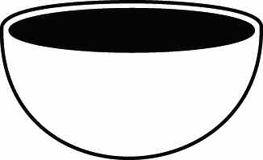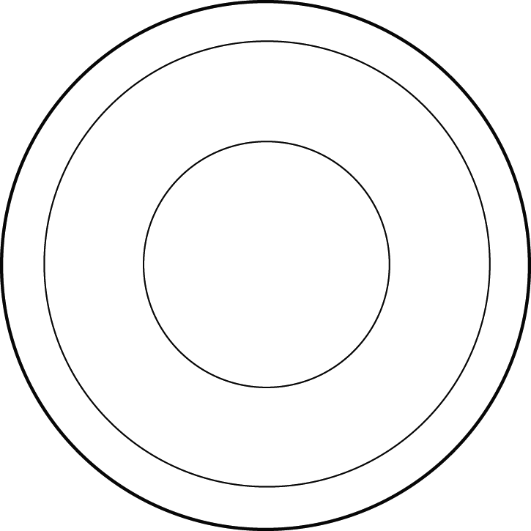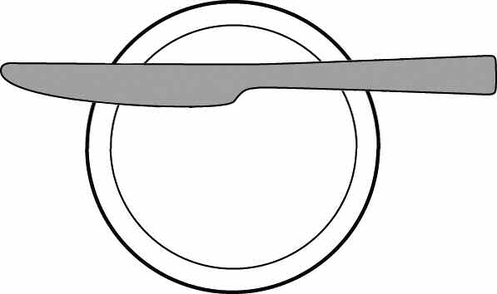

**Milk Glass**

**Juice/Water Glass**

**Dinner Plate**

**Salad Plate**

**Cup and Saucer**

**Dessert Cup**

**Dessert Plate**

**Bread and Butter Plate with Knife**

**Bowl**

15

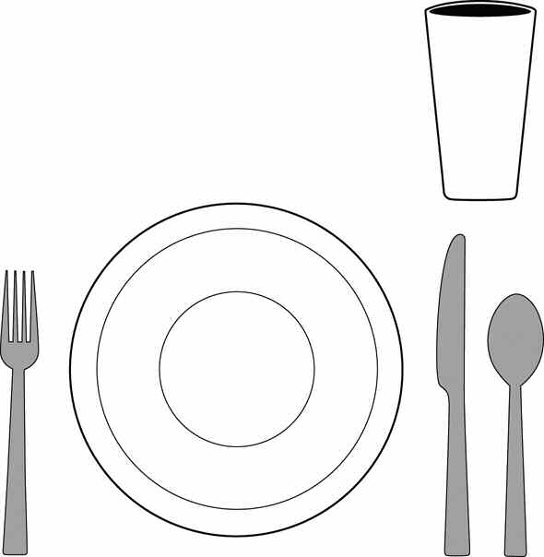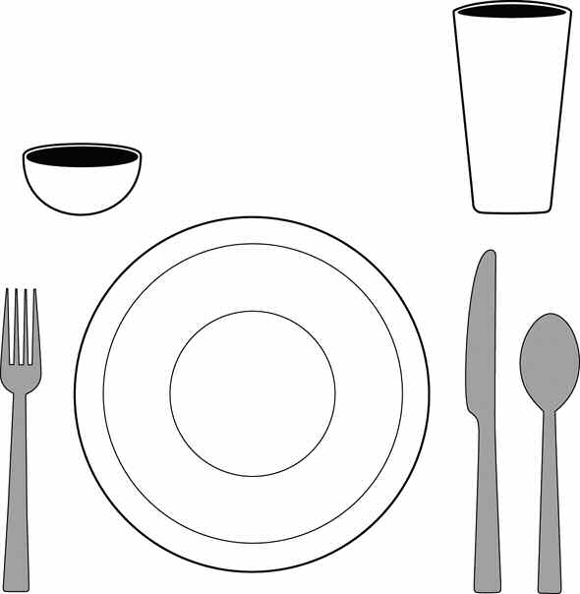

**Basic Table Setting:**

(may be used at any meal)

Your menu and recipe influence the number and type of dinnerware, flatware, and glasses/cups that you choose for your place setting.

**Unfolded Napkin**

**Folded Napkin**

**Fold**

**Open edges**

**Fold**

Grilled Reuben Sandwich Dill Pickles

German Potato Salad Milk

**Open edges**

**Fold**

Turkey Tetrazzini Crisp Relishes French Bread Chocolate Pudding Milk

**Open edges**

16

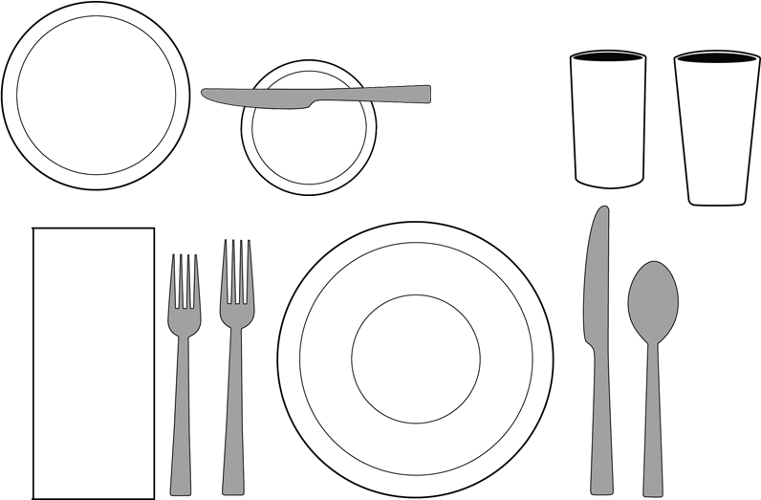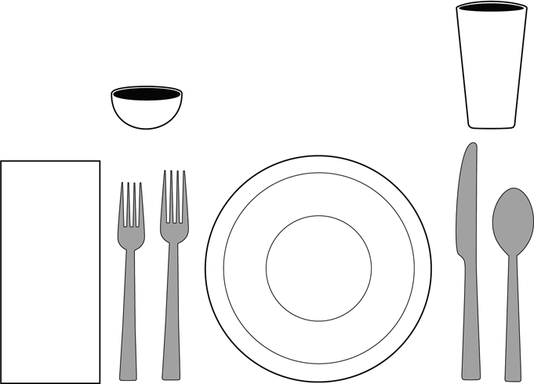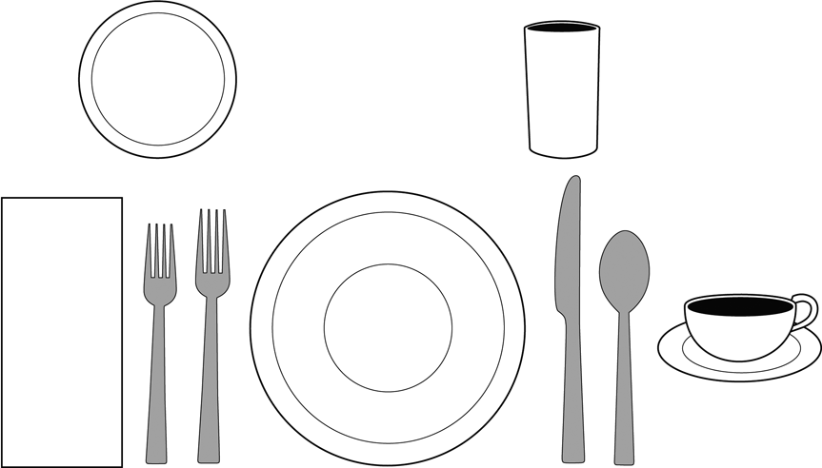

**Dinner/Lunch:**

Your menu and recipe influence the number and type of dinnerware, flatware, and glasses/cups that you choose for your place setting. In casual family settings, bread plates are often not needed.

Sweet & Sour Pork Chow Mien Noodles Asparagus-Lettuce Salad Fan-Tan Rolls

Milk Iced Tea

Raspberry Pie (the dessert is served following the meal)

Tossed Green Salad

Lasagna Skillet Zucchini Garlic Bread

Fresh Fruit Compote Cookies

Milk

(Salad served before meal)

Beef Roll-Ups Buttered Noodles

Green Peas w/ Mushrooms Perfection Salad

Crusty Rolls Coffee Milk

Blueberry Cheesecake (the dessert is served following the meal)

17

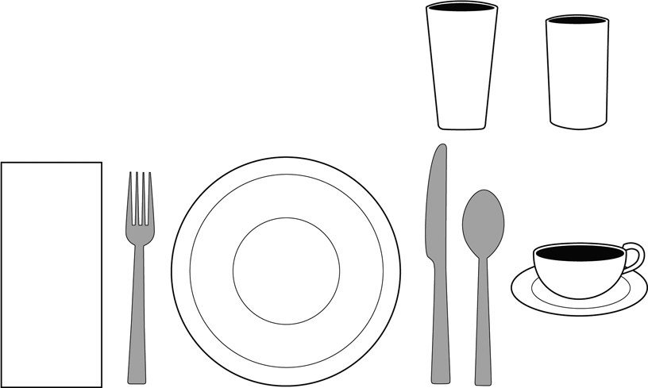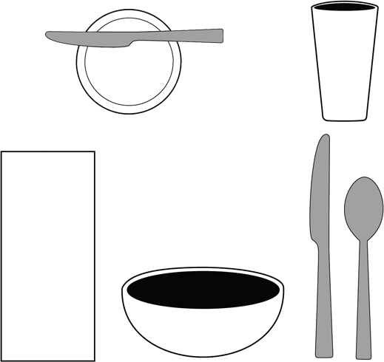

**Breakfast:**

Your menu and recipe influence the number and type of dinnerware, flatware, and glasses/cups that you choose for your place setting.

Tomato Juice Toasted English Muffins

Sausage Links Milk Coffee

Oatmeal Granola with Fresh Strawberries

*Toast Orange Marmalade Milk

*\*May use a separate bread plate or the plate under the bowl.*

18

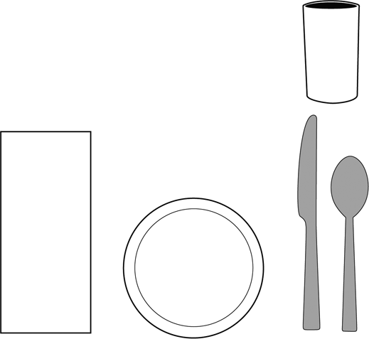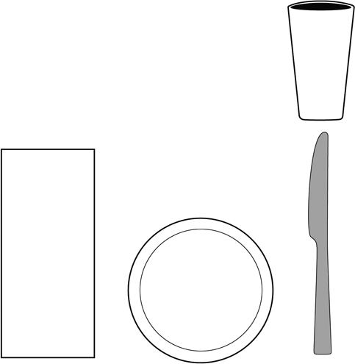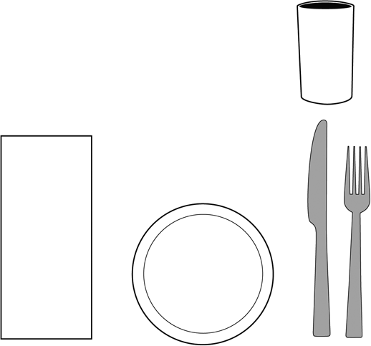

**Snack Menu:**

Your menu and recipe influence the number and type of dinnerware, flatware, and glasses/cups that you choose for your place setting.

Lemon Bread

Refreshing Orange Sipper

Whole Wheat Muffins

Whipped Strawberry Butter

Milk

Pizza Sandwiches

Strawberry-flavored Milk

19