Logic Model Template
Operations
 |  |  |  |  |  |  |  |  |  |  |  |  | Customers
Program |  |  |  |  | Program |  |  |  | Program |  |  |  | and |  |  |  | End
Inputs |  |  |  |  | Activities |  |  |  | Outputs |  |  |  | Intermediate |  |  |  | Outcomes
 |  |  |  |  |  |  |  |  |  |  |  |  | Outcomes
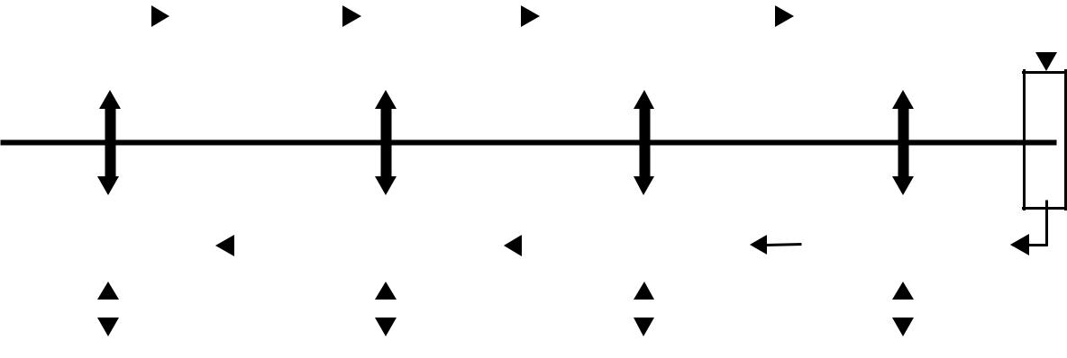
Mission

 | Management |  |  |  |  |  |  |  | Annual |  |  |  |  |  |  | Intermediate |  |  |  |  |  |  |  | Strategic
 | Objectives |  |  |  |  |  |  |  | Goals |  |  |  |  |  |  | Goals |  |  |  |  |  |  |  | Goals
 | Management |  |  |  |  |  |  |  | Annual |  |  |  |  |  |  | Intermediate |  |  |  |  |  |  |  | Long-Term
 | Measures |  |  |  |  |  |  |  | Measures |  |  |  |  |  |  | Measures |  |  |  |  |  |  |  | Measures
 | Evidence |  |  |  |  |  |  |  | Evidence |  |  |  |  |  |  | Evidence |  |  |  |  |  |  |  | Evidence
 |  |  |  |  |  |  |  |  |  |  |  |  | External Factors
RAND TR370-1.2

