You must currently be enrolled in a Cooking, Baking, Food Preservation, Home Environment, Cake Decorating or similar Project and have attended 80% of your project meetings.

Project Leaders or Club Leaders are responsible for making attendance determinations.

No cell phones or computer devices are allowed during setup. Exhibitors may use printed guides or printed photos only.

During setup times, only the person whose name appears on the entry form is allowed in the table setting exhibit at any time. Coaching and any interference from outside the table setting area is prohibited.

Exhibitors may not touch their own completed entry or another exhibitor's entry at any time. Once exhibitors leave the table setting area, they may not return to make any changes, nor can anyone else.

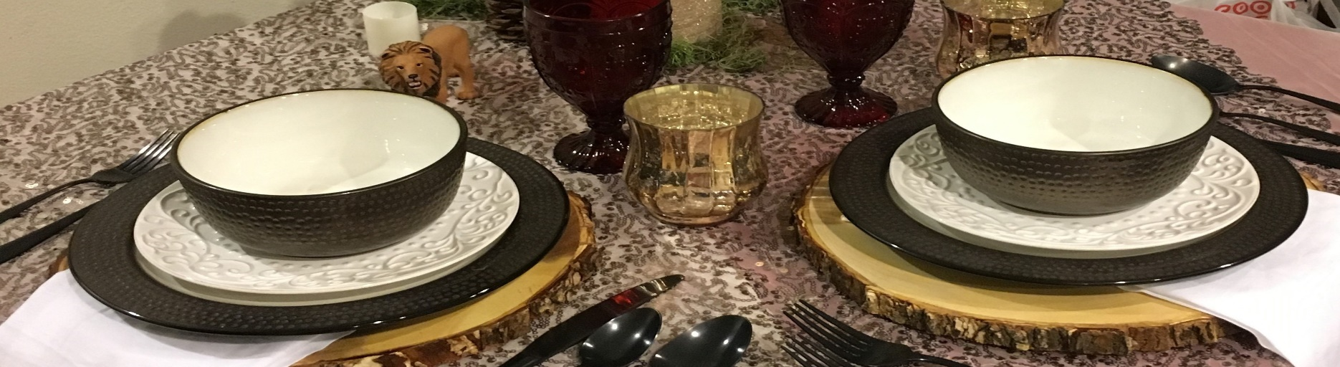

OC

4H

TABLE

SETTINGS

1.

Exhibitors are responsible for following these competition guidelines and rules, and entering their items in the correct Divisions/Classes. Failure to do so may result in disqualification.

2.

3.

4.

5.

6.

7.

All tables must display two place settings representing the class theme..

No fresh flowers, plants, or food items are to be used. Disposable place settings, paper tablecloths or napkins are not to be used in formal entries. Candles, if used, may not be lit.

Setting must include complete glassware, cups/saucers and flatware and be set for all courses on the menu. Do not set steak knives.

8.

9. Set dinnerware for all courses except dessert.

10. Menu must be displayed on the table, typed in 18 point or larger, free from spelling, grammar and punctuation

errors. Settings should correspond with the menu.

1. Table settings must be contained on the top of the table or may rise independently over the table. Table settings are not to exceed 6½ feet at its highest point and measured from the floor. No additional floor items allowed (e.g., chairs, rugs).
2. 4H staff will not maintain battery operated accessories. If used these items will not be replaced. No electricity is provided
3. Table dimensions are 36 inches square by 30 inches tall, "exhibitor must provide their own table".
4. Center piece can be scaled for a larger table that would seat more guests, but must not deter from overall effect, comfort of the guests or service of the meal.

1



OC 4H Culinary

TABLE

SETTINGS

Guidelines for OC 4H Table Settings Competitions

Judging criteria for OC 4H table settings, formal and informal, is modern American Standards. Although there are distinctions between formal and informal place settings, as well as settings unique to meals served, for the purpose of this show please follow the guidelines listed below.

Create a menu according to the theme of the class. Set the table with two place settings represented.

Set the table with two place settings and display the menu you are planning to serve. Set flatware, glassware, cups, saucers and plates corresponding to courses listed on the menu, with the exception of the dessert plate.

**Table Linens**

For formal settings the tablecloth can be 12-18 inches dropped from the table’s edge. For informal settings, mats or runners maybe used in conjunction with a table cloth.

Informal table cloth drop is 8-12 inches.

Place napkins folded in squares or rectangles, at the left of the forks with the open corner nearest to the plate. The folded napkin may also be laid on the empty plate. Informal place settings may have creatively folded napkins.

•

•

•

**Flatware**

Set flatware 1-inch from edge of the table in straight line. Utensils my follow the curve on a round table.

Flatware should be arranged at each place in the order of its use for the various courses, utensils on the outermost position to be used first.

Set no more than 3 pieces of flatware on each side of the plate.

Set forks, (except cocktail fork) at left of plate with prongs up. Cocktail fork, if needed, is placed on the plate or at extreme right.

Set knives and spoons to the right of plate. Set knives with blade turned toward the plate. Do not set steak knives.

If a salad course is served early in the meal, the salad fork should be further from the main course fork, with both set on the left.

For informal place settings, when an entree salad is the main course, dinner fork may be set for the course.

If a soup is served, the spoon is set on the right, further from the plate than the knife. For purposes of this show, dessert utensils (fork and teaspoon) should be set above the main plate horizontally (bowl of spoon facing left and the fork below with tines facing right), for both formal and informal tables.

Small bread knives or spreader are not required, but if used they should lay across the bread plate, parallel to edge of table with the handle pointing to the right, or at a 45 degree angle, handle to right, blade turned toward center of the plate.

If chopsticks are set, place them over the plate horizontally, tapered ends to the left. Asian soup spoons may set over the chopsticks, handle to the left.

Chopsticks and Asian soup spoons may not replace American utensils.

•

•

•

•

•

•

•

•

•

•

•

•

•

2

**Division 321 - Informal**

**Division 322 - Themed /Party**

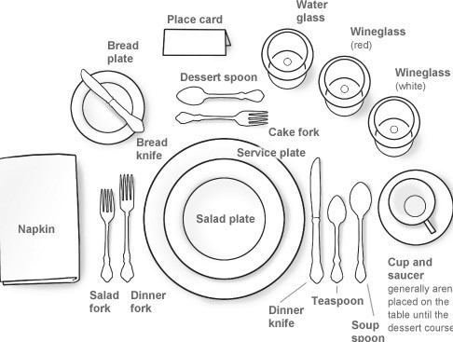

Guidelines for OC 4H Table Settings Competitions Cont..

**Tableware**

**(Sporting events, birthdays,**

**(informal table settings can use plastic, cloth or paper / preprinted table coverings with accompanying dinnerware in plastic, metal or paper.)**

**linens, china, glassware and silverware.)**

**(Formal table setting consists of**

**Division 320 - Formal**

Menu should be easy to read. 18 point or larger type, presented in a self standing frame which makes it visible.

Menu should reflect the theme or occasion. Food items should be balanced, offering sufficient dishes from all food groups.

For the purposes of this show , a minimum of two courses should be served.

**Menu**

Table decorations should usually be below eye level, and or not obstructive for diners. Centerpiece may be scaled for a larger table that would seat more guests, but cannot deter from the overall effect, the guests’ comfort or the service of the meal.

Place cards if you choose to use them, can be placed on top of the napkin (if napkin is on the plate) or above the dessert flatware.

**Centerpieces**

If a place plate or charger is used for a formal setting, it should be set 1 inch from the table’s edge.

For the purpose of this show, set bread and butter plate 1 inch above the outside fork, for both formal and informal settings.

Set all courses served according to menu with the exception of dessert. Salad plate, if needed, may be set to the left of the forks or on top of the dinner/meal plate.

If coffee or tea is listed on the menu, cups and saucers are set on the right of the knives and spoons or above the setting to the right if space is limited, handle turned to right.

**Glasses**

Drinking glasses of any kind - water, wine, juice, iced tea – are set at the top right of the dinner plate, above the knives and spoons.

Glasses designed for certain types of wine may be set if available. If only one type of glass is available, it is considered correct regardless of the type of wine provided.

For the purpose of this show, glasses may be set at a 45 degree angle from the water goblet, in a straight line or triangle formation.

Set a water glass for all menus and styles of service.

TABLE

SETTINGS

•

•

•

•

•

•

•

•

•

•

•

•

•

•

Napkin should be folded on the left and open on the right.

☞

**holidays, get inspired by a book,**

**wedding, etc.)**

3