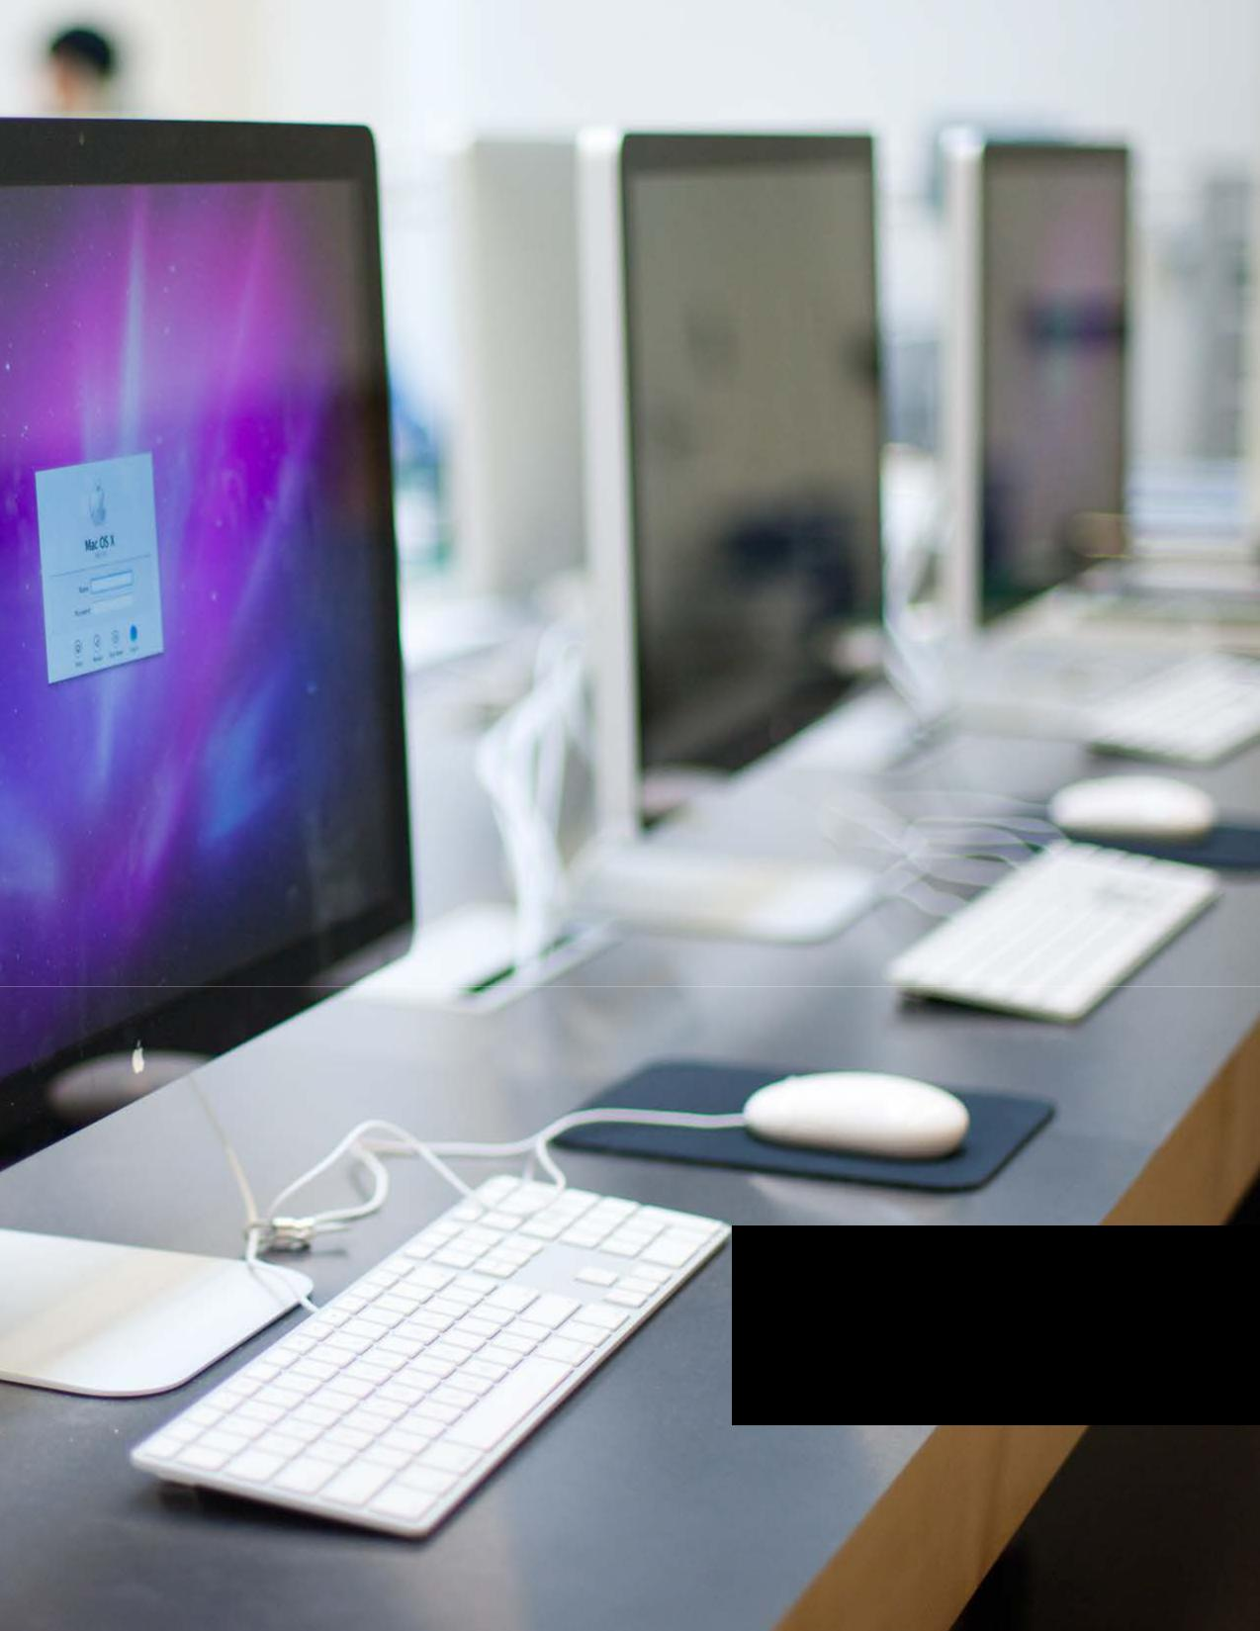

DIGITAL IMAGING CENTER

PRINT BOOKLET

CONTENTS

02 General Information | 20

03 Policy and Procedure | 22

05 5th Floor Printers | 23

06 6th Floor Printers | 24

07 How To Print | 27

12 Exporting a PDF

13 Tiling

18 Double Side Printing

2-Up Saddle Stitch

Booklet Checklist

Booklet Preview

Booklet Types

PURPOSE OF THIS PRINT GUIDE

Staff
This printing guide will provide

information for all students in the

capabilities of the Digital Imaging

Center. This will also cover the

general instructions of common

practices on the 5th and 6th floor

lab. This will become a valuable

asset as a reference for all students.

The DIC staff and lab assistants are

always here to assist and answer

any question you have. .

GENERAL LAB HOURS
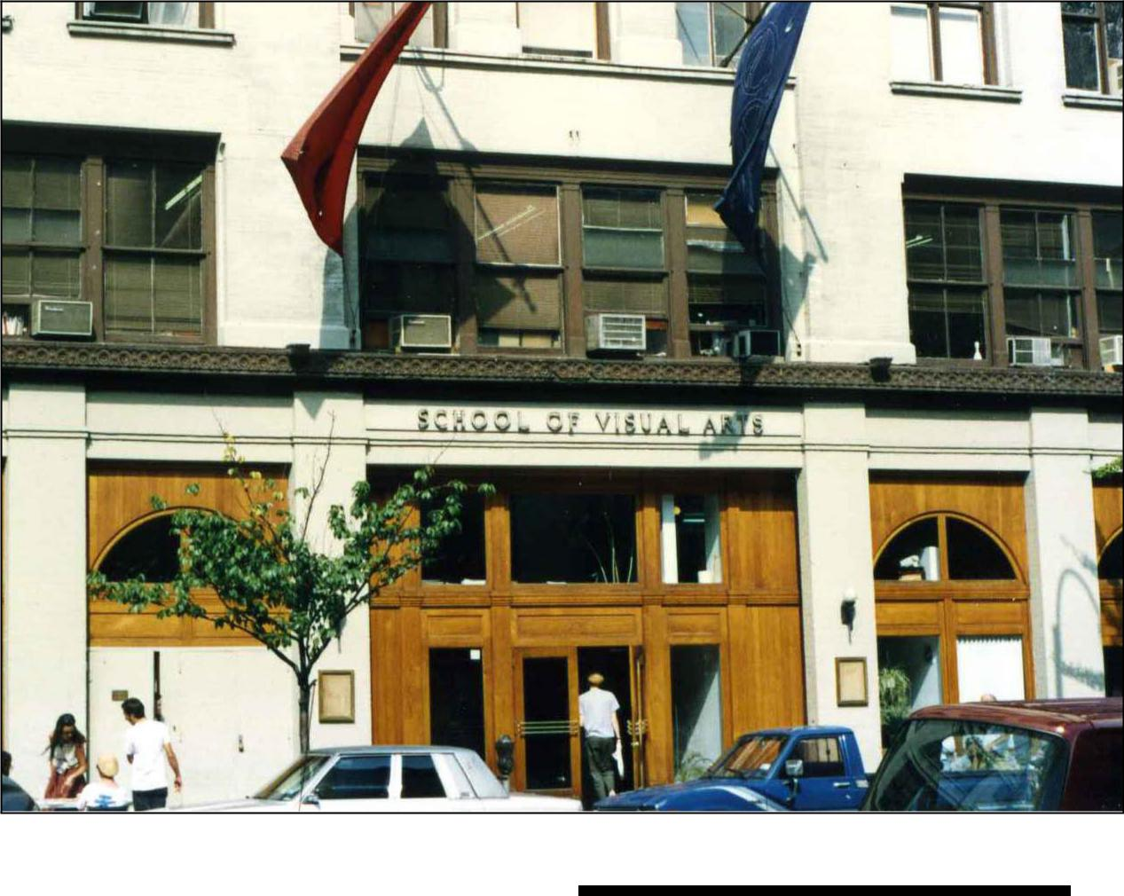

8:30am - 12:30pm Monday – Friday

10am – 9:30pm Saturday

12pm – 9:30pm Sunday.

The Lab is closed during Winter break and for two weeks prior to the summer session as well as the two weeks at the end of the sum-mer. Students must pay the summer Lab fees in order to use the Lab during the summer.

2

POLICY AND PROCEDURE POLICY AND PROCEDURE

- ID Cards

All currently enrolled SVA students must have a valid SVA Student ID Card with current stickers to enter all of SVA’s buildings. A D.I.C. sticker is also required upon entering the Digital Imaging Center. Students may obtain an ID

card/stickers at the Registrar’s office, located at 209 E. 23rd Street. Students should get their ID as soon as possible. The Security Guards on duty may ask to see your ID at any time and may not let you in the buildings if you cannot provide a valid SVA ID. Please keep your SVA ID card with you at all times.

- Lab Rules

To follow Lab rules ensures a healthy, safe and productive environment for all of SVA’s students, faculty and staff.

- Food and drinks are not permitted on computer desks at any time including bottled water.

- The installing of software is not allowed on any of the D.I.C. computers.

This causes computer malfunctions and virus outbreaks. Students may request a Systems Administrator to install particular software on a specific machine. Please note this request may also be denied.

- Smoking is not permitted. In accordance with New York State law, smoking is not permitted anywhere in the building. This includes the stairwells and bathrooms. Students must go outside to smoke.

- Do not connect, disconnect, or remove any piece of D.I.C. equipment from a computer system.

- Consult a Lab Assistant or Systems Administrator if it is necessary to change a system configuration.

- Do not print out manuals or long tutorials. Try to conserve paper and save a few trees!

- Please be courteous when using your cell phones in the Lab during free time. Please note you can be asked to finish your conversation outside of a lab room.

3. Saving and Backing-Up Data

You are responsible for your data. Save your data frequently as you work.

Back up early and back up often. It is advisable to purchase some sort of additional external storage devices to back up your work early and often.

The department is not responsible for any work or data that may be lost either from our regular maintenance or because of system failures, etc. Be sure to save multiple backup copies in more than one place.

The Temporary Student Server is deleted every other week on Friday at midnight. Schedules are posted in all the rooms.

4. Lounge Areas

These shared spaces should be kept clean at all times. Please be respectful of others, the Lab and the spaces shared by all in the D.I.C.

5. Lost and Found

Items found in the Lab will be placed in the Lost and Found, located at the front office.

6. Theft

Respect for the property of others is expected at all times. Report any missing items or other security issues to a member of the Administrative Staff or the Security Guard on duty. Unfortunately, sometimes thefts do occur, so please be mindful of all your belongings (keep purses, hard drives, and other valuables with you, etc.) We are not responsible for unattended items or missing items

7. Visitors

Students wishing to bring outside visitors to the Lab must fill out a Request For Access form and fax it to the SVA Security Office at least 24 hours in advance for approval. Visitors will not be allowed access without prior approval from SVA Security Office. Additionally, all guests must sign in at the guard’s desk and provide a current SVA ID and valid form of identification.

3 ⁴

5TH FLOOR PRINTERS
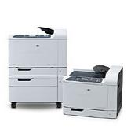

HP COLOR LASER CP6015

LOCATION:

In all Computer Lab rooms.

MEDIA SIZES:

8.5x11, 11x17

SETTINGS:

Double-Sided, Spreads, 2 Sided Output

5
6TH FLOOR PRINTERS
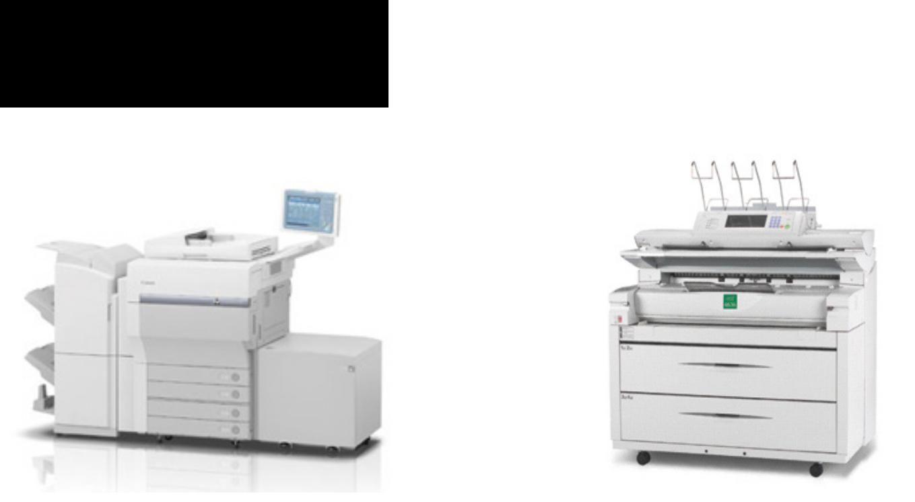

2x CANON C1 IMAGEPRESS KIP 3100 Zoomer

MEDIA SIZES: MEDIA SIZES:

8.5x11, 11x17, 12x18, 13x19 18x24, 24x36, 36x42, 36x60, 36x72

SETTINGS:

Double-Sided, Spreads, 2 Sided Output
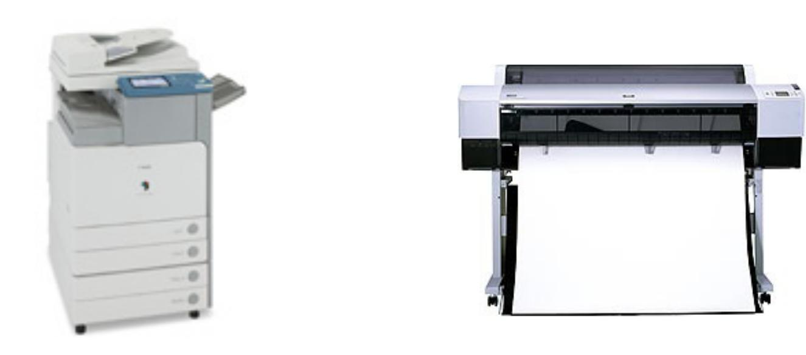

CANON C4580 Copier EPSON 9900

MEDIA SIZES: MEDIA SIZES:

8.5x11, 11x17, 12x18 18x24, 20x24, 24x36, 24x48, 24x60,

24x72, 24x84,24x96.30x40, 36x48,

36x60, 36x72, 36x84, 36x96.42x40,

42x48, 42x60, 42x72, 42x96.

6

HOW TO PRINT

ADOBE INDESIGN

- Choose FILE > PRINT (cmd-P)

- Specify the printer you’re using in the Printer menu.
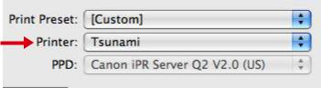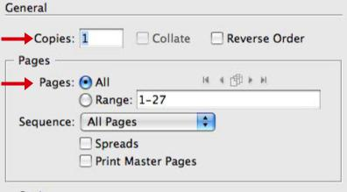

- In the General area, type the number of copies to print. Option: Choose All to print all pages of a document.
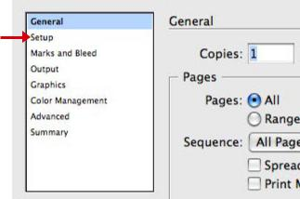

- Click on the Setup area to specify a printer and the correct page orientation. Click PRINT.
HOW TO PRINT

ADOBE PHOTOSHOP

1. Choose FILE > PRINT (cmd-P)
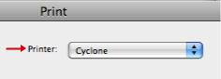

2. Specify the printer you’re using in the Printer menu.
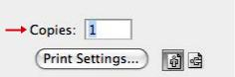

3. In the General area, type the number of copies to print.

- Click on Print Settings to specify a printer and select proper paper size.

- Click OK and click PRINT.

7 8

HOW TO PRINT

ADOBE ILLUSTRATOR

- Choose FILE > PRINT (cmd-P)

- Specify the printer you’re using in the Printer menu.

- In the General area, type the number of copies to print.

- In the Media Box select the paper size and orientation of the image.

- Click PRINT.
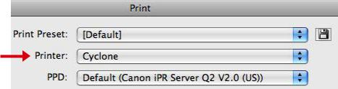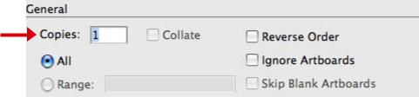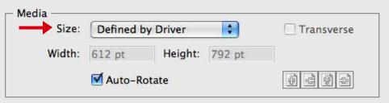
HOW TO PRINT

ADOBE ACROBAT

- Choose FILE > PRINT (cmd-P)

- Specify the printer you’re using in the Printer menu.
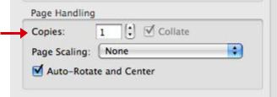

- In the page handling section select the number of copies.
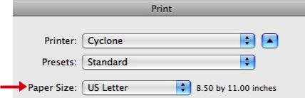

- Click on Page Setup and select the paper size available. Click OK.

- Click PRINT.

9 10

EXPORTING A PDF

ADOBE INDESIGN

A PDF (Portable Document File) is the preferred format

to print. This is because images and typefaces do not need

to be packaged.
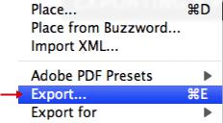

1. Go to FILE > EXPORT
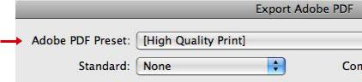

2. For Adobe PDF Preset select High Quality Print.

Note: High Quality Print Creates PDFs for quality printing on

desktop printers and proofing devices.

3. Click the EXPORT button.
TILING

A B
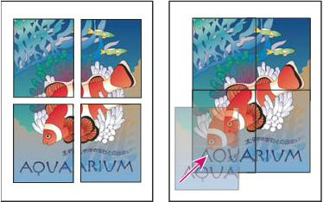

Oversized pages divided into printable tiles (left) and the over-lapping sections in final assembly

A document’s dimensions do not necessarily

match the paper sizes used by printers.

As a result, when you print, InDesign or

Illustratator divides the oversized document into

one or more rectangles, or tiles, that correspond

to the page size available on the printer. You can

then assemble the overlapping sections.

You can have InDesign or Illustrator tile

a document automatically, or you can specify

the tiles yourself. Tiling manually lets you control

the origin point for the upper-left corner of the

tile, so that you determine where the page falls

on the paper.

11 12

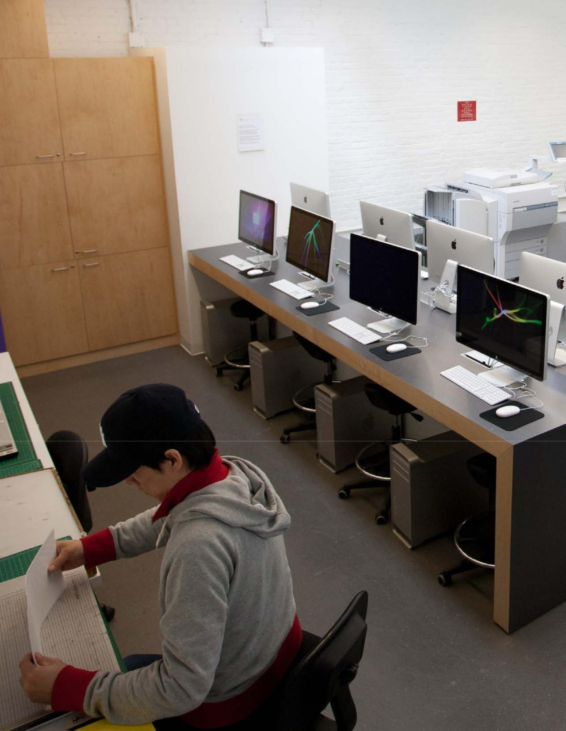TILING

ADOBE INDESIGN

1. Choose FILE > PRINT (cmd-P)
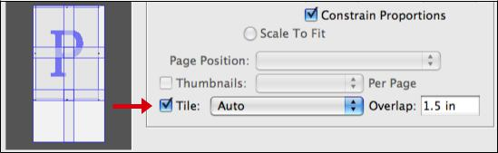

- In the Setup area of the Print dialog box, select TILE

- Choose one of the following options in the Tile menu drop down box:

Overlap

Type the minimum amount of duplicated information you want printed on each tile for ease in assembly. The Overlap option uses the unit of measure specified for the document.

Auto:

Automatically calculates the number of tiles required, including the overlap.

Auto Justified:

Increases the amount of overlap (if necessary) so that the right sides of the rightmost tiles are aligned at the right edge of the document’s page, and the bottom sides of the bottommost tiles are aligned at the bottom edge of the doc-ument’s page.

- Select the amount of overlap for each tiling. Click PRINT.

13

TILING

ADOBE ILLUSTRATOR

TILE A DOCUMENT

By default, Illustrator prints each artboard on a single sheet of paper. However, if the artwork is larger than the page sizes available on your printer, you can print onto multiple sheets of paper.

Dividing an artboard to fit a printer’s available page sizes is called tiling. You can choose a tiling option in the General section of the Print dialog box. To view the print tiling boundaries on the artboard, choose View > Show Print Tiling.

Artboard divided into multiple page tiles
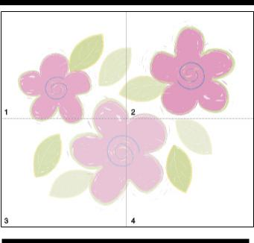

TIP: When you divide the artboard into multiple

tiles, the pages are numbered from left to right

and from top to bottom, starting with page 1.

These page numbers appear on-screen for your

reference only; they do not print. The numbers

enable you to print all of the pages in the file or

specify particular pages to print.

15
TILING

ADOBE ILLUSTRATOR

- Choose FILE > PRINT (cmd-P)

- Specify the printer you’re using in the Printer menu.
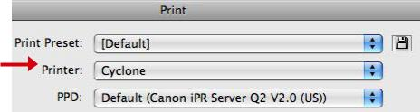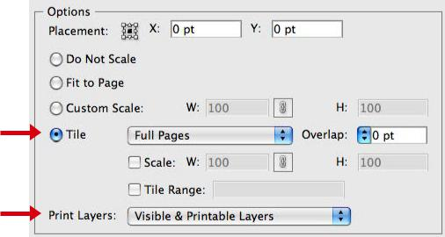

- Select TILE and select a tiling option from the drop down menu. Add an amount of overlap and select the proper print layers.

- After you have arranged the image, select the paper size and the orientation of the image. Click PRINT.
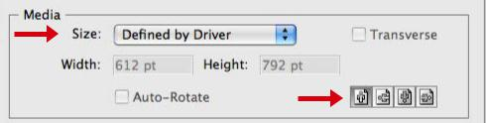

16

DOUBLE SIDE PRINTING

ADOBE INDESIGN

1. Choose FILE > PRINT (cmd-P)
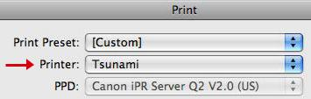

2. Select the TSUNAMI or CYCLONE printers.
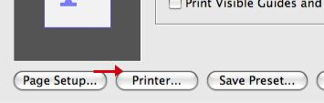

3. Select PRINTER and a new dialog box pops up.
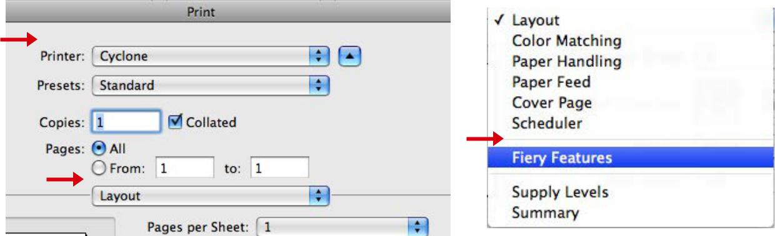

4. Select the printer then go to the drop down box with LAYOUT selected. Select FIERY FEATURES.
DOUBLE SIDE PRINTING

ADOBE INDESIGN
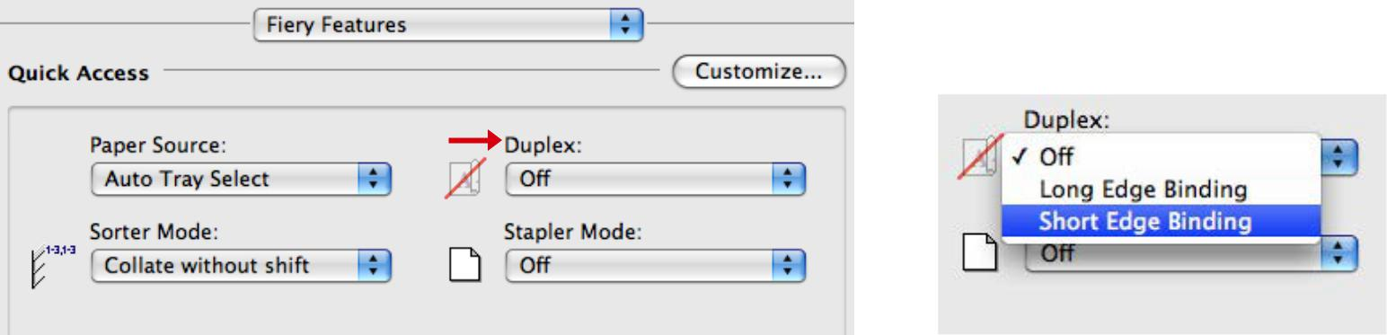

- Under the DUPLEX drow down box select either short edge or long edge binding.

- Click PRINT.

TIP: If you are printing a large document please test the prints out by printing the first 2 pages

17 18

2-UP SADDLE STITCH

ADOBE INDESIGN
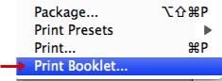

1. Choose FILE > PRINT (cmd-P)
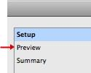

- Click PREVIEW on the left side of the dialog box to see small thumbnails of the booklet page sequence.
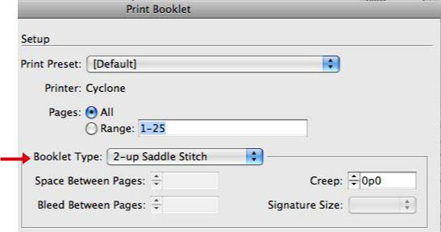

3. Select 2-UP SADDLE STITCH and adjust all available options.
2-UP SADDLE STITCH

ADOBE INDESIGN
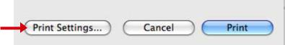

4. Select PRINT SETTINGS for a new dialog box to appear.
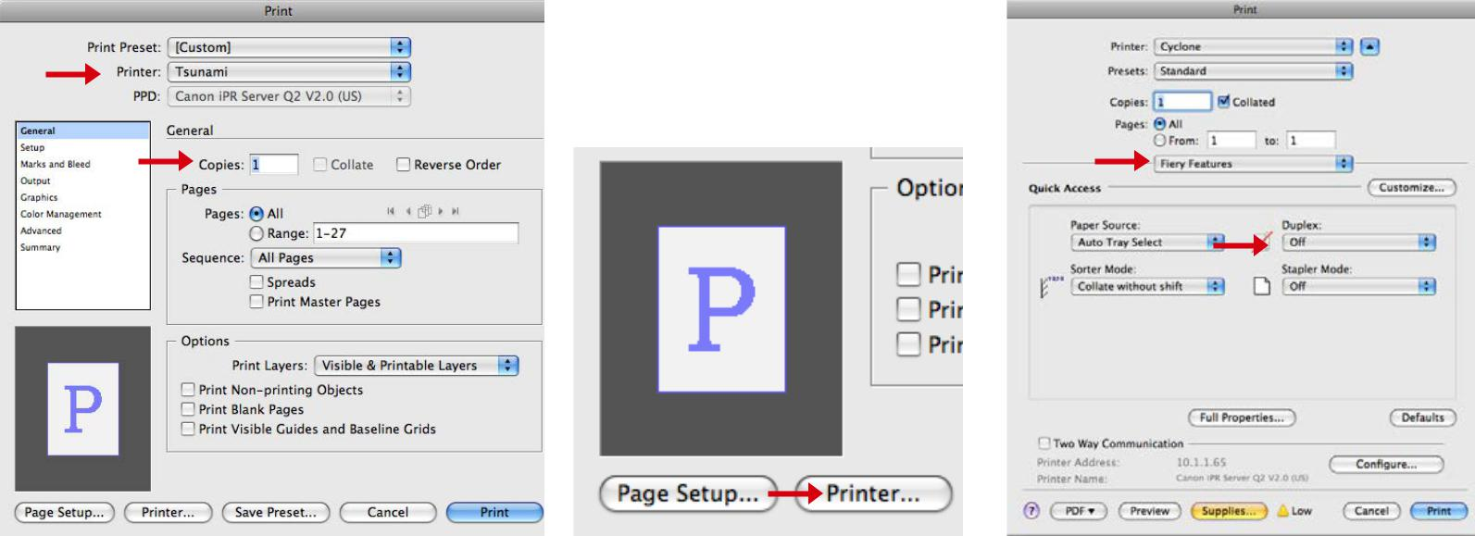

5. Select all necessary options such 6. Click on the Printer button for a new dialog box.

as printer, paper size, crop marks, Follow the double sided instructions. Select either short

spreads, range, etc. or long edge. Click PRINT.

19 20

BOOKLET CHECKLIST

ADOBE INDESIGN

STEP 1

A booklet must be divisible by four.
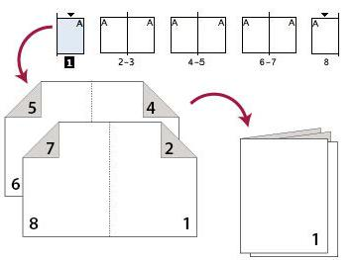

Tip: Revisit your layout, recheck your design because an extra page will be added and change your design layout.

STEP 2

Choose File Menu / Print Booklet to preview your spreads. For more information, read page 11. The Preview area of the Print Booklet (InDesign)

dialog box lets you review color thumbnails of the printer spreads created by your selected imposition style.

STEP 3

Print a black and White copy. Proof your booklet to ensure the layout is correct. Tip: Choose File Menu / Print Booklet to preview your spreads.

STEP 4

Backup your project

to PDF. For more

information, read

page 12.

STEP 5

If everything checks out cor-

rectly, you are ready to print

in color.
BOOKLET PREVIEW

ADOBE INDESIGN

The Preview area of the Print Booklet (InDesign) dialog box lets you review color thumbnails of the printer spreads created by your selected imposition style.
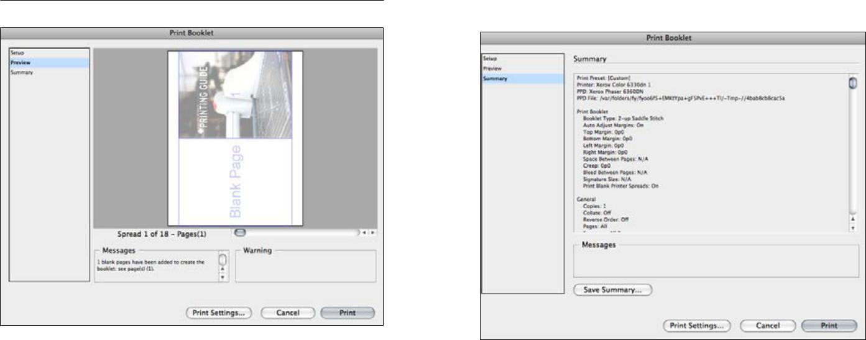

- Choose FILE> PRINT BOOKLET.

- Click PREVIEW on the left side of the dialog box. To flip through the printer spreads, click the scroll arrows.

- Click SUMMARY on the left side of the Print Booklet dialog box to view

a summary of current booklet settings. Check the bottom of the Summary area for any conflicting settings.

21 22

BOOKLET TYPES

BINDING

The protective covering on the front, back, and spine of a book.

LONG-EDGE SHORT-EDGE
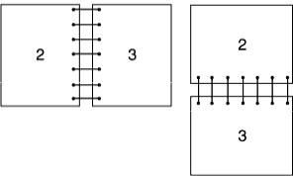

The page turns on the long side,

regardless of orientation.

The edge refers to where the |  |  |  | The page turns
next page follows on from with |  |  |  | on the short side,
your print remaining upright. For |  |  |  | regardless of orien-
example | long edge will mean |  |  | tation.
that you turn from one page to
the next along the long edge
of the paper, much like an A4
magazine or standard brochure.
Short | edge | would | mean
that you turn the page from
the short edge of the paper,
much like that |  | of a | notepad.

8 PAGE BOOKLET
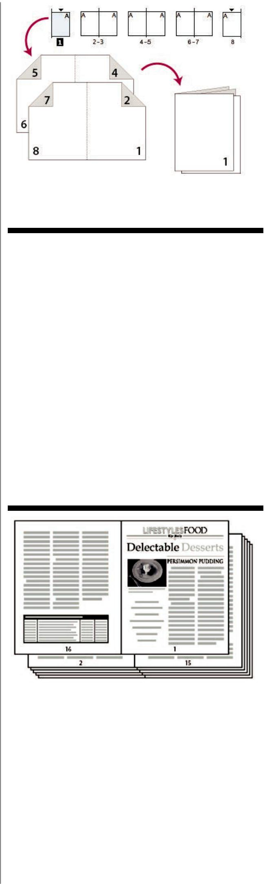

Impose a document for booklet printing.

Creates two-page, side-by-side printer spreads. These printer spreads are appropriate for printing on both sides, collating, folding, and stapling. InDe-sign adds blank pages as needed to the end of the finished document.

2UP SADDLE STITCH

Creates two-page, side-by-side printer spreads. These printer spreads are appropriate for printing on both sides, collating, folding, and stapling. InDe-sign adds blank pages as needed to the end of the finished document.

2up Perfect Bound Booklet
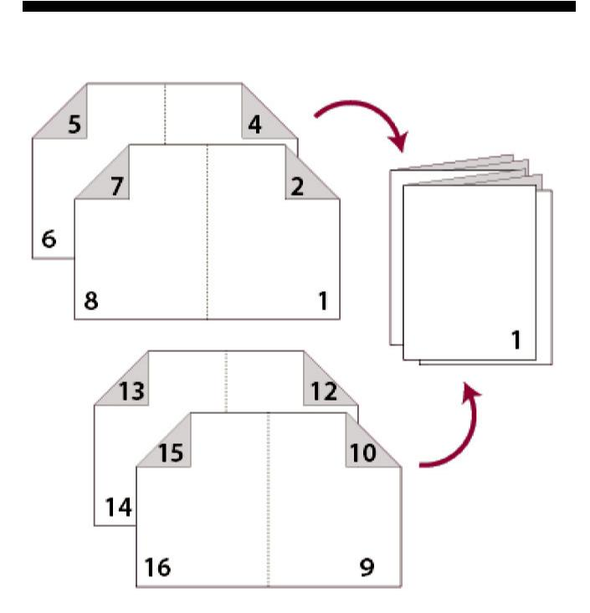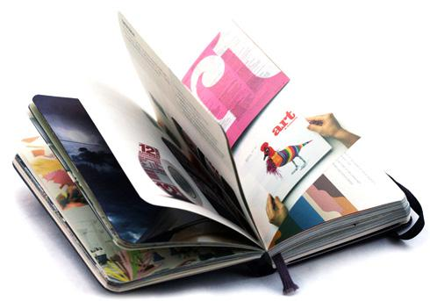

To produce a perfect bound book, however, the computer part is the same. The book is laid out and designed in the computer, then printed to sheets of paper in signatures.

Signatures

The number of pages in the booklet is known as the signature of the book. For example,

a booklet of signature 8 will print onto two sheets (front and back) in the following order:

Sheet 1 front side: pages 8 and 1

Sheet 1 reverse side: pages 2 and 7

Sheet 2 front side: pages 6 and 3

Sheet 2 reverse side: pages 4 and 5.

23 24

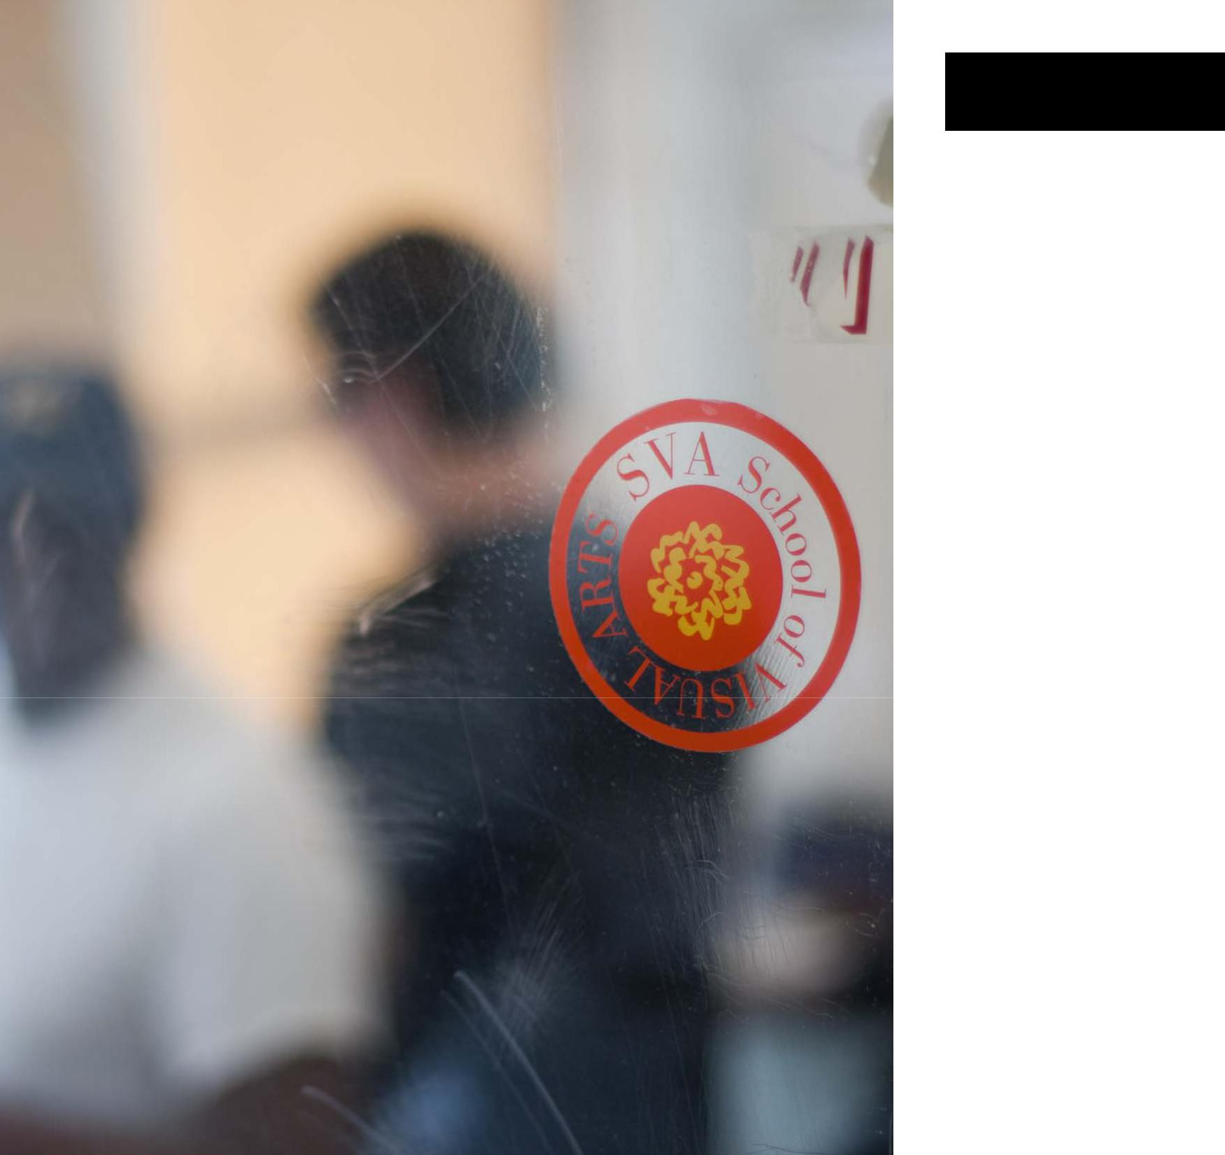STAFF

Senior Manager:

Stephen Alvarado

Digital Imaging Center 5th & 6th floor

Email: salvarado@sva.edu

Work: 212.592.2023

Media Workshop Manager:

Joe Jones

Digital Imaging Center, 6th floor

Email: jjones@sva.edu

Work: 212.592.2152

Assistant Workshop Manager:

Angel Ibanez

Digital Imaging Center, 6th floor

Email: aibanez@sva.edu

Work: 212.592.2152

Evening Workshop Manager:

Jason Ng

Digital Imaging Center, 6th floor

Email: jng@sva.edu

Work: 212.592.2152

Systems Administrator

Alexander Sullivan

Digital Imaging Center, 5th floor

Email: asullivan@sva.edu

Work: 212.592.2078

Lab Coordinator

Viveca Diaz

Digital Imaging Center, 5th floor

Email: vdiaz@sva.edu

Work: 212.592.2150

Weekend Supervisor

Andrew Gaska

Digital Imaging Center, 5th floor

Email: agaska@sva.edu

Work: 212.592.2150

SVA DIGITAL IMAGING CENTER

26

