SCHOOL DISTRICT
 | LETTER OF TRANSMITTAL SAMPLE
DATE: | August 23, 2021
TO: | DIR, Office of the Director
 | Attn: LCP Special Assistant
 | 455 Golden Gate Ave., 10th Floor
 | San Francisco, CA 94102
FROM: | Nancy Fergoda
 | Facilities Financial Analyst
RE: | LCP Report for 2015-2016 (for LCP ID #2011-00808)

Enclosed please find our Annual Labor Compliance Report for the period 7/1 /2015-6/30/2016.

Regards,

Nancy Fergoda

Facilities Financial Analyst

(650) 312-7887

1170 Chess Drive | Board of Trustees
Foster City, California 94404 | Chelsea Bonini, Ed Coady, Lory Lorimer Lawson, Audrey Ng, Colleen Sullivan
650.312.7700 Tel
650.312.7779 Fax | Superintendent
www.smfcsd.net
 | Joan Rosas, Ed.D.

__ l _{J} ^{_(} J _J

LCP-AR2
LABOR COMPLIANCE PROGRAM ANNUAL REPORT

Format for Awarding Body that enforces its own Labor Compliance Program for all projects (Labor Code §1771.5(a))

Report for the reporting period_07/01/2015_ to _ 06/30/2016_
(mm/dd/yyyy) (mm/dd/yyyy)

- Name of Labor Compliance Program (LCP): San Mateo-Foster City School District
 | 2. LCP I.D. Number (assigned by DIR): | 3. Date of Initial Approval:
 | 2011-00808 | 09/01/2011

- Contact person (include name, title, address, telephone, fax, and e-mail, if available): Alex Kristal - Senior Construction Manager

1410 S. Amphlett Blvd.

San Mateo, CA 94402

P: (650) 312-7880 F:N/A

5. Did LCP perform any LC§ 1771.5 enforcement activities during the 12 months in the reporting period?

Please check one: D If Yes, proceed to item 6 on the next page
YES
- If No, complete the information below, sign the form and submit to DIR, Office of the Director, Attn: LCP Special Assistant,
NO
455 Golden Gate Avenue, 10th Floor, San Francisco CA 94102

What suggestions do you have for the Department of Industrial Relations to better assist you with your program in the coming year? ( attach additional sheets if necessary)

None

_ j

SUBMITTED BY: M~ |  |  | 8/2!//6
Nf'' |  | Alex Kristal, Senior Construction Manager
'I | Signature | Name and Title | Date

LCP ANNUAL REPORT 8 CCR~ 16431 -- AB all projects 2008

----- ~ ___ _J_ ____ _l_ ------- ________u --- ^{j} ^{J}

LCP-AR2

  - LC § 1771.5 enforcement activities (provide all information requested, attaching as many sheets as necessary). A. List projects handled by LCP within the past 12 months.
 | Project Name | Bid Advertisement Date | Prime Contractor | Contract Amount
NIA |  | NIA | NIA | NIA

 | Total
 | B. List an | ro · ect sub· ect to the limited exem tion clause of LC |  | 1771.S(a , if a licable.
 |  | Project Name |  | Description of Project | Contract Amount
 | NIA |  | NIA |  | NIA

 |  | Total
 |  | C.Summa |  | enalties assessed and/or recovered.
 |  |  |  |  |  |  |  |  |  | Approval of
 |  | Project Name |  | Affected Contractor |  |  | Amount | Amount |  | Forfeiture
 |  |  |  | (who directly employed the |  |  |  |  |  | Requested from | Description of Violation
 |  |  |  |  |  |  | Assessed | Recovered
 |  |  |  | worker) |  |  |  |  |  | Labor
 |  |  |  |  |  |  |  |  |  | Commissioner?
 |  | NIA |  | NIA |  |  | NIA |  | NIA | NIA | NIA

LCP ANNUAL REPORT 8 CCR~ 16431 --AB all projects ₂₀₀₈

- ---- ~ . _____ _]_ __ - _j _lL _I I _I

LCP-AR2
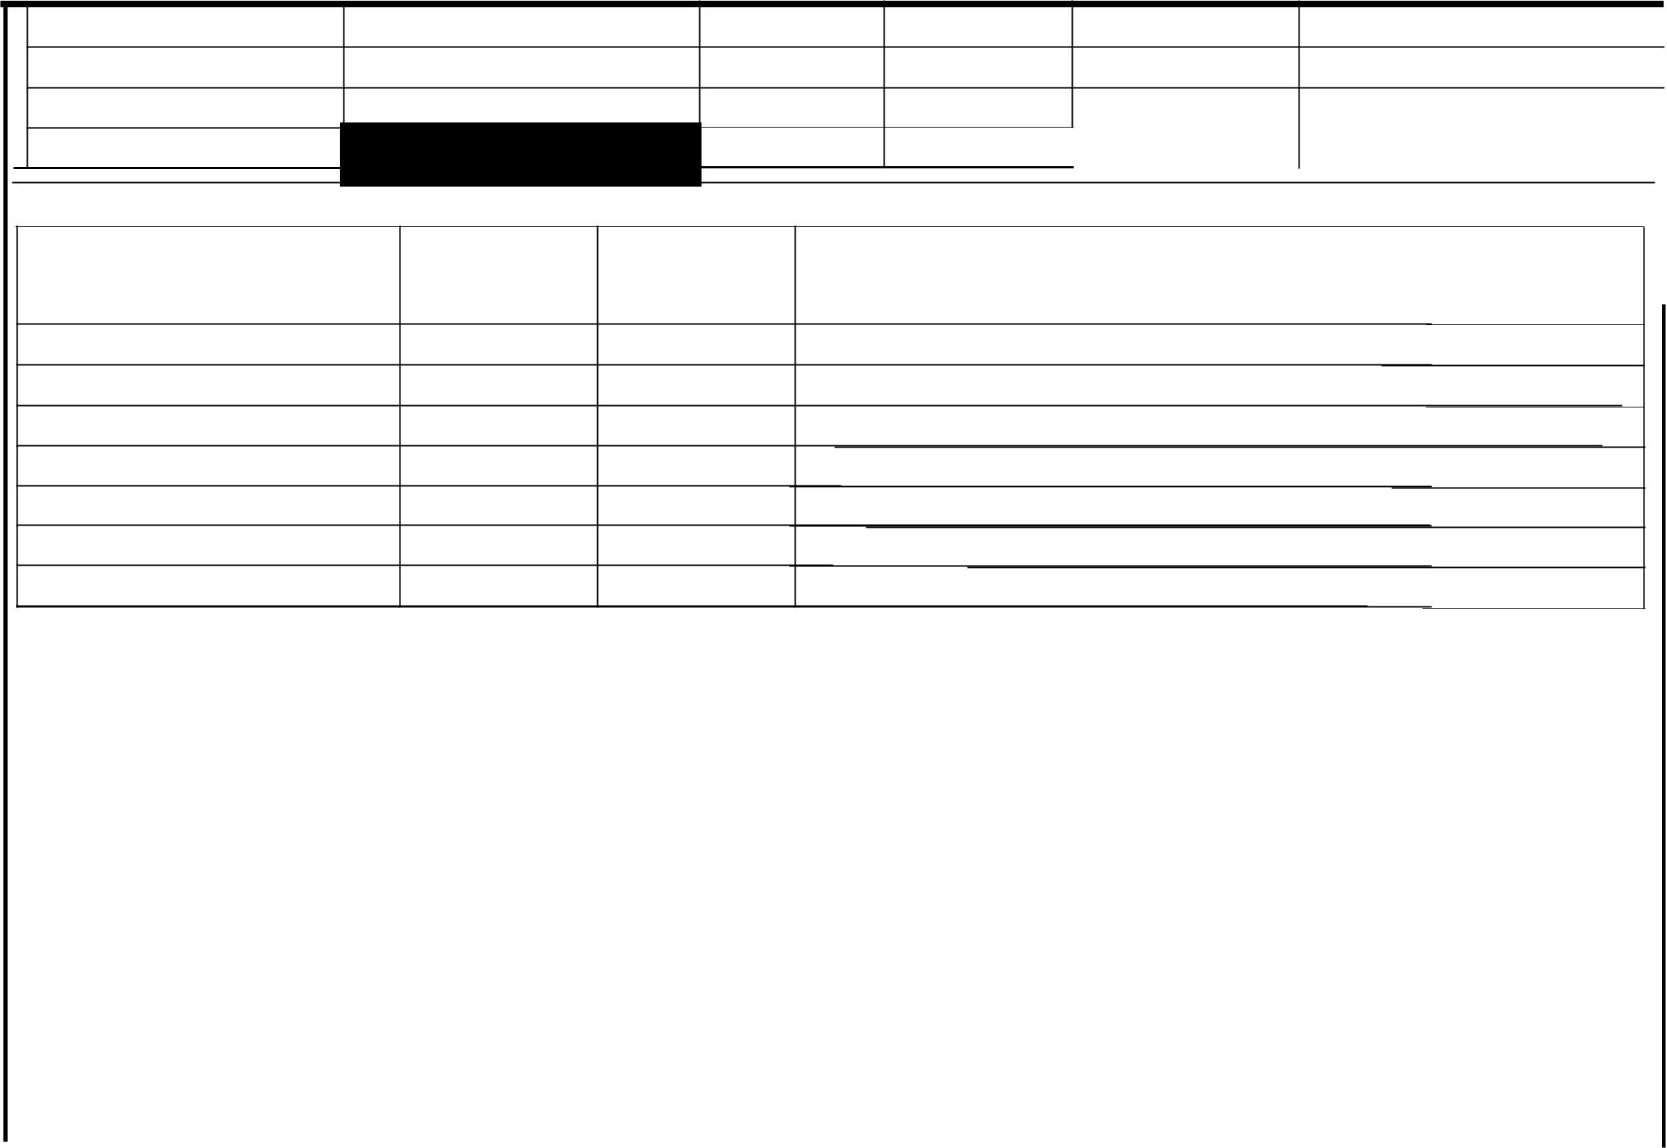

Total

D. For any amount identified in item C for which approval of forfeiture not requested from the Labor Commissioner, please explain below.

Project Name | Amount Assessed | Amount | Explanation
 |  | Recovered
NIA | NIA | NIA NIA

Total

I
I

E. For any amount identified in item C for which approval of forfeiture was requested from the Labor Commissioner, please provide the fo11owing:

Project |  | Amount |  | Assessed |  |  |  |  |  |  | Amount | Recovered
Name | LC §1776(g) | LC§ 1775 |  | LC§ 1813 | Wages | Total | LC§ 1776(g) |  |  |  | LC§ 1775 | LC§ 1813 |  |  |  | Wages |  |  |  |  |  | Total
NIA | NIA | NIA |  | NIA | NIA |  | NIA |  |  |  | NIA | NIA |  |  |  | NIA
Total

F. Identify cases that are or were the subject of LC§ 1742 proceedings.

 | Project Name |  | Contractor |  | Nature of Violation | ODLCase# | Current Status
 | NIA | NIA |  | NIA |  | NIA | NIA

G. Did ou refer an contractor to the Labor Commissioner for debarment | er LC § 1777 .1?
LCP ANNUAL REPORT 8 CCR § 16431 -- AB all projects
 | 2008

. ___ _j____ | -'· | ll | -• | J _.l

LCP-AR2

Please check one:

rYes

If yes, identify affected contractor(s) or subcontractor(s) and date(s) ofreferral: ----------------------------

H. Did you refer any apprenticeship violation to the Division of Apprenticeship Standards (DAS)?

Please check one: r yes

If yes, identify affected contractor(s) or subcontractor(s) and date(s) ofreferral: ------------------------------

LCP ANNUAL REPORT 8 CCR§ 16431 --AB all projects ₂₀₀₈

