DammaM Community College

Internship and Alumni Relationship office

SUMMER INTERNSHIP

BOOKLET

This document contains the guidelines for students conducting their summer internship for all Dammam Community College programs, King Fahd University of Petroleum & Minerals, Dhahran. Internship students, Field Supervisors (responsible for supervising the student on site), Summer Coordinators (responsible for supervising the student on the college) and any other party who is interested to know information on summer internship for DCC programs should refer to these guidelines.

The guidelines set guidelines set out DCC requirements and program requirements, internship objectives, and learning outcomes, in addition to other pertinent information relative to the internship experience.

Any student intern or field supervisor having questions concerning the internship program, or desiring additional information, guidance or clarification regarding any items contained within this document, should contact:

Internship and Alumni Relationship Office
Phone: 13-868 3300 Ext 809
Fax: 13-868 0744
Email: alumni@dcc.kfupm.edu.sa

Summer Coordinator
Phone: 13-868 3300 Ext 848
Email: internship@dcc.kfupm.edu.sa

TABLE OF CONTENTS
Introduction 5
Objectives of Summer Internship 6
Learning Outcomes of Internship 6
Eligibility Requirements 7
Registration Procedure 7
Employer's Role 7
Field Supervisor Role 8
College Role 9
Internship and alumni office role 9
Summer Coordinator Role 10
Student's Role 11
The semester preceding the internship 11
During the Internship 12
By the End of Internship 13
After the Internship 13
Internship Examination Committee 14
Grade Distribution 14
Grading Criteria 15
Scoring Rubrics for Internship Report 15
Scoring Rubrics for Internship Presentation 16
Guidelines on writing the internship report 17
Summer Internship Report Objective 17
Report Quality 17
Report Writing Format and Contents 17
Guidelines on Oral Presentation 19
Appendix 1: Student Academic Petition Form 20
Appendix 2: Training Plan 22
Appendix 3: Progress Report 25
Appendix 4: Summer Field Supervisor Survey 28
Appendix 5: Student Evaluation by Field Supervisor 31
Appendix 6: Internship Opportunity Form (company) 33
Appendix 7: Registration form for Summer Internship 35
Appendix 8: Internship Opportunity Form (student) 37
Appendix 9: Contact Guide 39
Appendix 10: Internship Obligation Form 41
Appendix 11a: Request for Internship Positions 43
Appendix 11b: Agreement on accepting Internship Student 45
Appendix 12: Course Withdraw Form 48
Appendix 13: Logbook Form 50
Appendix 14: Internship Submissions Schedule 52
Appendix 15: Field Experience Survey 54
Appendix 16: Attendance Report 58
Appendix 17: Summer Report Template 60

Introduction

The Summer Internship Program is a structured educational strategy, integrating theoretical knowledge learned in the classroom and laboratory with real world experiences. All programs in Dammam Community College include a 3credit hour internship course (XXX199), whose completion is a requirement for graduation.

The Internship and Alumni Relationship Office coordinates with public and private sector companies to find internship positions for DCC students in order to complete their internship program. However, should they prefer, students may themselves seek internship positions directly and bring them to the internship coordinator in the Internship and Alumni Relationship Office for processing and approval.

Students doing their internship program are assigned a field supervisor from the place of work and an academic supervisor from the college who are responsible for guiding and supervising the interns during the internship period. The internship program must satisfy the Student Learning outcome of the XXX 199 course and hence the internship program and the evaluation of the intern must be based on such requirement.

Students can undertake their internship abroad. The internship procedure for doing internships overseas will primarily follow all the steps applicable to internships locally. Any special conditions associated with supervision by the summer coordinator of the college will be addressed individually. International students must begin their search for internship early in order to ensure that work authorization is obtained prior to the commencement of the internship.

Objectives of Summer Internship

An Internship program as defined by the XXX 199 course is a structured opportunity to incorporate academic, professional and personal skill development which enables the student to gain a planned and directed learning experience. It enables the student to integrate knowledge gained through their classroom learning with the competencies gained through actual experience in a professional setting. The objectives of the program are to:

- Provide an opportunity for students to gain practical experience and internship before graduation
- Deepen the student's understanding of the theoretical knowledge gained in the classrooms
- Train the student to be responsible and punctual
- Train the student to engage effectively with the community outside the campus
- Accustom the student to being respectful of others and to listen to their opinions
- Provide an opportunity to companies to evaluate student performance and to build a databank on the available human resources and their capabilities.

Learning Outcomes of Internship

By the end of the internship program the student should be able to:

- Recognize the inner workings of an organization as they relate to his major.
- Integrate and apply the academic theory and knowledge acquired in the classroom to the actual practice of his major
- Demonstrate competencies expected in a professional environment related to his major
- Solve problems by taking initiative and using creativity
- Assess the suitability of his qualifications for and commitment to the profession of his major.
- Demonstrate communication skills through internship report and presentation
- Demonstrate teamwork and leadership skills effectively

Eligibility Requirements

The following criteria should be met before a student is considered eligible for admission to the summer internship programs:
- Student is currently enrolled in the college.
- Completion of 28 credit-hours or more of his study (Including the semester before starting the internship).
- Earned Cumulative and Major GPA of 2.0 or above.
- Completion of any special program requirements.
- Not subject to dismissal for academic causes.
- Not registered in any other courses during summer.
- Students with special circumstances should fill and submit Student Academic Petition. Form (Appendix 1) to waive one or more from the above requirements.

Registration Procedure

Eligible students must apply for enrollment in Summer Internship by:
- Completing the appropriate form obtained from the Student Affairs department.
- Registering for the course XXX 199 through online registration or by visiting the registrar office.

Employer's Role

The employer has the major role in ensuring the success of the Internship program. To achieve this goal, the employer is expected to adhere to the following:
- He should provide each student with a training plan outlining his internship assignment during the 8 weeks. The assignment needs to be related to the student's academic field of study.
- The trainee should be assigned to a professional in his field of study (field supervisor), who will be responsible for making the student’s internship program meaningful and effective.
- The trainee should be treated like any other employee in the organization. If he does not show up to work either on time or at all, the employer should inform the college so that corrective action can be taken. Absences should be reflected in the evaluation reports.
- If the trainee does not perform well or his performance does not meet the employer’s standard, the employer should inform the college so that corrective action is taken.
- Trainees should be encouraged and allowed to prepare technical reports and conduct oral presentations during the internship period.
- The employer should allow and encourage visits by the Summer Coordinator.
- Trainees should be introduced to the organization's safety codes before commencing, and the employer should ensure that trainees are aware of all safety measures in operation at the workplace.

Field Supervisor Role

The field supervisor, assigned by the employer, is a professional in the field of the student's major. The role of field supervisor is of prime importance in ensuring adequate professional development of an assigned DCC student. It is expected that the supervisor will set a working plan for the student that covers the internship assignment period. The supervisor will be mainly in charge of the following tasks:
- Provide adequate guidance and support to the trainee.
- Ensure that the student follows the training plan (Appendix 2) that has been provided by the company and approved by the DCC Summer Coordinator.
- Review and approve the student’s progress reports (Appendix 3) prior to their submission to the DCC Summer Coordinator.
- Evaluate the student using the student evaluation form (Appendix 4) and complete the field supervisor survey (Appendix 5) at the end of week 8 of the internship period.

College Role

The College will collaborate with the employer to make the program a success. To achieve this, the following parties are involved:

- Internship and Alumni Office (Student Affairs)
- Summer Coordinator
- Summer Internship Examining Committee

Internship and alumni office role

The Internship and alumni office at DCC is in charge of:

- Contacting the companies to solicit internship positions for the summer semester. This process should start at the beginning of the second semester and should be completed by the fifth week of the second semester. The office will send the Summer Internship Opportunity Form (Appendix 6) to the potential employers.
- Arranging for possible interview for the students by employers.
- Assigning qualified candidates to the positions which have been agreed upon and reserved for the internship program, matching the student's qualifications to the needs of the job and the student's preference where possible.
- Providing all necessary information required for the placement of all candidates for employment in the internship program.
- Liaising regularly with the participating employer/companies and with the student mentor through the channels authorized by the employer.
- Working closely with the summer coordinator to ensure the better running of the internship program.
- Preparing training packages for students.
- Helping and advising students on issues concerning their placement.
- Discussing the safety issues at the training place with the employer and ensuring that the workplace is safe. If necessary, an insurance agreement for the intern should be discussed with the employer.

Summer Coordinator Role

The Summer Coordinator is a faculty member from one of the DCC programs, assigned by the Dean to supervise the summer internship program. The role of the summer coordinator is to:

- Advise the students and guide them before the internship starts till they get their grades.
- Conduct a workshop for summer internship students, before the start of training, to ensure their preparedness.
- Ensure that each program conducts a second workshop for its students, focusing on issues related to their major, before starting the internship.
- Conduct a follow up meeting in which the internship students can reflect on, and generalize from, their internship experience. All program coordinators should attend this meeting and it should take place one week after announcing the grades for the students.
- Ensure the timely start and end of the internship program for each internship student.
- Provide students with the exact due dates for each report or form to be submitted.
- Ensure that each student get an internship opportunity in his field and that he is doing meaningful work during his internship.
- Monitor the quality of the students’ activities and training from the company.
- Discuss with the students their internship plan, activities, and reports.
- Visit and confer with the field supervisors on the progress of the students’ performance at least twice during the internship period.
- Receive evaluation reports and surveys from the field supervisor.
- Monitor the progress/final reports of students.
- Advise students on the writing of the Final Report. In addition, faculty from each program will assist in grading the Final Reports.
- Report final grades of all registered students.
- Prepare separate course files for each program.
- Conduct both Supervisor and Student Internship Surveys.
- Prepare reports of both surveys and include them in the course file.

Student's Role

The student’s role is divided into 3 periods:
- The semester preceding the Summer Internship.
- During the Summer Internship.
- After the Summer Internship.

Below, the activities required in each period are explained in detail.

The semester preceding the internship

All students who plan to take the Summer Internship should complete the following steps during the semester just before the start of their Summer Internship.

- Discuss with your academic advisor your eligibility for summer internship and get his advice on possible competencies to improve.
- Register online for the summer internship during early registration.
- Visit the Internship office to see the list of internship offers and to fill out the application form for summer internship (Appendix 7). In this form you will indicate three choices and the Internship office will forward your name to one of the three companies, if possible. If not, any available position in your major will be assigned to you. When the company confirms, you will receive an e-mail from the Internship office to collect your papers.
- A Student must attend the two workshops organized for summer internship students.
- If you are planning to do the Internship in a company that is not provided by the Internship office, you need to provide Internship office with the Internship Opportunity Form (Appendix 8) approved by the Summer Coordinator.
- You should fill out the Contact Guide Form and the Internship Obligation Form (Appendix 9 and 10) and submit them to the Internship office.
- Contact the Summer Coordinator and discuss with him the internship program and the best way of communication during the internship period.
- Collect the internship package from the internship office which contains a letter to the employer (Appendix 11) and the forms which will be needed during the internship period.
- If for any reason you decide not to continue the internship, you will need to see the Summer Coordinator to fill out the Withdrawal Form (Appendix 12). This should be done as per the academic calendar.

NOTE: It is the responsibility of the student with the help of his academic advisor to make sure that the internship work is completed before his last semester in the college. All Internship prerequisite courses have to be completed at least one semester prior to graduation.

During the Internship

- On the student’s arrival at the placement, he should provide a copy of the schedule to his work supervisor, along with copies of the forms, and provide him with the contact information of Summer Coordinator.
- The student should contact the Summer coordinator soon after he has arrived at his place of work. Any problems should be reported to the Summer Coordinator.
- The student should keep communicating with the Internship and Alumni Relationship Office and the Summer Coordinator during the entire internship to ensure the greatest assistance from both parties.
- The student should submit his training plan for the placement to the Summer Coordinator at the College. This should be at the first day of his placement.
- The student should maintain the logbook (Appendix 13) on daily basis which will help him to complete all his reports, and help the field supervisor to produce an accurate evaluation.
- The student should submit 3 progress reports (Appendix 3) bi-weekly, that is, by the end of weeks 2, 4, and 6. This should be by email, but fax is also acceptable. The hardcopy of the report should be signed by the field supervisor.
- The student should complete and return all required reports and forms to the summer coordinator according to the schedule provided at the beginning of the placement
(Appendix 14).
- Any late submission will be subject to penalty.
- The student himself must complete the reports but it must be agreed and endorsed by the field supervisor.
- The student should request his field supervisor to submit all forms and reports required.
- Student must conform to the general policies, procedures, rules, and regulations of the organization in the same way that all personnel of the organization must do.
- The students must pay particular attention to, and conscientiously observe, the ethical directives specific to the organization.
- The student must not interfere with the operations of the organization.
- The student must observe strict confidentiality of all information, as would be expected of.
- The student should follow the directions of the field supervisor at all times in matters pertaining to the organization.
- The student is encouraged to seek the advice, counseling, and guidance of the field supervisor and others assigned as the student's supervisor.
- The student should perform all tasks and activities assigned to him effectively and efficiently, to the best of his ability.

By the End of Internship

After finishing the Internship, students need to do the following by the end of the internship immediately:

- Fill out the Field Experience Survey Form (Appendix 15) about their Internship experience and submit it to the Summer Coordinator.
- Prepare a draft copy of the Internship final report then submit it to the Summer Coordinator for discussion and feedback.
- Submit an attendance report, signed by the employer/supervisor (Appendix 16), to the Summer Coordinator, via email or in person, at the end of internship period.
- During Week 8 the student must attend the follow up meeting. In this meeting, students will be expected to reflect on and generalize from their experience, relate it to studies previously undertaken, and apply that experience to situations likely to be faced in future employment.

After the Internship

After finishing the Internship, in the subsequent semester students need to do the following:

- During the third week students must submit a Final Report to the Summer Coordinator. The Summer Coordinator will guide and give recommendations to the student in preparing the report. A guide is also available on the website and included in the internship package.

- Prepare a presentation describing his internship and submit the soft copy file via e-mail to the summer coordinator by the end of Week 6.

- During Week 7 student will give an oral presentation on his summer internship. The student will present what knowledge and/or experience he gained during the 8 weeks of internship at the organization.

Internship Examination Committee

- The examination committee will consist of the Summer Coordinator as chairman and two faculty members from the relevant academic program assigned by the program coordinator.

- The examination committee evaluates the student's internship final report and presentation using the defined criteria/rubrics and will report the grade to the summer coordinator.

- The examination committee should follow the grade distribution defined below.

Grade Distribution
Successful completion of the internship period will carry 3 credit hours for the Associate Degree program. The grade obtained will be applied with full weight to the student's cumulative grade point average (CGPA). The following table shows the grade distribution in terms of percentage points earned for each report and form that will be graded.

 | Grade Distribution | Percentage
1. | 3 Progress Reports ( 5% each) | 15 %
2. | Field Supervisor Evaluation of Student's Performance | 20 %
3. | Final Report | 30 %
4. | Attendance (based on attendance report) | 10%
5. | Activities log | 10%
6. | Oral Presentation | 15 %

Grading Criteria

The Final Report and the Oral Presentation will be graded by the examination committee based on the following scoring rubrics:

Scoring Rubrics for Internship Report
 | 4 | 3 | 2 | 1
Organization/ Report format | Excellent | Good | Satisfactory | Poor
- Does the report contain all required parts? | 4 | 3 | 2 | 1
- Do all figures, graphs, tables correctly drawn, numbered, contain titles/captions, and strongly support the text? | 4 | 3 | 2 | 1
- Does the report of an acceptable length considering the subject matter presented? | 4 | 3 | 2 | 1
Contents
- Does the report contain a well written brief abstract | 4 | 3 | 2 | 1
- Does the student understand and clearly present in the report the type of the company business he worked for, and how the department he worked in contributes to the successful function of the whole company? | 4 | 3 | 2 | 1
- Does the student understand the main objective of his internship, and the relation of his job functions to other functions in the company. | 4 | 3 | 2 | 1
- Does the student describe his Internship experience with many details.? | 4 | 3 | 2 | 1
- Does the student make connections of how he has learned through his Internship experience? | 4 | 3 | 2 | 1
- Does the student identify areas in which he has made a significant contribution to the organization? | 4 | 3 | 2 | 1
- Does the present material relevant to the task performed? | 4 | 3 | 2 | 1
- Does the student provide concise and complete conclusions followed from the report? | 4 | 3 | 2 | 1
- Are appropriate reference citations presented, and are industrial terms and jargon, when used, adequately explained? | 4 | 3 | 2 | 1
Style/Mechanics
- Is the report very well written and free from grammar/spelling mistakes? | 4 | 3 | 2 | 1
- Are all sections in order, well-formatted, and readable? | 4 | 3 | 2 | 1
- In addition, constructive comments regarding the value of the program will be considered. | 4 | 3 | 2 | 1
Total marks

Scoring Rubrics for Internship Presentation
 | 4 | 3 | 2 | 1
Presentation | Excellent | Good | Satisfactory | Poor
- Does the topic introduce clearly and in an interesting way? | 4 | 3 | 2 | 1
- Was the outline of presentation given? | 4 | 3 | 2 | 1
- Were the points of the presentation well-organized and developed with sufficient and appropriate details? | 4 | 3 | 2 | 1
- Was the presentation summed up clearly and effectively, with key points emphasized?
- Is the length of presentation within the assigned time limits.
- Was the delivery poised, controlled, and smooth? | 4 | 3 | 2 | 1
Contents
- Does the student made clear link and connection between ideas? | 4 | 3 | 2 | 1
- Is the material included is relevant to the overall purpose, and prepared with appropriate amount? | 4 | 3 | 2 | 1
- The vocabulary of the presentation was appropriate for the topic. A variety of phrases and sentence structures were used. The presentation content was grammatically correct. | 4 | 3 | 2 | 1
- Visual aids were carefully prepared and supported the presentation effectively. They clarified and reinforced the spoken message. The aids added impact and interest to the presentation. | 4 | 3 | 2 | 1
Presenter
- Does the student speak clearly, loudly and at a good pace to ensure audience comprehension, and the delivery was fluent and expressive? | 4 | 3 | 2 | 1
- Does the student maintain good eye contact with the audience and is appropriately animated (e.g., gestures, moving around, etc.)? | 4 | 3 | 2 | 1
- Does the student answer questions without/little difficulty? | 4 | 3 | 2 | 1
- Does the student demonstrate very good knowledge of the topic? | 4 | 3 | 2 | 1
- Was the student language correct and fluent? | 4 | 3 | 2 | 1
Total marks

Guidelines on writing the internship report

Summer Internship Report Objective
The main objective of the Report is to prepare the student to write a professional and detailed report. This should demonstrate his ability to present specific information and to develop his overall communication skills. The essence of the Report is to describe the work a student has undertaken during his internship, the techniques he has learned, the skills he has acquired, the contributions he has made to his work environment and the conclusions he has drawn from his experience.

Report Quality

The organization of the Final Report should be logical and it should help the reader to obtain a clear understanding of the detailed points presented in the report.

Topics within the report should be coherent, clear and concise. Discussions should be focused on work-oriented.

The report should be illustrated with appropriate tables, diagrams and graphs where necessary. Tables and graphs should be properly labeled.

Any facts and figures about the company where the internship was completed should be supported by references, internal company reports, etc.

The report should be a minimum of 2500 words and not more than 5000 words.

The report should describe your work in your own words.

The report should have a bibliography and references, where appropriate.

A draft report should be submitted and reviewed by Summer Coordinator before the Final Report is submitted to the department for grading. The schedule for report submission is indicated in Appendix 14.

Report Writing Format and Contents
The report should follow the following format:

- Title Page: The title of the Report, and the author’s name, must be in capital letters. The name and address of DCC must also be included on this page and be in same case as the title. The type of degree must be written in capital letters. The year and major should be included. The Summer coordinator’s name must be provided, and a space for his signature must be reserved. The title page must not be numbered. (Appendix 17)

- Acknowledgements (Optional): This is an optional section which acknowledges the help, assistance and advice given to the student during his internship and the preparation of his report.

- Table of Contents: The report must have a table of contents, which shows the principal divisions of the work and the page numbers on which they are found. All the pages except the Title Page and Table of Contents page(s) must be listed. The Table of Contents page(s) must be numbered in lower case Roman numerals at the bottom center of each page, starting with “ii” or with “iii” if an Acknowledgements page has been included.

- Table of Abbreviations: This section should list each abbreviation within the report and its meaning.

- Abstract: This section will comprise a brief summary of the entire report. No illustrations, graphs, tables or charts should be included in this section.

- Introduction: The purpose of this section is to provide a brief introduction of the work. It should not exceed two pages (2) but should be a minimum of 300 words and should comprise the following topics:

- Company Background: A brief and clear presentation the type of business of the company and the functions of the department(s) in which the student conducted his internship.

- Training Objective: Description of the student’s internship objective and work accomplishments.

- Student’s Work Assignment: A general, non-technical presentation of the student’s function within the company and his work assignments.

- Technical Part: This section constitutes the core (substance) of the report. It describes the work that a student has accomplished during his internship, the techniques he has learned, the skills he has acquired, the contributions he has made, the responsibilities he has assumed, the equipment he has used (if any), the safety procedures he has followed and all other pertinent information. It contains all the crucial technical details including illustrations, equations, programs, software versions, graphs, tables, charts, diagrams, etc. These should be clearly numbered and/or titled for easy reference. Units, scales, labeling of the axes must be provided for easy understanding. The technical part may be presented in the form of chapters, sections or any other arrangement suitable to the nature of the technical report.

- Conclusion and Recommendations: The conclusions of the report are summarized in this section. Any pertinent conclusion concerning the internship, the work accomplished, the techniques learned, the importance and merits of the internship program, its benefits and drawbacks, recommendations on how to improve it and other constructive comments and suggestions should be included in this section. A student’s feedback and comments regarding his academic internship, his background, his technical preparation for launching his career and any related recommendations should also be included here.

- References: A list of the references must be provided. Each reference must be adequately cited where appropriate.

- Page Numbering: Numbers should begin with “1” on the first page of the text and continue throughout the report including the references page. The page numbers should be on the bottom middle or bottom right of each page throughout the text. The text must be double-spaced.

Guidelines on Oral Presentation

- Presentations must be conducted in English and are scheduled to last for approximately 15 minutes, including questions and comments.

- If special equipment is needed, the student must notify the summer coordinator a week ahead of his presentation.

The student must use an IT presentation package such as PowerPoint. It is also recommended that the student rehearse his presentation before his actual presentation.

There will be two or more faculty present to assess the quality of the presentation.

Presentation content should be specific and refer to the work done during the internship. The student should present his own work, experiences and learning.

- No. of slides: Minimum 7 slides and maximum 10.

- First slide should contain your name, major, and the company you worked for.

- Rest of the slides would be used for presenting your summer internship report.

- Dedicate at least one slide each to explain your company, assignment(s), weekly schedule, skills learned, interesting incident (if any) etc.

- No videos are allowed to give every student equal chance. Pictures, charts, graphs are allowed.

- Be ready to answer questions during presentation regarding your internship experience.

- You must complete your presentation in 10 minutes. Speak loud enough to be heard and clearly, smile, wear decent and neat clothes, and be confident.

Appendix 1: Student Academic Petition Form
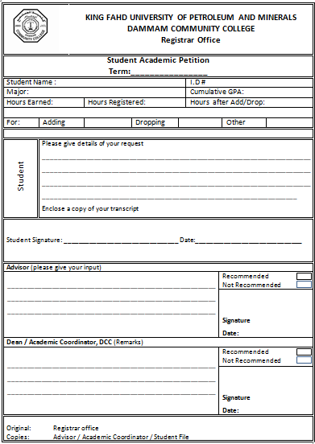

Appendix 2: Training Plan

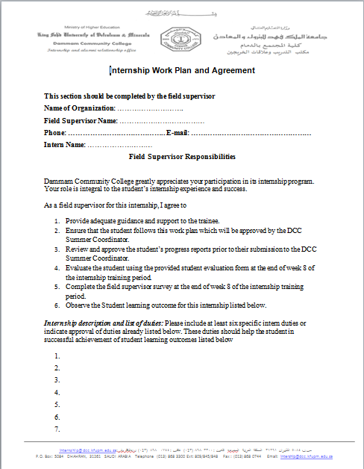

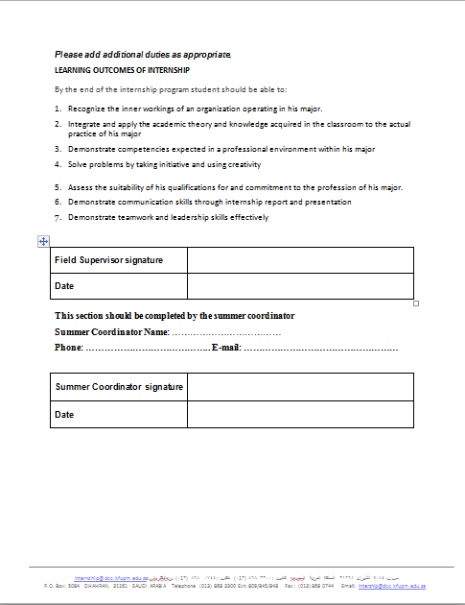

Appendix 3: Progress Report

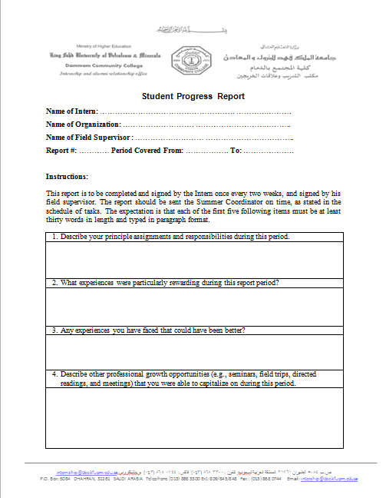
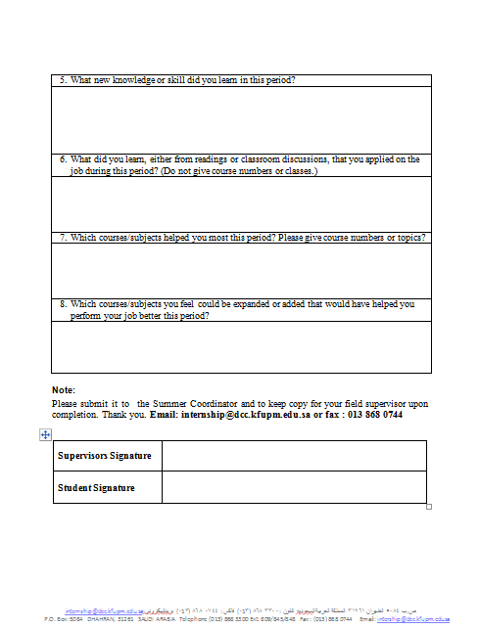

Appendix 4: Summer Field Supervisor Survey

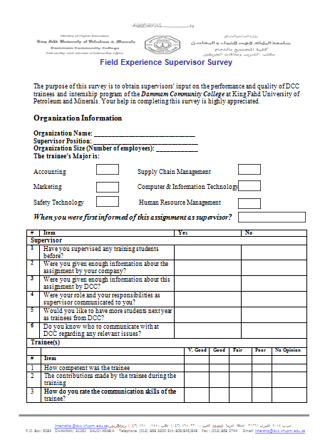

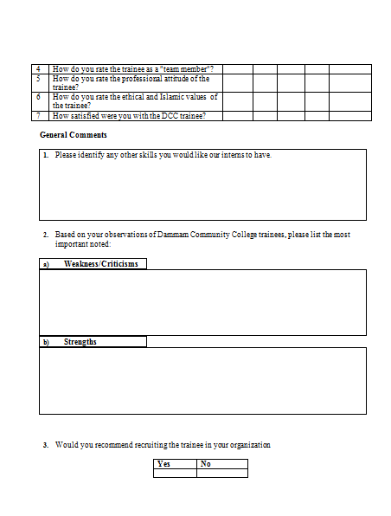

Appendix 5: Student Evaluation by Field Supervisor

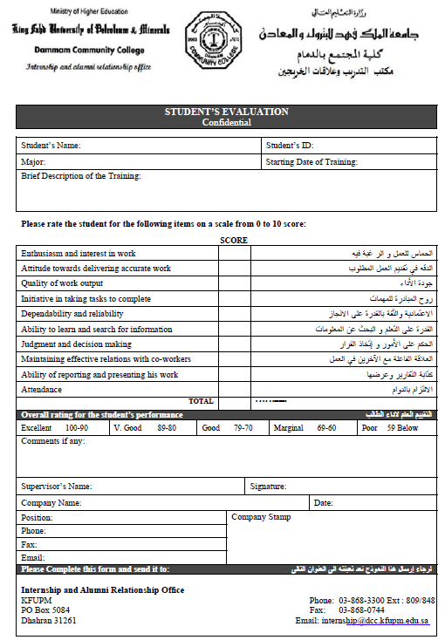

Appendix 6: Internship Opportunity Form (company)

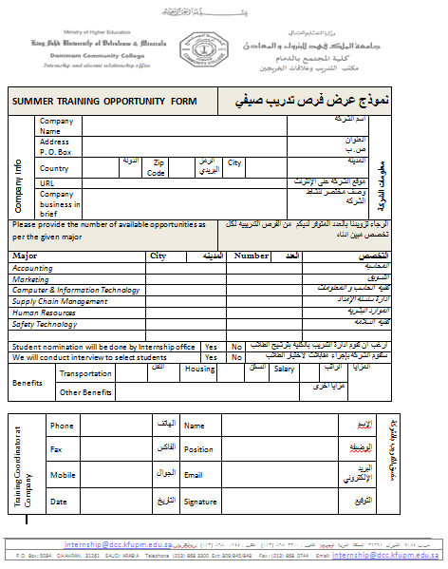

Appendix 7: Registration form for Summer Internship

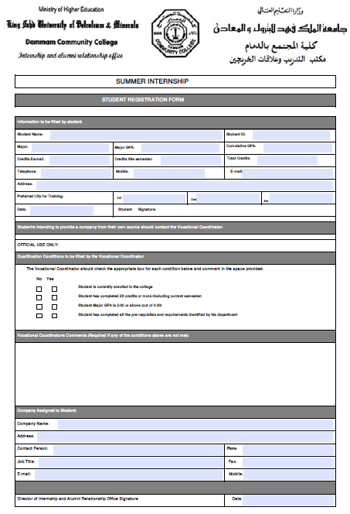

Appendix 8: Internship Opportunity Form (student)

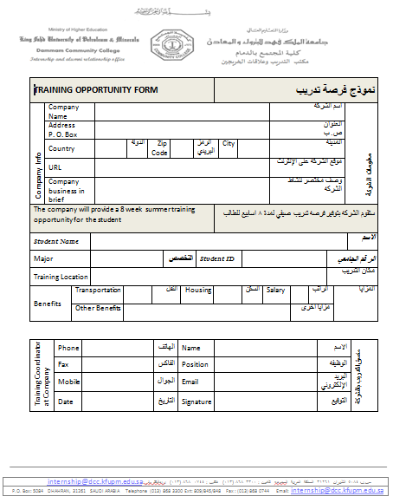

Appendix 9: Contact Guide

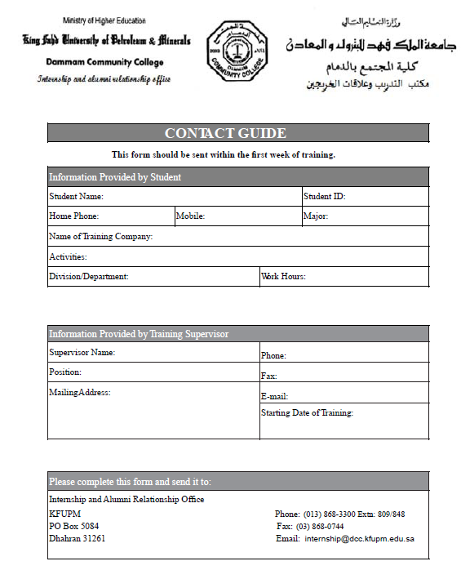

Appendix 10: Internship Obligation Form

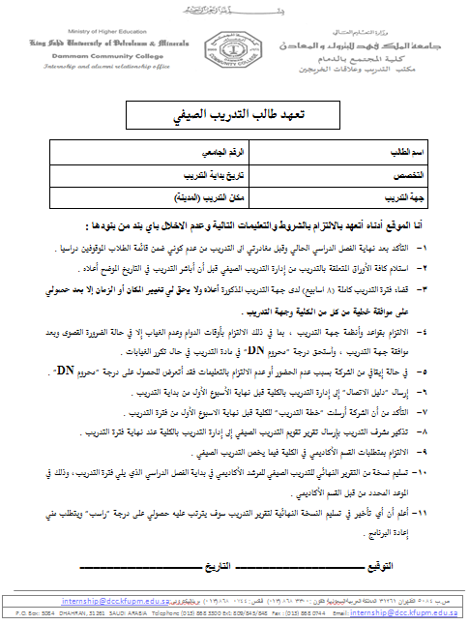

Appendix 11a: Request for Internship Positions

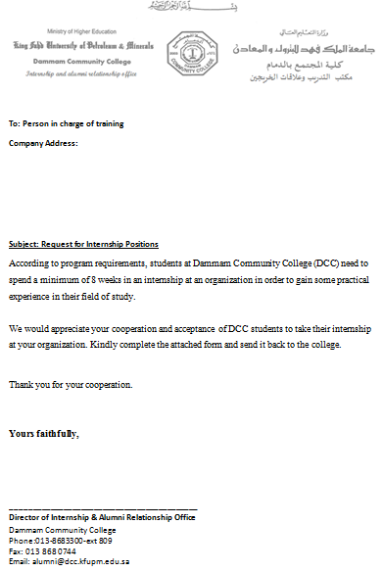

Appendix 11b: Agreement on accepting Internship Student

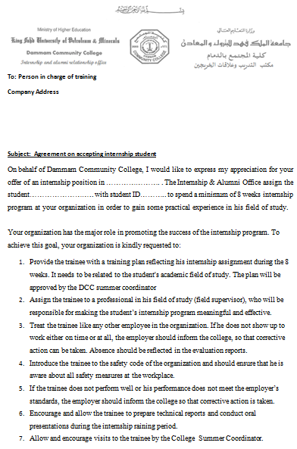

Appendix 12: Course Withdraw Form

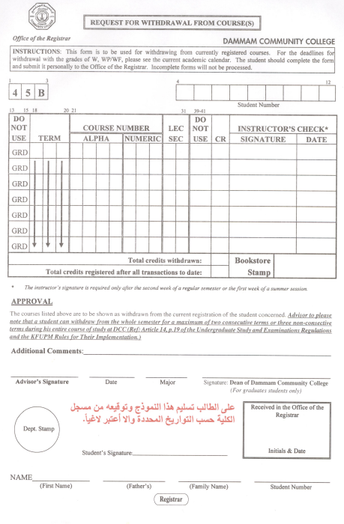

Appendix 13: Logbook Form

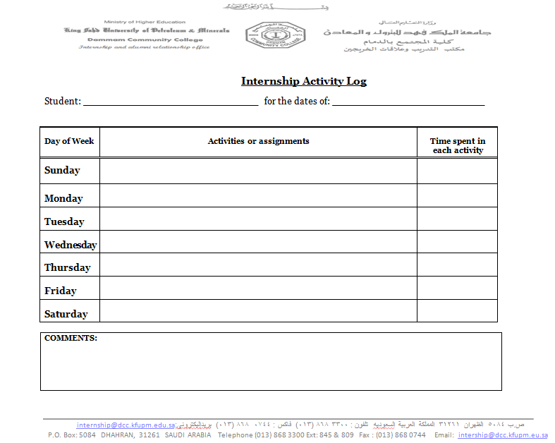

Appendix 14: Internship Submissions Schedule

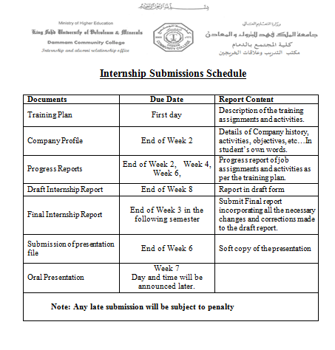

Appendix 15: Field Experience Survey

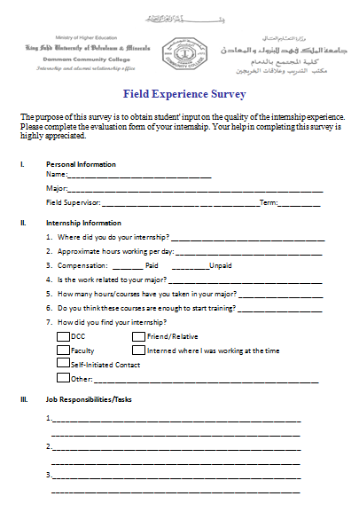

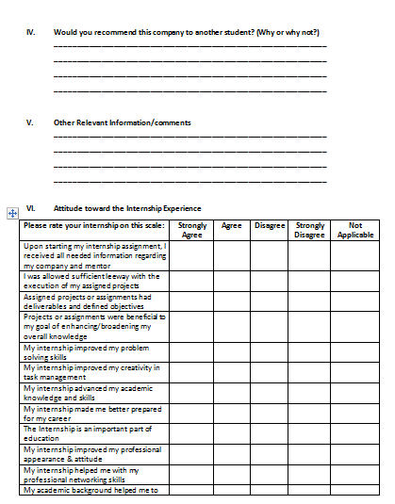

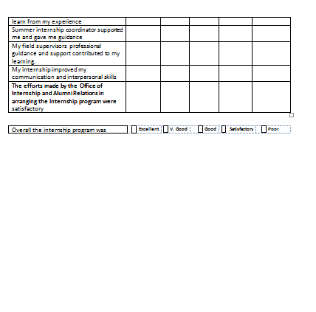

Appendix 16: Attendance Report

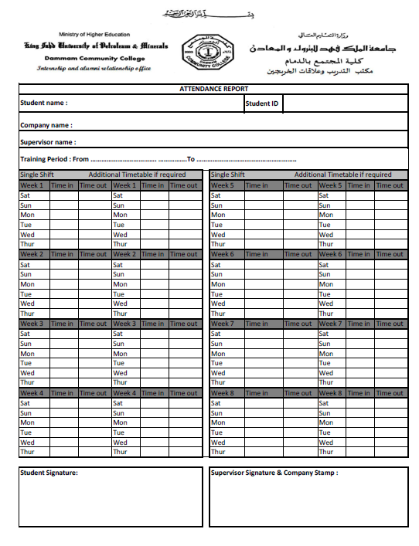

Appendix 17: Summer Report Template

