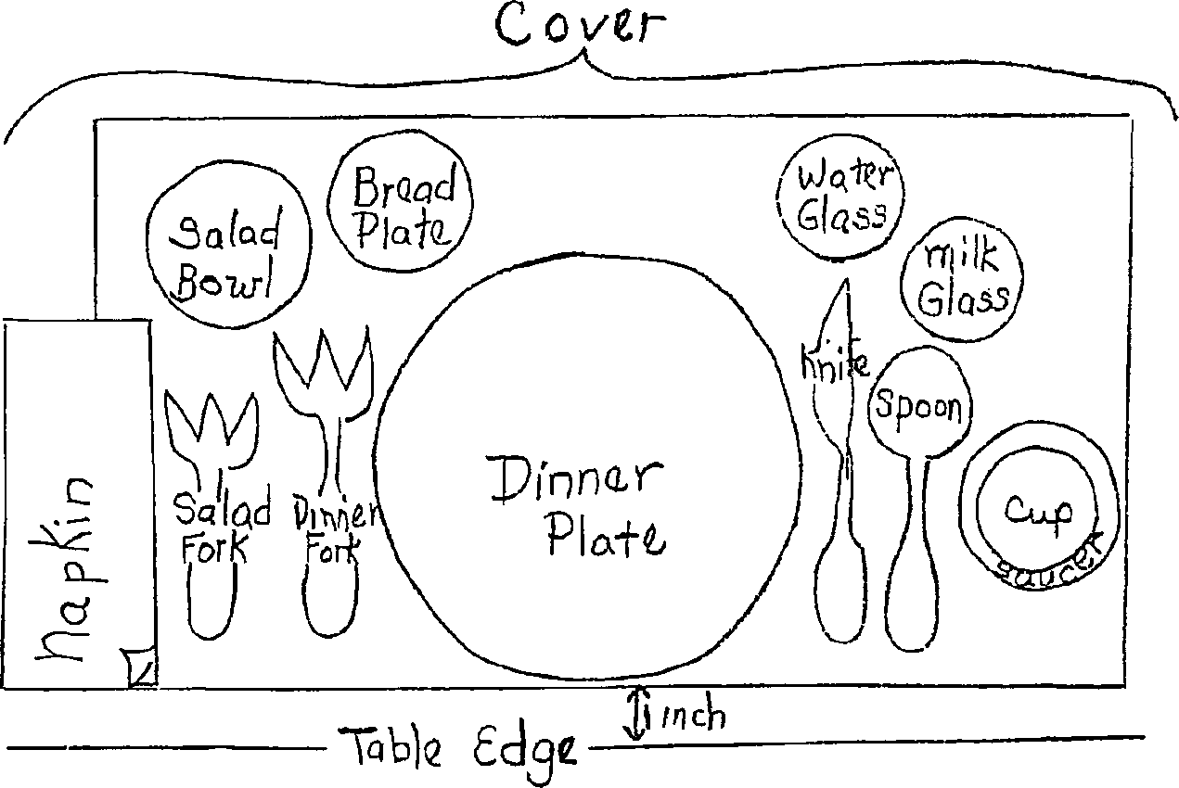

Ohio State University Extension

**BASIC GUIDELINES FOR TABLE SETTING**

1.

2.

A place setting for one person is a "cover."

The plate, flatware and placemat should be 1-1/2" from the table edge to allow for an attractive table and safety.

Flatware is placed in order of use from the outside in.

The napkin should be folded in a square or rectangle and placed so that the open edge is toward the plate.

Allow 20-24 inches for each place setting or cover.

Use only flatware and plates that are necessary for the specific meal.

Table cloth - the center fold should fall exactly on the center line of the table. The cloth then drops evenly on both sides. The cloth should hang over the table no more than 10-12 inches. Tables should be set according to these principles; art, common sense, concern for comfort for those eating and courtesy.

A good centerpiece is:

3.

4.

5.

6.

7.

8.

9.

-

-

-

-

in scale with the table

is low so people opposite each other can see across the table

can be placed anywhere on table as long as table looks well-balanced can be part of the meal (salad, fruit bowl, dessert, etc.)