Juneberry CD 14000  Blind Boy Fuller - Weeping Willow  1. 62369-A De 7331, De 7881 WEEPING WILLOW (7/14/37) 3:08  2. 17903-1 See notes HOMESICK AND LONESOME BLUES (7/26/35) 3:04  3. 19141-1 See notes TRUCKIN' MY BLUES AWAY (4/29/36) 3:05  4. 62353-B De 7892 STINGY MAMA (7/12/37) 2:40  5. 62370-A De 7331, De 7881 CORRINE, WHAT MAKES YOU TREAT ME SO?  (7/14/37) 2:56  6. MEM-103-1 See notes BABY, QUIT YOUR LOW DOWN WAYS (7/12/39) 2:30  7. 22677-1 Ok 06437 PICCOLO RAG (4/5/38) 2:48  8. 22679-1 Vo 04175 PAINFUL HEARTED MAN (4/5/38) 2:47  9. SC-27-1 See notes GET YOUR YAS YAS OUT (10/29/38) 2:23  10. WC-3142-A See notes THOUSAND WOMAN BLUES (6/19/40) 2:42  11. SC-29-1 See notes SCREAMING AND CRYING BLUES (10/29/38) 2:30  12. SC-28-1 Vo 04782, Cq 9281 JITTERBUG RAG (10/29/38) 2:29  13. 26619-A Vo 05527, Cq 9376 CROOKED WOMAN BLUES (3/7/40) 2:39  14. WC-3141-A Ok 05756, Cq 9580 LOST LOVER BLUES (6/19/40) 2:41  15. 19145-2 See notes MAMA LET ME LAY IT ON YOU (4/29/36) 2:53  16. W-26593-A See notes WORN OUT ENGINE BLUES (3/5/40) 3:00  17. 22165-1 Vo 04843 BYE BYE BABY BLUES (12/15/37) 2:33  18. 22674-1 See notes PISTOL SLAPPER BLUES (4/5/38) 2:40  19. 26616-A Ok 06231 GOOD FEELING BLUES (3/7/40) 2:37  20. 22690-2 Vo 04137, Cq 9076 MEAT SHAKIN' WOMAN (4/5/38) 2:41  21. 21649-1/-2 See notes CARELESS LOVE (9/8/37) 2:42  22. WC-3139-A Ok 05933, Cq 9757 BUS RIDER BLUES (6/19/40) 2:42  23. SC-25-1 Vo 04897 BIG HOUSE BOUND (10/29/38) 2:40  24. 26600-A Vo 05440, Cq 9373 THREE BALL BLUES (3/6/40) 2:51  25. 62356-A De 7878 YOU NEVER CAN TELL (7/12/37) 2:51  26. 21627-2 See notes STEALING BO-HOGG (9/7/37) 2:43  NOTES: All takes labeled as by Blind Boy Fuller, with Fuller, v/g, unless noted (see inside for details).  COVER: Blind Boy Fuller publicity photo | 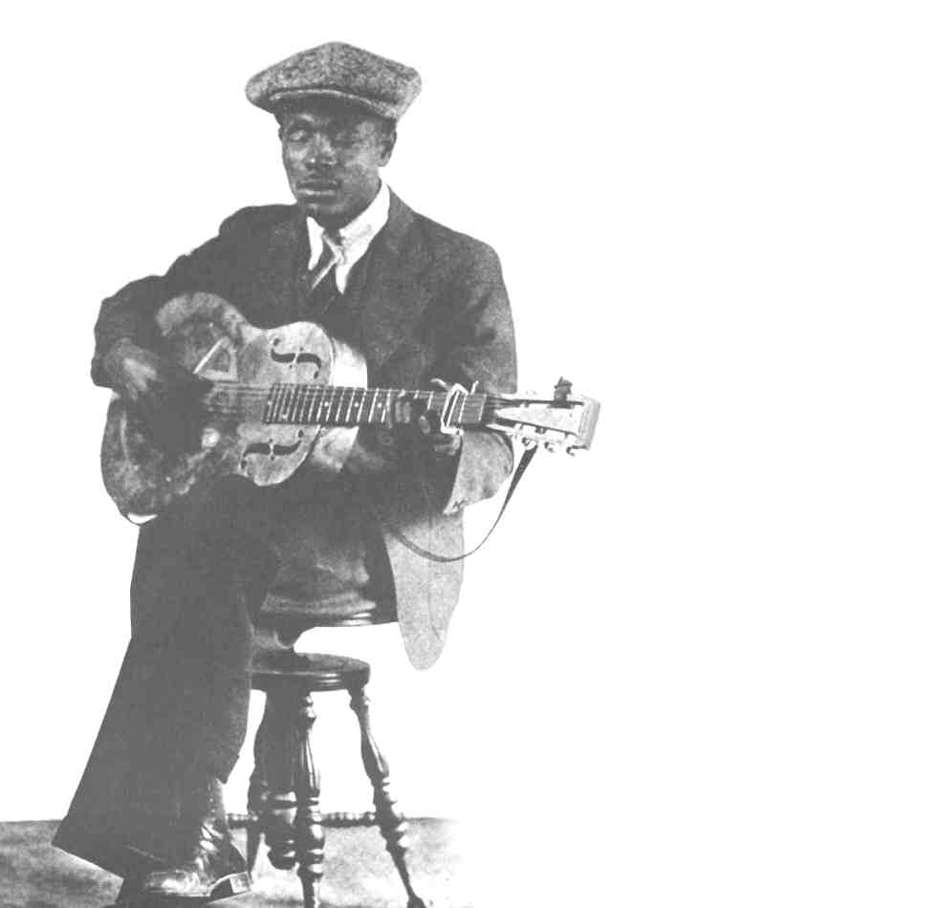  Blind Boy  Fuller  Weeping  Willow  Juneberry CD 14000
NOTES: (from back page)  Comments per Blues & Gospel Records, 4th ed., unless noted.  Track 2: Matrix 17903-1 was issued on ARC 7-03-67, Vo 03234, and Cq 8846.  Track 3: Matrix 19141-1 was issued on ARC 6-10-56, Vo 03098, Cq 8720, Co 30079 and Co 37777.  Track 6: Matrix MEM-103-1 was issued on Vo 05083, Cq 9311, Co 30061, and Co 37684  Track 9: Matrix SC-27-1 was issued on Vo 4519, Cq 9157, Co 30086, and Co 37784. Blind Boy Fuller, v/g; Bull City Red, wb.  Track 10: WC-3142-A was issued on Ok 05657, Cq 9377, Co 30090, and Co 37788.  Track 11: Matrix SC-29-1was issued on Vo 04603, Cq 9202, Co 30008, and Co 37165.  Track 12: Blind Boy Fuller, sp/g; Bull City Red, wb; unknown, k.  Track 14: Blind Boy Fuller, v/g; Oh Red, wb.  Track 15: Matrix 19145-2 was issued on ARC 6-08-54, Vo 03071, Cq 8756, and Cq 8770.  Track 16: Matrix W-26593-A was issued on Vo 05575, Co 30065, and Co 37688.  Track 17: Blind Boy Fuller v/g and Sonny Terry, h. Also recorded 6/19/40, matrix WC-3143-A, issued on Ok 05712 and Cq 8758 as BYE BYE BABY (w/o "Blues") and as by BLIND BOY FULLER AND SONNY TERRY.  Track 18: Matrix 22674-1 was issued on Vo 04106, Cq 9075, Co 30083, and Co 37781.  Track 19: Blind Boy Fuller, v/g; Sonny Terry, h; Oh Red, wb.  Track 21: Matrix 21649-1/-2 were issued on ARC 8-02-66, Vo 03457, and Cq 9012. It is not known which takes appear on which issues, except that 21649-2 is reported on Melotone 8-02-66 and Vocalion 03457.  Track 22: Blind Boy Fuller, v/g; Sonny Terry, h; Oh Red, wb.  Track 23: Blind Boy Fuller, v/g; Sunny Terry, h.  Track 24: Blind Boy Fuller, v/g; Sunny Terry, h.  Track 26: Matrix 21627-2 was issued on ARC 8-01-65, Vo 03438, Cq 8964, Co 30081, and Co 37779. | 