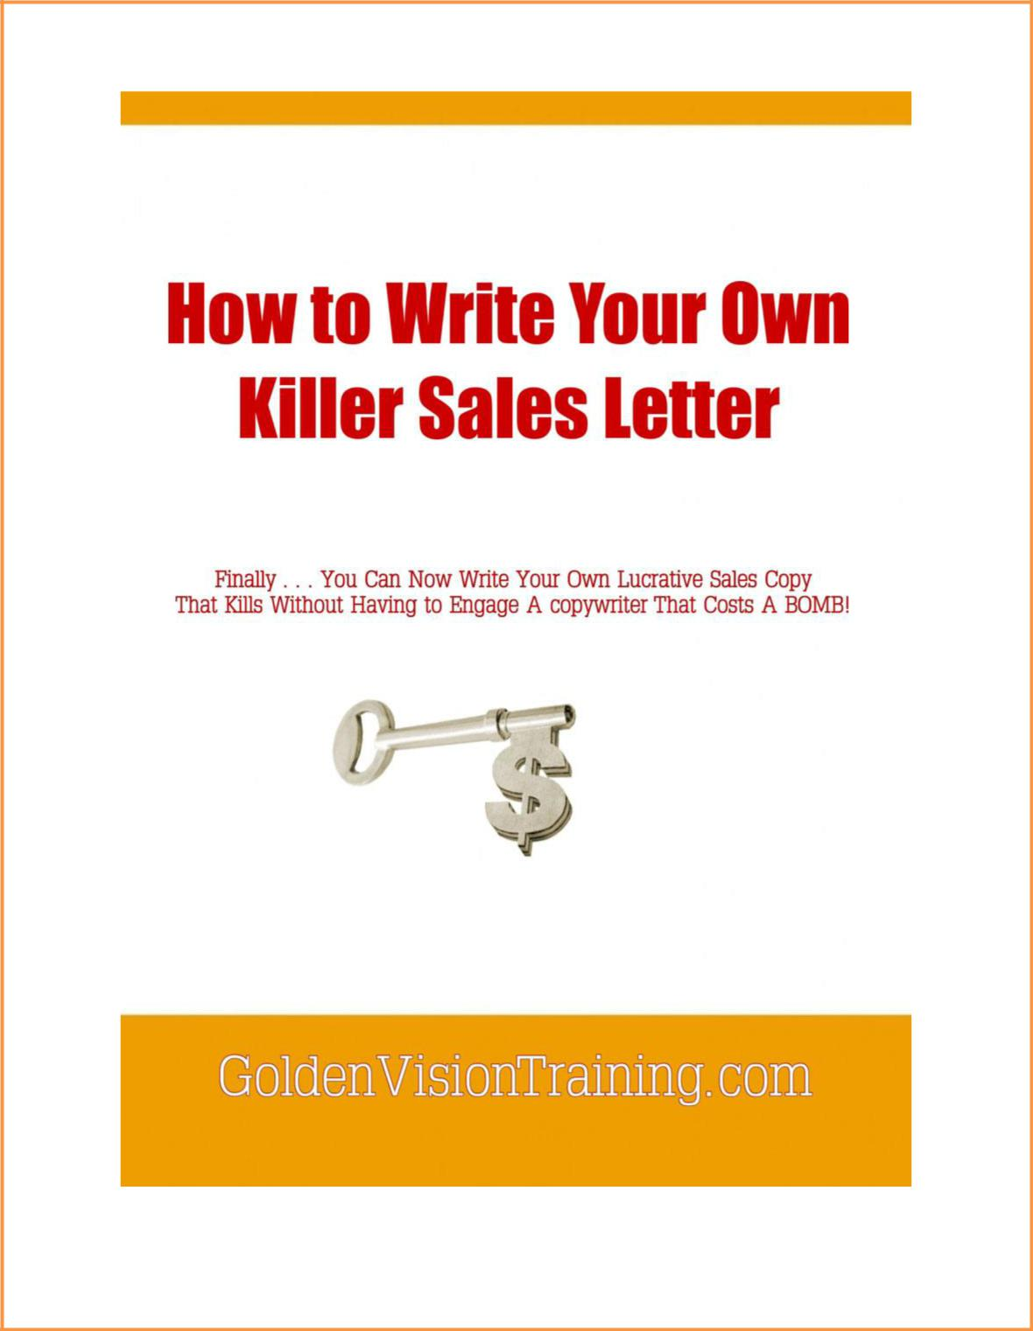
How to Write Your Own Killer Sales Letter 2

Copyright© Golden Vision Training

Feel free to share it with your friends.
It is NOT OK to alter any of its contents when you do.

To receive more tips and updates on Double Your Income Online,

join Double Your Income Newsletter at http://www.GoldenVisionTraining.com

GoldenVisionTraining.com 2

How to Write Your Own Killer Sales Letter 3

About The Authors: Oliver Gu and Mary Wang

Oliver Gu (MBA, MS) is an entrepreneur and coach on financial education, online marketing and personal development. He obtained his two masters' degrees in Finance and Computer Science in the US. Oliver started his online business as early as 1999 from selling on eBay. He has extensive experience and expertise in online marketing, real estate investment and network marketing. Oliver has been helping people build their online business and make money online through his well-received Internet marketing training

programs since 2010. Oliver and Mary founded GoldenVisionTraining.com in 2010.

Oliver has been awarded by Toronto Talent TV "The Most Favored Family and Individual Entrepreneur of 2012."

Mary Wang (MA, MS) was born and raised in China. She went to study in the US in 1995 to pursue her master's degrees in communication studies and computer science. She has many years experience in business and IT industry. She is an Internet marketing trainer and an investor with great passion for online marketing, financial education and personal development. Together with Oliver, Mary has been offering the most valuable and inspiring Internet marketing courses in Toronto since 2010.

From an introverted person struggling from paycheck to paycheck to who she is today, Mary's journey is a perfect example of thinking big and taking action. Mary's mission is to help people achieve their financial dreams through online marketing.

Oliver and Mary have put together a very comprehensive online marketing training membership site -- Double Your Income Online Blueprint. Our purpose is to help anyone who is brand new with no clue how to get started online or who is struggling to make money online. We are dedicated to eliminating the clutters and getting quick results.

http://DoubleIncomeOnline.com/public

GoldenVisionTraining.com 3

How to Write Your Own Killer Sales Letter 4

Table of Contents

Chapter 1: The Killer Sales Letter Concept 6

If You are Going to be in Business, You Must Know How to Sell 6

The Good News 7

Your Sales Letter is Your Sales Person 7

What You Need 8

Chapter2: The Killer Sales Letter Format 10

Layout 11

Fonts 11

Width of Letter 12

Color Scheme 12

Long Letter vs. Short Letter 13

Number of Pages 14

Any Other Links? 14

Chapter 3: Writing Your Sales Letter 16

Headline 16

Sub-headline 18

Addressing Your Prospect 19

Introduction Paragraph 21

Announcing Your Solution 25

Benefits vs. Features 26

Endorsements and Testimonials 28

Giving Bonus Incentives (optional) 32

Guarantee 34

Persuade to Buy Now 36

Post-Scripts 39

Chapter 4: More on Writing Your Sales Letter 41

Write With Personality 41

Identify Your Prospect – It Is One on One 43

Some of the Most Important Questions Answered 44

Pressing the Hot Buttons 45

Words You Should Avoid Using 49

GoldenVisionTraining.com 4

How to Write Your Own Killer Sales Letter 5

Chapter 5: Real Life Examples 52

In Closing 57

Test and Track 57

What Next? 58

GoldenVisionTraining.com 5

How to Write Your Own Killer Sales Letter 6

Chapter 1: The Killer Sales Letter Concept

Before we cover the “how to”, it is important that you understand the concept of a sales letter that kills – thoroughly.

If You are Going to be in Business, You Must Know How to Sell

Selling is the number one skill you MUST learn if you are going to be in business, and this applies online, too. If you do not know how to sell, you and your business will struggle financially.

Forget the numerous “no selling required” ads you have come across online because that is pure B.S. statement. The reason is simple: the truth is that if you do not know how to sell or HATE selling, you cannot make money.
Period.

If not for the ability to sell, how are professionals able to charge high service fees and still get paid the amount they ask for? If not for the ability to sell, how did the Wright brothers manage to convince the world about their first invented aircraft when people could still live and travel without them?

On the other hand, the Internet marketplace is jam-packed with plenty of fantastic ideas and wonderful products. Chances are that you have:

- A great idea that you think you can make money from,

- A product that solves a specific problem, and/or

- An income opportunity to provide to people online.

But the fact is this: if you do not know how to sell, you cannot turn your idea or product into a money-producing asset, no matter how great or high in quality they actually are.

GoldenVisionTraining.com 6

How to Write Your Own Killer Sales Letter 7

Having received several proposals on Joint Ventures and projects myself on a very regular basis, I am acutely aware whether the person has the ability to sell or not. I have learned that most people have million-dollar ideas, but also more often than not, they do not have the skill to sell them let alone instill commercial value in their ideas or products.

Okay, so this is beginning to sound like E-Commerce class but the point I want to drive home is, whether you are selling your intellectual asset, service, tangible goods, or whatever kind of product or solution, without the ability to sell, your product or asset is worth nothing.

The Good News

The good news is that with the Internet as leverage, there is no need for you to go door to door to sell. Even if you join an online Multi Level Marketing company, you get to cover many prospects in the shortest time possible, which you cannot possibly accomplish in conventional business.

There is no need for you to travel to meet your prospects, either, as the Internet brings every Internet user to your computer screen. In addition, there is no need for you to recruit your own salespeople – or even do the selling yourself manually with every single prospect!

All you need to do the selling on your behalf is a powerful sales copy.

Your Sales Letter is Your Sales Person

Your sales letter is your virtual sales person. Your sales letter does all the selling on your behalf to your prospects.

Unlike conventional and direct response marketing businesses, there is no need for you to train and recruit multiple sales people. All of your efforts

GoldenVisionTraining.com 7

How to Write Your Own Killer Sales Letter 8

should focus on creating a powerful sales letter that produces a minimum 2 to 4 percent conversion rate on your behalf, and better later on.

In other words, for every 100 prospects you refer or visit your web page, 2 to 4 of them will be your customers. After that, you just provide the marketing and draw in targeted prospects to visit your sales letter and it will do all the selling to your prospects for you.

Your sales letter is like a personal letter from you to your prospect. In your letter, you tell and convince your prospect to buy your product or access to service from you.

What You Need

You have probably already got a great idea or a product, now you will need to have the following in order to churn out a sales letter that kills:

- Good writing skills.

Since you will be writing your own sales copy, you will need to have good writing skills and a good command of English, at least. Note however, that there is a big difference between best-writing and best-selling. More on that later in the coming pages.

- Personality.

Yes, you must need personality. You will be writing somewhat a personal letter from you to your prospects so be friendly and approachable in your letter. Don’t write a stiff letter, because not only is it boring to read, you turn people away from your web page faster than Speedy Gonzalez!

Mix your writing skills with personality, and you will make most of a perfect sales letter that kills!

GoldenVisionTraining.com 8

How to Write Your Own Killer Sales Letter 9

And last but not least, you need…

- To take action!

There is wealth of information on how you can write your own killer sales copy staring at you – don’t waste them by not doing anything with the information!

Got it? Now, let’s get started.

GoldenVisionTraining.com 9

How to Write Your Own Killer Sales Letter 10

Chapter2: The Killer Sales Letter Format

Insert Your Headline Here

Insert Your Sub-headline (Hook) Here

From: [Insert your name here]

Date: [Today’s date]

Introduce yourself. Confirm the problems/challenges your prospect is facing.

Sub-headline: Introduce your product here

FIX

PRODUCT

IMAGE

HERE

Explain the benefits and features of your product.

Sub-headline: Insert your testimonials/endorsements here

Include a collection of neatly-lined up testimonials and endorsements.

Sub-headline: Bonuses (optional)

Sub-headline: Guarantee

Sub-headline: Buy now!

Persuade your prospect to buy now. Include Order Form here.

Privacy | Disclaimer

GoldenVisionTraining.com 10

How to Write Your Own Killer Sales Letter 11

The diagram above is an overview, rough format of what your sales letter should look like.

Layout

Your main text color should be black on a white background. You can have other colors and background images on your website, but the background behind the black text should always be white.

This is the easiest format to read. If you would study professionally written sales letters, you will learn that their layout is mostly white with mostly black text on them.

Fonts

Use fonts that are easy to read and relaxing for the eyes. Don’t use fonts that are too small, and don’t use regular fonts that are too big, either.

Some of the easiest read fonts are:

- Arial (easiest read font on computers)

- Verdana

- Georgia

- Tahoma

- Courier New

Words that are “hot buttons” should be decorated to grab your prospect’s attention by using font characters such as bold, italic, underline, different

color, different size, or highlight.

Warning! Do not use uncommon fonts. This is because not all PCs can recognize such font you are using for your sales letter, making your prospects see something else that appears otherwise on their computer screen thus damaging the impression and the looks of your sales letter.
GoldenVisionTraining.com 11

How to Write Your Own Killer Sales Letter 12

Width of Letter

Do not stretch your sales letter from one end to the other! That is a common novice mistake most budding sales copy writers do.

☒
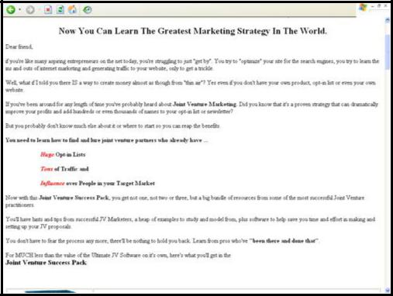

Avoid that, and space your width to have your sales letter cover 70-80% of the monitor’s width.

☑
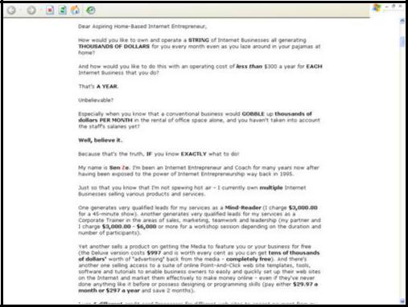

Color Scheme

GoldenVisionTraining.com 12

How to Write Your Own Killer Sales Letter 13

Do not use too many colors for your sales letter. In other words, use not more than 4 to 5 colors in your sales letter. Furthermore, the color scheme must blend well with black text and white background.

Long Letter vs. Short Letter

Now, we have come to the age-old question in writing your sales letter: is writing long sales letter better than writing a short one – or vice-versa?

You do not have to guess. The answer is: The long sales letter.

Why?

The more you write in your sales copy, the better. There is always a debate on whether a long sales letter works better than a short one. But the truth is that there is no debate whatsoever on this topic as long letter will, definitely, outsell the short one anytime.

Yes, some people will say they do not like to read a long sales letter. When that happens, you know that they are NOT going to be your customer. Also, I should think that they would not have any patience with your product or service, either. Is this the type of customer you want?

So, write a long and exciting sales letter. Produce an exciting sales letter that keeps your prospect to read from start to end. And if they like it, they will definitely look forward to another product from yours truly. This same secret will make back-selling easy. Make him see a good future he can get with the help of your product.

Think in this logic and you will be on the right track. It did very well for successful movie directors and copywriters, so why should you be an exception?

GoldenVisionTraining.com 13

How to Write Your Own Killer Sales Letter 14

Besides, you are writing a sales letter, not a brochure. A brochure only informs your prospect about the features of your product. It does not sell. Your sales letter does.

Number of Pages

There should only be ONE page. No Page 2, or [continue] whatsoever. The reason is simple: you want to get your prospect to read from top to bottom, and make his decision there and then on the same page. No Page 2 to distract him! Check out the rationale of this below:

Any Other Links?

Besides the link to the Pay button, there should be no other links on your sales letter. This is an important key to success for your sales letter. That means no links to About Me, F.A.Q., Sitemap, or even Page 2. You should not put any advertisements (banner ads, Google Adsense and the likes) on your sales letter, either. You do not want to distract your prospects. You want them to stay focused – and continue reading your sales letter from head to toe.

In other words, you have to explain who you are, what you do, and how you can help your prospects to solve their problems.

These links can be exceptional, however:

- Disclaimer and Privacy pages. If your prospects need to see these pages, try either putting them on the same page as the sales letter or open them in a new window. That way, your prospects will not get distracted from reading your sales letter.

You can get a disclaimer page for free here.

GoldenVisionTraining.com 14

How to Write Your Own Killer Sales Letter 15

- Your contact e-mail address. Should your prospects have any questions, this information is essential to put into your sales letter. However, you are advised NOT to hyperlink it as it can be a SPAM-magnet as there countless automatic spam-blasters creeping in cyberspace! Instead, just write your e-mail address as it is. Preferably, write your e-mail address in this format: yourname[at]emailaddress.com instead of yourname@emailaddress.com.

- A link to signing up for your affiliate program. A big number of the prospects who visit your sales letter will not likely buy your product. However, you can convert some of the non-buyers to be your affiliates.

- Membership login. This option should appear only available to your members if you are running a membership site. Generally, only members would go to this page and your prospects would not get distracted by this link as there is nothing more to this page than a login form.

With no other links in your sales letter, it boils down ultimately to whether your prospects buy from you or not.

GoldenVisionTraining.com 15

How to Write Your Own Killer Sales Letter 16

Chapter 3: Writing Your Sales Letter

Now, we will cover each and every component of your sales letter – from top to bottom, chronologically – in detail.

Headline

You must have something at the beginning of your web page that you do not see on majority of the web pages out there – a headline!

This is a hard and fast rule: your sales letter must have a headline. That is the first thing your prospect is going to look at when he visits your web site. Not having a headline is like looking at a headless person!

Your headline serves as an advertisement to your prospects. Your headline must grab the attention of your visitors or else they will not read the rest of your sales letter. This is very crucial – the headline will make or break your sales letter!
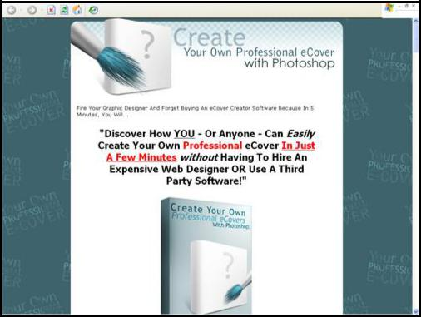

GoldenVisionTraining.com 16

How to Write Your Own Killer Sales Letter 17

The size of your headline should be bigger than the rest of the text in your sales letter (like the screenshot above). You may want to color and stylize (e.g. underline, bold, italic, highlight, and strike-through) your headline text.

Since your letter’s headline is the first contact your prospect has with your message, it must reach out to him. Promise him a benefit. Tell him how he will be better off if he reads the rest of the letter.

Headlines can be classified into the following 5 basic types:

- News Headlines

This form tells your prospect something he did not know before. "Now – a copy machine that copies in color" is an example of this type headline.

- Promise Headline

Here, you are promising something if the prospect follows your advice. For example: "Switch to XYZ Abs Flex and you will no longer see those spare tires in 6 weeks – guaranteed!"

- Selective Headline

Headline such as “To all who are suffering financially” or “Bald men

– lend me your ears” limits to a specific group of prospects. Caution however, that this type of headline can eliminate potential customers so use carefully or draw in targeted prospects to read your sales letter.

- Curiosity Headline

The purpose of this headline is to arouse the prospect's interest enough to make him read your letter. An example of this headline would be: "Do you have trouble going to sleep at night?" The drawback,

GoldenVisionTraining.com 17

How to Write Your Own Killer Sales Letter 18

however, is that this headline often appears "cute" or "clever" and sometimes even deceptive.

- Demand Headline

Watch out for this one as most people resist pushiness. "Do it now!" or "Get your copy today!" headlines generally can be improved by changing to less obtrusive words such as: "Call for your key to success!"

Effective headlines often combine two or more of these kinds.

Warning! Remember that when your message is printed in all upper-cased or capital letters, it is difficult for your prospect to follow and remain interested in your offer.

DOES THIS LOOK COMFORTABLE TO YOUR EYES?

I bet this sentence is easier to read and comfortable for your eyes compared to the upper-cased sentence above.

Even in headlines, ALL CAPITAL LETTERS should be refrained from being used. Even if you plan to use ALL CAPITAL LETTERS, limit this to only a selected few words, and make sure they are “hot buttons” or meant to grab your prospect’s attention.

Sub-headline

This is the next most important component after the headline. Your sub-headline serves as a “hook” that will encourage your prospect to read further.

GoldenVisionTraining.com 18

How to Write Your Own Killer Sales Letter 19

Basically, your sub-headline summarizes your sales letter and must elaborate on the benefits of reading your letter thus creating the urgency for your prospect to read – today, and no later!

You can also provide the “if problem, then solution” scenario in your sales letter. Usually, your sub-headline is smaller than your headline in size, and bigger than the regular fonts on your web page.

Examples of a sub-headline are:

Do you think you could learn something from someone whose websites are all within the top 1% of all sites visited online and several of which are in the top 1/10th of the 1% of all sites visited online?

At last, the truth will be unveiled in 212 power-packed letter-sized pages, PDF Format, so that YOU can CURE your asthma and get your breath back in the comfort of your own home!

Addressing Your Prospect

Below your sub-headline, comes the “From”, Date and Greeting lines.

From: [Insert Your Name Here]

Date: [Insert Automatic Script That Show today’s Date]

Dear [address your prospect],

Alternatively, you can write the following sentences:

- From the keyboard of [Your Name Here]

- From the desk of [Your Name Here]

- From the laptop of [Your Name Here]

GoldenVisionTraining.com 19

How to Write Your Own Killer Sales Letter 20

This is important as your prospect wants to know where the letter he is reading comes from.

As for the script that automatically show today’s date, your prospect would appreciate you having him aware of the most recent date. Therefore, there is absolutely nothing wrong with using a date script. In fact, it is the same as using a direct mail piece where the date is located at the top of the letter.

You can search the Internet for a free date script, but I will save you the trouble by including the following HTML codes into your web page below which I have personally found and used.

<SCRIPT LANGUAGE="JavaScript">

<!-- This script and many more are available free online at --> <!-- The JavaScript Source!! http://javascript.internet.com --> <!-- Author: www.cgiscript.net -->

<!-- Begin

- Get today's current date. var now = new Date();

- Array list of days.

var days = new

Array('Sunday','Monday','Tuesday','Wednesday','Thursday','Friday'

,'Saturday');

- Array list of months. var months = new Array('January','February','March','April','May','June','July','A ugust','September','October','November','December');

- Calculate the number of the current day in the week.

var date = ((now.getDate()<10) ? "0" : "")+ now.getDate();

- Calculate four digit year. function fourdigits(number) {

return (number < 1000) ? number + 1900 : number;

}

// Join it all together

today = days[now.getDay()] + ", " + months[now.getMonth()] + " " +

GoldenVisionTraining.com 20

How to Write Your Own Killer Sales Letter 21

date + ", " +

(fourdigits(now.getYear())) ;

- Print out the data. document.write(today);

- End -->

</script>

Now, address your prospects with a:

Dear Friend,

If you want to target a specific group of people or qualify your prospect, you can be more accurate in your address. For example, if the only type of people who will be interested in your ringworm remedy are those who are suffering from such infection, you can address:

Dear Ringworm Patient,

If you are targeting another Internet Marketer as only they will be interested in your offer, you can address:

Dear Internet Marketer,

While this makes your sales letter as laser-focused as possible, be warned that you can possibly lose potential customers who are not whom you addressed. For example, maybe a non-Internet Marketer can also be interested in your product but is not an Internet Marketer?

If your target market is broad, you will be safe to use “Dear Friend” to address your prospect. Not only is it a friendly approach, almost anyone can pass by as a friend.

Introduction Paragraph

Address the problem(s) your prospect is facing that you are going to solve.

GoldenVisionTraining.com 21

How to Write Your Own Killer Sales Letter 22

Now, the biggest challenge in writing an effective sales letter is keeping your prospect involved, engaged, and interested in reading your sales letter from top to toe.

If you forget for a moment to emphasize the "What is in it for you" nature of your offer, your prospect will tune out, turn off, and click away from your sales letter.

So, write your introduction to notify that there is a problem your prospect is facing. No, do not create a problem. Address the problem that already exists. Your prospect, like anyone else alive, is already having enough problems. You want to reduce as many problems as possible for your prospect and that is why your prospect should be interested in reading your sales letter.

If he is your target prospect, he will confirm and agree the problem you have addressed.

Below is an example of an introduction of a sales letter addressed to asthmatic prospects:

Dear Asthmatic Friend,

GoldenVisionTraining.com 22

My name is John Doe and I have something to share with you.

At the tender age of 2 years, I was diagnosed as asthmatic. This marked the beginning of a what-seemed-to-be-never ending struggle between life and death with a condition that almost destroyed my health life.

I remember vividly the pain and the deep agony I went through. I even tried to pretend that everything was all right!

Asthma, If You Were a Somebody, I Would Have Murdered You Terribly.

Now it's a small wonder why I wage a personal crusade against asthma even to this day.

The sleepless nights, constant hacking cough, the frightful feeling of suffocation, and continuous wheezing brought pain beyond words in the chest area, which can only be described as very unpleasant and difficult to manage.

It was a childhood stripped off from the frolics, merriment and fun. I felt like an outcast when it comes to curricular activities. I envied my friends who don't seem to have my health problem.

Not being able to participate in sport activities and events, missing school on a regular basis and frequenting the hospital became a habitual routine and one that left an indelible and a disturbing effect on the psyche. The scar that was made on my health was, needless to say.

So, I had a dream.

I wanted to eradicate asthma once and for all. I decided that it is too expensive to deny myself of a good and healthy life so I didn't take too long for me to spring into action and set out to look for a cure.

At that time, I didn't know how to do it but backed by confidence and a small array of hope, I knew it was possible.

I continued life as it was. But I didn't lose focus of my main goal. In trying times, all I was armed with was faith.

After all the intensive research, buying books on the subject, traveling to other countries, meeting health experts and doctors, and trying out countless ways to cure my asthma disease, I felt it was time to go for a medical test. I did just that.

I was nervous until the report came out. As I read through it, my frustration built over the years have stopped. I knew my primary goal was achieved.

I Did It!

The report surprised my parents and family members. I was, too, though I knew what I had done to bring such results.

Only in my adulthood did I realize that my asthma was congenital and that I was born with it.

How to Write Your Own Killer Sales Letter 24

Asthma, as a chronic disease, can only be described with absolute profundity and in detail by someone who has actually experienced the terrible effects of this condition first hand.

That said, I am qualified to explain how asthma can affect the psyche, how both internal and external factors can influence our well-being and lifestyle... and needless to say, the solutions!

Fear, anxiety and even the fright of a probable attack can be most disheartening and a ghastly experience. However, there is no need to worry anymore.

Now, the reason I'm telling you this is NOT because I want to impress you, but to impress upon you that asthma is a disease that can be totally eliminated without having to burn a BIG hole in your pocket on your part - because I already did that for you!

From the sales letter introduction above, notice that:

- The writer has addressed to a specific group of people, namely people who are suffering from asthma. He has got quite a huge demand here, as there are about 300 million people from around the world who are suffering from this painful, killing disease and that people do go online to search for a cure.

- The writer addresses and confirms the problem his prospect is facing, which in this case, is the asthma disease. Note that if the prospect is healthy or has other kinds of health problems, this letter is obviously not meant for him as the solution the writer has applies only to asthma patients.

- The writer connects very well with his prospect. The writer has something in common with his prospect and can relate his experience to him. The writer was an asthmatic, too. The writer suffered from tight breathes, wheezes and coughs at night like any other asthmatic people. His experience can be easily understood and appreciated by his prospect because they both have had them, too!

GoldenVisionTraining.com 24

How to Write Your Own Killer Sales Letter 25

- The introduction was interesting, especially to the asthmatic prospect. He, too, would definitely like to murder asthma if it were a

“somebody”! The writer was good at telling his story on how he had asthma at a very young age and later ventured on to search for a cure.

- Most importantly, the writer has already got a cure that his prospect can definitely use!

You will want to write your sales letter in an almost similar manner, no matter what solutions you have or market you are targeting.

Announcing Your Solution

Now, what? Follow through with the solution! Become a problem solver in writing. Once you confirm the problem your prospect is facing (and he probably nods to that), introduce your solution.

Your solution can come in the form of a tangible product, digital product, membership access, or even a service!

Example #1: Digital Resale Rights Club

http://www.digital-resale-rights.com/
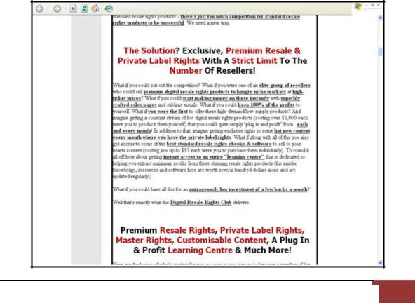

GoldenVisionTraining.com 25

How to Write Your Own Killer Sales Letter 26

Example #2: Megapreneur Million System

http://www.megapreneurmillions.com/
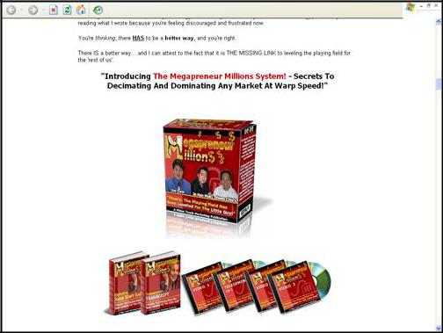

Benefits vs. Features

Copywriting 101, Lesson 3: What happens when you do not explain the benefits of your product in your sales letter?

Answer: No sales!

That is right. You do not have to be a savvy copywriter to know that. But somehow, most of us make this terrible mistake.

GoldenVisionTraining.com 26

How to Write Your Own Killer Sales Letter 27

More often than not, features are often being mistaken as benefits. I have been asked by friendly business associates to review their sales letters and sadly, this is a common mistake I always see in their sales letter. If I were in the shoes of a potential customer, I am more interested in how a product can benefit me than know what it looks like. Recall the last time you bought a product, online or offline. Why did you buy it? Did you buy it because of its features? Or did you buy it because it can benefit you or solve your problem?

To learn the distinct definitions of benefit and feature, see below.

- Benefit. According to the Pocket English Dictionary’s definition, it means an advantage; to be useful or profitable to. In the case of selling your product on your web page, you want to tell how useful or how your product can solve your prospect’s problems.

- Feature. According to the Pocket English Dictionary’s definition, it means characteristic. In the case of selling your product on your web page, you want to also tell your prospect in what form your product is (digital or physical).

The following are examples of benefits and features:

- You sell slimming powder on your web page (physical product). The feature of your product is easy-to-digest powder packed in a tin or carton. The benefit of your product is that consumers can now lose weight the easy way!

- You sell turtle pellets on your web page (physical product). The feature of your product is small and easy-to-digest green pellets for your pet amphibians. The benefit of your product is that it is easy for your pet amphibians to consume and grow healthily because they are going to get all the nutrition they can get in the pellets!

GoldenVisionTraining.com 27

How to Write Your Own Killer Sales Letter 28

- You sell an information product on your web page (digital product). The features of your product are .PDF format and have Master Resell Rights. Therefore, the benefits are your customers can download it instantly as soon as they pay and they have an income opportunity to make money and keep all the profits to themselves!

All in all, write BOTH features and benefits of your product. But sell a SOLUTION, NOT a product!

I know you are cringing when you hear this. All these while we have been talking about selling your product or service through your sales letter but remember, you do not buy a product for the sake of buying a product! And neither do anyone else on this planet. You buy a product because of getting the benefits or solving your problems! You did not buy a refrigerator because it was a refrigerator, did you? But you bought one because it sure is going to be a problem keeping your food out in the open!

Top Internet Entrepreneurs know this business principle very well. This also explains why exclusive product membership sites continue to thrive and grow. Their selling point is not in the product but the solutions and benefits the product gives.

Endorsements and Testimonials

Sure, you could go on and on rattling about what a good offer your prospect is looking at and why he should buy from you, but he would also be interested in the kind of results other customers who have tried out got from the product or service before he dives into the offer.

So, you need testimonials.

Testimonials from your customers are one of the strongest marketing tools available.

GoldenVisionTraining.com 28

How to Write Your Own Killer Sales Letter 29

What is a testimonial? It is a statement, usually written by your customer, saying nice things about some aspect of you, your product or service, and your business.

What to Have In Your Testimonials

- Testimonials about YOUR product, not you. Do not be fooled by the simplicity of this statement. Testimonials that say you are a great person whatsoever are NOT the type of testimonials your prospects are looking for, though such testimonials can build trust and your name. But your prospects are more interested in how your product can benefit them or solve their problems. They did not read your sales letter to see you praising yourself.

- Testimonials that mention results. The more specific they are, the better. Interested prospects want to know what the results other customers have benefited from the usage of your product or service.

- Quality / quantity. If you can get top names in your niche or field to endorse your product, it will help your increase your sales. If you do not know any experts or top names who can help endorse your product, you can make up in the quantity of testimonials. The more testimonials you have, the more convincing your sales letter will be.

- Customer essential details. Include your customer's Full Name and City/State/Country after his or her testimonial. You can include your customer's web site URL or contact e-mail address where applicable (with permission). And if you can, get your customer's photo and paste it into your sales letter. Using photos can increase your credibility and shows how pleased your customers are when using your product.

How to Collect Testimonials

There are many ways to get testimonials from your customers. You can:

GoldenVisionTraining.com 29

How to Write Your Own Killer Sales Letter 30

- Hold contests for the best-written testimonials. Give them a reward, gift or some publicity in exchange for their testimonials.

- Ask for letters of endorsements from your customers, vendors, suppliers, and any associates you have. Use them to promote your products and services. When you use testimonials to add credibility to what you do, you are letting your customers do some of the marketing for your business.

- If you are just starting out fresh, give a sample version of your product or trial service to those whom you know. They can be your business associates, friends, or people whom you know need your solution. This is the fastest way you can get testimonials. You start with proving your worth.

- Get top names, influential people and experts to endorse your product. So, look for top names and experts in your field and get their e-mail address. E-mail them and politely ask for their endorsement. Since they are only an e-mail away, why not? And if you

- You can participate in active forums and newsgroups where people of similar interest and mindset gather around and discuss on the same topic. This is a good place where you can meet people and get their testimonials simply by asking for their permission and give them a sample of your product. If your product is of genuine quality, you can count on them to send their honest testimonials in and spread the word for you.

When you use these testimonials, you want to weave them into your marketing story. Use them to support your claims and promises. For every benefit or objective you need to overcome in your products or services, it is the best scenario to have testimonials establishing or referencing each of those benefits or objections.

GoldenVisionTraining.com 30

How to Write Your Own Killer Sales Letter 31

The benefit of using testimonials on your web site can help link popularity in search engine results as well. Whether you use this marketing tool for either inbound or outbound reasons, you will have an advantage over your competition. Check them out next time you visit their office or web site and see for what people are saying about their business practices. You will be amazed!

Examples of How Testimonials and Endorsements Are Used

Example 1 : My Wizard Ads
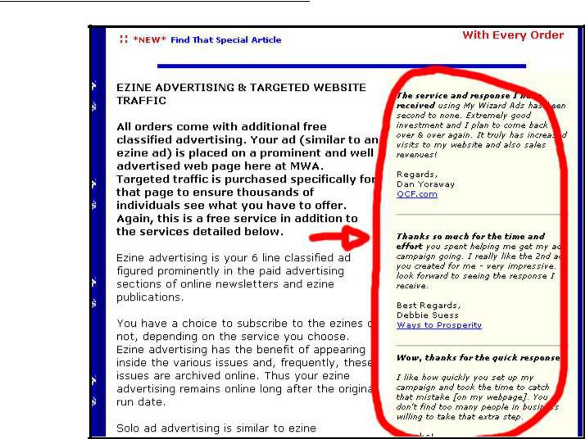

The testimonials by happy advertisers arranged neatly on your right. If you want to know more about the results of using this service, you can check with the testimonial writers who have left their web site URL under their names.

GoldenVisionTraining.com 31

How to Write Your Own Killer Sales Letter 32

Example 2 : Trafficology
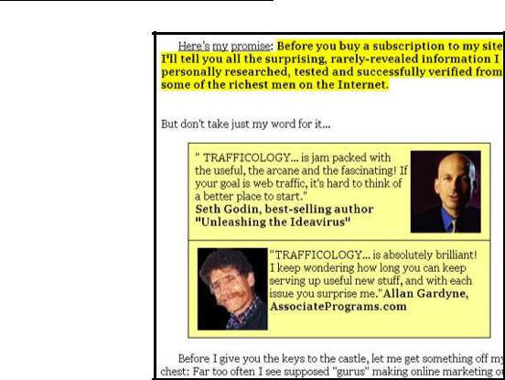

The top names are endorsing this service. Is there anymore doubt to using it if you need web site traffic?

Giving Bonus Incentives (optional)

Sometimes, I have been asked on whether one should throw in bonuses or not when selling a primary product or service on the Internet.

Now, this is not going to be a simple right or wrong answer that I am going to give.

For one, I have seen people making money beyond their wildest dreams, partly owing to the amount of attractive bonuses they give as an incentive for their prospects to buy their primary products from them. I have also witnessed those who are wondering when the next sale is going to come in spite of the amount of bonuses they throw in together.

And then there are other Internet Business owners who still sell like hot cakes even though there were little or no bonus incentives offered.

GoldenVisionTraining.com 32

How to Write Your Own Killer Sales Letter 33

So, bonuses: to give or not to give? That is the question.

I might sound as if I am taking this too lightly if I were to tell you that it is really up to you but the truth is, I have sold products WITH or WITHOUT bonuses before, so it is obvious that the bonuses factor is not the constant when it comes to making money, but rather the sales copy is one that decides the perceived value of your product.

Here are a few general ways you can pitch your sales letter to make people buy from you, whether you throw in bonuses or not.

If You Throw In Bonuses

Example : Megapreneur Million System

http://www.megapreneurmillions.com/
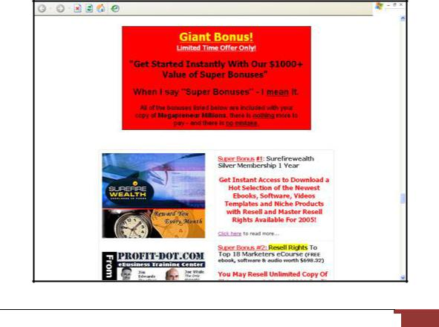

GoldenVisionTraining.com 33

How to Write Your Own Killer Sales Letter 34

- You get $1,000.00 worth of bonuses along with my main product. This is an offer you would not find elsewhere.

- Let’s do the math. You get Product 1 + Product 2 + Product 3 + Product

4 = $1,000.00. You get $1,000.00 worth of products for only the price of one. It would have cost you $1,000.00 if you purchase them ala carte elsewhere.

If You Are Not Throwing In Any Bonuses

- It is obvious that there are little (or no) bonuses added to this offer. But if you are not convinced of the true value of this product (or service), no amount of bonuses will ever convince you.

- Unlike most offers out there, I am NOT going to give you any bonuses. But look at it this way: I have kidnapped a top copywriter who charges $10,00.00 per sales letter written to spill his guts out for you, and you get to have his brains for only $97. Which one are you more interested in? Getting the $1,000.00 worth of bonuses which you might or might not come around using or invest your $97 in the product alone and write your own professional $10,000.00 sales copy and profit from it in a long time to come?

As you can see, both sides have valid point of views. And in general, as long as you can convince your prospect of the true value they are going to get from your solutions, you will be sure to make your money, with or without bonuses.

Guarantee

After telling your prospect all the wonderful things you product can do for him and proudly showcasing your precious testimonials, he is probably thinking, “That is good. But should I be taking the risk to buy this product from you?” And the answer is a resounding NO.

GoldenVisionTraining.com 34

How to Write Your Own Killer Sales Letter 35

Purchasing anything online is risky. Don’t blame your prospects for being scared. There are more idiots out there ready to rip and scam innocent people than you can count the stars in the night. I do not know why they choose to be crooks when it is too easy to do business legally and in a harmonious manner but I guess I will never find out.

But you can find out how you can win your prospect’s trust. Show your prospect that you are concerned and care for him. And you can easily demonstrate this buy giving a money-back guarantee policy.

Usually, a money-back guarantee for digital product is 90 days.

Here is a real-life example of how your money-back guarantee policy may look like in your sales letter:

Example : The Ultimate Success Manual

http://www.theultimatesuccessmanual.com/
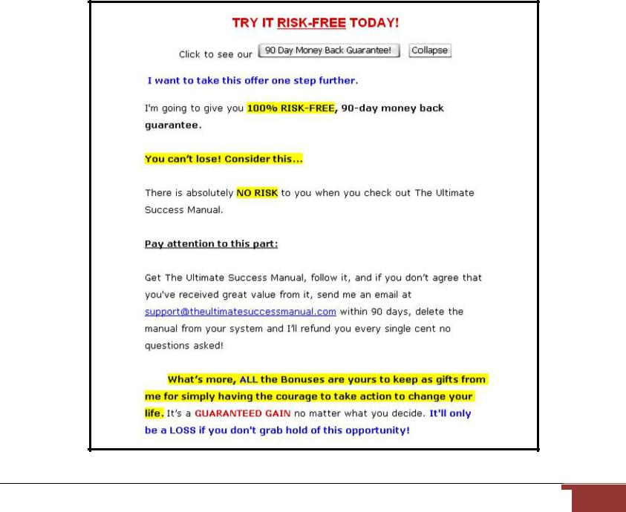

GoldenVisionTraining.com 35

How to Write Your Own Killer Sales Letter 36

This way, let your prospect know that you are shouldering all the risk for him. Giving a money-back guarantee also demonstrates how confident you are in the quality of your product. If for any reason your customer does not like your product or think it is not for him, he can promptly ask for a refund and delete the product from his PC. Your prospect cannot lose.

And then, here is another example of what your guarantee policy can be written like:

ABC’s 100% Rock-Solid, Satisfaction Guarantee

Buy Access to ABC Plan, and give my program a good try. If you don't agree that this is one of the best decisions you have ever made, simply cancel your access within 30 days and I will refund whatever amount you have paid in FULL.

Warning! Being in business with your prospects can be risky for you as an Internet Business owner, too. You will eventually learn that there are also idiots among your prospects who buy your product from your web page, and later ask for a refund (for the wrong reasons) and still keep your product! Worst still, he copies your product to his contacts! I am afraid that nothing much can be done about this. While you might be able to source for ways to protect your product as much as you can, it can be really effort and time-consuming to deal with these idiots. Your time is best spent on improving or bringing in more revenue for your business. Fortunately, there is only a minority of such people among the prospects in general. You can make up more in sales than the amount of refunds that they are almost negligible.

Persuade to Buy Now

You have confirmed the problem your prospect is facing or what he wants to achieve.

GoldenVisionTraining.com 36

How to Write Your Own Killer Sales Letter 37

You have introduced your solution, whether it comes in the form of a tangible product, digital product, membership access, or service.

You have described the benefits to your prospect.

You have proudly show-cased your collection of testimonials that back your claim.

You also let your prospect know that if he is to buy from you, he is protected by your guarantee. Now, what?

Now is the time to close the sale. After the good gamut told, do not give the prospect a chance to draw back or even a second to hesitate!

So, follow up with a sub-headline that presses your prospect to buy now.

The sub-headline can go like any of the following:

- Get your copy now.

- Don’t procrastinate.

- It is time to get a better life, isn’t it?

- Order now!

- Are you ready?

- Test-drive XYZ program now.

- Try ABC out for 30 days, risk-free.

You can remind your prospect about your risk-free guarantee policy. But, to prevent that, you can use guilt in the next paragraph. It is true that the fear of loss coupled by the “bragging rites” ego can trigger your prospect to buy from you.

GoldenVisionTraining.com 37

How to Write Your Own Killer Sales Letter 38

Name the price now, if you have not hinted or told your prospect yet up until now, and justify it. Let your prospect know that the price you have labeled is a bargain, or even a steal. Otherwise, you would not be able to make a sale!

Your prospect might think that it is not worth his money’s spent or that he is paying too much for too little.

A simple way to justify your price is that you show the math or calculations of the value to your products is and later reveal how much the investment is required on the part of your prospect.

For instance, you show that the total value of your products is $3,000.00, but you are charging only $3,000 $97. This is often true for people who sell multiple products.

If you sell only one product, you can very well say that if your prospect would see you in person for personal consultation, you would charge $100 per hour. If he would see you for 3 hours, it would cost him $300.

Thus it would make sense for your prospect to buy your $30 E-book as you can possibly dispense more information than in even 5 hours.

Of course, $30 to you is a lot less than $100 but face it, you have only 24 billable hours in a day, and that is assuming you give consultations around the clock.

By selling E-books, you can sell as many copies as you wish to those who want your advice, information and wisdom thus earning you residual income without having to depend on your limited time!

This is also where you include your Order Button or Order Form.

GoldenVisionTraining.com 38

How to Write Your Own Killer Sales Letter 39

Tip: Make your prospect see the future with or even without your product.

For example, if you sell an E-book that teaches your prospect how he can slim down and get fit with the easiest solutions and methods found in your electronic manual, you want to have him picture a good future of seeing himself slimmed down and become attractive. That is the good future.

You can also make your prospect see the BAD future. Call it reverse-psychology if you want to, but if done correctly, it can also be responsible for converting at least 2 to 4 out of every 100 prospects who visit your web page into customers!

Using the same example, you can tell your prospect that if he does not buy from you now, nothing will change. Your prospect will still look fat and his peers will still pick on him and maybe worse, he will probably be single for the rest of his life, simply because he does not even have the desire or discipline to slim down!

Post-Scripts

Post-scripts (P.S.) summarize your entire sales letter and persuade your prospect to act NOW. Usually, prospects will scan the sales message and shoot straight to the P.S.

Below, I use the same example to demonstrate my point.

Example : The Ultimate Success Manual

GoldenVisionTraining.com 39

How to Write Your Own Killer Sales Letter 40
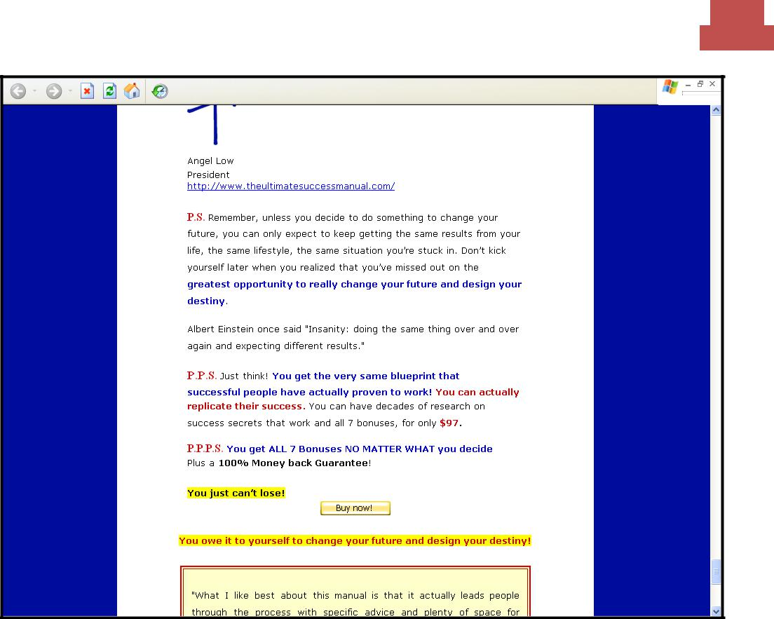

The writer of this letter summarizes her sales copy using a series P.S.es. She reminds her prospect that if he wants to change his lifestyle for the better, the solutions are found in her E-book. She is using the “make your prospect see a good future” technique!

She also reminds her prospect about her risk-free guarantee policy and that he can keep the bonuses even if he did ask for refund, should he find the E-book non-satisfactory or not what he is looking for.

$97 is very cheap, because having a lousy life is more expensive to the soul!

GoldenVisionTraining.com 40

How to Write Your Own Killer Sales Letter 41

Chapter 4: More on Writing Your Sales Letter

Write With Personality

Now, we have come to an interesting part of writing your sales letter where the champs love to express themselves and the chumps wish there was no such thing as writing a sales letter.

I once heard the speaker at a Network Marketing seminar say, “Talk with personality”. When you compose your sales letter, write with personality. Don’t write a stiff sales letter! Not only will it be boring, but your prospects would also not likely buy from you – unless they have got no personality, too.

Birds of a feather flock together. If you are fun and easy-going person, express yourself in such a manner in your sales letter. Be friendly and approachable. If you are serious person, you write in a serious manner (but not too serious, it might just sell people away from your web page, and it is cheaper that way).

Remember that attract people of the same kind. If you have to take a personality test on the Internet, please do. It will be worth your time!

Write casually. You may be in business, but the key here is to write an informal letter. Address your prospects with “Dear Friend” and not “Dear Sir”.

Be personal and find how you can relate yourself to your prospects. If you are a break dance enthusiast, you can relate to your prospects your first six months of snapping every bone in your body before getting the power moves down.

GoldenVisionTraining.com 41

How to Write Your Own Killer Sales Letter 42

You write with the understanding of the trouble and frustration your prospects are going through therefore you have the solution – you are going to teach your prospects how to break dance every step of the way with your how to videos!

Warning and tip: I noticed that many novices write their sales letters from the perspective of a group of people or a company. This is obvious as they always address themselves as “we”. And very often, “we” refers to the Internet Business owner – and the web site domain name!

Don’t hide behind a company or a group that never exists. Write from the perspective of “I” especially if you are working alone. It pays to be personal in your sales letter.

That way, you can build trust with your prospects. Include your signature (not your real one) and a good-looking photo of yourself, if possible.

If you have at least one business partner, you are still advised to write from the perspective of “I” instead of “we”. For example, at the beginning of my sales letter, I write:

From: John Doe with Jane Dee

Instead of:

From: John Doe and Jane Dee

That way, I can still write from the perspective of one person talking to my prospects and at the same time, the prospects are aware of my business partner.

More examples:

If I have more two business partners

GoldenVisionTraining.com 42

How to Write Your Own Killer Sales Letter 43

From: John Doe with Jane Dee and Robert Smith

If I have a team to represent (more than three members in the team, myself included)

From: John Doe with XYZ Team

Identify Your Prospect – It Is One on One

Now that you know you should write from the perspective of one person, you should also write your letter to one person and NOT many people, although many prospects will visit the same web page.

Do NOT address your prospects as “you all”. Address your prospects as “you”. Make your prospect feel personal, as if you are talking to your prospect in person. Besides, I doubt your prospect will like to be reminded of the truth that he is one of the many people visiting your web page.

Study your prospects problems and needs. Very likely, the people who need your product have the same problem.

For instance, if you are selling a product on weight loss, your customers are people who are looking for ways to lose those fats – and you have the solution. Therefore, your sales letter may start like the following:

Dear Friend,

Throughout my schooling days, my classmates kept mocking me Fatty Bom-Bom. It hurts like knife through my heart. Not being able to get along with my friends, looking for a suitable partner to go with to the prom and being called names owing to my physical looks was a turning point in my life. So I had a dream.

GoldenVisionTraining.com 43

How to Write Your Own Killer Sales Letter 44

Now, this is a personal letter from you to your prospect. Enter the word personal. Your prospect surely understands you. He is an obese himself and very likely, he is having the problems you used to have!

Let’s carry on:

I know I am good-looking. I just need to get rid of those spare tires! So I set out and look for every solution possible. I sampled slimming products – one after another. But none of them worked. Today, each time I see those slimming ads, I say to myself, “hog wash!”

Up until now, your prospect understands what you have to say. He is probably thinking that those slimming ads are hogwash, too! So, you have learned an important factor here: relate yourself with your prospects.

Important! Before I forget, here’s another important reminder: do not use slangs or be too informal! Avoid using words such as “Yo dude” “whazza!” “Check out the juice” and the likes.

Write your sales letter in simple English. This is a common problem especially for professionals. Professionals are very prone to using technical jargons and flashy words that only another professional of the same field like would understand.

Understand that not everyone’s first language is English. When your prospects leave your web page without understanding a thing, you know whose fault is it.

Some of the Most Important Questions Answered

In your sales letter, you MUST address and answer the important questions your prospect will definitely have in mind when he is reading your sales letter.

GoldenVisionTraining.com 44

How to Write Your Own Killer Sales Letter 45

I know. The problem is that you do not know who and how many of your prospects will be seeing your web page but I will help you out here by giving you some of the most important questions you MUST answer well, because these are the questions that almost everyone will definitely ask.

Here we go:

- Why should I buy from you? What credibility do you have?

- Why should I purchase your product or service? Why not other people’s?

- Why should I trust you?

- Why should I pay the price you ask?

- Why should I buy NOW and not later?

- How can your product or service help me?

If you cannot answer all of these questions well, your chance of making even at least one sale is almost second-to-none.

Pressing the Hot Buttons

Selecting the right words is critical to the success of the sales copy. Sales people and Network Marketing members aptly call it “pressing the hot buttons”. You will want to do the same for your own sales letter because it will be doing all the selling for you!

Recent research conducted at Yale University found that the following 12 words are the most personal and persuasive words in our language. Be sure to use as many of them as possible!

- You

GoldenVisionTraining.com 45

How to Write Your Own Killer Sales Letter 46

Notice something? It is “you” and not “I”. You see, the sales letter is about solving your prospect’s problem, not yours. You simply provide the solution. And when you write in terms of “you”, not only does it become more personal, you shift the focus of importance and limelight onto your prospect rather than blatantly talk away or praising yourself.

- Discovery

Sometimes, your prospect may perceive a problem he is facing as “cannot be solved” that he wishes, “I hope there is a solution” or subconsciously thinking, “It would be nice if someone had already discovered it”. Thus “discover” or “discovery” is a powerful hot button to press and use in your sales letter. For example, if you are facing a situation with your spouse and fear that if the divorce is granted, you would have to part 50% of your asset, you would probably wish there is a way to stop your divorce. What if I told you that I have discovered a way? Sure, you would jump on that!

- Safety

Most people are not risk-takers by nature, thus safety and security are appealing to them. When you especially recommend a tangible product or service, you can automatically put a seal of assurance by letting your prospect know that it is safe to use or 100% tested.

- Money

Money, money, money – this is yet another hot button to press on! Let’s face it, we are all interested in money, whether we admit or make a self denial. Words such as “make money”, “save money” and “multiply the amount of money you already have” are hot buttons you can easily tap on.

- Proven

GoldenVisionTraining.com 46

How to Write Your Own Killer Sales Letter 47

You want to convince your prospect that your product or service is already proven and tested before being brought to the online public. It would really scare most people if they are to find out that they are the first to test at their own risk of time and money. If you lose the sale, you know why!

- Results

No matter how highly you claim about your product or service in your sales pitch, your prospect would only find you spewing hot air without the results. So, you showcase your testimonials. So, you showcase your own results which you have personally tried with your own product or service. Examples of results are:

“I have lost 22kg in three weeks!” “I have made $1,031.00 with DEF program!” and “With JKL Software, I have saved 3.5 hours everyday in writing and submitting my articles to 1,211 directories!”

- Love

Tap onto your prospect’s positive emotion with this yet another hot button for you to press. Call it passion if you want to, but here are some examples on how you can use the word “love” in your sales letter: “Don’t you love the idea of having plenty of free time with your spouse and watching your children grow up?” and “You would love this program, because it can buy you the freedom to travel”.

- Guarantee

I have mentioned it earlier but it is worth mentioning again: most people are non-risk takers. They prefer certainty over uncertainty. Also, not everyone wants to be the first guinea pig. So, you offer a guarantee. You let your prospect know that you shoulder ALL of the risk for your prospect and he can test-drive your service or simply sample out your product for the next 30/45/90/180 days. Some even offer a lifetime guarantee, which makes your prospect feel silly if he ever leaves your page

GoldenVisionTraining.com 47

How to Write Your Own Killer Sales Letter 48

without giving your offer a try. If your prospect gets what he wants, well and good and if he does not, he can still ask for a refund. This is how confident you are in your offer, and it can clearly show to your prospect.

- Save

We would all do anything possible to save. In anything we do – we want to save money, we want to save time, and we want to save effort. Be extremely sure to use this word in your sales letter because everyone has the desire to save himself from a lot of trouble or even work. Here is an example of how you can use the word “save”: “For only $97, you can save yourself 10 years of guessing, credit card debt, risk, time, effort, and frustration!”

- New

The word “new” automatically beats “old” anytime in terms of opinion, facts, and even solutions. For example, in the past, people have to manually submit their articles to 100 directories. When you introduce your article submission software, you pitch in your sales letter that this is the latest, new solutions that would enable your prospect to submit their articles to 1,000 directories at the click of the button! This is an example of a new solution beating the old.

- Easy

Don’t make things look harder than it already is. Your prospect is probably willing to pay but it had better be a good investment. Your prospect has already had enough troubles and he is probably desperate for an easier solution. For example, if you have your own software for sale, you state the benefit that it is user-friendly and that it does not require any programming or technical skills on your prospect’s part. It is that easy – even a half-brainer can run the software!

- Health

GoldenVisionTraining.com 48

How to Write Your Own Killer Sales Letter 49

Health is a very HUGE niche on the Internet, and this word is a hot button to those who are health-conscious. If you are selling a health product, use this word – no other exceptions! Example: “If you want to feel good living your health life free from asthma (and spend less money and pain the process), then may I suggest you get a copy of my Ancient Secrets To Asthma Cure?”

Also noticed something else? The overused word “free” did not make it to the list.

Why Not Free?

“Free” is not a hot button. In fact in some cases, it is a cold button to press. You can use this word when offering bonus incentives, but you want to make money - ultimately. This is WHY you are in business. You cannot make money from free-loaders, period.

If the person has no intentions of buying from you in the first place, he is NOT your prospect.

Words You Should Avoid Using

Average and hyped sales letters we see today, either misleads the prospect, confuses them or takes forever to understand.

Speaking of hype, you should refrain from using words and phrases in your sales letter that can insult your prospect’s intelligence.

While there are many to name, I can think of one right now and it is the “Until Midnight” script. In a nutshell, a number of hyped sales letter use this “Until Midnight” script whereby the prospect reads the sales letter to the end and learns that if he does not buy the product by midnight, the price of the product will increase the next day.

GoldenVisionTraining.com 49

How to Write Your Own Killer Sales Letter 50

Some claim that this “Until Midnight” script works well for niche products outside Internet Marketing but it boils down to this – it is plain insulting people’s intelligence.

Chances are that some of your prospect-turned-customer will become Internet savvy in the near future and discover the B.S. behind the “until midnight” mania that your sales letter – like the other 1,001 sales letters out there with the same gimmick – was taking advantage of his ignorance at that time. What would he be thinking of you?

Words are powerful tools. They can persuade people. They can even drive people away from your web page. Below, I offer you a list of commonly used words in sales letters that you should consider changing or at least, be aware of:

Instead of… | Use… | Comment
Sell | Help, acquire | People in general do not like to be
 |  | sold, though selling happens all
 |  | the time. So, use words to make
 |  | your prospect feel involved.
Cost, price | Investment, | An investment makes your
 | amount | prospect feel that his hard-earned
 |  | money is put into something
 |  | worthwhile. Costing, on the other
 |  | hand, paints an ugly picture of
 |  | putting your prospect’s hard-
 |  | earned money down the drain.
Monthly fee | Monthly | Do not make your prospect see
 | investment | that he is paying bills instead of a
 |  | monthly investment into
 |  | something more worthwhile.
Buy | Own | Buy means that your prospect
 |  | takes his money out but
 |  | ownership means that your
 |  | GoldenVisionTraining.com |  | 50

How to Write Your Own Killer Sales Letter 51

 |  | prospect acquires something of
 |  | value in exchange for his money.
Deal | Opportunity | Opportunity spells out more like a
 |  | chance. Deal, on the other hand,
 |  | may just give your prospect the
 |  | picture of those shady “deals” that
 |  | crooks often do in the back alley
 |  | in the 1950’s.
Problem | Challenge | There are already enough
 |  | problems for everyone and no one
 |  | wants anymore. The least you can
 |  | do is making the “problem” a
 |  | challenge and a positive one at
 |  | that.
Cheaper | More | Cheap also means less in quality
 | economical | in many instances. Economical
 |  | means being thrifty.

GoldenVisionTraining.com 51

How to Write Your Own Killer Sales Letter 52

Chapter 5: Real Life Examples

Check out the following champion killer sales letters that are producing the kind of conversion rates you want to achieve for inspiration.

Example 1: World Wide List

http://www.listbuilderpro.com/
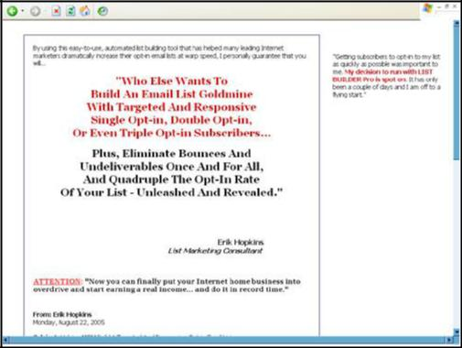

Finally, you can now build your mailing list exponentially in the shortest time possible with this list building program whereby you pay the list broker for every targeted subscriber they refer to your E-zine.

Would you rather pay a few cents per subscriber, or would you rather spend one year building your mailing list to achieve the same results? On top of

GoldenVisionTraining.com 52

How to Write Your Own Killer Sales Letter 53

that, your subscribers may NOT be targeted because you goofed up somewhere. Is that what you really want?

Example 2: 19 Internet Business Models You Can Copy

http://www.ebizmodelsyoucancopy.com/
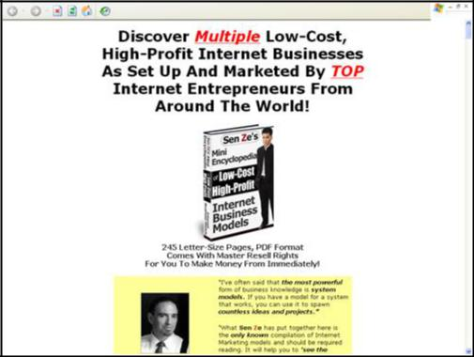

If you are clueless when it comes to starting your own Internet Business, this manual is for you.

For only $97, you can have access to 19 Internet Business blueprints and build your business according to whichever one that suits you best, or even mix and match. This manual is endorsed by Top Internet Marketing names so there is no doubt to its quality.

Would you rather pay $97 to get all the education you need to get started, or would you rather spend approximately 10 years of guessing in the dark, taking risks with your hard-earned money, and gamble your assets to pursue the uncertainty like the author of the manual once did when he started out just like you?

GoldenVisionTraining.com 53

How to Write Your Own Killer Sales Letter 54

Example 3: Secrets of Seduction

http://www.myseductionsecrets.com/
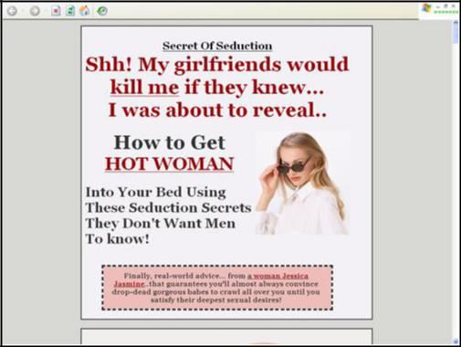

Suffering in your love life and relationships? Or you want to play Casanova very badly? Whatever it is, women are attractive creatures to you – if you are a man, that is.

If you are tired of having your dream girl stolen by another guy in front of your very own naked eyes, you can stop that now and turn the tables around. Instead, you can steal your dream girl and let your arch enemy squeeze his own heart in agony and contemplate suicide!

The good news is now you can be a chick magnet, and the truth is that women think there should be more of these Mr. Five Stars out there!

Think about all the beautiful women you can go out with - $49.99 is a very cheap price to pay, isn’t it? Or do you prefer to see another guy steal all beautiful women you want?

GoldenVisionTraining.com 54

How to Write Your Own Killer Sales Letter 55

Example 4: Create Your Own E-covers

http://www.virtual-cover-creator.net/
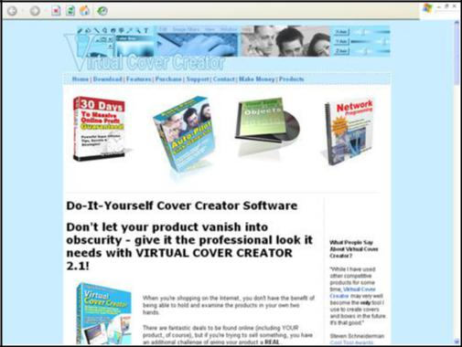

Finally… you can now easily and professionally create multiple E-covers for your own Internet Business and products you sell.

Would you rather make a one-off investment and create unlimited copies of your own E-covers with this user-friendly software? Or would you rather spend money on a DIY book to teach you how to use the Paint program, which can take a long time, depending on your understanding? Perhaps, you would rather pay a professional designer $99 per E-cover created?

*Warning! While these sales letters are here on display for your inspiration and ideas, do not copy the contents of the writers’ sales letters for your own, as their works are probably subjected to copyright.

GoldenVisionTraining.com 55

How to Write Your Own Killer Sales Letter 56

Tip: To protect your own works and discover if anyone else had copied your sales letter, use Copyscape.com to search for other similar results to your sales letter by entering your sales letter’s URL into the Search Box.

GoldenVisionTraining.com 56

How to Write Your Own Killer Sales Letter 57

In Closing

Test and Track

After writing your first sales letter using all the information in this manual, it is time to test and track your sales letter’s conversion rate.

The purpose of the last step is to determine your conversion rate of prospects into customers. This can be easily done if your web host provides a site statistic.

The Killer Sales Letter – The Final Product

A good conversion rate from a Killer Sales Letter is 2 – 4%.

In other words, for every 100 targeted prospects who visit your site, at least two of them will buy your product or pay access to your service. If the conversion rate is higher than 4%, then you are doing very, very well with your Internet Business!

On the other hand, if your sales letter’s conversion rate is less than 2%, then you will need to take quick action to make your site sell more effectively. You may have to change some words.

You may have to change the layout of your sales letter. You may have to get a better and more attention-grabbing headline. Whatever you need to do, you have to increase your conversion rate from poor to excellent!

Keep improving your sales letter until no improvements can be made.

And there is your final product – your very own killer sales letter!

GoldenVisionTraining.com 57

How to Write Your Own Killer Sales Letter 58

What Next?

If a copywriter can charge thousands of dollars to write such a professional copy for his clients, then the information within this manual is worth that – thousands of dollars.

I have given you all the information and copywriting wisdom you need to know in order to churn out your own professional sales copy that can convert at least 2-4% of your prospects into customers.

I hope that the many ideas, concepts and examples demonstrated in this manual will give you the inspiration to write your compelling sales letters as they have for me.

That said, I wish you all the best in writing your next killing letter and remember, take action and make it happen!

For more online marketing training on topics such as copywriting, email marketing, list building and web traffic and much more, become a member of Double Your Income Online Blueprint.

GoldenVisionTraining.com 58

