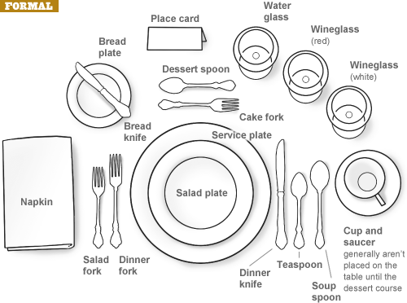

**Business Etiquette – Formal Place Setting**

* The napkin is put in the center of the place setting, or to the left of the forks if a plate is already on the table.
* The butter knife rests on the bread plate, which sits directly above the forks on the left.
* As for the other cutlery, a good rule of thumb is to begin using the utensils farthest from the plate and work your way in.
* The salad fork is placed to the far left, and the larger dinner fork goes next to the plate.
* Dessert spoons and forks are smaller in size than regular cutlery and are either placed directly above the plate – the spoon on top, with the handle of the spoon on the right and the fork handle on the left – or brought to the table when dessert is served.
* The salad plate is put directly on top of the dinner plate when salad is the first course, or set to the left of the forks.
* Knives go to the right, with the dinner knife on the inside and the salad knife to the right.
* A dinner spoon, useful for sauces, goes next to the salad knife, and when necessary, the soup spoon is placed to the far right.
* Finally, all glasses go above and to the right of the main plate, beginning with the water goblet at the far left, then the red-wine glass, which is larger than the white- wine glass.

With the number of forks, knives and spoons sometimes set out for a formal meal, it’s no wonder confusion arises. Here are some tips on table settings.