GAMMA COOL BOX

BILL OF MATERIAL
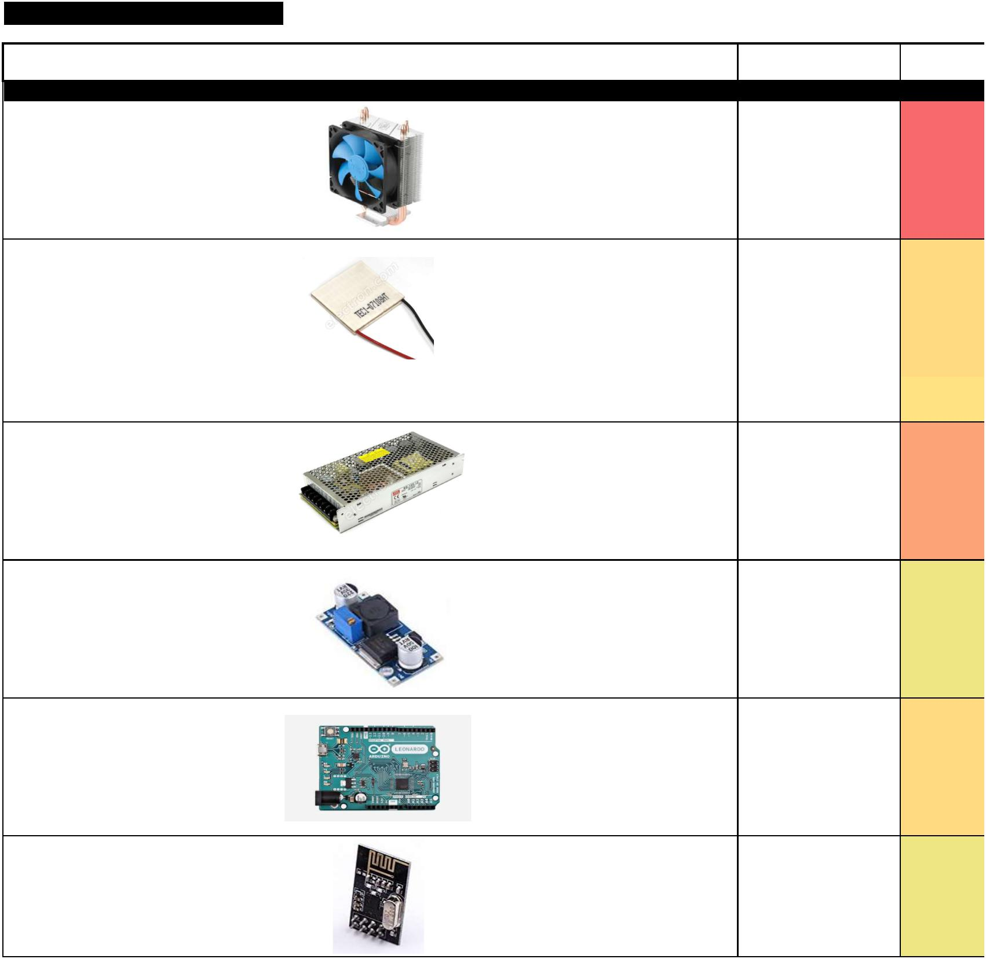

June 2018, by Mej

TOTAL |  | 236 €
 | Ref | Details | Unit cost | Quantity | Total cost
 |  |  | [€] |  | [€]
Modules |  | 124 €
Fan+Radiator | GAMMAX_200 | 12V, 200mA | 12.0 € | 5 | 60 €
 |  | 4pin connector
 |  | 95W
 |  | 30dB

Peltier | TEC1-07108HT | 30x30x3.5mm | 5.0 € | 2 | 10 €
 |  | 8.5V/8.5A

Peltier | TES1-3105 | 15x15x5mm | 3.0 | € | 2 | 6 | €
 |  | 3.5V/5A
Power supply | RS-150-12 | Input: 88-264V / 47-63Hz | 34.0 | € | 1 | 34 | €
 |  | Output: 12V / 12.5A (150W)
 |  | 199x98x38mm
 |  | ! Without cable !
DC/DC buck | LM2596 module | Step-down. 3A max | 2.0 | € | 1 | 2 | €
 |  | Manual potentiometer
 |  | IC alone cost 3-4€ per 10 on elec
 |  | suppliers…
MCU | Arduino Leonardo | ATmega32U4 | 10.0 | € | 1 | 10 | €
 |  | 5V/16MHz
 |  | Native USB core
 |  | 60kHz 8 bit PWM
RF | NRF24L01 module | RF module compatible MCU Arduino | 2.0 | € | 1 | 2 | €

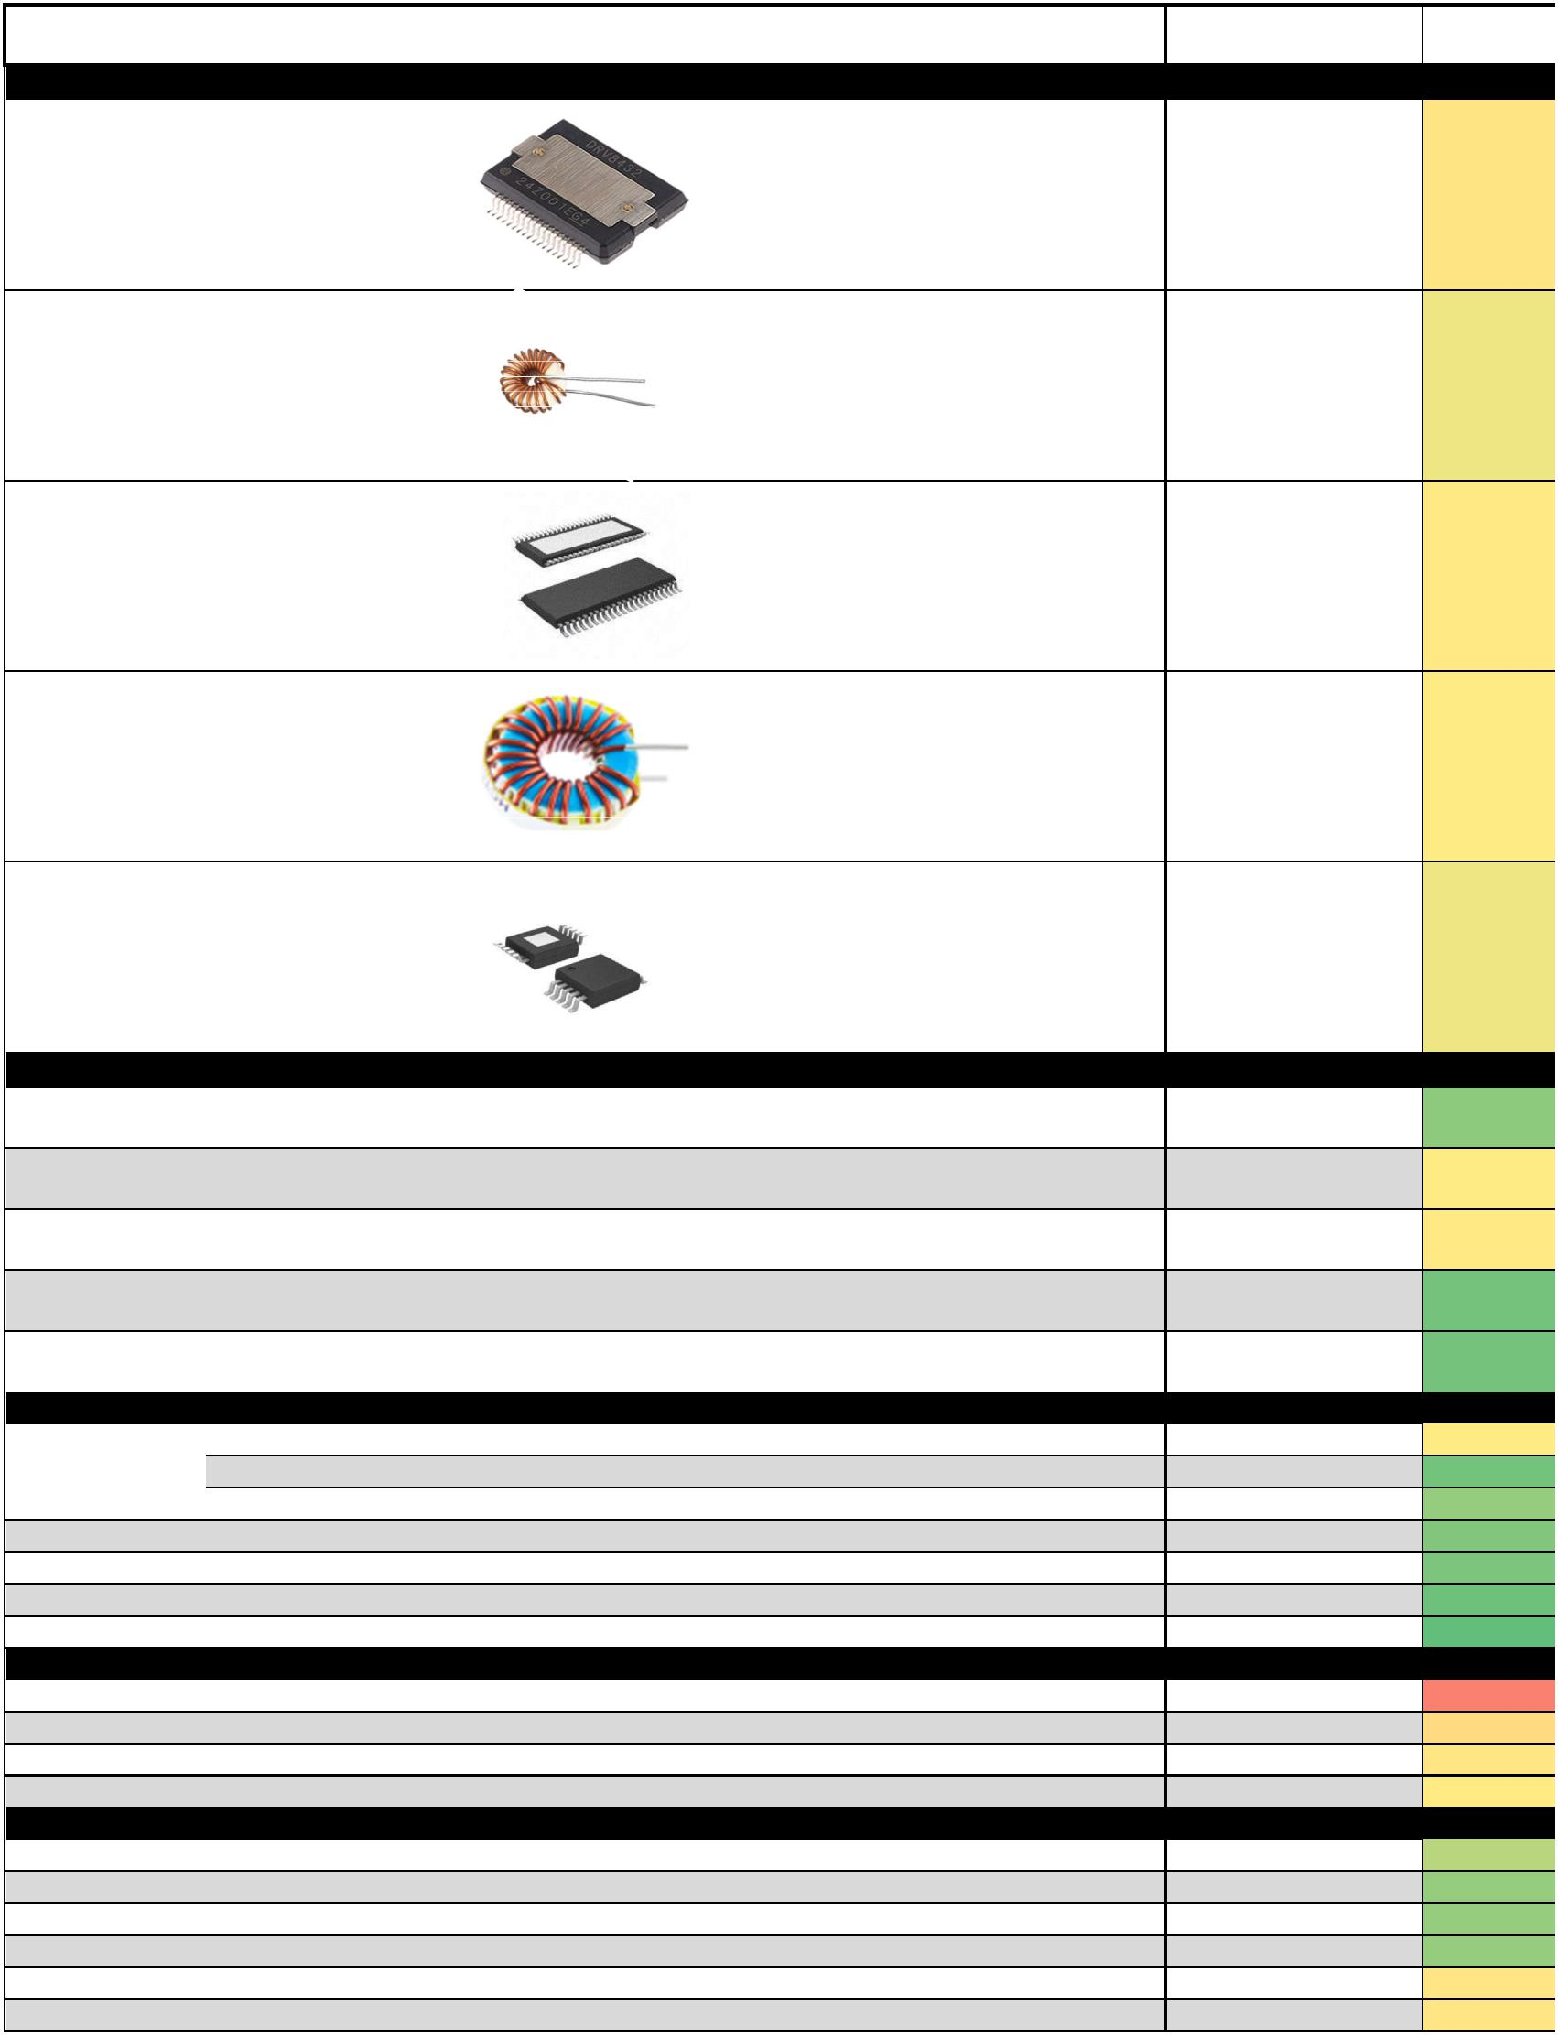 | Ref |  | Details | Unit cost |  | Quantity | Total cost
 |  |  |  | [€] |  |  | [€]
Drivers |  | 16 €
Dual Full-Bridge | DRV8432 |  | GND to Vcc output (Vcc = 12V) | 5.6 | € | 1 | 6 €
 |  |  | 7A/channel, 12A peak
 |  |  | PWM ctrl
 |  |  | Custom SSOP (14x16mm_Pitch0.65mm)
L | DENO-23-0001 |  | 2000uH - 16A max | 1.0 | € | 2 | 2 €
 |  |  | NOT shielded
 |  |  | TH, Ø23mm
Dual Full-Bridge | DRV8412 |  | GND to Vcc output (Vcc = 12V) | 3.5 | € | 1 | 4 €
 |  |  | 3A/channel, 6A peak
 |  |  | PWM ctrl
 |  |  | HTSSOP-44-EP (8x14mm_Pitch0.635mm)
L | HCTI-330-5.2 |  | 330uH - 5.2A max | 1.2 | € | 2 | 2 €
 |  |  | shielded
 |  |  | TH, Ø32mm
Single bridge | DRV8830 |  | 0.5V to 5V ouput (Vcc=6V) | 1.0 | € | 2 | 2 €
 |  |  | 1A max, 1.5A peak
 |  |  | I²C com
 |  |  | MSOP-10 (5x3mm_Pitch0.5mm)
Other ICs |  | 8 €
GPIO Expender | PCA9555 | SOIC-24 | 16 GPIO expender, I²C com | 0.9 | € | 1 | 1 €
 |  |  | 7.5x15.4mm_Pitch1.27mm
I²C Fan controler | MAX31790 | QFN-28-1EP | 6 channel "4 pin fan" controler | 2.4 | € | 1 | 2 €
 |  |  | 4x4mm_Pitch0.4mm
I²C Temp sensor | MCP9904T-A | VDFN-10 | 1 internal + 3 outside junction sensor | 0.7 | € | 5 | 4 €
 |  |  | 3x3mm_Pitch0.5mm
LDO 5V | MIC5219 | SOT23-5 | 3.3V/500mA, Vin=10V max | 0.6 | € | 1 | 1 €
LDO 3.3V | MIC5504 | SOT23-5 | 3.3V/300mA, Vin=5.5V max | 0.6 | € | 1 | 1 €
Passive electronic |  | 6 €
Connector | 2x4 SMD |  |  | 0.20 | € | 12 | 2 €
 | 1x4 SMD |  |  | 0.10 | € | 6 | 1 €
 | Bornier SMD |  | 9A | 0.50 | € | 2 | 1 €
Q |  |  | for thermal sensing | 0.05 | € | 15 | 1 €
LED |  | 1206 |  | 0.05 | € | 14 | 1 €
R |  | 1206, 0805 |  | 0.01 | € | 53 | 1 €
C |  | 1206, 0805, 0603 |  | 0.01 | € | 40 | 0 €
Raw stock |  | 68 €
Aluminium |  | 10mm |  |  |  |  | 50 €
Wood |  | 18mm |  |  |  |  | 10 €
Blue Foam |  | 80mm |  |  |  |  | 5 €
FR4 PCM |  | 1.6mm, 35µm Cu |  |  |  |  | 3 €
Miscellaneous |  | 14 €
Wires |  | 200mm, female, Pitch2.54mm |  | 0.05 | € | 28 | 1 €
USB Cable |  |  |  | 1 | € | 1 | 1 €
power cable |  |  |  | 1 | € | 1 | 1 €
Screws |  | M3, 22mm |  | 0.05 | € | 20 | 1 €
Thermal paste |  | 15cc syringe |  | 5 | € | 1 | 5 €
Soldering paste | Quickchip | 15cc syringe, 220°C |  | 5 | € | 1 | 5 €

