Tennessee Valley Authority

FY 20XX Budget Proposal & Management Agenda and FY 20XX Performance Report

For the Fiscal Year Ending

September 30, 20XX

Submitted to Congress

March 18, 20XX

TVA FY 2020 Budget Proposal & Management Agenda and FY 2018 Performance Report

Table of Contents

INTRODUCTION 2

BUDGET OVERVIEW 7

BUSINESS PLAN 10

MANAGEMENT INITIATIVES 15

OVERSIGHT AND GOVERNANCE 21

STRATEGIC IMPERATIVES, STRATEGIC OBJECTIVES,

AND PERFORMANCE GOALS 25

OTHER INFORMATION 41

APPENDIX A 42

APPENDIX B 45

Page 1

TVA FY 2020 Budget Proposal & Management Agenda and FY 2018 Performance Report

Introduction

TVA’s Mission

TVA was built for the people, created by Congress in 1933 and charged with a unique mission of service – to improve the quality of life in a seven-state region through the integrated management of the region’s resources. As it helped lift the Tennessee Valley out of the Great Depression, TVA built dams for flood control, provided low-cost power and navigation for commercial shipping, restored depleted lands, and raised the standard of living across the region. As times have changed, TVA has changed with them by updating and refining its work to accomplish its mission of providing affordable energy, economic development, environmental stewardship, integrated river system management, and technological innovation. While TVA's mission has remained constant since its inception, the environment in which TVA operates continues to evolve. The business and economic environment has become more challenging while the demand for power has decreased due to reduced customer usage and increased energy efficiency and demand response.

Strategic Imperatives

In order to continue its mission of service, TVA must continue to address four strategic imperatives: (1) rates:

maintain rates as low as feasible, (2) debt: live within its means, (3) assets: manage its assets to meet reliability expectations and provide a balanced portfolio, and (4) stewardship: be responsible stewards of the region’s natural resources. Through people performance excellence, TVA intends to continuously improve in these areas.
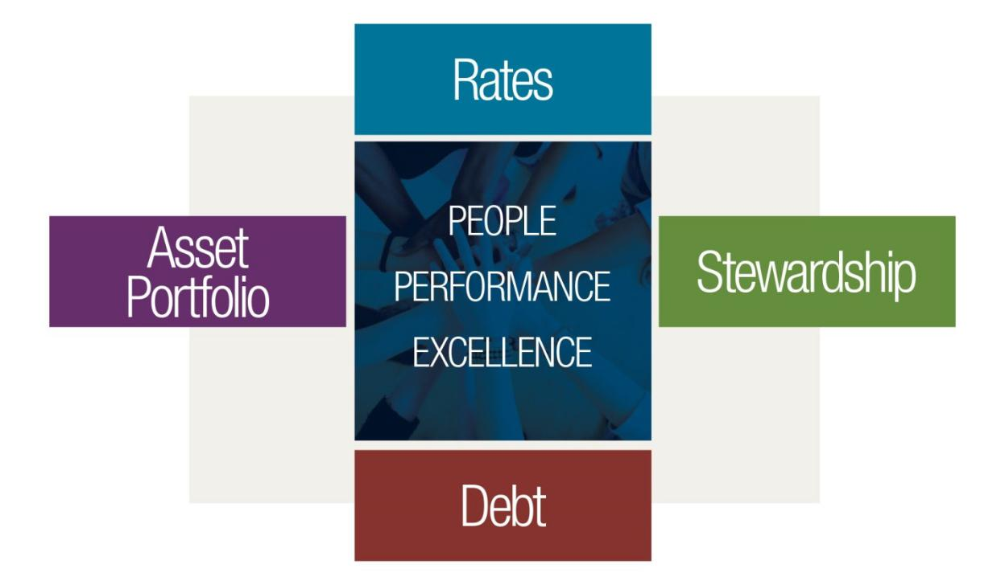

Rates

TVA is committed to providing energy at the lowest feasible cost, as specified in the Tennessee Valley Authority Act of 1933, as amended (the “TVA Act”). This customer focus requires scrutiny of all projects and use of resources so that the organization operates efficiently and responsibly.

Debt

TVA is committed to long-term debt management through a conservative approach to capital projects. While financing continues to be an important tool for funding TVA’s long-term power system investments, the organization is committed to managing its debt under the ceiling established by Congress.

Asset Portfolio

Balancing TVA’s assets with a diverse portfolio is vital to serving TVA’s customers reliably and at the lowest cost. In 2015, the TVA Board of Directors (“Board” or “TVA Board”) approved the Integrated Resource Plan ("IRP"), which provides strategic guidance on the resource mix to respond to changing market conditions while maintaining a

Page 2

TVA FY 2020 Budget Proposal & Management Agenda and FY 2018 Performance Report

reliable, low-cost supply of electricity for customers. The diverse portfolio identified in this study includes additional commitments to energy efficiency, renewables, nuclear generation, and natural gas-fired generation as part of the least-cost plan. While coal-based generation has declined relative to the 2015 levels in order to accommodate a least-cost plan, coal generation will remain an important part of TVA’s resource mix to satisfy the objective of maintaining a diversified portfolio. To meet the challenges of an evolving industry, an update to the 2015 IRP is currently underway.

Stewardship

TVA’s responsibility for stewardship of the waters and public lands of the Tennessee Valley was established in the TVA Act. These responsibilities include flood control, improved navigation of the Tennessee River, land and shoreline management, as well as agricultural and industrial development. TVA is committed to its role in these areas as activities are planned for dam safety and reservoir operation enhancements, stabilization of eroding shorelines, and the redevelopment of surplus properties.

Power Program

TVA operates the nation’s largest public power system and supplies power in most of Tennessee, northern Alabama, northeastern Mississippi, and southwestern Kentucky and in portions of northern Georgia, western North Carolina, and southwestern Virginia to a population of nearly 10 million people. In 1959, Congress passed an amendment to the TVA Act that required TVA’s power program to be self-financing from power revenues and proceeds from power program financings. While TVA’s power program did not directly receive appropriated funds after it became self-financing, TVA continued to receive appropriations for certain multipurpose and other nonpower mission-related activities as well as for its stewardship activities through 1999. TVA has not received any appropriations from Congress for any activities since that time, and now funds stewardship program activities primarily with power revenues, with the remainder funded with user fees and other forms of revenues derived in connection with those activities.

TVA received total power system appropriations of approximately $1.4 billion. The 1959 amendment to the TVA Act also required TVA, beginning in 1961, to make annual payments to the U.S. Treasury from net power proceeds as a repayment of and as a return on the Power Program Appropriation Investment. With the 2014 payment, TVA fulfilled its requirement under the 1959 amendment to repay $1.0 billion of the Power Program Appropriation Investment.
TVA has repaid $1.2 billion, including repayments made prior to 1959, along with interest of $2.6 billion, for total payments of $3.8 billion through September 30, 2018. The TVA Act requires TVA to continue making payments to the U.S. Treasury as a return on the remaining $258 million of the Power Program Appropriation Investment. The amount of the return on the Power Program Appropriation Investment is based on the Power Program Appropriation Investment balance at the beginning of each fiscal year and the computed average interest rate payable by the U.S. Treasury on its total marketable public obligations at the same date.

TVA now funds all its operations primarily from the sale of electricity and power system financings. TVA’s power system financings consist primarily of the sale of debt securities and secondarily of alternative forms of financing, such as lease arrangements.

TVA is primarily a wholesaler of energy. It sells electricity to local power company customers (“LPCs”) which then resell power to their customers at retail rates. TVA’s LPCs consist of (1) municipalities and other local government entities ("municipalities") and (2) customer-owned entities ("cooperatives"). These municipalities and cooperatives operate public power electric systems whose primary purpose is not to make a profit but to supply electricity to the general public or the cooperative's members. TVA also sells power directly to certain end-use customers, primarily large commercial and industrial loads and federal agencies, including military installations, with loads larger than 5,000 kilowatts ("kW"). In addition, power in excess of the needs of the TVA system may, where consistent with the provisions of the TVA Act, be sold under exchange power arrangements with certain electric systems. In fiscal year (“FY”) 2020, TVA expects sales of approximately 156 billion kilowatt-hours (“kWh”) of electricity.

Power generating facilities operated by TVA at September 30, 2018, included 29 conventional hydroelectric sites, one pumped-storage hydroelectric site, six coal-fired sites, three nuclear sites, 17 natural gas and/or oil-fired sites, and one diesel generator site. TVA’s renewable energy facilities include 14 solar energy sites, digester gas co-firing capacity at one coal-fired site, and biomass co-firing potential (located at coal-fired sites), although certain facilities were out of service as of September 30, 2018.

As of September 30, 2018, TVA’s coal-fired units accounted for 7,886 megawatts (“MW”) of net summer capability. The six coal-fired sites generated about 22 percent of the power from TVA-operated facilities, which excludes purchased power, during FY 2018. TVA’s system also includes 101 generators powered by natural gas and/or oil with

Page 3

TVA FY 2020 Budget Proposal & Management Agenda and FY 2018 Performance Report

a total net summer capability of 12,509 MW. These generators can be quickly started and are vital for meeting peak electricity demands. These generators provided 23 percent of the power from TVA-operated facilities in FY 2018. TVA’s nuclear units had a combined net summer capability of 7,723 MW at September 30, 2018, and generated 45 percent of the power from TVA-operated facilities in FY 2018. TVA-owned hydroelectric units had a combined net summer capability of 5,398 MW at September 30, 2018, and generated about 10 percent of the power from TVA-operated facilities in FY 2018.

Integrated Resource Plan

TVA’s mission sets the stage for its strategic planning process that includes strategic objectives, priorities, initiatives, and scorecards for performance designed to provide clear direction for improving TVA's core business. Additionally, TVA remains committed to planning its system in a way that ensures evolving resource portfolios remain reliable and provide the most value to all customers. TVA has begun the process of updating its IRP, a comprehensive study that provides direction on how to best meet future power demand by identifying the need for generating capacity, determining the best mix of resources, and evaluating the evolving role of distributed energy resources (“DER”). The IRP will consider many views of the future to determine how TVA can continue to provide low-cost, reliable electricity, support environmental stewardship, and spur economic development in the Tennessee Valley over the next 20 years. To inform TVA’s next long-term financial plan and proactively address the changing utility marketplace, TVA began this work sooner than originally planned.

To ensure TVA best meets projected future needs, TVA will continue its tradition of innovation in each IRP. The 2011 IRP focused on diversifying and modernizing its generation portfolio, part of which included adding cost-effective renewables. The 2015 IRP identified DER as a growing trend in the utility industry and designed a mechanism where energy efficiency could be chosen as a resource. The 2019 IRP will explore various DER scenarios, considering the speed and amount of DER penetration, improve TVA’s understanding of the impact and benefit of system flexibility with increasing renewable and distributed resources, and determine the implications to TVA’s diverse portfolio mix for the next 20 years.

TVA is primarily a wholesale power provider, and the LPCs are the service provider for most end-use consumers. Due to this public power business model, collaboration with customers and stakeholders is a vital part of the IRP process. Opportunities for customer and stakeholder engagement for public comment include public meetings, webinars, the IRP working group, and the Regional Energy Resource Council (“RERC”). The IRP working group and RERC consist of representatives from LPCs, direct-served customers, non-governmental organizations, state and local governments, and academia. As part of the IRP decision-making process, and in alignment with the National Environmental Policy Act (“NEPA”), TVA will also analyze potential environmental implications associated with an updated IRP by issuing an Environmental Impact Statement (“EIS”). TVA issued the draft IRP and EIS for public review and comment in February 2019 and anticipates submitting the final IRP, EIS, and recommended target power supply mix to the TVA Board in August 2019.

As discussed above, the IRP guides TVA in meeting its customers’ power needs while addressing the substantial challenges facing the electric utility industry. The target power supply mix provides flexibility to make sound choices as economic and regulatory changes occur. Resource recommendations in the IRP seek to balance cost, risk, system reliability, and environmental responsibility in providing energy for TVA’s customers.

Transmission System

TVA’s transmission system is a critical link in moving electricity throughout the eastern United States. In carrying out its responsibility for grid reliability in the TVA service area, TVA has operated with 99.999 percent reliability over the past 19 years in delivering electricity to customers. The TVA transmission system is one of the largest in North America. TVA’s transmission system has 69 interconnections with 13 neighboring electric systems and delivered over 160 billion kWh of electricity to TVA customers in FY 2018. TVA continues to invest in transmission assets to strengthen system reliability and incorporate new technology that provides a clearer picture of grid conditions over a wider area at any given time.

TVA’s transmission system interconnects with systems of surrounding utilities and consisted primarily of the following assets as of September 30, 2018:

Approximately 2,500 circuit miles of 500 kilovolt, 11,700 circuit miles of 161 kilovolt, and 2,000 circuit miles of other voltage transmission lines

508 transmission substations, power switchyards, and switching stations

1,321 customer connection points (customer, generation, and interconnection)

Page 4

TVA FY 2020 Budget Proposal & Management Agenda and FY 2018 Performance Report

The Administration proposes to sell the electricity transmission assets of TVA. The vast majority of the Nation's electricity infrastructure is owned and operated by for-profit investor owned utilities. The Administration believes that eliminating the Federal government's role in owning and operating transmission assets encourages a more efficient allocation of economic resources and mitigates unnecessary risk to taxpayers.

Natural Resource Stewardship

TVA’s natural resource stewardship work makes life in the Valley better, and it is a key part of TVA’s mission of service. TVA serves the people of the TVA region through the integrated management of the Tennessee River System and public lands, including approximately 11,000 miles of shoreline, 650,000 surface acres of reservoir water, and 293,000 acres of reservoir lands. In addition, TVA manages over 170 agreements with private entities for commercial recreation (such as commercial campgrounds and marinas), manages 130 agreements with public agencies for public recreation (such as public parks, day use areas, boat launches, and swimming areas), and is directly responsible for over 80 public recreation areas throughout the Tennessee Valley. TVA accomplishes its mission and supports the objectives of the TVA Environmental Policy through implementation of its natural resource stewardship strategy. Within this strategy, TVA confirms a desire to remain agile, balance competing demands, and be a catalyst for collaboration in order to protect and enhance biological, cultural, and water resources, as well as create and sustain destinations for recreation and opportunities for learning and research. TVA assists water-based community development with technical support, land agreements, and permitting, using planning, clear regulations, meaningful guidelines, and consistent enforcement. Additional guidance for carrying out many of TVA's essential stewardship responsibilities is provided in TVA's Natural Resource Plan (“NRP”). Building on the natural resources stewardship strategy and a comprehensive review of the 2011 NRP conducted in 2016, TVA is updating the NRP to improve its efficacy and continue to provide a sound framework for balancing land use, human activity and conservation to achieve the greatest public benefit from our natural resources. TVA has initiated an environmental review of the proposed changes, which include changes to the NRP’s structure and a more comprehensive approach to TVA’s work in natural resource stewardship. As proposed, the 2020 NRP will provide a flexible approach for long-term planning that will help TVA be better equipped to prioritize funding plans, create efficiencies in business planning and stewardship project implementation, and align with TVA’s mission.

Tennessee River System

Approximately 42,000 miles of rivers, streams, and tributaries, including the 652-mile-long Tennessee River, and 49 dams and 14 navigation locks constitute the Tennessee River System. It is a vital part of the nation’s inland waterway system, transporting more than 50 million tons of cargo annually. In addition to supporting commercial navigation, TVA’s integrated management of the river system supports recreation, public and industrial water supply needs, aquatic habitat protection, flood risk reduction, hydroelectric power production, and cooling water for TVA’s generation units. The watersheds of the Tennessee River and its 16 tributaries encompass more than 41,000 square miles across 125 counties in portions of seven states.

Economic Development

Since its creation in 1933, TVA has promoted the development of the Tennessee Valley region. Economic development is a core component of the mission of TVA, along with energy production and environmental stewardship. TVA works with LPCs, regional, state and local agencies, and communities to showcase the advantages available to businesses locating or expanding in TVA's service area. TVA's primary economic development goals are to recruit major business operations to the Tennessee Valley, encourage the location and expansion of companies that provide quality jobs, prepare communities in the Tennessee Valley for economic growth, and offer support to help grow and sustain small businesses. TVA seeks to meet these goals through a combination of initiatives and partnerships designed to provide program support, technical services, industry expertise, financial assistance, and site-selection assistance to new and existing businesses. TVA's economic development efforts helped recruit or expand over 211 companies into the TVA service area during FY 2018. These companies announced capital investments of over $11.3 billion and the expected creation and/or retention of over 65,000 jobs.

Technology Innovation

Consistent with the TVA Act, TVA makes investments in science and technological innovation to assist the agency in meeting future business and operational challenges in key areas and to establish national leadership in research, development, and demonstration. In addition to research that directly supports optimization of its generation and delivery assets, TVA also focuses on emerging technological advances, grid modernization, electrification, grid edge technologies, and distributed energy resources. TVA’s goal is to demonstrate how technologies can be used to improve/sustain reliability, reduce costs, lower emissions to the environment, and position TVA for a sustainable future.

TVA also seeks to leverage research and development activities and investments through partnerships with LPCs, the Electric Power Research Institute ("EPRI"), the Department of Energy, the Oak Ridge National Laboratory

Page 5

TVA FY 2020 Budget Proposal & Management Agenda and FY 2018 Performance Report

(“ORNL”) and other national labs, research consortiums, peer utilities, universities, and vendors and through participation in professional societies.

Commitment to the Future

TVA is a leader in public power, a model built on trust and partnerships with the people TVA serves. This model continues to deliver reliable electricity for nearly 10 million people and 700,000 businesses at the lowest feasible cost. It enables effective, integrated resource management and environmental stewardship in parts of seven southeastern states. TVA promotes alliances with others that help attract and retain jobs and investments that support economic development in the Tennessee Valley. TVA recognizes that the environment in which TVA does business continues to evolve. TVA is more flexible in its planning and more nimble in its execution and is also working to respond more quickly than ever to continually changing market conditions.

TVA continues to improve its operating and financial performance, including controlling O&M costs and adjusting capital spending based on market and regulatory conditions. One thing will not change – TVA’s commitment to providing safe, clean, reliable energy at rates as low as feasible. TVA is proud to honor this commitment.

Page 6

TVA FY 2020 Budget Proposal & Management Agenda and FY 2018 Performance Report

Budget Overview

Asset Portfolio

TVA, like the rest of the electric utility industry, is challenged to meet customer demand with cleaner, reliable energy resources while maintaining rates as low as feasible, per the TVA Act. This can require continuous review of capital investments in order to meet necessary operational needs. TVA funds asset investments through power revenues, the issuance of bonds up to a limit set by Congress, and alternative financings including lease financings.

TVA faces significant uncertainty from external factors such as weather, the economy, and decreased demand from energy efficiency and demand response initiatives. TVA’s financial information includes estimates, which are affected by these and other changing conditions. TVA projects total revenue to be $10.9 billion in FY 2020, which includes revenues related to fuel cost recovery and an adjustment to fund investments associated with TVA’s clean air program. The fuel cost recovery mechanism adjusts power rates monthly to reflect the changing costs of fuel, purchased power, and emission allowances.

In March 2013, TVA announced it would proceed with an emissions control project at Gallatin Fossil Plant (“Gallatin”). The project includes the installation of selective catalytic reduction systems (“SCRs”) and scrubbers at all four units of the 976 MW plant. The scrubbers were completed in the winter of 2016, and SCRs at all four units became operational by November 2017. On December 30, 2014, the TVA Board also approved adding additional pollution controls on Units 1 and 4 at the Shawnee Fossil Plant (“Shawnee”) site. Controls at both units officially became operational in December 2017.

In November 2013, the TVA Board approved the completion of a natural gas-fired facility at the Paradise Fossil Plant (“Paradise”) site. Construction of the natural gas-fired facility has been completed, and the facility began commercial operations in April of 2017. After completion of the natural gas-fired units, TVA retired Paradise coal-fired Units 1 and 2 effective April 15, 2017. Paradise Unit 3 continues to operate; however, the Board voted at its February 2019 meeting to retire Paradise Unit 3 by December 31, 2020, and to retire Bull Run Fossil Plant (“Bull Run”) by December 1, 2023, in order to maintain a low-cost and efficient generating fleet. At its August 21, 2014, meeting, the TVA Board approved the completion of a natural gas-fired facility at the Allen Fossil Plant ("Allen") site. Construction of the natural gas-fired facility has been completed, and the facility began commercial operations in April 2018. TVA retired the coal-fired units at Allen in March 2018.

TVA is also converting its wet ash and gypsum facilities to dry collection facilities. The estimated cost of its coal combustion residual (“CCR”) conversion program is $2.6 billion (excluding new requirements related to the Gallatin CCR lawsuits), and the current schedule for completion is by 2023, with the exception of the closure of the ponds at Gallatin. This program includes costs associated with pond closures, conversion of wet to dry handling, and landfill activities. TVA will continue to undertake CCR projects past 2023, including building new landfill sections under existing permits and closing existing sections once they reach capacity. As environmental studies are performed and closure methodologies are determined, detailed project schedules and estimates will be finalized.

TVA’s nuclear fleet is an important element in a diversified portfolio for the future. On October 22, 2015, the Nuclear Regulatory Commission (“NRC”) issued a forty-year operating license for Watts Bar Unit 2. Watts Bar Unit 2 officially became commercially operational on October 19, 2016, after completing the final phase of testing with a total completed cost within the $4.7 billion limit approved by the TVA Board. Also, as part of its efforts to maintain a well-balanced nuclear portfolio, TVA is currently implementing an extended power uprate project at all three units of the Browns Ferry Nuclear Plant. This project is expected to be completed by FY 2019 while providing approximately 465 MW of additional, clean, carbon free power to the TVA system.

In FY 2020, TVA estimates that it will invest about $1.9 billion in capital projects for the power system. These investments are subject to approval in the FY 2020 budgeting process.

Stewardship

In the 1998 Energy and Water Development Appropriations Act, Congress directed TVA to fund essential stewardship activities related to its management of the Tennessee River system and nonpower or stewardship properties with power revenues. Congress has not provided any appropriations to TVA to fund such activities since 1999. Consequently, during 2000, TVA began paying for essential stewardship activities primarily with power revenues, and the remainder is funded with user fees and other forms of revenues derived in connection with those activities. TVA has not received federal appropriations for stewardship since 1999, and none are requested for FY 2020.

Page 7

TVA FY 2020 Budget Proposal & Management Agenda and FY 2018 Performance Report

TVA Operating Budget
(Millions of dollars)
 |  | 2018 |  | 2019 |  | 2020
 | Actual |  | Estimate |  | Estimate
Revenue | $ | 11,233 | $ | 10,714 | $ | 10,856
Operating Expenses
Fuel & Purchased Power |  | (3,022) |  | (2,792) |  | (2,720)
Operating, Maintenance, & Other |  | (2,854) |  | (2,790) |  | (2,795)
Depreciation & Amortization |  | (2,527) |  | (1,728) |  | (1,778)
Tax Equivalents |  | (518) |  | (527) |  | (522)
Total Operating Expenses |  | (8,921) |  | (7,837) |  | (7,814)
Operating Income |  | 2,312 |  | 2,877 |  | 3,041
Other Income |  | 50 |  | (223) |  | (224)
Interest Expense, net |  | (1,243) |  | (1,291) |  | (1,275)
Net Income | $ | 1,119 | $ | 1,363 | $ | 1,542

Page 8

TVA FY 2020 Budget Proposal & Management Agenda and FY 2018 Performance Report

Capital Budget & Cash Flow

(Millions of dollars)

 | 2018 | 2019 |  |  | 2020
 | Actual | Estimate |  |  | Estimate
Cash flows from operating activities
Net income | $ 1,119 | $ 1,363 |  |  | $ 1,542
Items affecting operating activities* | 2,836 |  | 1,783 |  |  | 2,057

Net cash provided by operating activities | 3,955 |  | 3,146 |  | 3,600
Cash Used in Capital Budget
Capital Projects
Nuclear | (321) |  | (287) |  | (316)
Power Operations | (242) |  | (219) |  | (201)
River Operations | (74) |  | (122) |  | (130)
Transmission | (174) |  | (177) |  | (175)
Other Base Capital | (141) |  | (236) |  | (268)
Total Base Capital | (953) |  | (1,041) |  | (1,090)
Clean Air | (31) |  | (75) |  | (75)
Ash Remediation | (156) |  | (253) |  | (187)
Water Remediation | (12) |  | (45) |  | (33)
Total Environmental Costs | (200) |  | (373) |  | (295)
Paradise CC | (4) |  | - |  | -
Allen CC | (107) |  | (17) |  | (8)
Other Capacity Expansion | (430) |  | (476) |  | (480)
Total Capacity Expansion | (541) |  | (493) |  | (488)
Nuclear Fuel Capital | (457) |  | (432) |  | (408)
Other Investing Activities | (119) |  | (60) |  | (57)

Net cash used in investing activities | (2,269) |  |  | (2,399) |  | (2,338)
Borrowings (net of redemptions) | (1,512) |  |  | (595) |  | (1,129)
Other financing activities | (175) |  |  | (152) |  | (133)
Net cash provided by financing activities | (1,687) |  |  | (747) |  | (1,262)
Net change in cash and cash equivalents | (1) |  |  | - |  | -
Cash and cash equivalents at beginning of year | 300 |  |  | 300 |  | 300
Cash and cash equivalents at end of year | 299 |  |  | 300 |  | 300
Cash Payments to U.S. Treasury** | (5) |  |  | (6) |  | (6)
Increase/(Reduction) in Total Debt and Debt-Like Obligations | $ (1,741) |  | $ | (729) |  | $ (1,234)

*Kingston Ash Spill, Bellefonte and Ash ARO expenses are included in Operating Activities ** For federal reporting purposes Payments to U.S. Treasury are not considered

Note: Included budget estimates are subject to change by TVA management and the TVA Board.

Page 9

TVA FY 2020 Budget Proposal & Management Agenda and FY 2018 Performance Report

Business Plan

TVA is governed by the nine-member TVA Board of Directors, which is responsible for approving an annual budget. The information in this document is based on the FY 2019 annual budget, which was approved by the TVA Board in August 2018. The following were considered in preparing the budget.

Borrowing Limit

TVA works to fulfill its mission of supplying low cost and reliable energy, providing environmental stewardship, and stimulating economic development while effectively managing debt and living within its means. In achieving its mission while following sound financial principles, TVA generally uses financing to fund capital investments for new generation capacity and environmental controls.

TVA has the authority per the TVA Act to issue bonds, notes, and other evidence of indebtedness subject to a $30 billion limit, sometimes referred to as TVA’s statutory debt limit. TVA bonds are not backed by the full faith and credit of the federal government and do not count against the United States federal debt limit. Congress last raised TVA’s borrowing authority in 1979. As of September 30, 2018, TVA had $22.7 billion of bonds and notes outstanding. Bonds and notes are generally the lowest-cost form of financing available to TVA.

While the $30 billion limit on bonds and notes has not been raised since 1979, TVA’s business and operations have continued to grow along with the power needs of the Tennessee Valley. Since 1979, TVA has increased its total assets from $13 billion to $49 billion as of September 30, 2018. TVA’s balance of total financing obligations (“TFOs”), which includes statutory debt and other financing obligations, is projected to decrease by $729 million in FY 2019. This reduction, which follows an FY 2018 reduction of nearly $1.7 billion, is consistent with TVA’s plan and initiative to reduce debt levels to $21.8 billion by FY 2023. TVA will continue to effectively manage its debt in a responsible manner and remain below the statutory debt limit.

TVA Retirement System

Established in 1939, the TVA Retirement System (“TVARS”) is a separate legal entity from TVA. The TVARS Rules and Regulations are administered by a seven-member TVARS Board with three of the directors elected by and from the membership, three appointed by TVA, and a seventh who is a retiree selected by the other six. As of September 30, 2018, TVA's qualified pension plan had assets of $8.0 billion compared with liabilities of $11.7 billion. The plan has approximately 33,000 participants, of which approximately 24,000 are retirees or beneficiaries currently receiving benefits.

TVA is committed to meeting its obligations to current and future retirees, and as evidence of this commitment, has worked with the TVARS Board in recent years to implement several significant changes to ensure the long-term health of the retirement system. The first change closed the defined benefit plan to new employees who were hired on or after July 1, 2014. Employees hired on or after July 1, 2014 receive retirement benefits in a 401(k) plan only.

In 2016, additional amendments were approved by the TVARS Board and accepted by TVA that put a plan in place to close the gap between TVARS’ assets and obligations over a 20-year period. For approximately 7,700 employees, TVA increased non-elective and matching contributions to the 401(k) plan to offset reduced accruals in the defined benefit plan. As part of these amendments, TVA committed to annual contributions of at least $300 million to the defined benefit plan for the next 20 years or until the plan is fully funded, whichever occurs first. As further demonstration of TVA’s commitment to fully fund the qualified pension plan, TVA made an additional one-time pension contribution of $500 million in FY 2017.

All benefit payments to retirees continue to be met – approximately $714 million in FY 2018 – and TVA remains on track to eliminate the shortfall between assets and obligations by the end of FY 2036, barring any unknown or unforeseen events that could impact TVA’s ability to achieve this objective.

Coal-Fired Fleet Evaluation

TVA began constructing its coal-fired plants in the 1940s, and its coal-fired units were placed in service between 1951 and 1973. Coal-fired units are in either active or retired status. TVA considers a unit to be in an active state when the unit is generating, available for service, or temporarily unavailable due to equipment failures, inspections, or repairs. All other coal-fired units are considered retired. As of September 30, 2018, TVA had six coal-fired plants consisting of 26 active units. These active units accounted for 7,886 MW of summer net capability at September 30, 2018.

Page 10

TVA FY 2020 Budget Proposal & Management Agenda and FY 2018 Performance Report

Coal-fired plants have been subject to increasingly stringent regulatory requirements over the past few decades, including those under the Clean Air Act ("CAA"). Increasing regulatory costs combined with low natural gas prices and flat load projections have caused TVA to consider whether or not to make the required capital investments to continue operating these coal-fired facilities. In April 2011, TVA entered into two agreements (collectively, the "Environmental Agreements") to address a dispute under the CAA. The first agreement is a Federal Facilities Compliance Agreement with the Environmental Protection Agency ("EPA"). The second agreement is with Alabama, Kentucky, North Carolina, Tennessee, and three environmental advocacy groups: the Sierra Club, National Parks Conservation Association, and Our Children’s Earth Foundation. Under the Environmental Agreements, TVA agreed to retire 18 of its 59 coal-fired units by the end of 2017 and was generally absolved from any liability, subject to certain limitations and exceptions, under the New Source Review ("NSR") requirements of the CAA for maintenance, repair, and component replacement projects begun at TVA's coal-fired units prior to the execution of the agreements. TVA also agreed to retire, repower, or install air pollution controls on 16 of the remaining coal-fired units. As of September 30, 2018, TVA had completed the requirements in the Environmental Agreements related to retiring coal-fired units or installing controls on such units.

TVA is moving toward a more balanced generation plan with greater reliance on lower-cost and cleaner energy generation technologies. Since September 30, 2010, TVA has reduced its summer net capability of coal-fired units by 6,682 MW. TVA’s long-range plans will continue to consider the costs and benefits of significant environmental investments and other expenditures at its remaining coal-fired plants.

Coal Combustion Residuals Facilities

TVA has committed to a programmatic approach to the elimination of wet storage of CCRs within the TVA service area. Under this program (the “CCR Conversion Program”), TVA has committed to (1) convert all operational coal-fired plants to dry CCR storage, (2) close all wet storage facilities, and (3) meet all applicable state and federal regulations. To carry out its CCR Conversion Program, TVA is undertaking the following actions:

Dry generation and dewatering projects: Conversion of coal plant CCR wet processes to dry generation or dewatering is complete at Bull Run and Kingston Fossil Plant ("Kingston"). Construction is underway at Gallatin, Paradise, and Shawnee. Construction will begin at Cumberland Fossil Plant ("Cumberland") in FY 2019.

Landfills: Lined and permitted dry storage facilities have been constructed and are operational at Bull Run, Kingston, and Gallatin. Construction of new lined and permitted dry storage facilities are scheduled to begin at Cumberland, Paradise, and Shawnee in FY 2019. Construction of additional lined facilities may occur to support future business requirements.

Wet CCR impoundment closures: TVA is planning to close wet CCR impoundments in accordance with federal and state requirements when (1) coal-fired plants are converted to dry CCR processes and dry storage landfills become operational or (2) the related plant operations cease. Closure project schedules and costs are driven by the selected closure methodology (such as cap and close in place or closure by removal). TVA issued an EIS in June 2016 that addresses the closure of CCR impoundments at TVA's coal-fired plants. TVA issued its associated Record of Decision in July 2016. Although the EIS was designed to be programmatic in order to address the mode of impoundment closures, it specifically addressed closure methods at 10 impoundments. TVA subsequently decided to close those impoundments. The method of final closure for each of these facilities will depend on various factors, including the results of studies conducted pursuant to the NEPA and approval by appropriate state regulators. Additional NEPA studies will be conducted as other facilities are designated for closure.

Groundwater monitoring: Compliance with the EPA CCR rule as well as other requirements will require additional engineering and analysis as well as implementation of a comprehensive groundwater monitoring program. As further analyses are performed, including evaluation of monitoring results, there is the potential for additional costs for investigation and/or remediation. TVA expects to continue to evaluate and update these cost estimates.

On March 2, 2018, in accordance with the CCR rule issued by the EPA, TVA published the results of groundwater testing at TVA’s active CCR facilities. The initial results showed statistically significant increases in the levels of certain constituents at some facilities. The increases do not necessarily indicate a regulatory or permit violation; rather, they trigger further testing to determine if the increases are attributable only to the CCR facility and, if so, what steps need to be taken. TVA will work in compliance with the CCR rule and, as appropriate, with its regulators to carry out the required investigations. TVA’s permits remain in effect and operations have not been impacted.

Page 11

TVA FY 2020 Budget Proposal & Management Agenda and FY 2018 Performance Report

The CCR Conversion Program is currently scheduled to be completed by FY 2023 with the exception of the impoundments at Gallatin, although this schedule may change depending on the final closure method selected for each facility. The impoundments at Gallatin are pending additional studies to determine the final closure methodology and schedule. While plans are currently being formulated for the CCR closure methodology for Gallatin, TVA is involved in two lawsuits relating to alleged releases of waste materials from the CCR facilities at Gallatin.

On August 4, 2017, the court in one case ordered TVA to move all materials from the existing impoundments to a lined facility. Although a panel of the U.S. Court of Appeals for the Sixth Circuit later reversed this decision, the plaintiffs petitioned for a rehearing, which was subsequently denied. The costs of constructing a lined facility onsite and excavating and moving the ash is approximately $900 million. If TVA is required to use a facility offsite, then the costs could be approximately $2.0 billion, plus an amount of additional costs reflecting the expected impacts of inflation given the extended duration of an offsite relocation project. These amounts do not include costs or penalties associated with any order in the other case. These amounts cannot be estimated at this time, but could be material.

As of September 30, 2018, TVA had spent approximately $1.5 billion on its CCR Conversion Program. TVA expects to spend approximately an additional $1.1 billion on the CCR Conversion Program through FY 2023, excluding new requirements related to the Gallatin CCR facilities lawsuits. These estimates may change depending on the final closure method selected for each facility. Once the CCR Conversion Program is completed, TVA will continue to undertake certain CCR projects, including building new landfill sections under existing permits and closing existing sections once they reach capacity.

Variable Interest Entities

On August 9, 2013, TVA entered into a lease financing arrangement with Southaven Combined Cycle Generation LLC ("SCCG") for the lease by TVA of the Southaven Combined Cycle Facility ("Southaven CCF"). SCCG is a special single-purpose limited liability company formed in June 2013 to finance the Southaven CCF through a $360 million secured notes issuance and the issuance of $40 million of membership interests subject to mandatory redemption. The membership interests were purchased by Southaven Holdco LLC (“SHLLC”). SHLLC is a special single-purpose entity, also formed in June 2013, established to acquire and hold the membership interests of SCCG. A non-controlling interest in SHLLC is held by a third-party through nominal membership interests, to which none of the income, expenses, and cash flows of SHLLC are allocated. The membership interests held by SHLLC were purchased with proceeds from the issuance of $40 million of secured notes and are subject to mandatory redemption pursuant to scheduled amortizing, semi-annual payments due each August 15 and February 15, with a final payment due on August 15, 2033.

On January 17, 2012, TVA entered into a $1.0 billion construction management agreement and lease financing arrangement with John Sevier Combined Cycle Generation LLC ("JSCCG") for the completion and lease by TVA of the John Sevier Combined Cycle Facility ("John Sevier CCF"). JSCCG is a special single-purpose limited liability company formed in January 2012 to finance the John Sevier CCF through a $900 million secured notes issuance and the issuance of $100 million of membership interests subject to mandatory redemption. The membership interests were purchased by John Sevier Holdco LLC ("Holdco"). Holdco is a special single-purpose entity, also formed in January 2012, established to acquire and hold the membership interests in JSCCG. A non-controlling interest in Holdco is held by a third-party through nominal membership interests, to which none of the income, expenses, and cash flows of Holdco are allocated. The membership interests held by Holdco in JSCCG were purchased with proceeds from the issuance of $100 million of secured notes and are subject to mandatory redemption pursuant to scheduled amortizing, semi-annual payments due each January 15 and July 15, with a final payment due on January 15, 2042.

Wholesale Rate Structure Changes

Since the fall of 2013, TVA, LPCs, and directly served industries have worked collaboratively to develop changes to TVA’s rates that focus on TVA’s long-term pricing efforts. A comprehensive rate restructuring was implemented in October 2015 to improve pricing by better aligning rates with underlying cost drivers and to send improved pricing signals while maintaining competitive industrial rates and keeping residential rates affordable.

Consistent with the pricing goals and changes implemented through the 2015 rate restructuring, TVA staff recommended and the TVA Board approved the proposed 2018 rate change on May 10, 2018. This change will reduce wholesale energy rates for standard service customers while introducing a Grid Access Charge (“GAC”) at an offsetting rate to better recover fixed costs. The net impact to TVA, as a result of this change, is designed to be revenue neutral. The 2018 rate change better reflects the wholesale cost of energy and recognizes the value of the grid’s reliability and associated fixed costs. This modernized approach to pricing provides bill stability while maintaining reliability and fairness for all TVA customers. Concurrent with this process, an Environmental Assessment was completed on May 4, 2018, resulting in a finding of no significant impact.

Page 12

TVA FY 2020 Budget Proposal & Management Agenda and FY 2018 Performance Report

Recognizing the need for flexibility, all LPCs were presented with the option to implement the wholesale changes in October 2018 or defer the implementation of the GAC until October 2019. Seventy-nine LPCs implemented the GAC on October 1, 2018. TVA is working with the remaining LPCs to implement the GAC effective October 1, 2019.

Renewable Energy and Emerging Technologies

TVA's renewable energy portfolio includes both TVA-owned assets and renewable energy purchases. TVA owns 14 solar sites with a total net summer capability of approximately 1 MW. Certain coal-fired units have the capability for digester gas and biomass co-firing, which is accounted for as coal-fired generation summer net capability.

TVA tracks its renewable energy commitments and claims through the management of renewable energy certificates ("RECs"). The RECs, which each represent 1 MWh of renewable energy generation, are principally associated with wind, solar, biomass, and low-impact hydroelectric. TVA also acquires RECs from renewable purchased power.

Consumer desire for energy choice is, among other things, driving the expectation for flexible options in the electric industry. TVA and LPCs are working together to leverage the strengths of the Tennessee Valley public power model to provide distributed energy solutions that are economic, sustainable, and flexible. TVA will focus on the safety and reliability impacts of these resources as they are interconnected to the grid and will ensure that the pricing of electricity remains as low as feasible. Additional regulatory considerations and analysis may be required as the DER market, technologies, and programs evolve. TVA will work to develop pricing and regulatory structures with a deliberate and thoughtful analysis of each current and future program offering. This will require strong partnerships with LPCs to reinforce local control, provide customers choices, and provide end-use consumers the flexibility they desire. In May 2017, the TVA Board authorized up to $300 million to be spent over the next 10 years, subject to annual budget availability and necessary environmental reviews, to build an enhanced fiber network that will better connect its operational assets. Fiber is a vital part of TVA’s modern communication infrastructure. The new fiber optic lines will improve the reliability and resiliency of the generation and transmission system while enabling the system to better accommodate DER as they enter the market.

TVA has encouraged the development of solar, wind, biomass, and low-impact hydroelectric generation systems across the Tennessee Valley through various current and former offerings. As of September 30, 2018, the combined participation for all such renewable solutions is approximately 450 MW (DC) of installed operating capacity with nearly 134 MW (DC) of additional approved capacity. Additionally, TVA contracts for approximately 1,215 MW (AC) of operating wind capacity from outside the Tennessee Valley via power purchase agreements.

New energy management systems and energy storage technologies present opportunities for more sophisticated and integrated operation of the entire grid. The advent of electric vehicles and small-scale renewable generation has hastened the development of battery technologies that have the potential to mitigate the intermittent supply issues associated with many renewable generation options. Implementation of these technologies in conjunction with two-way communication to the site creates the potential for more efficient usage of other DER on the grid.

Onsite energy management technologies and the proliferation of companies interested in providing services to support and aggregate the impacts of such systems provide another DER opportunity. Such systems can afford the consumer benefits through reduced consumption, increased comfort, detailed energy use data, and savings from time-sensitive rate structures. TVA and LPCs must consider the integration of the impacts from changes in energy usage patterns resulting from the operation of such systems.

Demand response systems that take advantage of the increasing sophistication in communication to homes, businesses, and distribution system assets also afford the opportunity for more granular control of system demand.

Payments in Lieu of Taxes

TVA provided over $523 million in tax equivalent payments in FY 2018 to state and local governments where it sells electricity or has power properties. TVA pays tax equivalent payments annually to the eight states where it sells electricity or owns generating plants, transmission lines, substations or other power assets, and directly to 146 county governments where TVA owns power properties that were previously privately owned and operated and subject to ad valorem taxes.

The TVA Act requires TVA to return five percent of its gross proceeds from the sale of power during the previous fiscal year (excluding sales or deliveries to other federal agencies, off-system sales with other utilities, and power used by TVA, with a provision for minimum payments under certain circumstances) in the form of tax equivalent payments. The payments compensate state and local governments that cannot levy property or sales tax on TVA as a federal entity and make TVA one of the largest “taxpayers” in Tennessee and Alabama.

Page 13

TVA FY 2020 Budget Proposal & Management Agenda and FY 2018 Performance Report

State and local governments distribute the funds according to their own formulas and discretion to support a variety of initiatives, including schools, fire departments and other emergency response agencies, tourism and recreation, and human service organizations.

Since 1941, TVA has paid more than $13 billion in tax equivalent payments, with payments in the past 10 years totaling more than $5 billion.

Page 14

TVA FY 2020 Budget Proposal & Management Agenda and FY 2018 Performance Report

Management Initiatives

Rates/Debt

Financial Plan

Similar to balancing the competing demands of its integrated mission, TVA must also manage the financial tradeoff that exists between rates and debt. The TVA Board has adopted an approach designed to provide the lowest feasible rates while ensuring and maintaining TVA’s financial health. This approach, adopted in the FY 2014 planning cycle, serves as the baseline for the current financial plan and is designed to (1) maintain low rates and ensure rate competitiveness by comparison to regional peers and competitors, (2) reduce TVA’s debt interest expense to a sustainable level, and (3) manage spending and costs within the predetermined financial parameters in the plan.

In August 2013, the TVA Board adopted a strategic debt reduction goal to reduce TFOs to $21.8 billion by FY 2023. This goal included modest annual base rate actions of 1.5 percent of the retail rate, as long as rates remain competitive. The strategic debt goal was supported by TVA’s customers and the Office of Management and Budget (“OMB”). Through strong financial and operational performance achieved to date, TVA is well positioned to meet and potentially exceed the debt goal on a rate trajectory consistent with the Board-approved plan.

In support of its strategic debt and rate goals, TVA embarked upon an aggressive initiative in FY 2013 to align O&M spending with revenues by reducing its non-fuel O&M expenses by $500 million by FY 2015 compared with the FY 2013 budget. TVA exceeded this goal with an actual reduction of over $800 million. TVA remains committed to aligning O&M spending with revenues and targeting incremental O&M efficiencies over the near-term to offset inflation.

TVA annually refreshes its long-range financial plan that aligns short-term tactical plans with long-term strategic direction related to portfolio decisions, competitive rates, and financial health. Although planning assumptions may change over time, TVA remains committed to achieving its strategic debt and rate goals. For FY 2020, TVA projects ending TFOs of $22.3 billion, a decrease of over $1.2 billion for the year and a cumulative decrease of $5.2 billion from FY 2013 actuals.

For a discussion of factors that could prevent TVA from achieving its debt reduction goals, see Item 1A, Risk Factors in TVA’s Annual Report on Form 10-K for the fiscal year ended September 30, 2018.

Asset Portfolio

Efficient Energy Use

TVA is working with customers to provide products and services that best meet the needs of the Tennessee Valley through programs, pricing, and partnerships.

Programs – Offering customer-centric programs and services to help customers holistically manage their energy use.

Pricing – An economic and sustainable portfolio that optimizes the system for the Valley.

Partnerships – Positioning TVA and LPCs as trusted energy advisors and adapting to answer customer demands in a changing energy market.

The EnergyRight® Solutions (“ERS”) program continues to engage customers through services promoting the wise use of energy including residential, commercial, industrial, and power systems initiatives. Current ERS resources that are being implemented include the following:

Energy Efficiency – Offer services that make TVA’s customers more productive and comfortable, lower customer costs, and position LPCs and TVA as trusted energy providers. This reduces the need for future generation additions and reduces TVA’s carbon footprint, while serving our customers’ needs.

Smart Electric Technologies (Electrification) – Promote smart electric technologies to make TVA’s customers more productive and sustainable while generating efficient load and revenue for LPCs and

TVA. These technologies can also reduce TVA’s carbon footprint and overall rates.
Demand Response – Provide more than 1,600 MW of economical capacity while lowering rates for participating customers. This resource lowers TVA’s peak demand and offsets the need for additional generation.

In a world of flat to declining load, TVA continues to research and support products and services that benefit TVA’s customers in the wise use of energy, increase efficient load, and manage peaks, as each of these efforts are consistent with TVA’s mission of service and keeping rates as low as feasible.

Page 15

TVA FY 2020 Budget Proposal & Management Agenda and FY 2018 Performance Report

Cybersecurity

TVA has an established risk-based Cybersecurity Program designed to ensure alignment with applicable regulations, industry requirements, and best practices. The program includes multi-layer security standards, training, and metrics that assign clear accountability for all cybersecurity activities throughout TVA. Security controls have been integrated into business processes, enabling timely, coordinated, effective, and efficient execution of the program across TVA.

Cybersecurity management processes have been implemented agency-wide with the goal of being systematic, repeatable, and effective in achieving the strategic security goals of the program.

The budget of the Cybersecurity Program is allocated to responsible organizations to improve accountability and provide transparency. Budgeting and planning for the program’s components are integrated into the business planning process and are maintained in a three-year cybersecurity strategic plan. The plan will be modified to upgrade TVA’s capabilities as technology, threat vectors, and business requirements change.

Securing timely, accurate, and reliable information is critical to the success of the TVA mission and the role it plays as a National Critical Infrastructure Key Resource and Bulk Electric System provider. The Cybersecurity Program objectives are aligned with TVA’s business strategy and support the goals of the enterprise. TVA uses a full spectrum defense security model to predict, protect, detect, and respond to threats against its systems. TVA plans to invest approximately $60 million to $80 million in its Cybersecurity Program between FY 2019 and FY 2021 to ensure it meets its mission objectives.

People/Stewardship

TVA’s mission includes managing the Tennessee River, its tributaries, and federal lands along the shoreline to provide year-round navigation, flood damage reduction, affordable and reliable electricity, and, consistent with these primary purposes, recreational opportunities, adequate water supply, improved water quality, and natural resource protection. TVA’s integrated reservoir system is composed of 49 dams, and each may have ancillary structures to support or assist the main dam's function. The reservoir system provides approximately 800 miles of commercially navigable waterways and also provides significant flood reduction benefits throughout the Tennessee River system and further downstream on the lower Ohio and Mississippi Rivers. The reservoir system also provides water supply for residential and industrial customers, as well as cooling water for TVA’s coal-fired, combined cycle, and nuclear power plants.

TVA’s Environmental Policy provides objectives for an integrated approach related to providing cleaner, reliable, and low-cost energy, supporting sustainable economic growth, and engaging in proactive environmental stewardship in a balanced and ecologically sound manner. The Environmental Policy provides additional direction in several environmental stewardship areas, including water resource protection and improvements, sustainable land use, and natural resource management. TVA also manages approximately 11,000 miles of shoreline, 650,000 surface acres of reservoir water, and 293,000 acres of reservoir lands for cultural and natural resource protection, recreation, and other purposes.

Flood control is an important outcome of TVA’s mission of environmental stewardship. Over the years, TVA personnel have worked to avert millions of dollars of damage in the Tennessee Valley. TVA continues its work around flooding preparedness and dam safety initiatives, including remediation efforts at Boone Dam.

Navigation on the Tennessee River is made possible by a system of dams and locks and contributes to the regional economy. TVA owns 14 lock chambers at 10 dam sites on the Tennessee River and one tributary. The U.S. Army Corps of Engineers operates and maintains these locks for navigation. This provides an alternative mode of transportation for businesses in the region to ship their products. Barges can move bulk cargo on 652 miles of the Tennessee River, which ends where it flows into the Ohio River near Paducah, Kentucky. Secondary channels provide approximately 150 miles of additional commercially navigable waterways.

TVA's NRP, issued in August 2011, serves as a 20-year guide for TVA's essential stewardship efforts for managing biological resources (plants, animals, and aquatic species), cultural resources (archaeological sites, historical sites, and artifacts), recreation, water resources, reservoir land planning, and public engagement. The plan also guides TVA in achieving the objectives of its Environmental Policy for a more systematic and integrated approach to fulfilling its essential stewardship responsibilities. The NRP was developed with public input including participation from federal and state resource management agencies and the Regional Resource Stewardship Council (“RRSC”). Members of the RRSC, established in March 2000, represent public and private stakeholders affected by TVA’s management of the river system. They provide recommendations on TVA’s stewardship activities. In FY 2018, TVA initiated a multi-year effort to update the NRP. The public scoping period has been completed and staff have commenced environmental reviews to support and guide the supplement environmental impact statement. The NRP update work will continue through 2020 with future opportunities to allow for additional public input and comment.

Page 16

TVA FY 2020 Budget Proposal & Management Agenda and FY 2018 Performance Report

In managing the watershed, TVA balances water quality protection with other demands for water use. TVA has installed and is maintaining equipment at several dams to help provide the flows and oxygen levels needed for a healthy aquatic community in tailwaters (the areas immediately downstream from dams). As part of the NRP, TVA has implemented several programs to improve water resources including Tennessee Valley Clean Marinas, Nutrient Source-Watershed Identification and Improvement, Climate Change Sentinel Monitoring and Aquatic Ecological Management, and a Strategic Partnership Initiative. Under the Stream and Tailwater Monitoring Program in the NRP, TVA performs annual monitoring and analysis of streams and rivers within the Tennessee River Watershed. Upon request, TVA provides the monitoring data to other agencies, educational institutions, non-government organizations, and stakeholders.

Above normal runoff has persisted since February 2018 and has helped TVA meet its river system commitments, including managing minimum river flows for navigation, generating low-cost hydroelectric power, maintaining water quality, water supply, and recreation for the Tennessee Valley, and having cool water available to meet thermal compliance and enabling normal operation of TVA's nuclear and fossil-fueled plants. Moreover, this runoff has aided in oxygenating water to help fish species remain healthy. Rainfall and runoff in the Tennessee Valley in FY 2018 were 118 percent and 116 percent of normal, respectively, which resulted in conventional hydroelectric generation being 22 percent higher during FY 2018 as compared to FY 2017.

Air Quality in the Tennessee Valley

The CAA establishes a comprehensive program to protect and improve the nation’s air quality and control sources of air pollution. The major CAA programs that affect TVA’s power generation activities are described below.

Emissions from all TVA-owned and operated units (including small combustion turbine units of less than 25 MWs) have been reduced from historic peaks. Emissions of nitrogen oxide ("NOX") have been reduced by 94 percent below peak 1995 levels and emissions of sulfur dioxide ("SO2") have been reduced by 98 percent below CY 1977 levels through CY 2017. For CY 2017, TVA’s emission of carbon dioxide ("CO2") from its sources was 56 million tons, a 47 percent reduction from CY 2005 levels. This includes 3,049 tons from units rated at less than 25 MWs.

Mercury and Air Toxics Standards for Electric Utility Units. The U.S. Court of Appeals for the District of Columbia Circuit (“D.C. Circuit”) upheld the Mercury and Air Toxics Standards ("MATS") rule on April 15, 2014. In June 2015, however, the U.S. Supreme Court left the rule in place but remanded it back to the D.C. Circuit, finding that the EPA was required to consider cost before deciding whether the regulation of hazardous air pollutants emitted from steam electric utilities was appropriate and necessary. In response to the Supreme Court's remand, the EPA published the final Supplemental Finding That It is Appropriate and Necessary to Regulate Hazardous Air Pollutants from Coal- and Oil-Fired Electric Utility Steam Generating Units (the “Supplemental Finding”) in April 2016. Several groups filed petitions with the D.C. Circuit challenging the Supplemental Finding. On December 27, 2018, the EPA released a proposed rule to replace the Supplemental Finding with a new finding that it is not appropriate and necessary to regulate Hazardous Air Pollutants (“HAP”) emissions from steam electric utilities. However, the EPA also proposed that the new finding would not remove the source category from regulation under Section 112 of the CAA and would not rescind the MATS requirements. Additionally, the EPA proposed to find that further restrictions on HAP emissions are not warranted upon conducting a residual risk and technology review for this source category. Until a final rule is issued, specific impacts to TVA cannot be determined; however, as proposed, the rule would not change TVA’s MATS compliance requirements or strategy.

Proposed Affordable Clean Energy Rule. On December 28, 2017, the EPA published an advanced notice of proposed rulemaking (“ANPR”) to solicit information for a possible future rule: "State Guidelines for Greenhouse Gas Emissions from Existing Electric Utility Generating Units." This possible future rule would be a replacement rule for the Clean Power Plan ("CPP") should it be repealed or overturned. The ANPR solicited input on a broad range of issues. On August 21, 2018, the EPA proposed the Affordable Clean Energy ("ACE") rule to replace the CPP. The proposed rule sets guidelines requiring states to determine greenhouse gas ("GHG") emission standards for TVA's existing coal-fired units based on efficiency improvements that can be achieved at reasonable cost. TVA operates coal-fired units in Tennessee and Kentucky. Impacts to these units cannot be determined until the EPA finalizes the ACE rule, states submit to the EPA their State Implementation Plans (“SIPs”) implementing guidelines in the ACE rule, and the EPA approves these SIPs. The proposed rule allows states three years to submit their SIPs, and allows the EPA one year for approval.

New Source Performance Standards. On December 6, 2018, the EPA proposed revisions to the GHG emission standards for new, modified, and reconstructed electric utility generating units that were finalized by the EPA on October 23, 2015. For coal-fired units, the EPA proposes to revise the current new source standards by eliminating carbon capture and storage technology from what constitutes standards of performance that reflect the best system of emission reduction. The resulting limits are less stringent and can be met by modern coal-fired units (e.g.,

Page 17

TVA FY 2020 Budget Proposal & Management Agenda and FY 2018 Performance Report

supersaturated steam generators) in combination with best operating practices, but without carbon capture and sequestration. The EPA is not proposing to revise the standard for gas-fired units. If finalized as proposed, the revisions are not expected to significantly impact TVA since TVA does not currently plan to construct, modify, or reconstruct any coal-fired units.

New York Petition to Address Impacts from Upwind High Emitting Sources. On March 12, 2018, the State of New York filed a petition with the EPA under Section 126(b) of the CAA to address ozone impacts on New York from the NOx emissions from sources emitting at least 400 tons of NOx in CY 2017 from nine states including Kentucky. The New York petition requests that the EPA require daily NOx limits for utility units with SCRs such as Paradise Unit 3 and emission reductions from utility units without SCRs such as Shawnee Units 2, 3 and 5-9. Kentucky utility unit NOx emissions are already limited by the Cross-State Air Pollution Update Rule and are declining, and current EPA modeling projects no additional requirements to reduce Kentucky NOx emissions are necessary. Until the EPA responds to New York’s Section 126(b) petition, it is not possible to determine potential impacts on TVA’s Paradise and Shawnee units.

From FY 1970 to FY 2018, TVA spent approximately $6.7 billion on clean air controls to reduce emissions from its power plants, including $62 million, $206 million, and $259 million in FY 2018, FY 2017, and FY 2016, respectively. TVA estimates that compliance with existing and future CAA requirements (excluding GHG requirements) could lead to costs of $163 million from FY 2019 to FY 2023, which include existing controls on capital projects and air operations and maintenance projects.

Economic Development

TVA’s partnerships with its customers and communities have helped create quality jobs and attract significant capital investments from new and existing companies. TVA conducts these economic development efforts in partnership with private and public organizations, including local, regional, and state agencies. This serves the needs of TVA stakeholders through regional economic development, which contributes to a better quality of life for Tennessee Valley residents. TVA’s innovative programs and services combine to create effective tools for sustainable economic development. These programs and services include, but are not limited to, the following:

Recruiting Services - TVA works with LPCs and their customers and local, state, and regional economic development organizations to recruit companies through an integrated package of economic development resources.

Regional Development - TVA assigns a regional development specialist with economic development expertise to serve counties in a specific area to help create and sustain job growth.

Community Preparedness - TVA helps communities increase their competitiveness in attracting investment and creating jobs by delivering resources and training to local community leaders.

Rural Initiative Strategy - TVA helps rural communities develop and better market their sites and buildings to prospective companies. TVA also offers leadership development, planning, and project assistance.

Research - TVA provides economic and market research to help build the business case for the location and expansion of companies and prepare communities for future growth opportunities.

Business Development Support - An array of products and services is designed to meet the needs of prospective or existing industries. These include financial support and industry consulting services. This work provides vision to businesses for locating and being successful in the Tennessee Valley.

Technical Services - TVA offers general engineering design services to help industrial prospects make sound location decisions and to help communities market themselves for prospects and growth.

The results of some of TVA’s innovative economic development programs and offerings are described below.

For the thirteenth consecutive year, TVA made Site Selection magazine’s list of the top 10 utilities in North

America for economic development activity, one of only three utilities to earn this distinction.

TVA Economic Development recruits new companies and investments to the region in these targeted industry sectors: Transportation-Related Manufacturing, Consumer and Industrial Products, Aerospace and Defense, Advanced Manufacturing, and Power Intensive Industries.

TVA staff provides ongoing economic development assistance through technical services, economic research, proposal writing, training, and other services.

Financial support, offered by TVA and LPCs, continues to be successful in helping new and existing companies locate or expand and make a commitment to enhance economic development in the region.

Page 18

TVA FY 2020 Budget Proposal & Management Agenda and FY 2018 Performance Report

The Valley Sustainable Communities Program was launched in 2013. This community preparedness program assists communities in cataloging their sustainable assets and improving their competitiveness when companies are considering locating or expanding in the Valley. To date, 31 communities have completed this program to highlight and increase their sustainability efforts and differentiate their communities.

TVA's Rural Development strategy supports economic development efforts in rural and economically distressed areas.

TVA’s Economic Developments website, TVAsites.com, provides demographics, a searchable building and land database, and other key information about the benefits of the Tennessee Valley region.

FY 2018 announcements of jobs created and/or retained and capital investment include: Alabama: 10,200 jobs and $2 billion

Kentucky: 7,000 jobs and $1 billion

Middle Tennessee: 16,800 jobs and $3.3 billion

Mississippi: 6,200 jobs and $978 million

Northeast Tennessee and Virginia: 11,100 jobs and $1.8 billion

Southeast Tennessee, Georgia and North Carolina: 3,700 jobs and $1.1 million

West Tennessee: 10,000 jobs and $896 million

Technological Innovation

The TVA Act specifies that members of the TVA Board shall affirm support for the objectives and missions of TVA, including being a leader in technological innovation. A key element in achieving this vision is an annual investment in science and technology that enables TVA to be at the forefront of innovation in the utility industry and to help the agency meet future business and operational challenges. TVA’s goal is to demonstrate how technologies can be used to improve/sustain reliability, reduce costs, lower emissions to the environment, and position TVA for a sustainable future.

Each year TVA’s research portfolio and research strategic plan are updated based on a broad range of operational and industry drivers that help assess key technology gaps, performance issues, or other significant challenges that should be addressed through research and development. Core research activities directly support optimization of TVA’s generation and transmission assets, air and water quality, and distributed/clean energy integration. The current research strategy addresses focus areas that span most components of the power system, including sustainability, generating fleet evolution, grid modernization, cyber security, data analytics, and grid edge engagement. TVA's distributed/clean energy research effort seeks to understand the scope and impact of integrating DER, particularly solar photovoltaics (solar PV) and electric vehicles (EV), on operations and business economics and to develop strategies for adapting to the evolving electricity landscape in the Tennessee Valley.

Additional research focus is placed on grid modernization for distribution systems, electrification, grid edge technologies, and evolving DER applications. TVA's efforts are directed towards demonstrating and validating the performance, reliability, and consumer acceptance of new technologies as well as how LPCs and TVA should implement these technologies for the benefit of the people of the Tennessee Valley. TVA also coordinates activities with EPRI and industry stakeholders on transportation electrification to support operational fleet requirements and the needs of LPCs to provide guidance on matters of plug-in EV grid integration and readiness for transportation electrification technologies.

Technology evaluations are most often accomplished through studies and field scale demonstrations to document performance, needs, and requirements. TVA delivers or transfers results to the operating organizations and other stakeholders through reporting, technology transfer events, and educational outreach. TVA also serves as a technology advisor for LPCs and directly served customers. Investments in TVA’s research portfolio are highly leveraged through partnership and collaboration with LPCs, EPRI and other research consortiums, the Department of Energy, Oak Ridge National Laboratory and other national labs, federal agencies, peer utilities, universities, and industry vendors as well as through participation in professional societies.

Sustainability

Sustainability for TVA means ensuring its ability to provide the people of the Tennessee Valley with low-cost and reliable electricity, a healthy environment and a prosperous economy – without compromising the ability of future generations to do the same. The three Es – energy, environmental stewardship and economic development – continue to drive everything TVA does to sustain the Tennessee Valley Region. TVA’s mission to “serve the people to make life better,” is as relevant today as it was when President Roosevelt signed the TVA Act in 1933.

Since its inception, TVA has maintained a proud history of leadership in sustainability. In fact, sustainability is incorporated into the work performed at TVA to protect the miles of reservoir shoreline, to keep electricity rates as low

Page 19

TVA FY 2020 Budget Proposal & Management Agenda and FY 2018 Performance Report

as feasible, to reinforce TVA’s commitment to a safe employee workplace and public safety, to support TVA’s economic development efforts throughout the region, and to pursue continuous improvement in environmental performance. TVA also manages many environmental sustainability programs, including technology innovation, environmental stewardship and compliance, and a growing renewable energy portfolio.

Because the TVA mission includes serving the Tennessee Valley by providing affordable and reliable energy, environmental stewardship, and economic development, achieving sustainability goals directly supports this mission. TVA works to integrate these goals into existing and new innovative programs. These goals are an integral part of TVA’s business practices and are tracked along with other business objectives. The TVA Strategic Sustainability Performance Plan (“SSPP”) reports key aspects of TVA’s energy, environmental, economic, and social resources and responsibilities in the 21st century. TVA’s sustainability program issues and maintains the TVA SSPP, directs the TVA Sustainability Working Group, increases awareness and engages employees on sustainability, and initiates actions to reduce TVA’s internal environmental footprint through cross-organizational collaboration.

Page 20

TVA FY 2020 Budget Proposal & Management Agenda and FY 2018 Performance Report

Oversight and Governance

In December 2004, Congress passed legislation to make TVA’s governance structure more like that of other large corporations. The TVA Board changed from three full-time members to nine part-time members who are responsible for providing strategic direction, governance, and oversight. In addition, a full-time Chief Executive Officer (“CEO”) position was established to supervise day-to-day activities. The CEO is appointed by and reports directly to the TVA Board. The December 2004 legislation also amended the Securities Exchange Act of 1934 by adding Section 37. This section requires TVA, as a non-accelerated filer under Securities and Exchange Commission (“SEC”) rules, to file financial reports with the SEC. In December 2006, TVA filed its first Annual Report on Form 10-K with the SEC and now files Annual Reports on Form 10-K, Quarterly Reports on Form 10-Q, and Current Reports on Form 8-K with the SEC. As an SEC filer:

The management reporting requirements of Section 404(a) of the Sarbanes-Oxley Act became effective for TVA for FY 2008.

As a non-accelerated filer, the external auditor attestation requirements of Section 404(b) of the Sarbanes-Oxley Act are not applicable. However, TVA implemented the auditor attestation requirements of Section 404(b) in FY 2009 and continues to do so on a voluntary basis.

The Dodd-Frank Act deferred indefinitely the auditor attestation requirements of Section 404(b) for non-accelerated filers; however, management has chosen to continue to have external auditor attestations.

TVA Oversight

TVA is a government-owned corporation, and its mission of service is fundamentally different from that of publicly traded companies. TVA has oversight similar to other utilities, such as a board of directors, SEC requirements, credit rating agencies, and Sarbanes-Oxley requirements. In addition, TVA has oversight from Congress, the Government Accountability Office (“GAO”), OMB, the U.S. Treasury, and an independent inspector general.

Board of Directors

TVA is governed by the TVA Board. The TVA Board has nine part-time members, at least seven of whom must be legal residents of the TVA service area. The TVA Board members are appointed by the President of the United States with the advice and consent of the U.S. Senate. The TVA Board’s responsibilities include formulating broad goals, objectives, and policies for TVA, approving plans for their implementation, reviewing and approving annual budgets, setting and overseeing rates, and establishing a compensation plan for employees.

Audit Committee

The TVA Board established the Audit, Risk, and Regulation Committee. The committee is responsible for, among other things, recommending an external auditor to the TVA Board, overseeing the auditor’s work, and reviewing reports of the auditor and the TVA Inspector General.

Independent Auditor

An independent auditor audits TVA’s annual financial statements in accordance with standards of the Public Company Accounting Oversight Board and with Government Auditing Standards issued by the Comptroller General of the U.S. The auditor also provides an opinion as to whether those statements are presented in conformity with Generally Accepted Accounting Principles (“GAAP”).

Independent Inspector General

An independent Office of Inspector General (“OIG”) conducts ongoing audits of TVA’s operational and financial matters in accordance with Government Auditing Standards, which incorporate the American Institute of Certified Public Accountants Generally Accepted Auditing Standards. The OIG had 105 employees as of September 30, 2018, including more than 50 auditors. TVA’s Inspector General is appointed by the President of the United States and confirmed by the U.S. Senate. The OIG provides semi-annual reports to Congress on the results of its audit and investigative work.

As required by the Inspector General Reform Act of 2008 (Pub. L. No. 110-409), the TVA OIG made an aggregate budget request of $26 million for FY 2020, which includes amounts for OIG training and support of the Council of the Inspectors General on Integrity and Efficiency. TVA’s FY 2020 budget assumes OIG activities at the level requested. TVA received no additional comments from the OIG with respect to the budget proposal.

Page 21

TVA FY 2020 Budget Proposal & Management Agenda and FY 2018 Performance Report

$ million | 2013 | 2014 | 2015 | 2016 | 2017 | 2018 | 2019 | 2020
 | Actual | Actual | Actual | Actual | Actual | Actual | OIG Proposed | OIG Proposed
OIG Spend | $21 | $22 | $23 | $24 | $24 | $24 | $26 | $26

Congressional Oversight

Congress provides formal oversight of TVA through two committees, the U.S. House of Representatives Transportation and Infrastructure Committee and the U.S. Senate Environment and Public Works Committee. The audit arm of Congress, the GAO, also conducts audits of various TVA activities and programs, generally at the request of members of Congress.

Executive Branch

TVA routinely submits budget information to OMB, and TVA’s budget is included in the consolidated budget of the U.S. Government. TVA’s financial results also are included in the federal government’s financial statements, which are coordinated with the U.S. Treasury and are subject to audit by GAO.

The TVA Act

TVA’s congressional charter, the TVA Act of 1933, as amended, defines the range of TVA’s business activities. TVA is also subject to the Government Performance and Results Act, which requires that a strategic plan and an annual performance report be submitted to Congress.

Other Regulatory Oversight

In aspects of its operations, TVA is subject to regulations issued by other governmental agencies, including the EPA, state environmental agencies, the SEC, and the NRC. While TVA is generally not subject to regulations issued by the Federal Energy Regulatory Commission (“FERC”), this commission has some regulatory authority over TVA activities. Other organizations with major influence on TVA and others in the electric utility industry include the North American Electric Reliability Corporation and the industry-based Institute of Nuclear Power Operations.

Auditor Independence – Providing Assurance to Stakeholders

The TVA OIG conducts an annual audit of the work of TVA’s independent auditor to help ensure compliance with generally accepted Government Auditing Standards. Additionally, a peer review audit of the OIG is conducted every three years by another federal Inspector General’s office.

Accounting and Financial Reporting

On an annual basis, TVA submits a closing package, which is a set of special purpose financial statements and notes that represent TVA’s comparative, consolidated, department-level financial statements, to the U.S. Treasury to comply with the requirements of the U.S. Treasury Financial Manual. This provides financial information to the U.S. Treasury and the GAO to use in preparing the Financial Report of the U.S. Government. TVA’s independent auditor also provides an opinion on whether the closing package is prepared in accordance with accounting standards and other pronouncements issued by the Federal Accounting Standards Advisory Board. TVA’s financial transactions are subject to audit by the Comptroller General under various statutes.

TVA also submits financial information to the OMB, SEC, NRC, U.S. Treasury, Energy Information Administration, and others, in accordance with applicable regulatory and statutory requirements. As required by the TVA Act, TVA maintains its accounting records in accordance with the FERC’s Uniform System of Accounts for Public Utilities. In addition, TVA presents its financial statements and related disclosures in conformity with GAAP promulgated by the Financial Accounting Standards Board. These financial statements are annually audited by an independent financial auditor.

Consistent with the Improper Payments Information Act of 2002, as amended, TVA has determined that none of its programs or activities are susceptible to significant improper payments.

Monthly Reporting Process

Internal financial performance reporting is done on a monthly basis at all levels within the enterprise. The monthly financial performance reports contain analysis for the income statement, cash flow statement, and statement of capital expenditures. The reports also include a balance sheet analysis detailing significant changes during the reporting period. TVA also performs agency-wide financial forecasts on a monthly basis in order to anticipate and respond to events that may have a significant impact on financial performance during the year.

Page 22

TVA FY 2020 Budget Proposal & Management Agenda and FY 2018 Performance Report

Enterprise Risk Management

Enterprise Risk Management (“ERM”) is a strategic business function that provides TVA with a comprehensive risk perspective to more effectively identify and manage risks, capitalize on opportunities, and improve risk management behaviors. ERM is specifically responsible for risk governance structure, performing risk assessments and analysis, and facilitating enterprise risk discussions to evaluate risk profiles as an interrelated portfolio in order to support risk-informed decisions for achieving TVA’s strategic and operational objectives. The TVA Board has established an Enterprise Risk Council (“ERC”) to oversee TVA’s management of enterprise risks and establish an appropriate tone for a risk management culture throughout TVA, and the ERM organization, along with other designated subcommittees, carries out the ERC mission at the direction of the ERC and TVA’s Chief Risk Officer.

Fraud Disclosure

The Fraud Reduction and Data Analytics Act of 2015 was signed into law on June 30, 2016. The law is intended to improve federal agency financial and administrative controls and procedures to assess and mitigate fraud risks and to improve federal agencies’ development and use of data analytics for the purpose of identifying, preventing, and responding to fraud, including improper payments. TVA’s enterprise risk management and internal control programs consider the potential for fraud in developing appropriate processes and controls. TVA is in the process of adopting the GAO’s Fraud Risk Assessment Framework (the “GAO Framework”) to more formally document its basis for identifying potential financial fraud risks and schemes, ensuring that preventive and detective controls are present and working as intended.

TVA is implementing an incremental approach to adopt the GAO Framework. This approach allows TVA to implement its program over time while balancing program maturity and available resources. During FY 2017, TVA established a commitment to combating fraud by adopting an executive policy regarding fraud risk management, designating a specific business unit to lead fraud risk management activities, and establishing a cross-functional working group to lead implementation of the GAO Framework.

During FY 2018, TVA conducted fraud risk assessments and documented its fraud risk profile. Among other areas, TVA assessed fraud risk related to payroll, beneficiary payments, grants, large contracts, purchase and travel cards, physical asset misappropriation, and information technology and security. Based on the resulting fraud risk profile, TVA began designing and implementing a strategy to ensure assessed fraud risks are appropriately mitigated. As part of its strategy, TVA has considered the need for additional financial and administrative controls and the collection and analysis of fraud-related data. In developing its strategy, TVA considered both the fraud risk principle in Standards for Internal Control in the Federal Government and Office of Management and Budget Circular A–123 with respect to the leading practices for managing fraud risk.

During FY 2018, TVA also designed and developed a strategy to collect and analyze fraud risk data and outcomes in order to adapt its activities to improve fraud risk management. TVA will use this information to continue to mature its fraud risk management program and improve fraud controls.

Pending GAO and OIG Recommendations

Periodically, the GAO and OIG may offer recommendations to TVA as part of their standard review process of the organization. TVA actively works with GAO and OIG to review any potential recommendations in order to better serve the Valley.

The table on the following page lists recommendations that have been outstanding for at least one year as of the date of this report.

Page 23

TVA FY 2020 Budget Proposal & Management Agenda and FY 2018 Performance Report

Report |  |  | Report | Recommendation | Estimated
 | Source | Report Title |  |  | Date of
Number |  |  | Date | Status
 |  |  |  |  | Completion
 |  | Investment Management: Key
 |  | Practices Could Provide More |  | Accepted /
GAO-17-726 | GAO | Options for Federal Entities and | 9/13/2017 |  | Ongoing
 |  |  |  | Implementing
 |  | Opportunities for Minority- and
 |  | Women-Owned Asset Managers
 |  | Tennessee Valley Authority:
 |  | Actions Needed to Better |  | Accepted /
GAO-17-343 | GAO | Communicate Debt Reduction | 3/23/2017 |  | Ongoing
 |  |  |  | Implementing
 |  | Plans and Address Billions in
 |  | Unfunded Pension Liabilities
2013-14959 | OIG | TVA Environmental Risk | 8/7/2014 | Accepted / | 4/30/2020
 |  | Management |  | Implementing
2014-15216 | OIG | Follow-up Review of Coal Plant | 9/29/2014 | Accepted / | 8/13/2019
 |  | Fire Protection Systems |  | Implementing
2016-15386 | OIG | Organizational Effectiveness - | 7/27/2017 | Accepted / | 3/30/2019
 |  | Supply Chain (Materials Mgmt) |  | Implementing
2016-15445 | OIG | Organizational Effectiveness - | 12/21/2017 | Accepted / | 5/31/2019
 |  | Chief Human Resources Office |  | Implementing
2016-15445-01 | OIG | Organizational Effectiveness - | 5/18/2017 | Accepted / | 3/31/2019
 |  | Human Resources: Bus Office |  | Implementing
2016-15445-05 | OIG | Organizational Effectiveness - | 9/26/2017 | Accepted / | 9/28/2019
 |  | Human Resources: HR |  | Implementing

For additional information regarding the recommendations listed above, and TVA’s actions taken to date, please see Appendix A.

Page 24

TVA FY 2020 Budget Proposal & Management Agenda and FY 2018 Performance Report

Strategic Imperatives, Strategic Objectives, and Performance Goals

Strategic Imperatives

As discussed previously, TVA has established four strategic imperatives: (1) rates: maintain rates as low as feasible,

- debt: live within its means, (3) assets: manage its assets to meet reliability expectations and provide a balanced portfolio, and (4) stewardship: be responsible stewards of the region’s natural resources. Through people performance excellence, TVA intends to bring these goals to life and become safer, better, faster, and leaner.
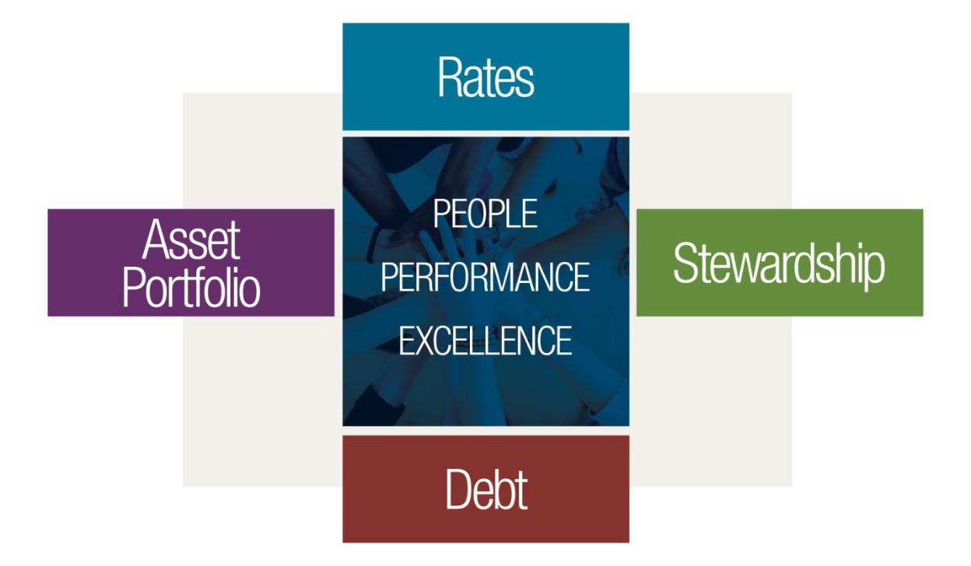

Strategic Objectives

In order to help ensure that TVA accomplishes its strategic goals, TVA is focusing on the following strategic objectives:

Maintain low rates and align O&M spending with revenues Effectively manage debt to ensure long-term financial health Work safely and effectively

Focus on values, competencies and behaviors Pursue operational excellence

Balance the portfolio to provide cleaner, efficient, and affordable energy

Stimulate economic development and investment in the Tennessee Valley

Protect and improve the environment, natural resources, and the use and enjoyment of public lands

Page 25

TVA FY 2020 Budget Proposal & Management Agenda and FY 2018 Performance Report

Performance Goals

To help measure how effectively TVA is achieving its strategic objectives, TVA has several performance goals. These performance goals include the following:

Rates/Debt

  - Retail Rates
  - Wholesale Rate, excluding Fuel
  - Operating Cash Flow
  - Net Income

  - Total Financing Obligations Asset Portfolio
  - Load Not Served
  - Coal Seasonal Equivalent Forced Outage Rate (“EFOR”)
  - Nuclear Performance Index
  - Combined Cycle Seasonal EFOR

  - Nuclear Unit Capability Factor People/Stewardship
  - Recordable Incident Rate
  - CO2 Emissions Rate
  - Reportable Environmental Events
  - Jobs Created and Retained

Each of these performance goals is described in more detail on the following pages.

Page 26

TVA FY 2020 Budget Proposal & Management Agenda and FY 2018 Performance Report

Rates/Debt

Retail Rates (cents/kWh) - 12 Month
Rolling Avg

Better

10.0
9.5 |  |  |  | 9.17 | 9.16 |  | 9.16
9.06 |  |  | 9.06 |  |  | 9.02
 |  |  |  | 8.94
9.0
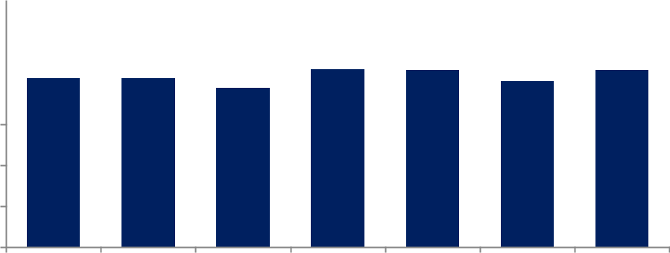

8.5

8.0

7.5

7.0

FY14 FY15 FY16 FY17 FY18 FY19 FY20
Actual Actual Actual Actual Actual Target Target

- Actual Results Exclude USEC and Off-System Revenue

Definition Average of the previous twelve months’ LPC reported retail power revenue and directly served power revenue divided by LPC reported retail power sales and directly served power sales.

Calculation (LPC reported retail power revenue + Directly served power revenue) / (LPC reported retail power sales + Directly served power sales)

Page 27

TVA FY 2020 Budget Proposal & Management Agenda and FY 2018 Performance Report

Wholesale Rate excluding Fuel
(cents/kWh)

Better

5.4
5.2 |  |  |  |  |  |  |  |  |  |  |  |  |  |  | 5.07
 |  |  |  |  |  |  |  |  |  |  |  |  |  |  |  |  |  |  |  |  |  |  | 5.22
5.0 |  |  |  |  |  |  |  |  |  |  |  |  | 4.92
 |  |  |  |  |  |  |  |  |  |  |  |  |  |  |  |  |  |  | 5.09
 |  |  |  |  | 4.78 |  |  |  | 4.80
4.8 |  | 4.64
4.6
4.4
4.2
4.0
 |  | FY14 |  | FY15 |  |  |  |  | FY16 |  |  |  | FY17 |  |  | FY18 |  |  | FY19 |  |  |  | FY20
 |  | Actual |  | Actual |  |  |  | Actual |  |  |  | Actual |  |  |  | Actual |  | Target |  |  |  | Target
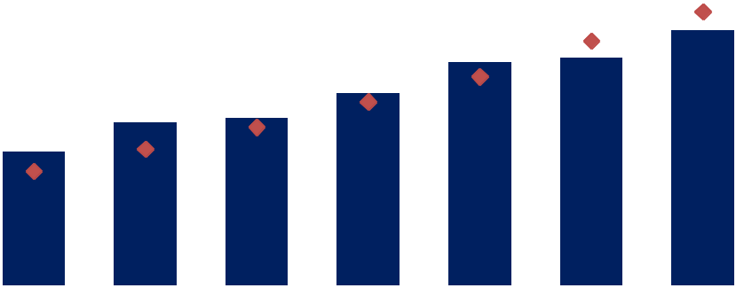

- Actual Results Exclude USEC and Off-System Revenue
Indicates results projected (cents/kWh) within the FY14 Long-Range Financial Plan

Definition The Wholesale Rate excluding Fuel measure represents TVA’s electric sales revenue excluding fuel divided by electric power sales.

Calculation TVA’s electric sales revenue excluding fuel / TVA’s electric power sales

Page 28

TVA FY 2020 Budget Proposal & Management Agenda and FY 2018 Performance Report

Operating Cash Flow ($ Million)

Better

4,500 |  |  |  |  |  |  |  |  |  |  |  |  |  |  |  |  | $3,955
4,000
 |  |  |  |  |  |  |  |  |  |  |  |  |  |  |  |  |  |  |  |  |  |  |  |  | $3,600
3,500 |  |  |  |  |  |  | $3,315
 |  |  |  |  |  |  |  |  |  |  |  |  |  |  |  |  |  |  |  |  | $3,146
 |  |  |  |  |  |  |  |  |  |  | $3,042
 |  |  | $2,980
3,000 |  |  |  |  |  |  |  |  |  |  |  |  |  |  | $2,736
2,500
2,000
1,500
1,000
500
0
 |  |  | FY14 |  |  |  | FY15 |  |  |  | FY16 |  |  |  | FY17 |  |  | FY18 |  |  | FY19 |  |  |  | FY20
 |  |  | Actual |  |  |  | Actual |  |  |  | Actual |  |  |  | Actual |  |  | Actual |  |  | Target |  |  |  | Target

Definition Operating Cash Flow refers to the amount of cash generated from power production and other mission-related activities and is generally defined as Operating Revenues received less cash payments made for Operating Expenses. This amount can be found on the Consolidated Statement of Cash Flows under Cash Flows from Operating Activities.

Calculation Net income + Non-cash expenses + Impact of changes in working capital and other deferred operating items

Page 29

TVA FY 2020 Budget Proposal & Management Agenda and FY 2018 Performance Report

Net Income ($ Million)

Better

1,800 |  |  |  |  |  |  |  |  |  |  |  |  | $1,542
1,600
 |  |  |  |  |  |  |  |  |  |  | $1,363
1,400 |  |  |  |  | $1,233
 |  |  | $1,111 |  |  |  | $1,185 |  | $1,119
1,200
1,000
800
600 |  | $469
400
200
0
 |  | FY14 |  | FY15 |  | FY16 |  | FY17 |  | FY18 |  | FY19 |  | FY20
 |  | Actual |  | Actual |  | Actual |  | Actual |  | Actual |  | Target |  | Target

- FY17 Actual Results Exclude $500M Incremental Pension Contribution

Definition Net Income is an entity's net earnings derived by adjusting revenues for the cost of doing business, including cost of sales, depreciation, interest, taxes, and other expenses. This amount is shown on the bottom line of the Consolidated Statement of Operations.

Calculation Operating Revenues - Operating Expenses + Other Income/(Expense) - Net Interest Expense

Page 30

TVA FY 2020 Budget Proposal & Management Agenda and FY 2018 Performance Report

Total Financing Obligations ($ Billion)

Better

30.0
28.0
26.1 | 26.1 | 26.2 | 26.0
26.0
 |  |  | $24.3
24.0 |  |  | $23.6
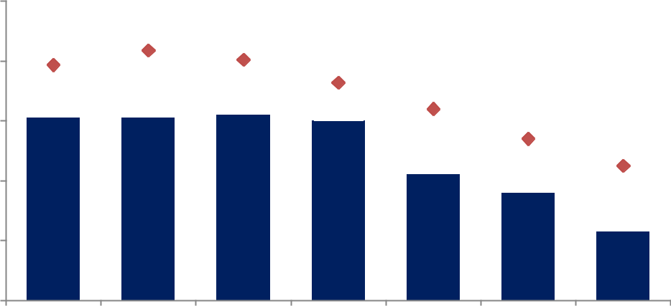

$22.3

22.0

20.0

FY14 FY15 FY16 FY17 FY18 FY19 FY20
Actual Actual Actual Actual Actual Target Target

Indicates results projected ($B) within the FY14 Long-Range Financial Plan

Definition Total Financing Obligations (“TFOs”) include all statutory debt and other financing obligations, as shown on TVA's balance sheet.

Calculation Long-term Power Bonds + Short-Term Debt + Leaseback Obligations + Energy Prepayment Obligations + Debt of Variable Interest Entities (“VIE”) + Membership Interests of VIE Subject to Mandatory Redemption + Notes Payable

- See Appendix B for a calculation of TFOs utilizing financial statement line items reported in accordance with Generally Accepted Accounting Principles.

Page 31

TVA FY 2020 Budget Proposal & Management Agenda and FY 2018 Performance Report

Asset Portfolio

Better

Load Not Served (System Minutes)

6.0 |  |  |  |  |  | 4.8
5.0
 |  |  |  |  |  |  | 4.3
 |  |  | 4.0
 |  |  |  |  |  |  |  |  |  |  | 4.0 |  | 4.0
4.0 |  |  |  |  | 3.8
 |  |  |  |  |  |  |  |  | 3.3
3.0
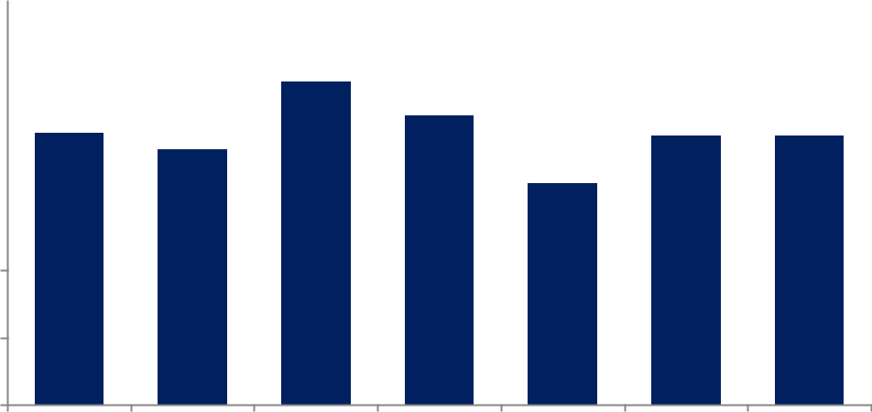

2.0

1.0

0.0

FY14 FY15 FY16 FY17 FY18 FY19 FY20
Actual Actual Actual Actual Actual Target Target

Definition Load Not Served measures the magnitude and duration of transmission system outages that affect TVA customers. This measure is expressed in system minutes and excludes events during declared major storms.

Calculation Percent of total load not served x Number of minutes in period

Page 32

TVA FY 2020 Budget Proposal & Management Agenda and FY 2018 Performance Report

Better

Coal Seasonal EFOR

16.0% |  |  |  |  |  |  |  |  |  |  |  |  | 14.5%
14.0%
 |  |  |  |  |  |  |  |  |  |  |  |  |  |  |  |  | 12.5%
12.0%
10.0% |  |  |  |  |  |  |  |  |  |  |  |  |  |  |  |  |  |  |  |  |  |  |  |  | 9.7%
 |  |  |  |  |  |  |  |  |  |  |  |  |  |  |  |  |  |  |  |  | 8.6%
8.0%
 |  |  | 5.4%
6.0% |  |  |  |  |  |  |  |  |  |  | 5.3%
 |  |  |  |  |  |  | 4.8%
4.0%
2.0%
0.0%
 |  |  | FY14 |  |  |  | FY15 |  |  |  | FY16 |  |  | FY17 |  |  | FY18 |  |  |  | FY19 |  |  |  | FY20
 |  |  | Actual |  |  |  | Actual |  |  |  | Actual |  |  | Actual |  |  | Actual |  |  | Target |  |  |  | Target

Definition Coal Seasonal EFOR measures the generation lost due to forced events as a percentage of time the unit would have been scheduled to run. This measure runs from December through March and June through September and includes the Allen, Cumberland, Gallatin, Kingston, Paradise, and Shawnee coal plants. This measure excludes events that are classified as “Outside Management Control.”

Calculation ((FOH X WNDC) + Forced MWhL) / ((FOH + SH) X WNDC) X 100

FOH = Forced Outage Hours

SH = Service Hours

WNDC = Winter Net Dependable Capacity

Forced MWhL = MWh Losses Due to Forced Derating

Page 33

TVA FY 2020 Budget Proposal & Management Agenda and FY 2018 Performance Report

Better

Nuclear Performance Index

100.0 |  |  |  |  |  |  |  | 95.7
95.0 |  |  |  |  |  |  | 94.2
 |  |  |  |  |  |  |  |  |  |  | 92.0
90.0 |  |  |  |  |  |  |  |  | 91.0
 |  |  |  |  | 87.9
 |  |  | 86.5
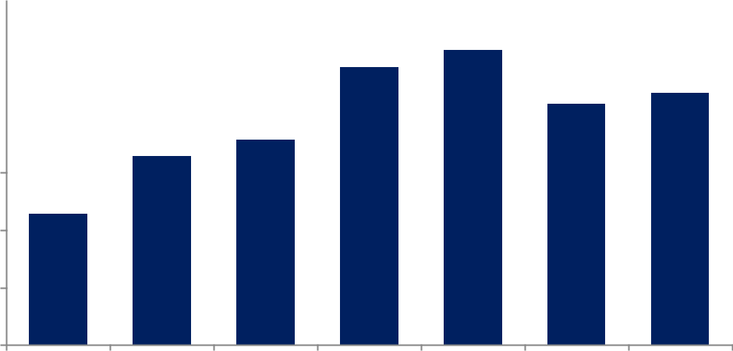

85.0
81.4

80.0

75.0

70.0

FY14 FY15 FY16 FY17 FY18 FY19 FY20
Actual Actual Actual Actual Actual Target Target

Definition The Nuclear Performance Index is a weighted combination of the key performance indicators based on standard nuclear industry definitions for station performance.

Calculation The Nuclear Performance Index for each unit is calculated using a weighted combination of key performance indicators based on standard nuclear industry definitions, with the maximum obtainable being 100 points. TVA's fleet-level Nuclear Performance Index is a simple average of the performance of each unit.

Page 34

TVA FY 2020 Budget Proposal & Management Agenda and FY 2018 Performance Report

 | 3.5%
 | 3.0%
Better | 2.5%
 | 2.0%
 | 1.5%
 | 1.0%

0.5%

0.0%

Combined Cycle Seasonal EFOR

3.2%
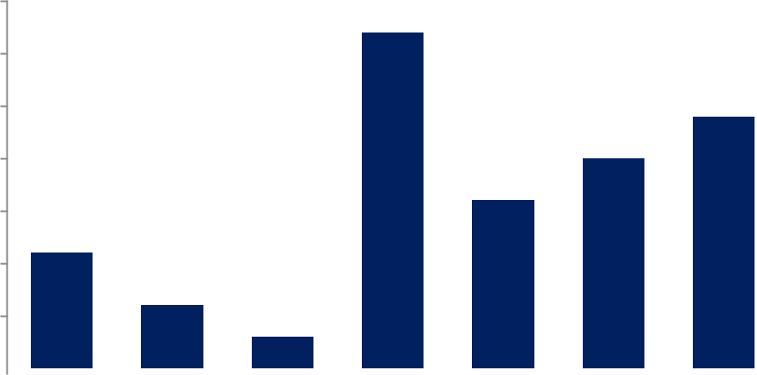

2.4%

 |  |  |  |  |  |  |  |  |  |  |  |  |  |  |  |  |  |  | 2.0%
 |  |  |  |  |  |  |  |  |  |  |  |  |  |  | 1.6%
 | 1.1%
 |  |  |  |  | 0.6%
 |  |  |  |  |  |  |  |  | 0.3%
 | FY14 |  |  |  | FY15 |  |  |  | FY16 |  |  | FY17 |  |  | FY18 |  |  |  | FY19 |  |  | FY20
 | Actual |  |  |  | Actual |  |  |  | Actual |  |  | Actual |  |  | Actual |  |  | Target |  |  |  | Target

Definition Combined Cycle Seasonal EFOR measures the generation lost due to forced events as a percentage of time the unit would have been scheduled to run. This measure runs from December to March and June to September and includes Caledonia, John Sevier, Lagoon Creek, Magnolia, and Southaven combined cycle plants. This measure excludes events that are classified as “Outside Management Control.”

Calculation ((FOH X NDC) + Forced MWhL) / ((FOH + SH) X NDC) X 100

FOH = Forced Outage Hours

SH = Service Hours

NDC = Net Dependable Capacity

Forced MWhL = MWh Losses Due to Forced Derating

Page 35

TVA FY 2020 Budget Proposal & Management Agenda and FY 2018 Performance Report

Nuclear Unit Capability Factor

Better

92.0% |  |  |  |  |  |  | 91.1% |  |  |  |  |  |  |  |  |  | 91.3%
 |  |  | 91.0%
 |  |  |  |  |  |  |  |  |  |  |  |  |  |  |  |  |  |  |  |  |  |  |  |  | 90.9%
 |  |  |  |  |  |  |  |  |  |  |  |  |  |  | 90.7%
90.0% |  |  |  |  |  |  |  |  |  |  |  |  |  |  |  |  |  |  |  |  | 90.3%
 |  |  |  |  |  |  |  |  |  |  | 89.2%
88.0%
86.0%
84.0%
82.0%
80.0%
 |  |  | FY14 |  |  |  | FY15 |  |  |  | FY16 |  |  |  | FY17 |  |  | FY18 |  |  | FY19 |  |  |  | FY20
 |  |  | Actual |  |  |  | Actual |  |  |  | Actual |  |  |  | Actual |  |  | Actual |  |  | Target |  |  |  | Target

Definition Nuclear Unit Capability Factor is the ratio of available energy generation over a given period of time to the reference energy generation over the same time period, expressed as a percentage.

Calculation [(REG - PEL - UEL - OEL) / REG] X 100

REG = Reference Energy Generation

PEL = Planned Losses

UEL = Unplanned Losses

OEL = Outage Extension Losses

Page 36

TVA FY 2020 Budget Proposal & Management Agenda and FY 2018 Performance Report

People/Stewardship

Better

Recordable Incident Rate (RIR)

0.80 |  |  | 0.73
0.70
0.60 |  | 0.52
0.50 |  |  |  |  | 0.43 |  | 0.39
0.40 |  |  |  |  |  |  |  |  | 0.34
0.30
0.20
0.10
 |  |  |  |  |  |  |  |  |  |  |  |  | 0.00 |  |  |  | 0.00
0.00
 |  | FY14 |  | FY15 |  | FY16 |  | FY17 |  | FY18 |  |  | FY19 |  |  |  | FY20
 |  | Actual |  | Actual |  | Actual |  | Actual |  | Actual |  | Target |  |  |  |  | Target

Definition The number of recordable injuries (as defined by TVA’s safety program) per 200,000 employee-hours worked by TVA employees and staff augmentation contractors

Calculation (Number of recordable injuries x 200,000) / (Number of employee-hours worked)

Page 37

TVA FY 2020 Budget Proposal & Management Agenda and FY 2018 Performance Report

Better

CO₂ Emissions Rate (tons/GWh)

600
 | 523
 |  |  | 502
500 |  |  |  |  | 473
 |  |  |  |  |  |  | 416
400
 |  |  |  |  |  |  |  |  | 346
 |  |  |  |  |  |  |  |  |  |  | 317
300 |  |  |  |  |  |  |  |  |  |  |  |  | 310
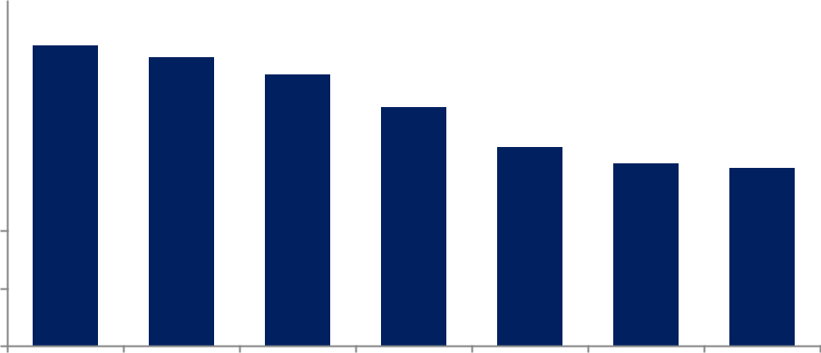

200

100

0

FY14 FY15 FY16 FY17 FY18 FY19 FY20
Actual Actual Actual Actual Actual Target Target

Definition This measure reflects TVA’s commitment to manage greenhouse gas emissions through efficient operation of its diverse generation mix.

Calculation Tons of CO2 emissions / GWh of generation

Page 38

TVA FY 2020 Budget Proposal & Management Agenda and FY 2018 Performance Report

 | 25
 | 20
Better | 15
 | 10
 | 5
 | 0

Definition

Calculation

Reportable Environmental Events
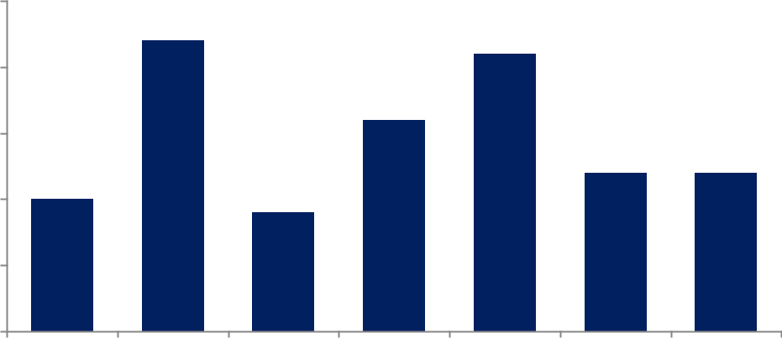

22
 |  |  | 21
 | 16
 | 12 |  |  |  | 12

10 | 9

FY14 FY15 FY16 FY17 FY18 FY19 FY20
Actual Actual Actual Actual Actual Target Target

An environmental event at a TVA facility or elsewhere caused by TVA or TVA contractors that violates permit conditions or other regulatory requirements and triggers regulatory required oral or written notification to or enforcement action by a regulatory agency. Multiple parameters or multiple media/regulatory violations that result from the same root cause/event are counted as one reportable environmental event (“REE”). However, repeat occurrences count as separate REEs if they occur in a different reporting period. In cases where there is lag time between the event and receipt of a Notice of Violation (“NOV”), the receipt date for the NOV will be used as the date of the REE if the NOV has not previously been counted as a REE, and if the fiscal year reporting deadline for TVA-level environmental metrics has passed.

Number of Reportable Environmental Events

Page 39

TVA FY 2020 Budget Proposal & Management Agenda and FY 2018 Performance Report

Jobs Created & Retained

Better

90,000 |  |  |  |  | 76,220
80,000
 |  |  |  |  |  |  |  |  | 72,171
 |  |  |  |  |  |  |  |  |  |  |  |  | 70,076
70,000 |  |  |  |  |  |  |  |  |  |  |  |  |  |  |  |  | 65,423 |  |  |  | 65,000 |  |  |  | 65,000
 |  |  | 60,378
60,000
50,000
40,000
30,000
20,000
10,000
0
 |  |  | FY14 |  |  | FY15 |  |  | FY16 |  |  |  | FY17 |  |  |  | FY18 |  |  |  | FY19 |  |  |  | FY20
 |  |  | Actual |  |  | Actual |  |  | Actual |  |  |  | Actual |  |  |  | Actual |  |  |  | Target |  |  |  | Target

Definition Jobs Created and Retained measures the number of new or retained jobs in the Tennessee Valley for which TVA has played a role in the recruitment or retention of the economic development project.

Calculation Number of Jobs Created and Retained as reported through TVA channels

Page 40

TVA FY 2020 Budget Proposal & Management Agenda and FY 2018 Performance Report

Other Information

Data Validation and Verification

Much of the data contained in this document was derived from TVA’s Annual Report on SEC Form 10-K for the year ended September 30, 2018 (the “Annual Report”). TVA filed the Annual Report with the SEC, and TVA’s Chief Executive Officer and Chief Financial Officer certified the Annual Report in accordance with the requirements of the Sarbanes-Oxley Act. In addition, TVA’s independent auditor, Ernst & Young LLP, audited the financial statements contained in the Annual Report.

TVA’s management is responsible for establishing and maintaining adequate internal control over financial reporting as defined in Rule 13a-15(f) under the Securities Exchange Act of 1934 and required by Section 404 of the Sarbanes-Oxley Act. TVA’s internal control over financial reporting is designed to provide reasonable, but not absolute, assurance regarding the reliability of financial reporting and the preparation of financial statements in accordance with GAAP. Because of the inherent limitations in all control systems, internal controls over financial reporting and systems may not prevent or detect misstatements.

TVA’s management, including the Chief Executive Officer, the Chief Financial Officer, and the Controller, evaluated the design and effectiveness of TVA’s internal control over financial reporting as of September 30, 2018, based on the framework in Internal Control — Integrated Framework (2013) issued by the Committee of Sponsoring Organizations of the Treadway Commission. Based on this evaluation, TVA’s management concluded that TVA’s internal control over financial reporting was effective as of September 30, 2018.

Although management’s report on the effectiveness of internal control over financial reporting was not required to be subject to attestation by TVA’s registered public accounting firm, TVA has chosen to obtain such a report. Ernst & Young LLP issued an attestation report on TVA’s internal control over financial reporting as of September 30, 2018.

Lower-Priority Program Activities

TVA has determined that it does not have any lower-priority program activities for purposes of 31 U.S.C. § 1115(b)(10).

Hyperlinks

Hyperlinks to documents discussed in this Performance Plan are set forth below:

Document |  | Hyperlink
Integrated Resource Plan |  | https://www.tva.gov/Environment/Environmental-Stewardship/Integrated-
 |  | Resource-Plan
Natural Resource Plan |  | https://www.tva.gov/Environment/Environmental-Stewardship/Environmental-
 |  | Reviews/Natural-Resource-Plan
Annual/Quarterly Report |  | http://www.snl.com/IRWebLinkX/docs.aspx?iid=4063363

Page 41

 |  |  |  |  |  |  | TVA FY 2020 Budget Proposal & Management Agenda and FY 2018 Performance Report
 | Appendix A
 | Report Number |  |  |  |  | GAO Recommendation |  |  | TVA Response
 |  |  |  |  |  |  |  |  | TVARS committed to the following:
 |  |  |  |  |  | The Chief Investment Officer of the Tennessee Valley Authority |  |  | - Document within TVARS policy a commitment to equal opportunity for all asset managers, including MWO
 |  |  |  |  |  |  |  |  | firms;
 |  |  |  |  |  | Retirement System (“TVARS”) should fully implement key
 |  |  |  |  |  | practices to increase opportunities for minority and women- |  |  | - Work with its consultant to establish a process for providing information on potential MWO asset managers
 |  |  |  |  |  | owned (“MWO”) asset managers as part of its selection |  |  | researched and evaluated by the consultant; and
 | GAO-17-726 |  |  |  |  | processes. Specifically, the Chief Investment Officer should take |  |  | - After identifying a short list of top, qualified firms for a particular investment strategy or mandate, request that at
 |  |  |  |  |  | actions to demonstrate top leadership commitment, and to the
 |  |  |  |  |  |  |  |  | least one MWO asset manager be included in the list for further evaluation and consideration.
 |  |  |  |  |  | extent that staff and resources are a constraint, should direct its
 |  |  |  |  |  |  |  |  | TVARS has followed through on each of these commitments. The inclusion of MWO asset managers in TVARS’
 |  |  |  |  |  | consultant to conduct outreach to MWO firms and communicate
 |  |  |  |  |  |  |  |  | searches has become a standard practice, and TVARS has hired an additional MWO firm that will manage
 |  |  |  |  |  | its priorities and expectations for an inclusive selection process
 |  |  |  |  |  |  |  |  | TVARS assets in a private real estate fund. Additionally, TVARS has been communicating its commitment to
 |  |  |  |  |  | by requesting its consultant conduct more inclusive asset
 |  |  |  |  |  |  |  |  | MWO opportunities by including a question asking for information on the number and percentage of employees
 |  |  |  |  |  | manager searches specifically for TVARS.
 |  |  |  |  |  |  |  |  | and partners who are women and minorities in Requests for Information, along with requesting a description of
 |  |  |  |  |  |  |  |  | the firm’s efforts and policies to promote diversity among employees and partners of the firm.
 |  |  |  |  |  |  |  |  | TVA has added language to its annual performance plan and annual performance report to better document and
 |  |  |  |  |  | The Board of Directors should ensure that TVA better document |  |  | communicate its goal to reduce its debt (see page 15) and its commitment to fully fund the qualified pension plan
 | GAO-17-343 |  |  |  |  | and communicate its goals to reduce its debt and unfunded |  |  | (see page 10). The additional language provides enhanced transparency about TVA’s goals and commitments for
 |  |  |  |  |  | pension liabilities in its performance plans and reports, including |  |  | these focus areas, the accomplishments to date, and future plans for achieving the debt goal and fully-funding the
 |  |  |  |  |  | detailed strategies for achieving these goals. |  |  | pension. In addition to the annual performance plan and annual performance report, TVA continues to utilize other
 |  |  |  |  |  |  |  |  | forums to ensure transparency with its stakeholders on its financial and operational performance. This includes
 |  |  |  |  |  |  |  |  | TVA’s public Board meetings and regular meetings with customers and public officials.
 |  |  |  |  |  |  |  |  | TVA remains committed to working with the TVARS Board, a separate legal entity from TVA, to ensure a fully-
 |  |  |  |  |  |  |  |  | funded retirement system. In addition to the 2016 plan amendments that were approved by the TVARS Board and
 |  |  |  |  |  |  |  |  | accepted by TVA that put in place a plan to close the gap between TVARS’ assets and obligations over a 20-year
 |  |  |  |  |  |  |  |  | period, other recent developments include:
 |  |  |  |  |  |  |  |  | - In FY 2017, TVA made an additional one-time pension contribution of $500 million to TVARS. This brought the
 | GAO-17-343 |  |  |  |  | The Board of Directors should ensure that TVA propose, and |  |  | total FY 2017 contribution to $800 million versus the required contribution of $300 million. This additional
 |  |  |  |  |  | work with the TVARS Board to adopt, funding rules designed to |  |  | contribution coupled with strong investment returns to date has improved the confidence of being fully-funded
 |  |  |  |  |  | ensure the plan's full funding. |  |  | over the original 20-year period.
 |  |  |  |  |  |  |  |  | - As of September 30, 2017, TVARS reported a funded ratio of approximately 84%, the highest funded ratio in
 |  |  |  |  |  |  |  |  | roughly a decade.
 |  |  |  |  |  |  |  |  | - In June 2018, the TVARS Board approved, and TVA accepted, rule changes that allowed employees with a
 |  |  |  |  |  |  |  |  | Cash Balance pension account to stop receiving Cash Balance pension benefits and instead shift their retirement
 |  |  |  |  |  |  |  |  | benefits to the 401(k) Plan effective October 1, 2018. This choice provided employees with greater flexibility in
 |  |  |  |  |  |  |  |  | future financial planning and the option to choose the retirement benefits that are best for them.

Page 42

 |  |  |  |  |  | TVA FY 2020 Budget Proposal & Management Agenda and FY 2018 Performance Report
 | Report Number |  |  |  | OIG Recommendation |  |  | TVA Response
 |  |  |  |  | Revise TVA environmental procedures to better describe responsibilities for |  |  | TVA agrees with the recommendation and is actively working to implement the updates. After
 |  |  |  |  | NEPA reviews and address the specific concerns identified in the OIG report.
 |  |  |  |  |  |  |  | updated procedures were drafted TVA published the procedures for public comment and
 |  |  |  |  | Update TVA NEPA procedures and guidance to reflect current TVA structure
 |  |  |  |  |  |  |  | addressed the comments it received. TVA submitted the final draft of the procedures to the
 |  |  |  |  | and procedures, reduce repetition, and improve ease of use. Work with TVA
 | 2013-14959 |  |  |  |  |  |  | Council on Environmental Quality (“CEQ”) on October 31, 2018. CEQ approval is required before
 |  |  |  |  | Projects to better describe requirements in project management procedures for
 |  |  |  |  |  |  |  | the procedures can be finalized, and TVA currently expects the procedures to be finalized by the
 |  |  |  |  | initiating, documenting, and completing environmental reviews. Include
 |  |  |  |  |  |  |  | end of FY 2019, which would be followed by a required 6-month implementation period. The
 |  |  |  |  | processes for identifying planned projects and significant work that require but
 |  |  |  |  |  |  |  | expected date of completion for this request is April of 2020.
 |  |  |  |  | have not initiated a NEPA review.
 |  |  |  |  |  |  |  | TVA agrees with the recommendation and will amend applicable aspects of the Fire Protection
 |  |  |  |  | Amend the Fire Protection Self-Assessments to include ratings of fire protection |  |  | Program to incorporate identified gaps.
 |  |  |  |  | system equipment, provide a more objective means for determining whether |  |  | The OIG has closed the following requirements of this recommendation:
 |  |  |  |  | preventive maintenance was performed, reflect prioritization of impairments and |  |  | 1. Reflect prioritization of impairments and work orders outstanding; and
 | 2014-15216 |  |  |  | work orders outstanding, and provide a synopsis of additional drivers of fire risk
 |  |  |  |  |  |  |  | 2. Share the methodology for assessing a site's compliance rate with site and corporate managers
 |  |  |  |  | at each site. In addition, methodology for assessing a site's compliance rate
 |  |  |  |  |  |  |  | to allow accurate interpretation of reports.
 |  |  |  |  | should be shared with site and corporate managers to allow accurate
 |  |  |  |  |  |  |  | The remaining requirements are in the process of being implemented within the Fire Protection
 |  |  |  |  | interpretation of reports.
 |  |  |  |  |  |  |  | Program and are on schedule to be completed by August 2019.
 |  |  |  |  |  |  |  | This recommendation was accepted with evidence demonstrating compliance provided to the OIG
 |  |  |  |  | Identify and implement ways to improve, within an identified department, (1) the |  |  | several weeks before the due date. After review, the OIG followed up with additional requests and
 | 2016-15386 |  |  |  | applicable managers' behaviors and leadership skills in demonstrating TVA's |  |  | TVA complied while offering supporting evidence demonstrating compliance in November 2018.
 |  |  |  |  | values and competencies and (2) teamwork issues. |  |  | Additional evidence has since been requested and provided by TVA. All follow-up interviews have
 |  |  |  |  |  |  |  | been held and closure of this recommendation is expected by the end of March 2019.
 |  |  |  |  | Address cross-functional risks impacting material availability and inventory
 |  |  |  |  | accuracy by (1) tracking incidents of materials received without matching
 |  |  |  |  | receiving documentation to identify trends, (2) determining the impact of
 |  |  |  |  | unlogged inventory and considering remediation steps as appropriate, and (3)
 |  |  |  |  | working with the Director, Sourcing, to find process efficiencies and increase |  |  | Recommendation was accepted to work with Nuclear for a determination (decision made not to
 | 2016-15386 |  |  |  | responsive time, support, and collaboration between departments. Vice |  |  | implement service-level agreements in this instance). Additional action has been taken with
 |  |  |  |  | President, Supply Chain, to work with Senior Vice President, Power Operations |  |  | evidence demonstrating compliance provided in February 2019 for closure. Closure is expected by
 |  |  |  |  | and Chief Nuclear Officer (“CNO”) to increase understanding of identified |  |  | March 2019.
 |  |  |  |  | processes and the impacts of deviations from processes to material availability
 |  |  |  |  | and inventory accuracy. CNO to determine if a standardized service level
 |  |  |  |  | agreement for nuclear outages would be beneficial for Supply Chain and TVA
 |  |  |  |  | Nuclear.
 |  |  |  |  |  |  |  | This recommendation was accepted and initial evidence demonstrating compliance was provided
 | 2016-15386 |  |  |  | Review FY 2018 goals, identified for a specified organization, to ensure they are |  |  | to the OIG. After review, additional action requested by the OIG was taken by TVA in order to
 |  |  |  |  | SMART (specific, measurable, action oriented, realistic, and time bound). |  |  | complete the request. The OIG was notified in November 2018 to pull evidence for review in order
 |  |  |  |  |  |  |  | to close the recommendation. Closure is expected by the end of March 2019.
 |  |  |  |  | Continue to focus on building relationships within the leadership team and |  |  | TVA has accepted the recommendation and is working to implement suggested resolutions.
 | 2016-15445 |  |  |  | across the Chief Human Resources Office (“CHRO”) to improve collaboration
 |  |  |  |  |  |  |  | Currently, TVA is on track to complete the request by May 2019.
 |  |  |  |  | and teamwork.

Page 43

 |  | TVA FY 2020 Budget Proposal & Management Agenda and FY 2018 Performance Report
 |  | Continue dialogue with employees to (1) gather differing opinions and encourage | TVA has accepted the recommendation and is working to implement suggested resolutions.
2016-15445 |  | employees to voice opinions even if those opinions differ from management and
 |  |  | Currently, TVA is on track to complete the request by May 2019.
 |  | (2) promote inclusive behaviors.
2016-15445 |  | Recommunicate expectations of ethical behaviors and monitor compliance with | TVA has accepted the recommendation and is working to implement suggested resolutions.
 |  | laws and regulations. | Currently, TVA is on track to complete the request by May 2019.
 |  | Utilize existing qualitative and quantitative measurements and/or develop metrics | TVA has accepted the recommendation and is working to implement suggested resolutions.
2016-15445 |  | to (1) gauge effectiveness of CHRO strategies and programs and (2) identify
 |  |  | Currently, TVA is on track to complete the request by May 2019.
 |  | risks to achievement of the CHRO initiatives and mission.
 |  | In conjunction with the Chief Executive Officer and the Senior Vice President and
2016-15445-01 |  | CHRO, identify and implement the changes needed to obtain compliance with | TVA has accepted the recommendation and is working to implement suggested resolutions.
 |  | the regulations regarding the placement and reporting structure of the Equal | Currently, TVA is on track to complete the request by March 2019.
 |  | Opportunity Compliance (“EOC”) department.
 |  | Increase communication around the selection process, including specifying the | TVA accepted the recommendation and addressed many of the requests through an
 |  |  | organizational redesign. Additionally, transparency in staffing, including the selection process, will
2016-15445-05 |  | criteria for promotion to senior Human Resources Generalist (“HRG”) and
 |  |  | be improved by increasing communication while making necessary adjustments as clarity is
 |  | address differences in HRG and senior HRG expectations and responsibilities.
 |  |  | gained on future roles. Closure of the recommendation is expected by September 2019.
 |  | Address execution risks by (1) continuing to support the HRG transition to a
 |  | more strategic role by communicating with TVA management regarding HRG
 |  | expectations, (2) implementing a feedback mechanism for employee feedback | TVA accepted the recommendation and is working to implement an employee feedback
 |  | regarding HRG support, (3) identifying areas in need of role clarity between
 |  |  | mechanism as part of a customer-centric approach while continuing to evaluate and improve the
 |  | Human Resources and other CHRO business units and address expectations of
2016-15445-05 |  |  | medical case management process as needed. Additionally, TVA is continuing to work to increase
 |  | each business unit's role, (4) refining the medical case management process in
 |  |  | communication and improve role clarity for future roles. Implementation of the recommended
 |  | order to reduce the amount of time spent on administrative tasks and clarifying
 |  |  | resolution is on track and scheduled for completion by September 2019.
 |  | the role Employee Health plays in leave abuse, and (5) continuing with efforts to
 |  | address the grievance backlog and work with TVA management to address
 |  | grievances in accordance with collective bargaining agreements.
 |  | Address the ethical concerns and concerns pertaining to inclusion by: (1)
 |  | communicating guidelines around rotational management positions to aid in
 |  | employee's understanding of the purpose of the process, (2) monitoring direct
2016-15445-05 |  | selections and rotational positions to ensure Human Resources is consistently | TVA has accepted the recommendation and is working to implement suggested resolutions.
 |  | following policies and procedures, and (3) continuing dialogue with employees to | Currently, TVA is on track to complete the request by September 2019.
 |  | gather differing opinions and encourage employees to voice their differing
 |  | opinions without fear and promote inclusive behaviors regardless of location,
 |  | position, or personal style.

Page 44

TVA FY 2020 Budget Proposal & Management Agenda and FY 2018 Performance Report

Appendix B

Total Financing Obligations is a financial measure that is not calculated and presented in accordance with Generally Accepted Accounting Principles (“GAAP”). TFO is measured by summing bonds and notes, gross, debt related to variable interest entities (“VIE”), leaseback obligations, energy prepayment obligations, the membership interests of VIE subject to mandatory redemption, and notes payable. A calculation of TFO utilizing financial statement line items reported in accordance with GAAP follows:

TENNESSEE VALLEY AUTHORITY

Unaudited Reconciliation of Total Financing Obligations

(in millions)

 |  |  |  |  |  |  |  |  |  |  |  | FY 2019 |  | FY 2020
 |  | FY 2014 |  | FY 2015 |  | FY 2016 |  | FY 2017 |  | FY 2018 | Projected |  |  | Projected
Total Financing Obligations | $ | 26,071 | $ | 26,120 | $ | 26,207 | $ | 26,022 | $ | 24,281 | $ | 23,552 | $ | 22,318
Energy prepayment obligations |  | (410) |  | (310) |  | (210) |  | (110) |  | (10) |  | - |  | -
Notes payable |  | - |  | - |  | (75) |  | (122) |  | (69) |  | (23) |  | -
Leaseback obligations |  | (691) |  | (616) |  | (467) |  | (339) |  | (301) |  | (263) |  | (223)
Membership interests of VIE subject to mandatory redemption |  | (39) |  | (37) |  | (35) |  | (32) |  | (30) |  | (28) |  | (25)
Debt of VIE |  | (1,311) |  | (1,279) |  | (1,245) |  | (1,211) |  | (1,175) |  | (1,137) |  | (1,098)
Bonds and Notes, gross |  | 23,620 |  | 23,878 |  | 24,175 |  | 24,208 |  | 22,696 |  | 22,101 |  | 20,971
Exchange loss (gain) |  | 44 |  | (21) |  | (150) |  | (125) |  | (147) |  | - |  | -
Unamortized discounts, premiums, issue costs and other |  | (88) |  | (107) |  | (173) |  | (163) |  | (154) |  | (250) |  | (254)
Notes payable |  | - |  | - |  | 75 |  | 122 |  | 69 |  | 23 |  | -
Debt of variable interest entities |  | 1,311 |  | 1,279 |  | 1,245 |  | 1,211 |  | 1,175 |  | 1,137 |  | 1,098
Total outstanding debt | $ | 24,887 | $ | 25,029 | $ | 25,172 | $ | 25,253 | $ | 23,639 | $ | 23,011 | $ | 21,815

Page 45

