Stabbing Recording Centre Ltd - Update 20XX

DVD

Specification Booklet

Design and Print

Contact Graphics: XXXX XXX XXX / graphic@abc.co.nz

*** Very Important ***

Artwork Supply Specifications for Packaging and Product

Stabbing and our printers use the Adobe color setting: Europe Prepress 2 - CMYK Coated FOGRA 27

Preferred file format to supply: Press Quality PDF - include trim marks, 3mm artwork bleed.

Fonts embedded or converted to paths. Files titled according to what they are.

Paper Parts Artwork Check List:

- Artwork should be CMYK or Greyscale unless you are using Pantone Solid Coated Colour (spot colour).

- All photos/artwork should be converted to CMYK and not be in RGB.

- Spot colours should be clearly labelled and setup properly in your documents if they are required. Every layout program has this color library added to it for easy selection. You can set up these colors very easily in Quark, InDesign and Illustrator. Photoshop is a little trickier.

- Overgloss / Matt varish or Foil is to be setup as a ‘overprint’ spot colour colour and clearly labelled.

- Metallic or Fluro spot inks should be clearly labelled using the Pantone Colour Library.

- Are you supplying ‘printer spreads’ for the booklet; your pages ‘must’ be numbered for correct imposition at the printers. Or supply as ‘single’ pages with bleed, trims, and in the correct order cover (pg1) through to last page.

- ‘Rich Black’ for paper parts should be setup with no more than 300% ink density. We suggest: C60 / M40 / Y40 / K100

- A text document should also be supplied with information about your package: Title: / Artist: / Catalogue number: (if any)
Package: ie: 12 page booklet, Base Inlay printed 2 sides, sticker

Colours: CMYK + 1 spot

Paper stock: Satin Matt Coated, or Alpine Gloss (standard for CD packaging)

It is important to supply to as much info as possible to your client also for ordering with our sales team so this information is entered into a job form.

We Can Supply Templates for Disc labels and Paper Parts:

Stebbing utilise Mac and PC Platforms and have templates available for use. Let us know program and version required.

We use Adobe CC 2014 - Indesign, Illustrator, Photoshop (PC & MAC), Quark Xpress 9.3 (Mac)

email: graphic@stebbing.co.nz

Common Customer Mistakes To be Aware of:

Image Resolution: It is very important to make sure that the image resolution for all images used is set at 300 dpi at 100% sizing.

Bleeds: It is very important to make sure all 4 cut sides of a piece have at least 3mm bleed or extended image area added.

This area is cut o during the nishing process. If bleeds are not added, we cannot guarantee accuracy in the cutting which make result in a white line appearing around the edges.

Templates: It is very important to make sure that you are using the proper template. If you have any questions as to which template you should be using, ‘please’ call or email us before proceeding.

Fonts: It is very important to include all fonts that are used in your layout. We all unable to make changes in the text if requested, and we may not be able to print the proper fonts if they are not supplied with the artwork.

In closing, if you have any questions at all concerning your artwork, please call us. A few questions in the beginning stages might save days of turnaround time and costly changes later.

Packaging And Product

Specifications and Templates

This pdf booklet contains:

CD and DVD logos (logos are pathed Adobe Illustrator for use)

DVD Specifications/measurements

Standard DVD Case Sleeve

Standard DVD Case Booklet

Slimline DVD Case Sleeve

Super Jewel DVD Specialised Booklet

Super Jewel DVD Specialised Case Tray Inlay

(NB. you will need both parts above for the Super Jewel when designing)

DVD Disc Label Spot Screen Printing Info

DVD Disc Label CMYK O set Printing Info

Disc Die-line

Other templates available on request depending on product used/requested, and printers

Game Caddys (single and double)

DigiPacks / Flexi Packs (see PDF download for templates)

CD Mailer

Custom templates/dielines can be created

LOGOS

(Adobe Illustrator outlined for use)

BACK TO PAGE 3
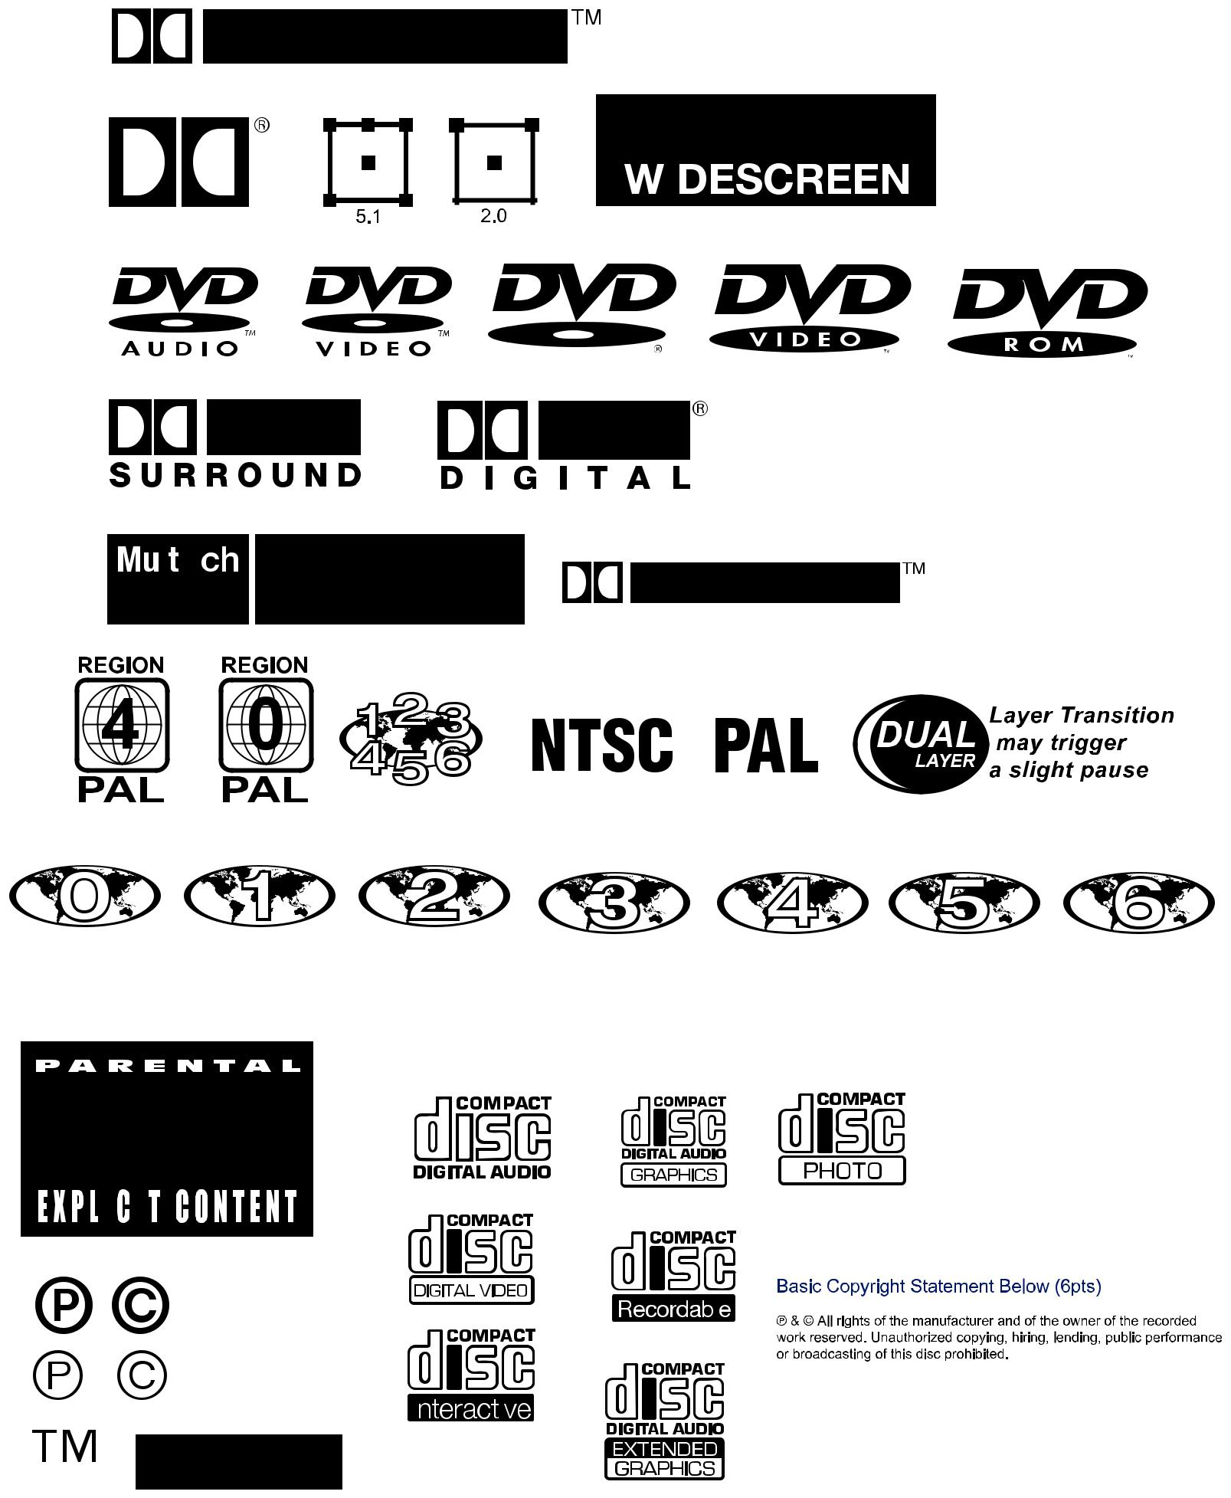

Setting Up Printer Spreads

for Booklets

BACK TO PAGE 3
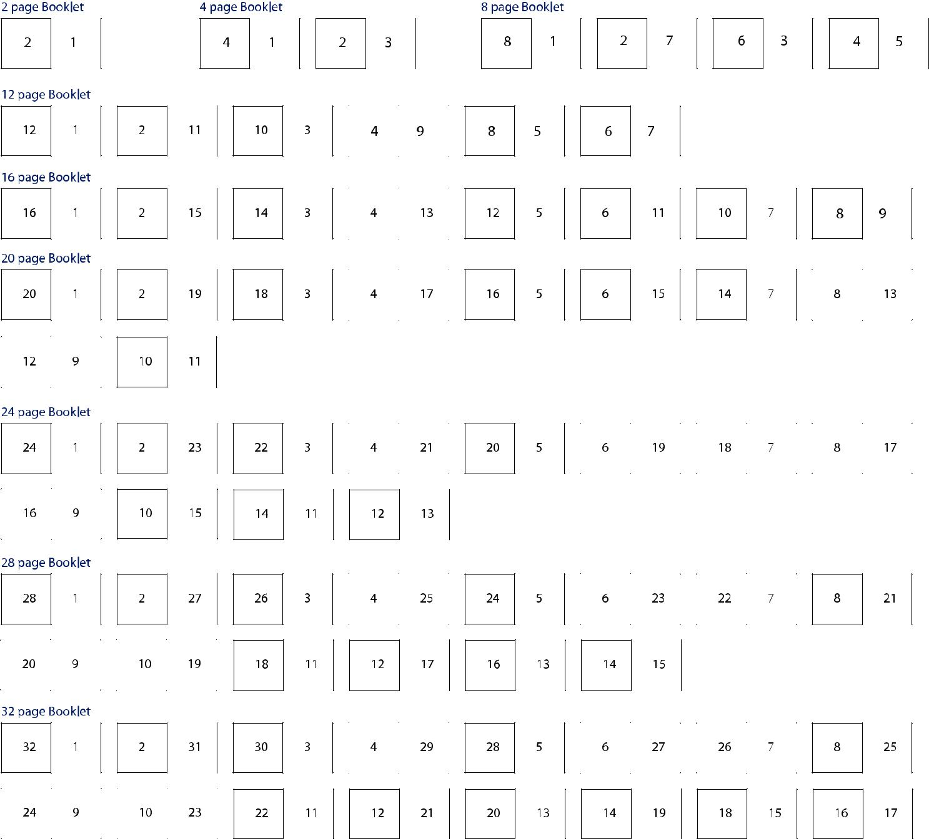

- If you are setting up and supplying artwork for booklets as ‘printer spreads’ see the above diagrams on how your pages are printed and need to be setup.

- Trim marks, page numbering and bleed must be output on your PDF Press Quality les or exist inside your native les.

- Alternately you can output and supply ‘single’ pages including trim marks, bleed and page numbering. We can impostition them quickly if all the above information is given.

- Recommended minimum 9pt font size for booklets with a minimum of 6pt for copyright statments. Its always advisable to print out and check you are happy with the font size and clarity.

BACK TO PAGE 3
5 Colour Spot Disc printing - CD , CD-R, DVD, DVD-R

Our silkscreen printer can print up to 5 spot colours. This method is ideal for large, at areas of colour and vector based designs.

Printing can be directly onto the silver of the disc or onto a standard white base (by default).

- Spot colours should be setup using the Pantone Solid Coated Colour Library with all colours correctly labelled.

- As screen print inks are glossy by default, if you require a Matt nish you must stipulate this in your artwork and within your artwork text le of package. If you don’t tell us we won’t know to print a matt coating over top of the ink or use matt inks.

- There is an additional charge for Metallic inks if you intend to use them.

- Convert all fonts to paths/outlines and ensure any graphics are embedded.

- We require PDF, EPS, or native design les (psd (600dpi), ai, indd or qxd) for spot colour printing.

- The disc surface is printable from 118mm diameter edge through to the centre hole of 17mm. No artwork bleed is required for disc label printing, so you ‘must’ ensure you measurements are correct or please ask for a template from us.
- CD-Roms that are to be ‘high-access’ discs should have no printing within 40mm’s of the centre.

- Most CD-R discs don’t require a stacking ring these days but may require a 27mm centre, it is best to leave this as a white circle rather than punching a hole out in the artwork, it allows us to tweak it if needed.

Require a ‘special’ white base to print with areas knocked out to the silver of disc?

- Set this up as a separate le. Ensure what is to be the silver is setup clear/or white on your artwork, and what needs to print being a spot colour re-labelled ‘White base’.

  - To Scale
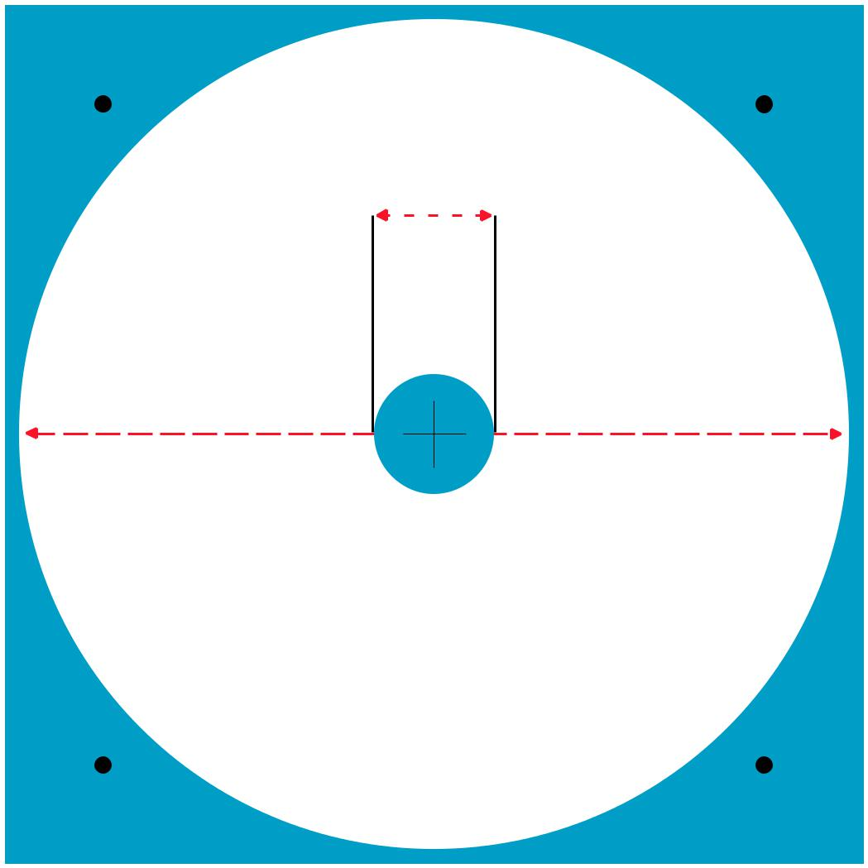

17mm

118mm

BACK TO PAGE 3

O set Disc printing - CD , CD-R, DVD, DVD-R

CMYK o set disc printing is suitable for artwork that has full colour photographic elements, complex textures or colour gradients.

Printing can be directly onto the silver of the disc or onto a standard white base (by default).

- Please supply a 300dpi (minimum) CMYK le, together with a proof for matching.

- Acceptable le formats for o set printing are: PSD, PDF, EPS, TIF or JPEG (jpeg’s must be maximum quality).

- Native les can be supplied if you embed graphics and convert fonts to paths/outlines. (psd, ai, indd, qxd)

- Convert all fonts to paths/outlines and ensure any graphics are embedded.

- If you have large areas of Black (K) to ensure a good ink coverage make you Black out of all 4 colours C100 / M100 / Y100 / K100 or as close as possible. Small Black text and logos can remain 100K only.
- The disc surface is printable from 118mm diameter edge through to the centre hole of 17mm. No artwork bleed is required for disc label printing, so you ‘must’ ensure you measurements are correct or please ask for a template from us.
- CD-Roms that are to be ‘high-access’ discs should have no printing within 40mm’s of the centre.

- Most CD-R discs don’t require a stacking ring these days but may require a 27mm centre, it is best to leave this as a white circle rather than punching a hole out in the artwork, it allows us to tweak it if needed.

Require a ‘special’ white base to print with areas knocked out to the silver of disc?

- Set this up as a separate le. Ensure what is to be the silver is setup clear/or white on your artwork, and what needs to print being a spot colour re-labelled ‘White base’.

  - To Scale

17mm

118mm

DVD - Inlay/Sleeve for Standard DVD Case

 |  | MIRT |  | MIRT
TRIM |  |  |  |  |  |  | TRIM

BACK COVER PAGE 2 | /Artist | FRONT COVER PAGE 1
or Page 3(inside) for clear case | numberCatalogue/Title | or Page 4(inside) for clear case
183mm
 | hereareaspineon

TRIM |  |  |  |  |  |  |  |  |  |  |  |  |  | TRIM
 |  |  |  |  | 130mm |  | 13mm |  | 130mm
 |  | MIRT |  |  |  |  |  |  | MIRT

* Include an extra 3mm (minimum) artwork bleed outside the trim area (shown in red)

BACK TO PAGE 3

*not to scale / email graphic@stebbing.co.nz for template with the

program require it in

DVD - Insert Booklet for Standard DVD Case

TRIM

TRIM

BACK COVER PAGE 4 FRONT COVER PAGE 1

/ Page 2 Inside / Page 3 Inside

TRIM

 |  |  | 230mm length
TRIM |  |  | * Include an extra 3mm (minimum) artwork bleed outside the trim area (shown in red)

BACK TO PAGE 3

TRIM

TRIM

minimum height

175mm

to maximum height

182mm

TRIM

TRIM

*not to scale / email graphic@stebbing.co.nz for template with the

program require it in

DVD Super Jewel Case Booklet *This is for a specialised case, not standard.

TRIM |  | FOLD

TRIM

BACK COVER PAGE 4 FRONT COVER PAGE 1

/ Page 2 Inside / Page 3 Inside

TRIM

 |  |  | 240mm
 | TRIM |  | * Include an extra 3mm (minimum) artwork bleed outside the trim area (shown in red)

TRIM

TRIM

180mm

TRIM

TRIM

BACK TO PAGE 3

*not to scale / email graphic@stebbing.co.nz for template with the

program require it in

DVD Super Jewel Case
Base Tray Inlay *This is for a specialised case, not standard. | BACK TO PAGE 3

TRIM
FOLD
TRIM

TRIM |  | FOLD | TRIM
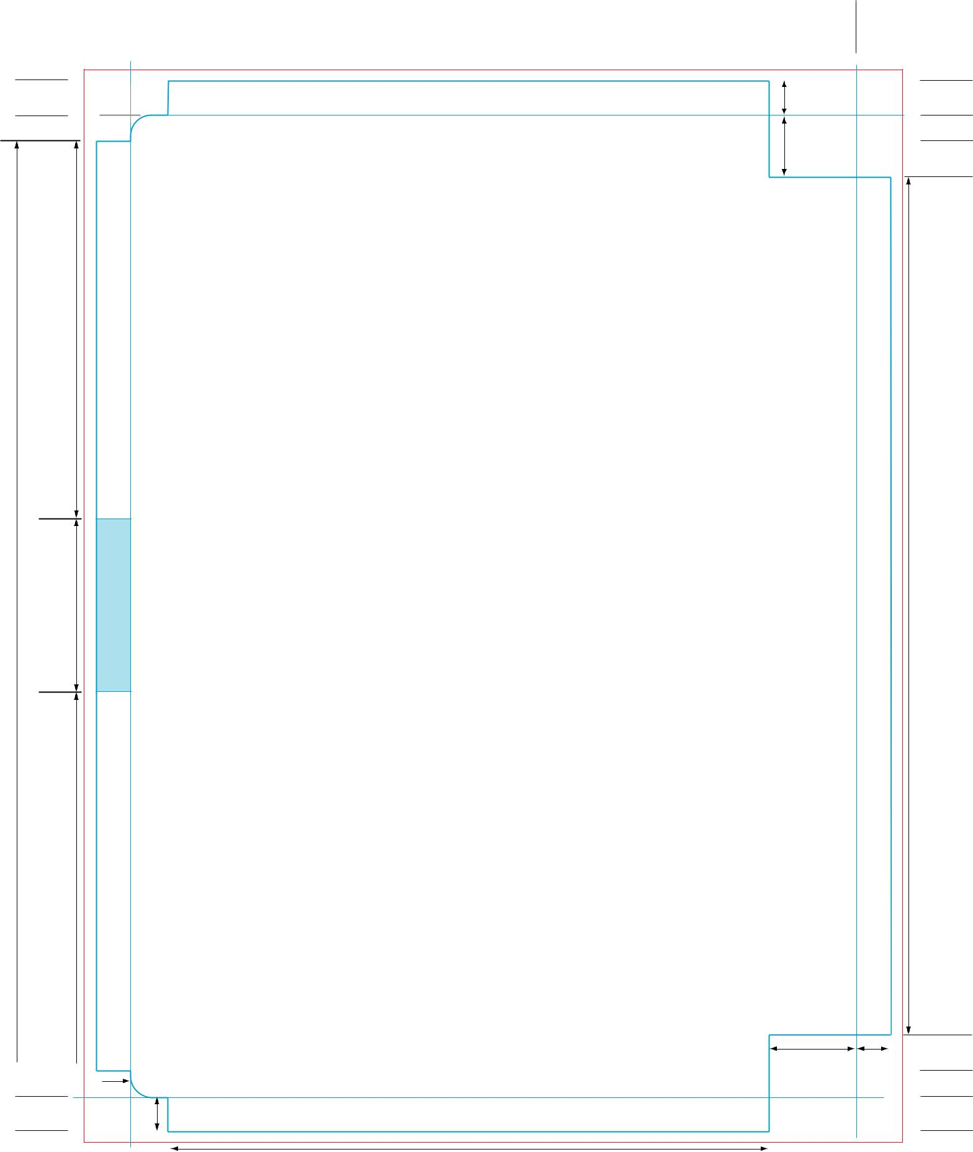

TRIM

FOLD

TRIM

17mm

175mm | 33mm

17mm

TRIM FOLD

TRIM

6mm

5mm

Artist / Title / Cat no.

Artist / Title / Cat no.

7mm

5.5mm

ARTIST / TITLE TO READ THIS WAY

HEAD

Main Outside Base Tray

/ Flip template for reverse use

ARTIST / TITLE TO READ THIS WAY

115mm

21mm 5.5mm

Artist / Title / Cat no.

16.5mm 7mm

TRIM

FOLD

TRIM

162mm

TRIM

TRIM

FOLD

FOLD
TRIM

TRIM

* Include an extra 3mm (minimum) artwork bleed outside the trim area (shown in red)

*TO SCALE / email graphic@stebbing.co.nz for template with the program require it in

DVD - Slimline Case

TRIM

TRIM
TRIM

TRIM

BACK COVER FRONT COVER

130mm | 6mm | 130mm
BACK COVER |  | FRONT COVER
 | spine

* Include an extra 3mm (minimum) artwork bleed outside the trim area (shown in red)
TRIM

BACK TO PAGE 3

TRIM

183mm

TRIM

TRIM

*not to scale / email graphic@stebbing.co.nz for template with the

program require it in

Standard Disc Label Die-line - CD , DVD
BACK TO PAGE 3

118mm / 17mm centre

- Refer to Spot and O set printing/design notes for correct setup

- Opens in Adobe Illustrator CMYK, or open in Adobe Photoshop as CMYK @ 300dpi for o set.

- By default Stebbing prints a white base colour underneath to enhance colour and to avoid the plastic ring centre showing through ink.

