School Department Budget Proposal

Stoneham Public Schools | 20XX-20XX
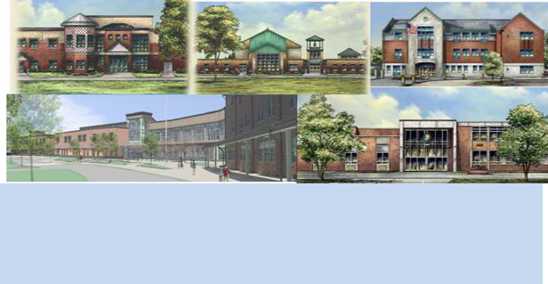

SPS

Stoneham Public Schools

Rising to the Challenge…………...…..2

Budget Guidelines………………………3

Operating Budget…………………….....4

Grants and Other Funds…………...…9

Per Pupil Expenditure……………….11

Our Students & Enrollment………..13

SPS 18-19 Additional Requests…..17

Rising to the Challenge Message from Superintendent of Schools John Macero

Providing quality public education to a diverse student population is exciting work. SPS rises to meet that challenge with resources that include a 7.2% ($1,996,549.00) budget increase for fiscal 19.

2017-2018 has thus far been a transition year for Stoneham Public Schools. This past June, Dr. Olson retired and in July, I became Superintendent. It has been a complete joy learning the ins and outs of how Stoneham Public Schools work. Moving forward growth is what education is all about. SPS challenges our students by creating a rich environment in which to grow--including curricula, technology, athletics, technical training, social supports, fine arts and more.

Due to rising fixed costs, our 18-19 budget faces multiple challenges. Special Ed Tuitions, Transportation, revamping curricula needs, upgrades to technology and additional compensation for programs that continue to grow. Therefore, in order to cover fixed costs such as Cola/Lane/Step increases, Special Ed Tuitions and new in-house Special Ed programs for the high school, our budget will need to increase by 5.5% ($1,528,290) otherwise anything less will force us to reallocate funds and possibly decrease current programs. The additional request of $468,259 would allow programs such as Elementary Literacy, STEM, Music, Physical Education, Art, World Language, and additional Extra Curricular Activities, would help improve student achievement across the board so that they can compete in a 21st century education.

Capital Improvement requests are not in the operating budget request. Our Capital Request submission of $1,550,000 has been submitted to the Capital Committee. Those items are attached for your review. However, I do think it is time for the School Committee to have a real heart to heart discussion in regards to the future of the Old Central Middle School. The building is similar to the High School whereas it may not be most prudent to keep pouring money into both with not much return.

As we embark on a new school year, we will continue to work together to offer the best possible education to all of our students. Given the restraints of the Town’s financial picture, it is true that even with the funds we have requested there will still be the possibility of restructuring. This of course is a reality we will have to face. It is the Superintendent’s responsibility to ensure all dollars allocated by the Town of Stoneham are being well spent for all students at all times and continues to move the Stoneham Public Schools in a forward direction.

I would like to thank the Stoneham School Committee, Finance Committee, Town Administrator and Town Meeting for their continued commitment to the education of Stoneham’s children. Your commitment to our students allows us to continue our work, creating a 21st century school system that provides a vibrant, innovative learning environment and meets the needs of each and every one of our children.

2

STONEHAM PUBLIC SCHOOLS

FY19 BUDGET PROPOSAL

Budget Guidelines

- Student Achievement should drive all budget decisions. This budget should promote improvement for all students, including students with disabilities and English Language Learners, as well as appropriate academic challenge for high-achieving students.

- Elementary School budgets must anticipate increasing enrollments, and support new technology initiatives and intervention programs aimed at increasing the overall academic/social success of all students, as well as keep class sizes fair and equitable.

- The Middle School budget should provide a superior academic and social experience that prepares all students for success in high school and post-secondary education. Funds should also be directed towards developing a social/emotional learning and support system.

- High School programs should provide the academic, social and extracurricular excellence we have come to expect, with support, guidance, and favorable class sizes available for all students.

- Up to date textbooks and assessments for Curriculum will ensure that students receive excellent instruction and coherent, high-quality curriculum.

- Family Engagement efforts should promote welcoming environments for all families. This budget should also support improved communication about our successes.

- School Climate should be safe, supportive, nurturing, and inclusive. Student and staff health and safety, as well as faculty diversity, are among our priorities.

- Operations & Long Range Planning decisions will be based on ongoing review and assessment of needs in the areas of staffing, curriculum, facilities, technology, and sustainability.
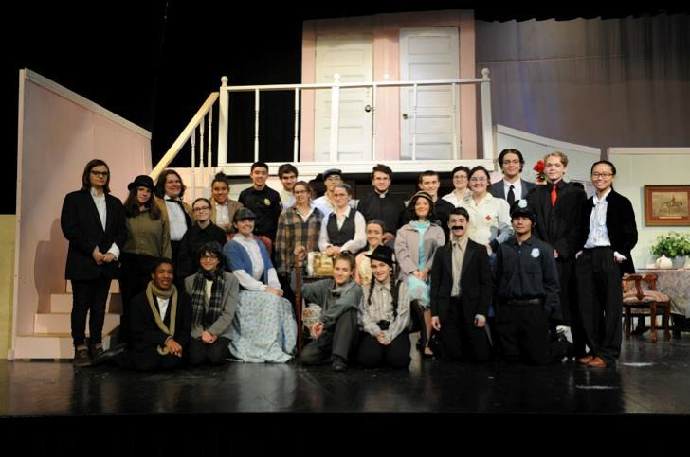

3
STONEHAM PUBLIC SCHOOLS FY19 BUDGET PROPOSAL

Operating Budget

The district’s operating budget is an allocation from the Town of Stoneham comprised of local property taxes, state and federal aid and miscellaneous Revenue sources.

Five year SPS General Fund Budget History

 | FY 14 |  | FY 15 | FY 16 |  | FY 17 |  | FY 18
TOTAL | $24,391,354 |  | $25,022,305 | $25,888,516 |  | $26,734,742 |  | $27,734,642
Allocation
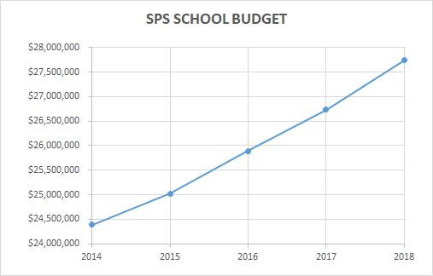

4
STONEHAM PUBLIC SCHOOLS FY19 BUDGET PROPOSAL

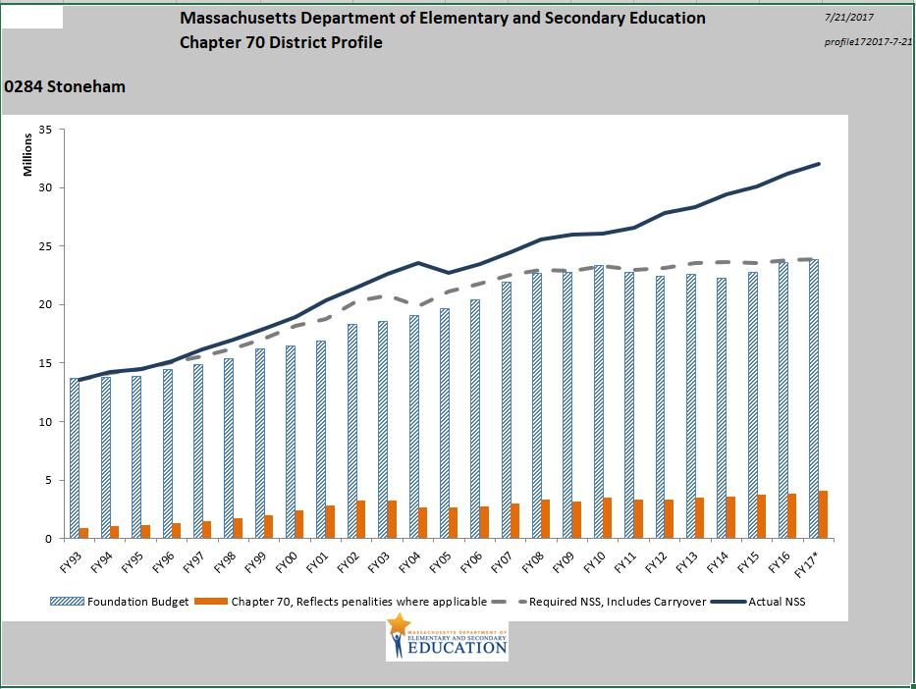

Mandated Expenditures

 |  | FY15 | FY16 | FY 17 | FY 18*
 | ELL Services
 |  | $192,193 | $202,153 | $298,601 | $151,097
 | Out of District | $3,729,626 | $3,335,651 | $3,265,260 | $1,193,400
 | Tuitions
 | Transportation | $21,164 | $27,361 | $43,426 | $113
 | (Homeless)
*Through | 12/31/17

5

STONEHAM PUBLIC SCHOOLS

FY19 BUDGET PROPOSAL

6

STONEHAM PUBLIC SCHOOLS

FY19 BUDGET PROPOSAL
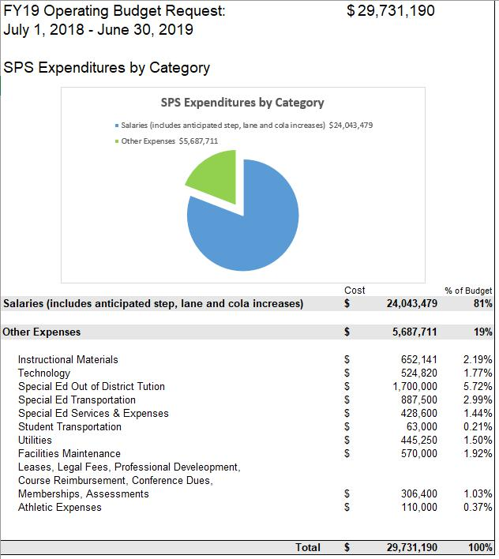

7

STONEHAM PUBLIC SCHOOLS

FY19 BUDGET PROPOSAL
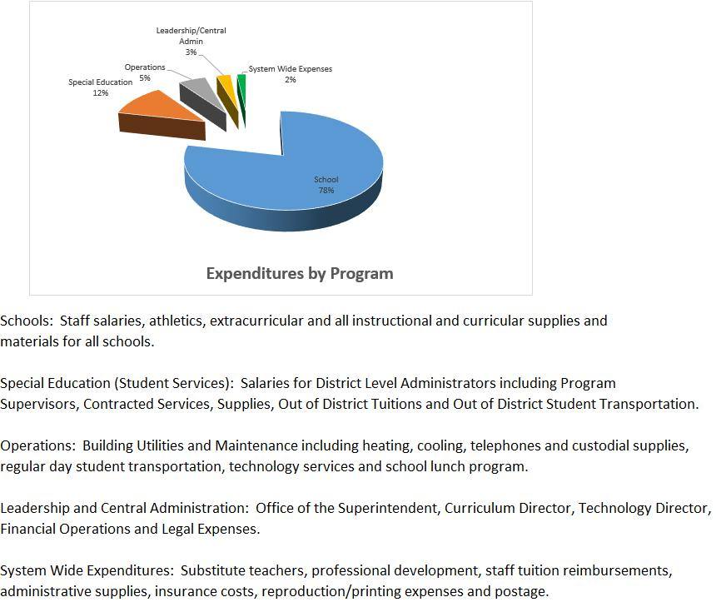

 | SPS Staff: Full Time Equivalent (FTE) Positions
 | (Proposed Budget)
 | Staff Position |  |  |  | FY 18 |  |  |  |  | FY 19
 | Classroom and Other Teachers |  |  |  | 214.1 |  |  | 221.9
 | Educational Support Personnel |  |  |  | 55.7 |  |  | 57.3
 | Library Media Specialists |  |  |  | 2 |  |  | 2
 | School Administration |  |  |  | 10 |  |  | 10
 | Clerical Staff |  |  |  | 16 |  |  | 16
 | Custodian, Maintenance |  |  |  | 18.2 |  |  | 18.2
 | ABA’s |  |  |  | 11 |  |  | 14
 | Nurses |  |  |  | 5.6 |  |  | 5.6
 | Information Technology Support |  |  |  | 5.6 |  |  | 5.6
 | District Administration |  |  |  | 12.2 |  |  | 12.2
 | Total (All Positions) |  |  |  | 350.4 |  |  |  |  | 362.8
Administration & Support Staff
(Custodial, Secretarial, Librarian, Nurse, Counselors)
Support Staff & Administration |  | CP |  | RH |  | South |  |  | CMS |  |  | SH |  |  | CO
 |  |  |  |  |  |  |  |  |  |  |  | S
2017-2018 |  | 6.4 |  | 6.3 | 6.3 |  |  | 14 |  |  |  | 21 |  | 7
2018-2019 |  | 6.4 |  | 6.3 | 6.3 |  |  | 14 |  |  |  | 21 |  | 7

 | POSITION |  |  | FY19 - CP |  |  | FY19 - SO
 | ATHLETIC |  | 0 |  |  | 0
 | DIRECTOR
 | PRINCIPAL |  | 1 |  |  | 1
 | ASST. PRINCIPAL |  | 0 |  |  | 0
 | SECRETARY |  | 1 |  |  | 1
 | SUPERVISOR |  | .4 |  |  | .3
 | GUIDANCE |  | 0 |  |  | 0
 | ADJ. COUNSELOR |  | 1 |  |  | 1
 | LIBRARIAN |  | 0 |  |  | 0
 | NURSE |  | 1 |  |  | 1
 | CUSTODIAN |  | 2 |  |  | 2

 | FY19 - RH |  |  |  | FY19 - |  |  |  |  |  | FY19- |  |  |  |  | CO |  |  | Tota
 |  |  |  |  |  | CMS |  |  |  |  |  | SHS |  |  |  |  |  |  | l
0 |  |  | 0 |  |  |  |  |  | 1 |  |  |  |  |  | 0 |  |  | 1
1 |  |  | 1 |  |  |  |  |  | 1 |  |  |  |  |  | 0 |  |  | 5
0 |  |  | 1 |  |  |  |  |  | 2 |  |  |  |  |  | 0 |  |  | 3
1 |  |  | 2 |  |  |  |  |  | 4 |  |  |  |  |  | 7 |  |  | 16
.3 |  |  | 2.6 |  |  |  |  |  | 2.6 |  |  |  |  |  | 0 |  |  | 6.2
0 |  |  | 2 |  |  |  |  |  | 4 |  |  |  |  |  | 0 |  |  | 6
1 |  |  | 2 |  |  |  |  |  | 1.3 |  |  |  |  |  | 0 |  |  | 6.3
0 |  |  | 1 |  |  |  |  |  | 1 |  |  |  |  |  | 0 |  |  | 2
1 |  |  | 1.6 |  |  |  |  |  | 1 |  |  |  |  |  | 0 |  |  | 5.6
2 |  |  | 4 |  |  |  |  |  | 5 |  |  |  |  |  | 3.2 |  |  | 18.2

TOTALS | 6.4 | 6.3 |  | 6.3 | 17.2 | 22.9 | 10.2 | 69.3
8
STONEHAM PUBLIC SCHOOLS |  |  |  |  | FY19 BUDGET PROPOSAL

Grant Funds

Beyond the Operating budget, the school district receives grant funding annually from State, Federal, and Private Sources.

Grants Award by Source

 | FY14 | FY15 | FY16 | FY17 | FY18
Total State and | $881,688 | $858,322 | $946,210 | $865,026 | $804,666
Federal Grants*
Circuit Breaker** | $864,536 | $974,266 | $1,007,952 | $924,938 | $900,000(est)
Total | $1,746,224 | $1,832,588 | $1,954,162 | $1,789,964 | $1,704,666

Following are summaries of our largest grants in each category.

*Federal and State Grants

- Individuals with Disabilities Act (IDEA) Allocation: Ensures that eligible students with disabilities receive a free and appropriate public education including special education and related services designed to meet their individual needs.

- Title I: Provides additional resources to improve student educational performance in schools.

- Title IIA: Teacher Quality: Seeks to increase student achievement by better preparing, training, recruiting and retaining highly qualified educators.

**State Aid

- Circuit Breaker: Partial reimbursement to public school districts for special education programs.
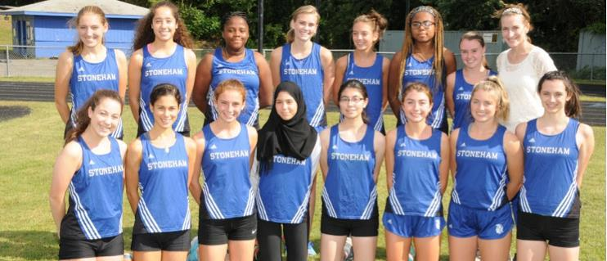

9

STONEHAM PUBLIC SCHOOLS

FY19 BUDGET PROPOSAL

Other Funds

Revolving Funds

Revenue from school lunch programs, school facilities rentals, athletic fees, after school and before school fees, preschool tuition and other programs with revenue receipts are ongoing and the district foresees revenues near prior years totals for FY18. Revenue generated supports the ongoing operational needs of each program.

 | Revolving Fund
FY14 | $1,632,186
FY15 | $1,779,143
FY16 | $1,814,126
FY17 | $1,805,934
FY18 (to date) | $850,724
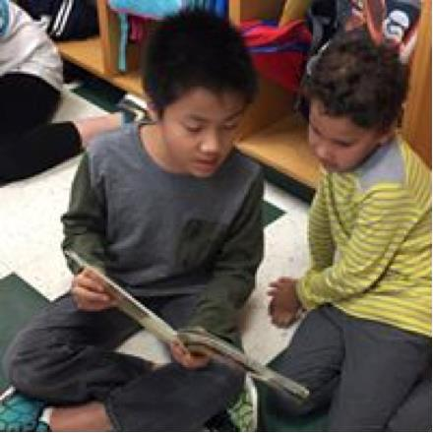

10
STONEHAM PUBLIC SCHOOLS FY19 BUDGET PROPOSAL

Stoneham Per Pupil Expenditure: $15,222.

State Avg. Per Pupil Expenditure: $15,545

Source: MA Department of Elementary and Secondary Education (FY16 Data)

“Per Pupil Expenditure” reflects school spending data in a way that is comparable across school districts in the State of Massachusetts.

This figure is composed of actual expenditures as reported in the Department of Elementary and Secondary Education (DESE) End of Year Financial Report. Published 9 - 12 months after the close of a fiscal year, the latest data reflects the year ending June 30, 2016.

DESE uses a standard formula, which includes more than just SPS Operating Budget dollars:

The formula does not include school construction/major renovations, debt service, or community services. In addition, please note that enrollment figures are based on an average calculated by the state.

Historical Trend in per Pupil Expenditure

 | 12-13 |  | 13-14 | 14- 15 | 15-16
Stoneham
 | $13,864 |  | $14,517 | $14,940 | $15,222
Statewide | $14,023 | $14,521 |  | $14, 942 | $15,545
Ave.

For More information regarding Comparable Net School Spending please see the following

http-//www.metrowestdail#C4A30A

11
STONEHAM PUBLIC SCHOOLS FY19 BUDGET PROPOSAL

Distribution of per Pupil Expenditure

Source: MA Department of Elementary and Secondary Education (FY16 Data)
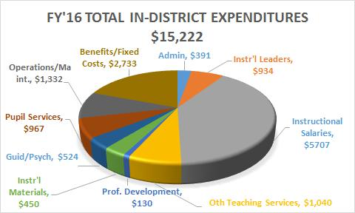

* Pupil Services includes Family Liaisons, security, athletics, school breakfast and lunch programs

12

STONEHAM PUBLIC SCHOOLS

FY19 BUDGET PROPOSAL

Our Students

Student Demographics

The diversity of the Town of Stoneham is reflected in our students. More than 21 languages are spoken at home by 87 English Language Learners. The most frequently spoken non-English languages are Spanish (29%), Portuguese (23%), and Arabic (14%).

Enrollment by Race/Ethnicity (2016/2017)

Race | % of District | % of State
African American | 2.0% | 8.9%
Asian | 4.4% | 6.7%
Hispanic | 6.6% | 19.4%
White | 83.6% | 61.3%
Multi-Race, Non-Hispanic & Other | 3.1% | 3.4%
Native American | 0.3% | 0.2%

 | Enrollment by Selected Populations (2016/2017)
 | Group | % of District | % of State
 | First Language Not English | 11.6% | 20.1%
 | English Language Learner | 3.5% | 9.5%
 | Students with Disabilities | 17.9% | 17.4%
 | High Needs | 32.5% | 45.2%
 | Economically Disadvantaged | 16.3% | 30.2%
13
STONEHAM PUBLIC SCHOOLS |  | FY19 BUDGET PROPOSAL

Enrollment History

Year | Pre K-4 | 5-8 | 9-12 | Out of | Total | Change | %
 |  |  |  | District |  |  | Change
SY 14 | 940 | 745 | 632 | 59 | 2,376 | -44 | 1.8%
SY 15 | 961 | 746 | 643 | 56 | 2,406 | 30 | 1.2%
SY 16 | 968 | 706 | 679 | 51 | 2,404 | -2 | 0.0%
SY 17 | 980 | 687 | 676 | 43 | 2,386 | -18 | 0.7%
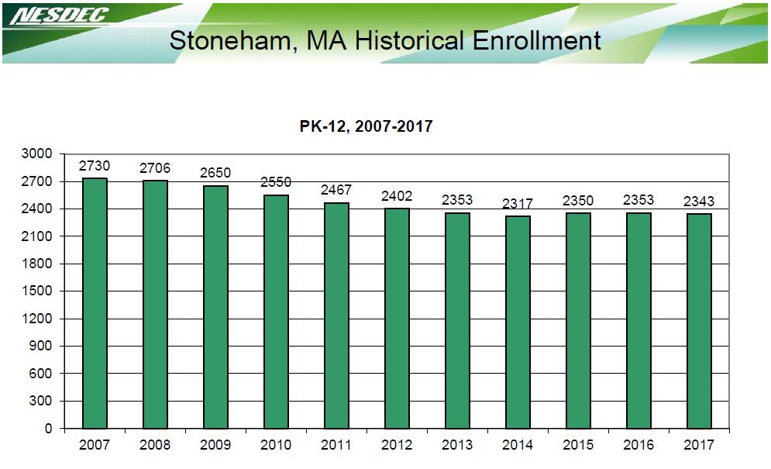

FY 17-18 Class Enrollment & Staff Allotment

Grade | PK | K | 1 | 2 | 3 | 4 | 5 | 6 | 7 | 8 | 9 | 10 | 11 | 12 | SP
#of Students | 88 | 173 | 181 | 180 | 172 | 186 | 174 | 170 | 171 | 172 | 180 | 171 | 172 | 152 | 1
#of Teachers ** | 5 | 8 | 8 | 8 | 8 | 8 | 8 | 8 | 8 | 8 |  | 44**
Core Academics
# of Paras* |  |  | 34.6 |  |  |  |  | 13 |  |  |  | 8.1

*# of Students/# core academic Teachers *Paraprofessionals are not generally classroom assigned

**High School Core Academic Subject Teachers (Teach Multiple Grades)

14
STONEHAM PUBLIC SCHOOLS FY19 BUDGET PROPOSAL

Current Class Size (2017-2018)

 | PreK |  |  |  |  | Kindergarten |  |  |  | Grade 1 |  |  |  | Grade 2 |  |  |  |  |  | Grade 3 |  |  |  |  |  | Grade 4 |  |  |  |  |  | Grades | Grades 9-
 |  |  |  |  |  |  |  |  |  |  |  |  |  |  |  |  |  |  |  |  |  |  |  |  |  |  |  |  |  |  |  | 5-8 | 12
Colonial | 13 |  | 5 | 14 | 26 |  | 25 | 0 |  | 25 | 25 | 0 |  | 25 |  | 22 |  | 0 |  | 21 |  | 21 |  | 0 |  | 24 |  | 24 |  | 0 |  | 0 | 0
Park | 12
Robin | 12 |  |  | 13 | 19 |  | 22 | 24 |  | 22 | 24 | 23 |  | 23 |  | 23 |  | 23 |  | 22 |  | 21 |  | 22 |  | 23 |  | 22 |  | 23 |  | 0 | 0
Hood | 11 |  |  | 12
South | 0 |  | 0 | 0 | 19 |  | 19 | 18 |  | 21 | 22 | 22 |  | 22 |  | 22 |  | 22 |  | 21 |  | 22 |  | 22 |  | 23 |  | 23 |  | 24 |  | 0 | 0
CMS | 0 |  | 0 | 0 | 0 |  | 0 | 0 |  | 0 | 0 | 0 |  | 0 |  | 0 |  | 0 |  | 0 |  | 0 |  | 0 |  | 0 |  | 0 |  | 0 |  | 687/22 | 0
SHS | 0 |  | 0 | 0 | 0 |  | 0 | 0 |  | 0 | 0 | 0 |  | 0 |  | 0 |  | 0 |  | 0 |  | 0 |  | 0 |  | 0 |  | 0 |  | 0 |  | 0 | 675/16
 | Projected Class Size (2018-2019)
 | PreK |  |  |  |  | Kindergarten |  |  |  | Grade 1 |  |  |  | Grade 2 |  |  |  |  |  | Grade 3 |  |  |  |  | Grade 4 |  |  |  |  |  | Grades 5- |  | Grades 9-
 |  |  |  |  |  |  |  |  |  |  |  |  |  |  |  |  |  |  |  |  |  |  |  |  |  |  |  |  |  |  | 8 |  | 12
Colonial | 0 |  | 0 | 0 |  | 23 | 23 |  |  | 17 | 17 | 17 |  | 25 | 25 |  |  | 0 |  | 24 |  | 24 |  |  | 21 |  | 21 |  | 0 |  | 0 |  | 0
Park
Robin | 12 |  |  | 13 |  | 20 | 20 |  | 20 | 21 | 22 | 22 |  | 23 | 23 |  |  | 23 |  | 23 |  | 23 |  | 23 | 22 |  | 22 |  | 22 |  | 0 |  | 0
Hood | 12 |  |  | 13
South | 12 |  | 5 | 14 |  | 20 | 20 |  | 20 | 18 | 19 | 19 |  | 22 | 22 |  |  | 22 |  | 22 |  | 22 |  | 22 | 22 |  | 22 |  | 22 |  | 0 |  | 0
 | 12
CMS | 0 |  | 0 | 0 |  | 0 | 0 |  | 0 | 0 | 0 | 0 |  | 0 | 0 |  |  | 0 |  | 0 |  | 0 |  | 0 | 0 |  | 0 |  | 0 |  | 701/22 |  | 0
SHS | 0 |  | 0 | 0 |  | 0 | 0 |  | 0 | 0 | 0 | 0 |  | 0 | 0 |  |  | 0 |  | 0 |  | 0 |  | 0 | 0 |  | 0 |  | 0 |  | 0 |  | 695/16
OOD |  |  |  |  |  |  |  |  |  |  |  |  |  |  |  |  |  |  |  |  |  |  |  |  |  |  |  |  |  |  | Dist |  | 47

15

STONEHAM PUBLIC SCHOOLS

FY19 BUDGET PROPOSAL

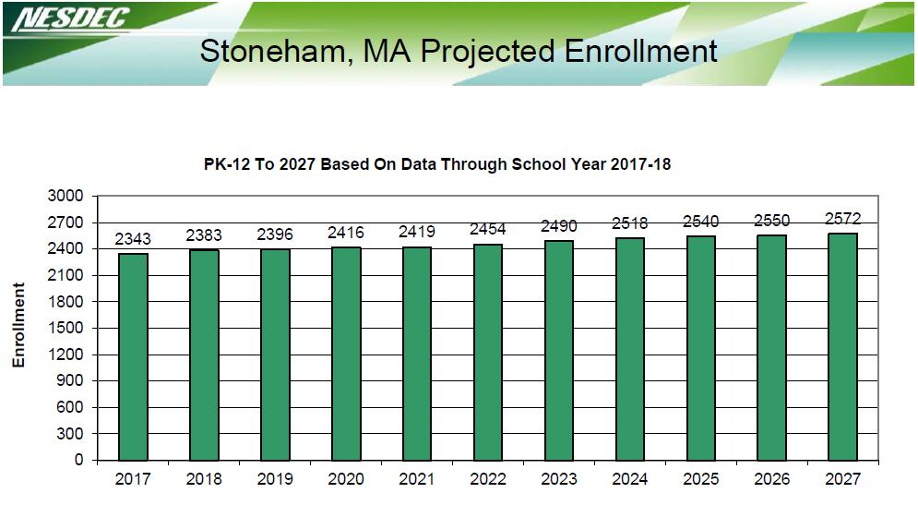

Misc. Student Data (SPS)

 | District Total
# of incoming School Choice students | 0
# of outgoing School Choice students | 7
# of Stoneham Students attending Charter Schools | 68
# of International Students | 1
# of students covered under any 766 funding | 409
# of Stoneham Special Ed students who attend out of | 43
district schools
# of students considered in "homeless" category | 4

16
STONEHAM PUBLIC SCHOOLS FY19 BUDGET PROPOSAL

17

STONEHAM PUBLIC SCHOOLS

FY19 BUDGET PROPOSAL
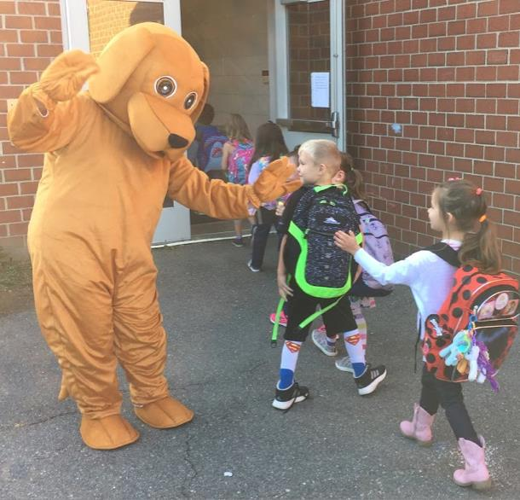

Stoneham Public Schools

2018-2019 Operating Budget Requests

Steps/Lanes/Cola | $901,288.00
Special Ed Tuitions/Summer School/PD | $400,000.00
HS Language Base and Rise Program | $226,674.00
1.0 Language Base Specialists $52,500
0.2 Speech | $10,500
0.2 Therapeutic | $10,500
0.2 BCBA | $10,500
0.2OT | $10,500
3 ABA | $98,174
1.6 Para Professional | $34,000

Elementary Literacy Program, Coach, Interventionists |  |  | $135,000.00
1. Literacy Coach |  | $85,000
Literacy Materials and Supplies |  | $50,000
STEM Increase at all levels |  |  | $141,750.00
0.8 STEM Increase | SHS | $42,000
0.6 STEM Increase | CMS | $31,500
0.6 STEM Increase | CP | $31,500
0.4 STEM Increase | RH | $21,000
0.3 STEM Increase | South | $15,750
Elementary PE Increase at all Elementary Schools |  |  | $ 63,000.00
0.4 Physical Education Increase |  | $21,000
0.6 Physical Education Increase |  | $31,500
0.4 Physical Education Increase |  | $21,000
Music Position for instrumental District Wide |  |  | $ 52,500.00
1.0 Instrumental Music Teacher |  | $52,500
Art Increase at Middle School |  |  | $ 15,750.00
0.3 ART Increase CMS |  | $15,750
High School Program |  |  | $ 55,587.00
0.2 Italian Increase |  | $11,087
1.0 MCAS Support Program |  | $5000
HS Textbooks/Supplies Increase |  | $32,500
HS Professional Development |  | $2000
Student Activities |  | $5000
District Stipends |  |  | $ 5000.00
Safety Care Stipend |  | $2500
Attendance Officer Stipend |  | $2500
Total |  |  | $1,996,549.00

18
STONEHAM PUBLIC SCHOOLS FY19 BUDGET PROPOSAL

2018-2019 Capital Request

$ | 100,000.00 | School Technology (Chromebooks
 |  | 1:1 Grades 5-12)
$ | 500,000.00 | Old Central School Repairs
$ | 350,000.00 | HS New Wing Roof
$ | 300,000.00 | Elementary Chillers
$ | 100,000.00 | Energy Management Upgrade
$ | 70,000.00 | Two 15 Passenger Vans
$ | 50,000.00 | Elementary School Phone Upgrades
$ | 25,000.00 | Radio System – Security
$ | 25,000.00 | Gator All Terrain Vehicle/Plow
$ | 25,000.00 | Flashing LED School Signs
$ | 1,550,000.00 | Total Costs Requests
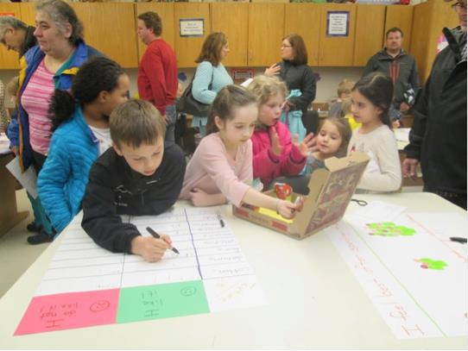

19
STONEHAM PUBLIC SCHOOLS FY19 BUDGET PROPOSAL

Stoneham Public Schools
Fiscal 2019 Budget Options
January 11, 2018

Option A |  |  | Option B |  |  |  |  |  |  | Option C |  |  |  |  |  |  |  |  | Option D |  |  |  |  |  |  |  |  | Option E |  |  |  |  |  |  |  |  | Option F
$29,731,190 | $29,262,932 |  |  |  |  |  | $29,121,374 |  |  |  |  |  |  |  | $28,982,700 |  |  |  |  |  |  |  |  | $28,844,027 |  |  |  |  |  |  |  |  | $28,705,354
$1,996,549 (7.2%) | $1,528,290 (5.5%) |  |  |  |  |  | $1,386.732 (5%) |  |  |  |  |  |  |  | $1,248,058 (4.5%) |  |  |  |  |  |  |  |  | $1,109,385 (4%) |  |  |  |  |  |  |  |  | $970,712 (3.5%)
Level Service w/Program | Level Service w/Special Ed |  |  |  |  |  |  | Level Service with |  |  |  |  |  |  |  |  | Level Service with |  |  |  |  |  |  |  | Level Service with |  |  |  |  |  |  |  |  |  | Level Service with
additions |  | Program Additions |  |  |  |  |  | Reductions |  |  |  |  |  |  |  |  | Reductions |  |  |  |  |  |  |  |  |  |  | Reductions |  |  |  |  |  |  |  | Reductions
Fixed Costs |  | Fixed Costs |  |  |  |  |  | Fixed Costs |  |  |  |  |  |  |  |  | Fixed Costs |  |  |  |  |  |  |  |  |  |  | Fixed Costs |  |  |  |  |  |  |  | Fixed Costs
COLA/STEP/Lane Increase | COLA/STEP/Lane Increase |  |  |  |  |  |  | COLA/STEP/Lane |  |  |  |  |  |  |  |  | COLA/STEP/Lane |  |  |  |  |  |  |  |  | COLA/STEP/Lane |  |  |  |  |  |  |  |  | COLA/STEP/Lane
$901,288 | $901,288 |  |  |  |  |  |  |  |  | Increase |  |  |  |  |  |  |  |  | Increase |  |  |  |  |  |  |  |  | Increase |  |  |  |  |  |  |  |  | Increase
 |  |  |  |  |  |  | $901,288 |  |  |  |  |  |  |  | $901,288 |  |  |  |  |  |  |  |  | $901,288 |  |  |  |  |  |  |  |  | $901,288
SPED Increase |  | SPED Increase |  |  |  |  |  | SPED Increase |  |  |  |  |  |  |  |  | SPED Increase |  |  |  |  |  |  |  |  |  | SPED Increase |  |  |  |  |  |  |  | SPED Increase
$400,000. | $400,000. |  |  |  |  |  | $400,000. |  |  |  |  |  |  |  | $400,000. |  |  |  |  |  |  |  |  | $400,000. |  |  |  |  |  |  |  |  | $400,000.
Additions |  |  | Additions |  |  |  |  |  | Additions |  |  |  |  |  |  |  |  | Additions |  |  |  |  |  |  |  |  |  | Additions |  |  |  |  |  |  |  |  | Additions
HS Language Base and Rise | HS Language Base and Rise |  |  |  |  |  | HS Language Base and |  |  |  |  |  |  |  |  | HS Language Base and |  |  |  |  |  |  |  |  | HS Language Base |  |  |  |  |  |  |  | HS Language Base and
Program $226,674 |  | Program $226,674 |  |  |  |  | Rise Program $226,674 |  |  |  |  |  |  |  |  | Rise Program $226,674 |  |  |  |  |  |  |  |  |  | and Rise Program |  |  |  |  |  |  |  |  |  | Rise Program
 |  |  |  |  |  |  | (-141,230) |  |  |  |  |  |  |  | (-280,232) |  |  |  |  |  |  |  |  | $226,674 |  |  |  |  |  |  |  |  | $226,674
 |  |  |  |  |  |  |  |  |  |  |  |  |  |  |  |  |  |  |  |  |  |  |  | (-418,905) |  |  |  |  |  |  |  |  | (-557,580)
Elementary Literacy Coach |  | No additional Added |  |  |  |  | Reduction of $141,230 |  |  |  |  |  |  |  |  | Reduction of $280,232 |  |  |  |  |  |  |  |  |  |  |  | Reduction of |  |  |  |  |  |  |  | Reduction of
Literacy Materials |  |  | Programs |  |  |  |  |  |  | Required |  |  |  |  |  |  |  |  | Required |  |  |  |  |  | $418,905 Required |  |  |  |  |  |  |  |  |  | $557580 Required
$135000
STEM Increase at All Levels |  |  |  |  |  |  |  | No additional Added |  |  |  |  |  |  |  |  | No additional Added |  |  |  |  |  |  |  |  |  | No additional |  |  |  |  |  |  | No additional Added
$141,750 |  |  |  |  |  |  |  |  | Programs |  |  |  |  |  |  |  |  | Programs |  |  |  |  |  |  |  | Added Programs |  |  |  |  |  |  |  |  |  |  | Programs
Increase Elementary PE
Common Planning for
Elementary
$63000
Increase Music Instrumental
$52500
Increase Art Services MS
$15750
Increase HS Programs
Italian, MCAS Program
Student Activities, PD
Textbooks, Supplies, Stipends
$60587

20
STONEHAM PUBLIC SCHOOLS FY19 BUDGET PROPOSAL

