SAMPLE BOOKLET

Design possibilities with LIGEO
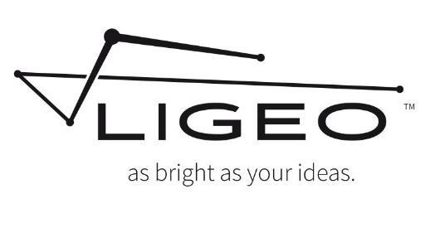

3 x 12inch/30cm LIGEOTM Light Bars
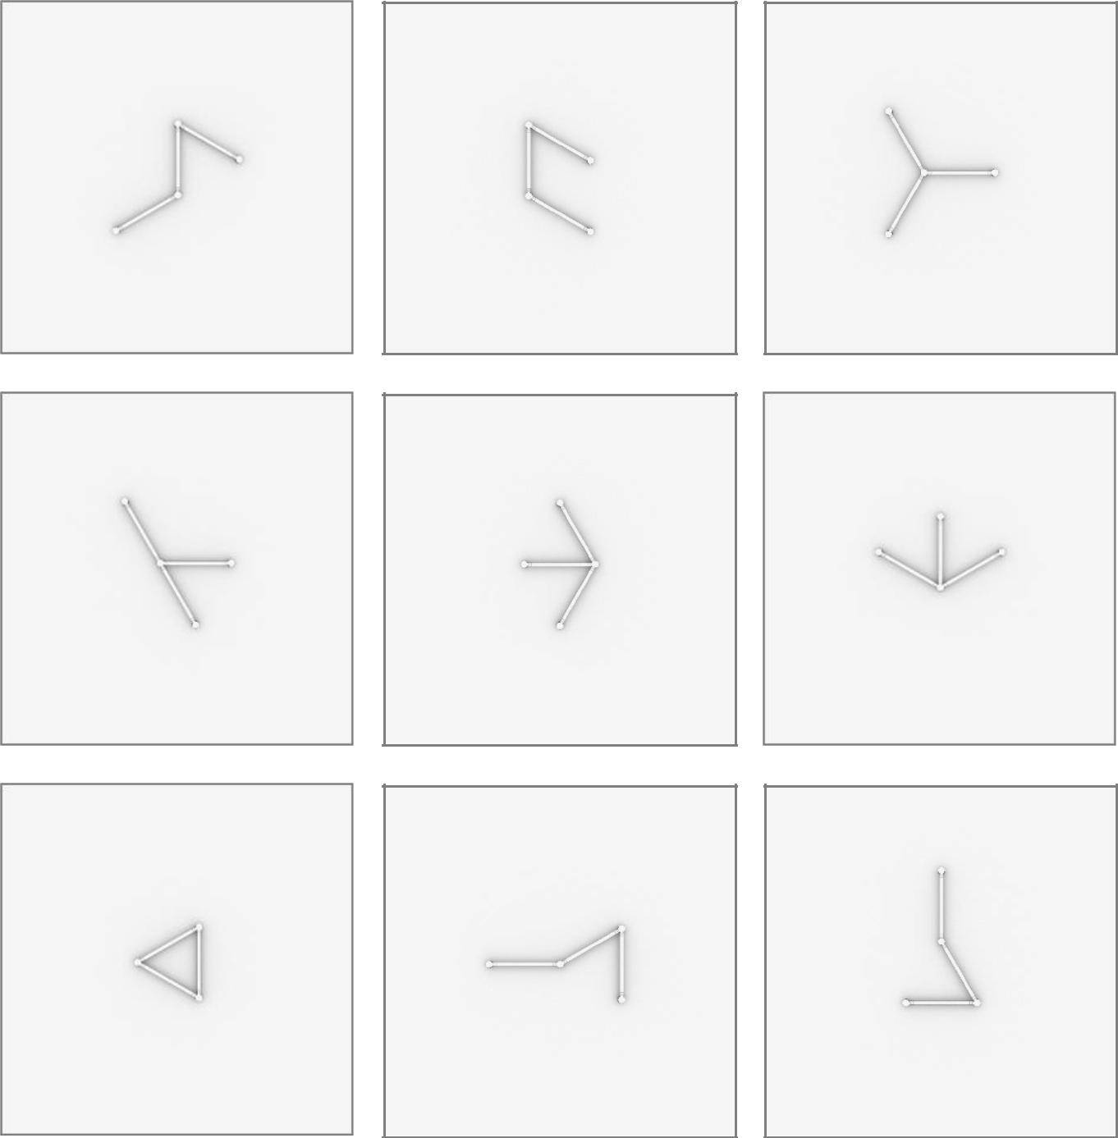

1

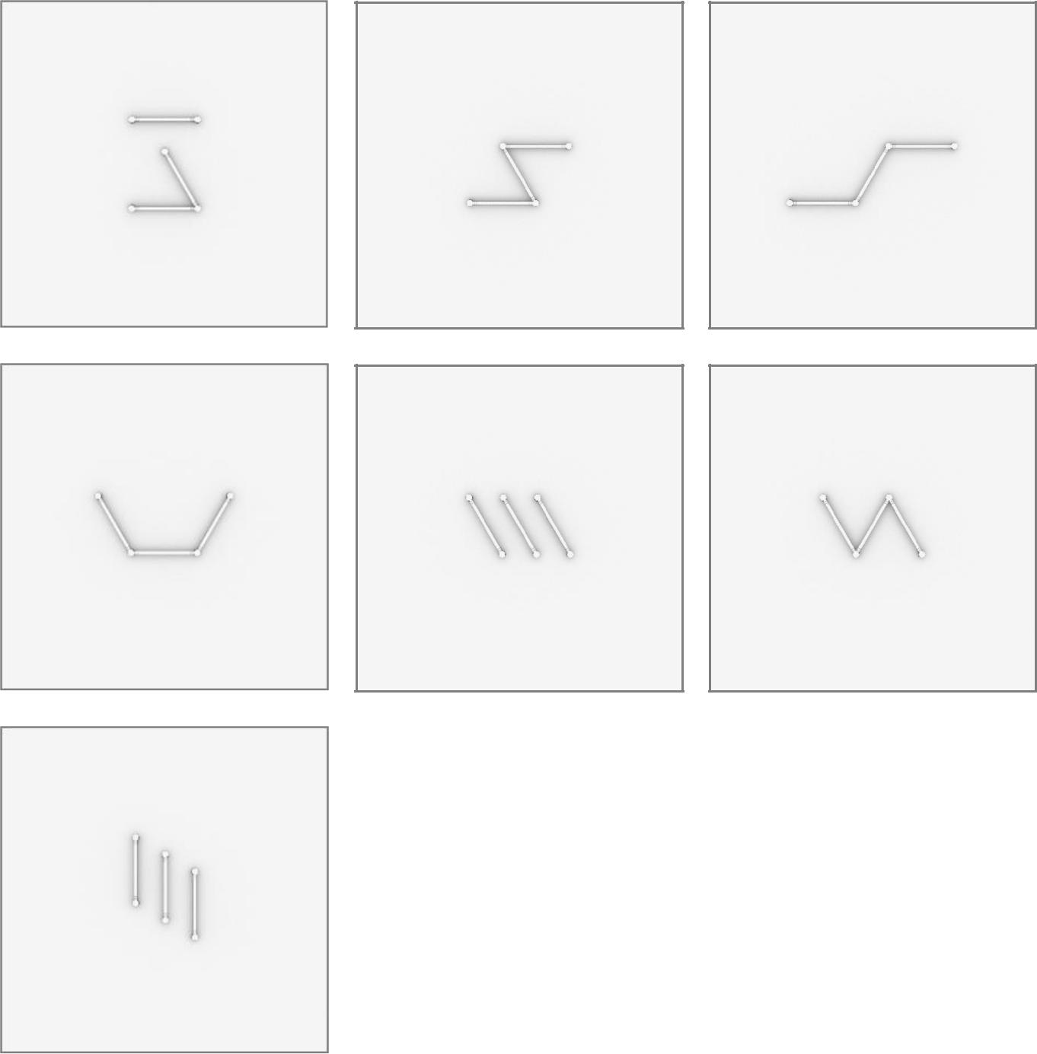

2

6 x 12inch/30cm LIGEOTM Light Bars
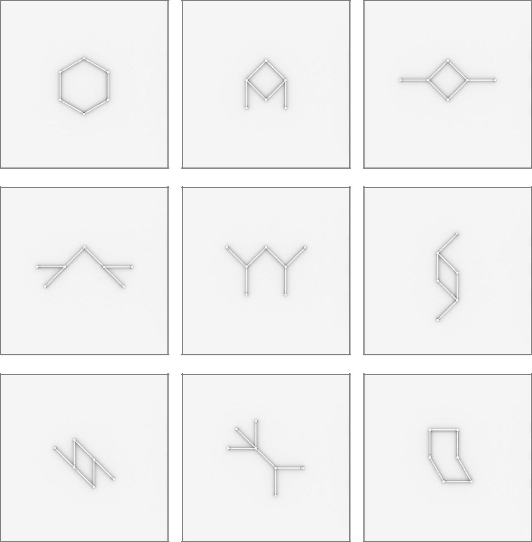

3

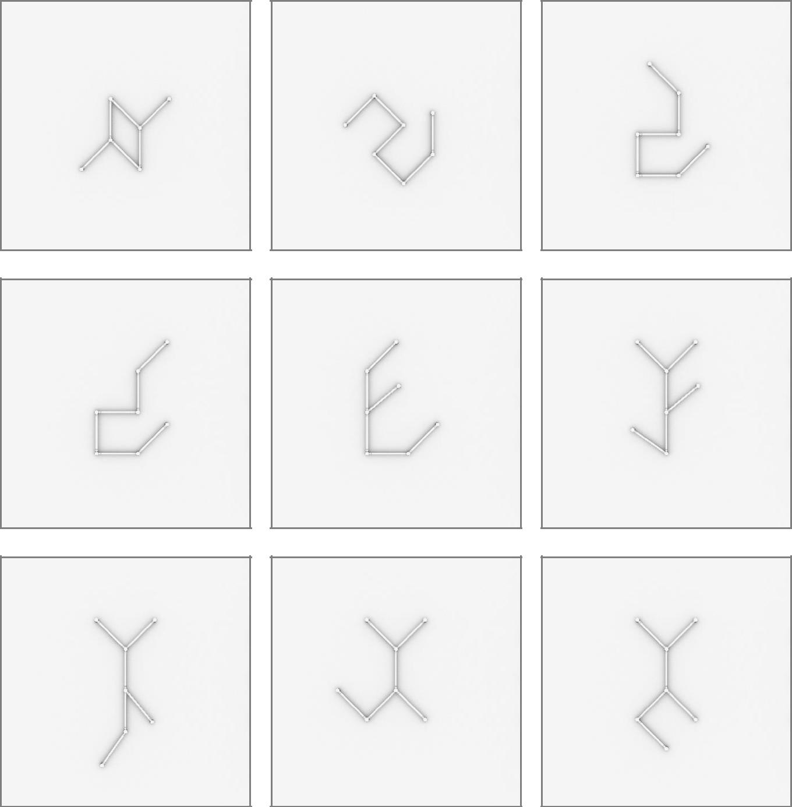

4

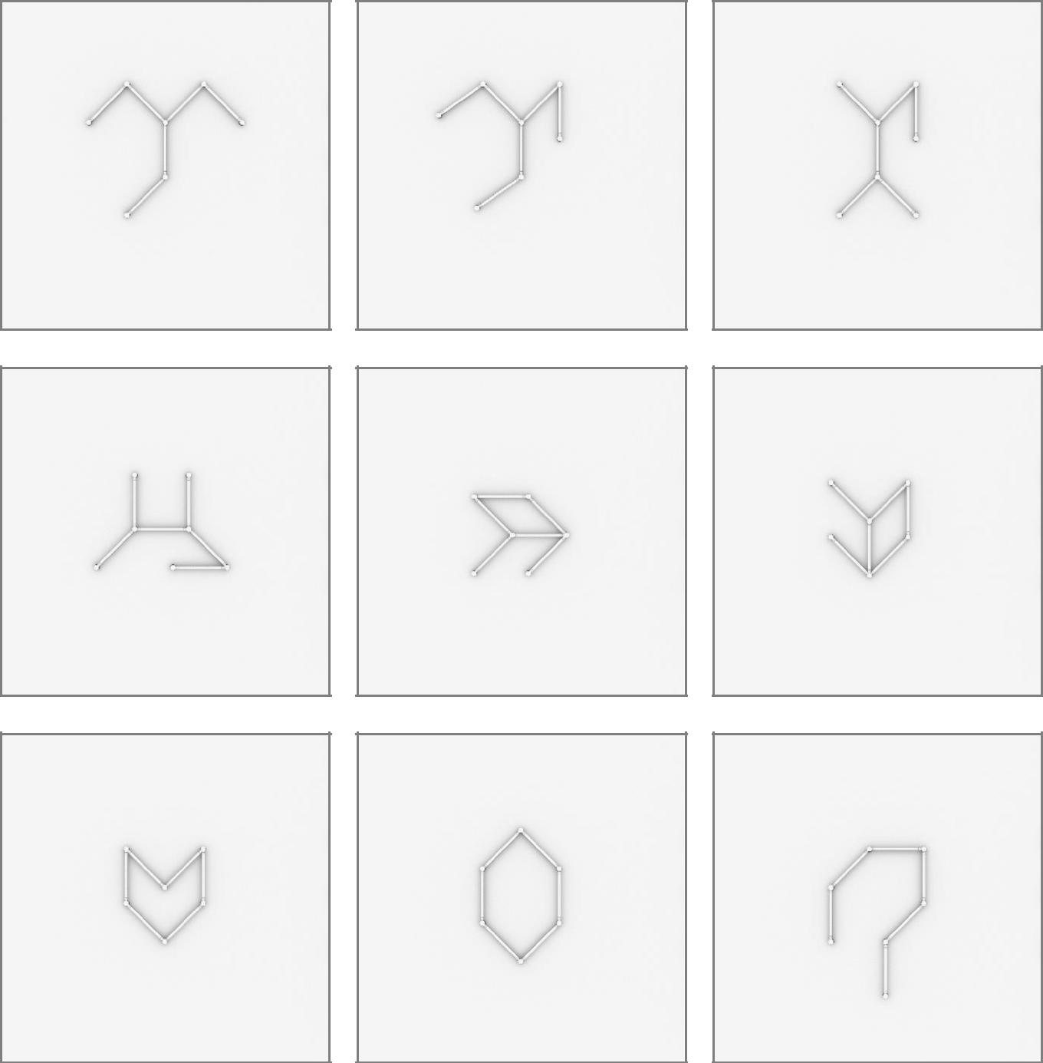

5

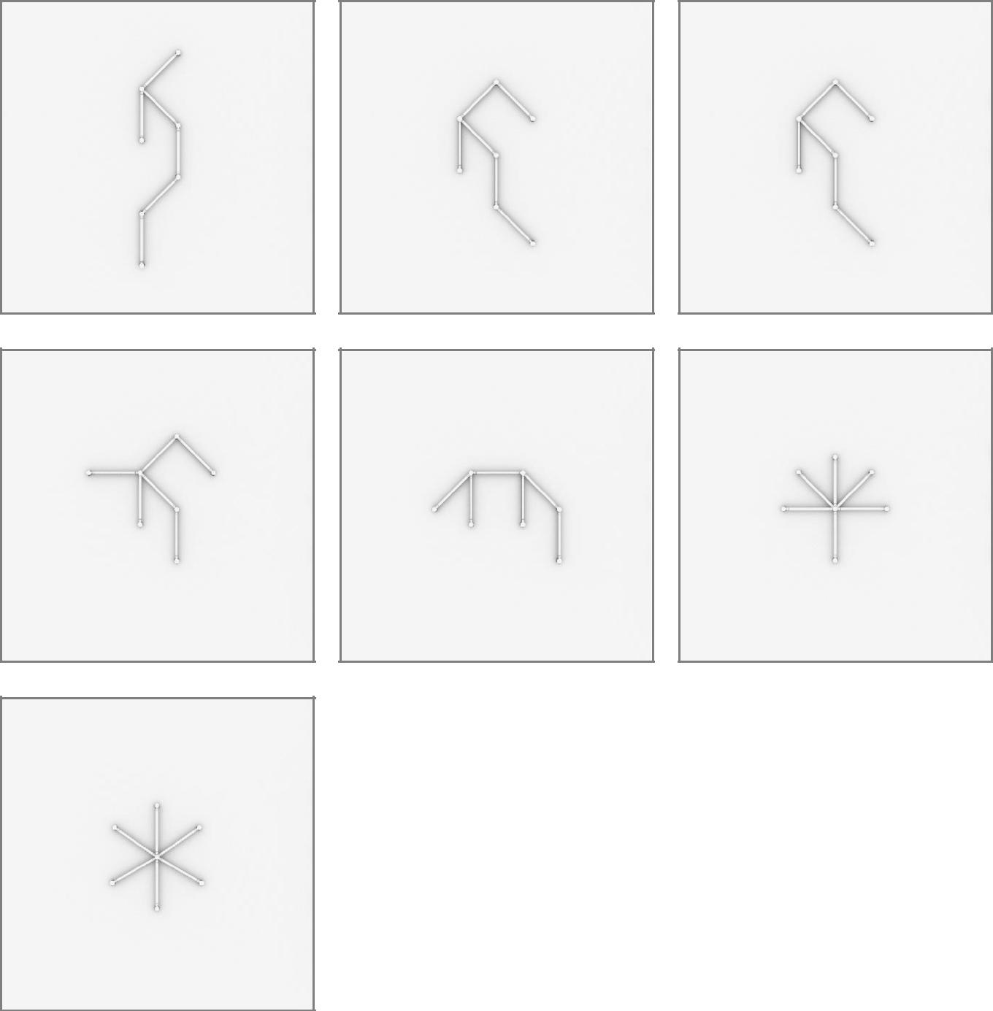

6

9 x 12inch/30cm LIGEOTM Light Bars
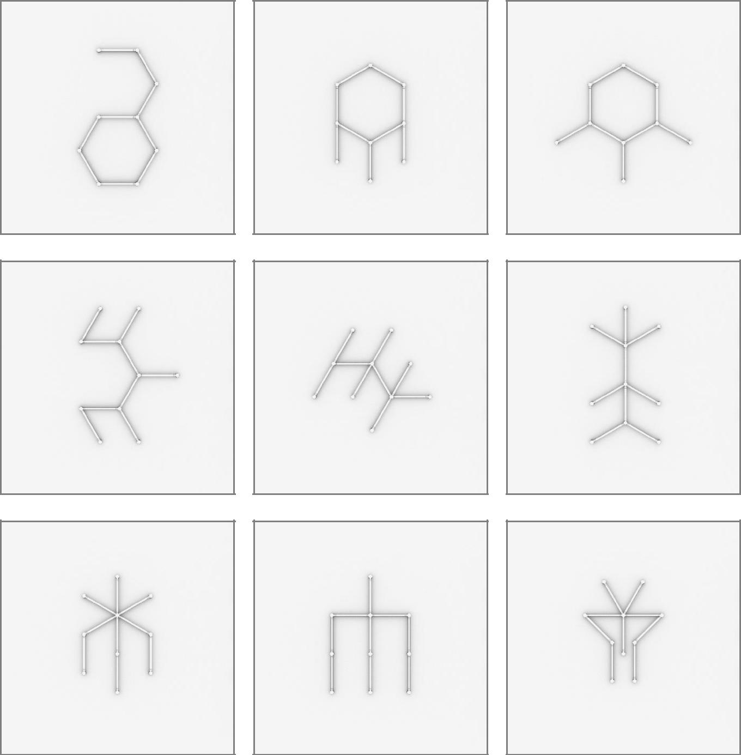

7

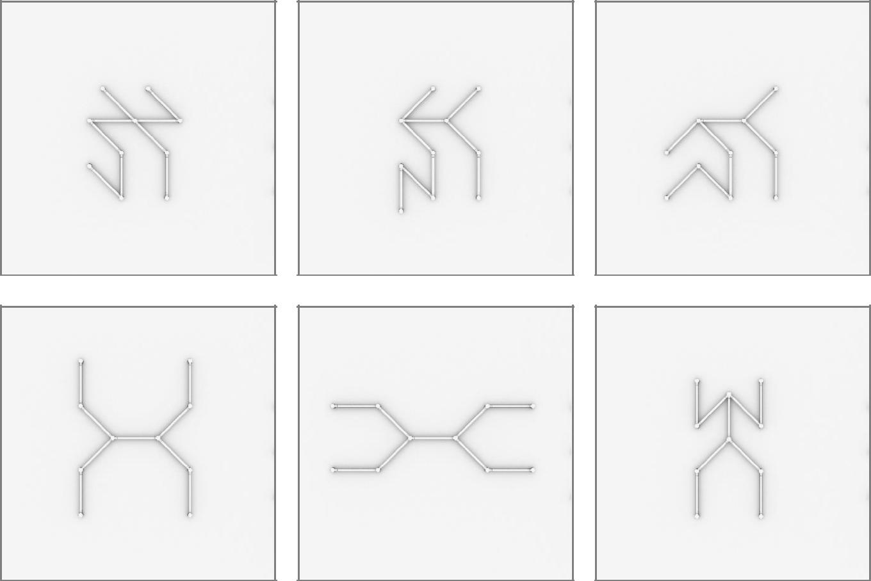

8

12 x 12inch/30cm LIGEOTM Light Bars
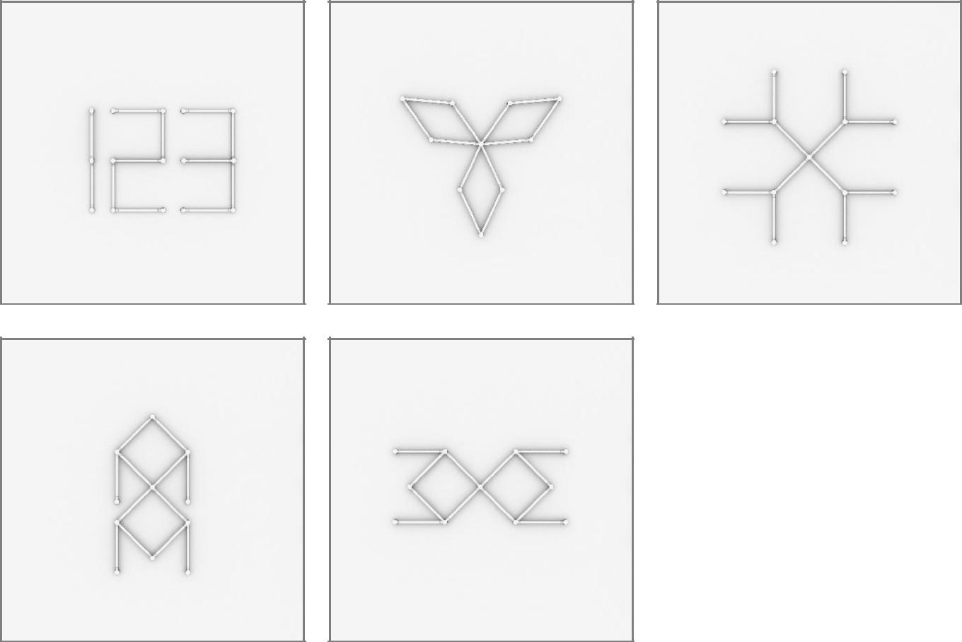

9

15 x 12inch/30cm LIGEOTM Light Bars
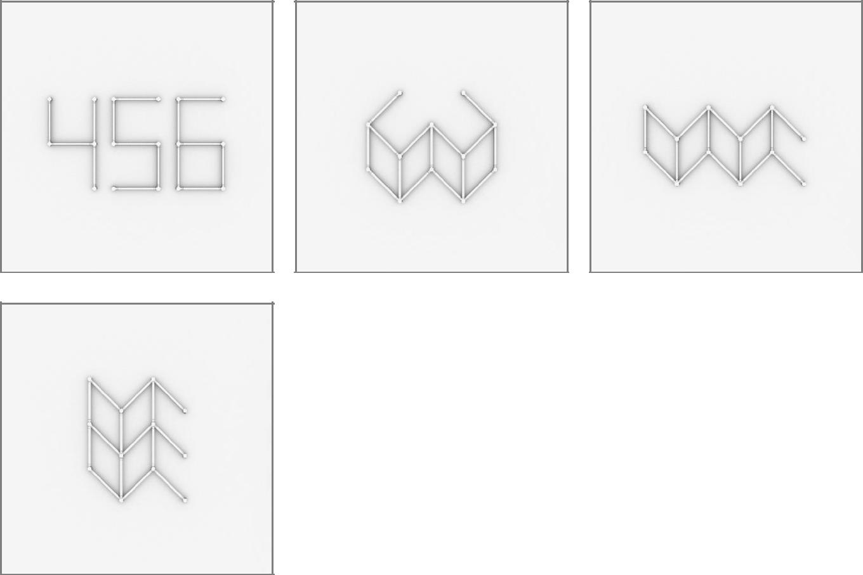

10

16 x 12inch/30cm LIGEOTM Light Bars

11

3 x 24inch/60cm LIGEOTM Light Bars

12

13

6 x 24inch/60cm LIGEOTM Light Bars
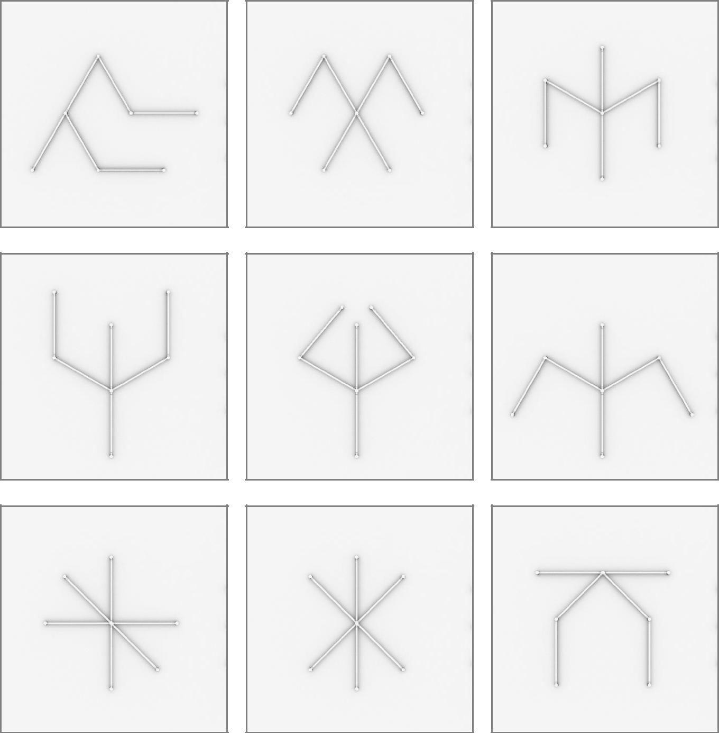

14

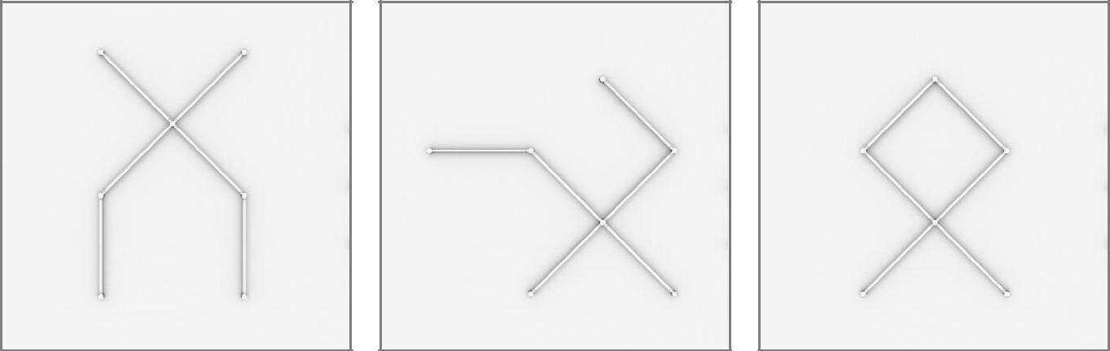

15

9 x 24inch/60cm LIGEOTM Light Bars
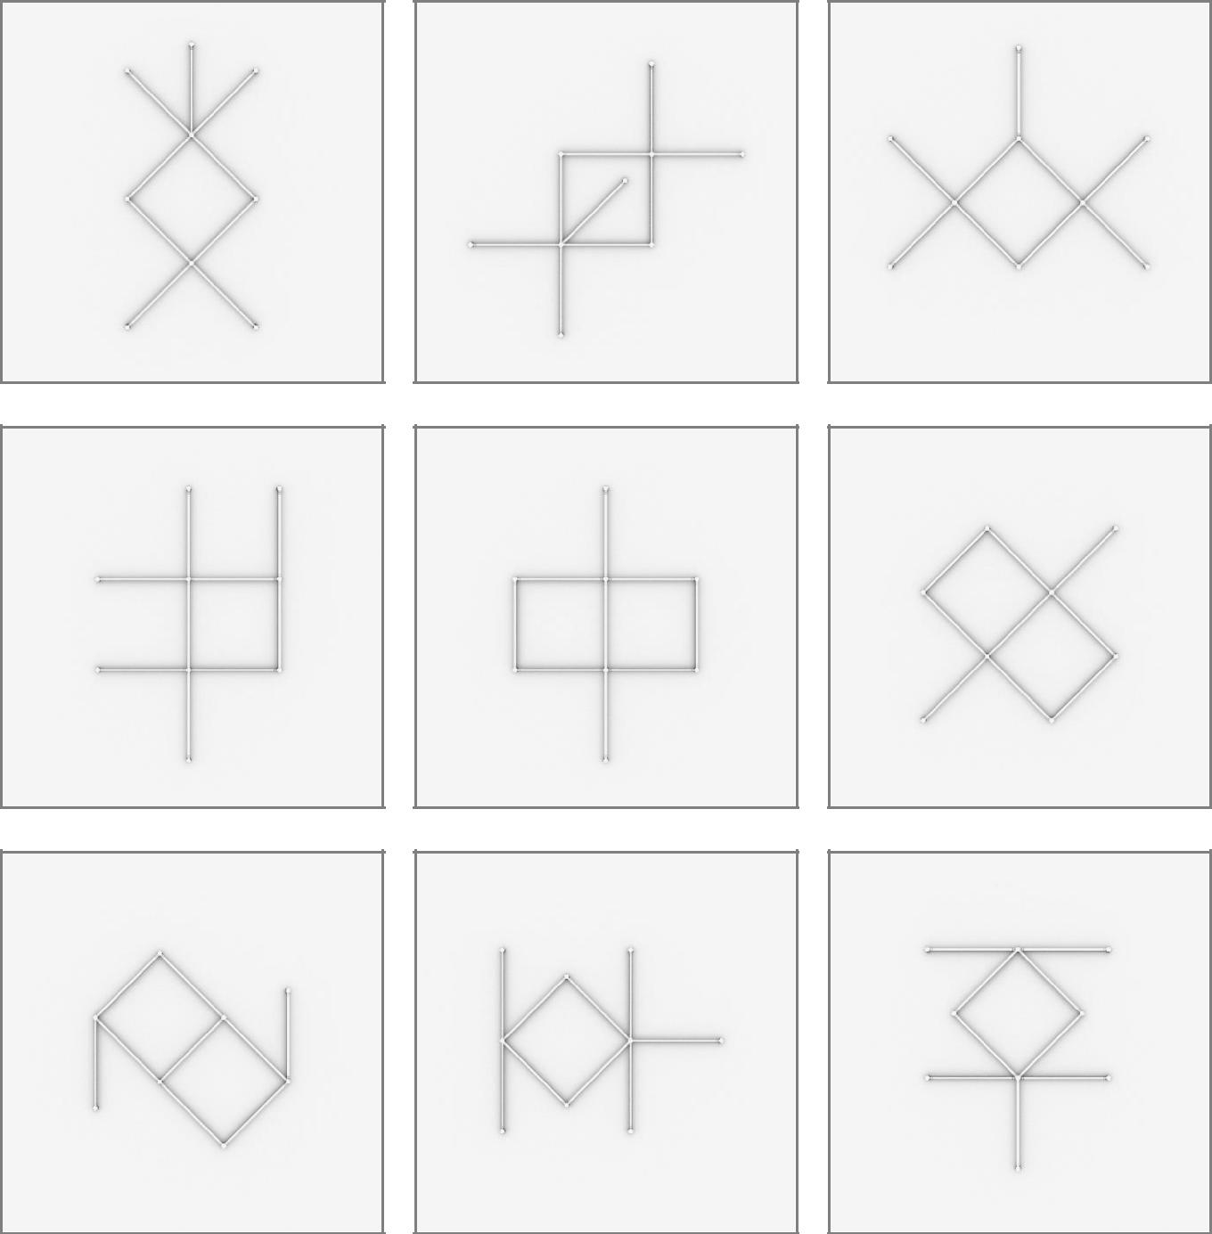

16

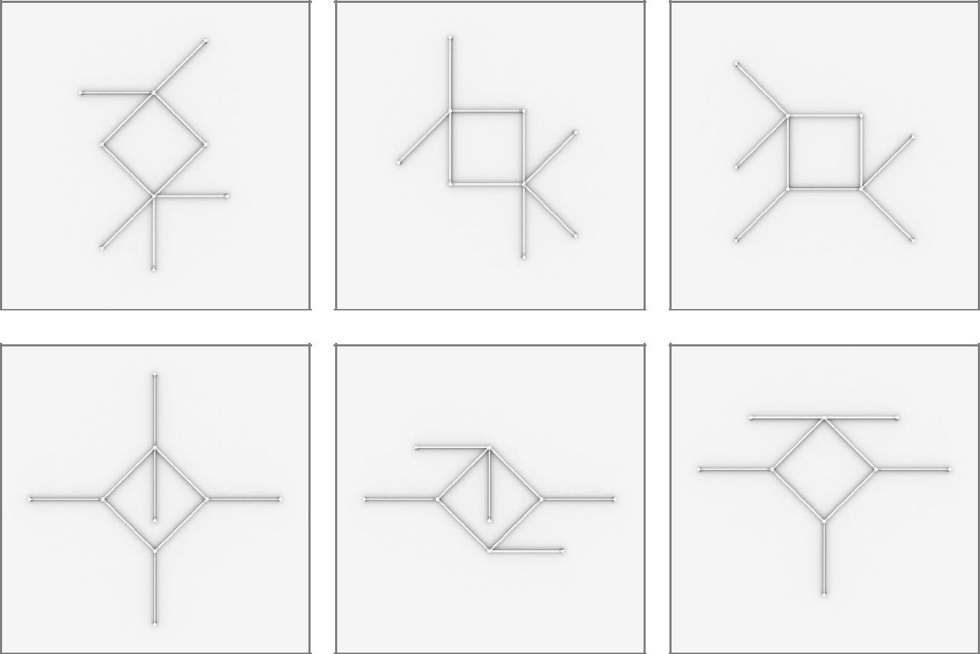

17

12 x 24inch/60cm LIGEOTM Light Bars
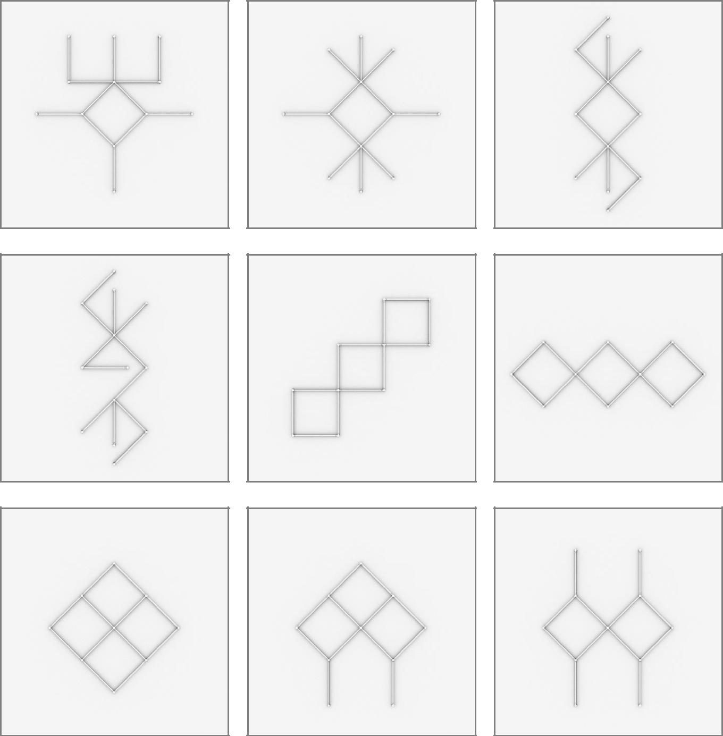

18

19

3 x 36inch/90cm LIGEOTM Light Bars
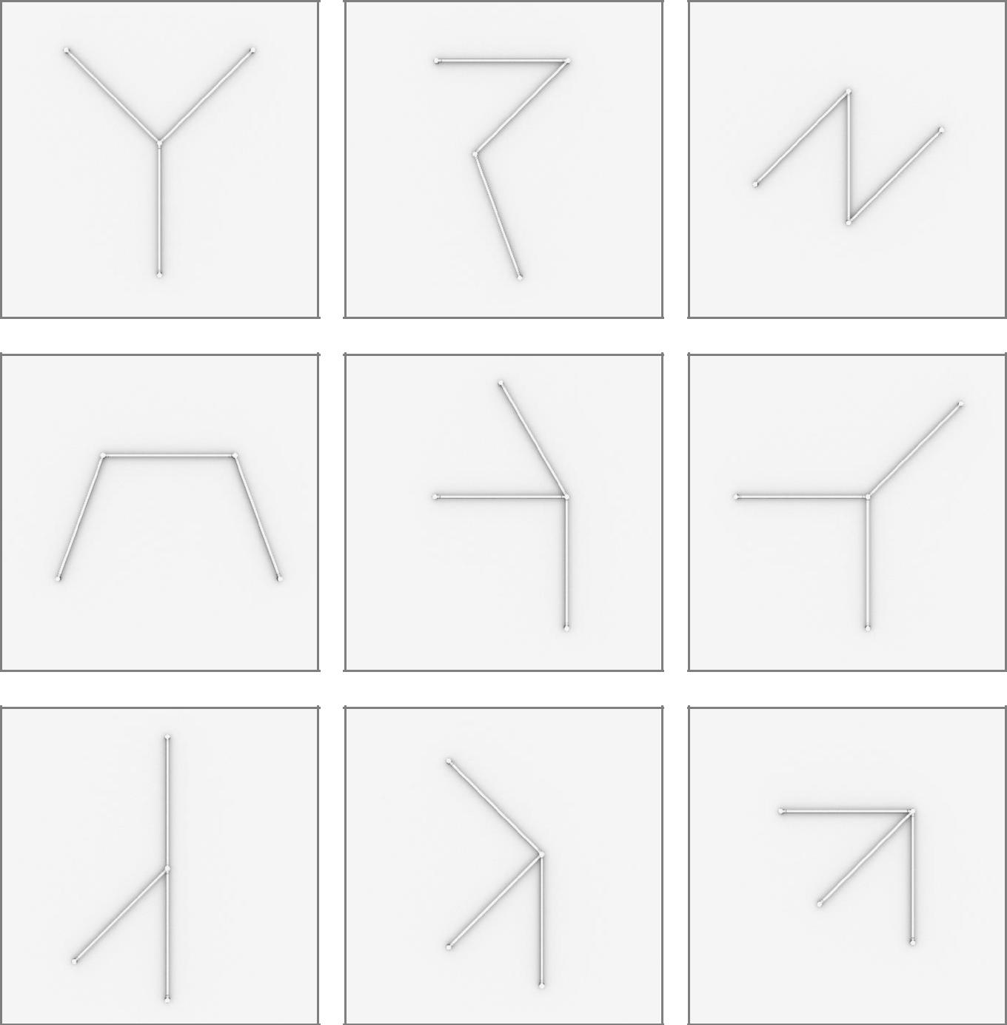

20

21

6 x 36inch/90cm LIGEOTM Light Bars
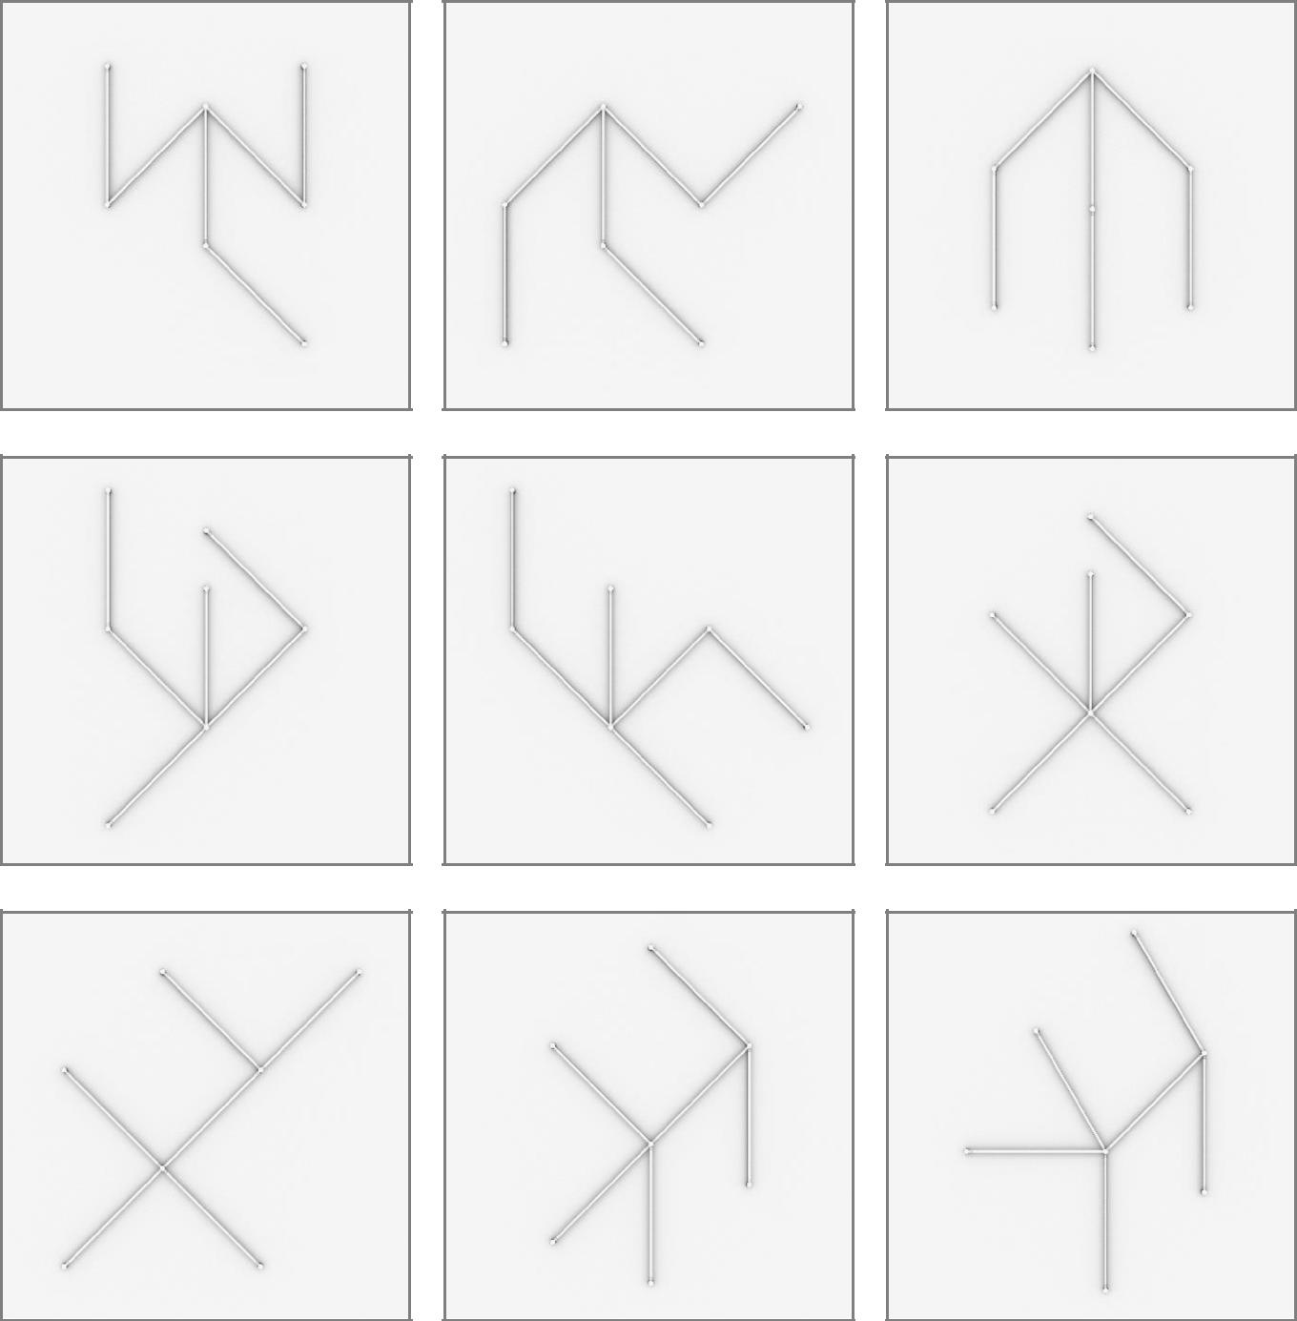

22

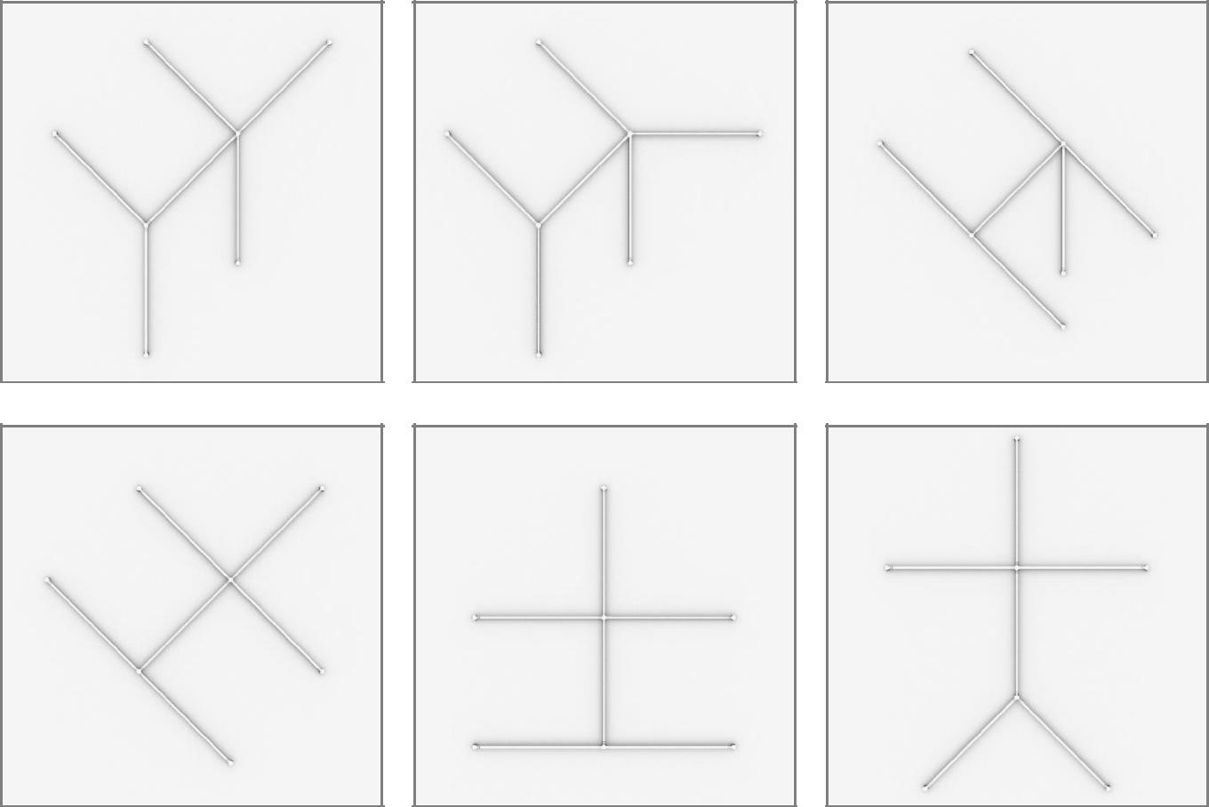

23

9 x 36inch/90cm LIGEOTM Light Bars
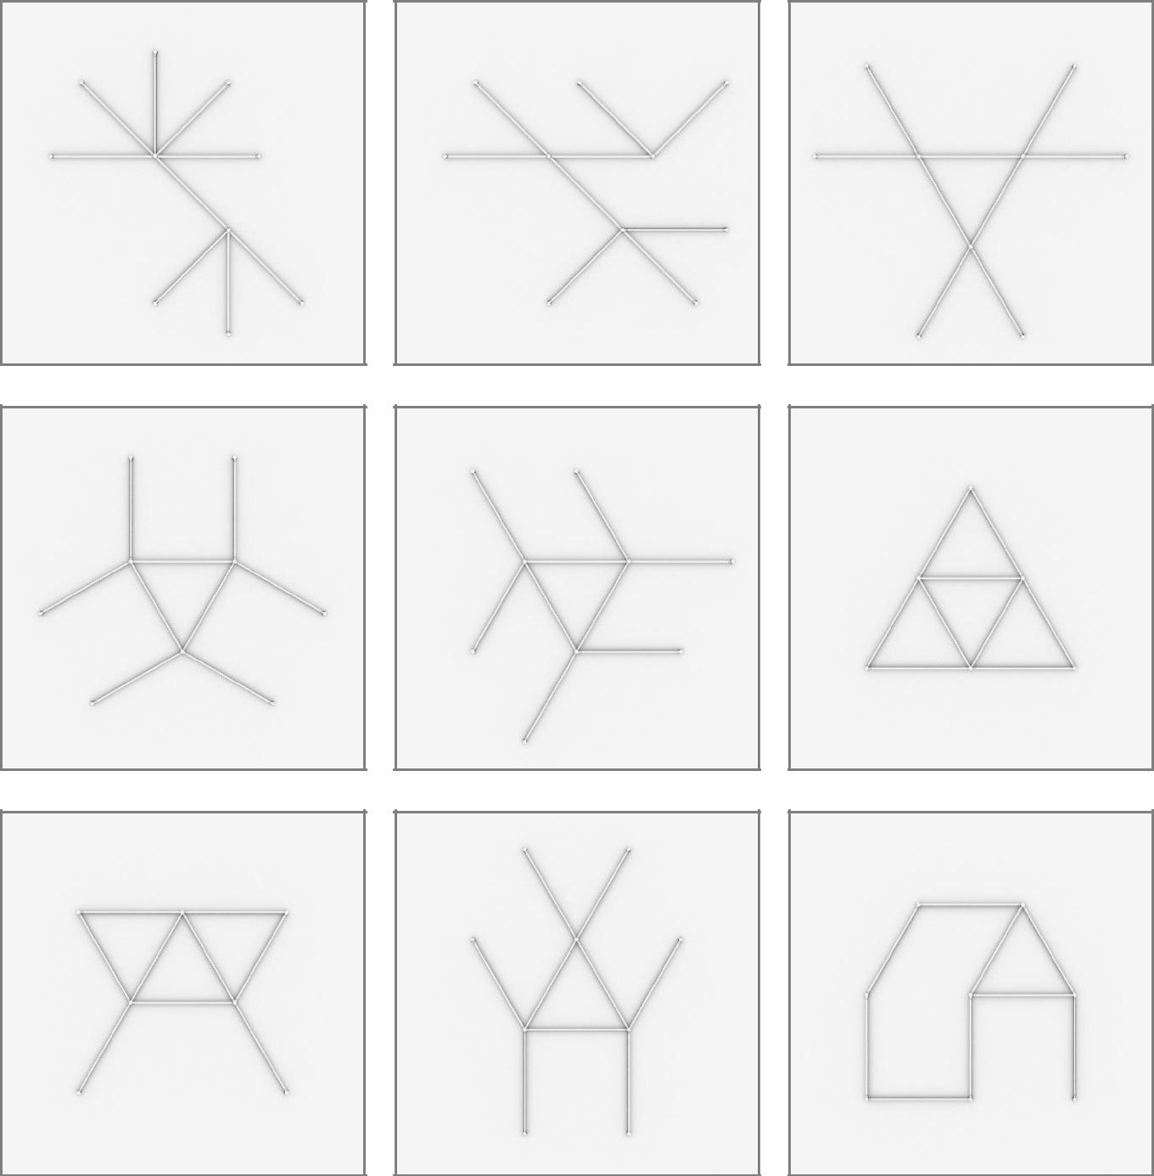

24

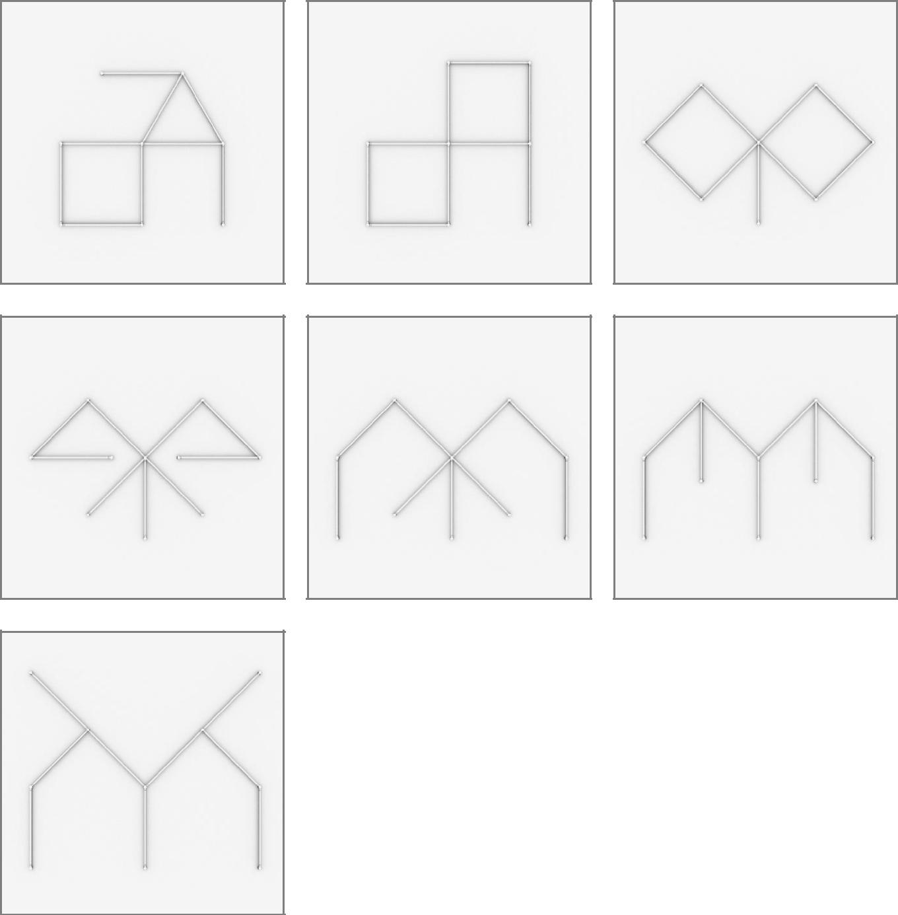

25

12 x 36inch/90cm LIGEOTM Light Bars
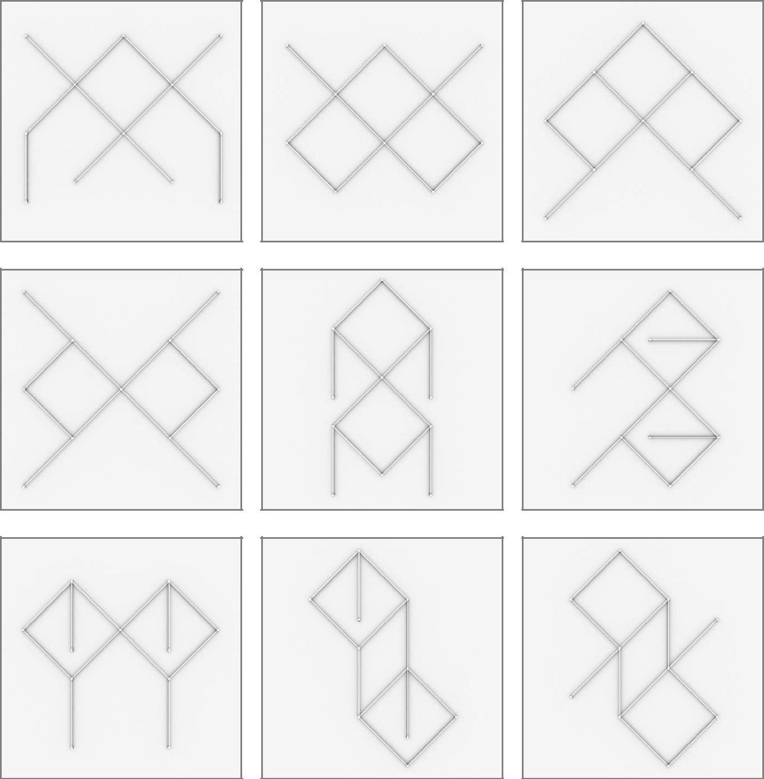

26

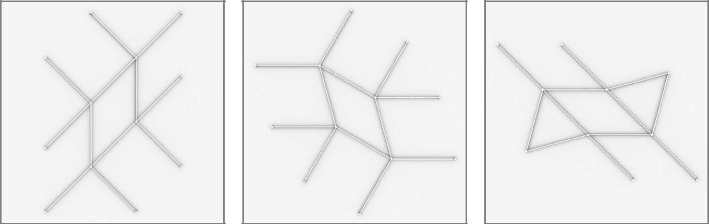

27

3 x 12inch/30cm & 3 x 24inch/60cm LIGEOsTM
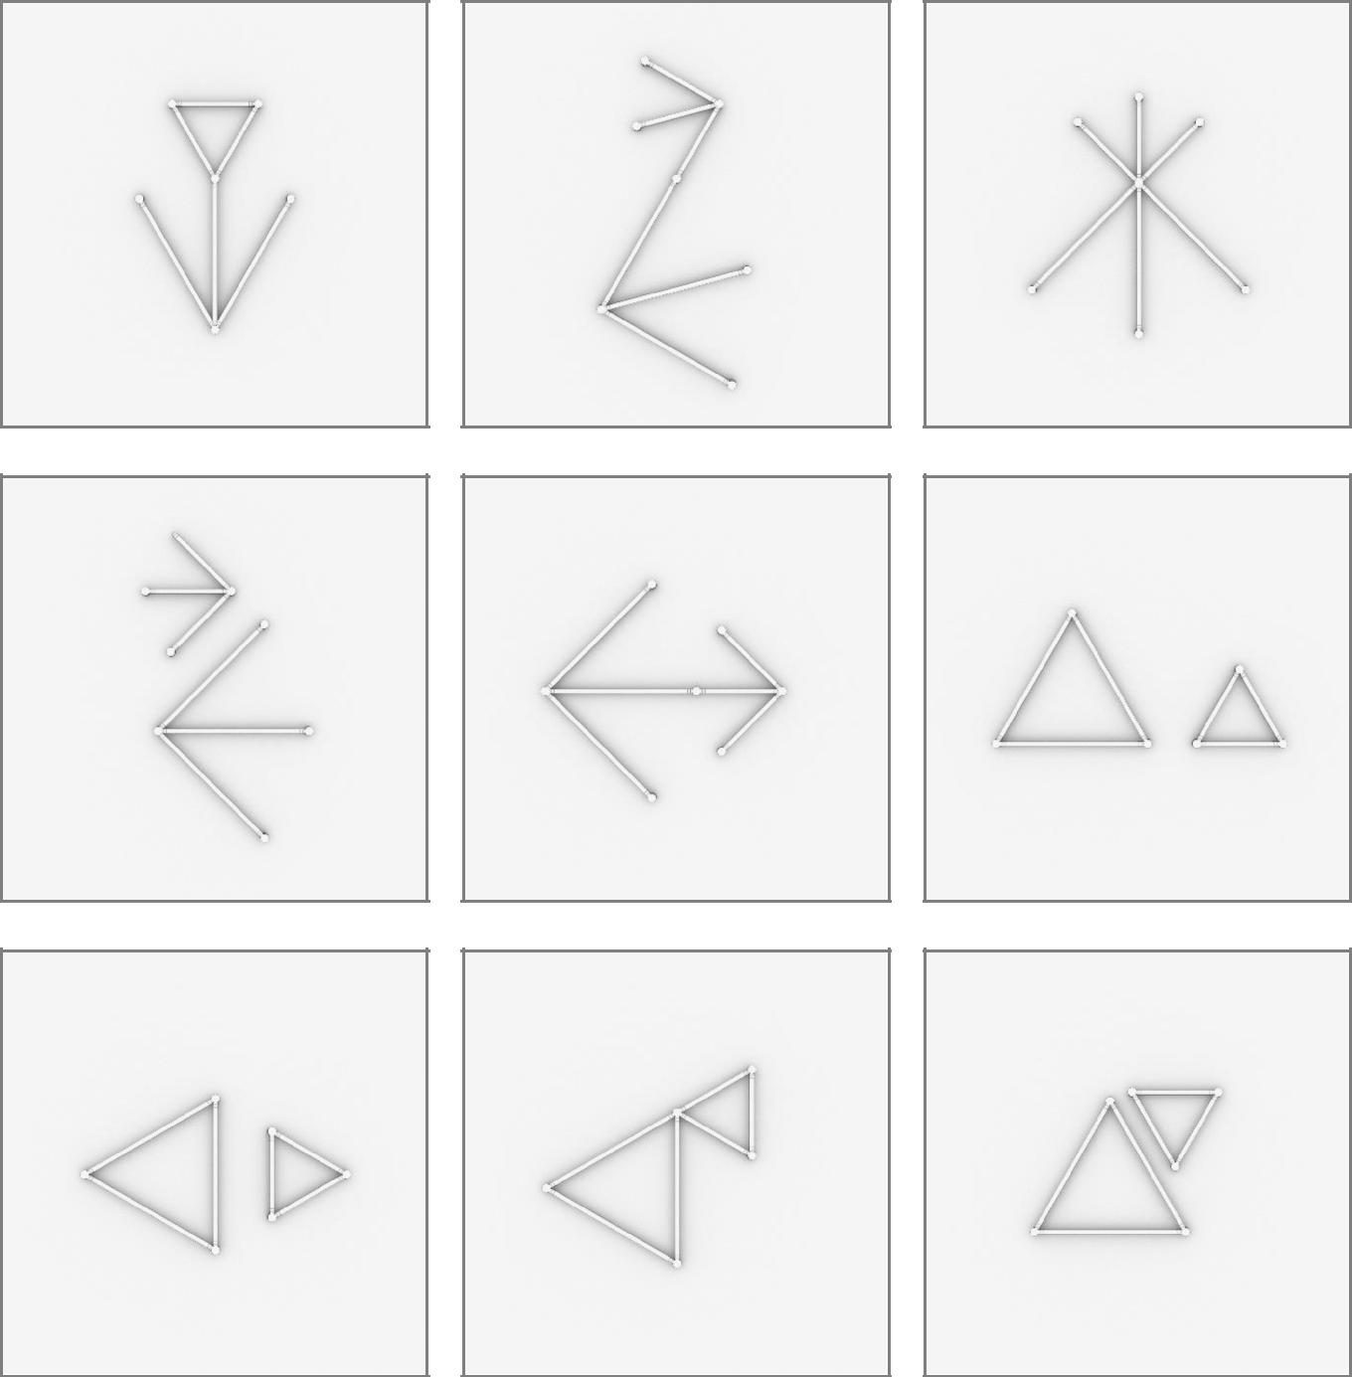

28

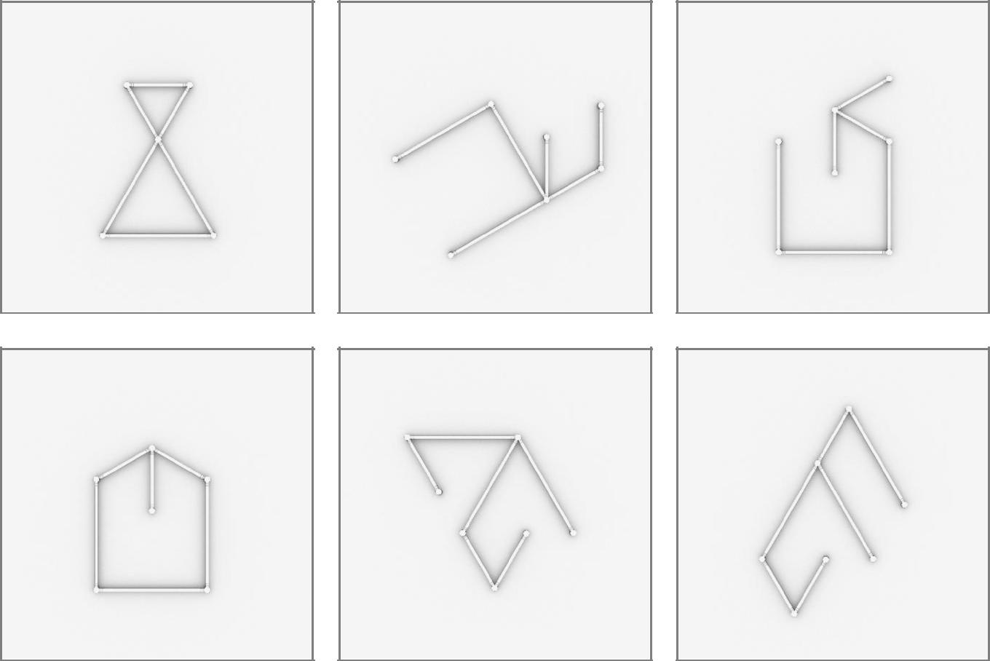

29

3 x 12inch/30cm & 3 x 36inch/90cm LIGEOsTM
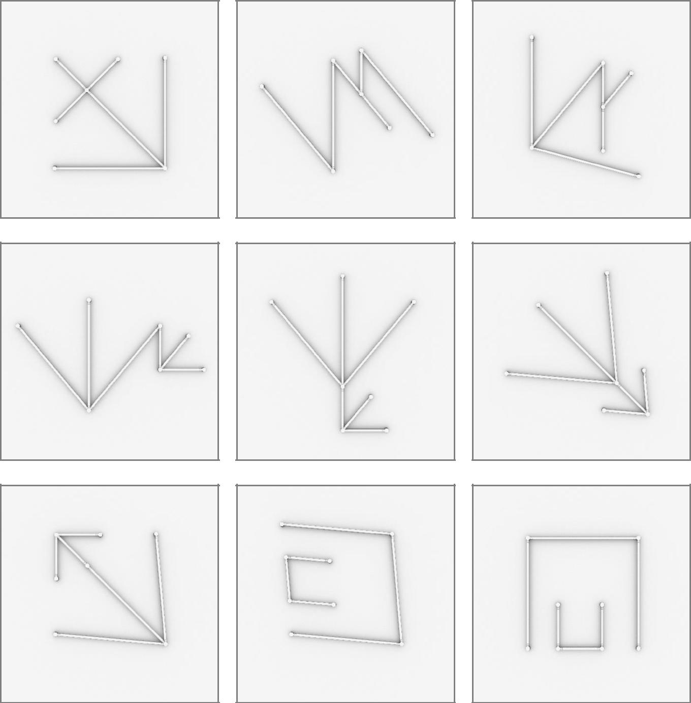

30

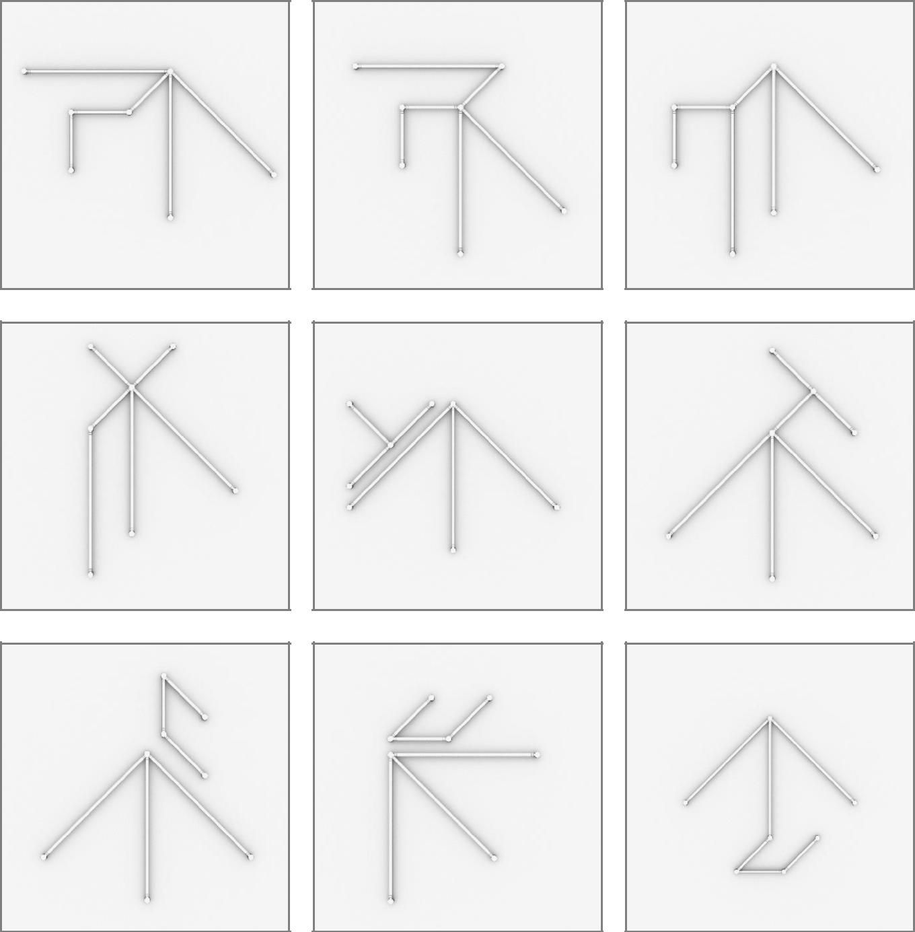

31

32

3 x 24inch/60cm & 3 x 36inch/90cm LIGEOsTM
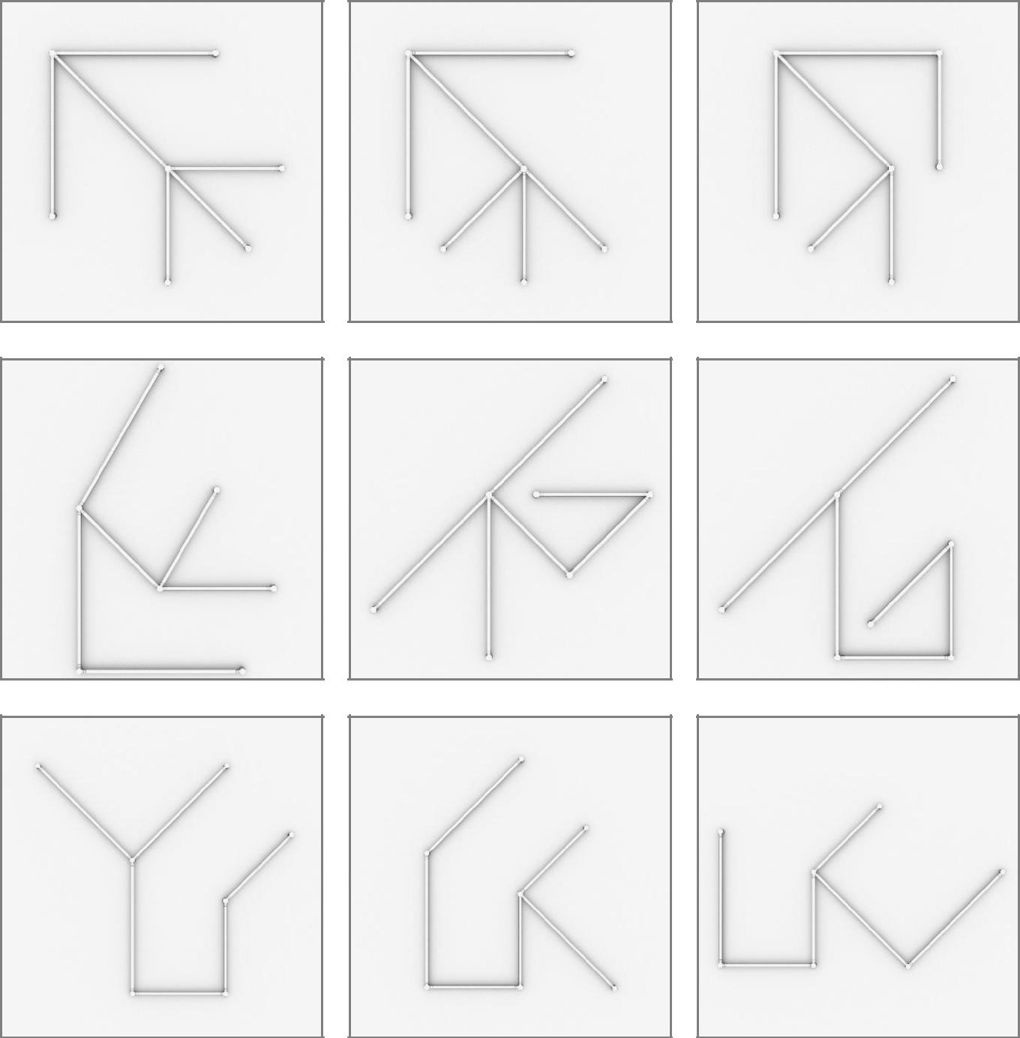

33

34

4 x 12inch/30cm & 4 x 24inch/60cm LIGEOsTM

35

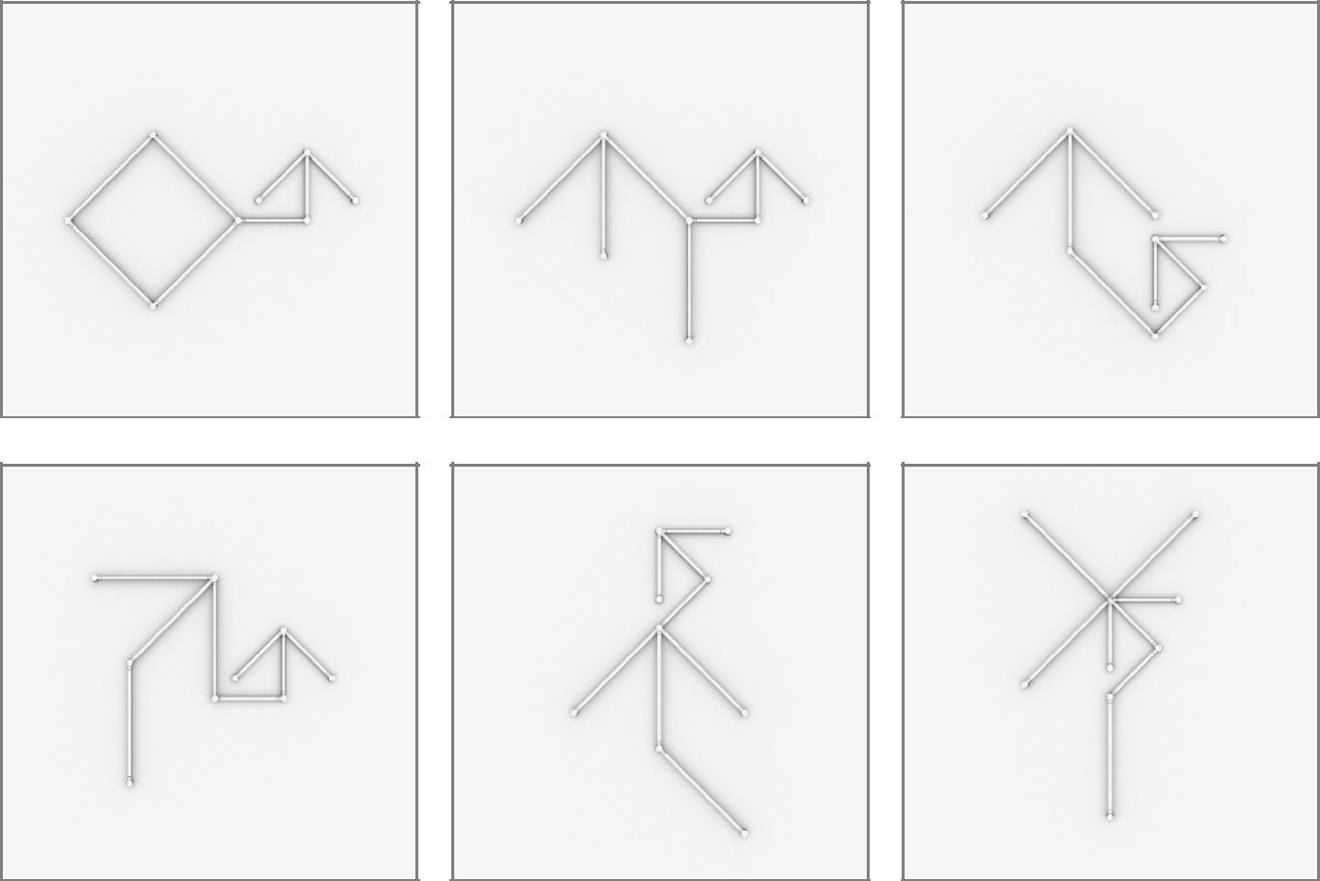

36

6 x 12inch/30cm & 3 x 24inch/60cm LIGEOsTM
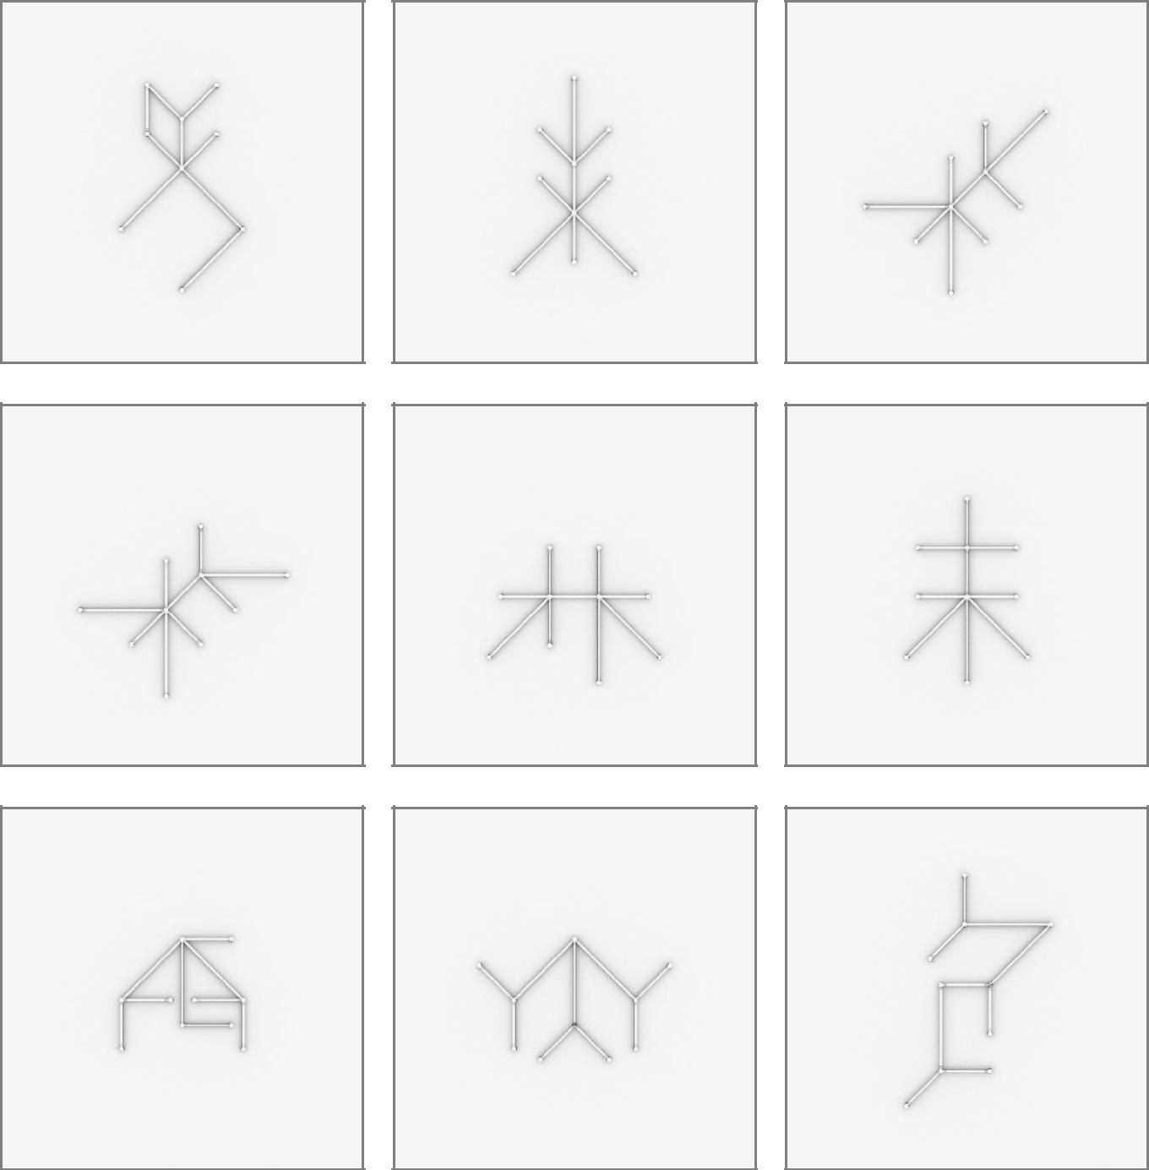

37

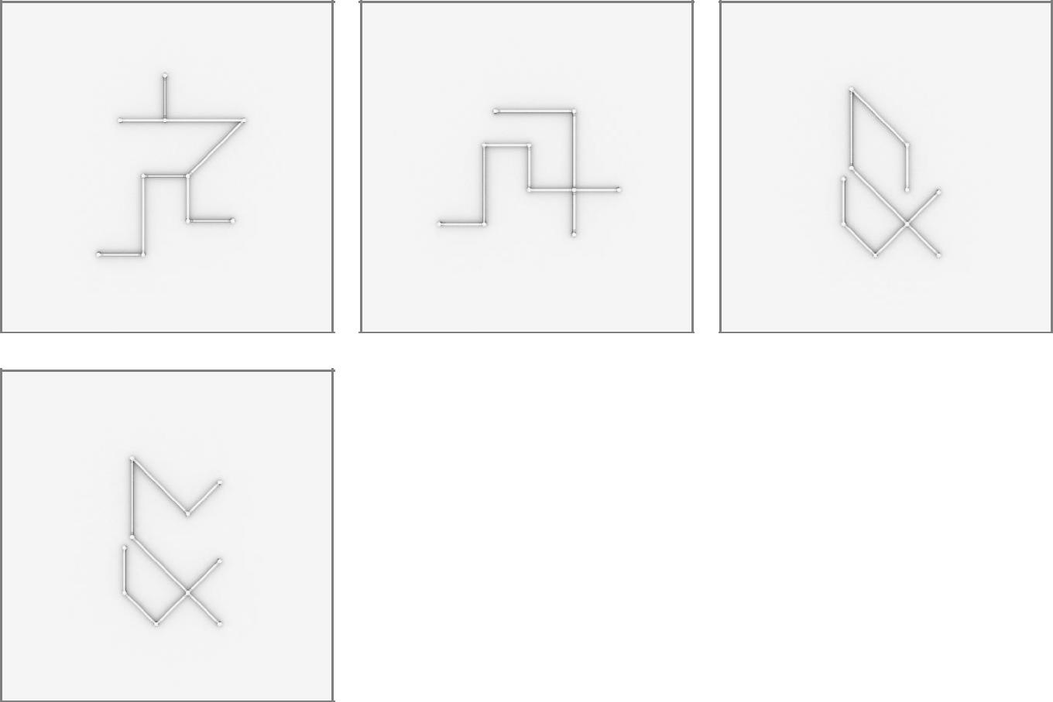

38

6 x 12inch/30cm & 3 x 36inch/90cm LIGEOsTM
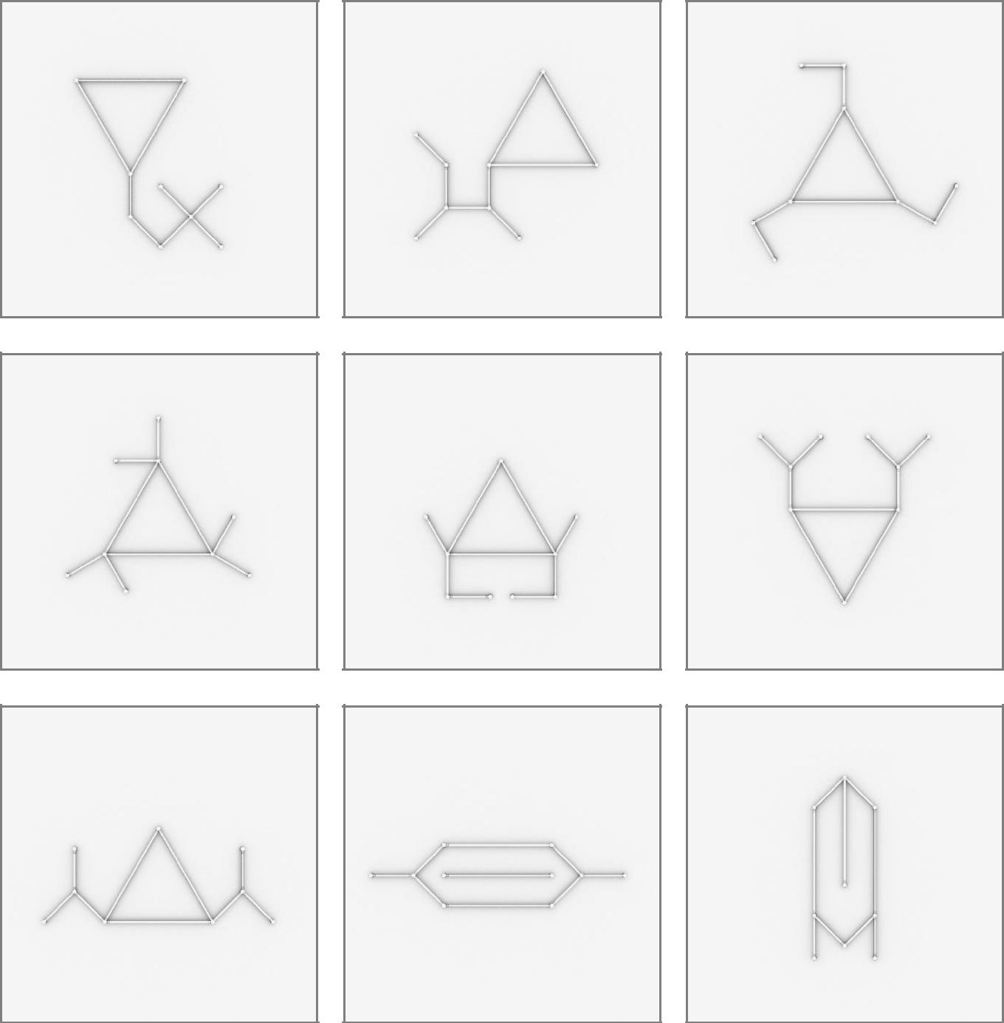

39

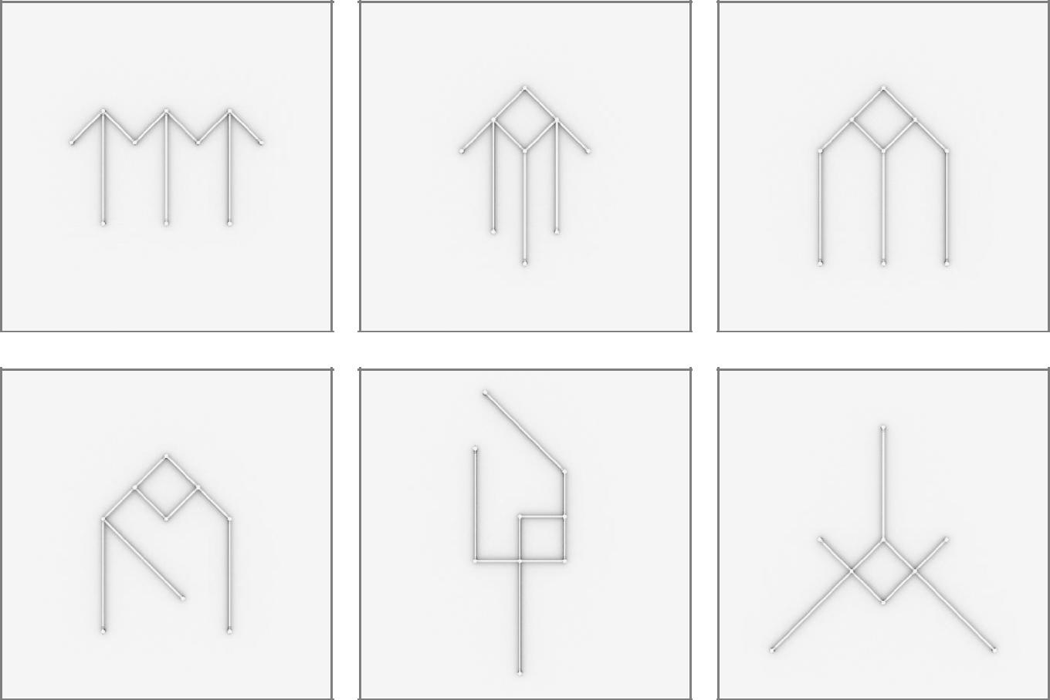

40

8 x 12inch/30cm & 4 x 24inch/60cm LIGEOsTM
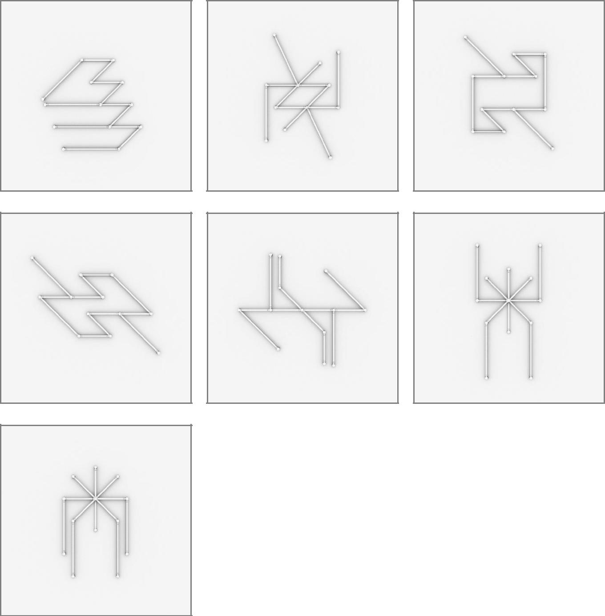

41

8 x 12inch/30cm & 3 x 24inch/60cm &

3 x 36inch/90cm LIGEOsTM
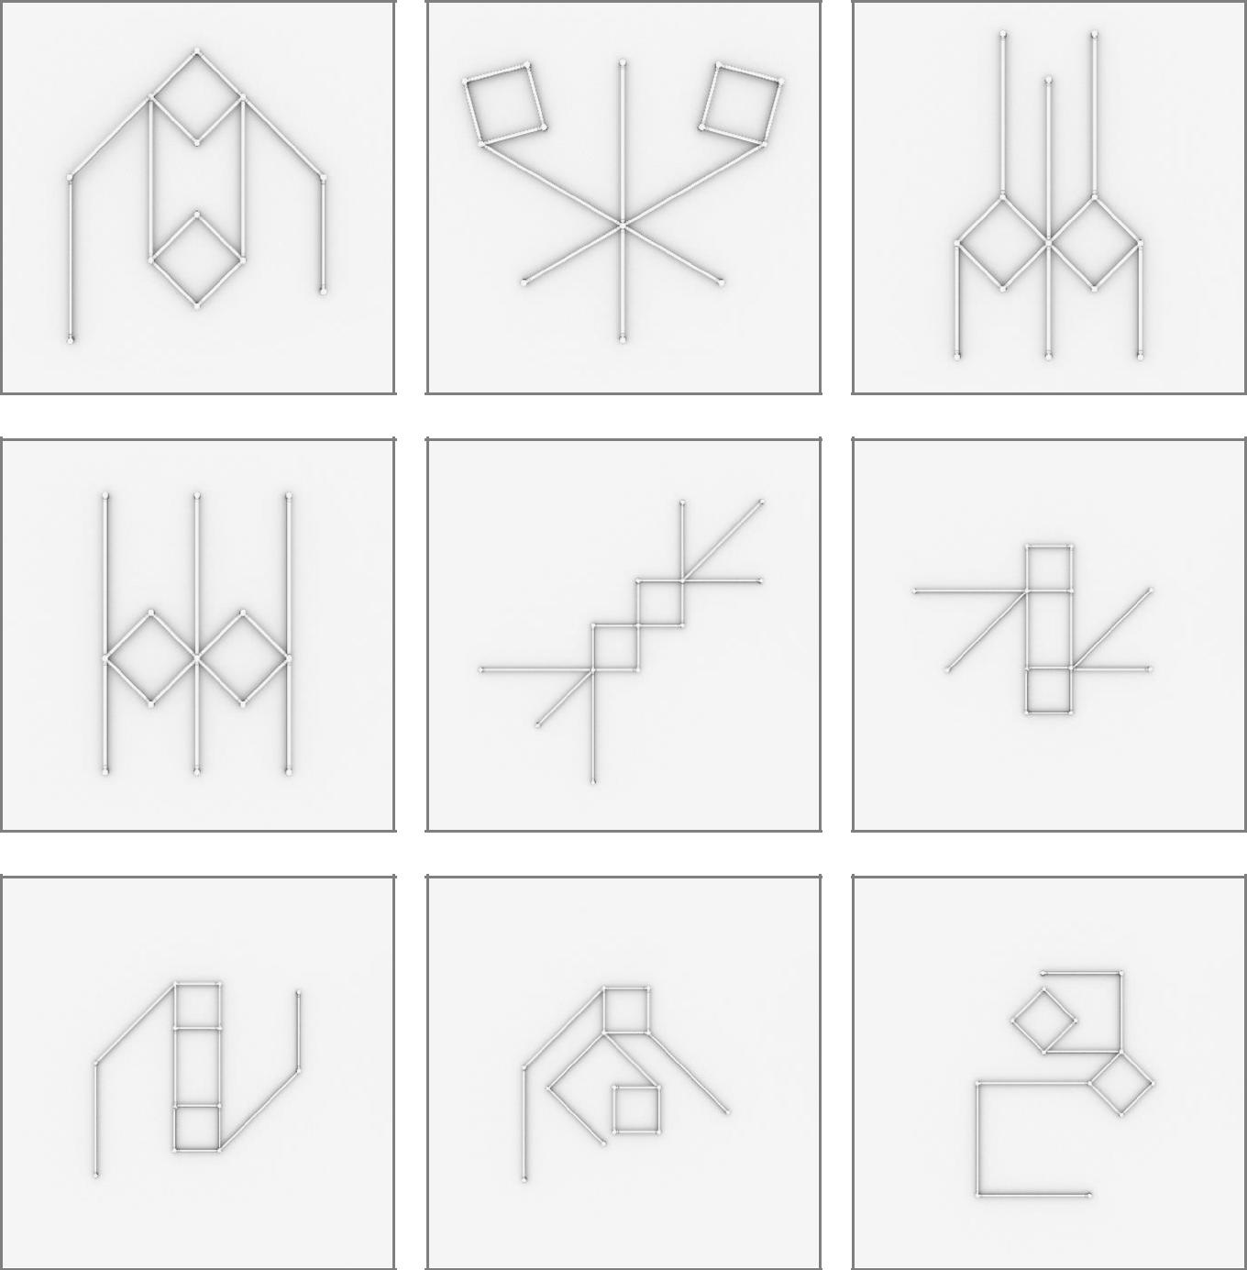

42

8 x 12inch/30cm & 4 x 24inch/60cm &

4 x 36inch/90cm LIGEOsTM
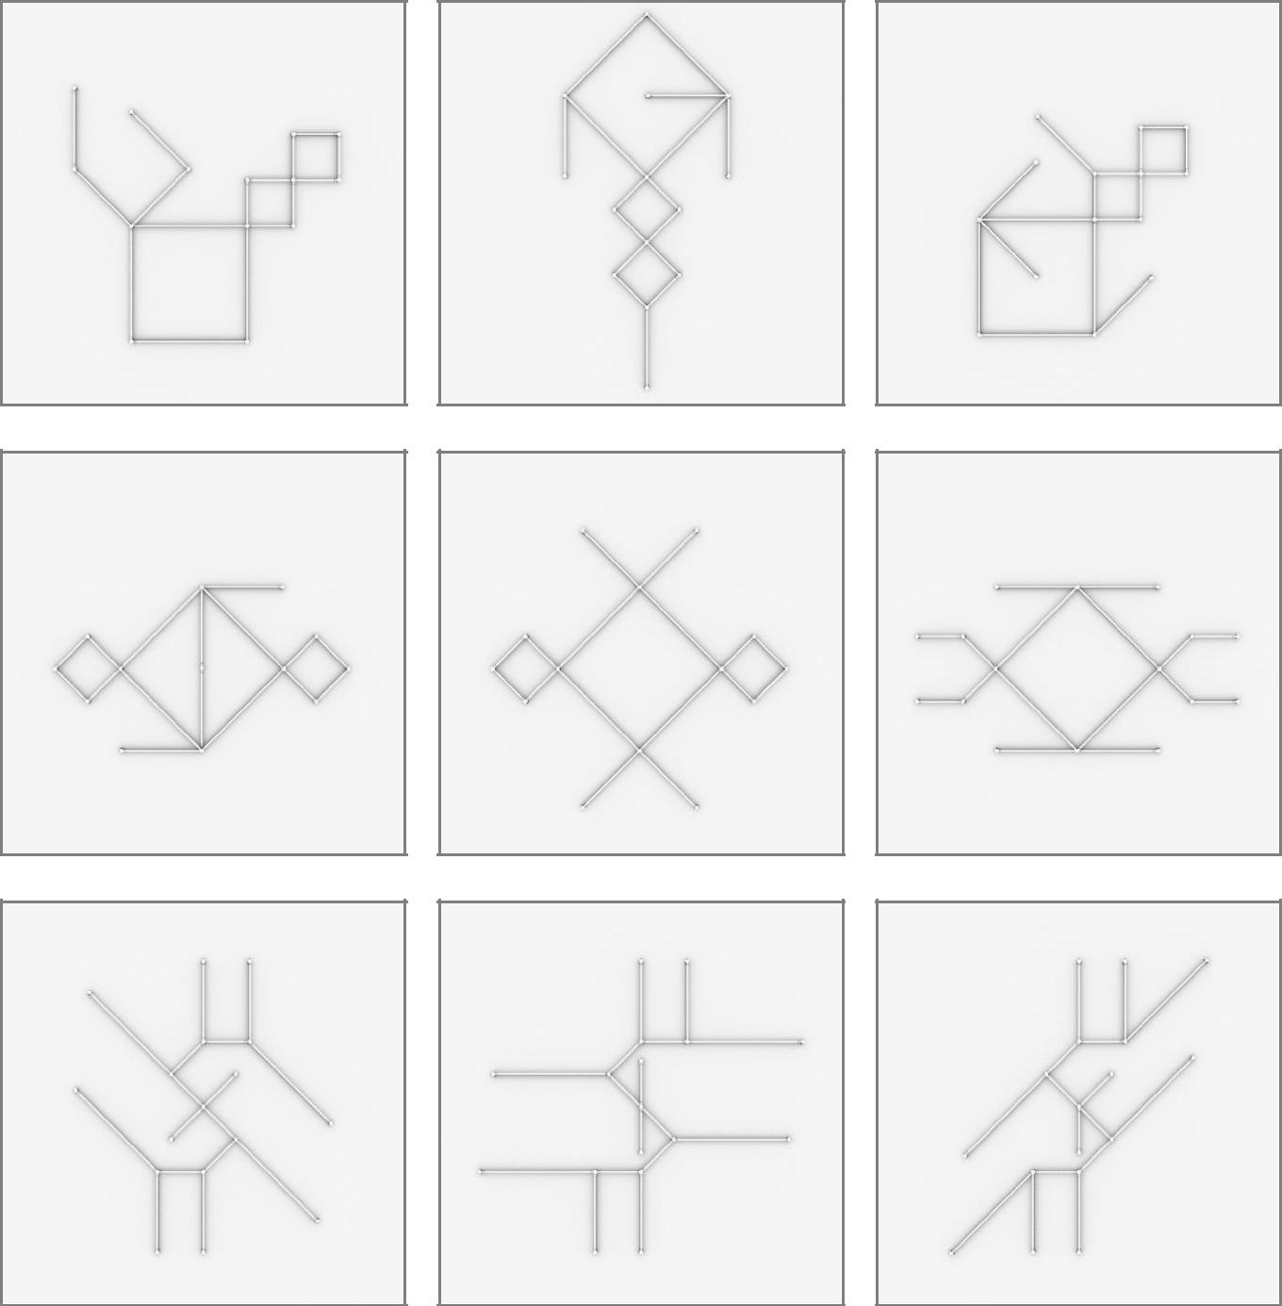

43

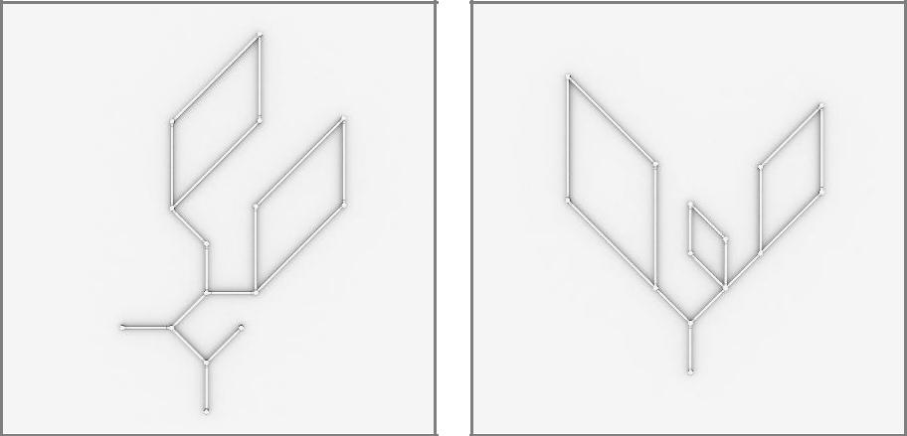

44

12 x 12inch/30cm & 6 x 24inch/60cm &

4 x 36inch/90cm LIGEOsTM

45

12 x 12inch/30cm & 8 x 24inch/60cm &

4 x 36inch/90cm LIGEOsTM
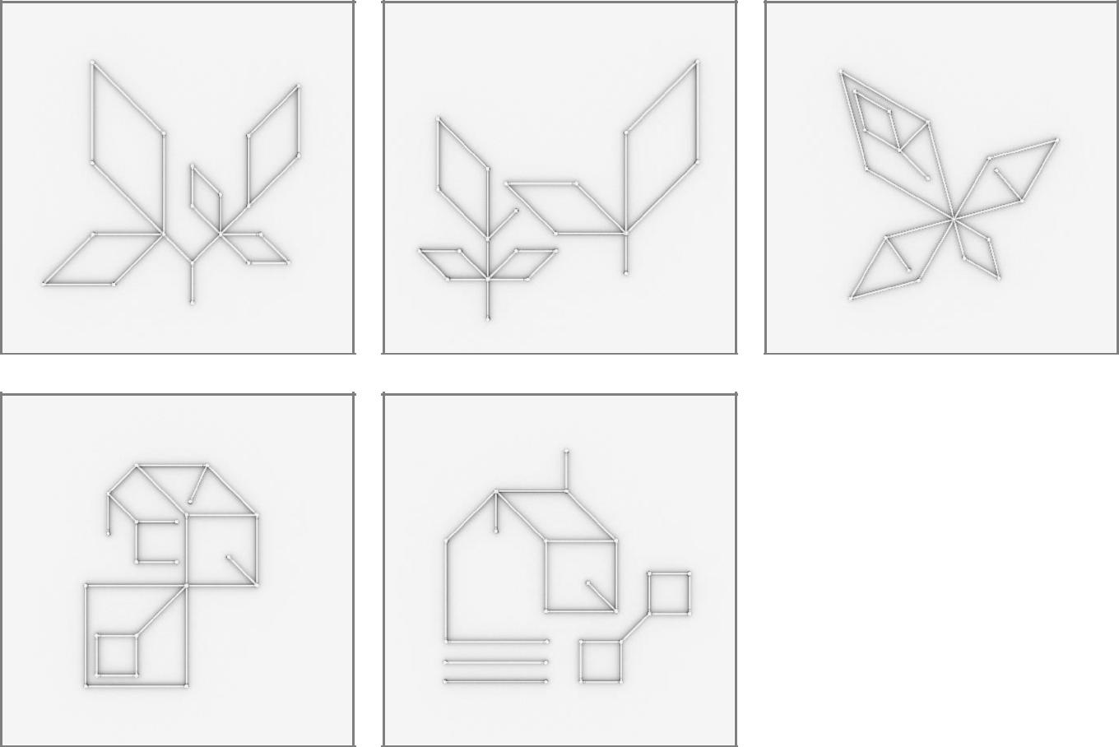

46

24 x 12inch/30cm & 8 x 24inch/60cm &

8 x 36inch/90cm LIGEOsTM
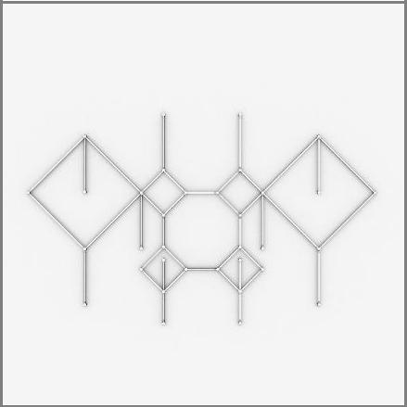

47

LIGEOTM Numbers
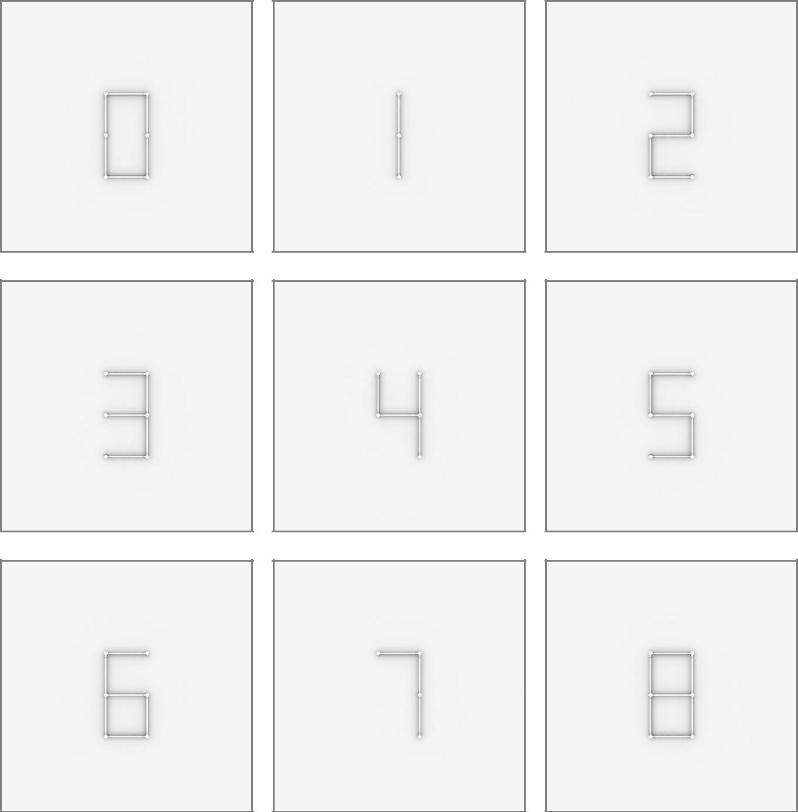

48

49

