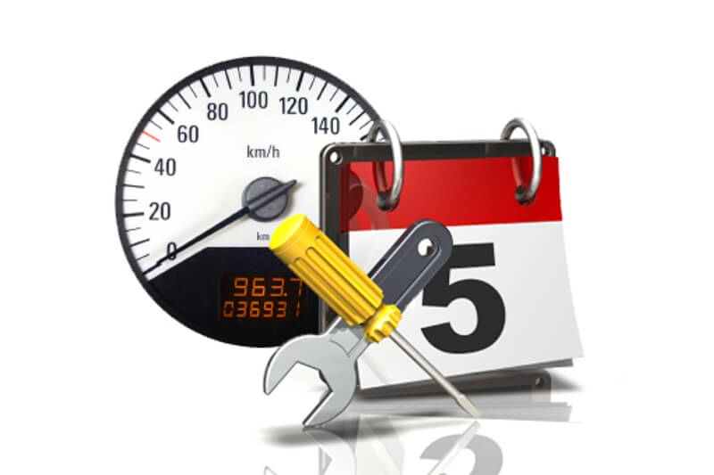 | Car Maintenance Schedule

FORD |  | RANGER |  | NRE 2258 |  | mm/dd/yyyy

Service | Interval | Kilometers
 |  | 5 | 10 | 15 | 20 | 25 | 30 | 35 | 40 | 45 | 50 | 55 | 60 | 65 | 70 | 75 | 80 | 85
Lubrication, Oil & Filter | Every 5,000KM or 3 Months
Air Filter - Inspect/Replace | Every 5,000KM or 3 Months
Drive Axle Boots & Seals | Inspect every 5,000KM or 3 Months
PCV Value | Inspect every 10,000KM or 6 months
Tire Rotation & Inspection | Every 10,000KM or 6 months
Tire Balance | Every 25,000KM or 12 months
Clean & Adjust Rear Brakes | As required, every 10,000KM or 6 months
Wiper Blades | Replace every 12 months
Wheel Alignment/Inspection | Every 25,000KM or 12 months
Fuel Filter Replacement | Every 40,000KM or 20 months
Transmission Service | Every 30,000KM or 2 years
Maintenance Tune-Up | As requried
Power Steering Fluid Flush | Every 50,000KM or 2 years

