**COMPANY**

**NAME & LOGO**

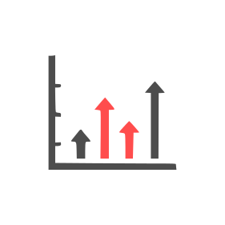

**5**

**Headline 5**

Lorem ipsum dolor sit amet, consectetuer adipiscing elit. Maecenas porttitor congue massa. Fusce posuere, magna sed pulvinar ultricies, purus lectus malesuada libero, sit amet commodo magna eros quis urna.



**4**

**Headline 4**

Lorem ipsum dolor sit amet, consectetuer adipiscing elit. Maecenas porttitor congue massa. Fusce posuere, magna sed pulvinar ultricies, purus lectus malesuada libero, sit amet commodo magna eros quis urna.



**3**

**Headline 3**

Lorem ipsum dolor sit amet, consectetuer adipiscing elit. Maecenas porttitor congue massa. Fusce posuere, magna sed pulvinar ultricies, purus lectus malesuada libero, sit amet commodo magna eros quis urna.



**1**

**Headline 1**

Lorem ipsum dolor sit amet, consectetuer adipiscing elit. Maecenas porttitor congue massa. Fusce posuere, magna sed pulvinar ultricies, purus lectus malesuada libero, sit amet commodo magna eros quis urna.



**2**

**Headline 2**

Lorem ipsum dolor sit amet, consectetuer adipiscing elit. Maecenas porttitor congue massa. Fusce posuere, magna sed pulvinar ultricies, purus lectus malesuada libero, sit amet commodo magna eros quis urna.



**6**

**Headline 6**

Lorem ipsum dolor sit amet, consectetuer adipiscing elit. Maecenas porttitor congue massa. Fusce posuere, magna sed pulvinar ultricies, purus lectus malesuada libero, sit amet commodo magna eros quis urna.

**CIRCULAR FLOW CHART**

**FLOW CHART DESCRIPTION – MAIN MESSAGE**