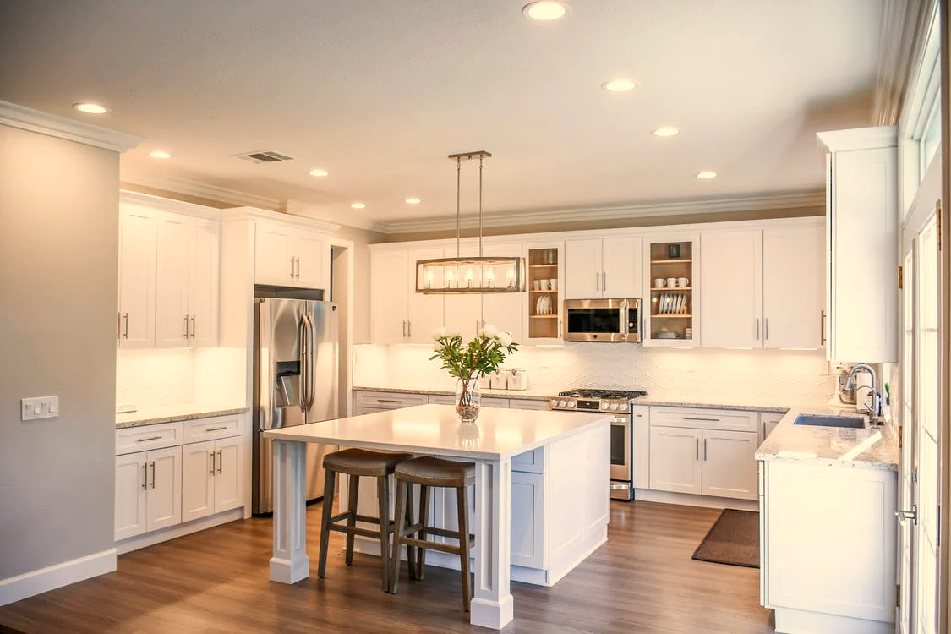

**PACKAGES**Full House Cleaning $0.00  
Basement $0.00  
All Purpose Cleaner $0.00  
Mopping Solutions $0.00  
Closets $0.00  
Dust Removal $0.00  
Loren Ipsum $0.00  
Loren Ipsum $0.00  
Loren Ipsum $0.00  
Loren Ipsum $0.00

**BASIC SERVICES**Mop $0.00  
Vacuum $0.00  
Closet Cleaning $0.00  
Windows $0.00  
Wash Bed Linens $0.00  
Loren Ipsum $0.00  
Loren Ipsum $0.00  
Loren Ipsum $0.00  
Loren Ipsum $0.00  
Loren Ipsum $0.00

**JOSEPH’S CLEANING SERVICES**  
The best in town!

**Book your appointment now:**  
Call: 000-000-0000  
Email: youremail@info.com