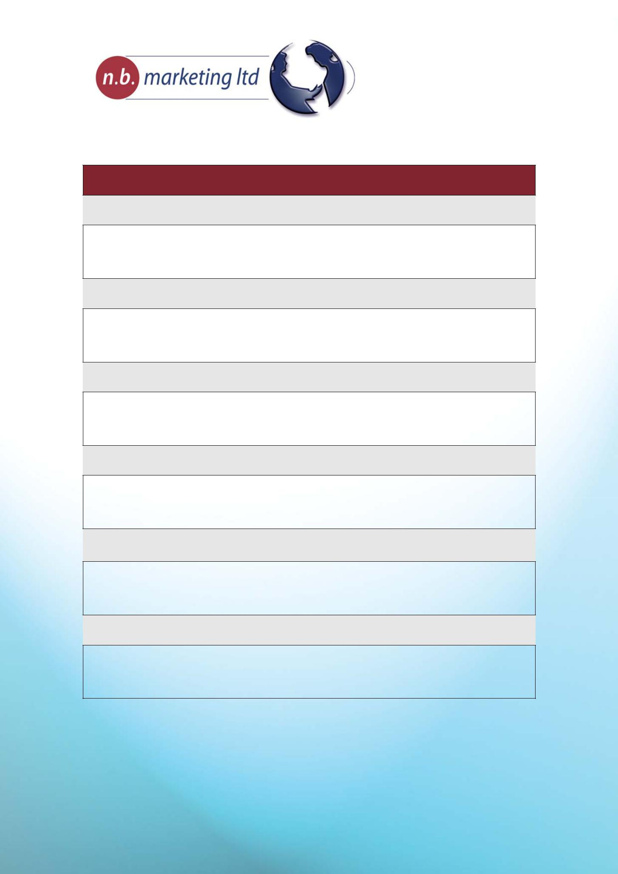

Creative Brief

Project Management – Please provide the basic facts of the project

- Project Name

- Project Type

- Company Name

- Brand Name

- Client Team – who from your team will be working on the project including project manager and contributors. Who is responsible for approvals?

- Agency Team/Resources required

© n.b. marketing ltd.

Southfield House, Southfield Business Park, Falcon Way, Bourne, PE10 0FF

t 01778 420640 e nbm@business-growth.net www.business-growth.net

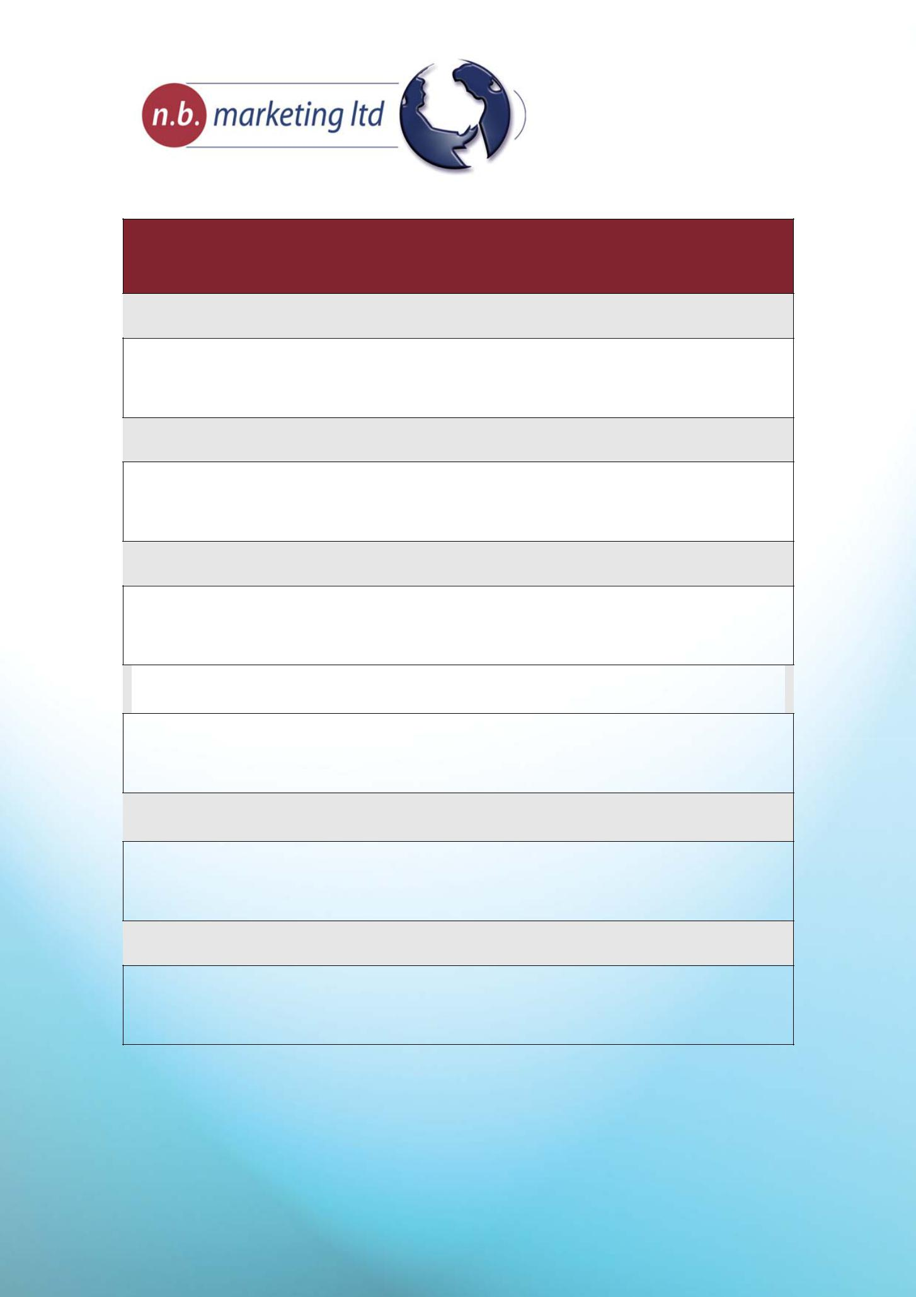

Project Background – Where you are now and where do you want to be.

Provide some background information on the marketing strategy behind this project.

This will help to fit the current project into your overall strategy.

7. What is the main purpose of your business?

8 Where is your market and who are your customers?

- What sort of position does your business hold in the market (market share? No. 1?)

- How would you describe your company’s image and reputation in the market in which you operate?

- Where are you trying to take the business and what sort of position/image/reputation would you like your business to hold? (Your objectives)

- How does this project fit into the overall marketing strategy for your business?

© n.b. marketing ltd.

Southfield House, Southfield Business Park, Falcon Way, Bourne, PE10 0FF

t 01778 420640 e nbm@business-growth.net www.business-growth.net

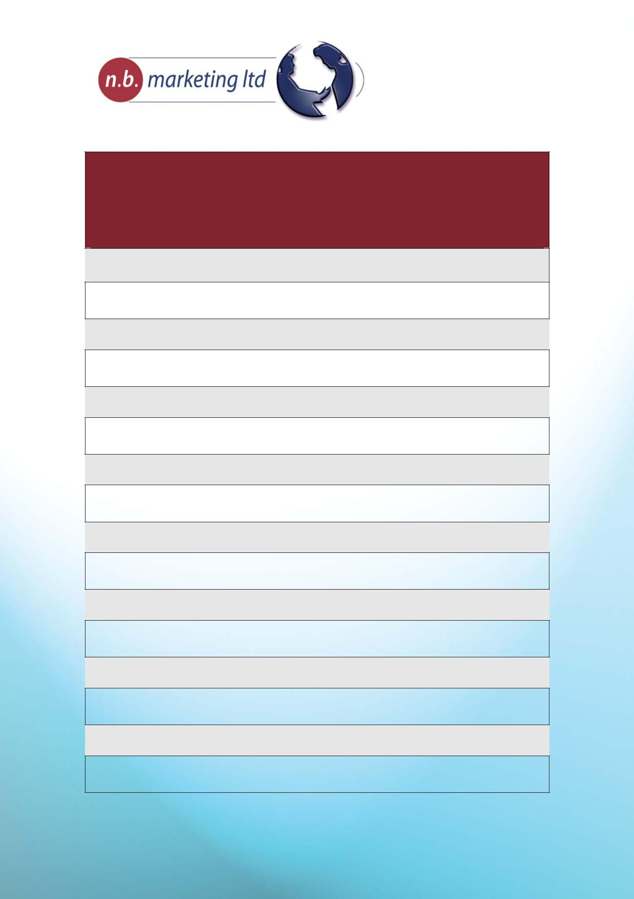

Current Project Overview – What are we doing to get there, who do we need to talk to, and how will you know you’ve arrived?

Provide as much information as you can about the project, how you would like it executed and what you want to achieve with it. Be clear about any design parameters that need to be considered e.g. brand guidelines, corporate style, terminology, or anything that you feel particularly strongly about.

- What is the purpose of the project? E.g. launch a new product or service with a view to creating awareness and/or enquiries

- What do you want to produce e.g. brochure, flyer, email, advert?

- Who is the project aimed at – your target audience?

- What ‘Customer Needs’ does this project address?

- What are the key themes you would like to convey?

18 What is your niche offer and call to action?

- What social evidence can be included? E.g. case studies, testimonials

- What are the key features and benefits of what you are offering?

© n.b. marketing ltd.

Southfield House, Southfield Business Park, Falcon Way, Bourne, PE10 0FF

t 01778 420640 e nbm@business-growth.net www.business-growth.net

