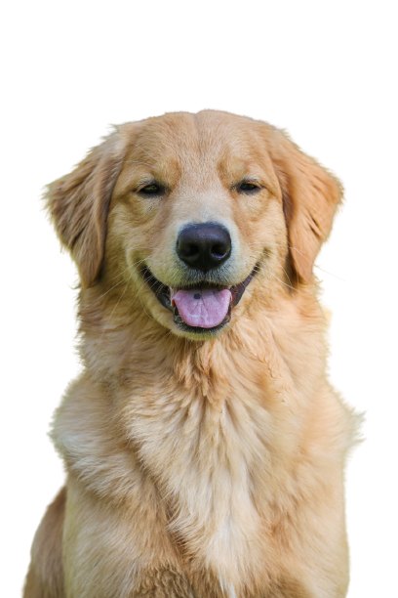

**BOOK YOUR APPOINTMENT NOW!**  
  
CALL NUMBER: 00-000-000  
EMAIL: youremail@info.com  
ADDRESS: Sixth Avenue, Jackson City, NY  
  
**FIND US ON SOCIAL MEDIA**

**INDIVIDUAL SERVICES**  
Nail Cutting $0.00  
Haircut $0.00  
Nail Polish $0.00  
Ears clean and plucked $0.00  
Tooth Brushing $0.00  
Loren Ipsum $0.00  
Loren Ipsum $0.00  
Loren Ipsum $0.00  
Loren Ipsum $0.00  
Loren Ipsum $0.00  
Loren Ipsum $0.00

**FULL GROOMING**  
Includes a haircut, bath, dry, nails clipped, and ears clipped. Price depends on the breed of the dog. Price start at $35.00+

**BASIC GROOMING**  
Includes bath, dry, nails clipped, and ears clipped. Price depends on the size of the dog. Price start at $25.00+

Dog Grooming Services

**LILLY’S PET SALON**