Template for Worship Aid

Catholic Funeral
Rites

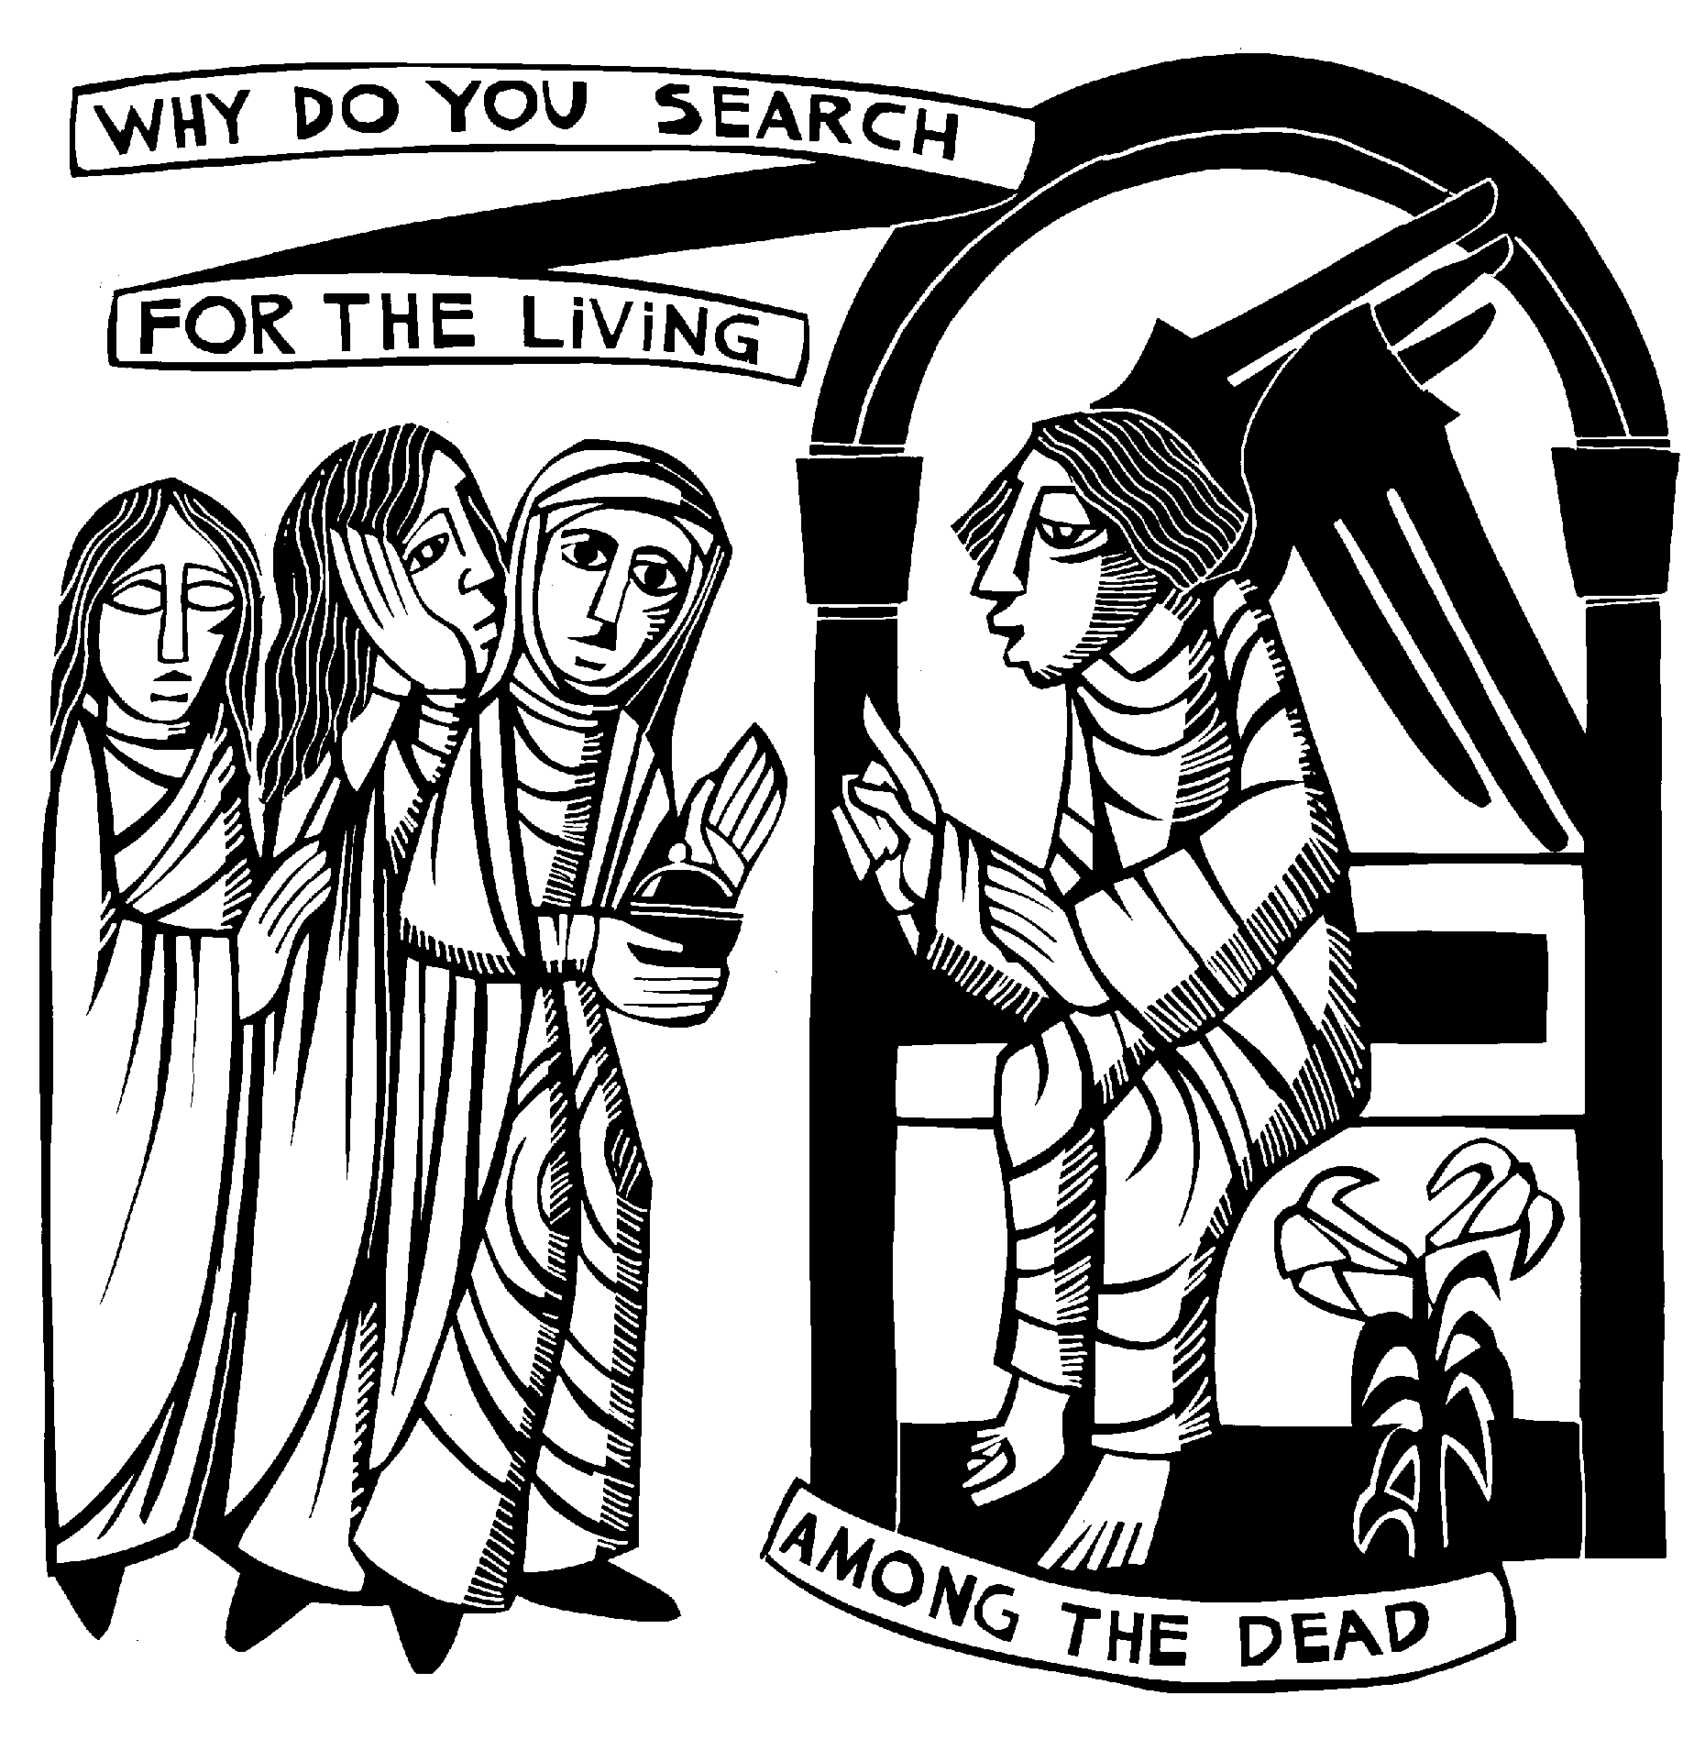

Prepared by
The Office of Liturgy
© 2016 Diocese of Salt Lake City

Catholic Funeral Rites

The Catholic Funeral Rite may not be easily understood by individuals who are not Catholic. Many times this causes confusion or discomfort as the assembly is uncertain when to sit, stand or respond. This guide is intended to provide a simple explanation of the Funeral Rites and assist in the participation of all those attending. It is not intended to replace comprehensive planning with the family of the deceased. Rather it’s a tool that can be used when planning is complete to create a worship aid/guide which explains the Catholic Funeral Rite.

The Catholic funeral rite consists of three separate ceremonies: the Vigil Service (or wake) the Funeral Mass and the Rite of Committal. This guide is best used to include all of these parts of the rite in one document. Individual parts can be separated out should the parish or family choose to do so.

Vigil Service
The Vigil Service usually takes place at the funeral home or Church the evening before the funeral. It is an opportunity to pray with the family and remember the deceased as God’s gift to us. A priest or deacon will lead the prayer service which includes scripture readings, hymns, a short homily and prayers. It may also include the recitation of the Holy Rosary. It is an opportunity for individuals to share a few words or eulogize the deceased.

At a Vigil the space includes a crucifix and votive candles. A prie-dieu is also near the casket, where it is customary to kneel for a few moments in prayer for the deceased. You may also see a holy card. This small memorial card
includes the name of the deceased and an appropriate prayer or verse. It is a keepsake and reminder to pray for the departed.

Funeral Mass
The Catholic Church teaches that death is a transition from life to New Life. When our earthly dwelling ends in death, we gain an everlasting life. In the Catholic funeral tradition, the purpose of the Funeral Mass is to offer worship to God for Christ’s victory over death, to comfort the mourners with prayers, and to pray for the soul of the deceased. The Catholic Church teaches that “Christians celebrate the funeral rites to offer worship, praise and thanksgiving to God for the gift of a life which has now been returned to God.” (The Order of Christian Funerals #5)

Rite of Committal
The third and final ceremony of a Catholic Funeral is the Rite of Committal. This prayer is celebrated at the grave or crematorium, or even at sea. It is a brief prayer expressing the hope that the remains of the deceased, together with those of the other faithfully departed, await together their bodily resurrection with Christ.

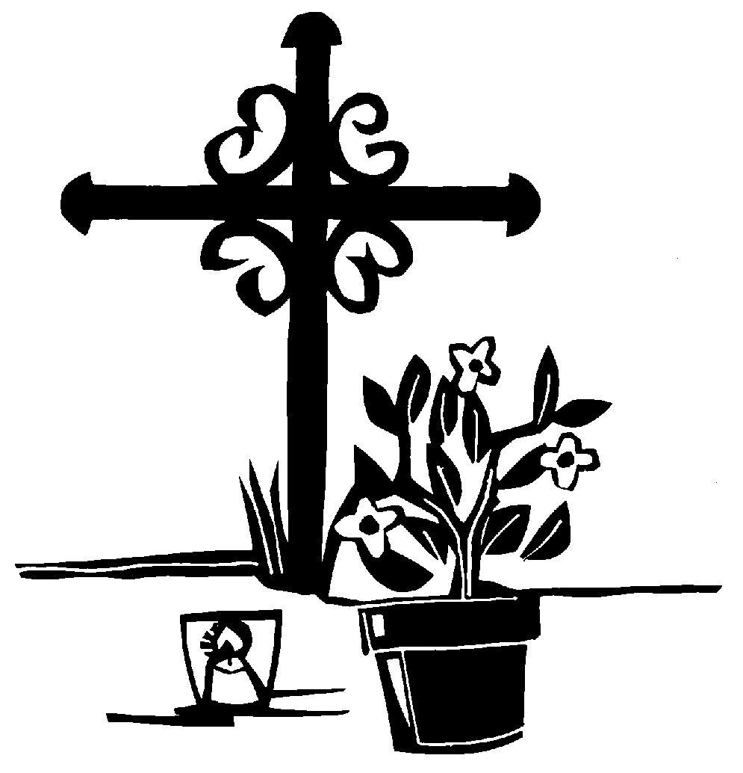
Funeral Rites Celebrating the Life of

Eric Martin Gonzalez
August 14, 1942—July 19 2014

The Vigil

Insert photo
July 23, 2014
7:30 PM
Ratterman Funeral Home

Funeral Mass
July 24, 2014
10:00 AM
St. Ann Catholic Church
Springfield, Utah

Committal
July 24, 2014
1:00 PM
St. Michael’s Cemetery

Presider Reverend Samuel Hendricks

Pall Bearers: Henry Gonzalez Frank Gonzalez
Tim Hernandez David Smith
Donald Sanders Dan Sanders

Lectors Tony Gonzales Julie Smith

Musicians Kate Mattingly
Chris Tolbert
Deborah Hardy

The Vigil Service

Introductory Rites
The Celebrant welcomes everyone and invites all to join together in prayer.

Liturgy of the Word
We celebrate God’s presence in His Word and listen to readings from the Bible.

First Reading Wisdom 3: 1-9
Gospel Reading John 6:37- 40

Homily
The Celebrant will give a short homily to help those present, find strength and hope in God’s saving word.

Prayers of Intercession
The community calls upon God to comfort the mourners and to show mercy to the deceased. Please respond, “Lord, have mercy.”

The Lord’s Prayer
We pray the “Our Father” together.

Remembrance
Members of the family and friends are invited to briefly speak in remembrance of Eric.

Concluding Rite
The Vigil concludes with a blessing.

[A Closing Song may be added. Title & # in the Missal]

The Funeral Liturgy

The Catholic Mass is the most important sacramental celebration in the Church. It is a celebration of the life, death and resurrection of our Lord Jesus Christ. During today’s Mass, we also celebrate the life of Eric.

The Catholic Mass follows a very set order and is divided into two equally important parts: Liturgy (prayer) of the Word and Liturgy (prayer) of the Eucharist. In each Liturgy, God reaches out to us and we respond in song, prayer and gestures.

First, is the Liturgy of the Word when we encounter Jesus in the Word of God, the Bible. We will hear selections from the Old Testament, New Testament and Gospel. The celebrant will then share a homily in which he expresses his thoughts and teachings about the scripture/readings.

Second, is the Liturgy of the Eucharist, when we encounter God and Jesus in Holy Communion. This part of Mass includes the Eucharistic Prayer. It is during this prayer that the priest, acting in the person of Christ, blesses the bread and wine and they become the Body and Blood of Christ. This is followed by the congregation praying “The Lord’s Prayer” together and the distribution of Holy Communion.

Sometimes referred to as "Catholic Calisthenics", we will stand, kneel and sit during the Mass. Sometimes we stand out of respect and honor as we listen; sometimes we kneel in worship; and other times we sit, listening to God’s Spirit in our hearts. These shared postures and gestures also unify us into one community, one family.

The Order of the Mass

Please stand.
Entrance Procession Song Title & # in the Missal
We gather as a community and praise God in song, reminding us that we are the people of God on a journey to the Kingdom. The procession to the altar, includes the ministers, the priest and the coffin.

Greeting
The priest greets the assembly.

Liturgy of the Word
We celebrate God’s presence in His Word and listen to readings from the Bible.

First Reading Wisdom 3: 1-9
Responsorial Psalm Psalm 23
Second Reading Romans 6:3-9

Please stand.

Gospel Acclamation
We sing praise to God for the Good News.

Gospel Reading John 6:37- 40
The Gospel reading is taken from one of the four Gospels in the Bible; Matthew, Mark, Luke or John and proclaimed by the priest or Deacon.

Please be seated.
Homily
The priest offers a commentary drawn from the Scripture readings, and how it can be a part of our daily lives, offering hope to all that we will gather again in God’s Kingdom.

Intercessory Prayer
We offer our prayers to God, trusting in his mercy and care.

Liturgy of the Eucharist

Presentation & Preparation of the Gifts
Bread and wine are brought to the altar table, and prepared for the celebration.

Offertory Hymn Song Title and # in the Missal
We praise God in song and our gifts of bread and wine are prepared.
Prayer over the Offerings
The priest prays that God will accept our gifts.
Please stand.

The Eucharistic Prayer [Page # of the Missal]
The Eucharistic Prayer begins with a dialogue between the Priest and the assembly. At the conclusion of the dialogue, together we sing Holy, Holy, Holy, an acclamation of praise.

Please kneel or sit.

Memorial Acclamation
This prayer of thanksgiving is the center and high point of the entire celebration. It includes the prayer of Consecration. We believe the bread and wine become the Body and Blood of Jesus Christ.

Please stand.
The Great Amen

The Lord’s Prayer
The Priests invites all to join in the Lord’s Prayer as we pray together Our Father ...

Sign of Peace
We offer one another Christ’s peace, greeting those around us.

Lamb of God
We pray for forgiveness, mercy, and peace.

Please kneel or sit.

Holy Communion
Catholics believe that the celebration of the Eucharist and sharing of Holy Communion is a sign of unity and shared beliefs. Reception of Holy Communion is for individuals who believe fully in the Catholic faith. All who are not receiving Holy Communion are welcome to come forward to receive a blessing, or spend this time in prayer.

Communion Hymn Song Title and # in the Missal

Please stand.

Prayer of Commendation
God gives us precious gifts, including the presence of Eric in our lives. We call upon God’s mercy, commend Eric to God’s care and affirm our belief that those who have died in Christ will share in Christ’s victory over death.

Recessional Hymn Song Title and # in the Missal

Rite of Committal

Invitation
A welcome to join in prayer for Eric Gonzalez.

Scripture Verse
A reminder of God’s presence with us.

Prayer over the Place of Committal
We commend Eric into the hands of the merciful Savior.

Intercessions
We join our prayers together, responding “Lord, hear our prayer.”

The Lord’s Prayer
We pray the “Our Father” together.

Concluding Prayer
Fr./Deacon __________________concludes the Funeral Rite with a prayer for Eric and for all of us.

Eric’s family and friends thank you
for joining in the celebration
of Eric’s life.

[Please Note: If including music (lyrics or words) in this Worship Aid, proper copyright information would need to be included here.]
Instructions and Directions for Printing

Microsoft Word
This booklet has been created in Microsoft Word which allows for ease of publishing and for two-siding printing.

Directions to Customize
- Heading color is currently black. These can be changed to another color.
- Font can be changed as well by “select all” and choosing a new font.
- It is recommended that the size of the font not be less than 12, to ensure ease of reading.
- Review the content of text in red. These items are customizable for each Rite or liturgy, such as scripture readings, songs, etc.
- Consider the readings and songs chosen with the family, and insert this information. Include references to page numbers in the parish missal as appropriate.
- Delete items which are not applicable to the liturgy.
- In order to print in booklet form, delete or add pages to in multiples of 4, for example 4, 8 or 16 pages total)
- It is recommended that printing occur on paper above 20 lb. A heavier paper will prevent bleeding of ink between the front and back of the Guide.

Printing
If using double-siding feature on printer, set to:
- letter size paper
- booklet, side-fold
- print on both sides / flip sheets on short edge
- In order to print in booklet form, delete or add pages in multiples of 4, for example 4, 8 or 16 pages total
- It is recommended that printing occur on paper above 20 lb. A heavier paper will prevent bleeding of ink between the front and back of the Guide.

References
◻ Aridas, Chris. The Catholic Funeral. Chestnut Ridge, NY: The Crossroad Publishing Company, (1998).
◻ Champlin, Joseph M. Through Death to Life. Notre Dame, IN: Ave Maria Press, Inc., (2012).
◻ Isca, Kay Lynn. Catholic Etiquette for Funerals. Huntington, IN: Our Sunday Visitor Publishing Division, (2003).
◻ Koehler, Kenneth. Prepare a Catholic Funeral, 3rd Edition. Denver, CO: Morehouse Education Resources. (2012).
◻ Order of Christian Funerals. Collegeville, MN: Liturgical Press. (1989).
◻ Order of Christian Funerals, Study Edition. Chicago IL: Liturgy Training Publications. (1989).

Acknowledgements
This template, was developed by Carol Ruddell, as her capstone project for the Diocese of Salt Lake City, Lay Ecclesia Ministry Program and was adapted for use by the Diocese of Salt Lake City, Office of Liturgy. Questions regarding this material can be referred to 801-328-8641.

Additional Resources from the Office of Liturgy
- Music for Catholic Weddings, Office of Liturgy, Diocese of Salt Lake City

