Direct Deposit Authorization Form

Please print and complete ALL the information below.

Name: ____________________________________________________________

Address: ____________________________________________________________

City, State, Zip: ____________________________________________________________

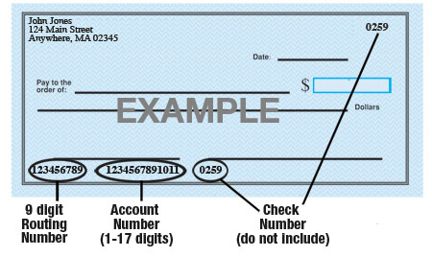

Name of Bank: ____________________________________________________________

Account #: ____________________________________________________________

9-Digit Routing #: ____________________________________________________________

Amount: ◻ $ ____________ ◻ ___________%  or ◻ Entire Paycheck

Type of Account: ◻ Checking ◻ Savings (Check One)

Attach a voided check for each bank account to which funds should be deposited (if necessary)

_____________________ [Company Name] is hereby authorized to directly deposit my pay to the account listed above. This authorization will remain in effect until I modify or cancel it in writing.

Employee’s Signature: ______________________________________________________

Date: ___________________________

