**NAME:**

**GENOGRAM TEMPLATE**

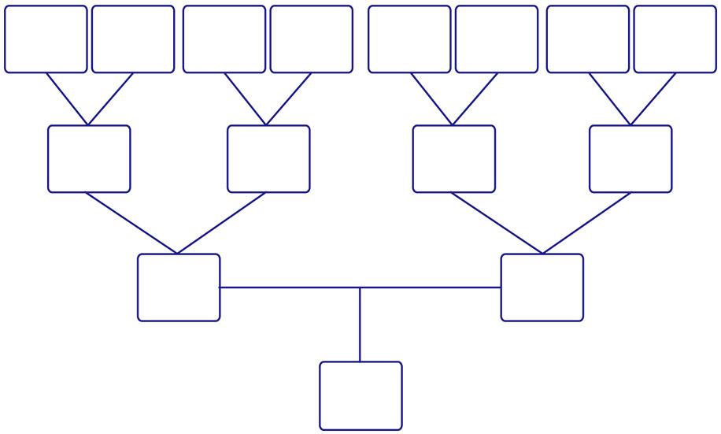

Name

Here

Name

Here

Name

Here

Name Here

Name

Here

Name

Here

Name

Here

Name

Here

Name

Here

Name

Here

Name

Here

Name

Here

Name

Here

Name

Here

Name

Here