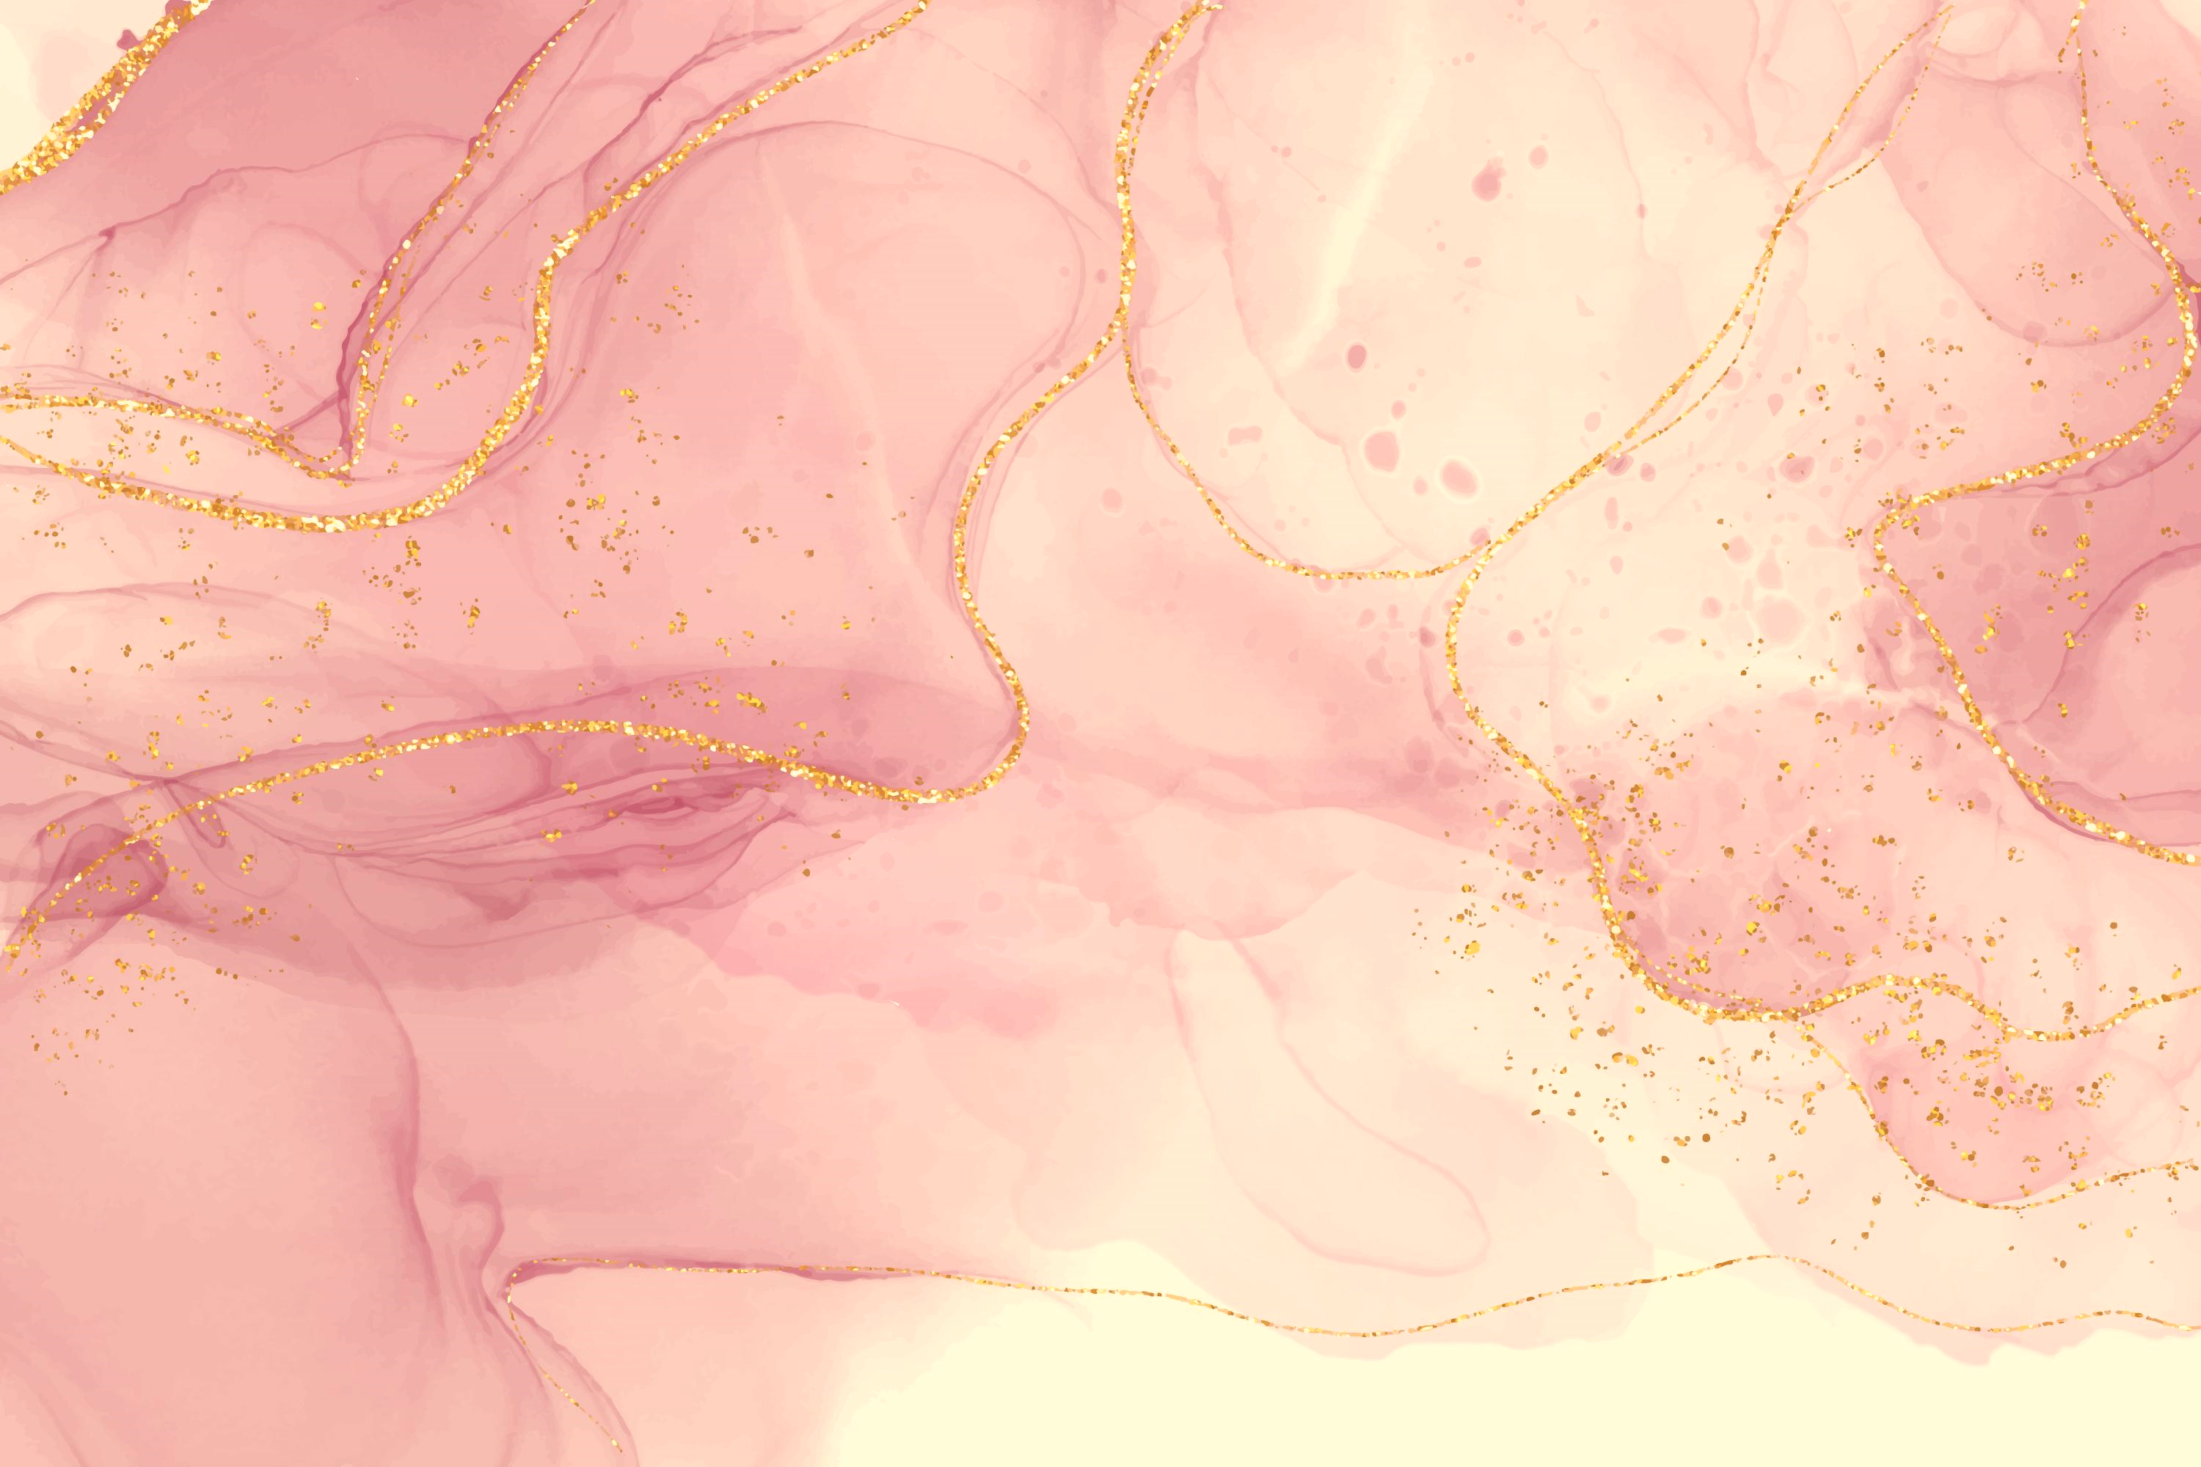

BOOK YOUR APPOINTMENT NOW!  
**Call #**: 000-000-0000  
**Email**: youremail@info.com  
**Address**: Sixth Avenue, Jackson City, NY

SPECIALS  
Special Manicure $0.00  
Special Pedicure $0.00  
Nail Designs $0.00  
Full Set $0.00  
Loren Ipsum $0.00  
Loren Ipsum $0.00  
Loren Ipsum $0.00  
Loren Ipsum $0.00  
Loren Ipsum $0.00  
Loren Ipsum $0.00  
Loren Ipsum $0.00

PEDICURE  
Basic Pedicure $0.00  
Deluxe Pedicure $0.00  
Hot Stone Pedicure $0.00  
Paraffin Pedicure $0.00  
American Pedicure $0.00  
OPI Pedicure $0.00  
Loren Ipsum $0.00  
Loren Ipsum $0.00  
Loren Ipsum $0.00

AIRBRUSH  
French Manicure $0.00  
One Color $0.00  
Multi Color $0.00  
French Airbrush $0.00  
Loren Ipsum $0.00  
Loren Ipsum $0.00  
Loren Ipsum $0.00

MANICURE  
Basic Manicure $0.00  
Deluxe Manicure $0.00  
Hot Stone Manicure $0.00  
Paraffin Manicure $0.00  
American Manicure $0.00  
OPI Manicure $0.00  
Loren Ipsum $0.00  
Loren Ipsum $0.00  
Loren Ipsum $0.00

MARTHA’S NAIL SALON