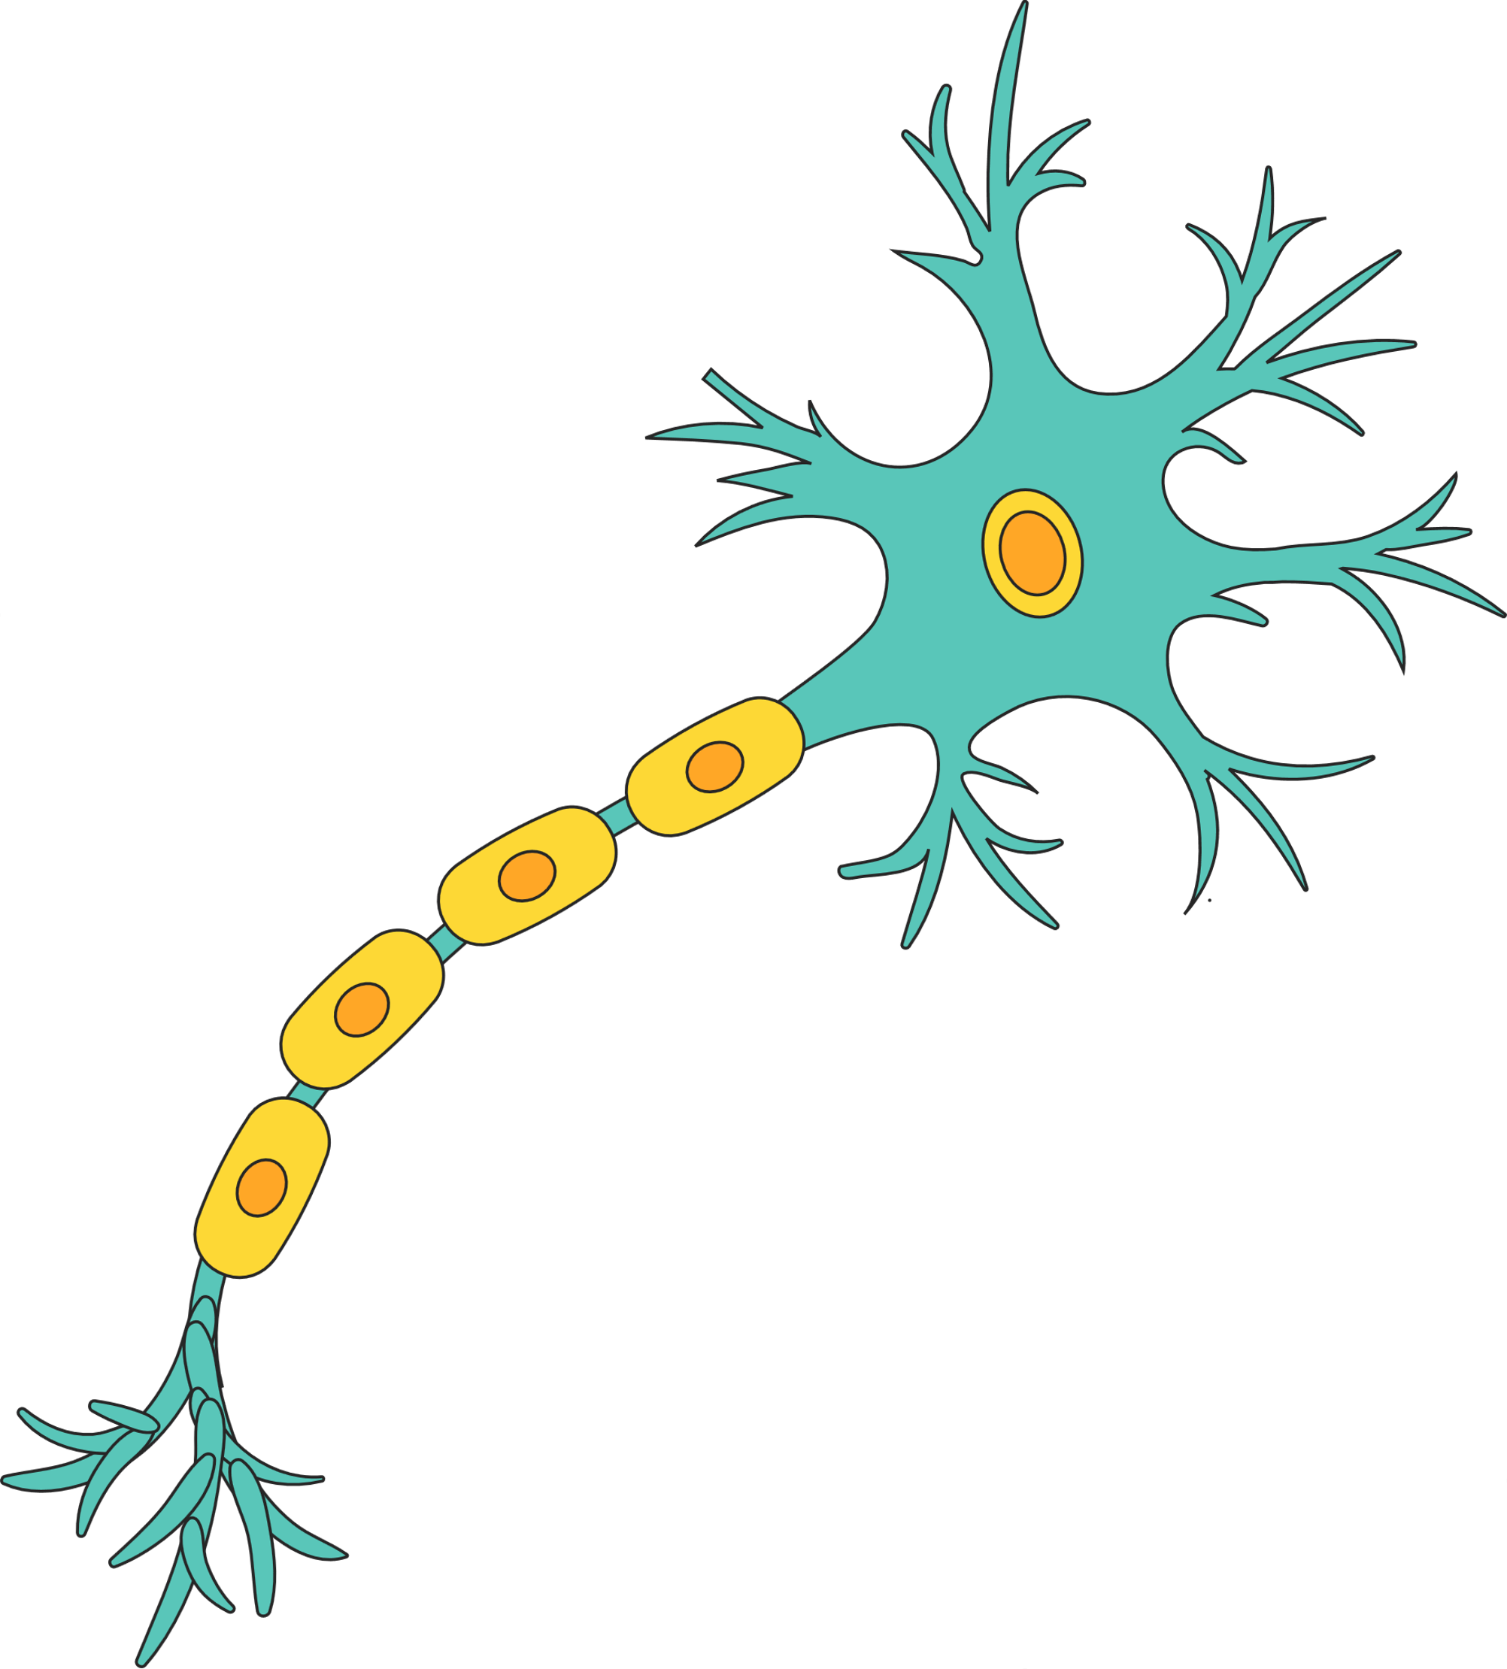

**Nervous system flow chart**



**Central NS**



**Peripheral NS**



**Spinal**

**Cord**



**Brain**

**stem**



**Brain**



**The autonomic NS**



**The**

**Somatic**

**NS**



**Sympathetic NS**



**Parasympathetic NS**