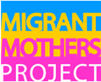 | Migrant Mothers Project  Policy Brief – Conditional Permanent Residence  March 26, 2015

This document provides a brief overview of Conditional Permanent Residence impacting sponsored spouses/partners who entered Canada as of October 2012.

Quick Facts

- Sponsored spouses and partners represent 25% of all family class applicants (CIC, 2014)
- Women represent 58% of the sponsored spouses (CIC, 2014)
- On October 25, 2012 CIC introduced a 2 year conditional permanent residence (PR) period for spouses & partners who have been cohabiting in a conjugal relationship for 2 years or less and have no children (being pregnant does not qualify as having children)
- The condition applies to all applicants entered on or after October 2012
- CIC outlines two exceptions to the condition:
  - Death of the sponsor and
  - Instances of abuse and neglect from the sponsor, including physical, sexual, psychological, financial abuse, neglect and coercion into forced marriage. Exception requests are to be processed via a Call Centre (CIC, 2014)
- As described in Operational bulletin 480, section 3.2, sponsored persons who are subject to the condition may request an exception to the condition under section 72.1 by calling CIC’s Call Centre. The Call Centre refers requests received to the appropriate local CIC office for their assessment of the request. A request for an exception can also be made directly with the responsible local CIC office in the case where evidence of the compliance with the condition is requested as part of an investigation. Persons requesting an exception to the condition are not required to submit an application form.
Policy Impact Since October 2012
- Between October 2012 and June 2014 - 23 % (17,795) of all sponsored spouses, common law partners and conjugal partners were granted Conditional PR status during the period Oct 2012-July 2014 (CIC, 2014)
- During this period, only 12 applications for an exception to the condition have been received: 4 were still in process, 4 were granted the exception, 3 denied due to insufficient evidence and 1 was referred for an inadmissibility review (Note: these numbers only reflect the period from Oct 2012 to July 2014 and thus likely reflect a lag in when people were ready to submit applications for the exemption)
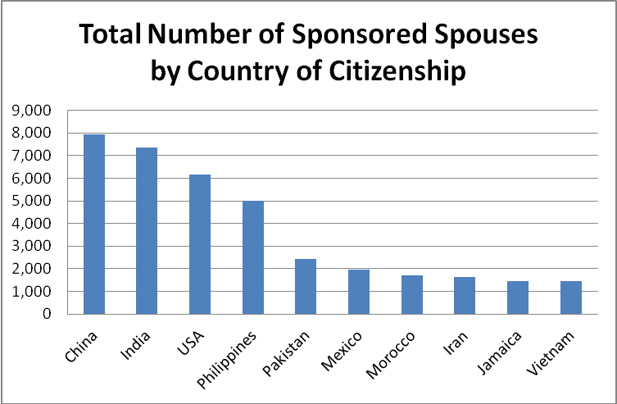
TABLE 1: Top ten countries with total number of sponsored spouses (Oct 2012 to July 2014)

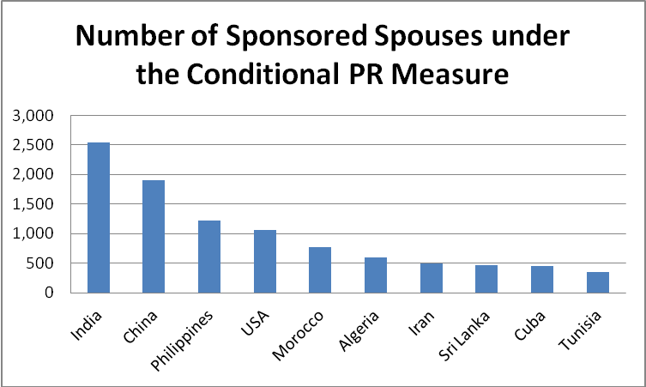
TABLE 2: Top ten countries with largest number of conditional PR (October 2012 to July 2014)

References:
CIC. (2014, November 11). Facts and figures 2013 – Immigration overview: Permanent residents. Citizenship and Immigration Canada. Available at http://www.cic.gc.ca/english/resources/statistics/facts2013/permanent/04.asp
CIC. (2014, October 10). Annual report to Parliament on immigration. Citizenship and Immigration Canada. Available at
http://www.cic.gc.ca/english/resources/publications/annual-report-2014/index.asp

CIC. (2014, June 11). Operational Bulletin 480. Conditional permanent residence measure for spouses and partners in relationships of two years or less and who have no children in common. Citizenship and Immigration Canada. Available at http://www.cic.gc.ca/english/resources/manuals/bulletins/2012/ob480.asp

