Policy Brief by - Saranya Jeevanandam
Introduction:
Every four seconds, someone is diagnosed with Alzheimer’s disease (AD). It’s the most common cause of dementia, affecting over 50 million people worldwide[1], and yet finding a cure is something that still eludes researchers today. Millions of Americans suffer from Alzheimer’s and from other forms of dementia, the number keeps increasing steadily each year and is expected to escalate as a public threat by 2050 [2][3]. According to the US demographics, by 2029, 60% of the population will be elders and patient comorbidities will increase[4]. The percentage of people affected by Alzheimer/Dementia worsens in upcoming years as the baby boomer generation ages. From the below Figure1:it shows an estimated 4.9 million Americans of all ages have Alzheimer’s in 2013 which includes people of age 65 and older and approximately 200,000 people younger than 65 [2].
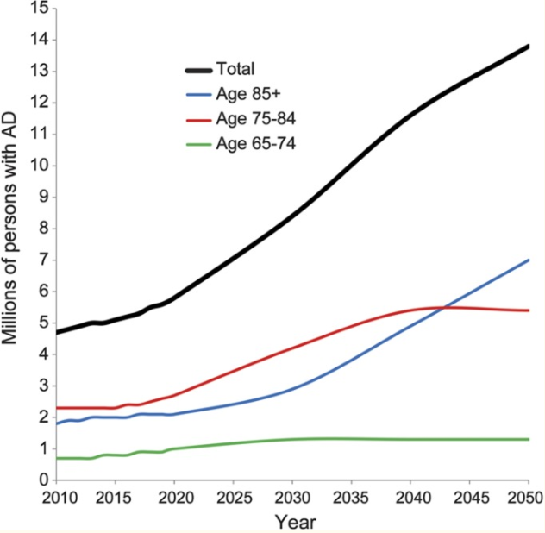
Figure 1: Estimated people with AD in the US in 2010 and projections through 2050.

Background about the disease:
Dr. Alois Alzheimer, a German psychiatrist, first described the symptoms in 1906[5]. The symptoms include difficulty sleeping, disturbed memory, drastic mood changes, and increasing confusion. The microscopic findings showed visible differences in brain tissue in the form of misfolded proteins called plaques, and neurofibrillary tangles. Both plaques and tangles work together to break down the brain’s structure. The destructive pairing of plaques and tangles starts in a region called the hippocampus, which is responsible for forming the memories. The first symptom of Alzheimer’s is usually the short-term memory loss. The protein invades into the other parts of the brain creating unique changes that signal various stages of the disease. At the front of the brain, the proteins destroy the abilities to process logical thoughts. Next, they move to the region that controls emotions, ensuing in erratic mood changes. At the upper part of the brain they cause paranoia and hallucinations, and once they reach the brain’s rear the plaque and tangles work together to erase the mind’s deepest memories. Ultimately the control centers governing heart rate and breathing are overpowered as well resulting in death. The immeasurably damaging nature of this disease has inspired many researchers to look for a cure but currently they are focused on slowing its progression[6]. One temporary treatment helps reduce the break down of acetylcholine, an important chemical messenger in the brain which is decreased in Alzheimer’s patients due to the death of the nerve cells that make it. Another possible solution is a vaccine that trains the immune system of the bodies to attack beta-amyloid plaques before they from clumps. But we still need to find an actual cure. Alzheimer’s disease was discovered more than a century ago, and yet it is not well understood still. The exact mechanism at work behind this threat and a solution will be extracted.

Caregivers:
It is not just those with the disease who suffer, but also their caregivers who are usually friends and family. Members of family and friends deliver enormous amount of care for people with AD and other dementias who resides in a community. The unpaid, informal caregivers are typically family members or friends, who often report higher levels of anxiety, depression and show poorer health outcomes than the people who do not provide care. Considering the prevalence of AD among the old age, it is assumed that informal caregivers also belong to the same age group and by the expected increase of AD community, so will the number of caregivers to provide care. Such group people may have chronic health conditions existing and assist/provide care to people with AD. Thus, making it more complex for their own healthcare and in turn contribute to caregiver burden, spiraling healthcare costs and economic hardship for people and their families. Caring for people with Alzheimer’s and other dementia is often very intimate and intrusive. In 2017, 16.1 million family members and friends provided 18.4 billion hours of unpaid care to people with AD, at an economic value of over $232 billion [7].
Health Care Expenditure:
It is painstaking that after cancer and coronary disease, AD is the most expensive disorder in the US, and the increasing aging society along with other chronic disease prevalence it more evident that it arises as a threat to the workflow of US healthcare. The total cost of dementia to society is defined as the good results and services offered to prevent, diagnose and manage with dementia. The family members, caregivers and the individuals are affected in terms of quality of life and economically. Basically, the total cost can be divided into direct costs and indirect costs where direct costs includes the medical services, hospital resources, drugs, social services, family payments to formal caregivers. Whereas the indirect costs refers to loss of income by the patient and loss or reduction for family members [8]. According to the World Alzheimer Report, it states that total estimated worldwide costs of dementia are $604 billion in 2010 and cited that if dementia care were a country, it would be world’s 18th largest economy [9]. In 2018, the direct costs to American society of caring for those AD and other dementia will total an estimated $277 billion[9][10].
- Cost of Alzheimer’s to Medicare and Medicaid:
Alzheimer’s association estimates that last five years of life, the costs of a person with dementia, on average, total more than $287,000(in 2010 dollars). This is compared to with $175,000 for a person with heart disease, and $173,000 for someone with cancer[10][9]. Utmost of the costs are stomached by Medicaid and Medicaid. In 2018, Medicare and Medicaid spent an estimated $186 billion caring for those with AD and other dementias (i.e. 67% of total costs). An estimated amount of $140 billion by federal government under Medicare and $47 billion combined by both Federal and State government under Medicaid are spent on the program caring for AD and other dementias. From Figure 2, it gives us an approximate amount spent by average per person, under Medicare the seniors with Alzheimer’s spends 3 times more than average per-person spending for all other seniors and under Medicaid, it is 23 times higher[10].
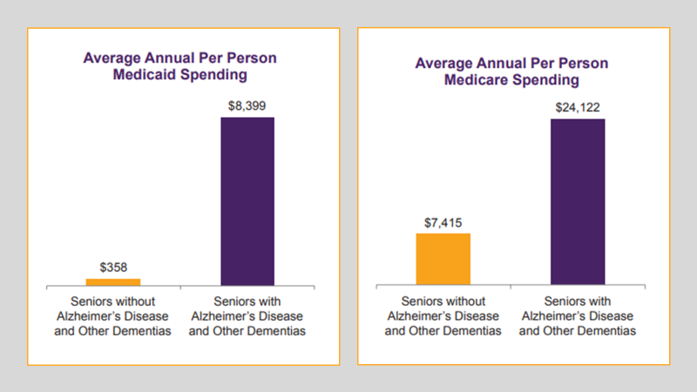
Figure2: Comparison of Medicare/Medicaid spending annually on Seniors with & without Alzheimer [10].
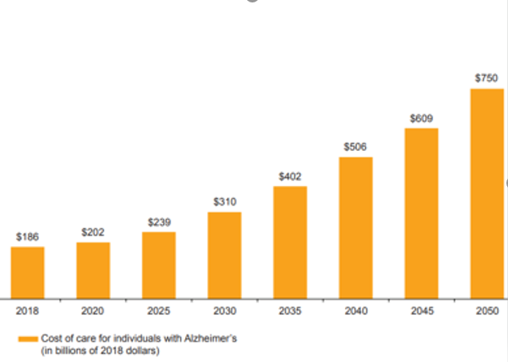
Figure 3: Graphical projection of costs spent by Medicare and Medicaid(in billions of 2018 dollars) [10].
From the below figure 3: we can find that the disbursement will increase in cost, subsequently by 2050 both Medicare and Medicaid spending on people with Alzheimer’s will quadruple to $750 billion (in 2018 dollars). Medicare will reach an increase of 300% and Medicaid by 310% from today’s spending levels. Early and accurate diagnosis could save up to $7.9 trillion in medical and care costs.
Risk Reduction:
The complexity of AD makes it difficult to understand what causes the disease. Age is also considered as an important risk factor. Researchers are vigorously investigating the part of genetics and amplified menace of developing Alzheimer’s Disease. Researchers are finding evidence that some of the risk factors for heart disease and stroke, such as high blood pressure and high cholesterol, may increase the risk of AD. There is also mounting evidence that mental, physical and social activities may decrease the risk of developing the disease. A 2015 Institute of Medicine (now known as the Health and Medicine Division of the National Academies of Sciences, Engineering, and Medicine) report provides evidence-based recommendations to promote brain health for individuals, families, communities, health care providers and systems, financial organizations, community groups, and public health agencies[11]. Health Human Services developed an online Brain Health Resource that offers current, evidence-based information and resources to facilitate conversations with older people and their families about brain health [12].
Healthy Brain Initiative:
With the congressional appropriations that began in 2005, the Healthy Aging Program was established by Centers for Disease Control and Prevention (CDC) and launched Healthy Brain Initiative. This initiative considers the cognitive health from a public health perspective and ensures that CDC notifies the state and local health departments about the significance of cognitive health. “The National Public Health Road Map to Maintain the Cognitive Health” is the first road map with a set of 44 actions, was partnered along with Alzheimer’s Association. The expansion of this initiative was directed by various committee which includes Alzheimer’s Association, CDC, National Institute on Aging, Administration on Aging and other experts from the nation.
The National Alzheimer’s Project Act (NAPA) was passed by congress in 2011 to escalate public health, economic and social consequences associated with AD. It creates a scope to build on Human Health Services (HHS) programs and facilitates federal efforts to transform the course of Alzheimer’s disease and related dementia (AD/ARD). As authorized by NAPA, HHS authorized a national plan to address Alzheimer’s Disease in 2012. This plan is annually updated to develop the understanding of the causes, treatments for and prevention of AD/ARD, in addition to increase the support for AD/ARD, caregivers. The second road map was released in 2013 with 35 actions to assist caregivers and brain health. The development of this road map was contributed by over 200 organizations which includes at national, state and local level.
Four traditional domains of public health were proposed under the 25 specific actions: 1) Educate and Power, 2) develop policies and mobilize partnerships, 3) monitor and evaluate, 4) guarantee a capable workforce. The action item speaks about the critical issues of disease such as risk identification and reduction, diagnosis, caregivers, education and training, and evidence on impact of the disease. As of April 2018, 48 states and territories published AD plans and few cities, counties have created regional plans. CDC has an established public health network and the ability to work with states to implement disease prevention and health promotion programs, including state plans and road map action items.
BOLD ACT (Building Our Largest Dementia Infrastructure for Alzheimer’s Act):
This bill was introduced in Senate (11/01/2017). “This bill amends the Public Health Service Act (HHS) to award Cooperative agreements. 1) The establishment or support of national or regional centers of excellence in public health practice in AD. 2) To state public health departments, Native American tribes, and other entities to promote cognitive functioning, address cognitive impairment and unique aspects of AD, meet the needs of caregivers. 3) For analysis and public reporting of data on the state and national levels regarding cognitive decline, caregiving, and health disparities, and monitoring of objectives on dementia and caregiving by the department of HHS” [13]. This bill was successfully signed by the President on 12/31/2018. It was a historic day in the fight against Alzheimer’s, the act authorized $20 million annually over the next 5 years.
What does the BOLD Infrastructure for Alzheimer’s Act (S.2076/H.R.4256) do?
To expand and promote the innovative, effective Alzheimer’s interventions would provide the investment by establishing Alzheimer’s centers of excellence across the country and funding state, local and tribal public health departments. This also increase detect early symptoms, reduce risk, prevent avoidable hospitalizations, reduce health disparities, support the needs of caregivers and support care planning for people with the disease[14]. It would increase the collection, analysis and timely reporting of data. The data is critical to identifying opportunities for public health interventions, helping stakeholders track progress in the public health response, and enabling state and federal policymakers to make informed decisions when developing plans and policies. Lastly, the bill would also strengthen nationwide implementation of the CDC’s Public Health Road Map, which includes strategic action items for state and local public health departments.
CDC’s Data Collection:
The unique surveillance system to monitor the health status of aged population and those living with AD/ARD. CDC uses a state-based Behavioral Risk Surveillance System (BRFSS), to gather information on self-reported subjective cognitive decline. BRFSS Surveys gather information on the prevalence of subjective cognitive decline and caregiving among adults. The subjective Cognitive Decline Module assess and monitors self-reported cognitive decline. The Caregiver Module collects information about the health, quality of life, and behaviors of caregivers, including caregivers of persons with dementia, to better understand the activities and needs. Both of these modules are optional for states to implement with CDC support. The expansion of National Health and Nutrition Examination Survey (NHANES) is supported by CDC to include cognitive data. CDC invited a lead workgroup to develop national objectives related AD/ARD as a part of Healthy Brain Initiative, in 2010. CDC co-chaired the effort with National Institute on Aging and worked with large set of stakeholders. The first objective shows the proportion of older adults aged 65 and older with a diagnosis of dementia, who are aware of the diagnosis. The second objective tracks preventable hospitalizations for persons with diagnosed dementias over the age of 65. The Healthy Brain Initiative worked with researchers to develop baseline measures and monitor these measures over the 10-year span to track progress over time.
Will it be successful or not?
https://www.forbes.com/sites/howardgleckman/2019/01/09/the-anti-alzheimers-bold-act-isnt-but-it-could-be-a-step-in-the-right-direction/#6b5c4f2ba56d

CONCLUSION:
Alzheimer’s is a painful disease. It slowly steals one’s intellect, ability to communicate, independence, and dignity, even control over basic bodily functions like eating and caring for personal hygiene. The disease also acts as an overwhelming burden on caregivers by emotionally, physically and emotionally. The commitment to fight against the Alzheimer’s disease and other dementia seems to be a major step. The plan recognizes the need for increasing clinical trial enrollment, compressing the drug development process, accelerating targeted research and coordinating activities with other countries.
However, I personally feel that a bolder plan is needed to fight against this cruel disease. There seems to be lack of strategy aggressiveness to achieve the goal of preventing and treating Alzheimer’s disease. The specificity in terms of timelines and deadlines for all the initiative taken can be monitored closely. By the facts, the threat seems to raise funds which does not hold a single high-level office or individual accountable person for the overall plan.
This threat also paves way for the increase in false drug use which keeps increasing in Pharmaceutical environment.

References:
[1] WHO Mental Health Gap Action Programme(mhGAP), “Dementia.” [Online]. Available: https://www.who.int/en/news-room/fact-sheets/detail/dementia. [Accessed: 18-Feb-2019].
[2] L. E. Hebert, J. Weuve, P. A. Scherr, and D. A. Evans, “Alzheimer disease in the United States (2010-2050) estimated using the 2010 census.,” Neurology, vol. 80, no. 19, pp. 1778–83, May 2013.
[3] J. M. Ortman, V. A. Velkoff, and H. Hogan, “An Aging Nation: The Older Population in the United States Population Estimates and Projections Current Population Reports,” 2014.
[4] “Analytics How to Improve Patient Outcomes for Chronic Disease and Comorbidities,” 2017.
[5] N. C. Berchtold and C. W. Cotman, “Evolution in the Conceptualization of Dementia and Alzheimer’s Disease: Greco-Roman Period to the 1960s,” Neurobiol. Aging, vol. 19, no. 3, pp. 173–189, May 1998.
[6] LOTUS_EAT3R, “All Behaviour Is Meaning &quot;Full&quot;: Alzheimer’s Disease: A Death of 1000 Subtractions.” [Online]. Available: http://lotuseat3r.blogspot.com/2015/06/alzheimers-disease-death-of-1000.html. [Accessed: 18-Feb-2019].
[7] I. Movement, “Alzheimer’s Disease Caregivers.”
[8] R. F. Allegri et al., “Economic impact of dementia in developing countries: an evaluation of costs of Alzheimer-type dementia in Argentina,” Int. Psychogeriatrics, vol. 19, no. 04, p. 705, Aug. 2007.
[9] “Report: Worldwide costs of dementia set to soar | Alzheimer’s Association.” [Online]. Available: https://www.alz.org/news/2010/new-report-reveals-global-cost-of-alzheimer_s-and. [Accessed: 18-Feb-2019].
[10] I. Movement, “Costs of Alzheimer’s.”
[11] “The Public Health Dimensions of Cognitive Aging : Health and Medicine Division.” [Online]. Available: http://www.nationalacademies.org/hmd/Activities/Aging/CognitiveHealthAging.aspx. [Accessed: 18-Feb-2019].
[12] “HHS Offers Evidence-based Materials for Conversations About Brain Health | ACL Administration for Community Living.” [Online]. Available: https://acl.gov/news-and-events/press-release-latest-news/hhs-offers-evidence-based-materials-conversations-about. [Accessed: 18-Feb-2019].
[13] S. M. Collins, “S.2076 - 115th Congress (2017-2018): BOLD Infrastructure for Alzheimer’s Act,” 2018.
[14] “‘Historic’ $100 million Alzheimer’s bill passes in House, heads to president’s desk - News - McKnight’s Senior Living.” [Online]. Available: https://www.mcknightsseniorliving.com/home/news/historic-100-million-alzheimers-bill-passes-in-house-heads-to-presidents-desk/. [Accessed: 19-Feb-2019].

