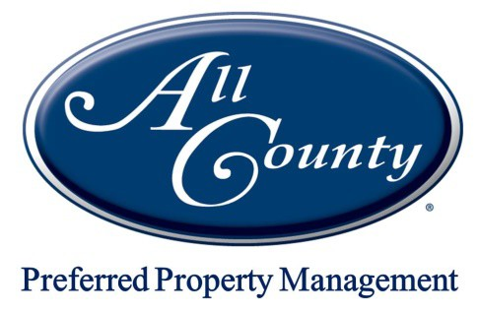
RENTAL VERIFICATION FORM
Tenant’s Name(s):

Present Address:

I / we hereby give authorization for the release of rental information to All County Preferred Property Management and its representatives:

Signature: Date:
NOTE: FOR LANDLORD'S OFFICE USE ONLY ‐ TENANT, PLEASE DO NOT WRITE BELOW THIS LINE.
(Fill out top of form, sign/date, and give to your landlord)
*********************************************************************************************** Landlord’s Name:
Landlord’s Phone # ( ) ‐ Fax # ( ) ‐

What was the above tenant's monthly rental amount? $ What were the start and end dates of the lease? From

to

Were there any late payments (circle one)? YES / NO If yes, number of late payments: Were any checks returned as NSF (circle one)? YES / NO If yes, number of NSF checks: Was the security deposit returned (circle one)? YES / NO If not, please explain why:

Was the home left in good condition (circle one)? YES / NO Was proper notice given (circle one)? YES / NO
What was the reason given for vacating?
Are you the owner of the property (circle one)? YES / NO Are you related to the tenants (circle one)? YES / NO
Were the tenants renting a room or the entire property?
Does the tenant have any pets (circle one)? YES / NO If yes, how many and what type/breed?

How many Occupants were in the property?

Would you re‐rent to this / these person(s) (circle one)? YES / NO

Person verifying: Position:

Signature: Date:

Landlord: Please fax the completed form to our office at 321‐607‐3707. Thank you!
Office: (321) 607‐3700 Applications@AllCountyPreferred.com Fax: 321‐607‐3707

