 | Central School District | K
 |  | Grade
Student Name: | Student ID:
Teacher Name: | Academic Year:

 | Academic Key
 | Exceeding New York State and District Standards | 4
 | Meeting New York State and District Standards | 3
 | Working Toward New York State and District Standards | 2
 | Not Meeting New York State and District Standards | 1
 | Not Assessed at this time | NA
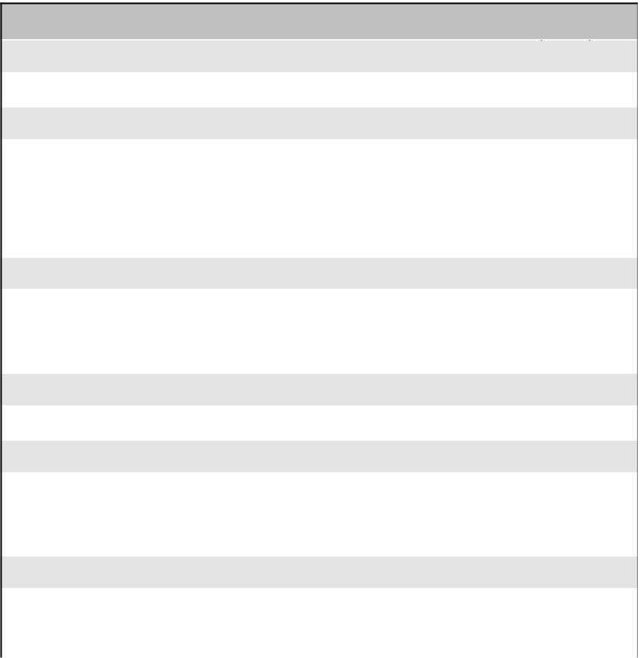
Math

Mathematical Reasoning | F | W | S
Clearly communicates mathematical thinking
Counting and Cardinality | F | W | S
Knows number names and the counting sequence
Counts to tell the number of objects
Compares sets of objects to tell more, less, or equal
quantities
Operations and Algebraic Thinking | F | W | S
Demonstrates an understanding of repeating patterns
Demonstrates addition as putting together and adding to
and subtraction as taking apart and taking from
Number Sense and Operations in Base Ten | F | W | S
Works with numbers 11-19 to demonstrate place value
Measurement and Data | F | W | S
Describes and compares measurable attributes
Classifies objects and counts the number of objects in each
category
Geometry | F | W | S
Identifies and describes shapes
Compares and creates shapes
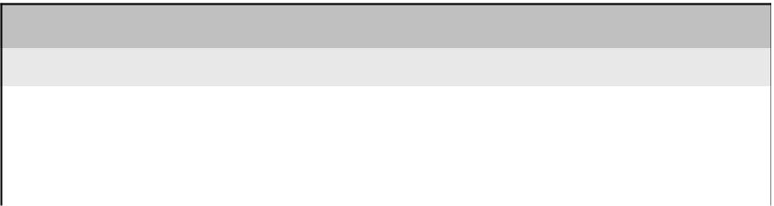
Social Studies

 | F | W | S
Demonstrates an understanding of social studies content
and concepts
Applies critical thinking to extend understanding of content
and concepts
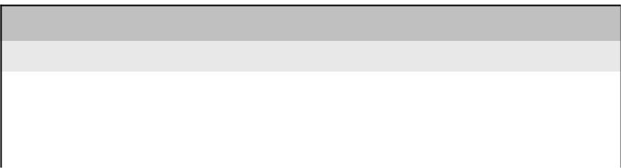
Science

 | F | W | S
Demonstrates an understanding of scientific content and
concepts
Applies process skills in problem-solving to develop and
justify explanations

English Language Arts - Reading
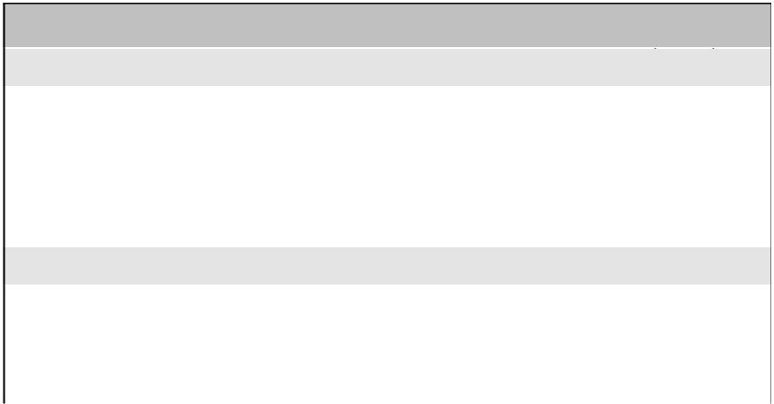
Literature/Informational Text | F | W | S
Answers questions about the text
Retells stories including key details such as characters,
settings, and major events
Describes connections between two individuals, events, or
ideas in the text
Foundational Skills | F | W | S
Reads emergent reader texts with purpose and
understanding
Knows and applies grade-level phonics and word analysis
skills in decoding words
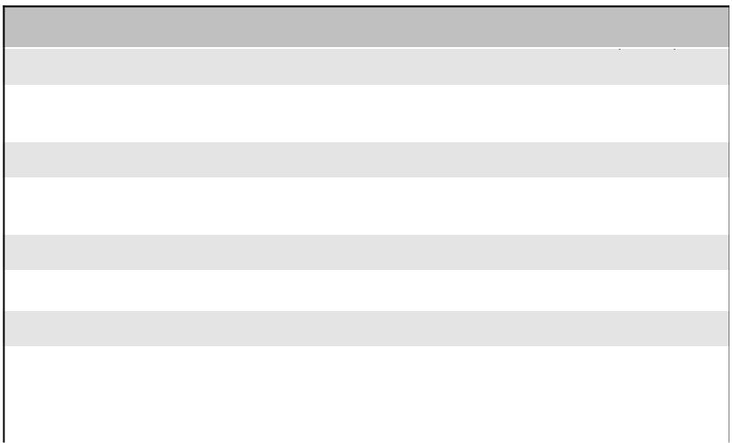
English Language Arts - Writing

Text Types and Purposes | F | W | S
Uses a combination of drawing, dictating, and writing to
communicate ideas and information effectively
Production and Distribution | F | W | S
Begins to respond to questions and suggestions to add
details to strengthen writing
Research to Build and Present Knowledge | F | W | S
Contributes to shared research and writing projects
Language | F | W | S
Demonstrates a command of the grade-level appropriate
conventions of standard English grammar and usage
Acquires and uses grade-level appropriate vocabulary
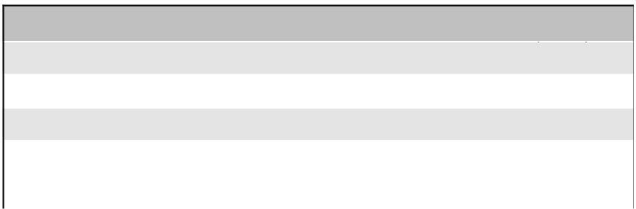
English Language Arts - Listening and Speaking

Comprehension and Collaboration | F | W | S
Engages in discussions within a group
Presentation of Knowledge and Ideas | F | W | S
Describes familiar people, places, things, and events orally
Expresses thoughts, feelings, and ideas clearly

Central School District | K
 | Grade

Student Name:

Teacher Name:

Student ID:

Academic Year:
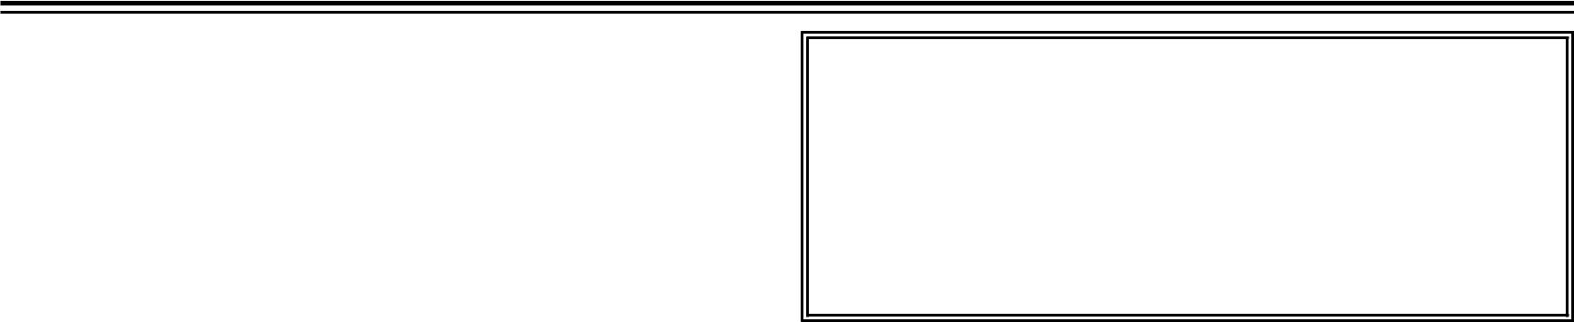

Learner Behaviors Key: Grade Level Expectations

Exceeding Expectations | 4
Meeting Expectations | 3
Working Toward Expectations | 2
Not Meeting Expectations | 1
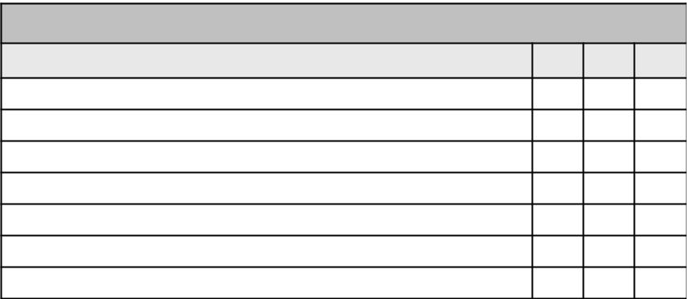
Learner Behaviors

F W S

Respects others' rights, feelings, and property

Accepts responsibility for own behavior.

Exercises self-control

Organizes self and materials.

Follows directions.

Approaches challenges using a variety of strategies.

Uses time effectively to produce quality work.

Attendance Key

Excused Absence- illness, doctor's appointment, funeral, impassable road conditions

Unexcused Absence- family vacation, overslept, missed bus, non-school related sports, or music activities.

Late Arrival- any time after the official beginning of the school day Early Dismissal- any time prior to the official end of the school day
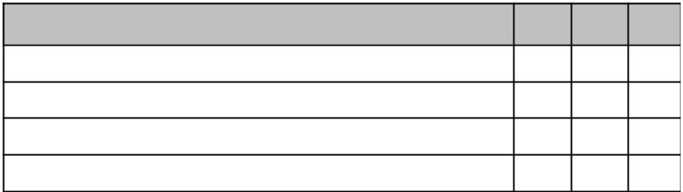
Attendance | F W S

Excused Absence

Unexcused Absence

Late Arrival

Early Dismissal

Teacher Comments ^{Winter:}

Fall:

Spring:

 | Central School District | 1
 |  | Grade
Student Name: | Student ID:
Teacher Name: | Academic Year:

 | Academic Key
 | Exceeding New York State and District Standards | 4
 | Meeting New York State and District Standards | 3
 | Working Toward New York State and District Standards | 2
 | Not Meeting New York State and District Standards | 1
 | Not Assessed at this time | NA
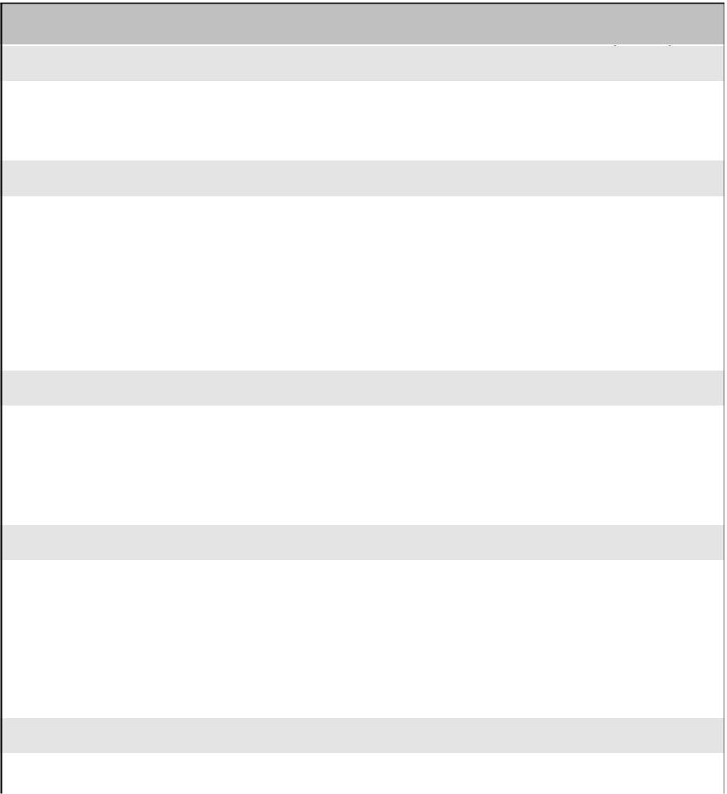
Math

Mathematical Reasoning | F | W | S
Efficiently applies strategies to solve problems
Clearly communicates mathematical thinking
Operations and Algebraic Thinking | F | W | S
Understands the relationship between addition and
subtraction
Adds whole number fluently
Subtracts whole numbers fluently
Solves word problems
Number Sense and Operations in Base Ten | F | W | S
Extends counting sequence
Understands place value
Uses place value understanding to add and subtract
Measurement and Data | F | W | S
Measures length
Tells and writes time
Identifies coins and values
Represents and interprets data
Geometry | F | W | S
Compares, composes, and partitions shapes
Social Studies

 | F | W | S
Demonstrates an understanding of social studies content
and concepts
Applies critical thinking to extend understanding of content
and concepts
Science

 | F | W | S
Demonstrates an understanding of scientific content and
concepts
Applies process skills in problem-solving to develop and
justify explanations

English Language Arts - Reading
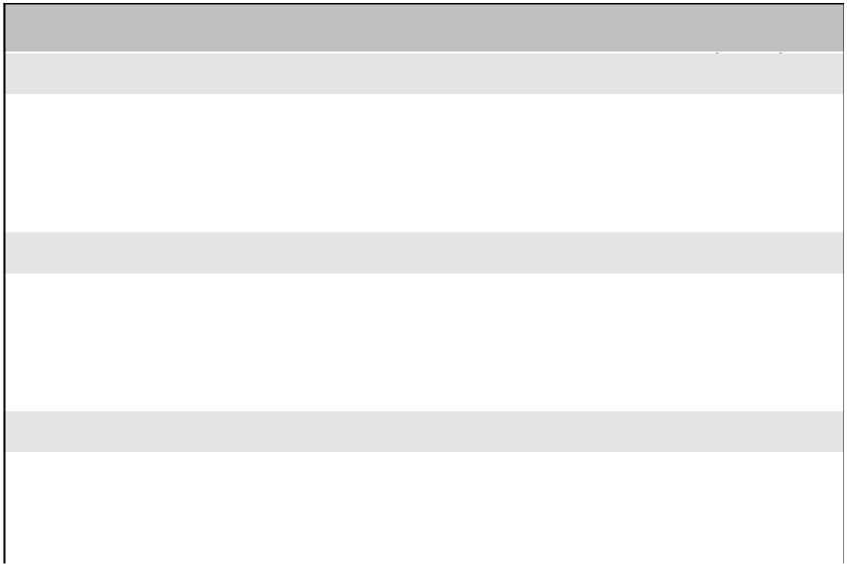
Literature | F | W | S
Answers questions about key details in the text
Retells stories to include key details
Identifies who is telling the story at various points in the text
Informational Text | F | W | S
Answers questions about key details in the text
Identifies the main topic and retells key details of the text
Uses text features to locate information in the text
Foundational Skills | F | W | S
Knows and applies grade-level phonics and word analysis
skills in decoding words
Reads accurately and fluently to support comprehension
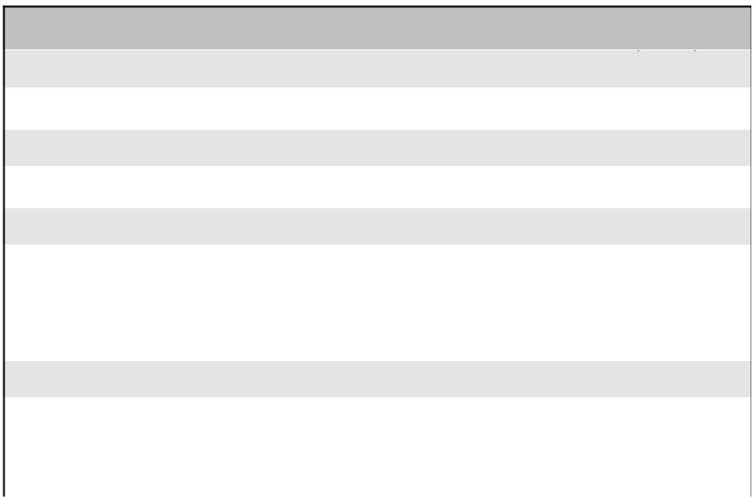
English Language Arts - Writing

Text Types and Purposes | F | W | S
Writes to communicate ideas and information effectively
Production and Distribution | F | W | S
Focuses on a topic and adds details to strengthen writing
Research to Build and Present Knowledge | F | W | S
Gathers information from print/digital sources and personal
experiences
Collaborates in a shared research and writing project about
a topic
Language | F | W | S
Demonstrates a command of the grade-level appropriate
conventions of standard English grammar and usage
Acquires and uses grade-level appropriate vocabulary
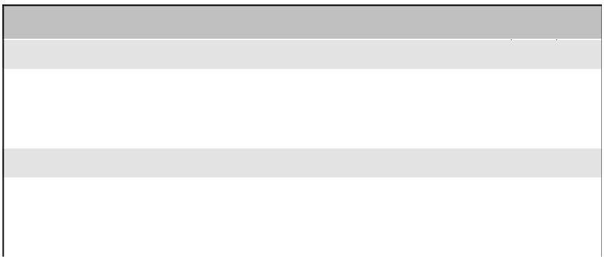
English Language Arts - Listening and Speaking

Comprehension and Collaboration | F | W | S
Participates in discussions with a group
Asks and answers questions about key details from text
read aloud
Presentation of Knowledge and Ideas | F | W | S
Describes familiar people, places, things, and events with
relevant details
Describes and expresses ideas and feelings clearly

Central School District | 1
 | Grade

Student Name:

Teacher Name:
Student ID:

Academic Year:

Learner Behaviors Key: Grade Level Expectations

Exceeding Expectations | 4
Meeting Expectations | 3
Working Toward Expectations | 2
Not Meeting Expectations | 1
Learner Behaviors

F W S

Respects others' rights, feelings, and property

Accepts responsibility for own behavior.

Exercises self-control

Organizes self and materials.

Follows directions.

Approaches challenges using a variety of strategies.

Uses time effectively to produce quality work.

Attendance Key

Excused Absence- illness, doctor's appointment, funeral, impassable road conditions

Unexcused Absence- family vacation, overslept, missed bus, non-school related sports, or music activities.

Late Arrival- any time after the official beginning of the school day Early Dismissal- any time prior to the official end of the school day
Attendance | F W S

Excused Absence

Unexcused Absence

Late Arrival

Early Dismissal

Teacher Comments ^{Winter:}

Fall:

Spring:

 | Central School District | 2
 |  | Grade
Student Name: | Student ID:
Teacher Name: | Academic Year:

 | Academic Key
 | Exceeding New York State and District Standards | 4
 | Meeting New York State and District Standards | 3
 | Working Toward New York State and District Standards | 2
 | Not Meeting New York State and District Standards | 1
 | Not Assessed at this time | NA
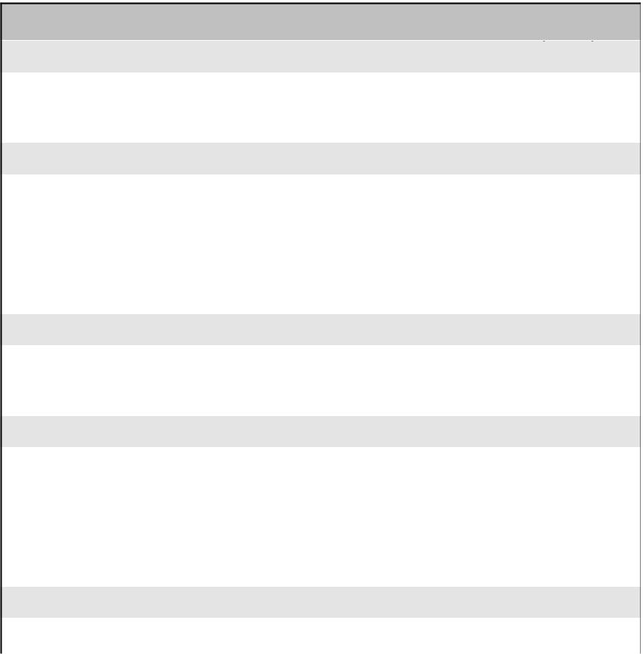
Math

Mathematical Reasoning | F | W | S
Efficiently applies strategies to solve problems
Clearly communicates mathematical thinking
Operations and Algebraic Thinking | F | W | S
Adds whole numbers fluently
Subtracts whole numbers fluently
Demonstrates foundations of multiplication
Solves word problems
Number Sense and Operations in Base Ten | F | W | S
Understands place value
Uses place value understanding to add and subtract
Measurement and Data | F | W | S
Measures and estimates lengths
Tells and writes time
Solves problems using money
Represents and interprets data
Geometry | F | W | S
Recognizes, draws, and partitions shapes
Social Studies

 | F | W | S
Demonstrates an understanding of social studies content
and concepts
Applies critical thinking to extend understanding of content
and concepts
Science

 | F | W | S
Demonstrates an understanding of scientific content and
concepts
Applies process skills in problem-solving to develop and
justify explanations

English Language Arts - Reading
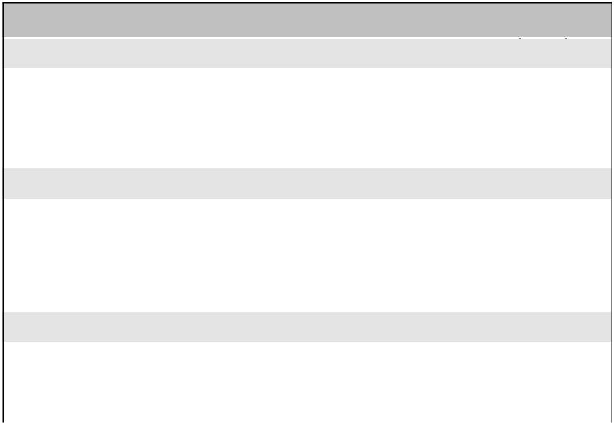
Literature | F | W | S
Asks and answers questions about the text
Recounts stories to include story elements
Acknowledges differences in the points of view of characters
Informational Text | F | W | S
Asks and answers questions using evidence from the text
Determines the main idea of the text
Compares and contrasts the most important points
presented by two texts on the same topic
Foundational Skills | F | W | S
Knows and applies grade-level phonics and word analysis
skills in decoding words
Reads accurately and fluently to support comprehension
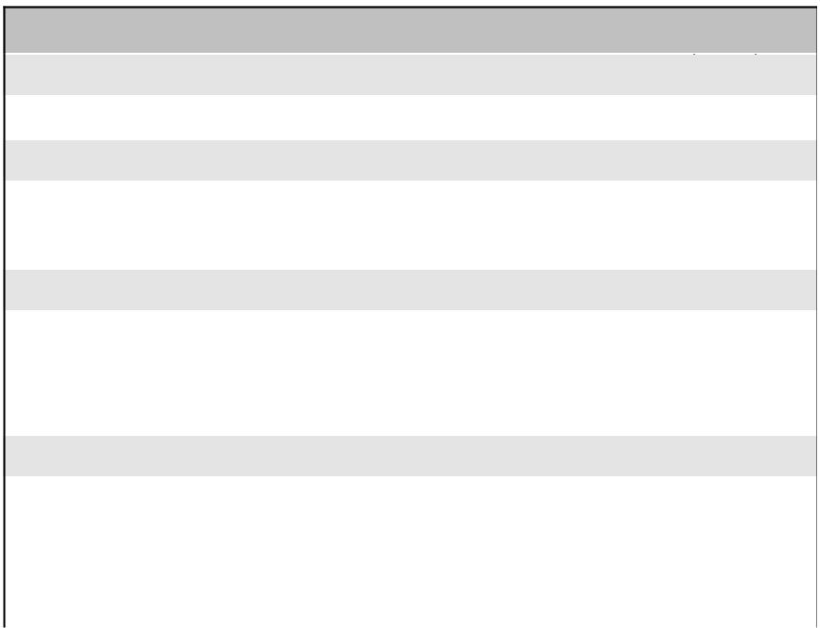
English Language Arts - Writing

Text Types and Purposes | F | W | S
Writes to communicate ideas and information effectively
Production and Distribution | F | W | S
Focuses on a topic and adds details to strengthen writing
Develops writing by planning, revising, and editing
Research to Build and Present Knowledge | F | W | S
Gathers information from print/digital sources and personal
experiences
Collaborates in a shared research and writing project about
a topic
Language | F | W | S
Demonstrates a command of the grade-level conventions of
standard English grammar and usage
Acquires and uses grade-appropriate vocabulary
Applies correct spelling of grade-level words in written work
English Language Arts - Listening and Speaking

Comprehension and Collaboration | F | W | S
Effectively participates in discussions within a group
Recounts or describes main ideas and details from text read
aloud
Presentation of Knowledge and Ideas | F | W | S
Presents information with appropriate facts and relevant
descriptive details
Expresses complete thoughts, feelings, and ideas clearly

Central School District | 2
 | Grade

Student Name:

Teacher Name:
Student ID:

Academic Year:

Learner Behaviors Key: Grade Level Expectations

Exceeding Expectations | 4
Meeting Expectations | 3
Working Toward Expectations | 2
Not Meeting Expectations | 1
Learner Behaviors

F W S

Respects others' rights, feelings, and property

Accepts responsibility for own behavior.

Exercises self-control

Organizes self and materials.

Follows directions.

Approaches challenges using a variety of strategies.

Uses time effectively to produce quality work.

Attendance Key

Excused Absence- illness, doctor's appointment, funeral, impassable road conditions

Unexcused Absence- family vacation, overslept, missed bus, non-school related sports, or music activities.

Late Arrival- any time after the official beginning of the school day Early Dismissal- any time prior to the official end of the school day
Attendance | F W S

Excused Absence

Unexcused Absence

Late Arrival

Early Dismissal

Teacher Comments ^{Winter:}

Fall:

Spring:

 | Central School District | 3
 |  | Grade
Student Name: | Student ID:
Teacher Name: | Academic Year:

 | Academic Key
 | Exceeding New York State and District Standards | 4
 | Meeting New York State and District Standards | 3
 | Working Toward New York State and District Standards | 2
 | Not Meeting New York State and District Standards | 1
 | Not Assessed at this time | NA
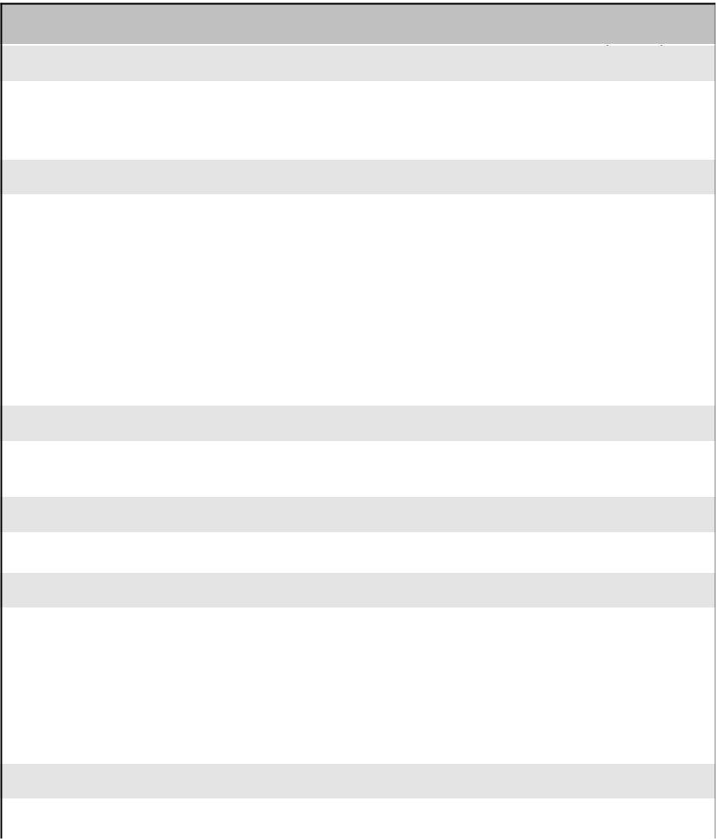
Math

Mathematical Reasoning | F | W | S
Efficiently applies strategies to solve problems
Clearly communicates mathematical thinking
Operations and Algebraic Thinking | F | W | S
Adds and subtracts whole numbers fluently
Represents and solves problems involving multiplication and
division
Multiplies whole numbers fluently
Divides whole numbers fluently
Solves word problems
Number Sense and Operations in Base Ten | F | W | S
Uses place value understanding to perform multi-digit
arithmetic
Number Sense and Operations - Fractions | F | W | S
Demonstrates an understanding of fractions
Measurement and Data | F | W | S
Tells and writes time
Solves problems involving measurement
Represents and interprets data
Demonstrates an understanding of area and perimeter
Geometry | F | W | S
Categorizes and partitions shapes
Social Studies

 | F | W | S
Demonstrates an understanding of social studies content
and concepts
Applies critical thinking to extend understanding of content
and concepts
Science

 | F | W | S
Demonstrates an understanding of scientific content and
concepts
Applies process skills in problem-solving to develop and
justify explanations

English Language Arts - Reading
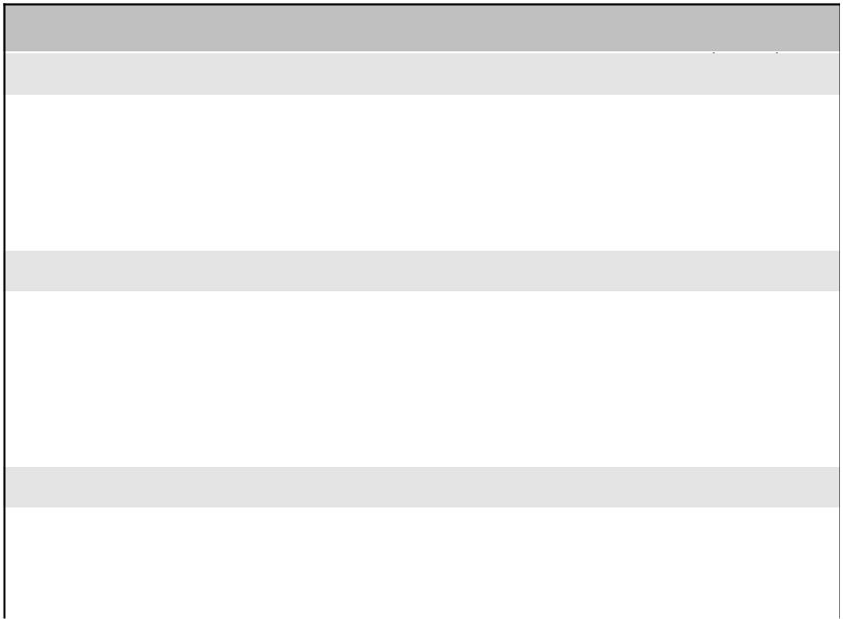
Literature | F | W | S
Asks and answers questions about the text
Recounts stories to include story elements
Distinguishes a personal point-of-view from that of the
narrator/characters
Informational Text | F | W | S
Asks and answers questions using evidence from the text
Determines the main idea of a text; recounts the key details
and explains how they support the main idea
Compares and contrasts the most important points and key
details presented by two texts on the same topic
Foundational Skills | F | W | S
Knows and applies grade-level phonics and word analysis
skills in decoding words
Reads fluently and accurately to support comprehension
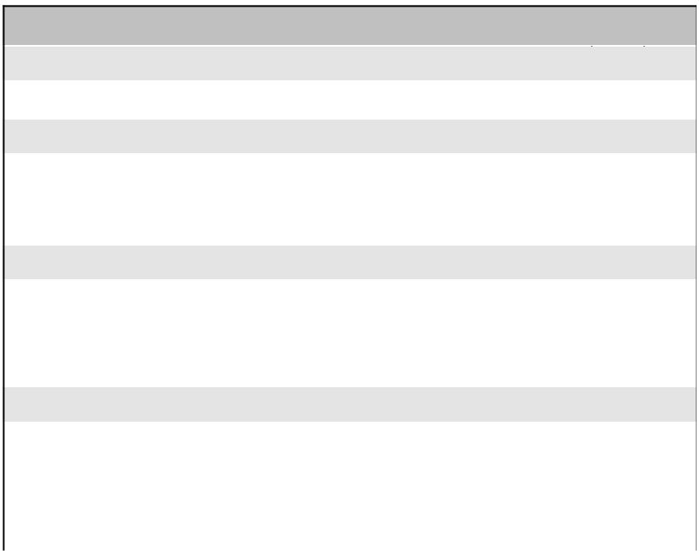
English Language Arts - Writing

Text Types and Purposes | F | W | S
Writes to communicate ideas and information effectively
Production and Distribution | F | W | S
Produces writing in which the development and organization
are appropriate to the task
Strengthens writing by planning, revising, and editing
Research to Build and Present Knowledge | F | W | S
Conducts short research projects that build knowledge about
a topic
Takes brief notes when gathering information from
print/digital sources and personal experiences
Language | F | W | S
Demonstrates a command of the grade-level conventions of
standard English grammar and usage
Acquires and uses grade-level appropriate vocabulary
Applies correct spelling of grade-level words in written work
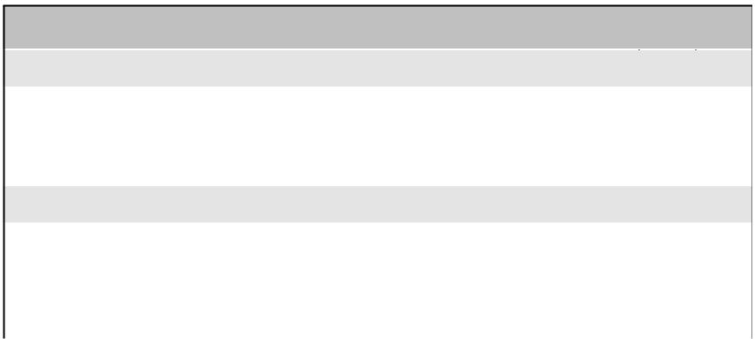
English Language Arts - Listening and Speaking

Comprehension and Collaboration | F | W | S
Effectively engages in discussions within a group
Understands and identifies main ideas and details from text
read aloud
Presentation of Knowledge and Ideas | F | W | S
Presents information with appropriate facts and relevant,
descriptive details
Speaks clearly with appropriate pace, volume, and
expression

Central School District | 3
 | Grade

Student Name:

Teacher Name:
Student ID:

Academic Year:

Learner Behaviors Key: Grade Level Expectations

Exceeding Expectations | 4
Meeting Expectations | 3
Working Toward Expectations | 2
Not Meeting Expectations | 1
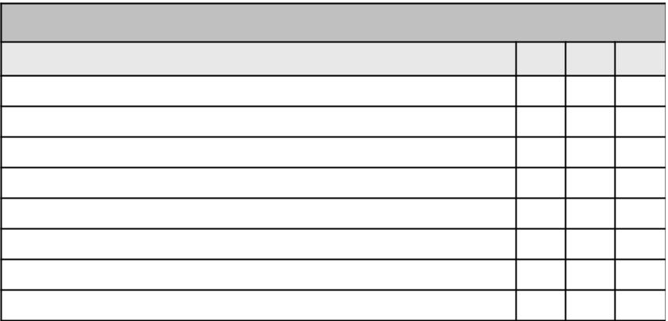
Learner Behaviors

F W S

Respects others' rights, feelings, and property

Accepts responsibility for own behavior.

Exercises self-control

Organizes self and materials.

Follows directions.

Approaches challenges using a variety of strategies.

Uses time effectively to produce quality work.

Completes homework.

Attendance Key

Excused Absence- illness, doctor's appointment, funeral, impassable road conditions

Unexcused Absence- family vacation, overslept, missed bus, non-school related sports, or music activities.

Late Arrival- any time after the official beginning of the school day Early Dismissal- any time prior to the official end of the school day
Attendance | F W S

Excused Absence

Unexcused Absence

Late Arrival

Early Dismissal

Teacher Comments ^{Winter:}

Fall:

Spring:

 | Central School District | 4
 |  | Grade
Student Name: | Student ID:
Teacher Name: | Academic Year:

 | Academic Key
 | Exceeding New York State and District Standards | 4
 | Meeting New York State and District Standards | 3
 | Working Toward New York State and District Standards | 2
 | Not Meeting New York State and District Standards | 1
 | Not Assessed at this time | NA
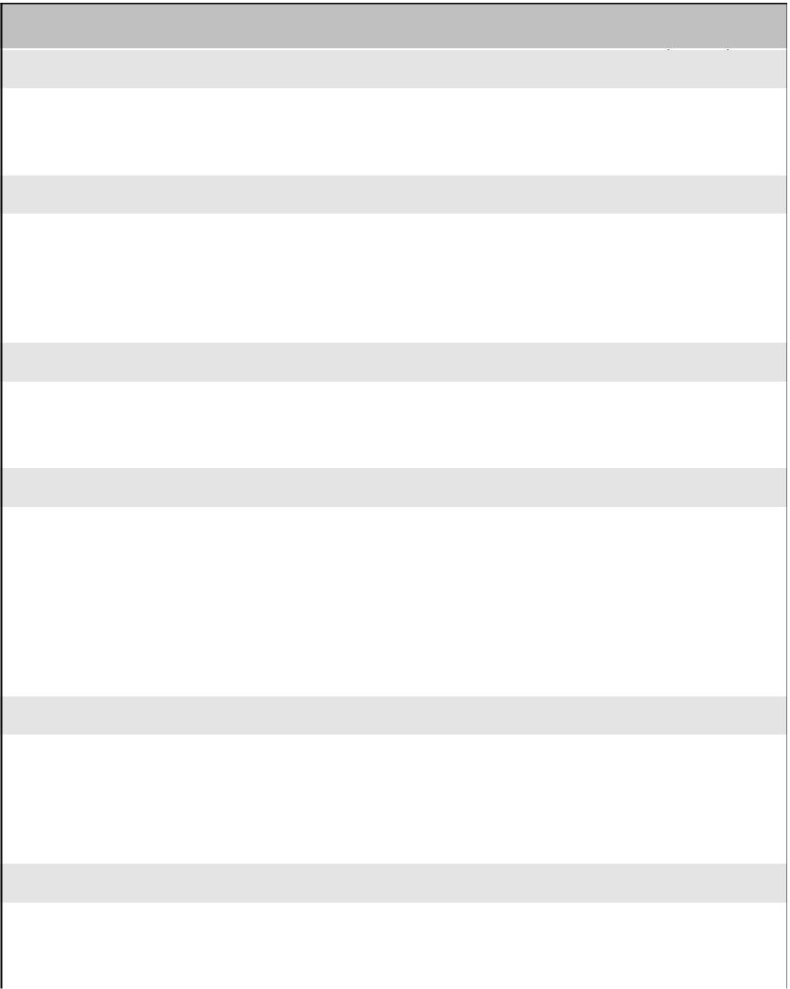
Math

Mathematical Reasoning | F | W | S
Efficiently applies strategies to solve problems
Clearly communicates mathematical thinking
Operations and Algebraic Thinking | F | W | S
Understands factors and multiples
Knows multiplication and division facts fluently
Solves multi-step word problems
Number Sense and Operations in Base Ten | F | W | S
Understands multi-digit place value
Performs operations with multi-digit numbers
Number Sense and Operations - Fractions | F | W | S
Demonstrates an understanding of fraction equivalents
Compares and orders fractions
Adds and subtracts fractions with like denominators
Demonstrates an understanding of the relationship between
fractions and decimals
Measurement and Data | F | W | S
Solves problems involving measurement
Converts units of measure
Represents and interprets data
Geometry | F | W | S
Draws and identifies lines and angles
Classifies shapes based on lines and angles
Social Studies

 | F | W | S
Demonstrates an understanding of social studies content
and concepts
Applies critical thinking to extend understanding of content
and concepts
Science

 | F | W | S
Demonstrates an understanding of scientific content and
concepts
Applies process skills in problem-solving to develop and
justify explanations

English Language Arts - Reading
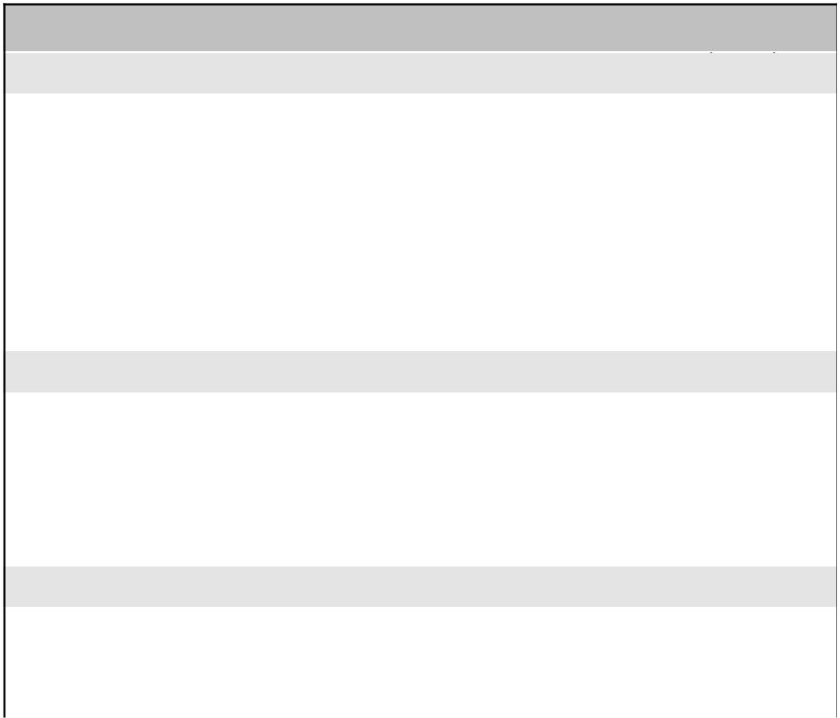
Literature | F | W | S
Refers to details and examples in a text when explaining
what the text says explicitly
Refers to details and examples in a text when drawing
inferences from the text
Summarizes a text to determine a theme of a story, drama,
or poem from the details in the text
Compares and contrasts the points of view from which
different stories are narrated
Informational Text | F | W | S
Asks and answers questions using evidence from the text
Determines the main idea of a text and explains how it is
supported by key details; summarizes the text
Uses information from two texts to write or speak about the
subject knowledgeably
Foundational Skills | F | W | S
Knows and applies grade-level phonics and word analysis
skills in decoding words
Reads accurately and fluently to support comprehension
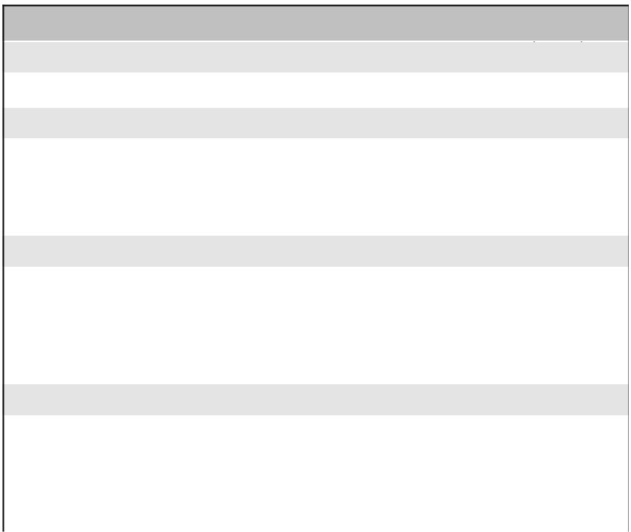
English Language Arts - Writing

Text Types and Purposes | F | W | S
Writes to communicate ideas and information effectively
Production and Distribution | F | W | S
Produces writing in which the development and organization
are appropriate to task, purpose, and audience
Strengthens writing by planning, revising, editing, and
rewriting
Research to Build and Present Knowledge | F | W | S
Conducts short research projects that build knowledge
through investigation of different aspects of a topic
Takes notes when gathering information from print/digital
sources and personal experiences; categorizes information
and provides a list of sources
Language | F | W | S
Demonstrates a command of the grade-level conventions of
standard English grammar and usage
Acquires and uses grade-level appropriate vocabulary
Applies correct spelling of grade-level words in written work
English Language Arts - Listening and Speaking

Comprehension and Collaboration | F | W | S
Effectively engages in discussions within a group
Paraphrases a text read aloud or information presented in
various formats
Presentation of Knowledge and Ideas | F | W | S
Presents information with appropriate facts and relevant,
descriptive details
Speaks clearly with appropriate pace, volume, and
expression

Central School District | 4
 | Grade

Student Name:

Teacher Name:
Student ID:

Academic Year:

Learner Behaviors Key: Grade Level Expectations

Exceeding Expectations | 4
Meeting Expectations | 3
Working Toward Expectations | 2
Not Meeting Expectations | 1
Learner Behaviors

F W S

Respects others' rights, feelings, and property

Accepts responsibility for own behavior.

Exercises self-control

Organizes self and materials.

Follows directions.

Approaches challenges using a variety of strategies.

Uses time effectively to produce quality work.

Completes homework.

Attendance Key

Excused Absence- illness, doctor's appointment, funeral, impassable road conditions

Unexcused Absence- family vacation, overslept, missed bus, non-school related sports, or music activities.

Late Arrival- any time after the official beginning of the school day Early Dismissal- any time prior to the official end of the school day
Attendance | F W S

Excused Absence

Unexcused Absence

Late Arrival

Early Dismissal

Teacher Comments ^{Winter:}

Fall:

Spring:

 | Central School District | 5
 |  | Grade
Student Name: | Student ID:
Teacher Name: | Academic Year:

 | Academic Key
 | Exceeding New York State and District Standards | 4
 | Meeting New York State and District Standards | 3
 | Working Toward New York State and District Standards | 2
 | Not Meeting New York State and District Standards | 1
 | Not Assessed at this time | NA
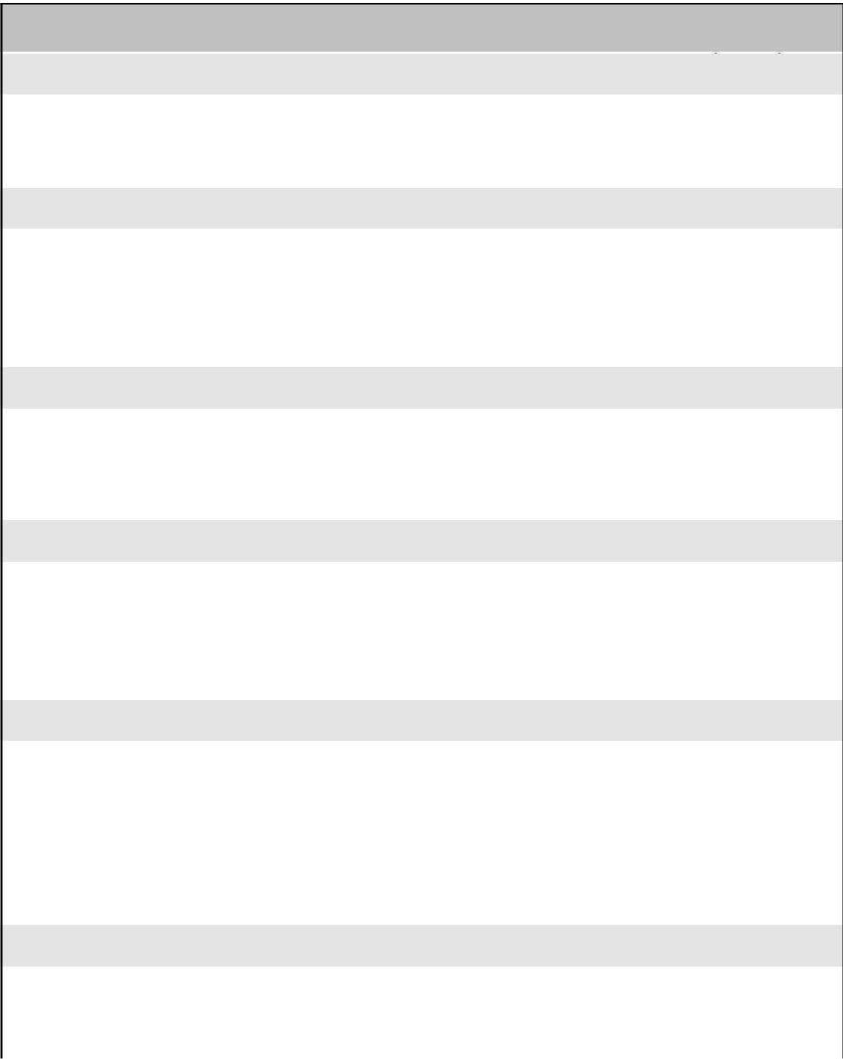
Math

Mathematical Reasoning | F | W | S
Efficiently applies strategies to solve problems
Clearly communicates mathematical thinking
Operations and Algebraic Thinking | F | W | S
Writes and interprets numerical expressions
Knows multiplication and division facts fluently
Solves multi-step word problems
Number Sense and Operations in Base Ten | F | W | S
Understands the place value system
Performs operations with multi-digit whole numbers and with
decimals
Number Sense and Operations - Fractions | F | W | S
Adds and subtracts fractions with unlike denominators
Multiplies and divides fractions
Solves word problems with fractions
Measurement and Data | F | W | S
Converts like units within a given measurement system
Represents and interprets data
Understands concepts of volume
Relates volume to multiplication and addition
Geometry | F | W | S
Graphs points on a coordinate plane to solve problems
Classifies two dimensional figures based on properties
Social Studies

 | F | W | S
Demonstrates an understanding of social studies content
and concepts
Applies critical thinking to extend understanding of content
and concepts
Science

 | F | W | S
Demonstrates an understanding of scientific content and
concepts
Applies process skills in problem-solving to develop and
justify explanations

English Language Arts - Reading
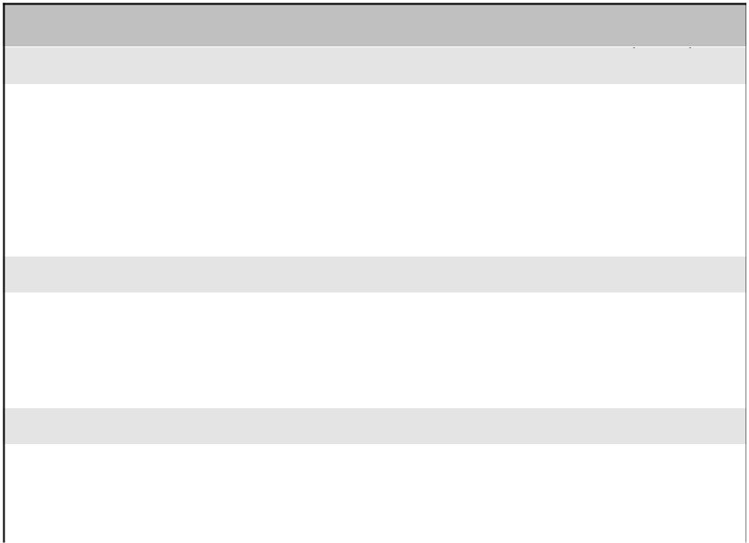
Literature | F | W | S
Accurately quotes from a text when explaining what the text
says explicitly and when drawing inferences
Summarizes a text to determine a theme of a story, drama,
or poem from details in the text
Describes how a narrator's point-of-view impacts the events
in the text
Informational Text | F | W | S
Determines two or more main ideas of a text and explains
how they are supported by key details; summarizes the text
Analyzes multiple accounts of the same topic noting the
similarities and differences unique to various points of view
Foundational Skills | F | W | S
Knows and applies grade-level phonics and word analysis
skills in decoding words
Reads accurately and fluently to support comprehension
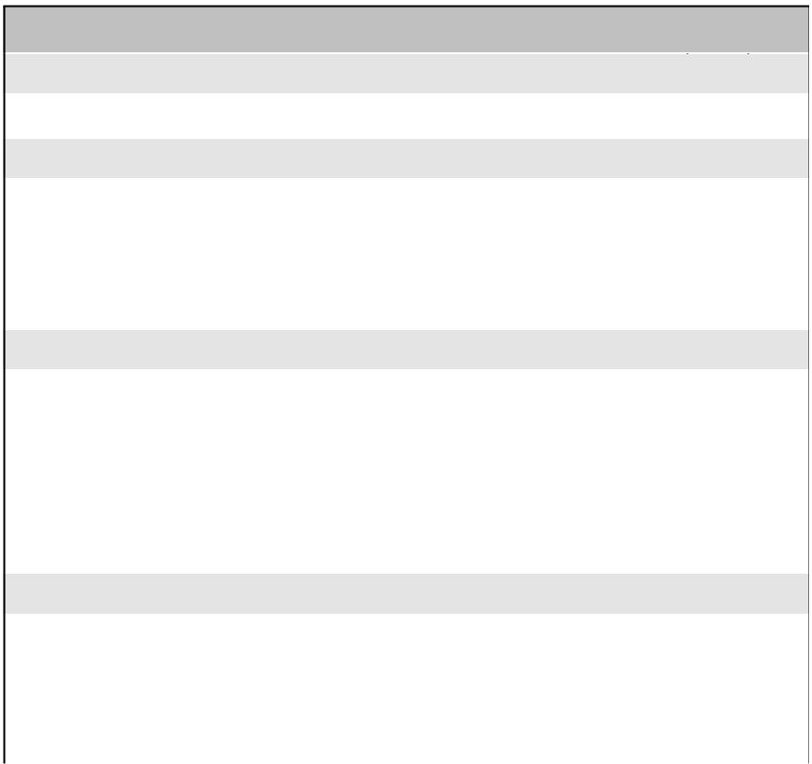
English Language Arts - Writing

Text Types and Purposes | F | W | S
Writes to communicate ideas and information effectively
Production and Distribution | F | W | S
Produces clear and coherent writing in which the
development and organization are appropriate to task,
purpose, and audience
Strengthens writing by planning, revising, editing, and
rewriting
Research to Build and Present Knowledge | F | W | S
Conducts short research projects that use several sources
to build knowledge through investigation of different aspects
of a topic
Takes notes when gathering information from print/digital
sources and personal experiences; summarizes or
paraphrases information in notes and provides list of
sources
Language | F | W | S
Demonstrates a command of the grade-level conventions of
standard English grammar and usage
Acquires and uses grade-level appropriate vocabulary
Applies correct spelling of grade-level words in written work
English Language Arts - Listening and Speaking

Comprehension and Collaboration | F | W | S
Effectively engages in discussions within a group
Summarizes a text read aloud or information presented in
various formats
Presentation of Knowledge and Ideas | F | W | S
Presents information, including opinions, with appropriate
facts and relevant, descriptive details
Speaks clearly with appropriate pace, volume, and
expression giving attention to context and audience

Central School District | 5
 | Grade

Student Name:

Teacher Name:
Student ID:

Academic Year:

Learner Behaviors Key: Grade Level Expectations

Exceeding Expectations | 4
Meeting Expectations | 3
Working Toward Expectations | 2
Not Meeting Expectations | 1
Learner Behaviors

F W S

Respects others' rights, feelings, and property

Accepts responsibility for own behavior.

Exercises self-control

Organizes self and materials.

Follows directions.

Approaches challenges using a variety of strategies.

Uses time effectively to produce quality work.

Completes homework.

Attendance Key

Excused Absence- illness, doctor's appointment, funeral, impassable road conditions

Unexcused Absence- family vacation, overslept, missed bus, non-school related sports, or music activities.

Late Arrival- any time after the official beginning of the school day Early Dismissal- any time prior to the official end of the school day
Attendance | F W S

Excused Absence

Unexcused Absence

Late Arrival

Early Dismissal

Teacher Comments ^{Winter:}

Fall:

Spring:

