Residential tenancy agreement
Residential Tenancies Act 1997 Section 26
Residential Tenancies Regulations 20XX – Schedule 1 Form 1
Warning: Enter text in spaces provided only. This form will be invalid if you remove or change any questions or other text.

Important information
Please read this before completing the Residential Tenancy Agreement
- This form is your written record of your tenancy agreement. This is a binding contract under the Residential Tenancies Act 1997, so please read all terms and conditions carefully.
- If you need advice on your rights and responsibilities, please call the Consumer Affairs Victoria Helpline on 1300 55 81 81 before signing the Agreement.
- Both the landlord and tenant should keep signed copies of the completed Agreement for future reference. The landlord must supply the tenant with a copy of the completed Agreement within 14 days of the tenant signing.
- This Agreement is printed on carbonless paper and will produce copies for both the landlord and tenant. To fill out the Agreement, place on a hard surface and write firmly. Do not fold the Agreement while writing.
- If you require extra space to list additional items and terms, attach a separate sheet. All attachments should be signed and dated by both the landlord and tenant to show that both parties have read and agree to any attachments. Both the landlord and tenant should keep a copy of any attachments for future reference.
- The landlord must give the tenant a copy of Renting a home: a guide for tenants booklet at the start of each tenancy.
- When a bond is paid, the landlord and tenant must complete a Condition Report and both keep a copy for their records.

Telephone Interpreter Service
If you have difficulty understanding English, contact the Translating and Interpreting Service (TIS) on 131 450 (for the cost of a local call) and ask to be put through to an Information Officer at Consumer Affairs Victoria on
1300 55 81 81.
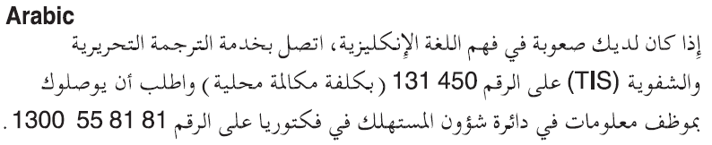
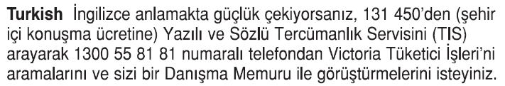
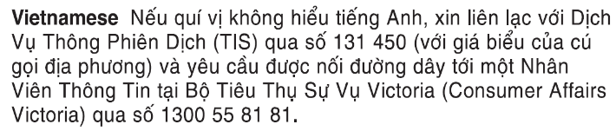
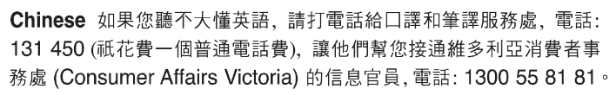
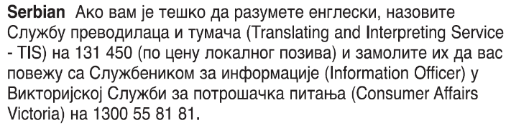
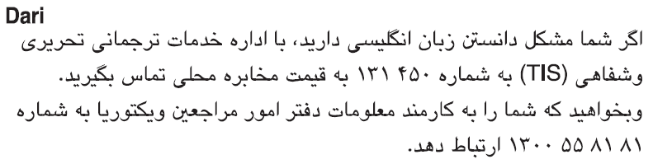
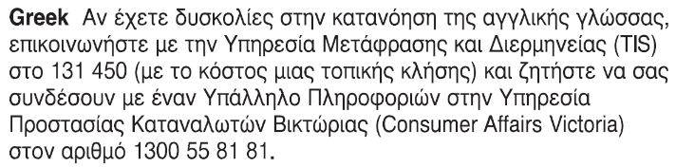

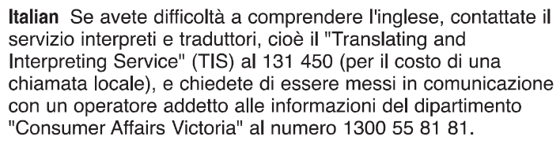

Residential tenancy agreement Landlord’s copy
Residential Tenancies Act 19XX Section 26

This agreement is made on the day of
Date: | / /
This agreement is between

LANDLORD
Name:

Address:
Postcode:

ACN (if applicable):
whose agent is (if applicable)
Name:

Business address:
Postcode:

Telephone number:
ACN (if applicable):

and TENANT(S)
Name of TENANT 1:

Current address:
Postcode:

ACN (if applicable):

Name of TENANT 2:

Current address:
Postcode:

Name of TENANT 3:

Current address:
Postcode:

Name of TENANT 4:

Current address:
Postcode:

Premises
The landlord lets the premises known as
Address:
Postcode:
together with those items indicated in the Schedule
(strike out if not applicable)

Rent
The rent amount is ($):
Date first rent payment due: | / /
Pay period
Weekly:
Fortnightly:
Monthly:
Day of each month (e.g. 15th):
Place of payment:

Bond
- The TENANT must pay the bond of $ amount specified below.
- In accordance with the Residential Tenancies Act 1997, the LANDLORD/agent must lodge the bond with the Residential Tenancies Bond Authority (RTBA) within 10 business days after receiving the bond.
- If the TENANT does not receive a bond receipt from the RTBA within 15 business days of handing over the bond money, they should telephone the RTBA on 1300 13 71 64.
Bond amount ($):
Date bond payment due: | / /
If there is more than one TENANT and they do not contribute equally to the total bond, the amounts they each contribute must be listed here. This list is for reference only and will not be recognised by the RTBA.
Name of TENANT | Bond amount ($)

Period
Fixed period:

The period of the agreement commences on: | / /
and ends on: | / /
unless the agreement terminates in accordance with the Residential Tenancies Act 1997, the agreement will continue as a periodic tenancy
OR Periodic:

The agreement will commence on: | / /
and continue until terminated in accordance with the Residential Tenancies Act 1997.

Condition of the premises
The LANDLORD must:
- ensure that the premises are maintained in good repair, and
- If the LANDLORD owns or controls the common areas, take reasonable steps to ensure that the common areas are maintained in good repair.

Damage to the premises
- The TENANT must ensure that care is taken to avoid damaging the rented premises.
- The TENANT must take reasonable care to avoid damaging the premises and any common areas.
- The TENANT who becomes aware of damage to the rented premises must give notice to the LANDLORD of any damage to the premises as soon as practicable.

Cleanliness of the premises
- The LANDLORD must ensure that the premises are in a reasonably clean condition on the day on which it is agreed that the TENANT is to enter into occupation of the premises.
- The TENANT must keep the premises in a reasonably clean condition during the period of agreement.

Use of premises
- The TENANT must not use or allow the premises to be used for any illegal purpose.
- The TENANT must not use or allow the premises to be used in such a manner as to cause a nuisance or cause an interference with the reasonable peace, comfort or privacy of any occupier of neighbouring premises.

Quiet enjoyment
The LANDLORD must take all reasonable steps to ensure that the TENANT has quiet enjoyment of the premises.

Assignment or sub-letting
- The TENANT must not assign or sub-let the whole or any part of the premises without the written consent of the LANDLORD. The LANDLORD’s consent must not be unreasonably withheld.
- The LANDLORD must not demand or receive any fee or payment for the consent, except in respect of any fees, costs or charges incurred by the LANDLORD in relation to the preparation of a written assignment of the agreement.

Residential Tenancies Act 1997
- Each party must comply with the Residential Tenancies Act 1997.
- For further rights and duties refer to the Residential Tenancies Act 1997.

Schedule: A. Items let with the premises (if any); B. Additional terms (if any)
This section lists any additional items and terms to this agreement. The terms listed cannot take away any of the rights and duties included in the Residential Tenancies Act 1997. If you need extra space, please attach a separate sheet.
Both the LANDLORD and TENANT should sign and date any attachments.
Any additional terms must also comply with the Unfair Contract Terms under the Fair Trading Act 1999. Contact Consumer Affairs Victoria on 1300 55 81 81 for further information.

Signatures

LANDLORD
Signature of LANDLORD:
Urgent repairs emergency contact name and telephone number:

TENANT(S)
Signature of TENANT 1:
Signature of TENANT 2:
Signature of TENANT 3:
Signature of TENANT 4:

Residential tenancy agreement
Residential Tenancies Act 1997 Section 26
Residential Tenancies Regulations 2008 – Schedule 1 Form 1
Warning: Enter text in spaces provided only. This form will be invalid if you remove or change any questions or other text.

Important information
Please read this before completing the Residential Tenancy Agreement
- This form is your written record of your tenancy agreement. This is a binding contract under the Residential Tenancies Act 1997, so please read all terms and conditions carefully.
- If you need advice on your rights and responsibilities, please call the Consumer Affairs Victoria Helpline on 1300 55 81 81 before signing the Agreement.
- Both the landlord and tenant should keep signed copies of the completed Agreement for future reference. The landlord must supply the tenant with a copy of the completed Agreement within 14 days of the tenant signing.
- This Agreement is printed on carbonless paper and will produce copies for both the landlord and tenant. To fill out the Agreement, place on a hard surface and write firmly. Do not fold the Agreement while writing.
- If you require extra space to list additional items and terms, attach a separate sheet. All attachments should be signed and dated by both the landlord and tenant to show that both parties have read and agree to any attachments. Both the landlord and tenant should keep a copy of any attachments for future reference.
- The landlord must give the tenant a copy of Renting a home: a guide for tenants booklet at the start of each tenancy.
- When a bond is paid, the landlord and tenant must complete a Condition Report and both keep a copy for their records.

Telephone Interpreter Service
If you have difficulty understanding English, contact the Translating and Interpreting Service (TIS) on 131 450 (for the cost of a local call) and ask to be put through to an Information Officer at Consumer Affairs Victoria on
1300 55 81 81.

Residential tenancy agreement Tenant’s copy
Residential Tenancies Act 1997 Section 26

This agreement is made on the day of
Date: | / /
This agreement is between

LANDLORD
Name:

Address:
Postcode:

ACN (if applicable):
whose agent is (if applicable)
Name:

Business address:
Postcode:

Telephone number:
ACN (if applicable):

and TENANT(S)
Name of TENANT 1:

Current address:
Postcode:

ACN (if applicable):

Name of TENANT 2:

Current address:
Postcode:

Name of TENANT 3:

Current address:
Postcode:

Name of TENANT 4:

Current address:
Postcode:

Premises
The landlord lets the premises known as
Address:
Postcode:
together with those items indicated in the Schedule
(strike out if not applicable)

Rent
The rent amount is ($):
Date first rent payment due: | / /
Pay period
Weekly:
Fortnightly:
Monthly:
Day of each month (e.g. 15th):
Place of payment:

Bond
- The TENANT must pay the bond of $ amount specified below.
- In accordance with the Residential Tenancies Act 1997, the LANDLORD/agent must lodge the bond with the Residential Tenancies Bond Authority (RTBA) within 10 business days after receiving the bond.
- If the TENANT does not receive a bond receipt from the RTBA within 15 business days of handing over the bond money, they should telephone the RTBA on 1300 13 71 64.
Bond amount ($):
Date bond payment due: | / /
If there is more than one TENANT and they do not contribute equally to the total bond, the amounts they each contribute must be listed here. This list is for reference only and will not be recognised by the RTBA.
Name of TENANT | Bond amount ($)

Period
Fixed period:

The period of the agreement commences on: | / /
and ends on: | / /
unless the agreement terminates in accordance with the Residential Tenancies Act 1997, the agreement will continue as a periodic tenancy
OR Periodic:

The agreement will commence on: | / /
and continue until terminated in accordance with the Residential Tenancies Act 1997.

Condition of the premises
The LANDLORD must:
- ensure that the premises are maintained in good repair, and
- If the LANDLORD owns or controls the common areas, take reasonable steps to ensure that the common areas are maintained in good repair.

Damage to the premises
- The TENANT must ensure that care is taken to avoid damaging the rented premises.
- The TENANT must take reasonable care to avoid damaging the premises and any common areas.
- The TENANT who becomes aware of damage to the rented premises must give notice to the LANDLORD of any damage to the premises as soon as practicable.

Cleanliness of the premises
- The LANDLORD must ensure that the premises are in a reasonably clean condition on the day on which it is agreed that the TENANT is to enter into occupation of the premises.
- The TENANT must keep the premises in a reasonably clean condition during the period of agreement.

Use of premises
- The TENANT must not use or allow the premises to be used for any illegal purpose.
- The TENANT must not use or allow the premises to be used in such a manner as to cause a nuisance or cause an interference with the reasonable peace, comfort or privacy of any occupier of neighbouring premises.

Quiet enjoyment
The LANDLORD must take all reasonable steps to ensure that the TENANT has quiet enjoyment of the premises.

Assignment or sub-letting
- The TENANT must not assign or sub-let the whole or any part of the premises without the written consent of the LANDLORD. The LANDLORD’s consent must not be unreasonably withheld.
- The LANDLORD must not demand or receive any fee or payment for the consent, except in respect of any fees, costs or charges incurred by the LANDLORD in relation to the preparation of a written assignment of the agreement.

Residential Tenancies Act 1997
- Each party must comply with the Residential Tenancies Act 1997.
- For further rights and duties refer to the Residential Tenancies Act 1997.

Schedule: A. Items let with the premises (if any); B. Additional terms (if any)
This section lists any additional items and terms to this agreement. The terms listed cannot take away any of the rights and duties included in the Residential Tenancies Act 1997. If you need extra space, please attach a separate sheet.
Both the LANDLORD and TENANT should sign and date any attachments.
Any additional terms must also comply with the Unfair Contract Terms under the Fair Trading Act 1999. Contact Consumer Affairs Victoria on 1300 55 81 81 for further information.

Signatures

LANDLORD
Signature of LANDLORD:
Urgent repairs emergency contact name and telephone number:

TENANT(S)
Signature of TENANT 1:
Signature of TENANT 2:
Signature of TENANT 3:
Signature of TENANT 4:

