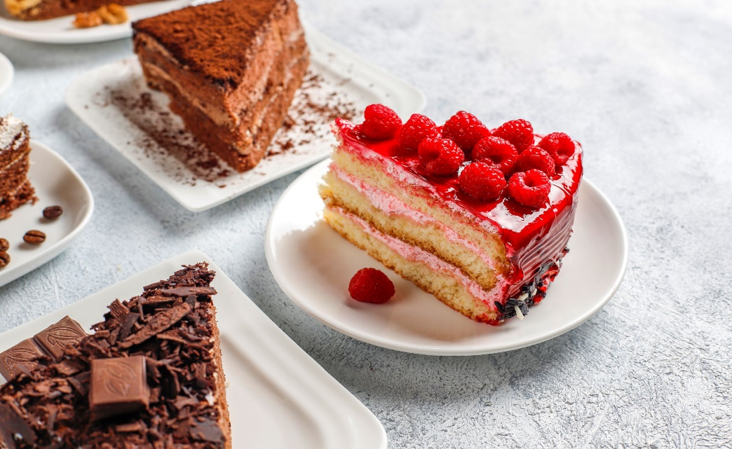

FOOD AND BEVERAGES

Menu 2 | 00
Description

Menu 4 | 00
Description

Menu 4
Description

Menu 4
Description

Menu 4
Description

