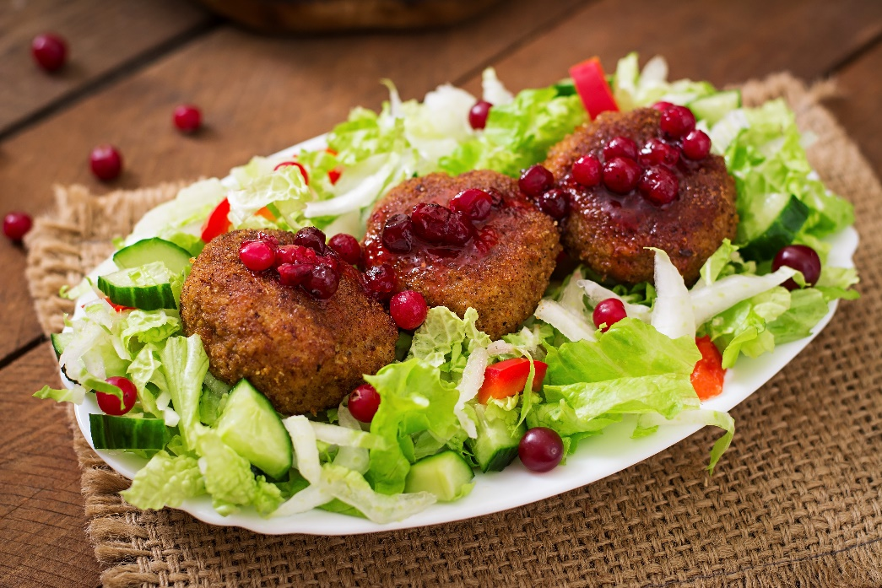

Menu Templates

Name of Restaurant
__________________

Menu 2 | 00
Description

Menu 4 | 00
Description

Menu 4
Description

Menu 4
Description

Menu 4
Description

