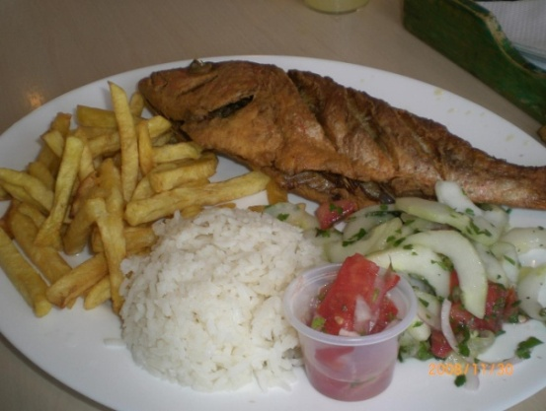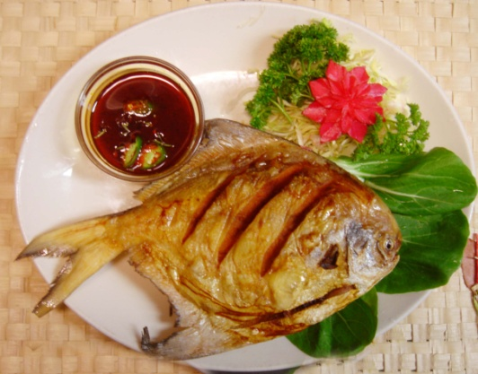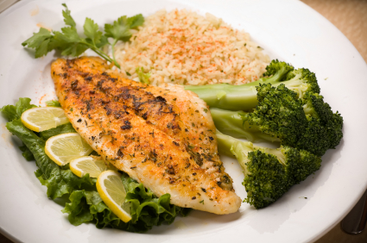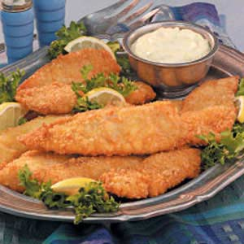

Cod

*Gadus morhua*

Cod’s lean, moist white flesh has a

flaky texture. The large tender flakes

Have a mild, delicate and sweet

Flavor. A characteristic white line runs along the skin of the fillet.

Haddock

*Melanogrammus aeglefinus*

Haddock is similar to Cod but slightly

stronger in flavor with moderate- to

firm-textured flesh. A real taste of the

sea. A characteristic black line runs along the skin of the fillet.

Rock

*Squalus acanthias*

Rock fillets are sturdier.

Than those of Cod and

Haddock, with a meatier

texture and a taste like fresh Salmon. A thick bone runs along the

center of the fillet.

Scampi

*Nephrops norvegicus*

Scampi is the fleshy tail of the Norway lobster

(sometimes called Dublin Bay prawn) coated.

in breadcrumbs. Scampi is closer in both tastes.

and texture to Lobster than Prawn or Shrimp.

Plaice

*Pleuronectes platessa*

Plaice is a flat fish with soft flesh and a

subtle but distinctive flavor, which is well.

complimented with a slice of lemon. Plaice is

recognizable by orange spots on its skin.

FISH FOOD MENU