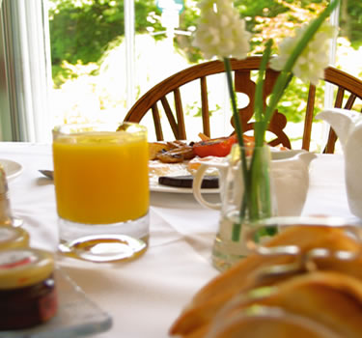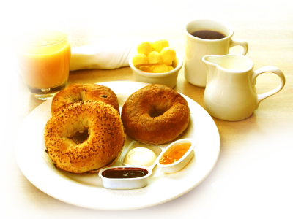

**For Contact:**

555-555-5555

email@example.com

Location: [Write Location of Your Restaurant Here]

Eggs-served the way you like  
bacon  
sausages/vegetarian sausages  
haggis  
black pudding  
Mushrooms  
tomatoes  
hash brown  
cereals.

Fruit  
brown or white toast  
oatcakes  
fruit juices  
tea  
coffee

BREAKFAST MENU