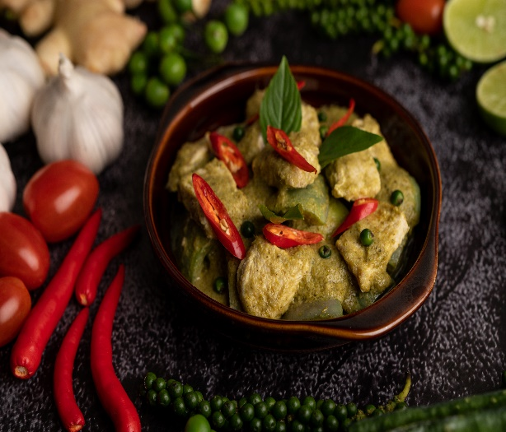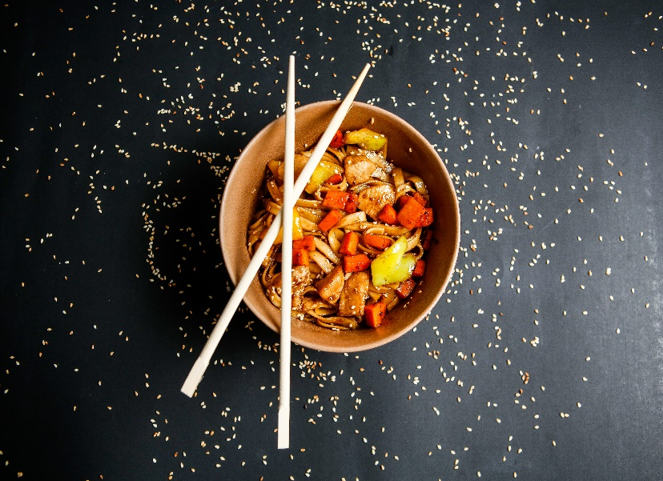

**Desserts**

Cheesecake served with  
a hot fresh berry sauce  
chocolate cake served with  
berry sauce  
fresh fruit flan served with  
whipping cream  
cheesecake served.

**Wines**

Sautéed garlic  
mushrooms in olive oil  
balsamic vinegar served with hot fish  
steamed rice with onion and garlic sauce  
steamed mussels with red wine  
all entrees are served with grilled vegetables and nugget potatoes  
juicy prawns are also available.

**Main course**

Sautéed garlic  
mushrooms in olive oil  
balsamic vinegar served with hot fish  
steamed rice with onion and garlic sauce  
steamed mussels with red wine  
all entrees are served with grilled vegetables and nugget potatoes  
juicy prawns are also available.

**Starters**

Sautéed garlic  
mushrooms in olive oil  
balsamic vinegar served with hot fish  
steamed rice with onion and garlic sauce  
steamed mussels with red wine.

Welcome to our

Restaurant