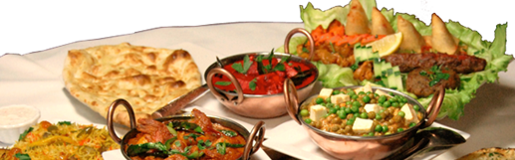

Restaurant Name

*You can add your restaurant slogan here*

*Address: add your address here*

*Email: email@example.com*

*Ph: 555-555-5555*

**Daily Specials**

Main course …………………………………………£3.50

Dessert ……………………………………………….£1.00

**Hot Choices**

Jacket Potato

One filling ………………………………………………£3.00.

Two fillings ……………………………………………. £3.40

One filling ………………………………………………£3.00.

Two fillings ……………………………………………. £3.40

One filling ………………………………………………£3.00.

Two fillings ……………….....………………………….£3.40

One filling ……………………….………………………£3.00

Two fillings ……………………………..……………….£3.40

One filling ………………………………………………£3.00

Two fillings …………………………………………….£3.40

One filling ………………………………………………£3.00

Two fillings ………………………..…………………….£3.40

**Cold choices**

Mixed Salad with choice of:

Egg/Ham/Tuna …………………………………………..£2.90

Side salad/Garnish ……………………….……………..£0.50

**Daily Specials**

Main course ……………………………………………£3.50

Dessert ……………………..…………………………..£1.00

**Hot Choices**

Jacket Potato

One filling ………………………………………………£3.00

Two fillings …………………………………………….£3.40

One filling ………………………………………………£3.00

Two fillings ………………………………………….£3.40

One filling ……………………………………………£3.00

Two fillings …………………………………………….£3.40

One filling ………………………………………………£3.00

Two fillings …………………………………………….£3.40

One filling ……………………………………………£3.00

Two fillings …………………………………………….£3.40

One filling ………………………………………………£3.00

Two fillings …………………………………………….£3.40

**Cold choices**

Mixed Salad with choice of:

Egg/Ham/Tuna ………………………………………..£2.90

Side salad/Garnish ……………………………………..£0.50