**Pizza Menu**

*Address: add your restaurant address here*

*Email: email@example.com*

*Ph: 555-555-5555*

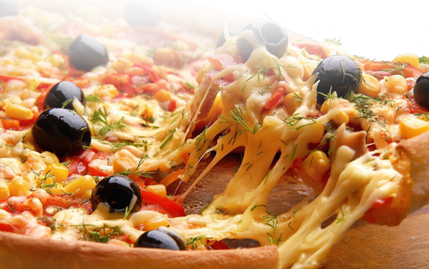Sh

**Kebabs**

**REG LARGE**

**Donner Kebab 3.00 3.80**

**Shish Kebab 3.00 3.80**

**Shish Special 3.00 3.80**

**Chicken Kebab 3.00 3.80**

**Chicken Special 3.00 3.80**

**Charcoal Mixed Kebab 3.00 3.80**

**Mixed Grill 3.00 3.80**

**Donner Kebab 3.00 3.80**

**Shish Kebab 3.00 3.80**

**Shish Special 3.00 3.80**

**Chicken Kebab 3.00 3.80**

**Chicken Special 3.00 3.80**

**Extra Toppings**

**Donner Kebab Topping**

**REG: £1.00 LARGE: £2.00 FAMILY: £3.00**

**Garlic Breads**

**Garlic Bread with butter and Fresh Garlic**

**Garlic Bread with Cheese**

**Garlic Bread with Mushrooms**

**Garlic Bread with Cheese and Mushrooms**

**Pizzas**

**Regular Large Family**

Margarita 3.20 5.20 6.00

Mushroom 3.20 5.20 6.00

Vegetarian 3.20 5.20 6.00

Hot Vegetarian 3.20 5.20 6.00

Spicy Beef 3.20 5.20 6.00

Hot Shot 3.20 5.20 6.00

Ham and Mushroom 3.20 5.20 6.00

Ham and Pineapple 3.20 5.20 6.00

Chili Corn Carne 3.20 5.20 6.00

Bolognese 3.20 5.20 6.00

Margarita 3.20 5.20 6.00

Mushroom 3.20 5.20 6.00

Vegetarian 3.20 5.20 6.00

Hot Vegetarian 3.20 5.20 6.00

Spicy Beef 3.20 5.20 6.00

Hot Shot 3.20 5.20 6.00

Ham and Mushroom 3.20 5.20 6.00

Ham and Pineapple 3.20 5.20 6.00

Chili Corn Carne 3.20 5.20 6.00

Bolognese 3.20 5.20 6.00

Margarita 3.20 5.20 6.00

Mushroom 3.20 5.20 6.00

Vegetarian 3.20 5.20 6.00

Hot Vegetarian 3.20 5.20 6.00

Spicy Beef 3.20 5.20 6.00

Hot Shot 3.20 5.20 6.00

Ham and Mushroom 3.20 5.20 6.00

Ham and Pineapple 3.20 5.20 6.00

Chili Corn Carne 3.20 5.20 6.00

Bolognese 3.20 5.20 6.00