Olive Chapel Elementary Name _____________________________

Family Marathon

Running Log Teacher ____________________________
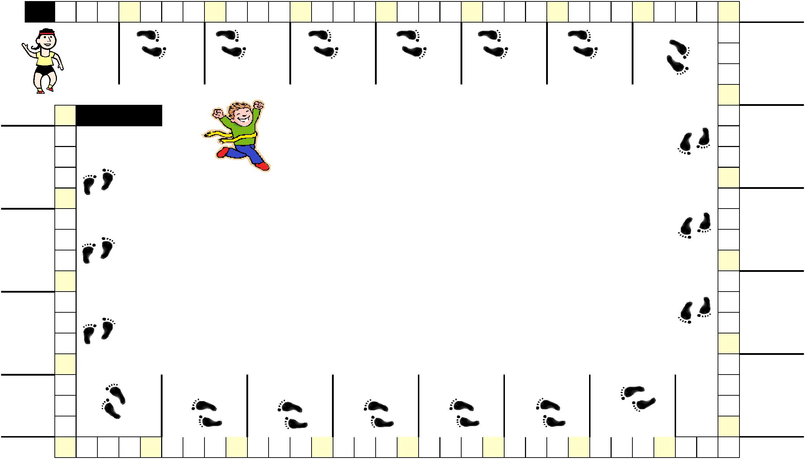

Start | 1/4 | 1/2 | 3/4 | 1 | 1/4 | 1/2 | 3/4 | 2 | 1/4 | 1/2 | 3/4 | 3 | 1/4 | 1/2 | 3/4 | 4 | 1/4 | 1/2 | 3/4 | 5 | 1/4 | 1/2 | 3/4 | 6 | 1/4 | 1/2 | 3/4 | 7 | 1/4 | 1/2 | 3/4
 |  |  | SignatureParent |  |  |  | SignatureParent |  |  |  | SignatureParent |  |  |  | SignatureParent |  |  |  | SignatureParent |  |  |  | SignatureParent |  |  |  | SignatureParent

8
_{1/4} Parent Signature

1/2

3/4

9

25 At-Home Finish

Parent Signature | 3/4 | on the day of the Family
 |  | Marathon.

1/2

1/4

24

Parent Signature | 3/4
 | 1/2
 | 1/4

Congratulations!

Turn in your completed form

to your classroom teacher.
_{1/4} Parent Signature

1/2

3/4

10
_{1/4} Parent Signature

1/2

3/4

11

23

Parent Signature | 3/4
 | 1/2
 | 1/4
 | 22
Parent Signature | 3/4
 |  |  |  | Signature |  |  |  | Signature |  |  |  | Signature |  |  |  | Signature |  |  |  | Signature |  |  |  | Signature |  |  | Signature
 | 1/2
 |  |  |  | Parent |  |  |  | Parent |  |  |  | Parent |  |  |  | Parent |  |  |  | Parent |  |  |  | Parent |  |  | Parent
 | 1/4
Parent Signature _{213/4}
 |  | 1/2 | 1/4 20 3/4 |  | 1/2 | 1/4 19 3/4 |  |  | 1/2 | 1/4 18 3/4 |  |  | 1/2 | 1/4 17 3/4 |  |  | 1/2 | 1/4 16 3/4 |  |  | 1/2 | 1/4 15 3/4 |  |  | 1/2 | 1/4 14 3/4 |  | 1/2
_{1/4} Parent Signature

1/2

3/4

12
_{1/4} Parent Signature

1/2

3/4

13
_{1/4} Parent Signature

